Exercise 3 Solution

Exercise 3: Regional Customer Profiles
Patagonia wants to understand how customer profiles and purchase activity differ across U.S. regions before planning regional marketing messages.
Use customer_data.csv and store_transactions.csv to prepare one short client report. The files describe the same customers, identified by customer_id. Purchase activity means the number of purchases in December 2018 (dec_2018), the latest month in these historical transaction data.
Choose one discrete customer characteristic and one continuous characteristic, such as income or credit score. Use region as the comparison groups, rather than as the characteristic itself. Decide which analysis operations and chart forms will answer the client’s question.

The Client Report
Include:
- A count table and a clearly labeled chart comparing your discrete characteristic across regions.
- A numeric summary describing your continuous characteristic and December 2018 purchase activity in each region.
- A clearly labeled chart comparing the distribution of your continuous characteristic across regions.
- One finding that connects your discrete and continuous evidence to regional messaging, with purchase activity as context, and one limitation of that conclusion.
Submit a Word document rendered from Quarto containing your code, tables, charts, and interpretation. Use the tidyverse and the coding conventions practiced in class. Choose and justify your approach; different defensible analyses are welcome.

Grading Rubric
Five points total, one point each for:
- Discrete comparison. Provide a correct count table and a clearly labeled chart comparing one discrete customer characteristic across regions. Counts or within-region proportions are acceptable when accurately labeled. Region supplies the comparison groups; identifiers alone are not customer characteristics.
- Regional numeric summary. Correctly summarize a continuous characteristic and December 2018 purchase activity for each region using the supplied customer and transaction records. Income or credit score is appropriate; purchase counts alone do not satisfy the continuous-variable requirement.
- Continuous comparison. Provide a correct, clearly labeled chart comparing the distribution of the chosen continuous characteristic across regions.
- Interpretation. Explain a supported finding connecting the discrete and continuous evidence to regional messaging, using purchase activity as context, and one relevant limitation. Distinguish an observed pattern from evidence that a particular message will work.
- Complete and readable submission. Submit a Word document rendered from Quarto containing code, tables, charts, and interpretation. Use the tidyverse, readable pipes and spacing, meaningful names, and useful comments.
Different defensible variables, summaries, chart forms, and conclusions can earn full credit. The example below is one possible response, not an output students must duplicate.

One Possible Solution
We compare college-degree status and annual income across regions, with average purchases in December 2018 as context for regional messaging research.

Customer and Purchase Records
# Connect each customer's profile with their purchase history.
library(tidyverse)
customer_data <- read_csv("customer_data.csv",
show_col_types = FALSE)
store_transactions <- read_csv("store_transactions.csv",
show_col_types = FALSE)
crm_data <- customer_data |>
left_join(store_transactions, join_by(customer_id))
Each file has one record per customer and the same 10,531 customer IDs, so this combination retains one row per customer. The fields used below have no missing values in these supplied files.

Discrete Customer Profile
# Retain counts so the sizes of the regional groups are visible.
crm_data |>
count(region, college_degree)
# A tibble: 8 x 3
region college_degree n
<chr> <chr> <int>
1 Midwest No 229
2 Midwest Yes 872
3 Northeast No 640
4 Northeast Yes 2584
5 South No 891
6 South Yes 220
7 West No 989
8 West Yes 4106
Regions have different numbers of customers. The chart compares degree-status proportions within each region; the table retains the customer counts.
crm_data |>
count(region, college_degree) |>
ggplot(aes(x = region, y = n, fill = college_degree)) +
geom_col(position = "fill") +
labs(
title = "College-Degree Status by Region",
x = "Region",
y = "Proportion of Customers",
fill = "College Degree"
)
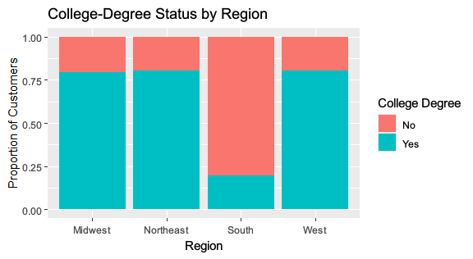

Income and Purchase Activity
# Compare income and purchase activity on a per-customer basis.
crm_data |>
group_by(region) |>
summarize(
customers = n(),
avg_income = mean(income),
avg_purchases = mean(dec_2018)
)
# A tibble: 4 x 4
region customers avg_income avg_purchases
<chr> <int> <dbl> <dbl>
1 Midwest 1101 143411. 1.56
2 Northeast 3224 141975. 1.53
3 South 1111 111971. 1.52
4 West 5095 141278. 1.55
Income supplies the continuous measure. The average purchase count describes activity in the latest month available, December 2018; it is not a measure of current activity.
crm_data |>
ggplot(aes(x = income, y = region)) +
geom_boxplot() +
labs(
title = "Customer Income by Region",
x = "Annual Income",
y = "Region"
)
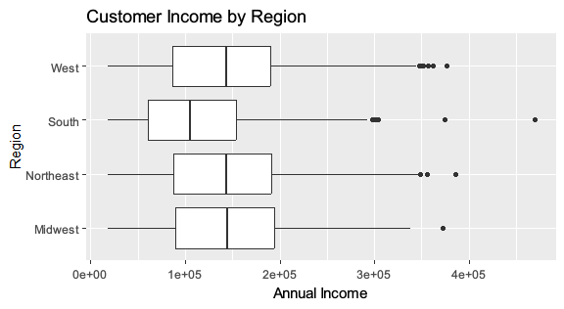
The boxplots show variation within each region, which a regional average alone would conceal.

Interpretation
About 20% of customers in the South have college degrees, compared with roughly 79-81% in the other regions. Mean annual income is also lower in the South, about $112,000 versus $141,000-$143,000 elsewhere. The income chart shows a lower central income range in the South as well as variation within each region.
Mean December 2018 purchases are fairly similar across regions, about 1.52-1.56 per customer. Together, these findings suggest that Patagonia should test whether regional messages resonate with customers whose profiles differ, rather than assume the overall customer profile represents every region. Purchase activity provides little evidence of a large difference in average activity in this particular month.
These historical CRM records do not establish that education or income causes message preferences, or that a regional campaign would improve engagement. One month of purchases may not describe sustained activity, and the records may not represent today’s customers or prospective customers. Message testing and more recent data would be needed before choosing a campaign.

