Cory CaddellS
Pseudo-Code and UML
Project

Driver Class Pseudo-Code:
- Display menu:
  - Read menu selection from keyboard
  - Read assignment info from keyboard to establish base line, if menu options 1 – 7 are selected.
  - Read confirmation from keyboard to allow user to review their input, if menu option 0 is selected
- Repeat step 1 until user selects option 0 to move on to next menu
- Display menu:
  - Read input from keyboard:
    - if task 1 is selected:
      - Read student information from keyboard
      - Display student information
      - Write to file
    - if task 2 is selected
      - Display student grades from file to screen
    - if task 3 is selected
      - Display class grades from file to screen
- Repeat step 3 until user selects to exit program.

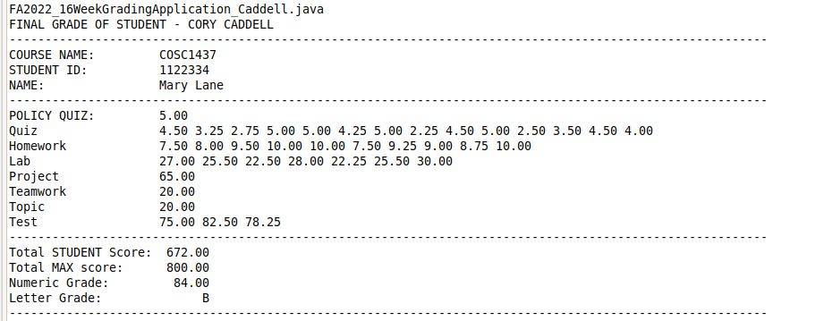

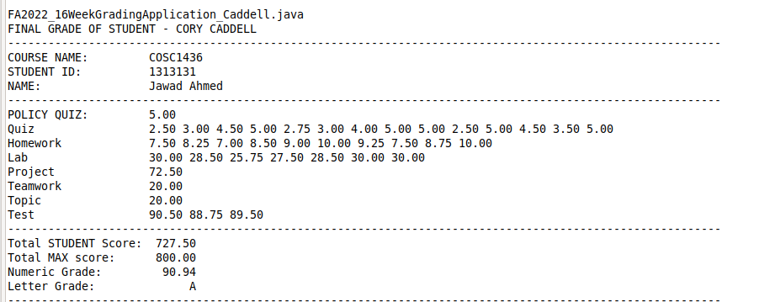

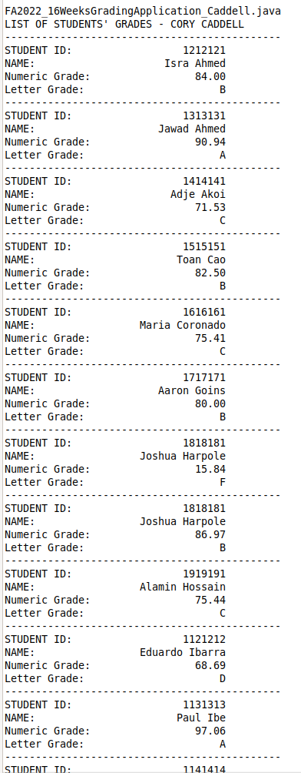

Student Class UML:

FA2022_Student_Caddell
- courseName : String
- studentID : String
- firstName : String
- lastName : String
- extraCreditScore : float
- ARRAY_SIZE : int
- assignmentNames : String[]
- studentScores : int[][]
- studentScoresString : String[]
- maxScores : float[]
+ FA2022_Student_Caddell()
+ FA2022_Student_Caddell(cn:String, id:String, fn:String, ln:String, ex:float, an:String[], ss:float[][], sss:String[], ms:float[])
+ calcTotalMaxScore() : float
+ calcTotalStudentScores() : float
+ calcNumericGrade() : float
+ calcLetterGrade() : char
+ toFile():String : void
+ shortOutput() : String
+ toString() : String

