Cory Caddell
Pseudo-Code
Lab2

Part 1 – Calculator SavingMoney

- Read input:
  - Customer name
  - Initial savings account deposit
  - Interest Rate
- Calculate ending account balance (beginning balance + beginning balance * interest rate)
- Format and display output to screen

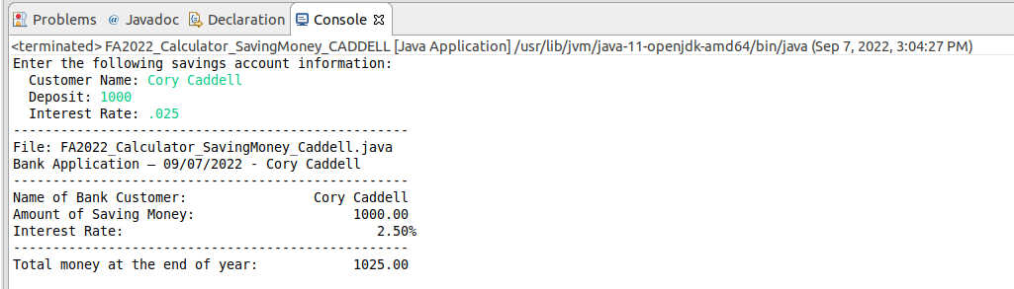

Part 2 – BMI ManageWeight

- Read input:
  - Name
  - Height (in inches)
  - Targeted BMI Value
- Calculate target weight ((BMI * height * height) / 703)
- Format and display output to screen

