Cory CaddellS
Pseudo-Code and UML
Lab6

Part 2 – Sale Product

Driver Class Pseudo-Code:
- Read user input from keyboard
  - product id
  - product name
  - unit price per each size of products
  - total units of each product size purchased
- Calculate total sale:
  - gross sales + sales tax = total sales
- Display sales report to screen

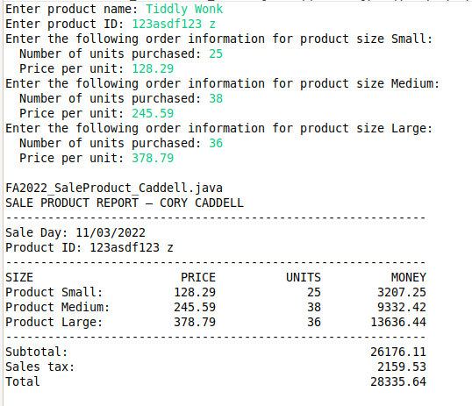

Product Class UML:

FA2022_Product_Caddell
- SIZE:int
- productID:String
- productName:String
- productUnits:int[]
- productUnitPrice:float[]
+ FA2022_Product_Caddell()
+ FA2022_Product_Caddell(id:String, n:String, u:int[], p:float[])
+ setProductID(id:String):Void
+ setProductName(n:String):Void
+ setProductUnits(u:int[]):Void
+ setProductUnitPrice(p:float[]):Void
+ getProductID():String
+ getProductName():String
+ getProductUnits():int[]
+ getProductUnitPrice():float[]
+ calculateSaleMoney():float
+ calculateSalesTax():double
+ calculateTotalSaleMoney():double
+ toString():String

