Cory CaddellS
Pseudo-Code and UML
Lab 7

Part 1 – Employee Salar per Week

Driver Class Pseudo-Code:
- Read salary information from keyboard input
- Calculate salary for one week
- Display salary information to screen
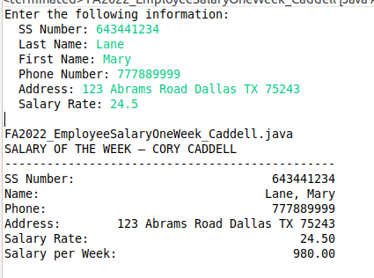

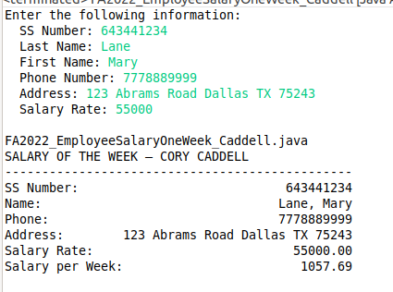

Product Class UML:

FA2022_Person
# SSNumber:String
# lastName:String
# firstName:String
# phone:String
# address:String
+ FA2022_Person()
+ FA2022_Person(num:String, last:String, first:String, phoneN:String, addr:String)
+ setLastName(lname:String)
+ setFirstName(fname:String)
+ setPhone(newPhone:String)
+ setAddress(addr:String)
+ getLastName():String
+ getFirstName():String
+ getPhone():String
+ getAddress():String
+ toString():String

FA2022_Employee_Caddell
# salaryRate : float

+ FA2022_Employee_Caddell()
+ FA2022_Employee_Caddell(num:String, last:String, first:String, phoneN:String, addr:String, sr:float)
+ setSalaryRate(sr:float)
+ getSalaryRate():float
+ salaryOneWeek():float
+ toString():String

Part 2 – Carpet Installation Quote

Driver Class Pseudo-Code:
- Read input – number of rooms to quote
- Display menu
- Read Input – room information
- While ‘0’ is not selected or room information read does not equall number of rooms per step 1, repeat steps 2 and 3
- Calculate total area
- Calculate costs
- Display installation quote to screen

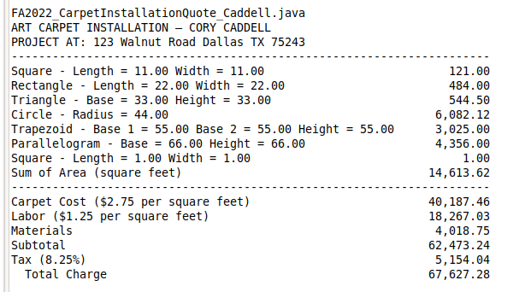

FA2022_StaticMethod_Caddell
+ isInteger(keyboard : Scanner) : void
+ isPositiveFloat(keyboard : Scanner) : float
+ isPositiveDouble(keyboard : Scanner) : double
+ isPositiveInteger(keyboard : Scanner) : int
+ isMenuSelect(keyboard : Scanner, min : int, max : int) : int
+ yesOrNo(keyboard : Scanner, input : String) : char

