Cory Caddell
Pseudo-Code and UML
Lab4

Part 2 – Salary of Sale Representative

Driver Class Pseudo-Code:
- Read user input from keyboard:
- Calculate salary, which is the sum of:
  - Base salary
  - Commission:
    - if sale amount is greater than $0, commission rate is 3.29% of sale amount
    - else commission rate is 0.00%
  - Bonus:
    - if sale amount is greater than or equal to $15,000, bonus rate is 2.59% of sales in excess of $10,000
    - else if sale amount is greater than $10,000, bonus rate is 2.19% of sales in excess of $10,000.
    - else bonus rate is 0.00%
- Display output to screen

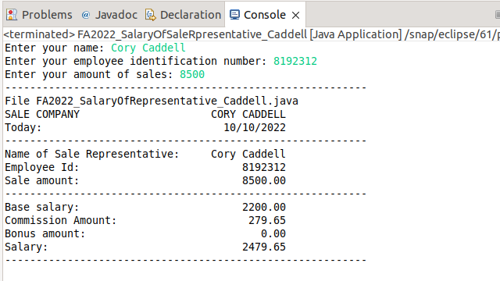

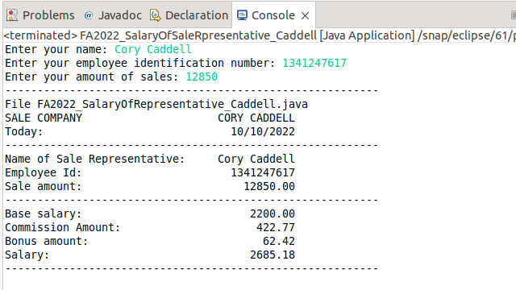

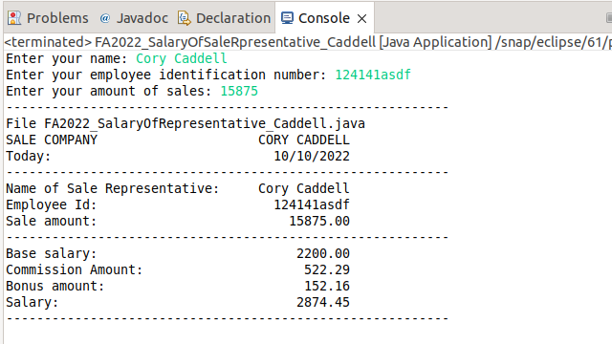

Sale Representative Class UML:

FA2022_SaleRepresentative_Caddell
- name:String
- employeeID:String
- saleAmount:float
+ FA2022_SaleRepresentative_Caddell()
+ FA2022_SaleRepresentative_Caddell(n:String, id:String, s:float)
+ setName(n:String):void
+ setEmployeeID(id:float):void
+ setSaleAmount(s:float):void
+ getName():String
+ getEmployeeID():String
+ getSaleAmount():float
+ calcCommission():double
+ calcBonus():double
+ calcSalary():double
+ toString():String

