22May2017

YPrime Nuget Reference Sheet

**Quick reference:**

* Nuget package folder:
  + \\AZ-IRTWEBDEV01\Sites\YPrime_NuGet\Packages

**These are the steps to generate a nuget package for deployment.**

**Steps to Create Nuget Package**

1. Increment assembly version
2. Build the project
3. 
4. Open the folder in command window
   1. Right click on project and open in command window
5. 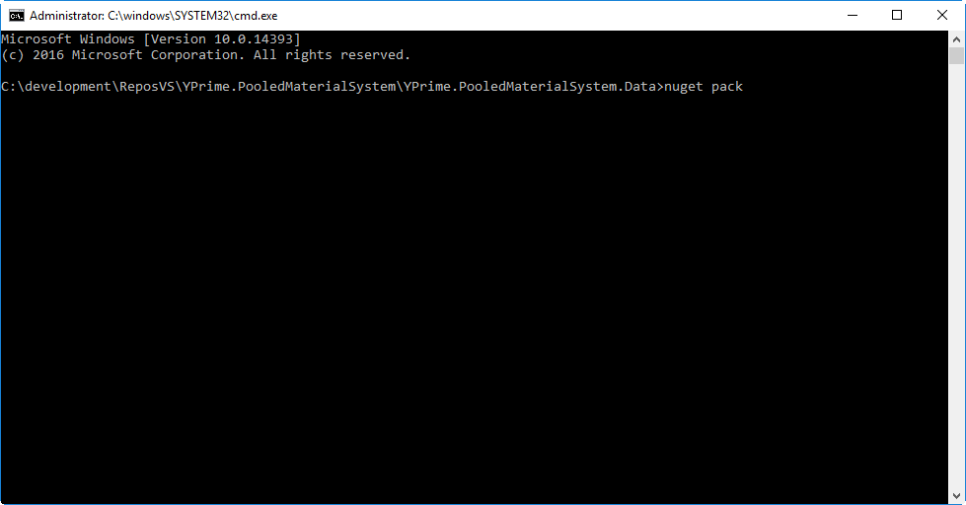
6. Make sure there is an env variable for system path. The exe can usually be found under code repository \nuget folder
7. Enter
   1. nuget pack
8. the package will be created in the project folder root
9. 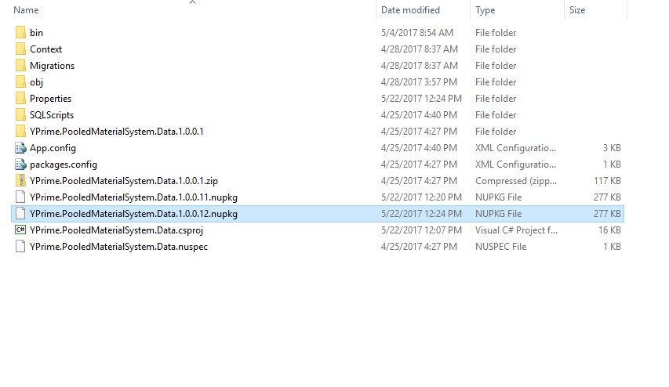
10. On command line (make sure to check the package name and version):
    1. nuget push YPrime.PooledMaterialSystem.Data.1.0.0.**##**.nupkg 0F81B130-C65E-4090-ACB2-938F7D05530C -Source http://yprimenuget.eclinicalcloud.net/api/v2/package
    2. this will publish the package to the nuget server
11. In your project enter this from the command line to install the new version:
    1. install-package YPrime.PooledMaterialSystem.Data -version 1.0.0.12

WEB TEMPLATE

nuget push YPrime.Shared.WebTemplate.1.0.3.**##**.nupkg 0F81B130-C65E-4090-ACB2-938F7D05530C -Source http://yprimenuget.eclinicalcloud.net/api/v2/package

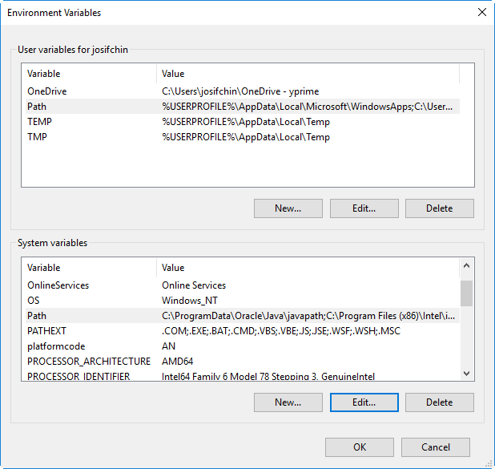

Be sure to set your nuget path in the environment variables.