**Epidemic Prediction Initiative Website Instructions**

**Create an Account**

1. Go to <https://predict.cdc.gov/>
2. Click “Create Account” in the top right corner.
3. Fill in the fields and click “Register”.
4. You will see a new screen than says “Welcome! You will get an email shortly from episupport@cdc.gov to have your account activated. You can also contact support should you encounter any problems.”

**Join a Project**

1. Log into your account at <https://predict.cdc.gov/>
2. You should see a field to create a team for open projects similar to the one below.

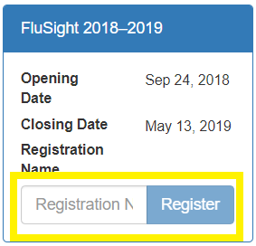

1. Enter your model name here.
2. Click “Register".
3. The system will notify us of your request to join the project.
4. We will approve your request with 2 business days. Send an email to episupport@cdc.gov if you have any questions or concerns.

**Submit a Forecast**

1. Log into the website at <https://predict.cdc.gov/>
2. Click on “Go to project” under your team name in the project box

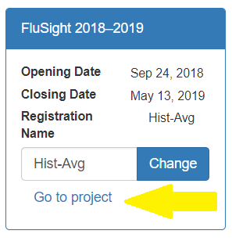

1. In the left menu bar, click on “Submit” to access the submission page

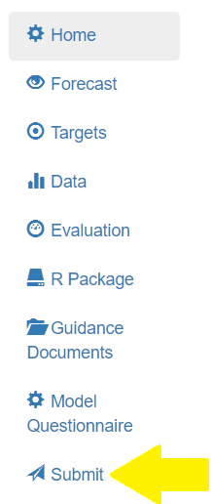

1. In the row for the submission you are uploading, click “Upload CSV” and select your submission file.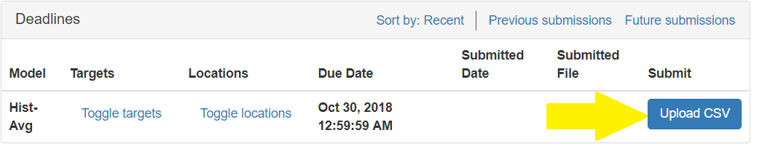
2. You should see “Processing…” and then “Sending…” appear next to the Upload button while your data are transmitted and the system checks to make sure your submission is valid.
3. If the submission is successful, you will see an “Open JSON” link next to the upload button. Clicking this will open the JSON file that your submission has been converted to that will eventually be used for visualizations and analyses.
4. If your submission is not successful, an error message should popup explaining what rows/columns are out of agreement with a valid submission. Try to fix those errors and resubmit. Contact episupport@cdc.gov if you experience technical issues with submitting.