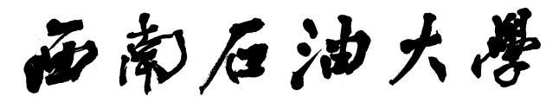

**本科毕业设计（论文）**



|  |  |
| --- | --- |
| **题目** | **三维空间最短路径** |
| **算法设计与实现** | |

|  |  |  |  |
| --- | --- | --- | --- |
| **学生姓名** | **陈东** | **学　号** | **201731062232** |
| **教学院系** | **计算机科学学院** | | |
| **专业年级** | **软件工程2017级** | | |
| **指导教师** | **刘小玲** | **职　称** | **讲 师** |
| **单　　位** | **计算机科学学院** | | |
| **辅导教师** |  | **职 称** |  |
| **单　　位** |  | | |

|  |  |  |  |  |  |  |
| --- | --- | --- | --- | --- | --- | --- |
| **完成日期** | **2021** | **年** | **05** | **月** | **27** | **日** |