10 or 25/25

Computer Assignment 2

Alda Magnúsdóttir

**Hildur Mist Pálmarsdóttir**

Tinna Brá Sigurðardóttir

Þórdís Gísladóttir

Reykjavik University

**Question 1**

1. Item 10 is the hardest one and item 5 is the easiest one. 2

Discrimination Difficulty Guessing

Item 1 1 -1.40938612 0

Item 2 1 -0.35055656 0

Item 3 1 -0.90318970 0

Item 4 1 -0.97412011 0

Item 5 1 -1.62671110 0

Item 6 1 0.02533657 0

Item 7 1 -0.41418545 0

Item 8 1 -0.87993298 0

Item 9 1 -0.91498121 0

Item 10 1 0.52959427 0

Item 11 1 -1.17125435 0

Item 12 1 -0.04749604 0

Item 13 1 0.15008663 0

Item 14 1 -0.74253017 0

Item 15 1 -0.74245332 0

Item 16 1 0.36963876 0

Item 17 1 -0.84513136 0

Item 18 1 -1.45145349 0

1. -1.62671110 +1.96 * 0.1320051 = -1.367981004

-1.62671110 - 1.96 * 0.1320051 = -1.885440996

There is a 95% chance that the confidence interval contains the true item difficulty. In this case it lies between -1.367981004 and -1.885440996. 2

Discrimination SE Difficulty SE Guessing SE

Item 1 NA 0.1267448 0

Item 2 NA 0.1128011 0

Item 3 NA 0.1178581 0

Item 4 NA 0.1188426 0

Item 5 NA 0.1320051 0

Item 6 NA 0.1118476 0

Item 7 NA 0.1131572 0

Item 8 NA 0.1175527 0

Item 9 NA 0.1180162 0

Item 10 NA 0.1136598 0

Item 11 NA 0.1220123 0

Item 12 NA 0.1118797 0

Item 13 NA 0.1119630 0

Item 14 NA 0.1159197 0

Item 15 NA 0.1159189 0

Item 16 NA 0.1126941 0

Item 17 NA 0.1171115 0

Item 18 NA 0.1276902 0

1. The black line (item 5) is the easiest item and the red one (item 10) is the hardest item.

Ability estimate for the black line is approximately -1.8 and for the red line is approximately 0.8. 1

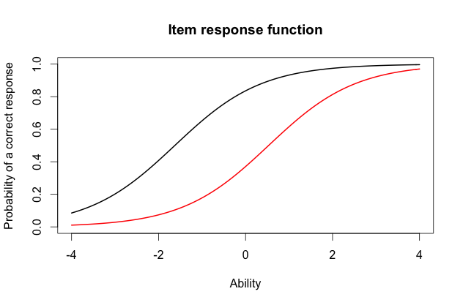

1. The probability of a correct response for the red line would be around 0.4 and for the black line is around 0.9 for someone who had an ability score of 0. 2
2. The score for the person who did the best on the test is 3.999921 and for person who did worst is -3.999947. 2

> min(est_abl$est) # Prints the minimum score

[1] -3.999947

> max(est_abl$est) # Prints the maximum scores

[1] 3.999921

f) 3.999921 + 1.96 * 2.204373 = 8.32049208  
 3.999921 - 1.96 * 2.204373 = -0.32065008

The 95% confidence interval defines a range of values that you can be 95% certain contains the true ability score. In this case it lies between 8.32049208 and -0.32065008. 2

est sem n

49 3.999921 2.204373 18

**Question 2**

1. We chose item 5, 10, 15 1
2. 1  
   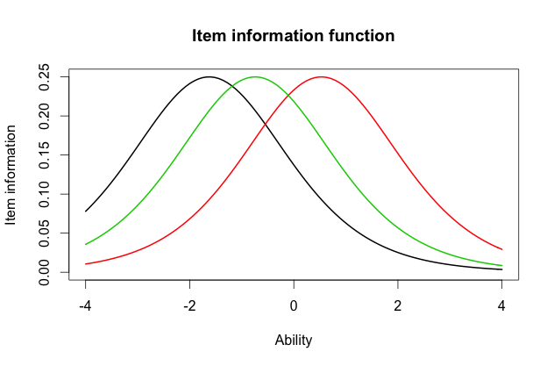
3. The curves are all the same but where they are located is the difference. 2
4. 1  
   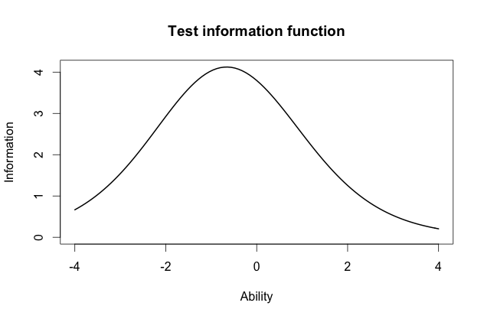
5. The majority of the information is located between 0 and -1. 1

**Question 3**

1. Highest discrimination is item 8 with 2.2881772. Lowest discrimination is item 12 with 0.3329130. 2

Discrimination Difficulty Guessing

Item 1 0.6326689 -2.00058101 0

Item 2 1.5469622 -0.26815483 0

Item 3 1.2534918 -0.77297206 0

Item 4 0.9842598 -0.97706755 0

Item 5 1.6407242 -1.19389580 0

Item 6 1.4702029 0.01833431 0

Item 7 0.5632837 -0.65124651 0

Item 8 2.2881772 -0.56753253 0

Item 9 1.8004066 -0.64761748 0

Item 10 1.1142107 0.48542889 0

Item 11 1.0344119 -1.13363005 0

Item 12 0.3329130 -0.12951933 0

Item 13 0.3369968 0.36344671 0

Item 14 0.6608229 -1.01479867 0

Item 15 1.5980393 -0.55640285 0

Item 16 1.0362116 0.35459121 0

Item 17 1.8591845 -0.59017915 0

Item 18 1.2808752 -1.22177042 0

1. No in Rasch model it was item 5 and 10. However in the 2-PL item 10 was also the hardest but the easiest item was a different item than in the Rasch model, it was item 1. 2
2. The correlation between the Rasch model and 2-PL is 0.9709497. This is a very large correlation and that means that there is almost perfect correlation between this two tests. So if you get a high score on one test it is likely you will also get high score on the other test. We can draw the same conclusion for both models. They are practically the same.

2

> cor(twopl_abl$est,est_abl$est)

[1] 0.9709497

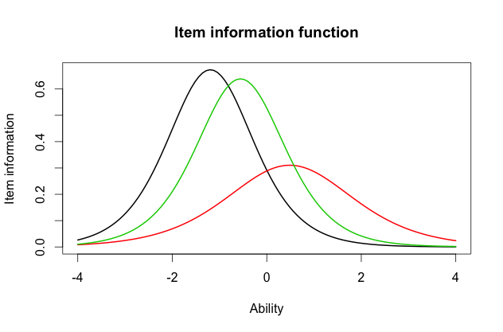

1. 1
2. The black line has the most information at the item location and the red one has the lowest information because it is wide. The black one has the highest discrimination, the green line has a bit more discrimination than the black one and red one the lowest. The black line is the easiest question.

In 2-PL model there is much more difference between the questions on the item information, the curves are not similar like in the Rasch model. In Rasch model the item information was all the same but just not located at the same place, that is not the case in 2-PL model. But in both model the black line is the easiest question and the red one the hardest.

2