8,2 or 20.5/25

Gunnur Hulda Stefánsdóttir  
Stefanía Bergmann Magnúsdóttir

**QUESTION 1**

**(a) Which item was the easiest item and which item was the hardest?**

The easiest item is item 5 (-1.62671110) and the hardest is item 10 (0,5295).

Discrimination Difficulty Guessing

Item 1 1 -1.40938612 0

Item 2 1 -0.35055656 0

Item 3 1 -0.90318970 0

Item 4 1 -0.97412011 0

Item 5 1 -1.62671110 0

Item 6 1 0.02533657 0

Item 7 1 -0.41418545 0

Item 8 1 -0.87993298 0

Item 9 1 -0.91498121 0

Item 10 1 0.52959427 0

Item 11 1 -1.17125435 0

Item 12 1 -0.04749604 0

Item 13 1 0.15008663 0

Item 14 1 -0.74253017 0

Item 15 1 -0.74245332 0

Item 16 1 0.36963876 0

Item 17 1 -0.84513136 0

Item 18 1 -1.45145349 0  
  
  
  
  
  
  
  
(b) **Provide a 95% confidence interval for the easiest item and interpret it**: We calculated this with -1.62671110+1.96*0.1320051= -1.367981  
and then we calculated this with minus -1.62671110-1.96*0.1320051 = -1.885441. Interpretation -1

Discrimination SE Difficulty SE Guessing SE

Item 1 NA 0.1267448 0

Item 2 NA 0.1128011 0

Item 3 NA 0.1178581 0

Item 4 NA 0.1188426 0

Item 5 NA 0.1320051 0

Item 6 NA 0.1118476 0

Item 7 NA 0.1131572 0

Item 8 NA 0.1175527 0

Item 9 NA 0.1180162 0

Item 10 NA 0.1136598 0

Item 11 NA 0.1220123 0

Item 12 NA 0.1118797 0

Item 13 NA 0.1119630 0

Item 14 NA 0.1159197 0

Item 15 NA 0.1159189 0

Item 16 NA 0.1126941 0

Item 17 NA 0.1171115 0

Item 18 NA 0.1276902 0  
  
> -1.62671110+1.96*0.1320051

[1] -1.367981

> -1.62671110-1.96*0.1320051

[1] -1.885441

(**c) Provide a plot that contains both the easiest and the hardest item**: The red line is the harder one and the black one is the easiest one.  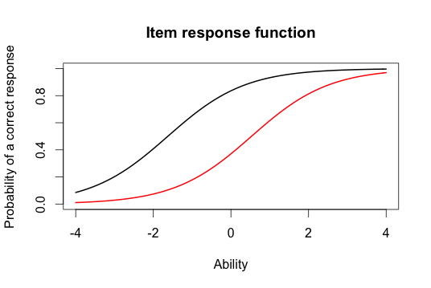

(d) **What would we expect the probability of a correct response would be for someone who had an ability score of 0 for these two items?** The probability of a correct response would be -0,4 for the red line and the probability for the correct response for the black line would be +0,8.

(e) **What was the score of the person who did the best on the test? What was the score of the person who did the worst on the test**? The score for the person who did the best on the test was 3,99 and the score for the person who did the worst on the test was -3,99.  
  
> min(est_abl$est) # Prints the minimum score

[1] -3.999947

> max(est_abl$est) # Prints the maximum scores

[1] 3.999921

(f) **Provide a 95% confidence interval for the estimated ability for the student who did the best on the test and interpret it**. : We calculated this with 3.99+1.96*2.204 = 8.30984 and then we calculated this with minus 3.99-1.96*2.204 = -0.32984

> 3.99+1.96*2.204

[1] 8.30984

> 3.99-1.96*2.204

[1] -0.32984

Interpretation -1

**QUESTION 2**  
**(a)** **Please state the three items you selected**: We selected items 1,3 and 5.

**(b) Provide a plot that contains these three items’ information functions:**   
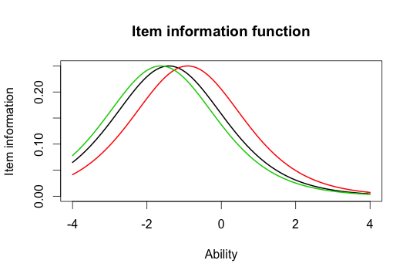

**(c) What is the same about these items' information functions? What is different?** The lines are similar, especially the green and the black one. The red line has a little more distribution? They are located at different places, the item difficulties -.5

(d) Provide a plot of the test information function  
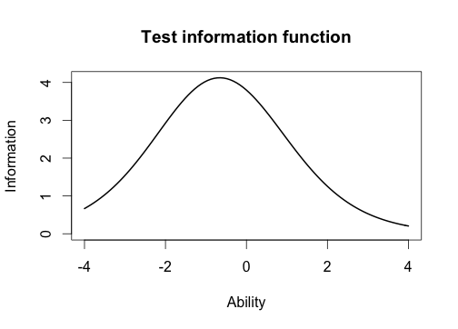

**(e) Where is the majority of the information for this test located?** The majority of the information for this test is located at -0,5.

**QUESTION 3**  
**(a) Which item had the highest discrimation? Which one had the lowest discrimination?** The item that had the highest discrimination is item 8 (2,2881772) and the lowest discrimination is item 12 (0,3329130).   
  
 Discrimination Difficulty Guessing

Item 1 0.6326689 -2.00058101 0

Item 2 1.5469622 -0.26815483 0

Item 3 1.2534918 -0.77297206 0

Item 4 0.9842598 -0.97706755 0

Item 5 1.6407242 -1.19389580 0

Item 6 1.4702029 0.01833431 0

Item 7 0.5632837 -0.65124651 0

Item 8 2.2881772 -0.56753253 0

Item 9 1.8004066 -0.64761748 0

Item 10 1.1142107 0.48542889 0

Item 11 1.0344119 -1.13363005 0

Item 12 0.3329130 -0.12951933 0

Item 13 0.3369968 0.36344671 0

Item 14 0.6608229 -1.01479867 0

Item 15 1.5980393 -0.55640285 0

Item 16 1.0362116 0.35459121 0

Item 17 1.8591845 -0.59017915 0

Item 18 1.2808752 -1.22177042 0

(b) **Are the items that were the easiest and hardest in the Rasch model, also the easiest and hardest in the 2-PL?** No, in the Rasch model item 5 and 10 were the easiest and hardest ones, but in the 2-PL item 8 and 12 were the easiest and the hardest ones. Those are discrimination parameters not the difficulty parameters, please see the answer key - 1

**(c) What is the correlation between the ability estimates on the Rasch model and the 2-PL? If your interest was solely on estimating person abilities, do you think you would draw the same conclusions from both models? Why? 2-PL:** The correlation between the ability estimates on the Rasch model and the 2-PLis 0.9709497.   
Yes, we would draw the same conclusion from both models because the correlation is high(0,97) between the ability estimates on the Rasch model and the 2-PL.  
  
> cor(twopl_abl$est,est_abl$est)

[1] 0.9709497

**(d) Provide a plot of the item information function for the three items you selected in Question 2 but this time for the 2-PL model.**   
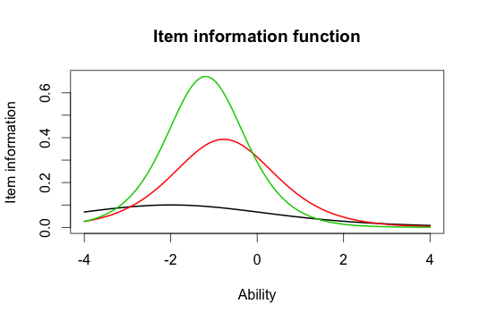

**(e) For the 2-PL model, how do the item information functions for these items differ? How do the 2-PL item information functions from these items differ from their Rasch item information functions?** In the 2-PL the items are different from the Rasch items. Especially the black item, in the 2-PL item the black item has small information and large range. The green item has a greater information.

In general, what is different? The Rasch they all had the same shape and different locations. In the 2PL they have different shape (because of different discriminations) and locations. Comparing between the 2, we see that they can have different shape and location even if they are the same item -1