0,6 or 15/25

Háskólinn í Reykjavík 01. Mars. 2015

Viðskiptadeild

Sálfræðisvið

Próffræði og mælingar í sálfræði

**R Lab # 2**

Nemandi: Ísak Hrafn Stefánsson Kennari: Christopher David Desjardins

**Question 1 - Item Response Functions and Person Estimates**

1. **Which item was the easiest item and which item was the hardest? (2 points)**

Item 5 vas the easiest, difficulty = -1.626, SE = 0.132 and item 6 vas the hardest, difficulty = 0,025 SE = 0.111. Item 10 was the hardest. -1

1. **Provide a 95% confidence interval for the easiest item and interpret it. (2 points)**

It can be said with 95% assurance that question 5 = 0,626 was the easiest. You need to calculate the 95% confidence interval and then interpret it -2.

1. **Provide a plot that contains both the easiest and the hardest item. (1 point)**

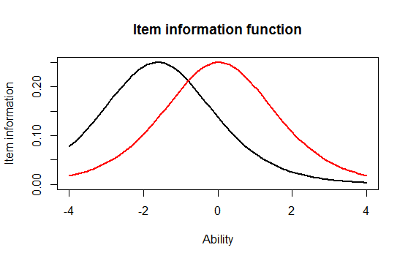

**(d) What would we expect the probability of a correct response would be for someone who had an**

**ability score of 0 for these two items? (2 points)**

About 0,15 with the hardest one and about 0,25 with the easy one.

Please see the answer key. You need to look at the IRFs not the IIFs that you have picture above -2.

**(e) What was the score of the person who did the best on the test? What was the score of the**

**person who did the worst on the test? (2 points)**

The person who scored the best had a score of = 3.999921. The person who scored the worst had a score of = -3.999947.

**(f) Provide a 95% confidence interval for the estimated ability for the student who did the best on**

**the test and interpret it. (2 points)**It can be said with 95% confidence that individual 49 had the highest score on the test.

You need to calculate the 95% confidence interval and interpreted it. -2

**Question 2 - Information**

**For this question, you will choose three items to investigate.**

1. **Please state the three items you selected. (1 point)**

Items 6, 7 and 8.

1. **Provide a plot that contains these three items’ information functions. (1 point)**

**-1 these are IRFs not the item information functions.**

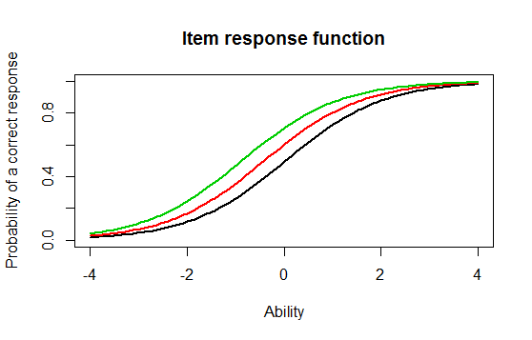

1. **What is the same about these items’ information functions? What is different? Hint: This can be a very short answer. (2 point)**

They all start to differ in probability of getting them right in the middle, and then they get more similar towards the ends.

They will differ by their shape and location. -2

**(d) Provide a plot of the test information function. (1 point)** 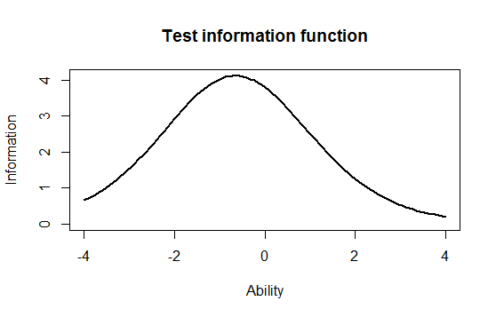

**(e) Where is the majority of the information for this test located? (1 point)**

Between 0 and -1.

**Finally, you will need to run a 2-PL**

**Question 3 - Comparing the 2-PL**

1. **Which item had the highest discrimation? Which one had the lowest discrimination? (2 point)**

Item 12 had the lowest discrimination = 0.3329. Item 8 had the highest discrimination of 2.2881.

**(b) Are the items that were the easiest and hardest in the Rasch model, also the easiest and hardest**

**in the 2-PL? (1 point)**

Item 6 is still the hardest but item 1 is now the easiest. The same with 6 but not with 1. Item 10 is the hardest not sure why you are getting 6.

**(c) What is the correlation between the ability estimates on the Rasch model and the 2-PL? If**

**your interest was solely on estimating person abilities, do you think you would draw the same**

**conclusions from both models? Why? (2 point)**

The correlation is 0.97094. The correlation is almost perfect so you should you should get the same conclusions from both models.

**(d) Provide a plot of the item information function for the three items you selected in Question 2**

**but this time for the 2-PL model. (1 point)**

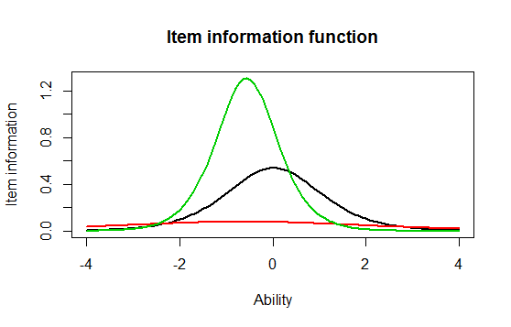

**(e) For the 2-PL model, how do the item information functions for these items differ? How do**

**the 2-PL item information functions from these items differ from their Rasch item information**

**functions? (2 point)**

They green line is still the highest, but the red and black have sort of changed places. The main difference is still in the middle but you can see the difference more clearly than in the Ranch model. And the black and red line have switch places. How about just for the 2PL? There shapes differ and their locations. What you write is correct comparing the 2PL with the Rasch but you need to talk about it within the 2PL. -1

**The output**

> install.packages("irtoys")

Warning in install.packages :

downloaded length 227 != reported length 227

trying URL 'http://cran.rstudio.com/bin/windows/contrib/3.1/irtoys_0.1.7.zip'

Content type 'application/zip' length 128823 bytes (125 Kb)

opened URL

downloaded 125 Kb

package ‘irtoys’ successfully unpacked and MD5 sums checked

The downloaded binary packages are in

C:\Users\isak\AppData\Local\Temp\Rtmp0u1STx\downloaded_packages

> library("irtoys")

Loading required package: sm

Package 'sm', version 2.2-5.4: type help(sm) for summary information

Loading required package: ltm

Loading required package: MASS

Attaching package: ‘MASS’

The following object is masked from ‘package:sm’:

muscle

Loading required package: msm

Loading required package: polycor

Loading required package: mvtnorm

Loading required package: sfsmisc

> library("irtoys")

> install.packages("irtoys")

Error in install.packages : Updating loaded packages

Restarting R session...

> install.packages("irtoys")

trying URL 'http://cran.rstudio.com/bin/windows/contrib/3.1/irtoys_0.1.7.zip'

Content type 'application/zip' length 128823 bytes (125 Kb)

opened URL

downloaded 125 Kb

package ‘irtoys’ successfully unpacked and MD5 sums checked

The downloaded binary packages are in

C:\Users\isak\AppData\Local\Temp\RtmpWOKEyQ\downloaded_packages

> library("irtoys")

Loading required package: sm

Package 'sm', version 2.2-5.4: type help(sm) for summary information

Loading required package: ltm

Loading required package: MASS

Attaching package: ‘MASS’

The following object is masked from ‘package:sm’:

muscle

Loading required package: msm

Loading required package: polycor

Loading required package: mvtnorm

Loading required package: sfsmisc

> getwd()

[1] "C:/Users/isak/Downloads"

> rasch_model <- est(Scored, model="1PL", engine="ltm", rasch = TRUE)

> est_params <- rasch_model$est

> colnames(est_params) <- c("Discrimination", "Difficulty", "Guessing")

> rownames(est_params) <- paste("Item", 1:18)

> est_params

Discrimination Difficulty Guessing

Item 1 1 -1.40938612 0

Item 2 1 -0.35055656 0

Item 3 1 -0.90318970 0

Item 4 1 -0.97412011 0

Item 5 1 -1.62671110 0

Item 6 1 0.02533657 0

Item 7 1 -0.41418545 0

Item 8 1 -0.87993298 0

Item 9 1 -0.91498121 0

Item 10 1 0.52959427 0

Item 11 1 -1.17125435 0

Item 12 1 -0.04749604 0

Item 13 1 0.15008663 0

Item 14 1 -0.74253017 0

Item 15 1 -0.74245332 0

Item 16 1 0.36963876 0

Item 17 1 -0.84513136 0

Item 18 1 -1.45145349 0

> est_se <- rasch_model$se

> colnames(est_se) <- c("Discrimination SE", "Difficulty SE", "Guessing SE")

> rownames(est_se) <- paste("Item", 1:18)

> est_se

Discrimination SE Difficulty SE Guessing SE

Item 1 NA 0.1267448 0

Item 2 NA 0.1128011 0

Item 3 NA 0.1178581 0

Item 4 NA 0.1188426 0

Item 5 NA 0.1320051 0

Item 6 NA 0.1118476 0

Item 7 NA 0.1131572 0

Item 8 NA 0.1175527 0

Item 9 NA 0.1180162 0

Item 10 NA 0.1136598 0

Item 11 NA 0.1220123 0

Item 12 NA 0.1118797 0

Item 13 NA 0.1119630 0

Item 14 NA 0.1159197 0

Item 15 NA 0.1159189 0

Item 16 NA 0.1126941 0

Item 17 NA 0.1171115 0

Item 18 NA 0.1276902 0

> plot(irf(est_params[c(1,3,5),]),)

> plot(irf(est_params[c(1,3,5),]), co = NA)

> est_abl <- as.data.frame(mlebme(Scored, ip = est_params))

> min(est_abl$est) # Prints the minimum score

[1] -3.999947

> max(est_abl$est) # Prints the maximum scores

[1] 3.999921

> which.min(est_abl$est) # Prints out the person minimum score

[1] 393

> which.max(est_abl$est) # Prints out the person with the maximum score

[1] 49

> est_abl[200,]

est sem n

200 -0.6390908 0.492458 18

> plot(iif(est_params[c(1,3,5),]), co = NA)

> plot(tif(est_params))

> twopl_model <- est(Scored, model="2PL", engine="ltm")

> plot(tif(est_params))

> plot(iif(est_params[c(1,3,5),]), co = NA)

> twopl_model <- est(Scored, model="2PL", engine="ltm")

> plot(irf(est_params[c(1,3,5),]), co = NA)

> est_abl <- as.data.frame(mlebme(Scored, ip = est_params))

> min(est_abl$est) # Prints the minimum score

[1] -3.999947

> max(est_abl$est) # Prints the maximum scores

[1] 3.999921

> which.min(est_abl$est) # Prints out the person minimum score

[1] 393

> which.max(est_abl$est) # Prints out the person with the maximum score

[1] 49

> est_abl[200,]

est sem n

200 -0.6390908 0.492458 18

> plot(iif(est_params[c(1,3,5),]), co = NA)

> plot(tif(est_params))

> est_abl <- as.data.frame(mlebme(Scored, ip = est_params))

> min(est_abl$est) # Prints the minimum score

[1] -3.999947

> which.min(est_abl$est) # Prints out the person minimum score

[1] 393

> which.max(est_abl$est) # Prints out the person with the maximum score

[1] 49

> est_abl[200,]

est sem n

200 -0.6390908 0.492458 18

> plot(iif(est_params[c(1,3,5),]), co = NA)

> plot(tif(est_params))

> twopl_model <- est(Scored, model="2PL", engine="ltm")

> plot(irf(est_params[c(1,3,5),]), co = NA)

> plot(irf(est_params[c(6,7,8),]), co = NA)

> plot(iif(est_params[c(5,6),]), co = NA)

> twopl_model <- est(Scored, model="2PL", engine="ltm")

> twopl_params

Error: object 'twopl_params' not found

> twopl_params <- twopl_model$est

> colnames(twopl_params) <- c("Discrimination", "Difficulty", "Guessing")

> rownames(twopl_params) <- paste("Item", 1:18)

> twopl_params

Discrimination Difficulty Guessing

Item 1 0.6326689 -2.00058101 0

Item 2 1.5469622 -0.26815483 0

Item 3 1.2534918 -0.77297206 0

Item 4 0.9842598 -0.97706755 0

Item 5 1.6407242 -1.19389580 0

Item 6 1.4702029 0.01833431 0

Item 7 0.5632837 -0.65124651 0

Item 8 2.2881772 -0.56753253 0

Item 9 1.8004066 -0.64761748 0

Item 10 1.1142107 0.48542889 0

Item 11 1.0344119 -1.13363005 0

Item 12 0.3329130 -0.12951933 0

Item 13 0.3369968 0.36344671 0

Item 14 0.6608229 -1.01479867 0

Item 15 1.5980393 -0.55640285 0

Item 16 1.0362116 0.35459121 0

Item 17 1.8591845 -0.59017915 0

Item 18 1.2808752 -1.22177042 0

> twopl_abl <- as.data.frame(mlebme(Scored, ip = twopl_params))

> cor(twopl_abl$est,est_abl$est)

[1] 0.9709497

> plot(iif(twopl_params[c(1,3,5),]), co = NA)

> twopl_model <- est(Scored, model="2PL", engine="ltm")

> twopl_params <- twopl_model$est

> colnames(twopl_params) <- c("Discrimination", "Difficulty", "Guessing")

> rownames(twopl_params) <- paste("Item", 1:18)

> twopl_params

Discrimination Difficulty Guessing

Item 1 0.6326689 -2.00058101 0

Item 2 1.5469622 -0.26815483 0

Item 3 1.2534918 -0.77297206 0

Item 4 0.9842598 -0.97706755 0

Item 5 1.6407242 -1.19389580 0

Item 6 1.4702029 0.01833431 0

Item 7 0.5632837 -0.65124651 0

Item 8 2.2881772 -0.56753253 0

Item 9 1.8004066 -0.64761748 0

Item 10 1.1142107 0.48542889 0

Item 11 1.0344119 -1.13363005 0

Item 12 0.3329130 -0.12951933 0

Item 13 0.3369968 0.36344671 0

Item 14 0.6608229 -1.01479867 0

Item 15 1.5980393 -0.55640285 0

Item 16 1.0362116 0.35459121 0

Item 17 1.8591845 -0.59017915 0

Item 18 1.2808752 -1.22177042 0

> twopl_abl <- as.data.frame(mlebme(Scored, ip = twopl_params))

> cor(twopl_abl$est,est_abl$est)

[1] 0.9709497

> plot(iif(twopl_params[c(1,3,5),]), co = NA)

> cor(twopl_abl$est,est_abl$est)

[1] 0.9709497

> plot(iif(twopl_params[c(6,7,8),]), co = NA)