9,4 or 23.5/25

1. Item response funtions and person estimates
   1. Which item was the easiest item and which item was the hardest? (2 points)

rasch_model <- est(Scored, model="1PL", engine="ltm", rasch = TRUE)

est_params <- rasch_model$est

colnames(est_params) <- c("Discrimination", "Difficulty", "Guessing")

rownames(est_params) <- paste("Item", 1:18)

est_params

Discrimination Difficulty Guessing

Item 1 1 -1.40938612 0

Item 2 1 -0.35055656 0

Item 3 1 -0.90318970 0

Item 4 1 -0.97412011 0

Item 5 1 -1.62671110 0

Item 6 1 0.02533657 0

Item 7 1 -0.41418545 0

Item 8 1 -0.87993298 0

Item 9 1 -0.91498121 0

Item 10 1 0.52959427 0

Item 11 1 -1.17125435 0

Item 12 1 -0.04749604 0

Item 13 1 0.15008663 0

Item 14 1 -0.74253017 0

Item 15 1 -0.74245332 0

Item 16 1 0.36963876 0

Item 17 1 -0.84513136 0

Item 18 1 -1.45145349 0

Item 5 is the easiest one and item 10 is the hardest one.

* 1. Provide a 95% confidence interval for the easiest item and interpret it. (2 points)

> est_se <- rasch_model$se

> colnames(est_se) <- c("Discrimination SE", "Difficulty SE", "Guessing SE")

> rownames(est_se) <- paste("Item", 1:18)

> est_se

Discrimination SE Difficulty SE Guessing SE

Item 1 NA 0.1267448 0

Item 2 NA 0.1128011 0

Item 3 NA 0.1178581 0

Item 4 NA 0.1188426 0

Item 5 NA 0.1320051 0

Item 6 NA 0.1118476 0

Item 7 NA 0.1131572 0

Item 8 NA 0.1175527 0

Item 9 NA 0.1180162 0

Item 10 NA 0.1136598 0

Item 11 NA 0.1220123 0

Item 12 NA 0.1118797 0

Item 13 NA 0.1119630 0

Item 14 NA 0.1159197 0

Item 15 NA 0.1159189 0

Item 16 NA 0.1126941 0

Item 17 NA 0.1171115 0

Item 18 NA 0.1276902 0

> -1.62671110 + 1.96*0.1320051

[1] -1.367981

> -1.62671110 - 1.96*0.1320051

[1] -1.885441  
  
The 95% confidence interval for the easiest question (which is number 5) is between -1.368 and -1.885.

interpretation -1

* 1. Provide a plot that contains both the easiest and the hardest item. (1 point)

> plot(irf(est_params[c(5,10),]), co = NA)

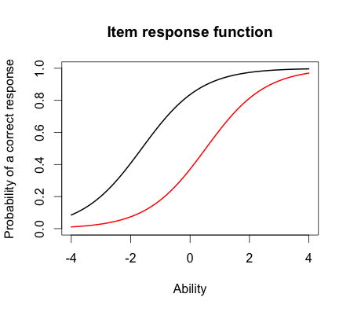

* 1. What would we expect the probability of a correct response would be for someone who had an ability score of 0 for these two items? (2 points)

That person’s probability of getting question 10 right would be about 40% and for question 5 it would be about 80%.

* 1. What was the score of the person who did the best on the test? What was the score of the person who did the worst on the test? (2 points)

> est_abl <- as.data.frame(mlebme(Scored, ip = est_params))

> min(est_abl$est) # Prints the minimum score

[1] -3.999947

> max(est_abl$est) # Prints the maximum scores

[1] 3.999921

The person that scored the lowest got the score -3.999947. The person that scored the highest got the score 3.999921.

* 1. Provide a 95% confidence interval for the estimated ability for the student who did the best on the test and interpret it. (2 points)

> which.max(est_abl$est) # Prints out the person with the maximum score

[1] 49

> est_abl[49,]

est sem n

49 3.999921 2.204373 18

> 3.999921 + 1.96*2.204373

[1] 8.320492

> 3.999921 - 1.96*2.204373

[1] -0.3206501  
The 95% confidence interval for the true ability for the student who did the best on the test is between -0.3206501 and 8.320492. -.5

1. Information – For this question you will choose 3 items to investigate
   1. Please state the three items you selected. (1 point)

I chose questions 2, 4 and 17.

* 1. Provide a plot that contains these three items’ information functions. (1 point)  
     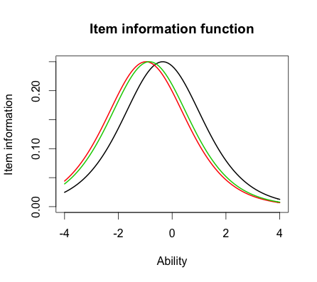
  2. What is the same about these items’ information functions? What is different? Hint: This can be a very short answer. (2 point)  
     Question 2 (the black line) is the hardest question of these three. Question 4 and 17 seem to be about the same difficulty but question 17 (the green line) seems to be a tiny bit more difficult than question 4 (the red line).

The items differ by item difficulty.  
All of the curves seem to be normally distributed, because that’s what the Rasch model assumes.

All the items have the same item information 0,25 at the peak of their distribution.

* 1. Provide a plot of the test information function. (1 point)

> plot(tif(est_params))

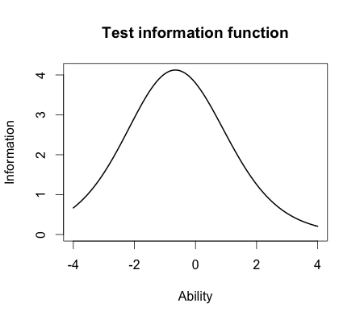

* 1. Where is the majority of the information for this test located? (1 point)   
     The majority of the information is about 0.7.

Finally, you will need to run a 2-PL.

1. Comparing the 2-PL

> twopl_model <- est(Scored, model="2PL", engine="ltm")

> twopl_params <- twopl_model$est

> colnames(twopl_params) <- c("Discrimination", "Difficulty", "Guessing")

> rownames(twopl_params) <- paste("Item", 1:18)

> twopl_params

Discrimination Difficulty Guessing

Item 1 0.6326689 -2.00058101 0

Item 2 1.5469622 -0.26815483 0

Item 3 1.2534918 -0.77297206 0

Item 4 0.9842598 -0.97706755 0

Item 5 1.6407242 -1.19389580 0

Item 6 1.4702029 0.01833431 0

Item 7 0.5632837 -0.65124651 0

Item 8 2.2881772 -0.56753253 0

Item 9 1.8004066 -0.64761748 0

Item 10 1.1142107 0.48542889 0

Item 11 1.0344119 -1.13363005 0

Item 12 0.3329130 -0.12951933 0

Item 13 0.3369968 0.36344671 0

Item 14 0.6608229 -1.01479867 0

Item 15 1.5980393 -0.55640285 0

Item 16 1.0362116 0.35459121 0

Item 17 1.8591845 -0.59017915 0

Item 18 1.2808752 -1.22177042 0

* 1. Which item had the highest discrimination? Which one had the lowest discrimination? (2 point)  
     Question number 8 had the highest discrimination (2.2881772) and question 12 had the lowest discrimination (0.3329130)
  2. Are the items that were the easiest and hardest in the Rasch model, also the easiest and hardest  in the 2-PL? (1 point)  
     No in the 2-PL model the hardest question is number 10 and the easiest question is number 1.
  3. What is the correlation between the ability estimates on the Rasch model and the 2-PL? If your interest was solely on estimating person abilities, do you think you would draw the same conclusions from both models? Why? (2 point)  
     > cor(twopl_abl$est,est_abl$est)

[1] 0.9709497  
The correlation between the ability estimates on the Rasch model and the 2-PL is 0.9709497. That means that the models are extremely similar.

* 1. Provide a plot of the item information function for the three items you selected in Question 2 but this time for the 2-PL model. (1 point)  
     > plot(iif(twopl_params[c(2,4,17),]), co = NA)

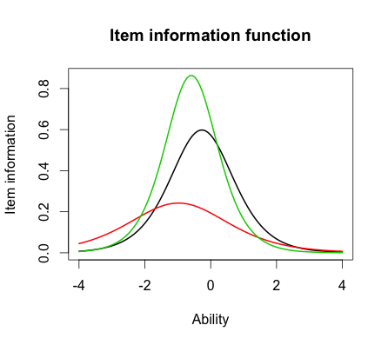

* 1. For the 2-PL model, how do the item information functions for these items differ? How do the 2-PL item information functions from these items differ from their Rasch item information functions? (2 point)  
     The item information for question 17 (the green line) is the most and goes up to about 0.85 at it’s highest. The item information is the most when a persons ability is about -0.5.   
     Question 2’s item information (the black line) goes up to about 0.6 at it’s highest. The item information is the most when a persons ability is about -0.25.  
     Question 4’s item information (the red line) goes up to about 0.24. The item information is the most when a persons ability is about -1.1.  
     The steepness is most in question 17 so we could say with more precision where a persons ability is when the person’s ability is located around -0.5. In question 4 however we have less information about a persons ability than in the other questions.

When comparing the questions we see that question 2 (black line) is the hardest one, after that question 17 (the green line) and the easiest questions of these is question 4 (the red line).

In the Rasch model we don’t have discrimination and therefore can not see the steepness of the items. The Rasch model assumes that the item information is the same for all items while the 2-PL model discriminates between items.