9,8 or 24.5/25

1. Which item was the easiest item and which item was the hardest? (2 points)

* Item 5 is the easiest 10 is the hardest

Discrimination Difficulty Guessing

Item 1 1 -1.40938612 0

Item 2 1 -0.35055656 0

Item 3 1 -0.90318970 0

Item 4 1 -0.97412011 0

Item 5 1 -1.62671110 0

Item 6 1 0.02533657 0

Item 7 1 -0.41418545 0

Item 8 1 -0.87993298 0

Item 9 1 -0.91498121 0

Item 10 1 0.52959427 0

Item 11 1 -1.17125435 0

Item 12 1 -0.04749604 0

Item 13 1 0.15008663 0

Item 14 1 -0.74253017 0

Item 15 1 -0.74245332 0

Item 16 1 0.36963876 0

Item 17 1 -0.84513136 0

Item 18 1 -1.45145349 0

1. Provide a 95% confidence interval for the easiest item and interpret it (2 points).

> -1.626711 + 1.96 \* 0.1320051

[1] -1.367981

> -1.626711 - 1.96 \* 0.1320051

[1] -1.885441

We can be 95% confident that the item difficulty lies between -1.367981 and -1.885441

That the true item difficulty -.5

Discrimination SE Difficulty SE Guessing SE

Item 1 NA 0.1267448 0

Item 2 NA 0.1128011 0

Item 3 NA 0.1178581 0

Item 4 NA 0.1188426 0

Item 5 NA 0.1320051 0

Item 6 NA 0.1118476 0

Item 7 NA 0.1131572 0

Item 8 NA 0.1175527 0

Item 9 NA 0.1180162 0

Item 10 NA 0.1136598 0

Item 11 NA 0.1220123 0

Item 12 NA 0.1118797 0

Item 13 NA 0.1119630 0

Item 14 NA 0.1159197 0

Item 15 NA 0.1159189 0

Item 16 NA 0.1126941 0

Item 17 NA 0.1171115 0

Item 18 NA 0.1276902 0

>

1. Provide a plot that contains both the easiest and the hardest item (1 point).

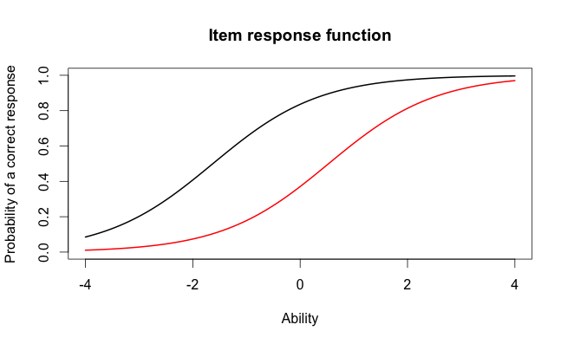

1. What would we expect the probability of a correct response would be for someone who had an ability score of 0 for these two items? (2 points)

* For item 10 we would expect the probability of correct response would be 0,4 and for item 5 it would be 0,8

1. What was the score of the person who did the best on the test? What was the score of the person who did the worst on the test? (2 points)

* The person´s score who did the best on the test is 3.999921. The person who did the worst on the test got -3.999947.

1. Provide a 95% confidence interval for the estimated ability for the student who did the best on the test and interpret it. (2 points)

> 3.999921 + 1.96 \* 2.204373

[1] 8.320492

> 3.999921 - 1.96 \* 2.204373

[1] -0.3206501

We can be 95% confident that the person´s ability lies between 8.320492 and -0.3206501.

1. Please state the three items you selected (1 point)

* I chose items number 2, 3 and 18 to investigate

1. Provide a plot that contains these three items’ information functions.

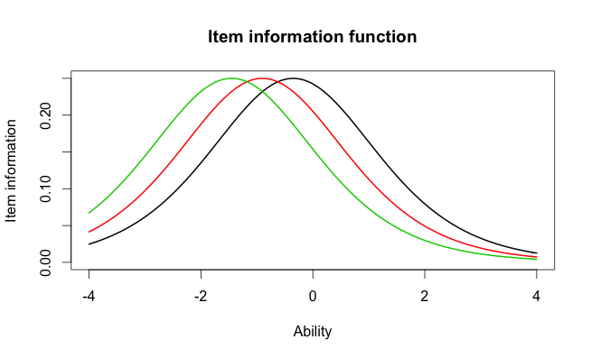

1. What is the same about these item’ information functions? What is different? Hint: This can be very short answer. (2. Points)

* The items differ by item difficulty. The Rasch model doesn´t look at discrimination or guessing. The shape is the same and all the items are assumed to have equal discrimination power. The items might discriminate at different places places on the ability scale depending on item difficulty. The item located on the black line is the hardest and the item located on the green line is the easiest.

1. Provide a plot of the test information function (1 point)

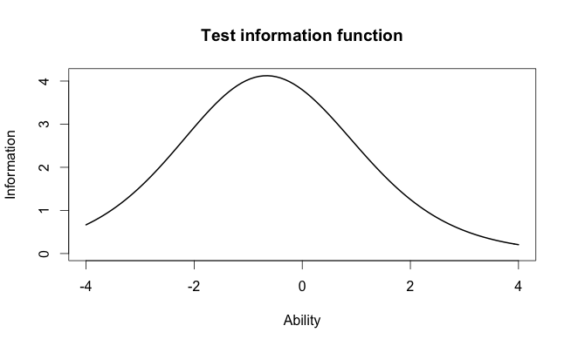

1. Where is the majority of the information for this test located? (1 point)

* The majority of the information is located around -0,7. On the peak of the hill. At 1-4 we don´t have much information about persons ability on the item.

1. Which item had the highest discrimination? Which item had the lowest discrimination? (2 points)

* Item 8 has the highest discrimination = 2.2881772 and item 12 has the lowest discrimination = 0.3329130.

Discrimination Difficulty Guessing

Item 1 0.6326689 -2.00058101 0

Item 2 1.5469622 -0.26815483 0

Item 3 1.2534918 -0.77297206 0

Item 4 0.9842598 -0.97706755 0

Item 5 1.6407242 -1.19389580 0

Item 6 1.4702029 0.01833431 0

Item 7 0.5632837 -0.65124651 0

Item 8 2.2881772 -0.56753253 0

Item 9 1.8004066 -0.64761748 0

Item 10 1.1142107 0.48542889 0

Item 11 1.0344119 -1.13363005 0

Item 12 0.3329130 -0.12951933 0

Item 13 0.3369968 0.36344671 0

Item 14 0.6608229 -1.01479867 0

Item 15 1.5980393 -0.55640285 0

Item 16 1.0362116 0.35459121 0

Item 17 1.8591845 -0.59017915 0

Item 18 1.2808752 -1.22177042 0

1. Are the items that were the easiest and hardest in the Rasch model, also the easiest and hardest in the 2-PL? (1 point).

* No the items are not the same in between models. In the Rasch model the easiest item was number 5 and the hardest was number 10 like said before but in the 2-PL model the easiest item was item 1 and the hardest item was number 10

Discrimination Difficulty Guessing

Item 1 0.6326689 -2.00058101 0

Item 2 1.5469622 -0.26815483 0

Item 3 1.2534918 -0.77297206 0

Item 4 0.9842598 -0.97706755 0

Item 5 1.6407242 -1.19389580 0

Item 6 1.4702029 0.01833431 0

Item 7 0.5632837 -0.65124651 0

Item 8 2.2881772 -0.56753253 0

Item 9 1.8004066 -0.64761748 0

Item 10 1.1142107 0.48542889 0

Item 11 1.0344119 -1.13363005 0

Item 12 0.3329130 -0.12951933 0

Item 13 0.3369968 0.36344671 0

Item 14 0.6608229 -1.01479867 0

Item 15 1.5980393 -0.55640285 0

Item 16 1.0362116 0.35459121 0

Item 17 1.8591845 -0.59017915 0

Item 18 1.2808752 -1.22177042 0

1. What is the correlation between the ability estimates on the Rasch model and the 2-PL? If your interest was solely on estimating person abilities, do you think you would draw the same conclusions from both models? Why? (2 points)

* The correlation between models on person´s ability is 0.9709497. I could draw the same conclusion from bot models because the correlation is almost 1 therefore the models are very similar.

1. Provide a plot of the item information function for the three items you selected in Question 2 but this time for the 2-PL model (1 point)

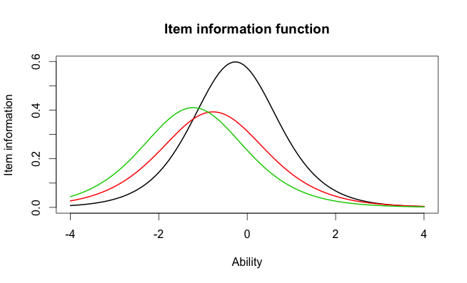

1. For the 2-PL model, how do the item information functions for these items differ? How do the 2-PL item information functions from these items differ from their Rasch item information functions? (2 points).

* The item information functions differ in that way that the black item (about -0,2 in ability) is steeper than the others (0,6 in item information), which provides more information at the item location and we can estimate with more precision where the individual is located, indicating that the item is a good predictor for those scoring in the range where the peak is. The items are norm referenced in adaptive testing???. The red (about -0,9 in ability) and green line (about -1,1 in ability) don´t give as much information and precision (where the red line shows slightly less item information (0,39) than the green line (o,4)) , their items are also easier and provide much less information about the person´s ability.
* In the Rasch model we don´t have any discrimination and therefore we can´t see the steepness of the items. The model assumes that the item information is the same for all the questions. The 2-PL model on the other hand, discriminates between items