9,8 or 24.5/25

**R Computer Lab #2 – PRMA 2015 – Karen Gréta Minney Pétursdóttir**

1. a) Item 10 was the hardest and item 5 was the easiest.

b) -1.626 + 1.96 * 0.132 = -1.36728

-1.626 – 1.96 * 0.132 = -1.88472

We can be 95% certain that the true item difficulty of item 5 lies between -1.36728 and   
-1.88472. -.5

c) Plot for items 10 and 5: 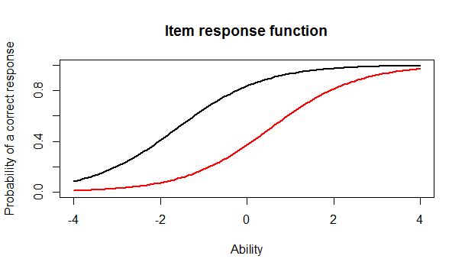

The red line represents item 10 and the black line represents item 5.

d) A person with the ability of 0 is about 35% likely to answer item 10 correctly and 80% likely to answer item 5 correctly.

e) The person who did the best on the test scored a 3.999921 and the person who did the worst scored a -3.999947.

f) 3.999921 + 1.96 * 2.2043730 = 8.32049208

3.999921 - 1.96 * 2.2043730 = -0.32065008

We can be 95% certain that the person’s ability lies between 8.32049208 and   
-0.32065008.

2. a) I chose items 1, 2 and 3.

b) 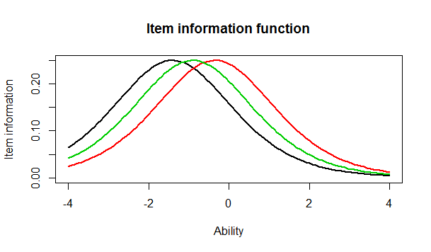

c) What is the same: The items all curve in the same way, like a slightly skewed normative curve. What is different: The items don’t have the same difficulty. Item 1 (black line) is the easiest and therefore people with a lower ability are more likely to get that one correct rather than items 2 and 3.

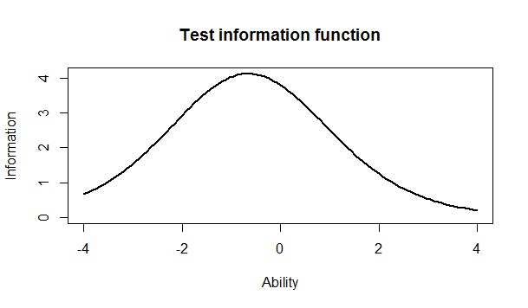d)

e) The majority of the information is located between -1 and 0. -.5

3. a) Item 8 had the highest discrimination (2.288). Item 12 had the lowest discrimination (0.333).

b) No.

c) The correlation between the ability estimates on the Rasch model and the 2-PL is 0.9709497. Yes, I would draw the same conclusion from both models because their   
correlation is so high.

d) 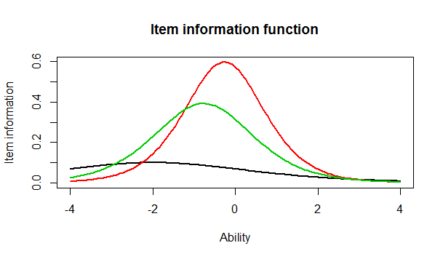

e) Item 1 is very flat and very different from items 2 and 3.   
The plot above is very different from the one in the Rasch model. In the Rasch one, the items were much more parallel but in this one the lines are very different from each other.

**R Output**

Discrimination Difficulty Guessing

Item 1 1 -1.40938612 0

Item 2 1 -0.35055656 0

Item 3 1 -0.90318970 0

Item 4 1 -0.97412011 0

Item 5 1 -1.62671110 0

Item 6 1 0.02533657 0

Item 7 1 -0.41418545 0

Item 8 1 -0.87993298 0

Item 9 1 -0.91498121 0

Item 10 1 0.52959427 0

Item 11 1 -1.17125435 0

Item 12 1 -0.04749604 0

Item 13 1 0.15008663 0

Item 14 1 -0.74253017 0

Item 15 1 -0.74245332 0

Item 16 1 0.36963876 0

Item 17 1 -0.84513136 0

Item 18 1 -1.45145349 0

Discrimination SE Difficulty SE Guessing SE

Item 1 NA 0.1267448 0

Item 2 NA 0.1128011 0

Item 3 NA 0.1178581 0

Item 4 NA 0.1188426 0

Item 5 NA 0.1320051 0

Item 6 NA 0.1118476 0

Item 7 NA 0.1131572 0

Item 8 NA 0.1175527 0

Item 9 NA 0.1180162 0

Item 10 NA 0.1136598 0

Item 11 NA 0.1220123 0

Item 12 NA 0.1118797 0

Item 13 NA 0.1119630 0

Item 14 NA 0.1159197 0

Item 15 NA 0.1159189 0

Item 16 NA 0.1126941 0

Item 17 NA 0.1171115 0

Item 18 NA 0.1276902 0

>

plot(irf(est_params[c(5,10),]), co = NA)

> min(est_abl$est) # Prints the minimum score

[1] -3.999947

> max(est_abl$est) # Prints the maximum scores

[1] 3.999921

> which.min(est_abl$est) # Prints out the person minimum score

[1] 393

> which.max(est_abl$est) # Prints out the person with the maximum score

[1] 49

> est_abl[200,]

est sem n

200 -0.6390908 0.492458 18

Discrimination Difficulty Guessing

Item 1 0.6326689 -2.00058101 0

Item 2 1.5469622 -0.26815483 0

Item 3 1.2534918 -0.77297206 0

Item 4 0.9842598 -0.97706755 0

Item 5 1.6407242 -1.19389580 0

Item 6 1.4702029 0.01833431 0

Item 7 0.5632837 -0.65124651 0

Item 8 2.2881772 -0.56753253 0

Item 9 1.8004066 -0.64761748 0

Item 10 1.1142107 0.48542889 0

Item 11 1.0344119 -1.13363005 0

Item 12 0.3329130 -0.12951933 0

Item 13 0.3369968 0.36344671 0

Item 14 0.6608229 -1.01479867 0

Item 15 1.5980393 -0.55640285 0

Item 16 1.0362116 0.35459121 0

Item 17 1.8591845 -0.59017915 0

Item 18 1.2808752 -1.22177042 0

> plot(iif(est_params[c(1,2,3),]), co = NA)

> twopl_model <- est(Scored, model="2PL", engine="ltm")

>

> cor(twopl_abl$est,est_abl$est)

[1] 0.9709497

> plot(iif(twopl_params[c(1,2,3),]), co = NA)