E-411-PRMA – Lab 2

Helga Margrét Ólafsdóttir

Department of Psychology

Reykjavík University

March 1st , 2015

Worked in collaboration with:

Guðrún Cartensdóttir

Laufey Ásta Guðmundsdóttir

Katrín Mjöll Halldórsdóttir

Sigrún Ósk Jakobsdóttir

Question 1 - Item Response Functions and Person Estimates

1. Which item was the easiest item and which item was the hardest? (2 points)

Item 10 is the hardest item with difficulty of 0.52959427 ≈ 0.53

Item 5 is the easiest item with difficulty of -1.62671110 ≈ -1.63

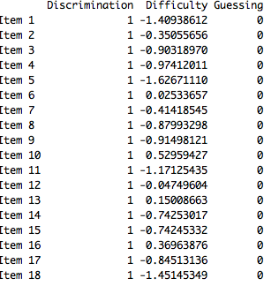

1. Provide a 95% confidence interval for the easiest item and interpret it. (2 points)

Confidence interval: item difficulty ± 1,96 \* SE

For item 5: SE: 0.1320051

1,96\* 0.1320051= 0.258729996

-> 95% confidence interval = -1.62671110 ±0.258729996

-> Upper bound= -1.367981104 ≈ -1.37 and lower bound = -1.885441096 ≈ -1.89

This means that we can be 95 % certain (95 % probability) that the item lies between

-1.89 and -1.37.

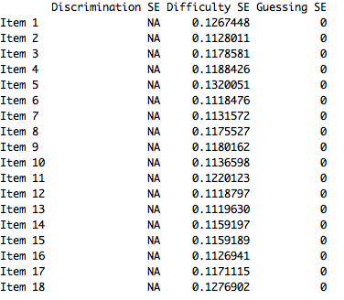

(c) Provide a plot that contains both the easiest and the hardest item. (1 point)

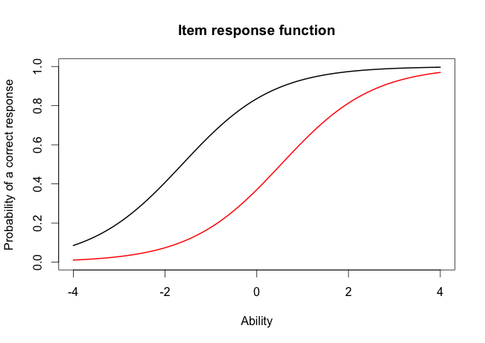

Item 10

Item 5

1. What would we expect the probability of a correct response would be for someone who had an ability score of 0 for these two items? (2 points)

Item10 ≈ 0.4 -> 40 % probability of correct response for θ = 0

Item5 ≈ 0.8 -> 80 % probability of correct response for θ = 0

1. What was the score of the person who did the best on the test? What was the score of the person who did the worst on the test? (2 points)

The score of the person who did best on the test had an ability score of 3.999921 ≈ 4.00 (person nr. 49)

The score of the person who did worst on the test had an ability score of -3.999947 ≈ -4.00 (person nr. 393)

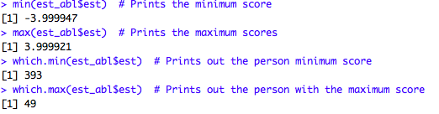

1. Provide a 95% confidence interval for the estimated ability for the student who did the best on the test and interpret it. (2 points)

95 % confidence interval = θ ± 1.96\*SEM

Person 49 had the best ability with SEM= 1.96\* 2.204373 = 4,32057108

-> 95% confidence interval = 3.999921 ± 4,32057108

-> Upper bound = 8.32049208 ≈ 8.32 and lower bound = -0,32065008 ≈ -0.32

This means that we can be 95 % certain (95 % probability) that the ability score of the student who did best on the test lies between -0.32 and 8.32. This is a very wide range and it exceeds possible ability score on the scale, also the person could have a pretty low ability.



Question 2 - Information For this question, you will choose three items to investigate.

1. Please state the three items you selected. (1 point)

I chose items 7, 9 and 13.

1. Provide a plot that contains these three items’ information functions. (1 point)

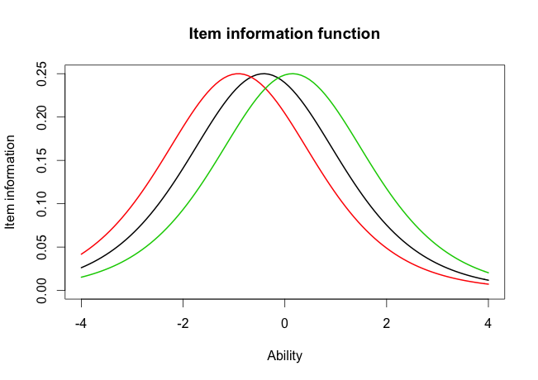

1. What is the same about these items’ information functions? What is different? Hint: This can be a very short answer. (2 point)

Even though the shape of the curves is the same for all of the items 7, 9, 13 the items’ locations/difficulties are different. Therefore the majority of information is not at the same place on the scale.

1. 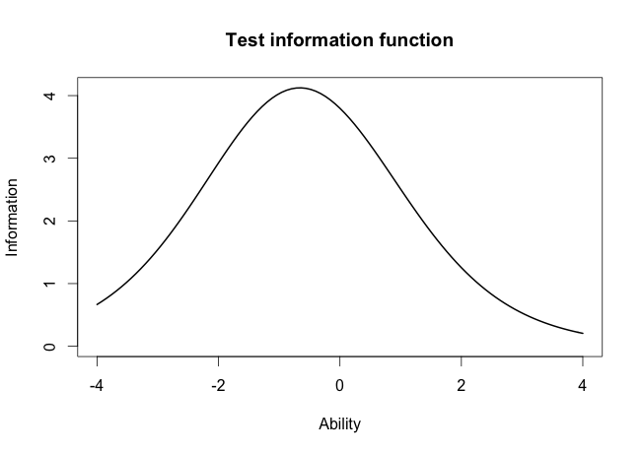Provide a plot of the test information function. (1 point)
2. Where is the majority of the information for this test located? (1 point)

The majority of the information is located around θ ≈ -0.6, that is where the curve peaks(the highest point) and therefore we can be more precise in the discrimination between individuals around -0.6. The confidence interval would in turn become smaller.

Question 3 - Comparing the 2-PL

1. Which item had the highest discrimation? Which one had the lowest discrimination? (2 point)

Item 8 has the highest discrimination of 2.2881772 ≈ 2.29

Item 12 has the lowest discrimination of 0.3329130 ≈ 0.33

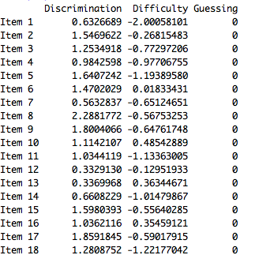

1. Are the items that were the easiest and hardest in the Rasch model, also the easiest and hardest in the 2-PL? (1 point)

Yes and no. Item 10 is the hardest in both models but the easiest items are different.

In Rasch: item 10 is the hardest and item 5 is the easiest.

In 2-PL: item 10 is the hardest and item 1 is the easiest.

This is because that in 2-PL model the item discrimination is taken into account, not just the item difficulty.

1. What is the correlation between the ability estimates on the Rasch model and the 2-PL? If your interest was solely on estimating person abilities, do you think you would draw the same conclusions from both models? Why? (2 point)

The correlation between the ability estimates of those two models is 0.9709497 ≈ 0.97

Because the correlation is almost perfect it doesn’t matter which model we use to estimate person ability and we can draw very similar conclusion about them.

Ability estimate’s distribution of the Rasch model explains about 94 % in the ability estimate’s distribution of the 2-PL model.

1. Provide a plot of the item information function for the three items you selected in Question 2 but this time for the 2-PL model. (1 point)

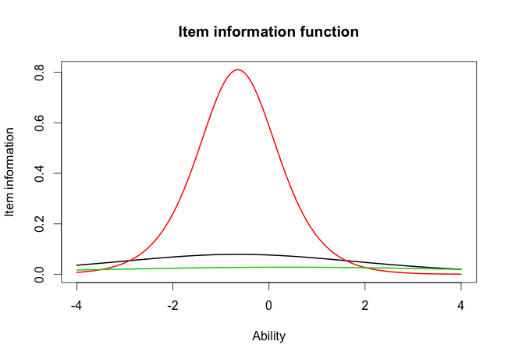

1. For the 2-PL model, how do the item information functions for these items differ? How do the 2-PL item information functions from these items differ from their Rasch item information functions? (2 point)

i)The item information functions of item 7,9 and 13 differ in three ways.

-In the item location/difficulty (the peak of the curve): the items vary in item difficulty. Item 13 has the highest difficulty of those three and is more to the right on the ability axes.

-The shape of the curves: item 9(the red line) is much steeper than the other two items because it has higher discrimination parameter. The other items have a flat curve, the green line especially.

-The “peak” information: where most of the information is and where it is best to discriminate. For item 7 and 13 (black and green line) it is very difficult to discriminate because there is less information than for item 13(has high discrimination).

ii)The information function for these items differs from the Rasch item information function in those three same ways:

-item location/difficulty : item difficulty is less for item 7 in 2-PL and has shifted to the left on the ability axes, but item difficulty has increased for item 9 and 13, shifted to the right.

-the shape of the curve : in Rasch all of the items had the same shape of the curve but it has chanced in 2-PL. The curves of item 7 and 13 (green and black line) are not as steep, they have flattened out.

-the “peak” information-: For item 9 it is the same in both models(the red line) and has a lot of information of ability (higher discrimination parameter) but the other two are less informative in 2PL than in Rasch.

This differences comes from the influence of the discrimination parameter in the 2-PL takes the item discrimination into account. Because higher discrimination leads to steeper curve.