­University of Reykjavík 08.02.15

Psychology department Assignment #2

Test and measurement in psychology



Student: Teacher:

Laufey Ásta Guðmundsdóttir [Christopher David Desjardins](https://myschool.ru.is/myschool/Default.asp?Page=Exe&ID=1.8&Action=2&Kennitala=2604802519)

Sigrún Ósk Jakobsdóttir

Katrín Mjöll Halldórsdóttir

Helga Margrét Ólafsdóttir

Guðrún Carstensdóttir

R computer Lab #2

**Question 1 - Item Response Functions and Person Estimates**

a) Item 10 with item difficulty 0.53 is the hardest and the easiest is item 5 with item difficulty -1.63

b) Item difficulty +/- 1.96 * standard error

-1.63+1.96*0.132 = 0.044

-1.63-1.96*0.132 = 0.473

c) 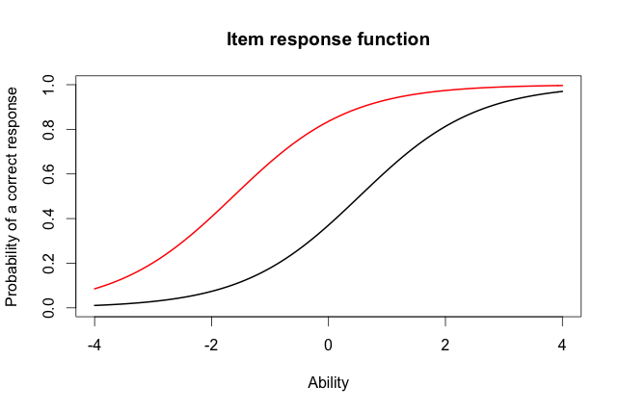

d) We expect the probability of a correct response would be about 0.4 for someone who had an ability score of 0 for the hard item and about 0.8 for the easiest item.

e) 3.999921 was the score of the person who did the best on the test and

-3.999947 was the score of the person who did the worst on the test

f) Ability score +/- 1.96*SEM

3.999921+1.96*2.204 = 8.32

3.999921-1.96*2.204 = - 0.32

**Question 2 – Information**

a) I choose items 1, 7 and 13

b) 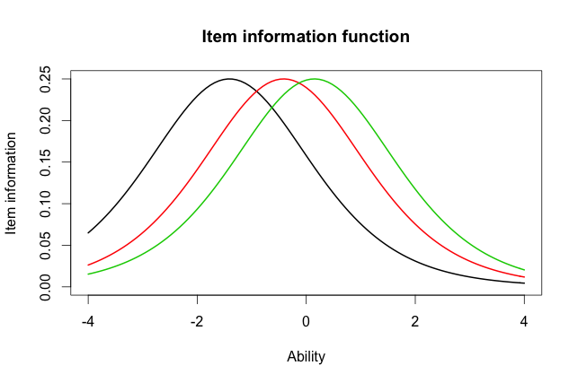

c) The item difficulty is different and the shape and the function of the items are the same.

d) 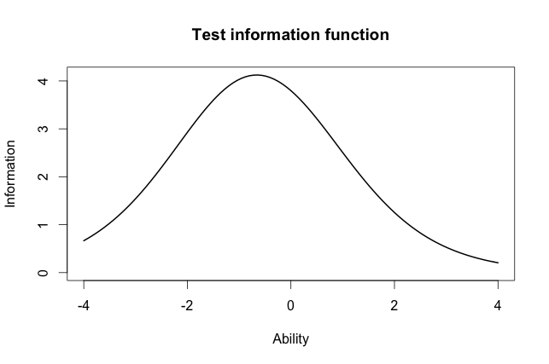

e) The most information is for test takers with ability score between -1 and 0.

**Question 3 - Comparing the 2-PL**

1. Item 8 has the highest discrimination (2.2881772) and item 12 has the lowest discrimination (0.3329130)
2. No, in the 2-PL model Item 1 is easiest (-2.00058101) and the hardest is item 10 (0.48542889).
3. R = 0.9709497

Yes I would provide the same conclusion because the correlation is so high (close to 1) that the models are testing almost completely the same.

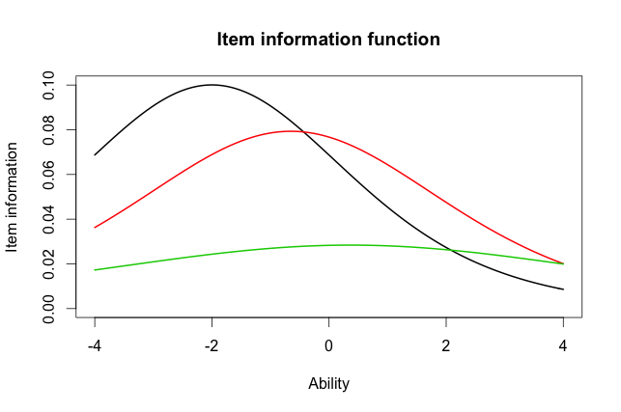

1. The items have information accuracy in different ability scores. In fact the green item has no accuracy.

In the Rash model the item difficulty is different between the items but in the 2-PL model the item discrimination is different.

Output

> library("irtoys")

Loading required package: sm

Package 'sm', version 2.2-5.4: type help(sm) for summary information

Loading required package: ltm

Loading required package: MASS

Attaching package: 'MASS'

The following object is masked from 'package:sm':

muscle

Loading required package: msm

Loading required package: polycor

Loading required package: mvtnorm

Loading required package: sfsmisc

> getwd()

[1] "/Users/laufeyasta"

> rasch_model <- est(Scored, model="1PL", engine="ltm", rasch = TRUE)

> est_params <- rasch_model$est

> colnames(est_params) <- c("Discrimination", "Difficulty", "Guessing")

> rownames(est_params) <- paste("Item", 1:18)

> est_params

Discrimination Difficulty Guessing

Item 1 1 -1.40938612 0

Item 2 1 -0.35055656 0

Item 3 1 -0.90318970 0

Item 4 1 -0.97412011 0

Item 5 1 -1.62671110 0

Item 6 1 0.02533657 0

Item 7 1 -0.41418545 0

Item 8 1 -0.87993298 0

Item 9 1 -0.91498121 0

Item 10 1 0.52959427 0

Item 11 1 -1.17125435 0

Item 12 1 -0.04749604 0

Item 13 1 0.15008663 0

Item 14 1 -0.74253017 0

Item 15 1 -0.74245332 0

Item 16 1 0.36963876 0

Item 17 1 -0.84513136 0

Item 18 1 -1.45145349 0

> est_se <- rasch_model$se

> colnames(est_se) <- c("Discrimination SE", "Difficulty SE", "Guessing SE")

> rownames(est_se) <- paste("Item", 1:18)

> est_se

Discrimination SE Difficulty SE Guessing SE

Item 1 NA 0.1267448 0

Item 2 NA 0.1128011 0

Item 3 NA 0.1178581 0

Item 4 NA 0.1188426 0

Item 5 NA 0.1320051 0

Item 6 NA 0.1118476 0

Item 7 NA 0.1131572 0

Item 8 NA 0.1175527 0

Item 9 NA 0.1180162 0

Item 10 NA 0.1136598 0

Item 11 NA 0.1220123 0

Item 12 NA 0.1118797 0

Item 13 NA 0.1119630 0

Item 14 NA 0.1159197 0

Item 15 NA 0.1159189 0

Item 16 NA 0.1126941 0

Item 17 NA 0.1171115 0

Item 18 NA 0.1276902 0

> plot(irf(est_params[c(1,3,5),]), co = NA)

> plot(irf(est_params[c(10,5),]), co = NA)

> est_abl <- as.data.frame(mlebme(Scored, ip = est_params))

> min(est_abl$est) # Prints the minimum score

[1] -3.999947

> max(est_abl$est) # Prints the maximum scores

[1] 3.999921

> which.min(est_abl$est) # Prints out the person minimum score

[1] 393

> which.max(est_abl$est) # Prints out the person with the maximum score

[1] 49

> est_abl[200,]

est sem n

200 -0.6390908 0.492458 18

> est_abl[49,]

est sem n

49 3.999921 2.204373 18

> plot(iif(est_params[c(1,7,13),]), co = NA)

> plot(tif(est_params))

> twopl_model <- est(Scored, model="2PL", engine="ltm")

> twopl_params <- twopl_model$est

> colnames(twopl_params) <- c("Discrimination", "Difficulty", "Guessing")

> rownames(twopl_params) <- paste("Item", 1:18)

> twopl_params

Discrimination Difficulty Guessing

Item 1 0.6326689 -2.00058101 0

Item 2 1.5469622 -0.26815483 0

Item 3 1.2534918 -0.77297206 0

Item 4 0.9842598 -0.97706755 0

Item 5 1.6407242 -1.19389580 0

Item 6 1.4702029 0.01833431 0

Item 7 0.5632837 -0.65124651 0

Item 8 2.2881772 -0.56753253 0

Item 9 1.8004066 -0.64761748 0

Item 10 1.1142107 0.48542889 0

Item 11 1.0344119 -1.13363005 0

Item 12 0.3329130 -0.12951933 0

Item 13 0.3369968 0.36344671 0

Item 14 0.6608229 -1.01479867 0

Item 15 1.5980393 -0.55640285 0

Item 16 1.0362116 0.35459121 0

Item 17 1.8591845 -0.59017915 0

Item 18 1.2808752 -1.22177042 0

> twopl_abl <- as.data.frame(mlebme(Scored, ip = twopl_params))

> cor(twopl_abl$est,est_abl$est)

[1] 0.9709497

> plot(iif(twopl_params[c(1,7,13),]), co = NA)