8,4 or 21/25

Verkefni 2

R Assignment 2

Ólafur Þór Jónsson

Working with Brynjar Þór Hreggviðsson

**Question 1**

*> # This actually runs the model*

*> rasch_model <- est(Scored, model="1PL", engine="ltm", rasch = TRUE)*

*>*

*> #*

*> # Estimated Parameters*

*> #*

*> est_params <- rasch_model$est*

*> colnames(est_params) <- c("Discrimination", "Difficulty", "Guessing")*

*> rownames(est_params) <- paste("Item", 1:18)*

*> est_params*

*Discrimination Difficulty Guessing*

*Item 1 1 -1.40938612 0*

*Item 2 1 -0.35055656 0*

*Item 3 1 -0.90318970 0*

*Item 4 1 -0.97412011 0*

*Item 5 1 -1.62671110 0*

*Item 6 1 0.02533657 0*

*Item 7 1 -0.41418545 0*

*Item 8 1 -0.87993298 0*

*Item 9 1 -0.91498121 0*

*Item 10 1 0.52959427 0*

*Item 11 1 -1.17125435 0*

*Item 12 1 -0.04749604 0*

*Item 13 1 0.15008663 0*

*Item 14 1 -0.74253017 0*

*Item 15 1 -0.74245332 0*

*Item 16 1 0.36963876 0*

*Item 17 1 -0.84513136 0*

*Item 18 1 -1.45145349 0*

*>*

*> #*

*> # Standard Errors*

*> #*

*> est_se <- rasch_model$se*

*> colnames(est_se) <- c("Discrimination SE", "Difficulty SE", "Guessing SE")*

*> rownames(est_se) <- paste("Item", 1:18)*

*> est_se*

*Discrimination SE Difficulty SE Guessing SE*

*Item 1 NA 0.1267448 0*

*Item 2 NA 0.1128011 0*

*Item 3 NA 0.1178581 0*

*Item 4 NA 0.1188426 0*

*Item 5 NA 0.1320051 0*

*Item 6 NA 0.1118476 0*

*Item 7 NA 0.1131572 0*

*Item 8 NA 0.1175527 0*

*Item 9 NA 0.1180162 0*

*Item 10 NA 0.1136598 0*

*Item 11 NA 0.1220123 0*

*Item 12 NA 0.1118797 0*

*Item 13 NA 0.1119630 0*

*Item 14 NA 0.1159197 0*

*Item 15 NA 0.1159189 0*

*Item 16 NA 0.1126941 0*

*Item 17 NA 0.1171115 0*

*Item 18 NA 0.1276902 0*

*> #*

*> # Estimated abilities*

*> #*

*> est_abl <- as.data.frame(mlebme(Scored, ip = est_params))*

*> min(est_abl$est) # Prints the minimum score*

*[1] -3.999947*

*> max(est_abl$est) # Prints the maximum scores*

*[1] 3.999921*

*> which.min(est_abl$est) # Prints out the person minimum score*

*[1] 393*

*> which.max(est_abl$est) # Prints out the person with the maximum score*

*[1] 49*

*>*

*> # To find out score for person 200*

*> est_abl[200,]*

*est sem n*

*200 -0.6390908 0.492458 18*

a) the hardest item is number 10 with item difficulty of 0,53 and the easiest item was number 5 with item difficulty of - 1,63.

b) With 95% confidence, probability of correctly answering of item 5 was between -1,38 and -1,88

-1,63+1,96*0,13=-1,367981 = -1,38

-1,63-1,96*0,13=-1,88

That interpretation is incorrect. Please see the answer key -1

c) 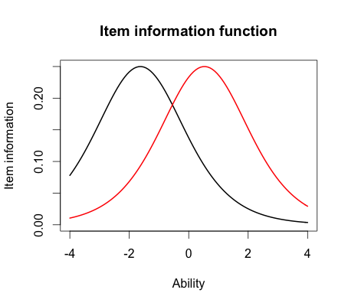

d) For item 10 the probability is 0,4 of correct response and for item 5 the probability of correct response 0,85

e) the person who scored the best was 3,999 and the person who scored the worst was -3,999

f) 3,999+1,96*2,2= 8,311

With 95% confidence, the estimated ability for the student who got the best score was 8,311

Where is the rest of the confidence interval that is only half. Also, you are talking about the true ability not their estimate -1.5

**Questions 2.**

a) The items we selected were number, 12, 13 and 14

b) 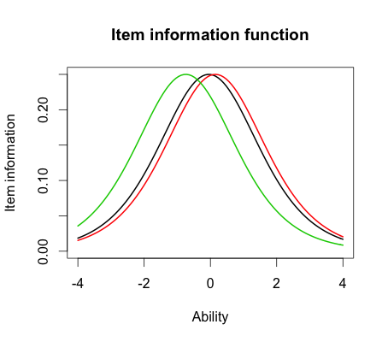

c) the items are all normal distributed. Item number 14 was the easiest (-0,74), but items number 12 (-0,05)and 13 (0,15) are similar on difficult level.

So they have identical shapes but different locations.

d) 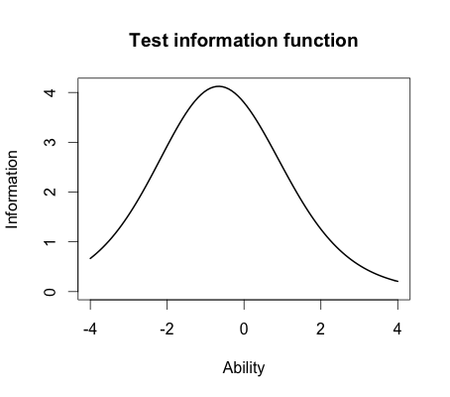

e) the linear curve is negative distributed (to the left)???? the majority of information therefor is under ability zero or between 0 and -2

**Question 3.**

*> # This actually runs the model*

*> twopl_model <- est(Scored, model="2PL", engine="ltm")*

*>*

*> #*

*> # Estimated Parameters*

*> #*

*> twopl_params <- twopl_model$est*

*> colnames(twopl_params) <- c("Discrimination", "Difficulty", "Guessing")*

*> rownames(twopl_params) <- paste("Item", 1:18)*

*> twopl_params*

*Discrimination Difficulty Guessing*

*Item 1 0.6326689 -2.00058101 0*

*Item 2 1.5469622 -0.26815483 0*

*Item 3 1.2534918 -0.77297206 0*

*Item 4 0.9842598 -0.97706755 0*

*Item 5 1.6407242 -1.19389580 0*

*Item 6 1.4702029 0.01833431 0*

*Item 7 0.5632837 -0.65124651 0*

*Item 8 2.2881772 -0.56753253 0*

*Item 9 1.8004066 -0.64761748 0*

*Item 10 1.1142107 0.48542889 0*

*Item 11 1.0344119 -1.13363005 0*

*Item 12 0.3329130 -0.12951933 0*

*Item 13 0.3369968 0.36344671 0*

*Item 14 0.6608229 -1.01479867 0*

*Item 15 1.5980393 -0.55640285 0*

*Item 16 1.0362116 0.35459121 0*

*Item 17 1.8591845 -0.59017915 0*

*Item 18 1.2808752 -1.22177042 0*

*>*

*> #*

*> # Estimated abilities*

*> #*

*> twopl_abl <- as.data.frame(mlebme(Scored, ip = twopl_params))*

*>*

*> # Correlation between the ability estimates*

*> cor(twopl_abl$est,est_abl$est)*

*[1] 0.9709497*

*> # Plot Item Information Function for items 1, 3, 5*

*> #*

*> plot(iif(twopl_params[c(12,13,14),]), co = NA)*

a)

Item 8 had the highest discrimination (2,288) and item 12 had the lowest discrimination (0,333)

b) No they aren't. Item 5 (easiest) had the difficulty of -1,19 which is the second easiest item in 2-PL model. Item 10 (hardest) had the difficulty of 0,485 therefore is no not close to be the hardest item.

c) the correlation between the ability estimate on the Rasch model and the 2-PL is 0,971. Very strong correlation, almost perfect.

So would conclusions be the same or nearly so? -1

d)

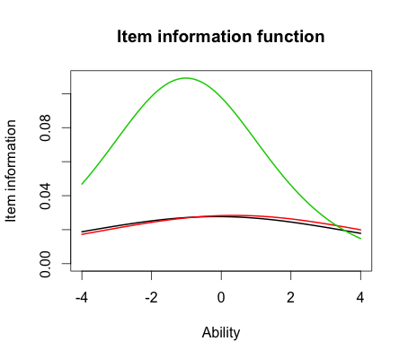

e) The item number 14 differ from the others in 2-PL model because the level of difficulty is much lower then items 12 and 13. Items 12 and 14 are under the ability of 0 and item 13 has more above ability than 0. The difference between the Rasch model and 2-PL model is that the 2-PL model takes the discrimination in account and questions don't have the same weight. For that reason the difference between the item difficulty is more observable.

But specifically, what about the shape of the these curves? How do they differ from the Rasch? -.5