Help for Dog Owners
Hot Diggity Dog Resort · how to use our website · September 29, 2026

Start here
What you can do on our new website, and where to find help.
Welcome to the new Hot Diggity Dog Resort website! You can do almost all of your dog jobs here. You can book, sign forms, and add shot records. You can do it on a phone or a computer.

What you can do on the website
- Make your own account. It is free.
- Add each of your dogs.
- Send us your dog's shot records. Just snap a photo.
- Sign the waiver and forms online. No paper at the desk.
- Book daycare, boarding, grooming, and vet visits.
- See, print, or cancel a booking.
- Buy daycare passes and join L.E.E.P. Monthly.
- Find the webcam login.
- Turn text messages on or off.

Steps
- Go to our website on your phone or computer.
- Press Log In at the top. On a phone, tap Menu first.
- Log in, or make a new account.
- You land on My Account. This is your home page on the site.
- Use the menu on the left to get around. On a phone, the menu is a row of buttons under My Account. Swipe it sideways to see them all.
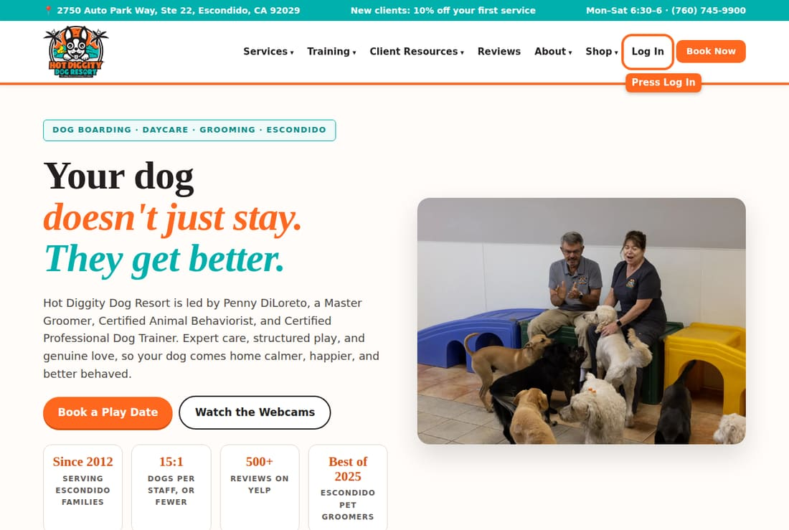
Tip: Did you use our old system? Read Coming from the old system first. Your dogs are already here.

Our hours
- Monday to Saturday, 6:30 am to 6:00 pm.
- Please come by 5:45 pm. We close at 6:00 pm.
- Sundays and holidays: no daycare or grooming. Boarding drop-off and pickup are by appointment, at 10 am or 4 pm.

All the help topics
- Create your account
- Log in, or reset your password
- Add your dog
- Upload shot records
- Sign forms and the waiver
- First visit: the Temperament Assessment
- Book daycare
- Book boarding
- Book a groom
- Book a vet visit
- See or cancel a booking
- Pay and see your bill
- Daycare passes and L.E.E.P. Monthly
- Watch the webcams
- Text messages
- Change your details or your dog's info
- Coming from the old system
- Order from the shop
- Ask about in-home training
Stuck? Call us at (760) 745-9900.

Create your account
Make a free account so you can add your dog and book.
You need an account to book with us. It is free and takes about two minutes. Did you come to us before, on our old system? Then you may already have an account. See Coming from the old system first.

Steps
- Go to our website. Press Log In at the top. On a phone, tap Menu first.
- Under the gray box, tap Create an account.
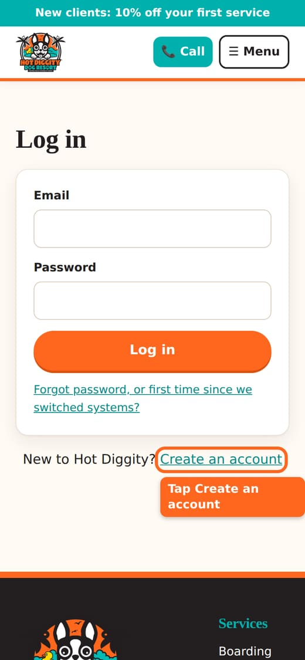
- Type your First name and Last name.
- Type your Email. Use one you check often. We send booking news there.
- Type your Mobile phone number.
- Make up a Password. It needs at least 8 letters or numbers.
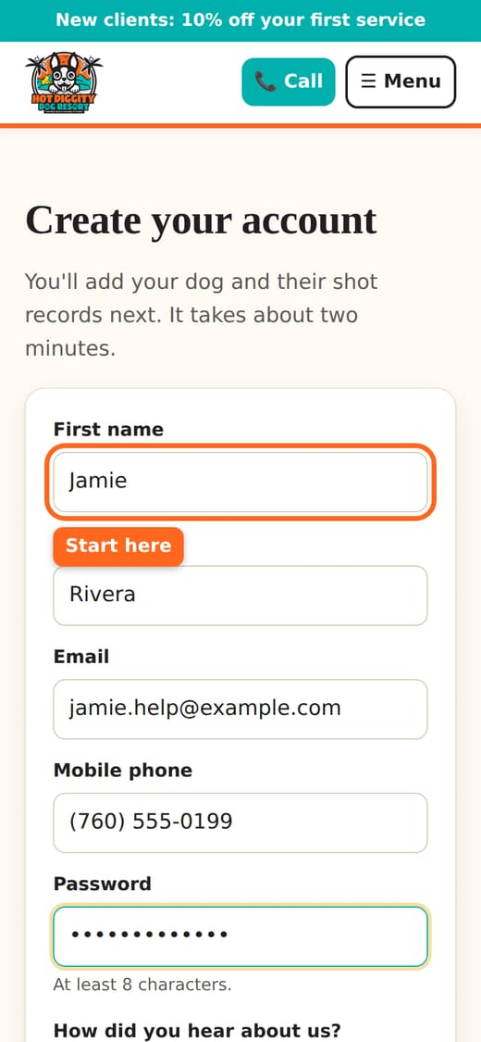
- Pick an answer for How did you hear about us? You can skip this one.
- Look at the text box that starts with "Yes, text me." It starts out empty. That means no texts.
- Want texts from us? Tap the box to check it. Don't want texts? Leave it empty.
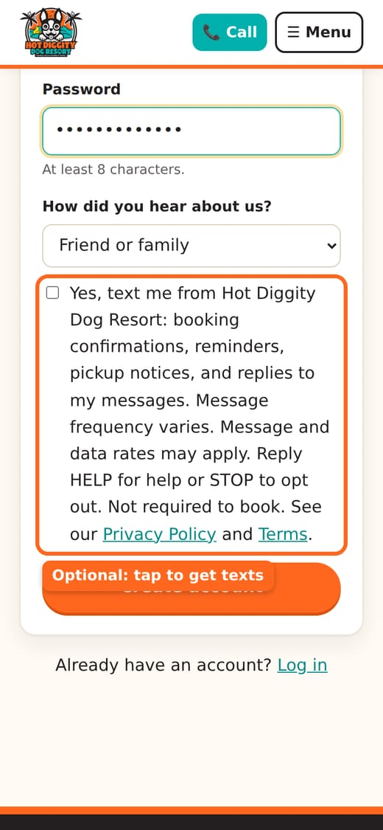
Good to know: Texts are your choice. You do not need them to book. You still get emails either way. You can change your mind later in My details.
Tip: Texts are handy. We text to confirm a booking, remind you the day before, and tell you when your dog is ready.
- Tap Create account.
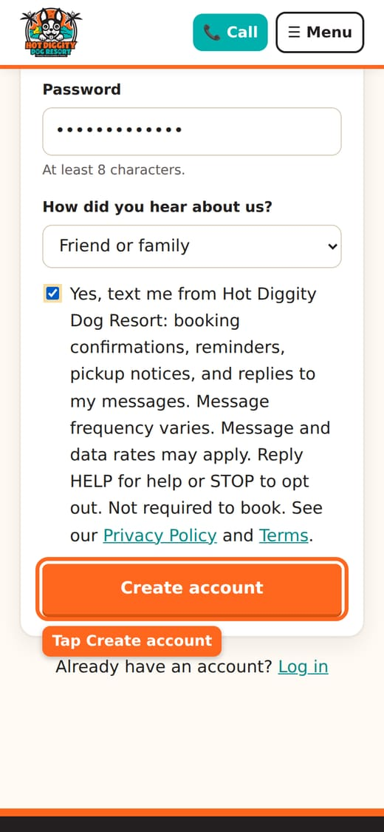
- You are in! The site takes you right to Add a dog. It says "Welcome! Now tell us about your dog."
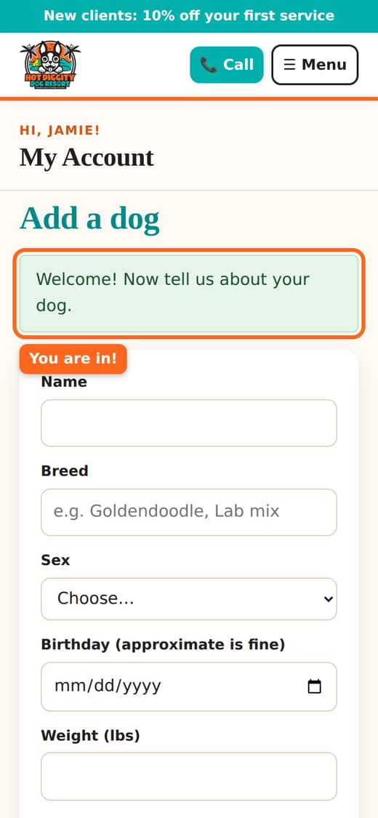
- Next, go to Add your dog.

If you see a message
- "You already have an account. Log in below." You made an account before. Log in with that email.
- "We already have you on file from our old system." Good news! You are already here. Follow the steps on that page to make a password.
- "Please fill in every field." A box is empty. Fill in your name, email, and phone.
- "Passwords need at least 8 characters." Make your password longer.
Tip: New clients get 10% off the first service. Look for the "New clients" sign-up at the top of the site.
Stuck? Call us at (760) 745-9900.

Log in, or reset your password
How to get into your account, and what to do if you forgot your password.
Log in to book, see your dogs, and sign forms. Forgot your password? You can make a new one in a few minutes.

Log in
- Press Log In at the top of the website. On a phone, tap Menu first.
- Type your Email.
- Type your Password.
- Press the Log in button.
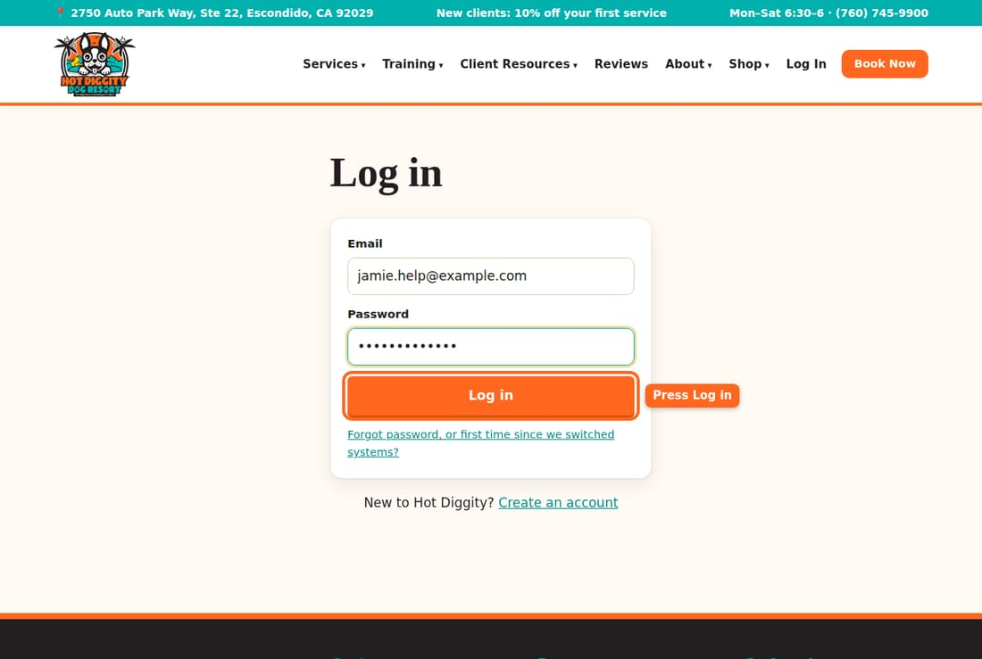
- You land on My Account. You are in.
Tip: Once you log in, the top of the site says My Account instead of Log In.

Forgot your password?
- On the Log in page, press Forgot password, or first time since we switched systems?
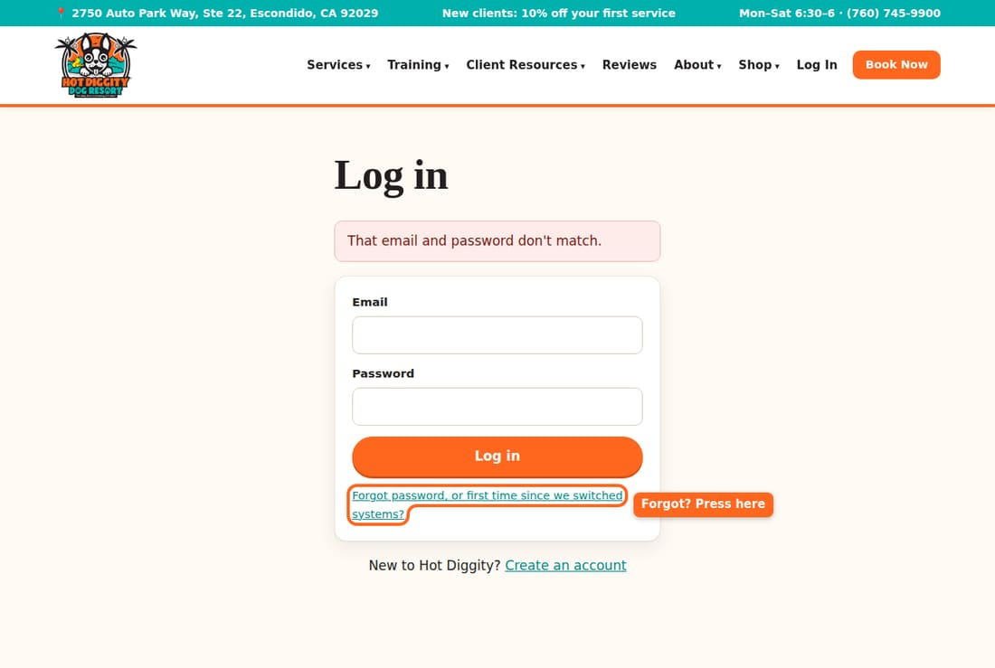
- Type the email you use with us.
- Press Send me a link.
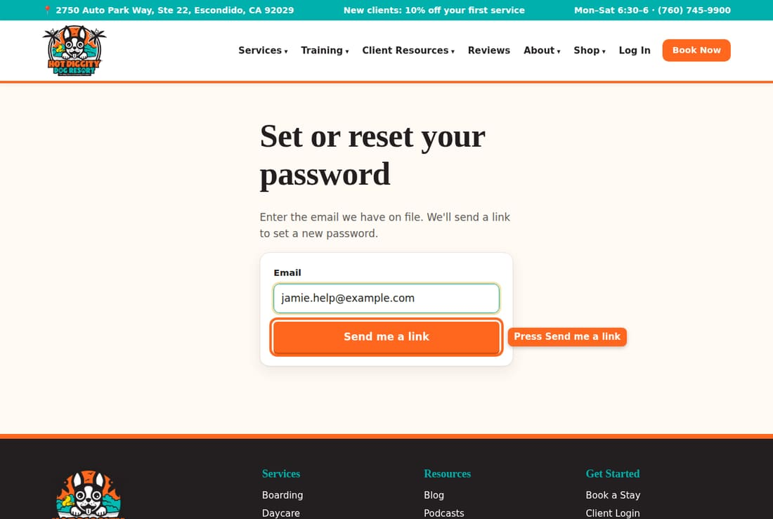
- You see "If that email is on file, a link is on its way."
- Open your email. Look for a note from Hot Diggity Dog Resort. Check your spam folder too.
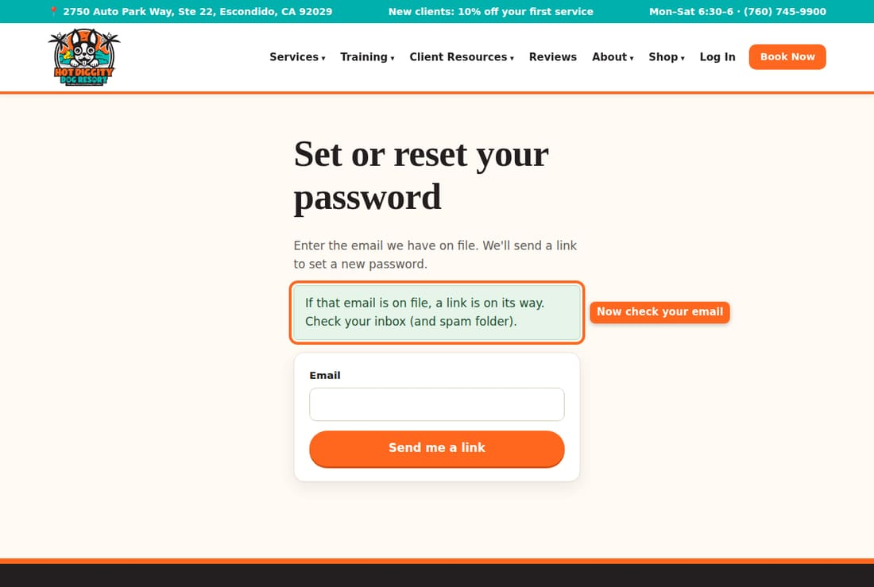
- Press the link in the email.
- Type a New password. It needs at least 8 letters or numbers.
- Press Save password.
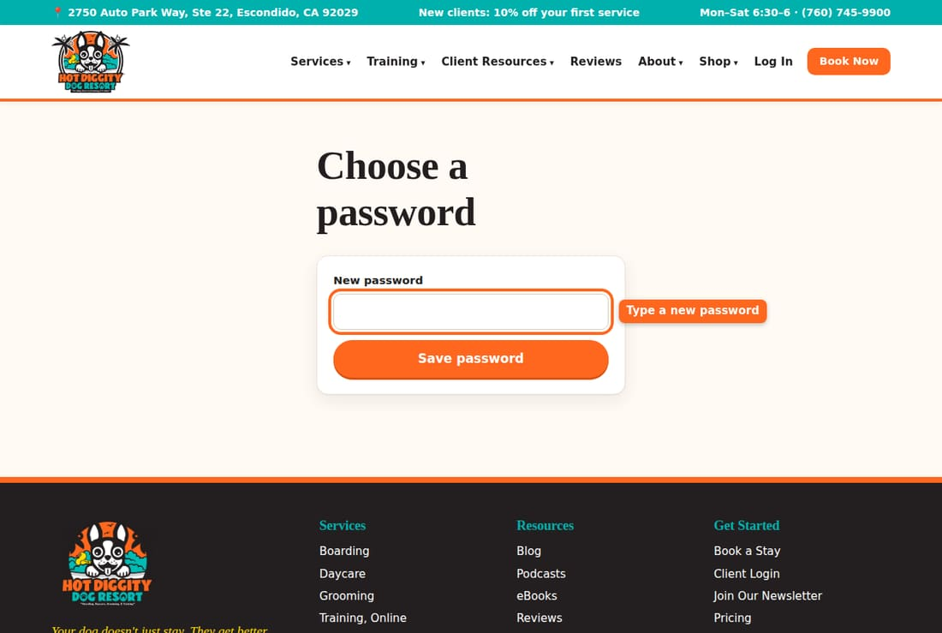
- You are logged in. You see "Password set. Welcome back!"
Good to know: The link works for 2 hours. After that, ask for a new one. Only the newest link works.
Good to know: Setting a new password logs you out on your other phones and computers. Just log in again there.

If you see a message
- "That email and password don't match." Check your typing. Or reset your password.
- "Too many tries." Wait 15 minutes, or reset your password.
- "That link has expired." Ask for a new link.
- No email came? Check spam. Still nothing? Call us. We may have a different email for you.

Log out
- In the menu on the left, press Log out. On a phone, swipe the menu row to the end.
Stuck? Call us at (760) 745-9900.

Add your dog
Tell us about your dog so you can book.
Each dog needs its own page on your account. Add your dog before you book. Have two dogs? Add them one at a time.

Steps
- Log in. On My Account, tap Add a dog in the menu. You can also tap + Add another dog under My dogs.
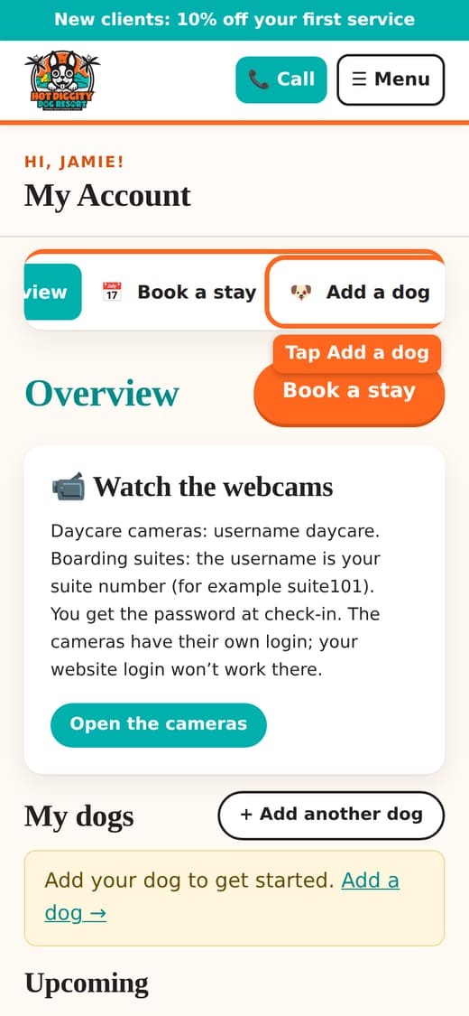
- Type your dog's Name. This is the only box you must fill in.
- Type the Breed. Start typing and pick from the list. A mix is fine, like "Lab mix."
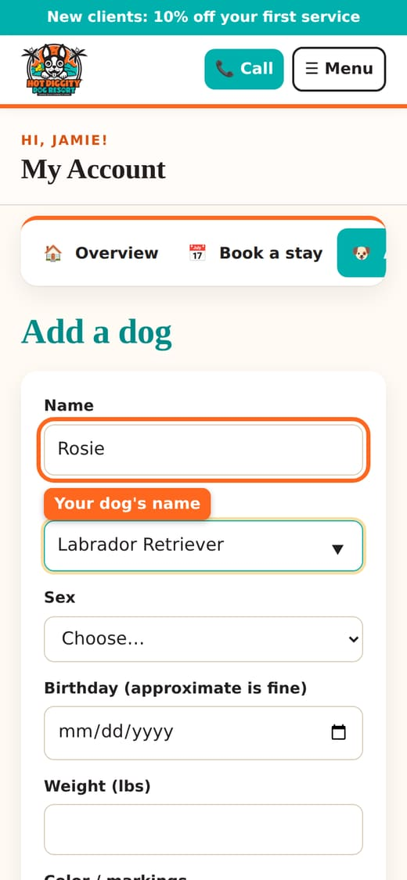
- Pick the Sex.
- Pick the Birthday. A close guess is fine.
- Type the Weight (lbs). Grooming and daycare prices depend on it.
- Type the Color / markings, like "brown with a white chest."
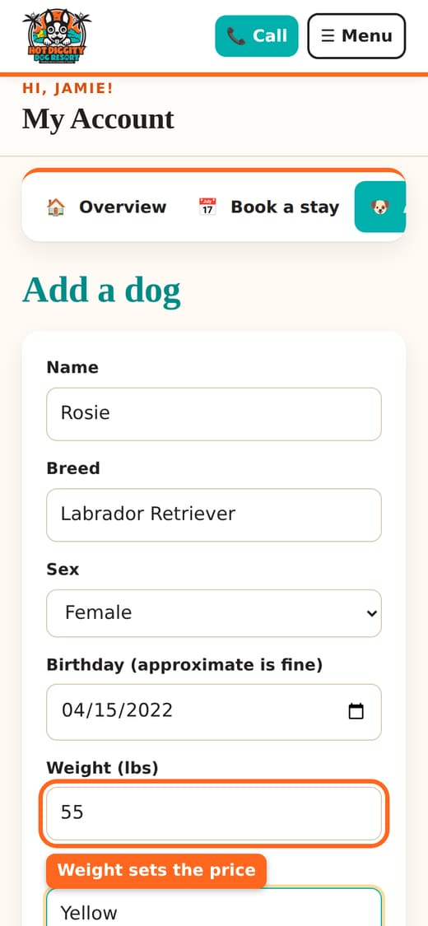
- Pick the Coat type. Not sure? Leave it. We will go by the breed.
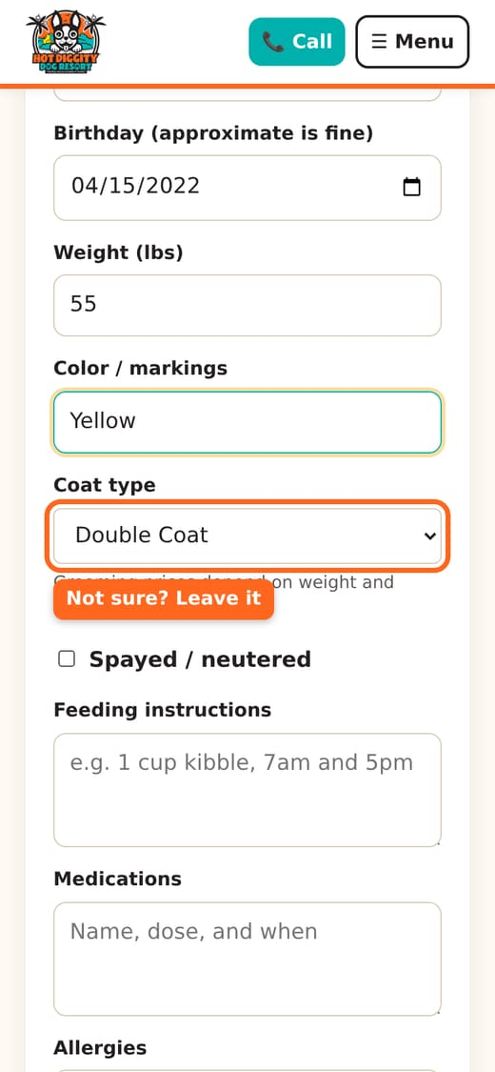
- Is your dog fixed? Check Spayed / neutered.
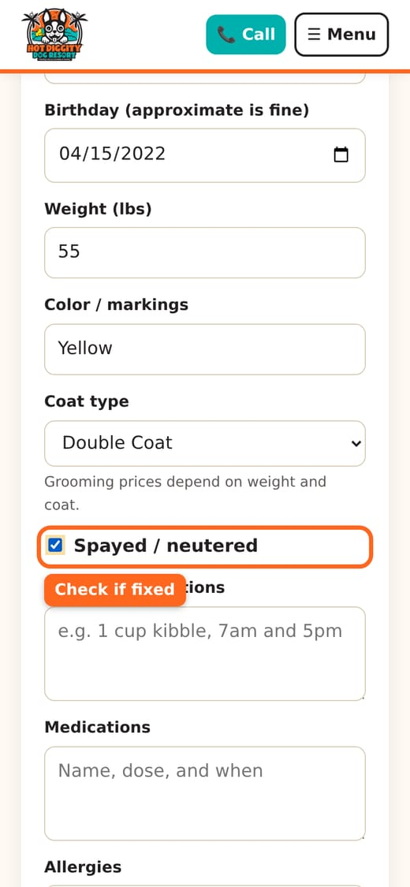
Good to know: For daycare and boarding, dogs must be spayed or neutered before 8 months of age.
- Fill in Feeding instructions. Say how much food and when.
- Fill in Medications and Allergies, if any.
- Tell us fun facts in Anything we should know? Fears, favorite toys, and how they act with other dogs all help.
- Type your Veterinarian and Vet phone.
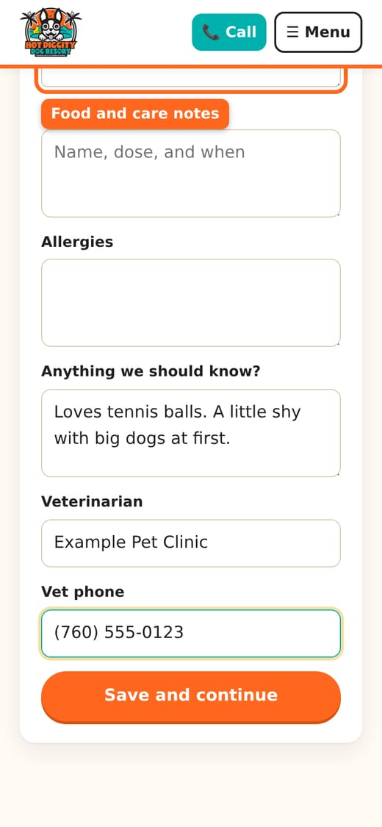
- Tap Save and continue.
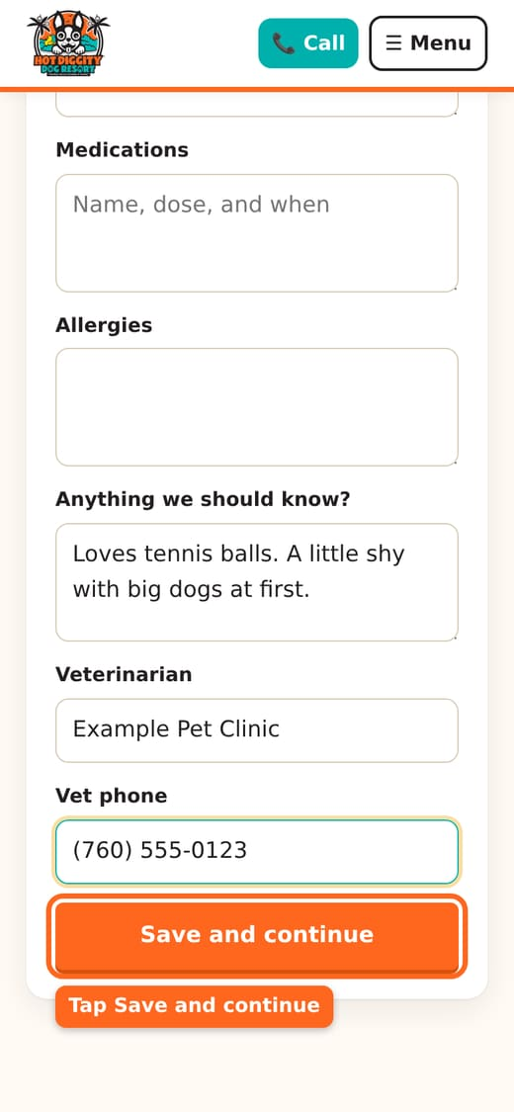
- You see your dog's page. It says your dog is added.
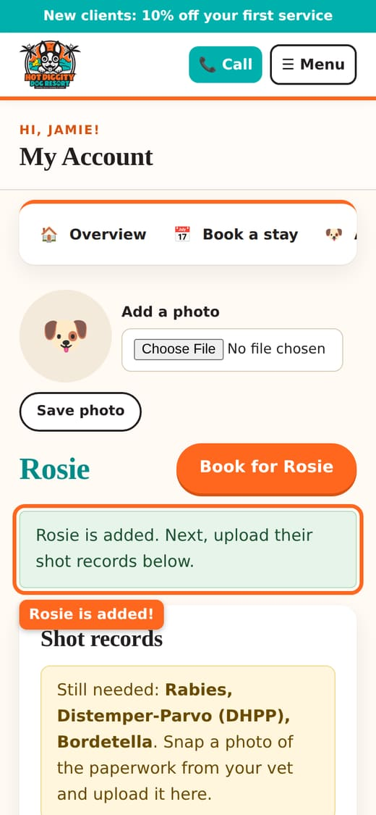
- Next, add the shot records. See Upload shot records.
Tip: Add a photo of your dog at the top of the dog's page. It helps our team know your pup. See Change your details.
Good to know: Our insurance does not allow bully breeds in boarding or daycare. They are welcome for grooming and training. We also can't take dogs with a history of biting in daycare or boarding.
Stuck? Call us at (760) 745-9900.

Upload shot records
Send us a photo of your dog's shot papers from the vet.
Every dog needs three shots on file before a visit. You can send them from your phone. Just take a photo of the papers from your vet.

The shots we need
- Rabies
- Distemper-Parvo (DHPP): this is one shot that covers a few dog illnesses.
- Bordetella: this is the kennel cough shot.

Steps
- Log in. On My Account, find My dogs. Press your dog's name.
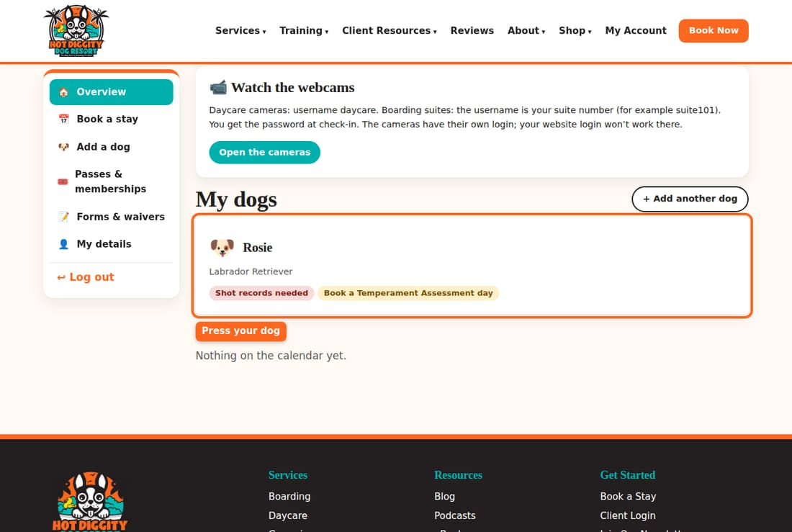
- Find Shot records. The yellow box says which shots are Still needed.
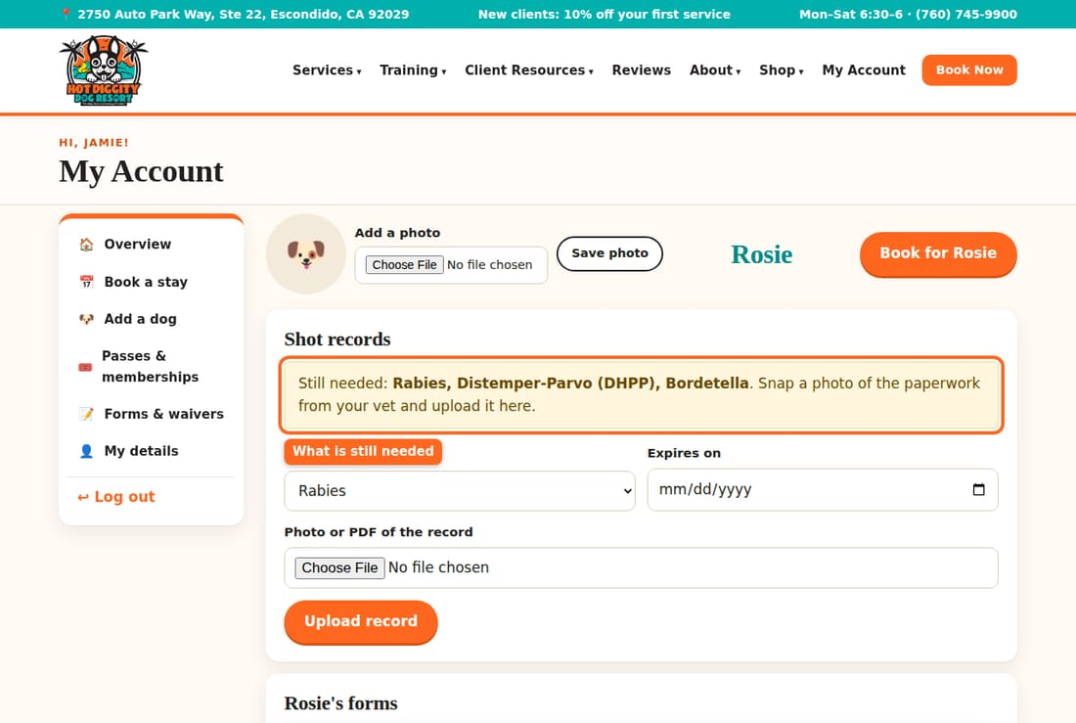
- Under Vaccine, pick the shot. Pick one shot at a time.
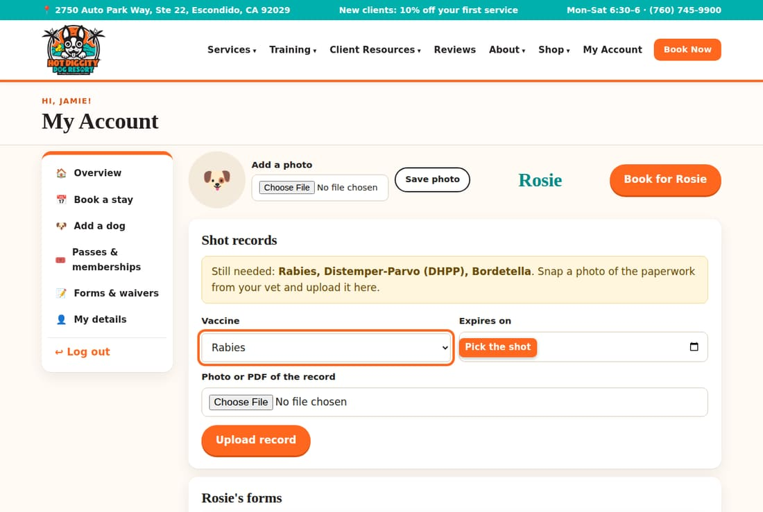
- In Expires on, pick the date the shot runs out. Look on your vet papers. It may say "due" or "next due."
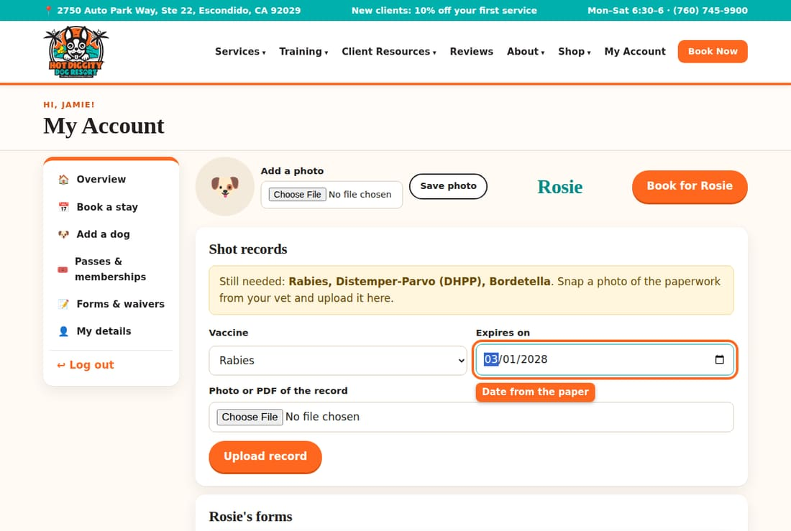
- Under Photo or PDF of the record, press Choose File. On a phone, you can take a new photo or pick one you have.
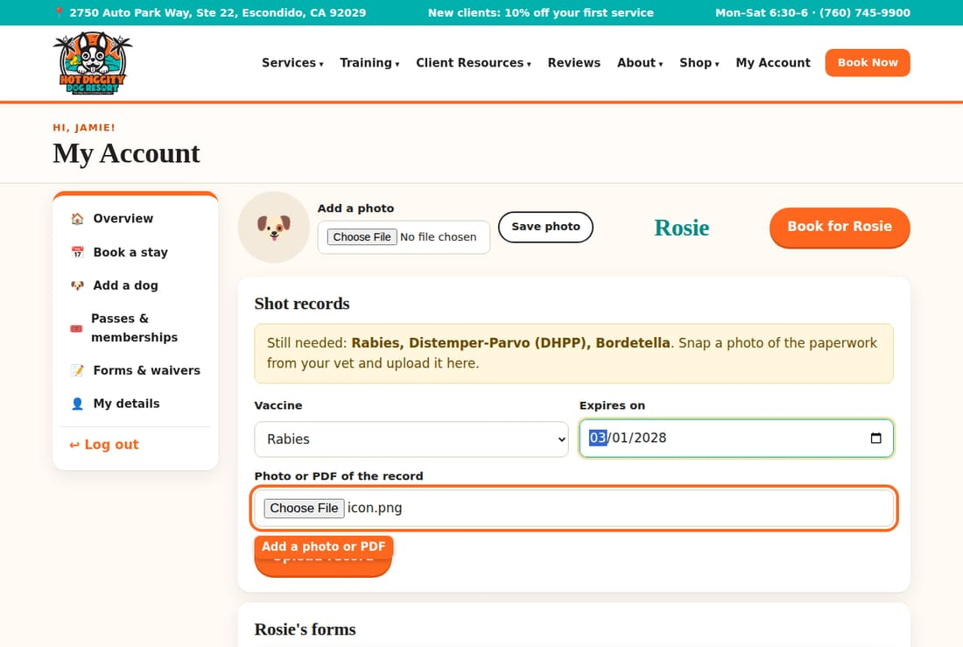
- Press Upload record.
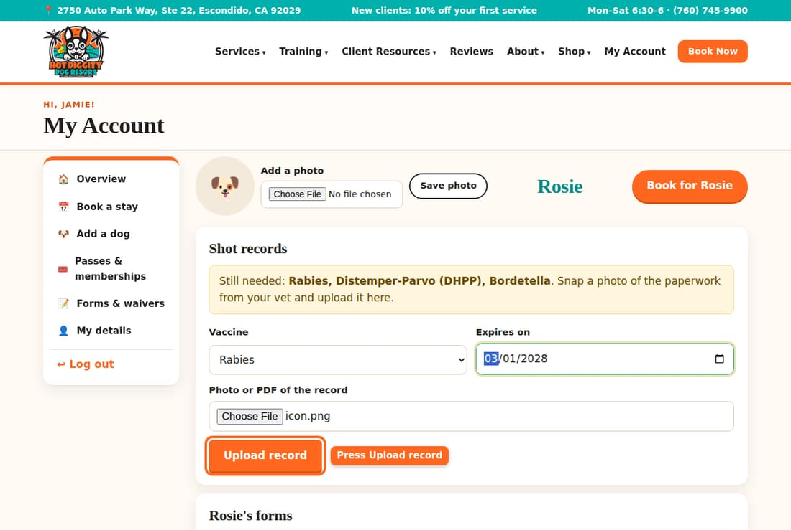
- You see "record uploaded. We'll verify it shortly." The shot shows Checking until our team looks at it. Then it says Verified.
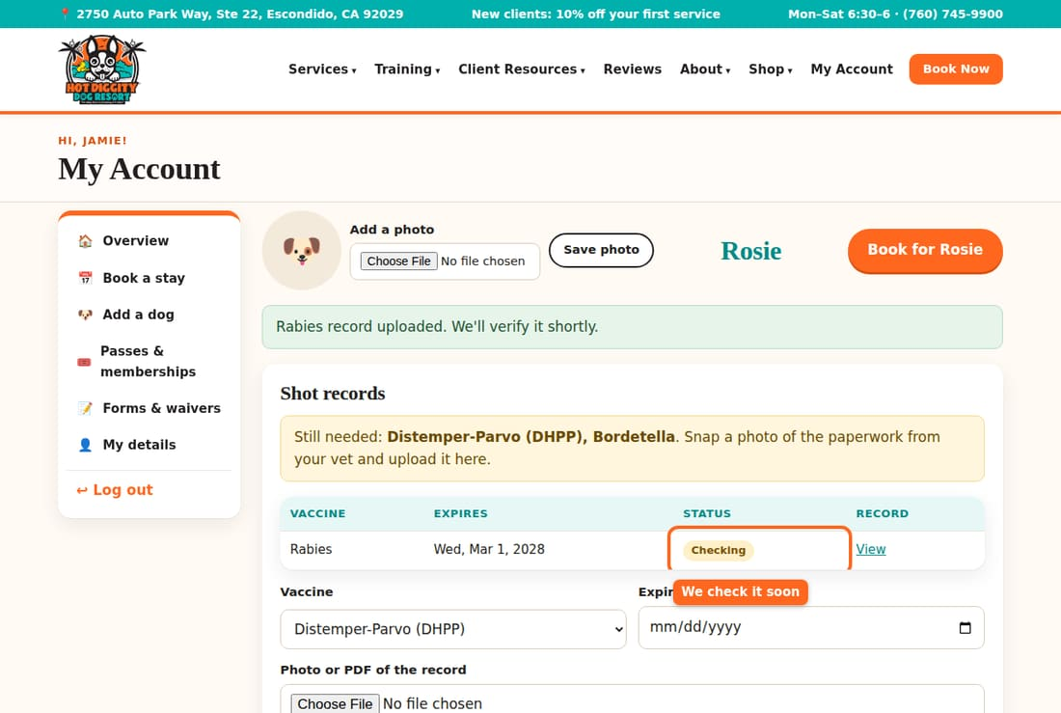
- Do steps 3 to 6 again for each shot.
- When all three are in, you see "All required shots are on file."
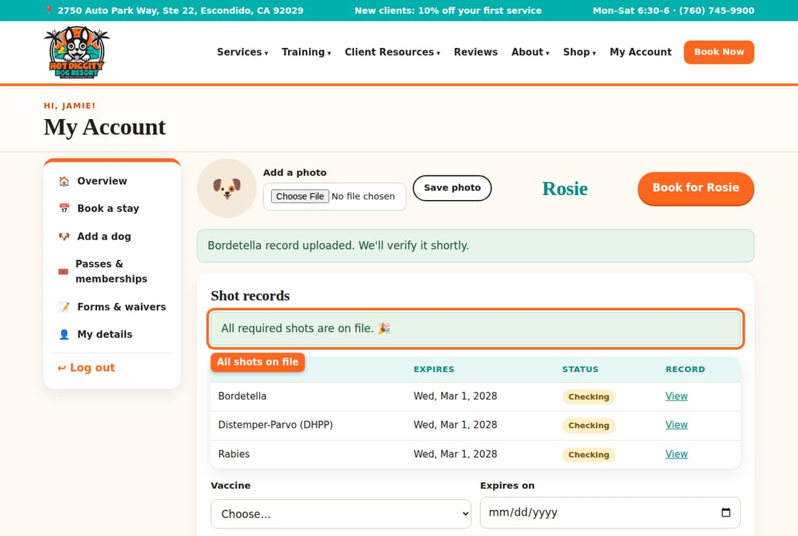
Tip: One paper often lists all three shots. That's fine. Upload the same photo three times, once for each shot.
Good to know: Shots must still be good on the last day of your visit. If a shot runs out during a stay, the site will ask for a new record before it books.
Good to know: We send a reminder about a month before a shot runs out. Then upload the new record the same way.
Tip: Need a shot? Our vet, Dr. Moston, gives shots on vet days. See Book a vet visit.

If you see a message
- "Please choose which vaccine this is." Pick a shot in the Vaccine list.
- "Please enter the expiration date from the record." Fill in Expires on.
- "That date has already passed." The shot has run out. Your dog needs a new shot first.
- "Please attach a photo or PDF of the record." Add the photo, then press Upload record again.
Stuck? Call us at (760) 745-9900.

Sign forms and the waiver
Fill out and sign your forms online, so check-in is quick.
We need a few forms before your dog's first visit. You can do them all online. Then there is no paperwork at the front desk.

Which forms you need
- Daycare & Boarding Waiver and Release of Liability: one for you. You need it for daycare or boarding. It also covers grooming.
- Grooming Waiver and Release of Liability: one for you. Only groom with us? This short one is enough.
- Daycare Registration Form: one for each dog. You need it for daycare or boarding.
- Food and Medication Form: one for each dog. You need it for boarding.

Steps
- Log in. Look at Finish your profile on My Account. It lists what is still to do. Press any line to go right there.
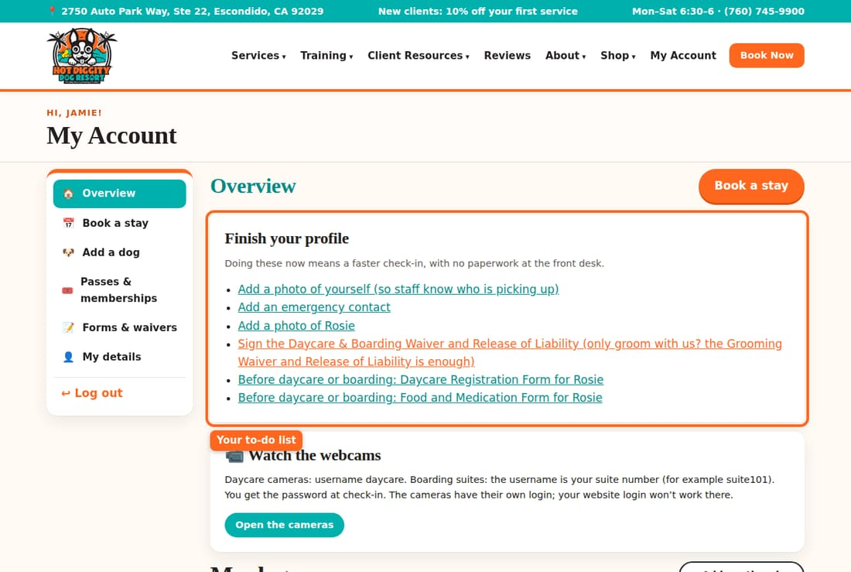
- Or press Forms & waivers in the menu. You see every form and its Status.
- Next to a form that says Not done, press Fill out.
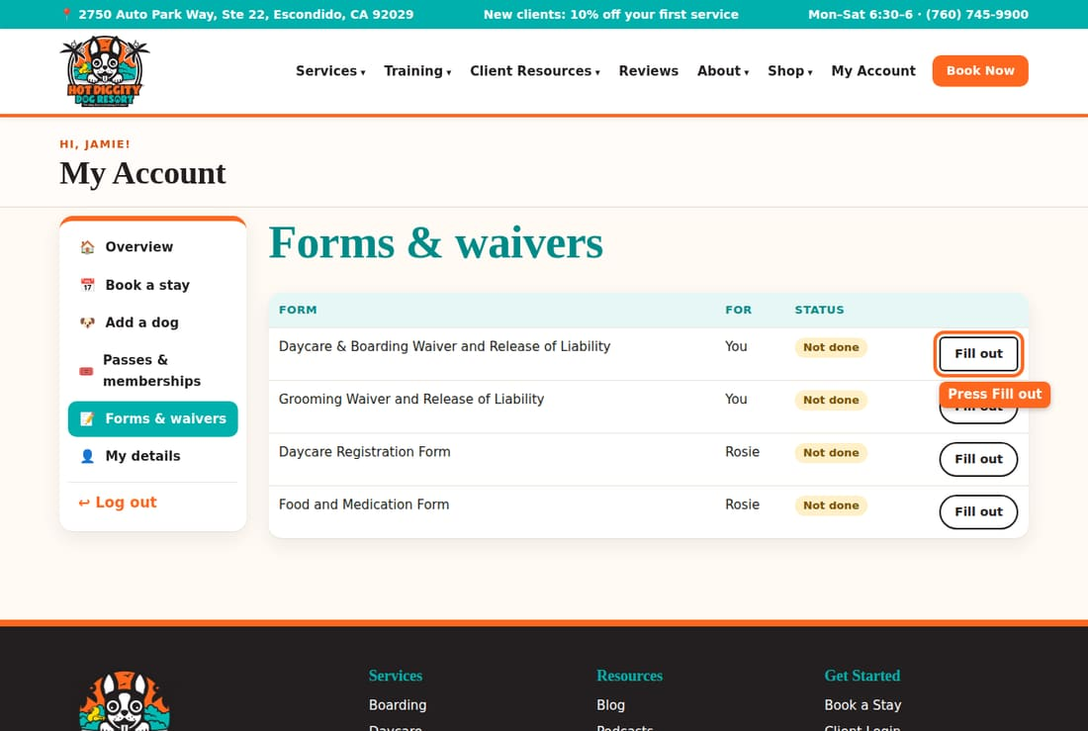
- Read the form in the box at the top. Scroll inside the box to read it all.
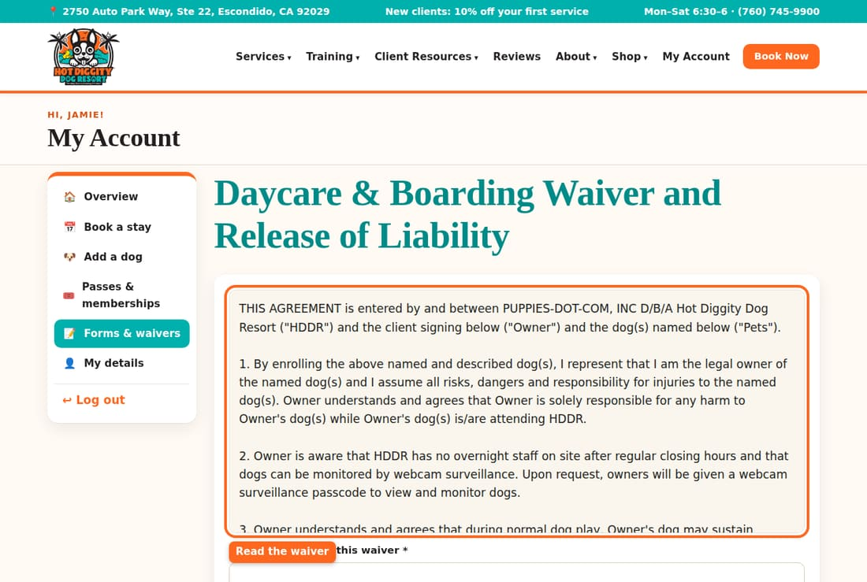
- Answer each question. The ones with a star (*) must be filled in.
- On the waiver, type your dog's name. Then type your initials in each box. There is one box for each part.
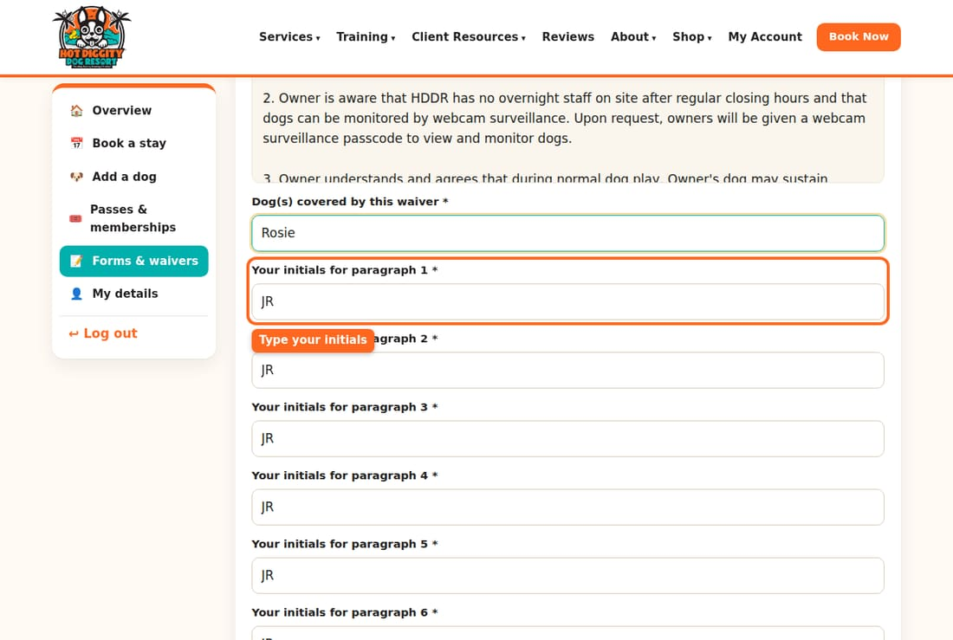
- At the bottom, find Signature. Check I have read this and agree.
- Check your name in Type your full name to sign. Your name is already filled in.
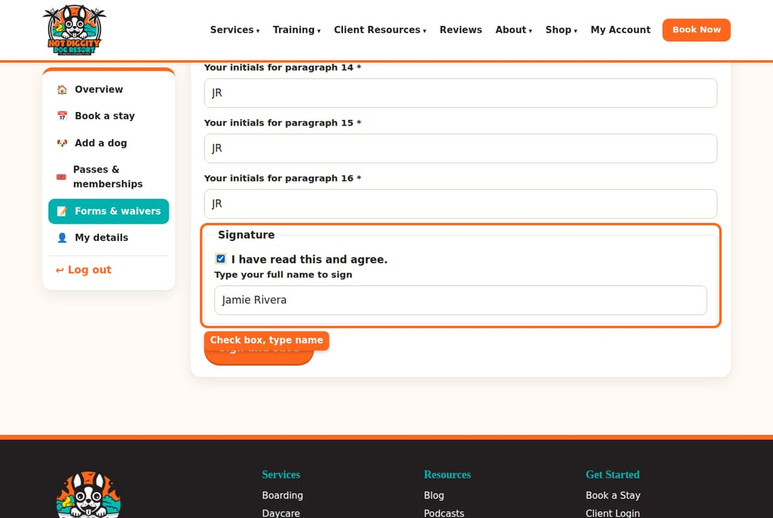
- Press Sign and save.
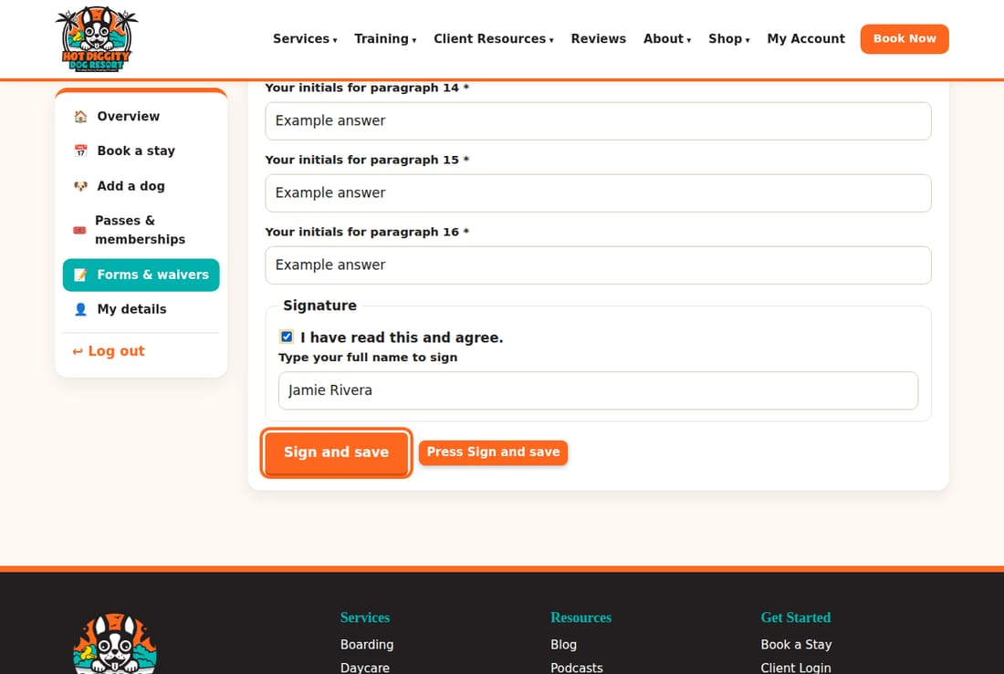
- You are back on Forms & waivers. The form now says Signed with the date.
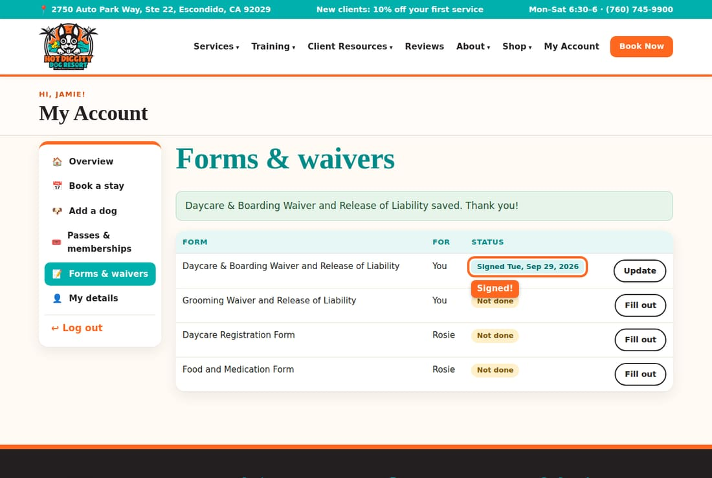
- Do the same for each form that says Not done.
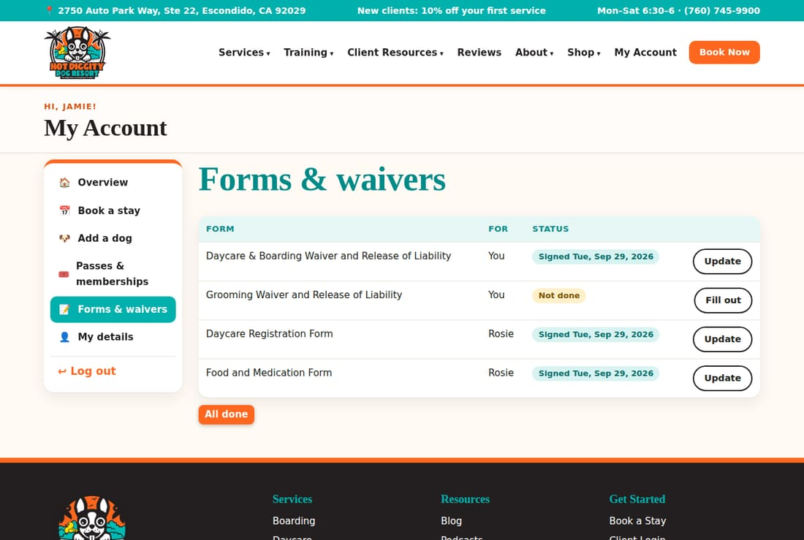

Forms for each dog
Each dog has its own Daycare Registration Form and Food and Medication Form. You can find them on your dog's page too.
- On My Account, press your dog's name.
- Scroll to your dog's forms. Press Fill out online. After it's done, it says Update.
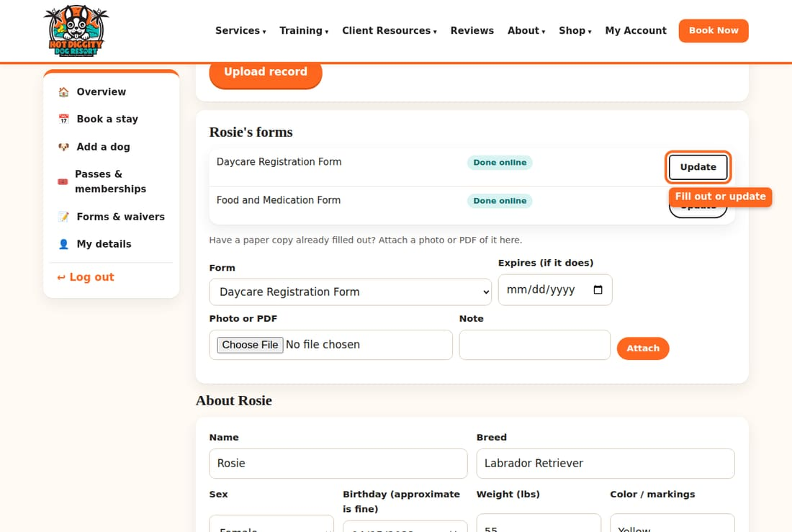
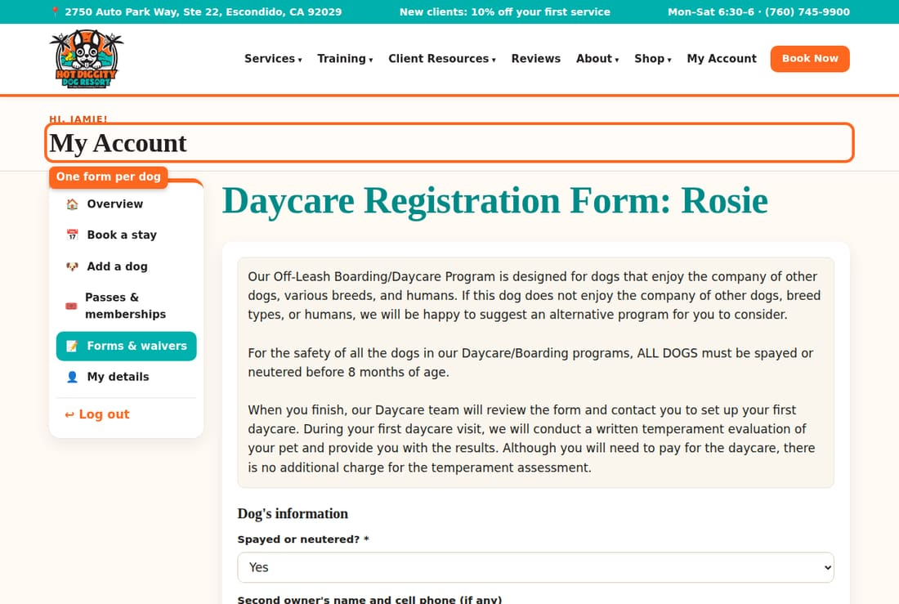

Have a paper copy?
Did you already fill out a paper form? You can send us a photo of it.
- On your dog's page, find "Have a paper copy already filled out?"
- Under Form, pick which form it is.
- Under Photo or PDF, press Choose File.
- Press Attach.
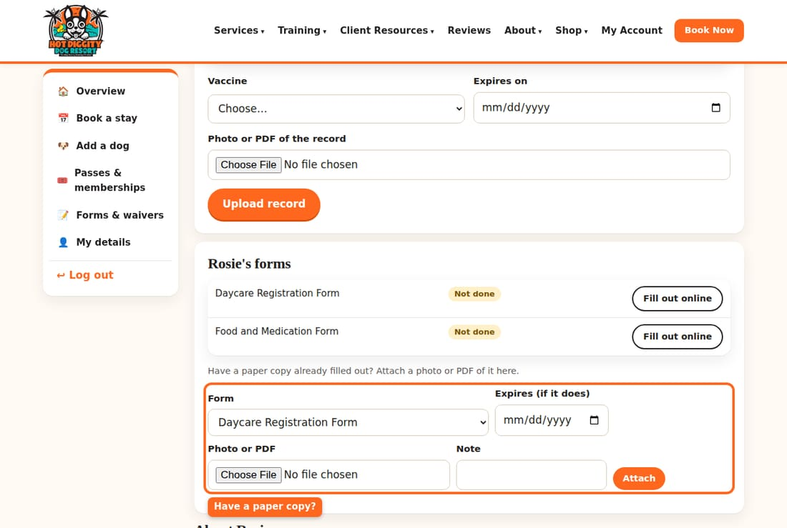
Tip: Forgot a form? No worry. When you book, the site takes you to the missing form. It says "Before we can book this, please fill out..." Fill it out. Then book again.
Good to know: Need to change an answer? Press Update next to the form. Change it, then save again.
Stuck? Call us at (760) 745-9900.

"First visit: the Temperament Assessment"
Every new dog starts with one fun daycare day, so we can get to know them.
Every new dog starts with a Temperament Assessment. Some pages call it a Play Date. It is a full daycare day. We watch how your dog plays with other dogs and people. It keeps every dog safe. Your dog needs it before daycare or boarding. Grooming does not need it.

What to know first
- It is one full day of daycare. It costs the regular daycare price. There is no extra charge.
- Drop off by 10:00 am. You can come as early as 6:30 am.
- Pick up no earlier than 3:00 pm. You can come as late as closing.
- Your dog needs shots on file and the forms signed first. See Upload shot records and Sign forms and the waiver.
- Your dog must be spayed or neutered before 8 months of age.

Steps
- Log in. On My Account, look at your dog under My dogs. It may say Book a Temperament Assessment day.
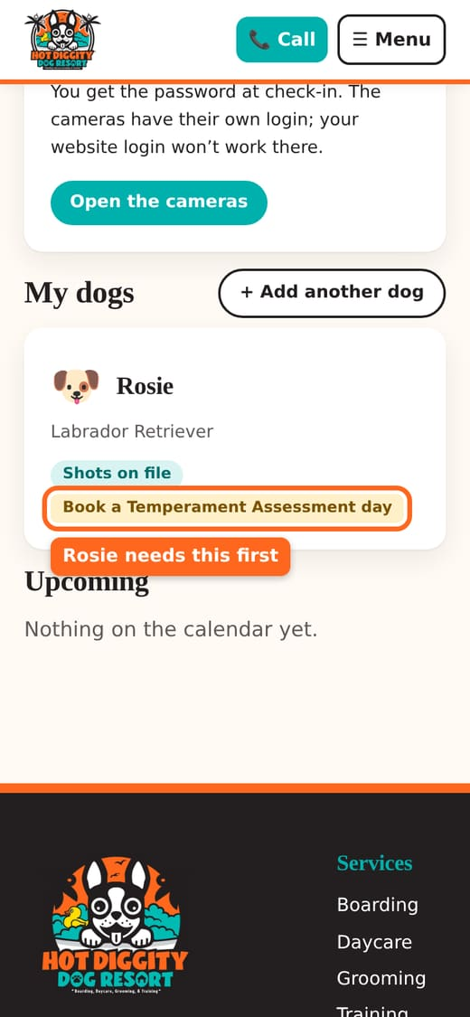
- Press Book a stay.
- Under What would you like to book?, pick Temperament Assessment (first daycare day).
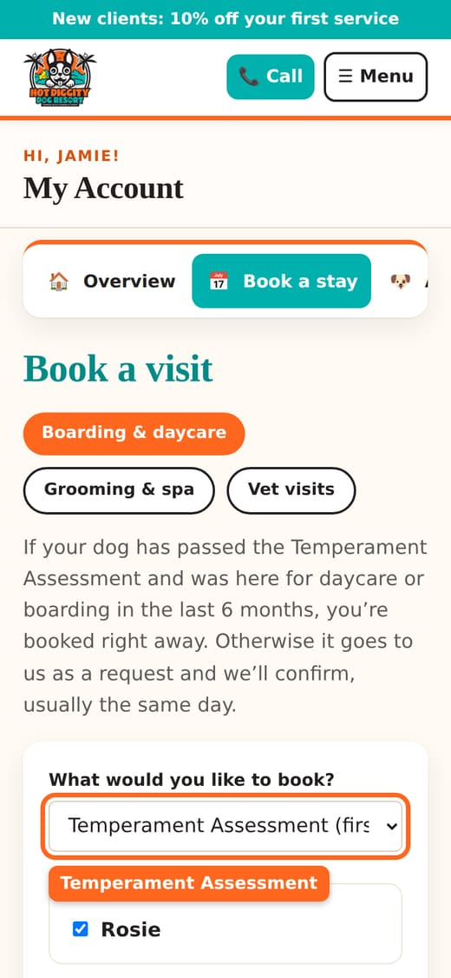
- Check your dog under Which dogs?
- Pick the First day. Pick a Monday to Saturday.
- In Drop-off time, pick 10:00 am or earlier.
- In Pickup time, pick 3:00 pm or later.
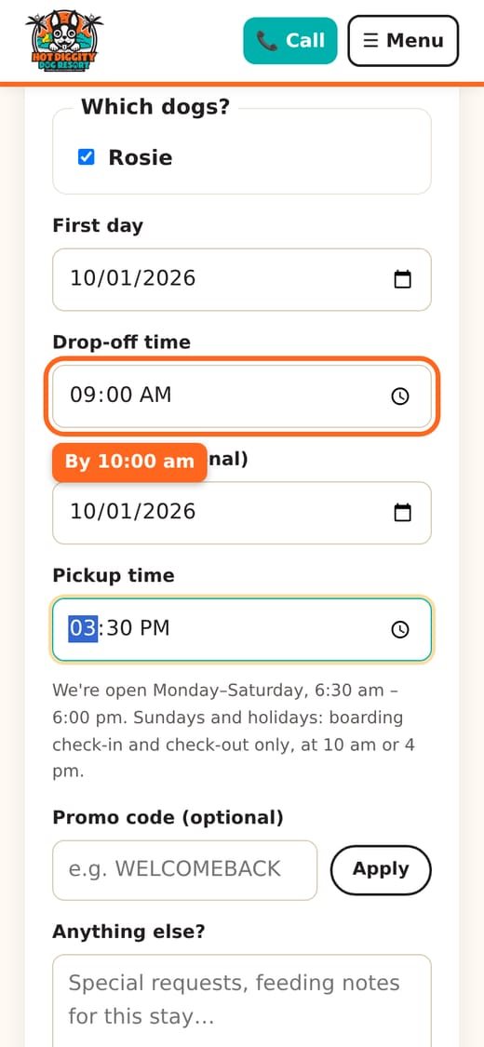
- Look at the price box. It shows your total.
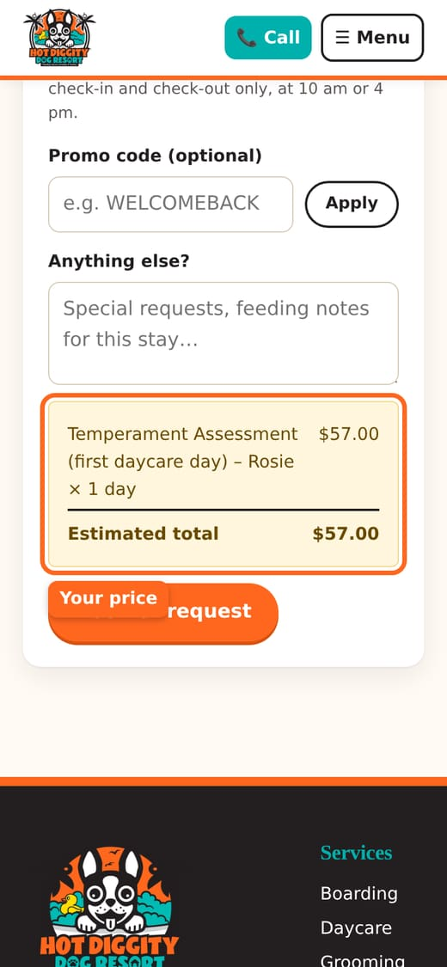
- Press Book or request.
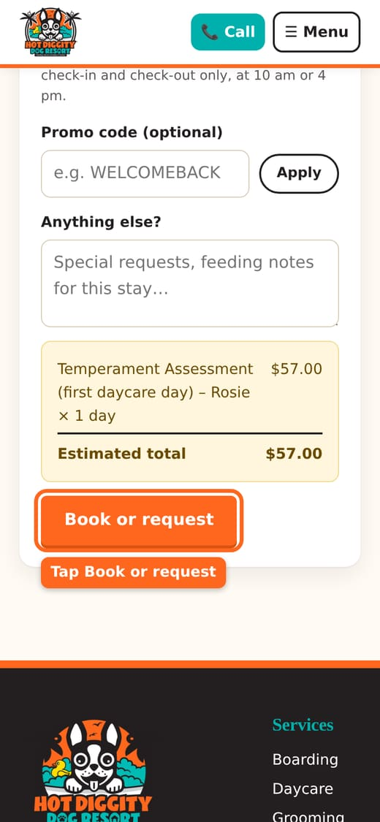
- You see "Request sent! We'll confirm by email or text." Your booking says Requested for now.
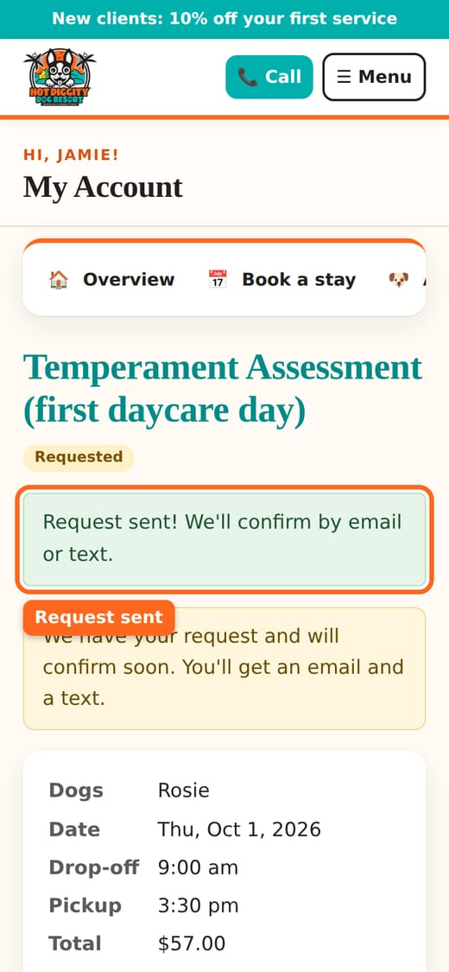
- We look at it and confirm, usually the same day. Then it says Confirmed.
Good to know: This first day is always a request. A person on our team confirms it. It is not booked until it says Confirmed.
Tip: Tried to book daycare first? The site will stop you. It says your dog's first daycare day is a Temperament Assessment. Just book that instead.
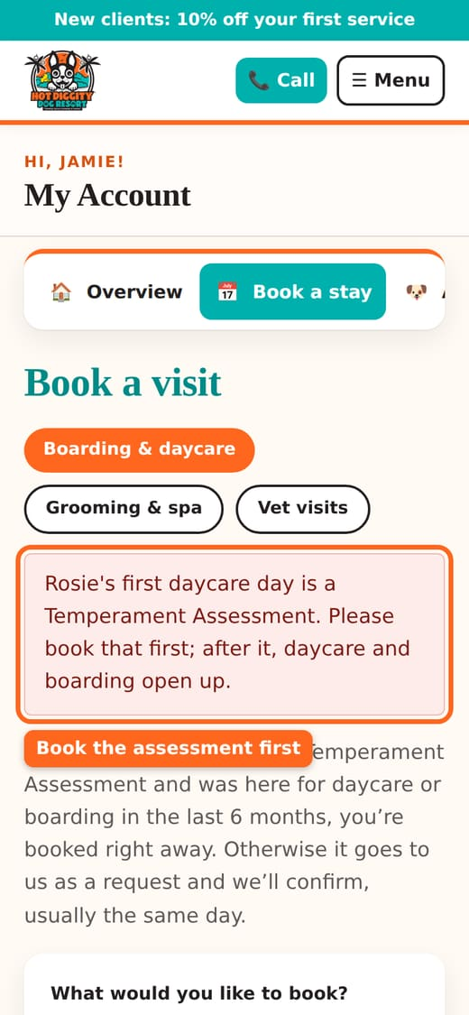
Good to know: Away more than 6 months? Your dog needs a new Temperament Assessment day before daycare or boarding.

If you see a message
- "Please drop off by 10:00 am and pick up no earlier than 3:00 pm." Change the times.
- "The Temperament Assessment is a single day." Pick just one date.
Stuck? Call us at (760) 745-9900.

Book daycare
Book a full or half day of play for your dog.
Daycare is a day of fun with other dogs. Your dog plays in small groups, with rest breaks. You can book a full day or a half day.

Before you start
- Your dog has passed the Temperament Assessment. New dog? See First visit.
- Shots are on file. See Upload shot records.
- The waiver and Daycare Registration Form are signed. See Sign forms.

Steps
- Log in. On My Account, tap Book a stay.
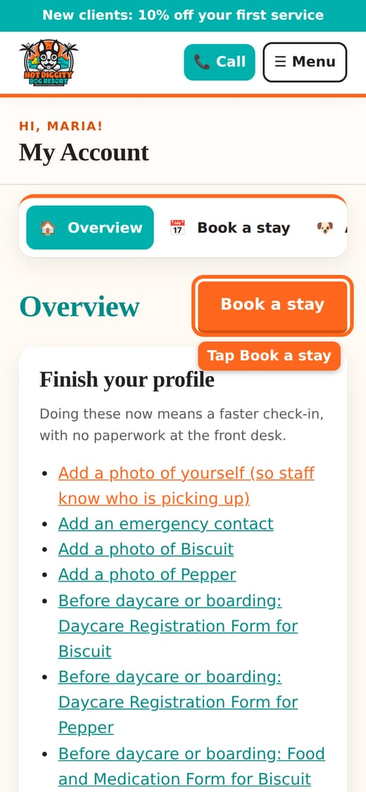
- You are on Book a visit. Make sure Boarding & daycare is picked at the top.
- Under What would you like to book?, pick Daycare: Full Day or Daycare: Half Day (AM or PM).
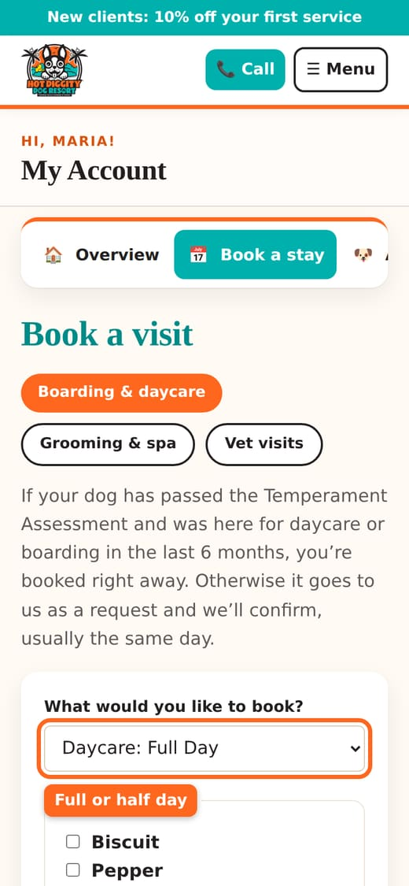
- Under Which dogs?, check each dog who is coming.
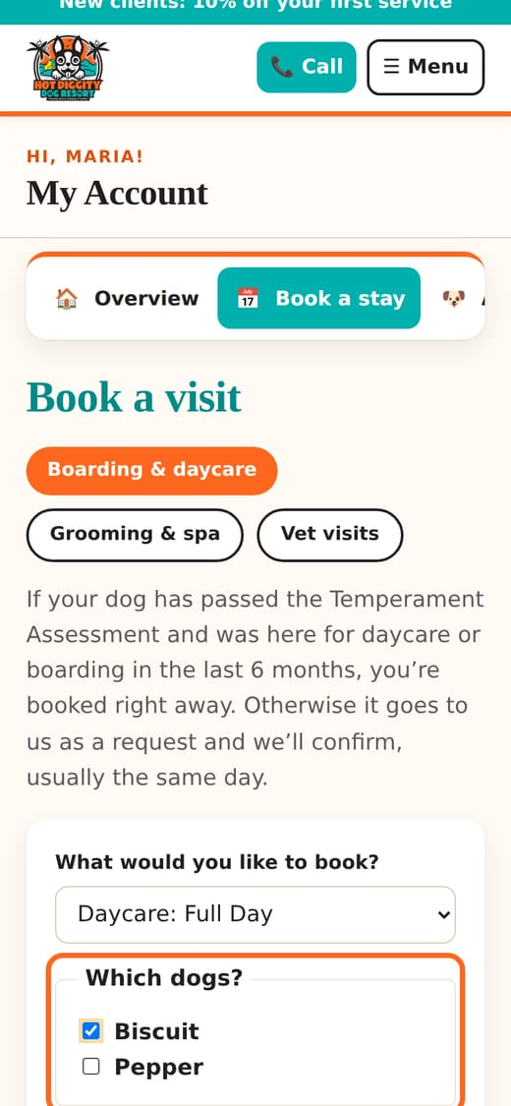
- Pick the First day.
- Pick a Drop-off time, between 6:30 am and 6:00 pm.
- Coming more than one day in a row? Pick the Last day (optional). We skip Sundays and holidays for you.
- Pick a Pickup time.
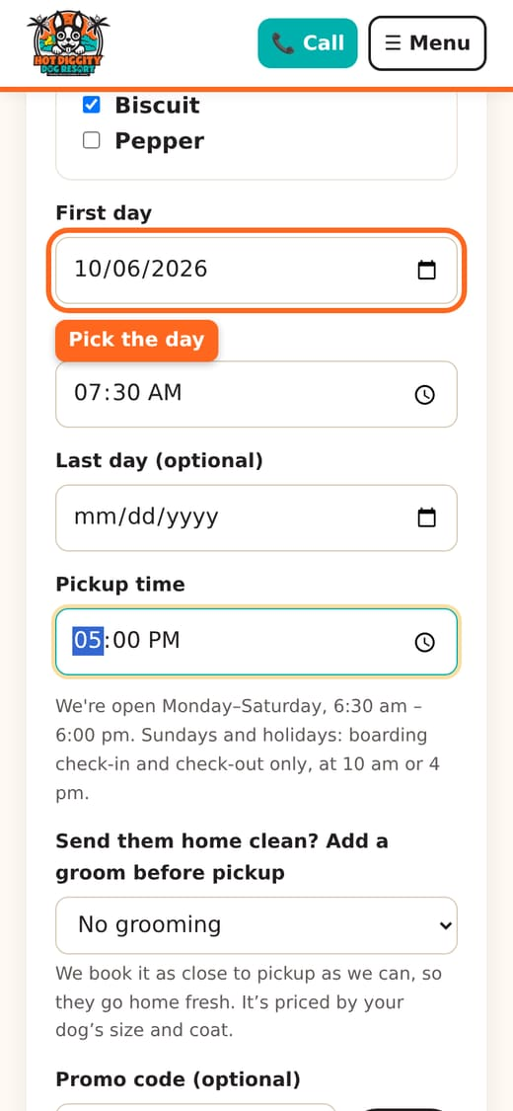
- Want a bath or groom before you pick up? Pick one in Send them home clean? Add a groom before pickup. Or leave No grooming.
- Have a promo code? Type it in Promo code (optional). Press Apply.
- Add any notes in Anything else?
- Look at the price box. It shows your total.
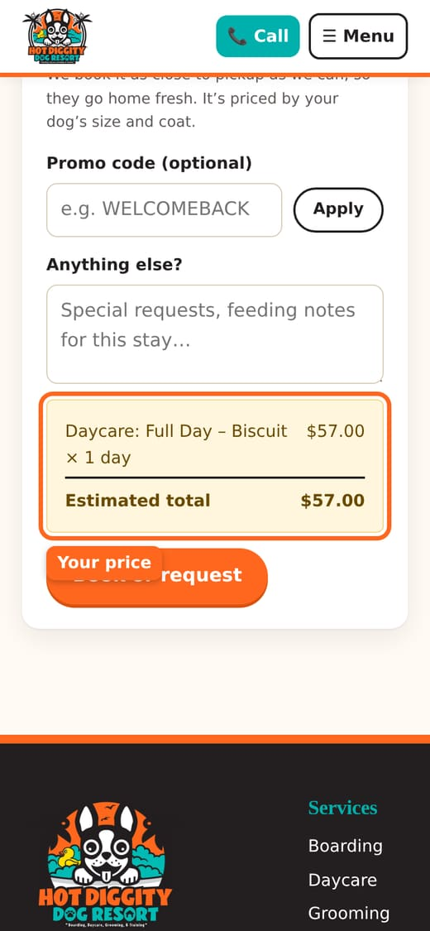
- Tap Book or request.
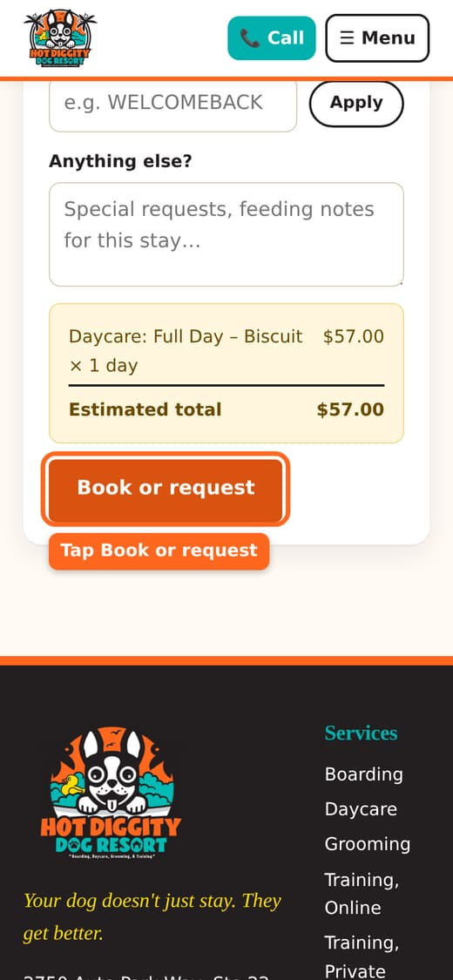
- See "You're booked!"? You are all set. The booking says Confirmed.
- See "Request sent!"? We will look at it and confirm, usually the same day.
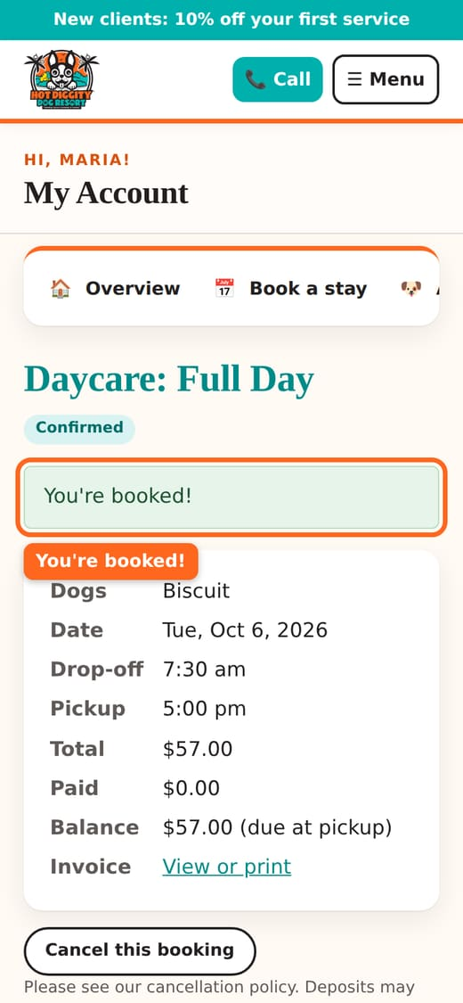
Good to know: When is it booked right away? Your dog passed the Temperament Assessment. And your dog came for daycare or boarding in the last 6 months. If not, it goes to us as a request. A request is not booked until it says Confirmed.
Tip: Missing a form? The site takes you to it and says "Before we can book this, please fill out..." Fill it out and press Sign and save. You come back to Book a visit. Then pick your day again.
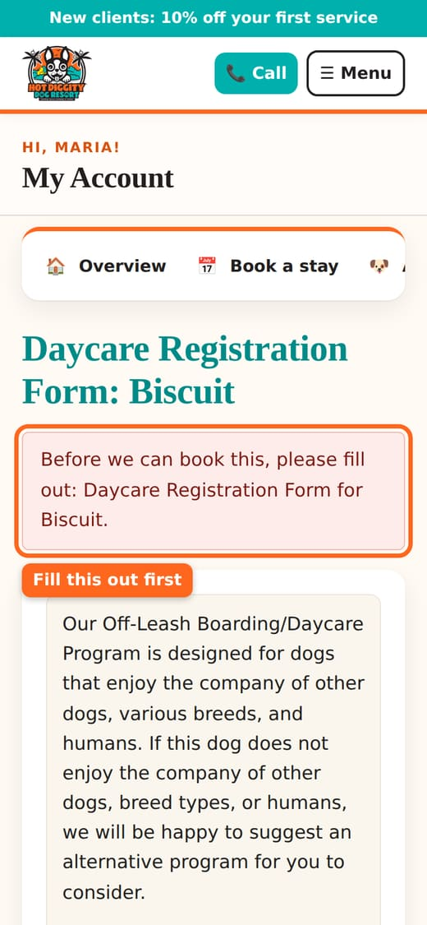
Good to know: Daycare is closed on Sundays and holidays. Please pick up by 5:45 pm. We close at 6:00 pm.
Tip: Come often? A daycare pass saves money. See Daycare passes.

If you see a message
- "Sorry, we're full on..." That day is full. Call us to get on the waitlist.
- "We're closed Sundays for daycare." Pick a Monday to Saturday.
- "Drop-off and pickup need to be between 6:30 am and 6:00 pm." Change the times.
- "...need current shot records on file..." Upload the shots, then book again.
Stuck? Call us at (760) 745-9900.

Book boarding
Book an overnight stay in a private suite.
Boarding is an overnight stay. Your dog gets a private suite, not a cage. Daycare play is part of every day. You can book it on your phone.

Before you start
- Your dog has passed the Temperament Assessment. See First visit.
- Shots are on file, and good through the last day of the stay.
- The waiver, Daycare Registration Form, and Food and Medication Form are signed.

Steps
- Log in. Tap Book a stay.
- Under What would you like to book?, pick Overnight Boarding.
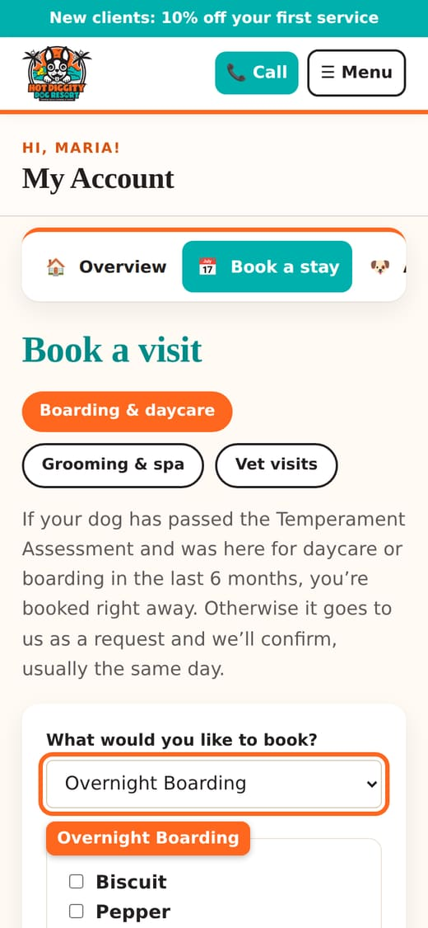
- Under Which dogs?, check each dog who is coming.
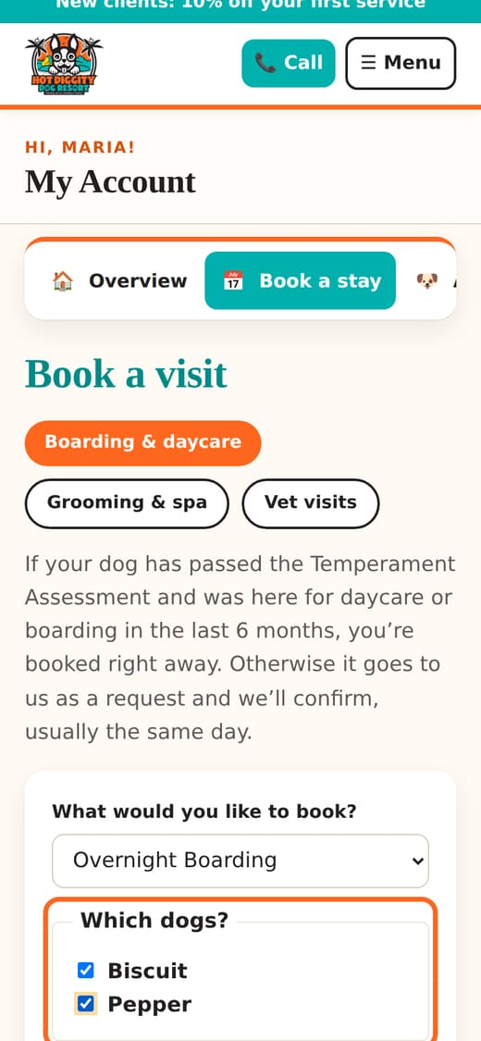
- Pick the Drop-off date and Drop-off time.
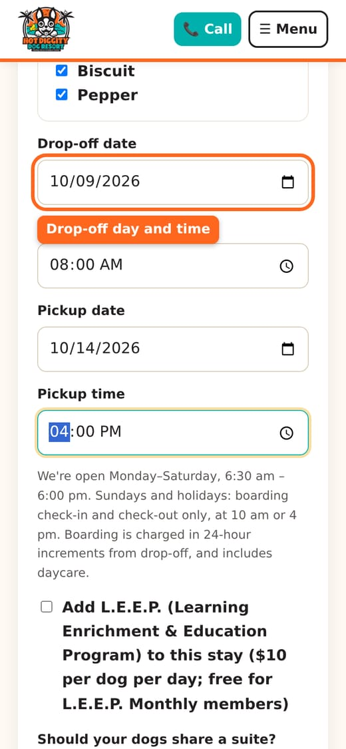
- Pick the Pickup date and Pickup time.
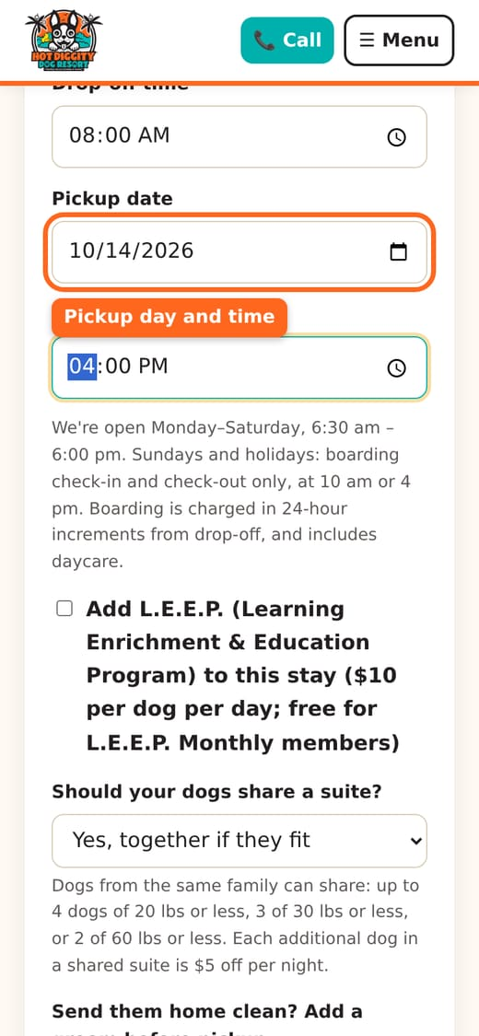
Good to know: Boarding is charged by 24-hour blocks from drop-off. Pick up within 4 hours of your drop-off time to keep the price. Drop off at 8 am? Then pick up by noon. Later adds one more day.
- Want extra fun? Check Add L.E.E.P. It adds a 15-minute one-on-one play and learning time each day. It costs $10 per dog per day. It is free for L.E.E.P. Monthly members.
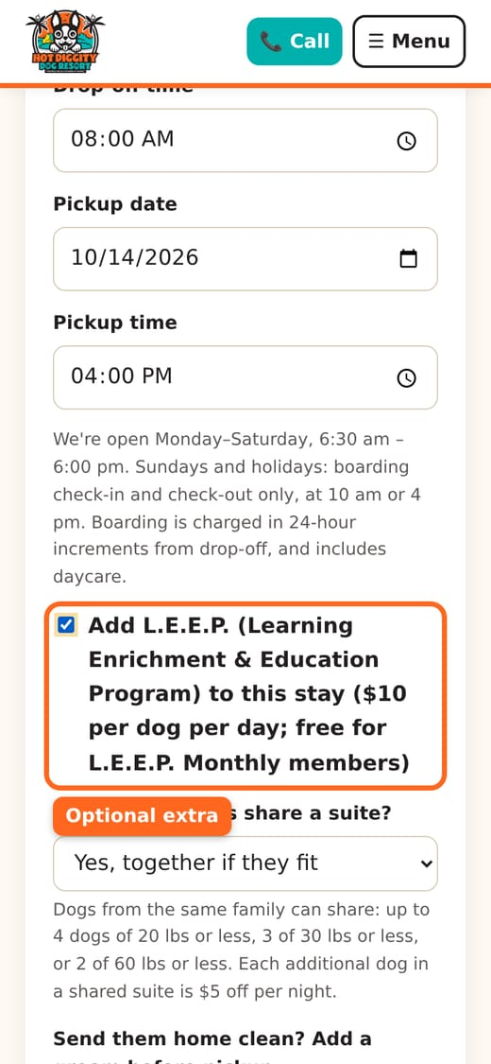
- Two or more dogs? Pick an answer for Should your dogs share a suite?
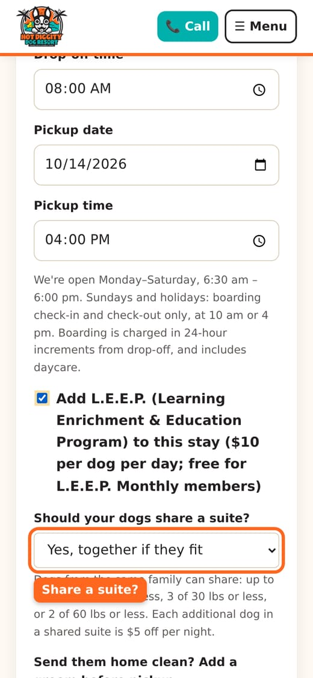
Good to know: Only dogs from the same family share. A suite fits up to 4 dogs of 20 lbs or less, 3 dogs of 30 lbs or less, or 2 dogs of 60 lbs or less. Each extra dog in a shared suite is $5 off per night.
- Want your dog to go home clean? Pick a groom in Send them home clean? Add a groom before pickup. We do it as close to pickup as we can.
- Staying 5 nights or more? You get a free bath. Pick Just the free bath in the same list. It is a bath only. No nails or trim.
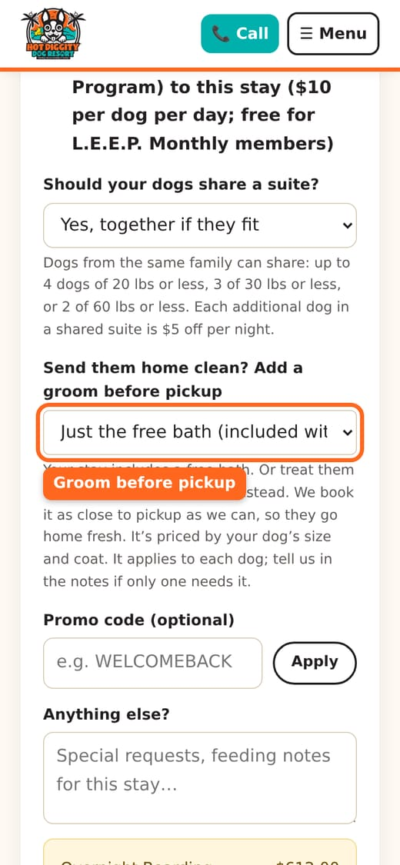
- Have a promo code? Type it in Promo code (optional). Press Apply.
- Type any notes in Anything else? Feeding notes for this stay go here.
- Look at the price box. It shows your estimated total.
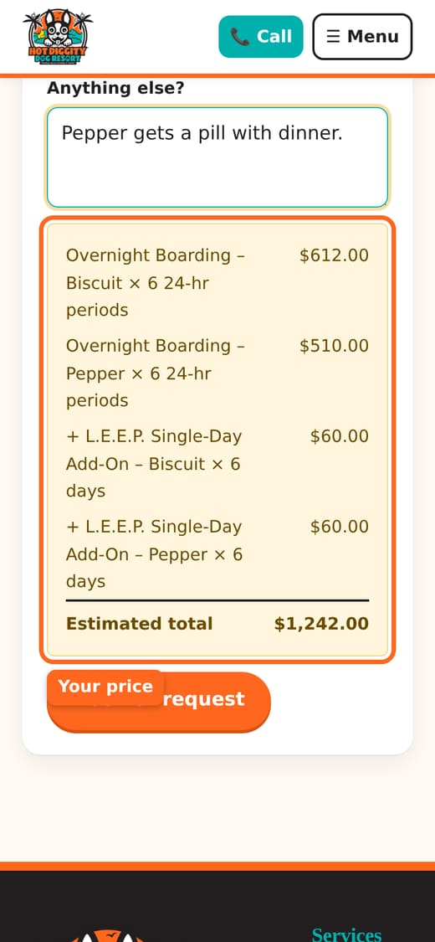
- Tap Book or request.
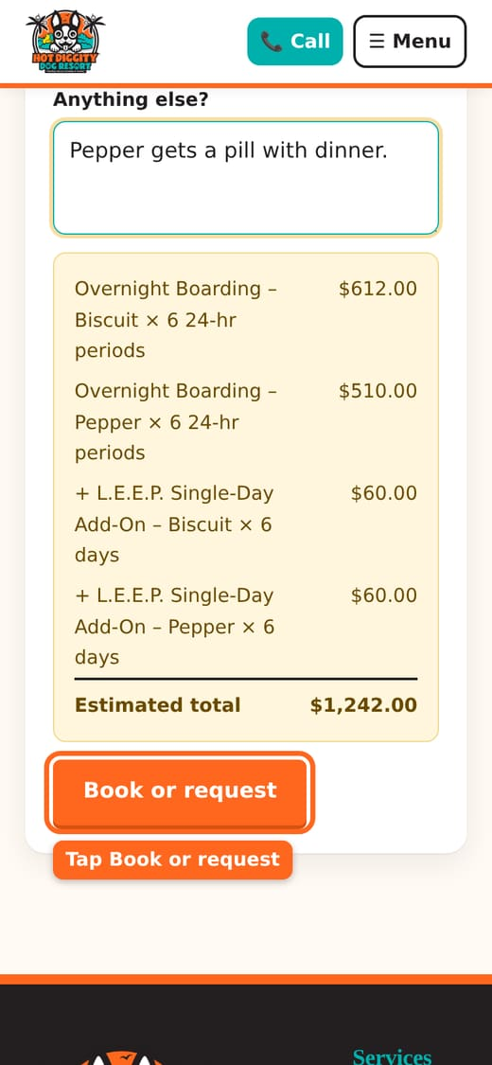
- See "You're booked!"? You are all set.
- See "Request sent!"? We will confirm by email or text, usually the same day.
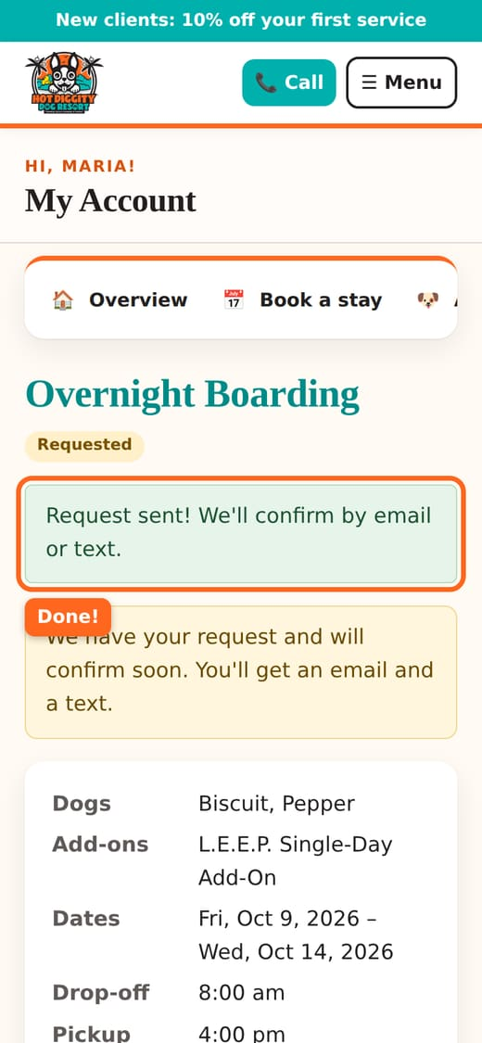
Good to know: A stay is booked right away only when your dog passed the Temperament Assessment, came in the last 6 months, and gets its own suite. Otherwise it is a request. A request is not booked until it says Confirmed.

Sundays and holidays
We are closed for daycare and grooming on Sundays and holidays. But you can still drop off or pick up for boarding. It is by appointment, at 10 am or 4 pm.
- Pick a Sunday or holiday date.
- The time box turns into a list. Pick 10:00 am or 4:00 pm.
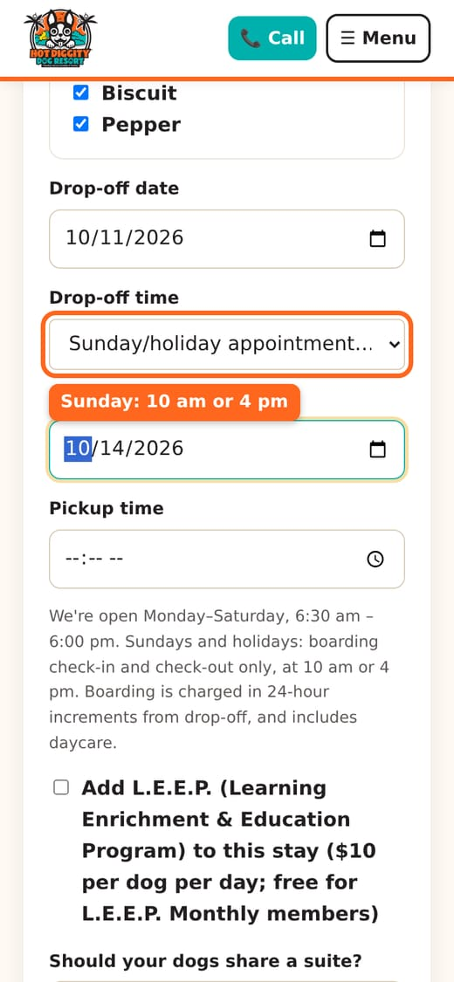

Holiday stays
- A holiday fee is added for each day that starts on a holiday. The price box shows it.
- Stays over Thanksgiving or Christmas need at least 3 nights.
- See the full list of holidays on our Policies page.
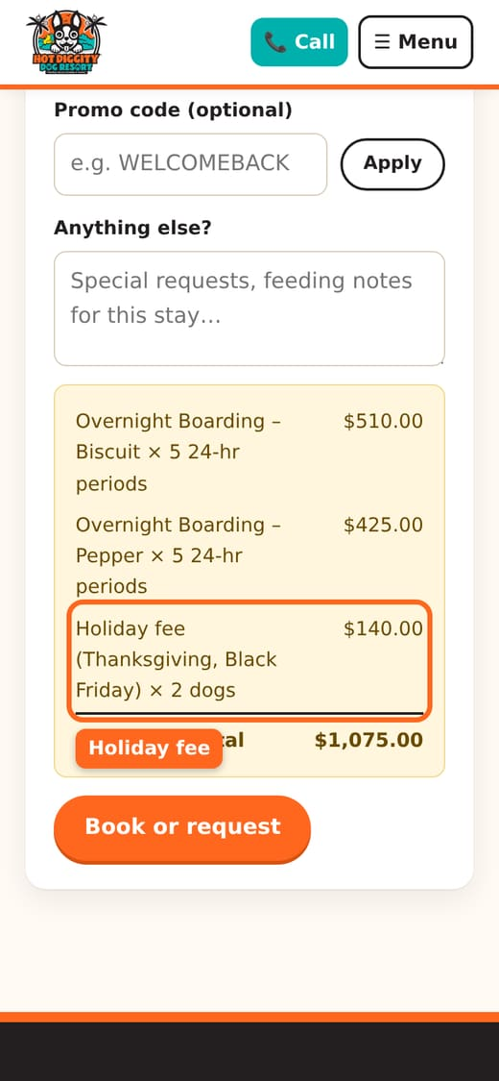
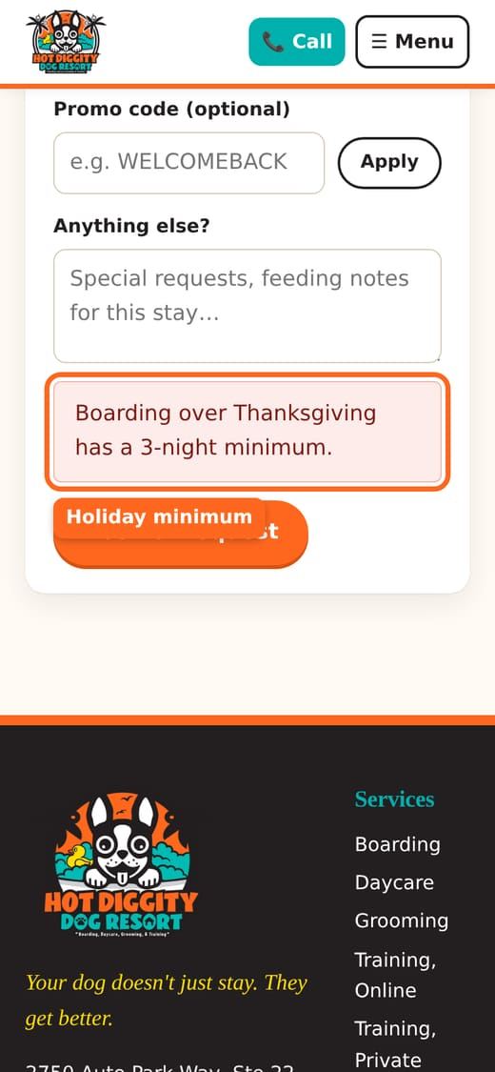
Good to know: Need to cancel? Please tell us at least 48 hours before drop-off. Holidays may need more notice. See Cancel a booking.
Tip: Please pack food in bags, one bag per meal, plus a little extra. Bring medicine in its labeled bottle. If food runs out, we have house food for $3.00 per day per dog.

If you see a message
- "Pickup has to be at least one night after drop-off." Change the dates.
- "On Sundays, boarding drop-off and pickup are by appointment at 10:00 am or 4:00 pm." Pick one of those times.
- "Sorry, we're full on..." Call us. We will try to help.
Stuck? Call us at (760) 745-9900.

Book a groom
Pick a service, a day, and an open time with one of our groomers.
You can book a bath, haircut, or other groom online. You pick the time yourself. Grooming does not need a Temperament Assessment.

Before you start
- Add your dog, with weight. Prices depend on weight and coat.
- Shots are on file.
- Sign the Grooming Waiver. Or the Daycare & Boarding Waiver, which covers grooming too.

Steps
- Log in. Tap Book a stay.
- At the top, tap Grooming & spa.
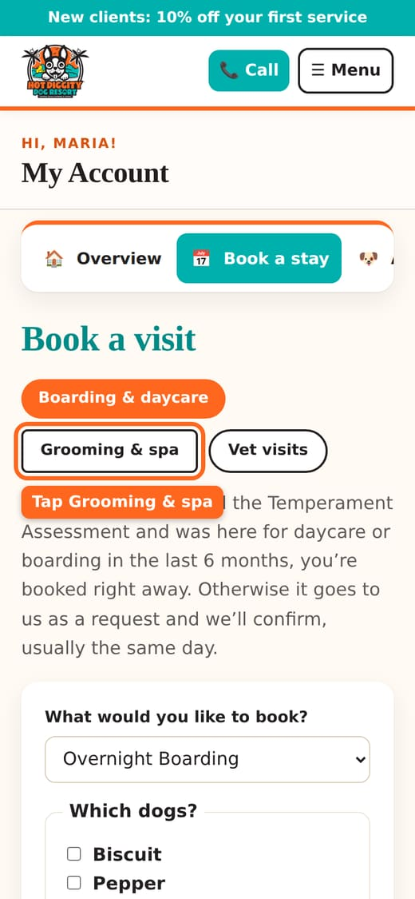
- Under Dog, pick your dog.
- Under Service, pick what you want. For a haircut, pick Hair Cuts - Full Grooms.
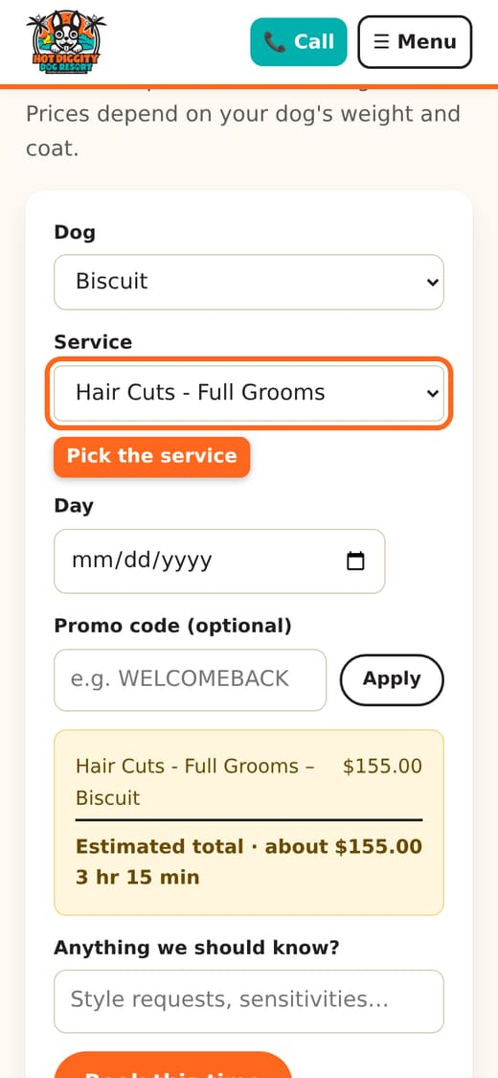
- Want extras, like a nail trim? Tap Add-ons. Check the ones you want.
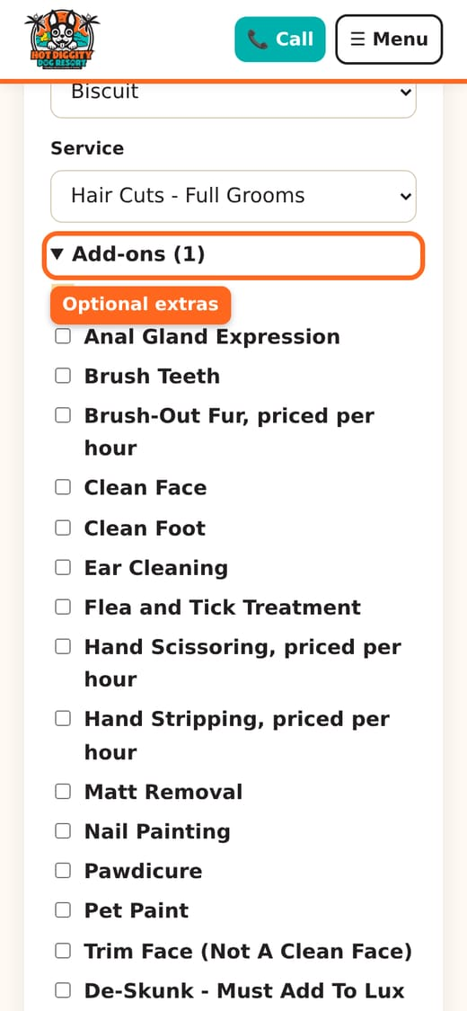
- Under Day, pick a day.
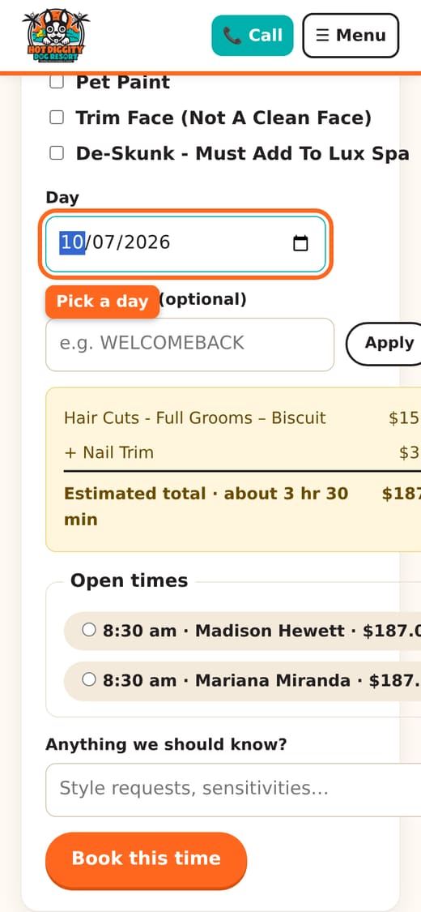
- Look at the price box. It shows the price and about how long it takes.
- Look under Open times. Tap the time you want. Each time shows the groomer and the price.
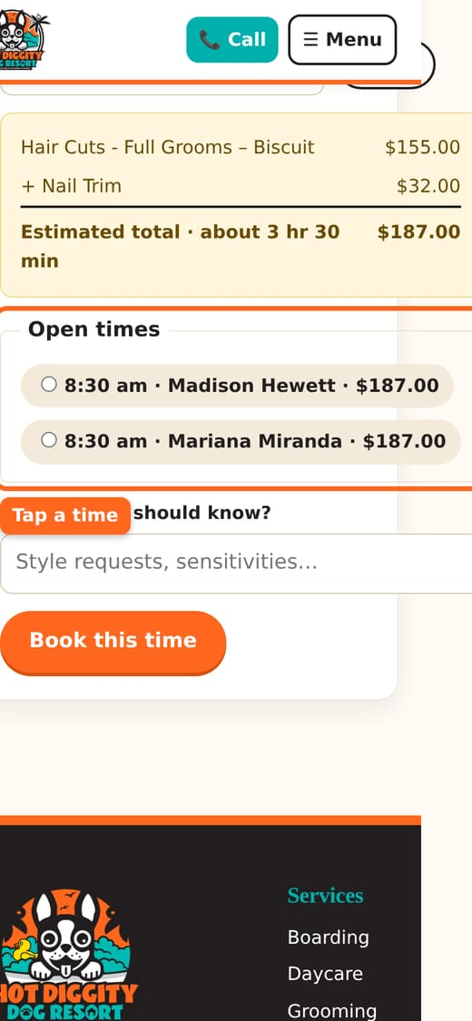
- Add notes in Anything we should know? Style wishes go here.
- Tap Book this time.
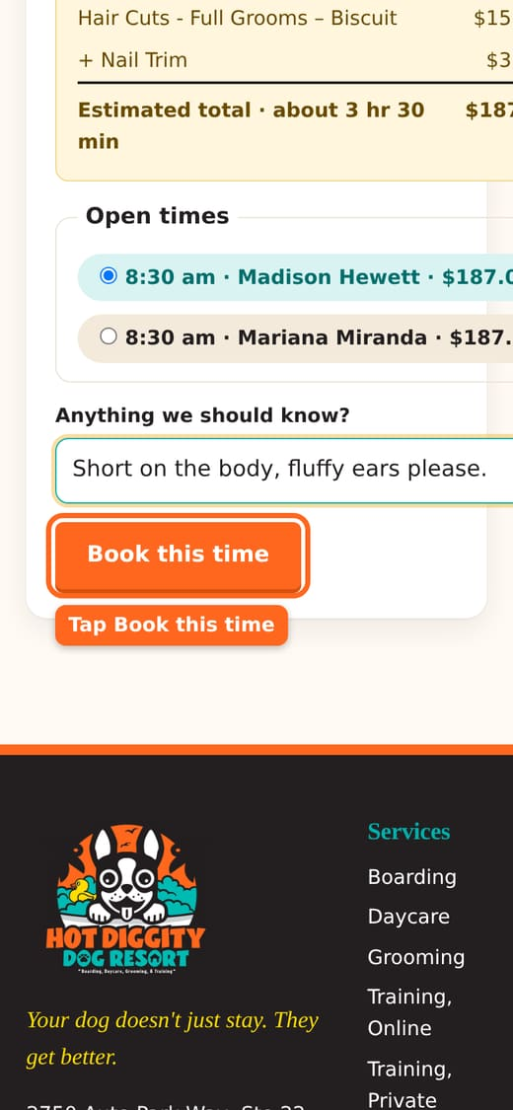
- See "You're booked!"? You are all set.
- See "Request sent! We're holding your time"? We hold that time and confirm soon.
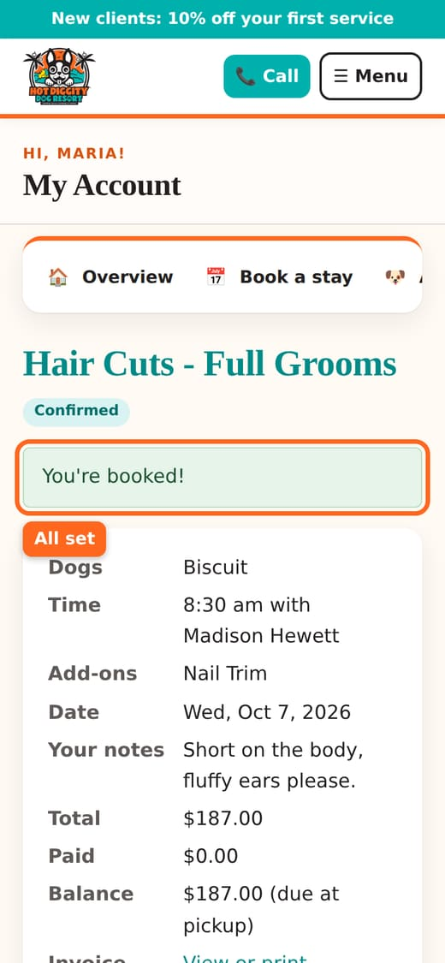
Good to know: New to grooming with us? Your first groom is a request. We confirm it soon. After your first visit, most grooms book right away.
Tip: The site shows the times that fit best in our groomers' day. You may see only a few. Need a different time? Call us.
Tip: A time with a star (★) is with a Signature Groomer. The price may be a bit higher.

No open times?
- It says "No openings that day." Try another day.
- Or tap Join the waiting list for this day. We text or call if a spot opens.
- The salon is closed on Sundays and holidays.
- You can see your waiting list spots on My Account. Tap Remove to leave the list.
Good to know: Need to cancel? Please tell us at least 24 hours before. See Cancel a booking.
Good to know: About 20 minutes before your dog is done, we text you. Please reply C. See Text messages.
Tip: Your dog is boarding or in daycare? You can add a groom to that booking instead. See Book boarding.
Stuck? Call us at (760) 745-9900.

Book a vet visit
Ask for a teeth cleaning, shots, or a microchip on one of our vet days.
Dr. Janet Moston, DVM, comes to us every other Monday. She does teeth cleanings without general anesthesia. She also gives shots and puts in microchips. You can ask for a visit online.

Steps
- Log in. Press Book a stay.
- At the top, press Vet visits.
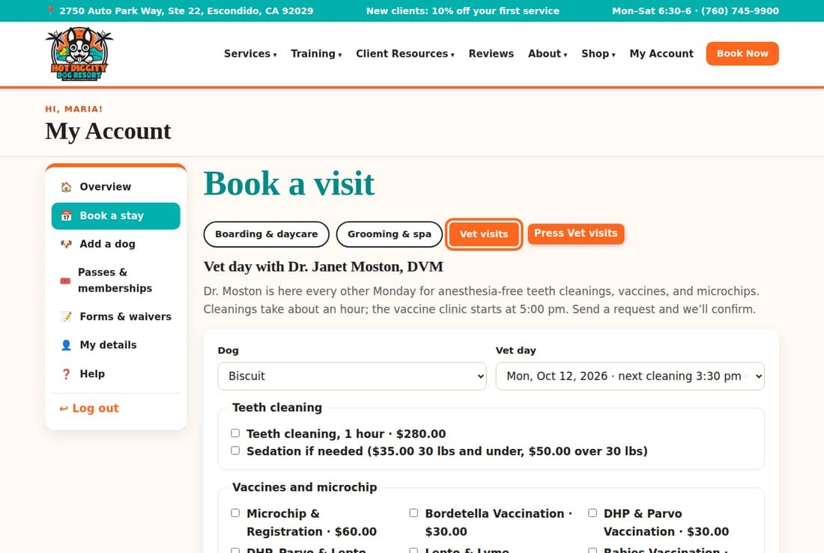
- Under Dog, pick your dog.
- Under Vet day, pick a day. Each day shows the next cleaning time and how many are left.
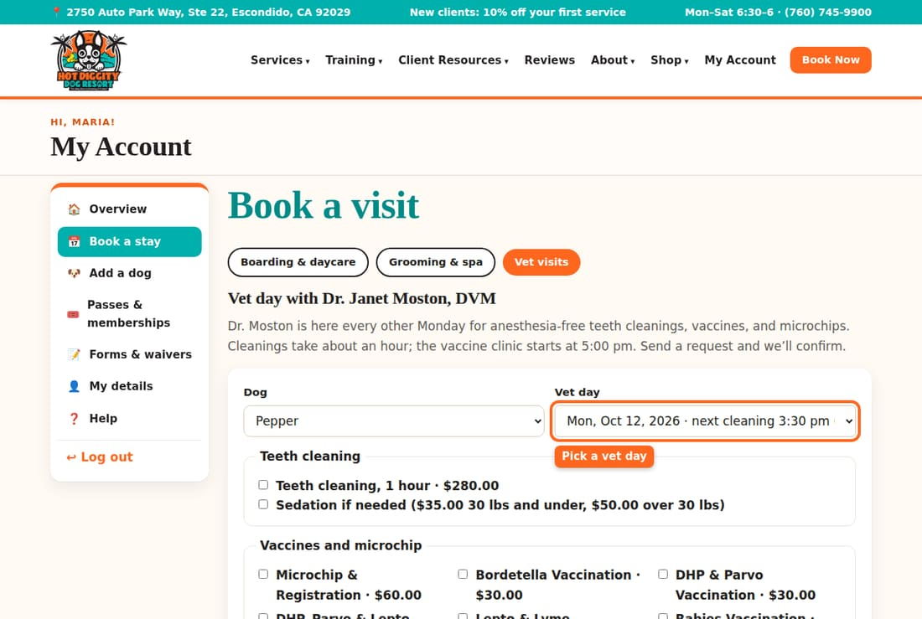
- Want a teeth cleaning? Check Teeth cleaning, 1 hour.
- If Dr. Moston thinks your dog needs to be calm, she can use light sedation. Check Sedation if needed to say yes to that.
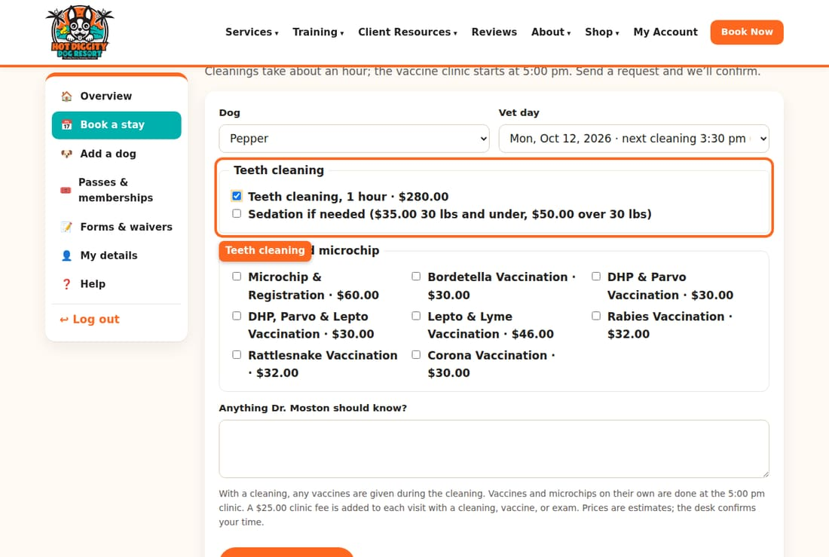
- Want shots or a microchip? Check them under Vaccines and microchip.
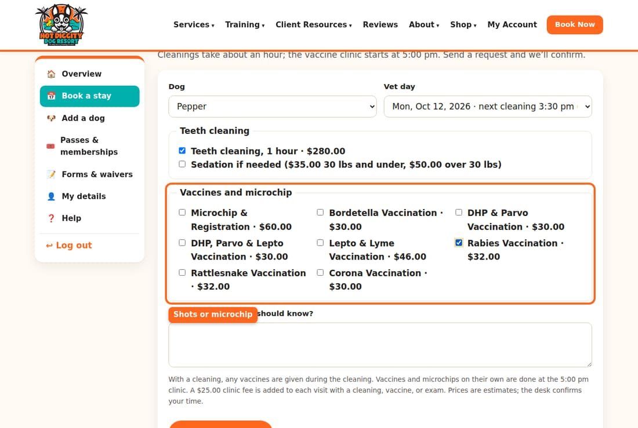
- Type notes in Anything Dr. Moston should know?
- Press Request vet visit.
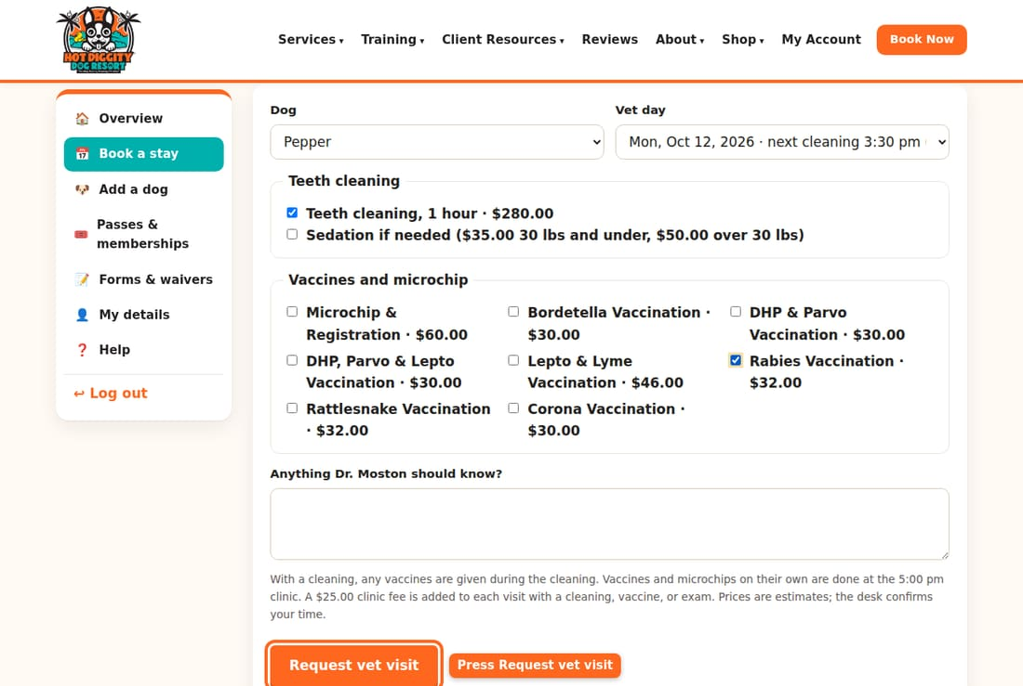
- You see "Request sent! We're holding" a time for you. We confirm it soon.
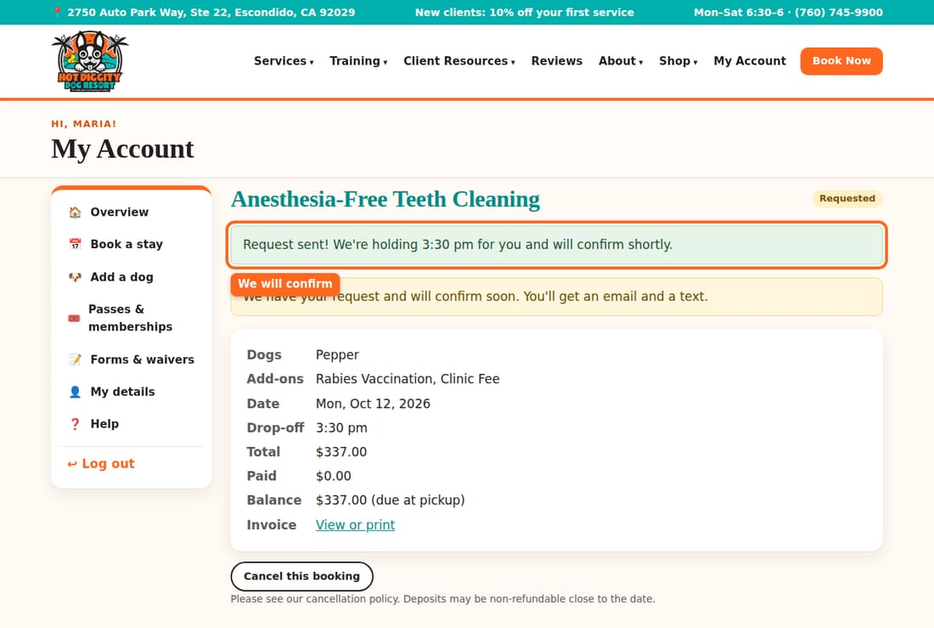
Good to know: With a cleaning, any shots are given during the cleaning. Shots or a microchip alone are done at the 5:00 pm clinic.
Good to know: A clinic fee is added to each visit with a cleaning, shot, or exam. The prices are estimates. The desk confirms your time.
Tip: No vet days on the list? Call us. Some days are skipped for holidays.
Stuck? Call us at (760) 745-9900.

See, change, or cancel a booking
Check your bookings, and cancel one if your plans change.
All your bookings are on My Account. You can see the details and cancel online. To change a booking, call us or cancel and book again.

See your bookings
- Log in. On My Account, scroll to Upcoming. Past visits are under History.
- Each row shows the Dates, Service, Dogs, Status, and Total.
- Press the dates to open a booking.
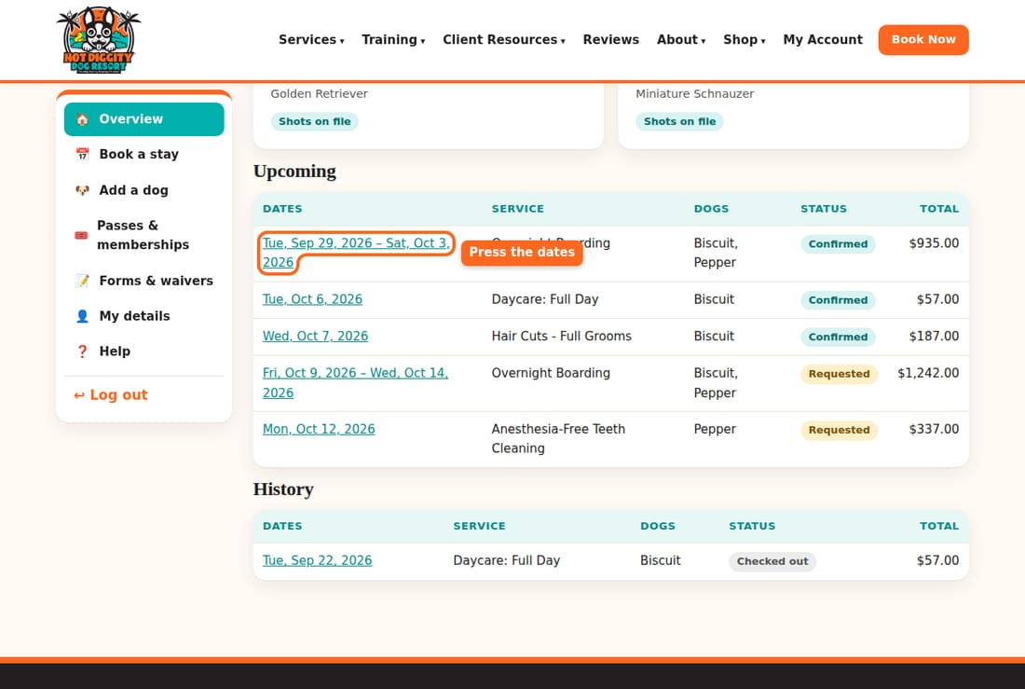
- You see all the details. The Status is at the top.
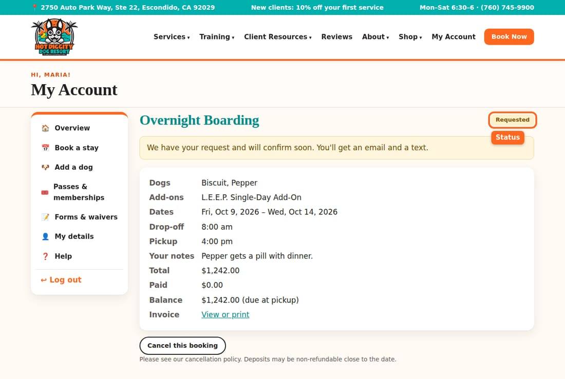

What the status means
- Requested: we have your request. It is not booked yet. We confirm soon.
- Confirmed: you are booked.
- Checked in: your dog is here with us now.
- Checked out: the visit is done.
- Cancelled: the booking is off.
- Declined: we could not fit you in. Please call us to find another day.
Tip: After a daycare or boarding day, look for Report cards on the booking page. They tell you how your dog's day went.

Cancel a booking
- Open the booking.
- Scroll down. Press Cancel this booking.
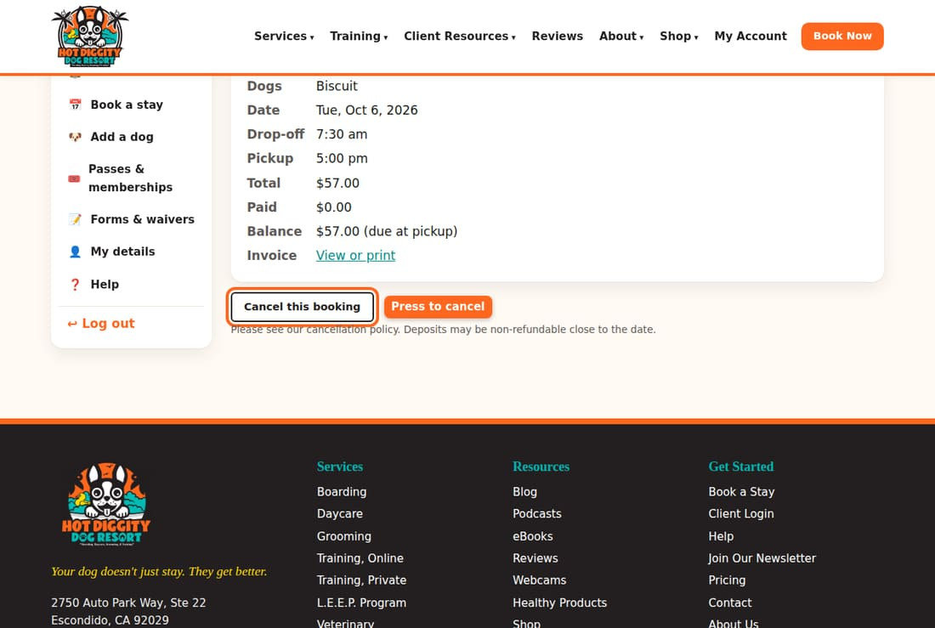
- You see "Your booking is cancelled." The status now says Cancelled.
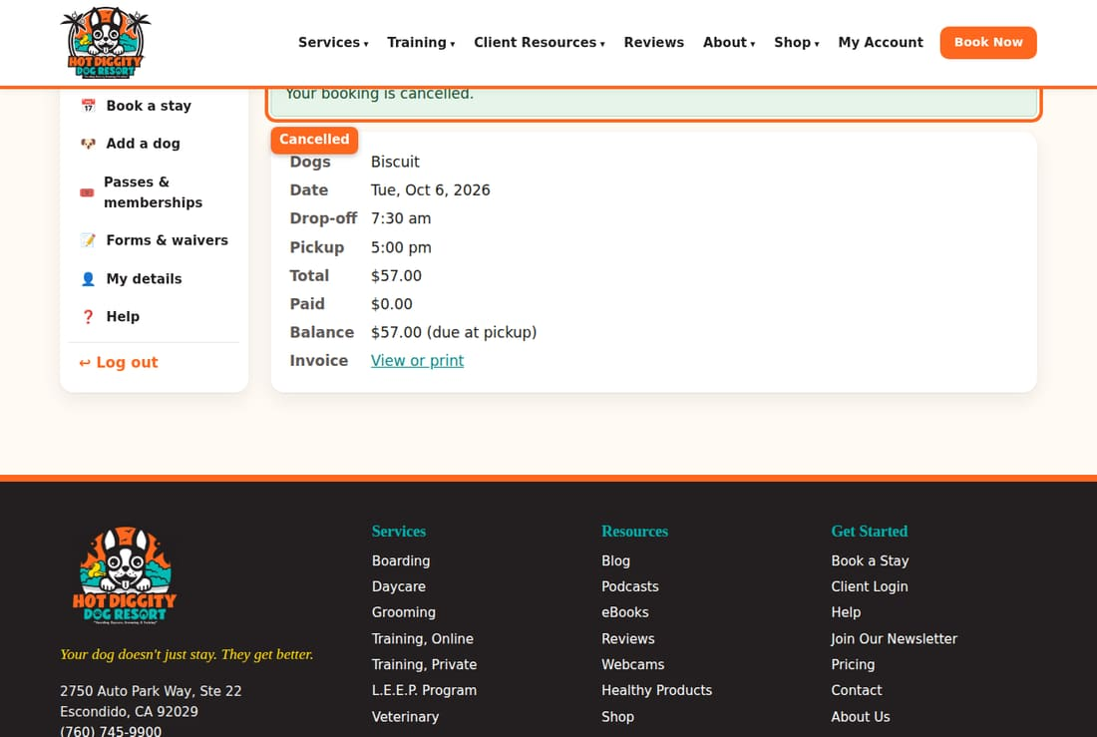
Good to know: Please cancel at least 48 hours before a boarding stay. Please cancel at least 24 hours before grooming and everything else. Holidays may need more notice.
Good to know: Cancel in time and we refund what you paid. Late cancels and no-shows are not refunded. They may have a fee. Deposits may not be refunded close to the date.
Good to know: The site lets you press cancel at any time. But the time rules above still apply. Our team checks each cancel for refunds.
Tip: Once your dog is checked in, you can't cancel online. Please call us.

Change a booking
There is no change button yet. Here is what to do:
- Call us at (760) 745-9900. We can change it for you.
- Or cancel the booking, and then book the new dates. Mind the cancel rules above.
Stuck? Call us at (760) 745-9900.

Pay and see your bill
See what you owe, pay a deposit, and print your bill.
Each booking shows what it costs and what you still owe. You pay the rest when you pick up your dog. You can also view or print your bill anytime.

See what you owe
- Log in. On My Account, open a booking under Upcoming or History.
- Look at Total, Paid, and Balance.
- The Balance is what you still owe. It says "due at pickup."
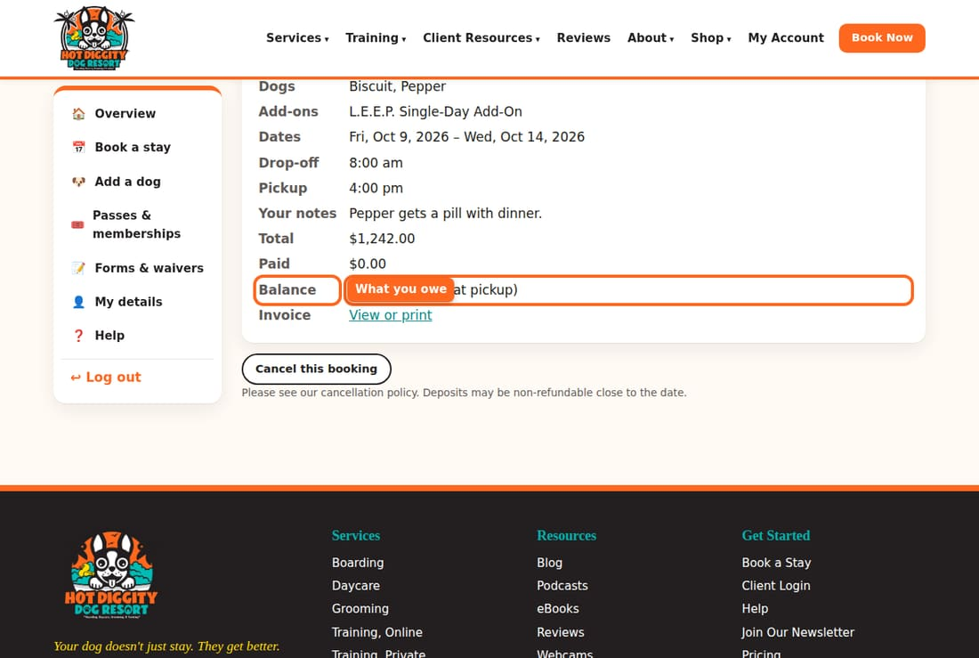
Good to know: The total is an estimate. It can change if you add things, or pick up late.

Pay a deposit
Some bookings need a deposit to hold your spot. If yours does, you see a Deposit box on the booking page.
- Open the booking.
- In the Deposit box, press Pay deposit by card.
- A safe card page opens. Type your card and pay.
- You come back to the booking. It says "Payment received. Thank you!" It can take a minute to show.
Good to know: The deposit comes off your final bill. Deposits may not be refunded close to the date.
Tip: Don't see the card button? The box will say to call us to pay the deposit, or pay at drop-off.

Pay the rest
- You pay the balance at the front desk when you pick up.
- There is no button to pay the full balance online yet.

View or print your bill
- Open the booking.
- Next to Invoice, press View or print.
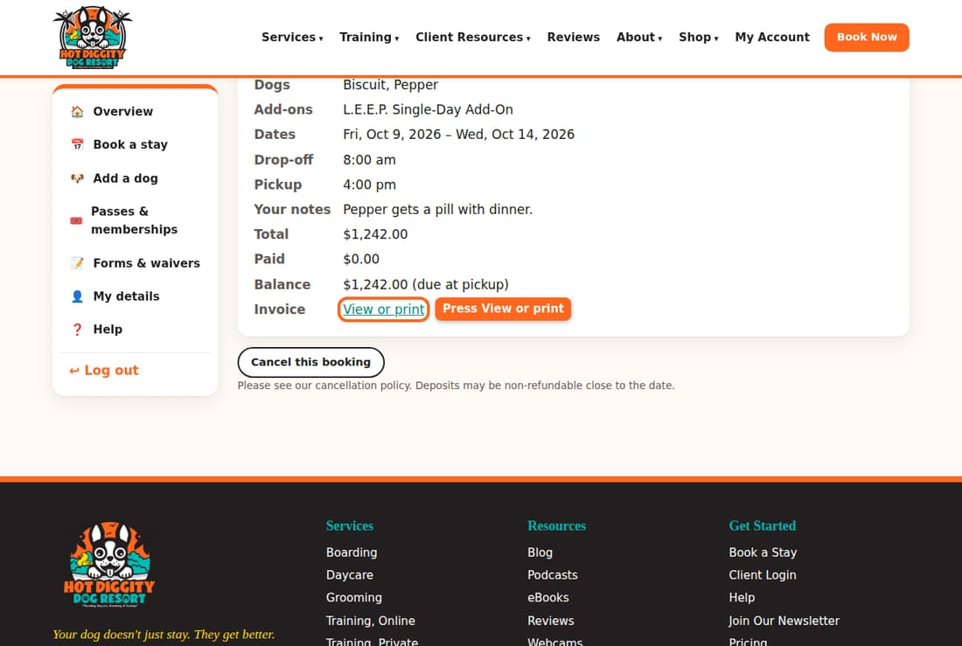
- Your bill opens. It shows each item and the total.
- Press Print or save as PDF. Print it, or save it as a file.
- Press Back to the booking when you are done.
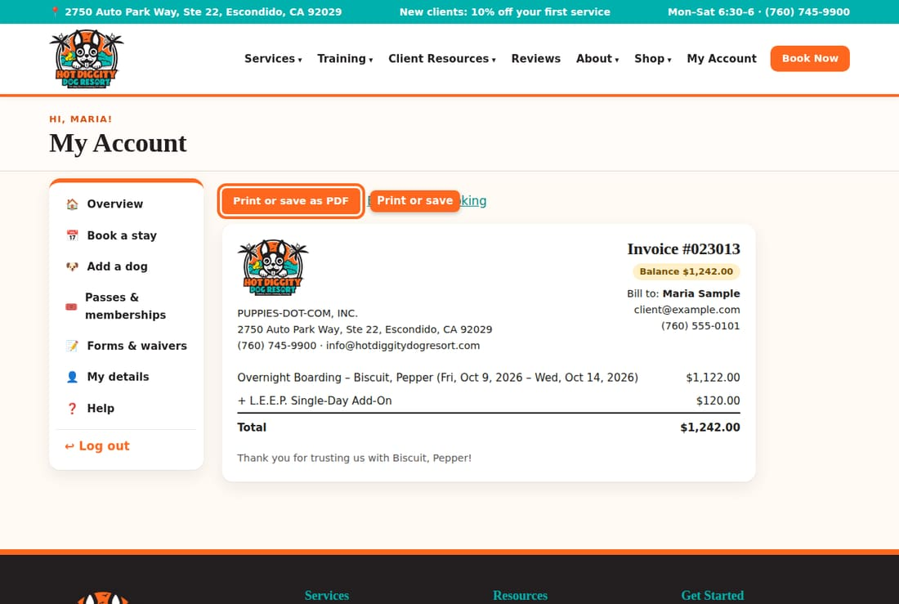
Good to know: Active and retired military get 10% off. Tell the front desk, and we will add it to your account.
Stuck? Call us at (760) 745-9900.

Daycare passes and L.E.E.P. Monthly
Save on daycare with a pass, or join L.E.E.P. Monthly for daily enrichment.
Come to daycare often? A pass saves you money. You can also join L.E.E.P. Monthly. L.E.E.P. gives your dog a 15-minute, one-on-one session each day they are here. It works their body and their brain.

Daycare passes
- A 10-day pass saves 5%. A 20-day pass saves 10%.
- There are passes for full days and for half days.
- Each daycare day uses one credit for that dog.
- Passes can't be refunded. They run out 90 days after you buy them.

Buy a pass
- Log in. Press Passes & memberships in the menu.
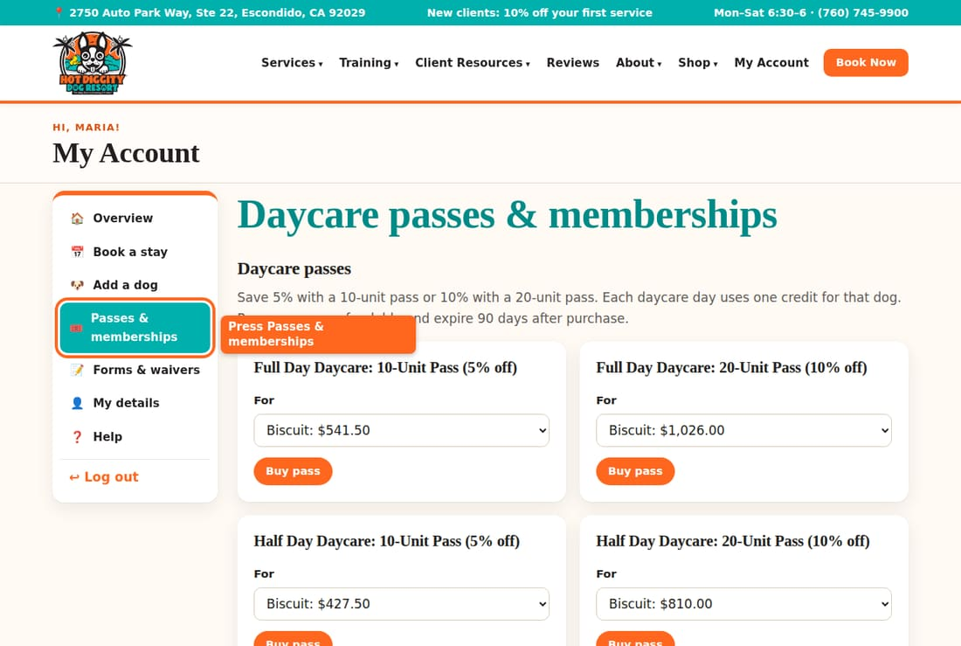
- Find the pass you want.
- Under For, pick your dog. The price for that dog shows next to the name.
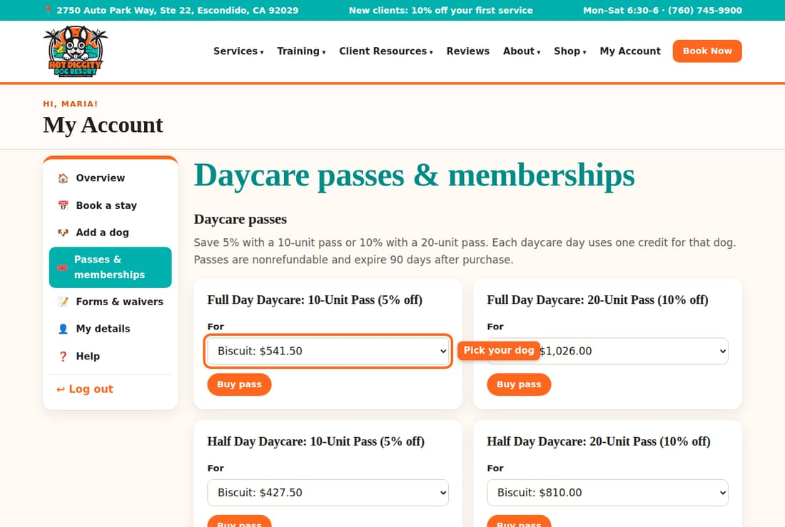
- Press Buy pass.
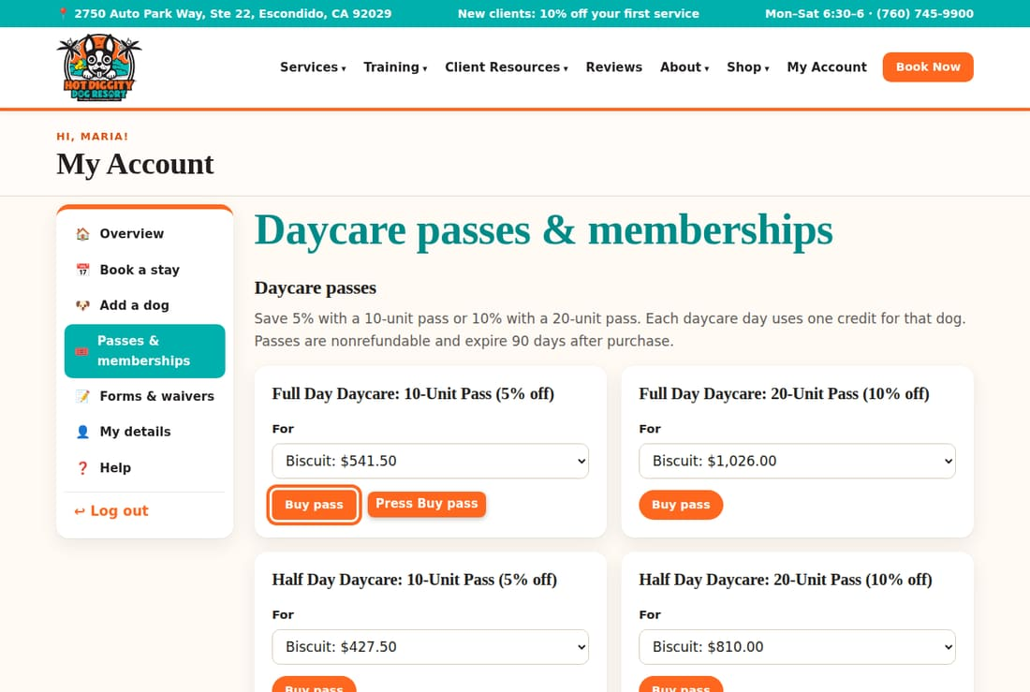
- A safe card page opens. Type your card and pay.
- Your pass shows under What you have. It says how many days are left.
Tip: It says "(add weight first)" next to your dog? Add your dog's weight on the dog's page. The price depends on it.
Tip: See "Online payment isn't set up yet"? Buy your pass at the front desk, or call us.

Join L.E.E.P. Monthly
L.E.E.P. Monthly is $50 a month. It renews on its own each month until you cancel.
- On Passes & memberships, find Memberships.
- Under For, pick your dog.
- Read the Automatic renewal terms. They say what you pay and when.
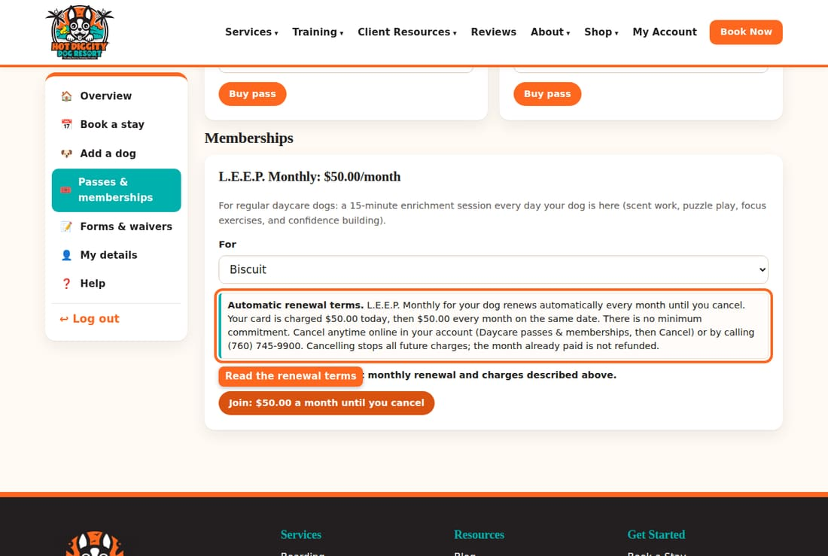
- Check I agree to the automatic monthly renewal and charges described above.
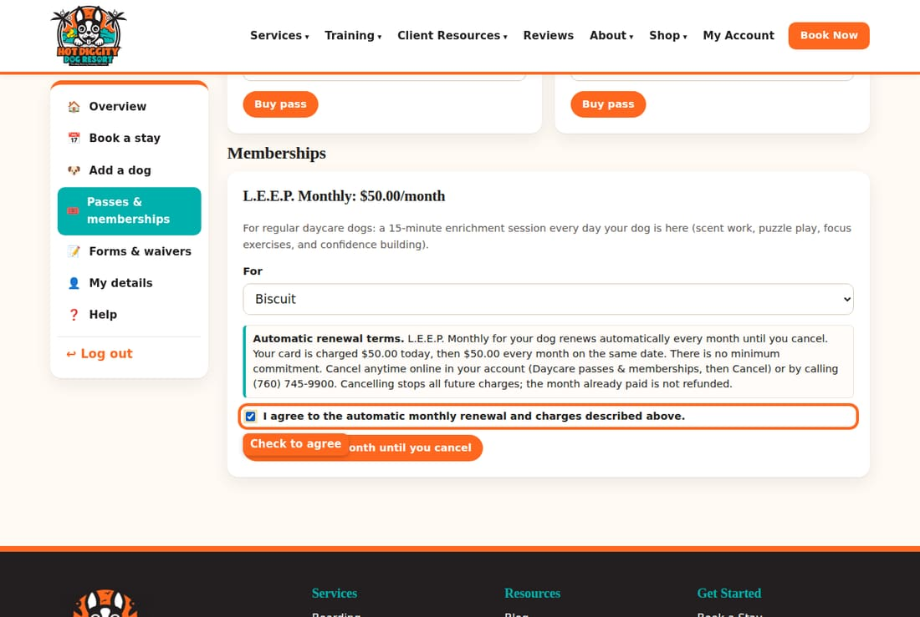
- Press Join: $50.00 a month until you cancel.
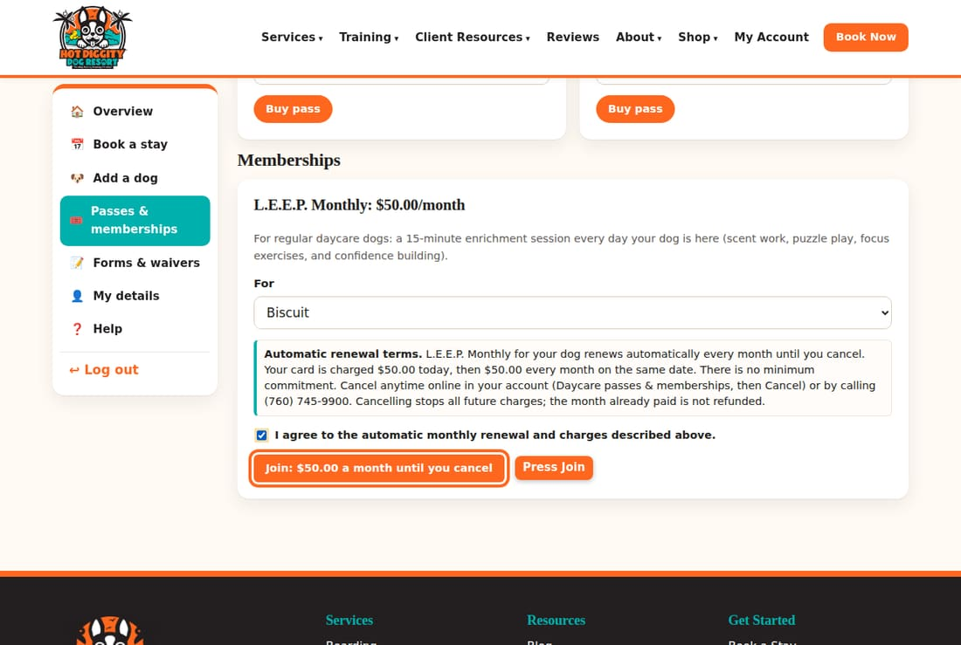
- A safe card page opens. Type your card and pay.
Good to know: Your card is charged today. Then it is charged again every month on the same date. There is no minimum time. You can cancel anytime.
Good to know: Canceling stops all future charges. The month you already paid is not refunded.
Good to know: Once a year, we email you a reminder of the terms. The law asks us to.

Cancel L.E.E.P. Monthly
- Log in. Press Passes & memberships.
- Find your membership under What you have.
- Press Cancel.
- You see "Your membership is canceled. No further charges."
Tip: You can also cancel by calling us.

Set up auto-pay
Were you a L.E.E.P. member before we switched systems? You may need to set up auto-pay.
- On Passes & memberships, look under What you have.
- If you see Set up monthly auto-pay, read the terms.
- Check the I agree box.
- Press Set up monthly auto-pay. Then add your card.
- Your card is not charged until the month you already paid runs out. The page tells you the date.
Stuck? Call us at (760) 745-9900.

Watch the webcams
Peek in on your dog while they play or stay with us.
You can watch our daycare floor and boarding suites. Use any phone, tablet, or computer. There is no app to get. The cameras have their own login. Your website login won't work there.

Steps
- Log in. On My Account, find Watch the webcams.
- Read the login help in that box.
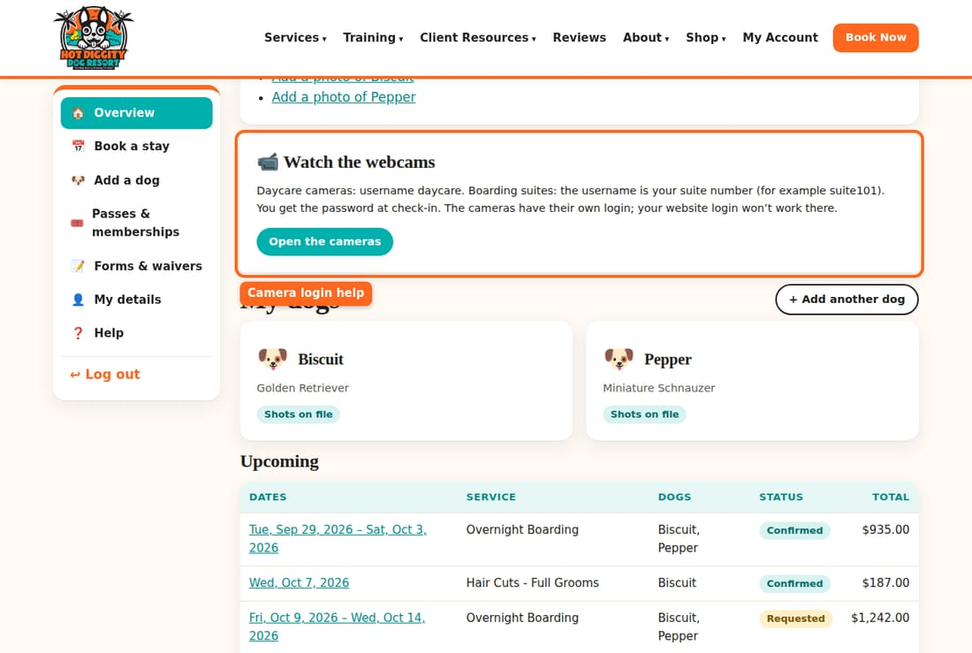
- While your dog is checked in, the box shows the camera username and Password. At other times, it tells you how the login works.
- Press Open the cameras. The camera page opens.
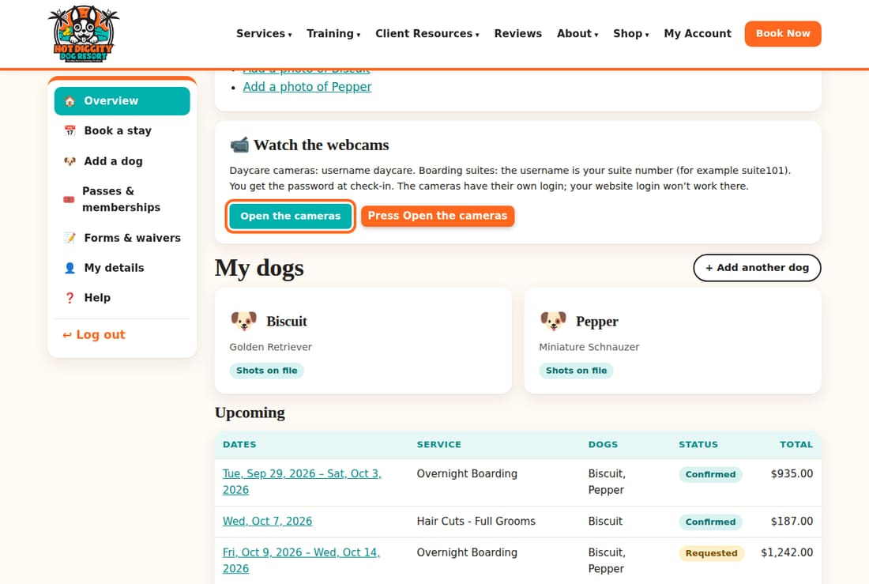
- Type the camera username and password. Then watch!

Which username?
- Daycare: the username is daycare.
- Boarding: each suite has its own. The username is your suite number, like suite101.
- You get the password at check-in. While your dog is here, it also shows in your account.
Tip: You can also find the cameras from our Webcams page. Press Get your camera login to go to your account.
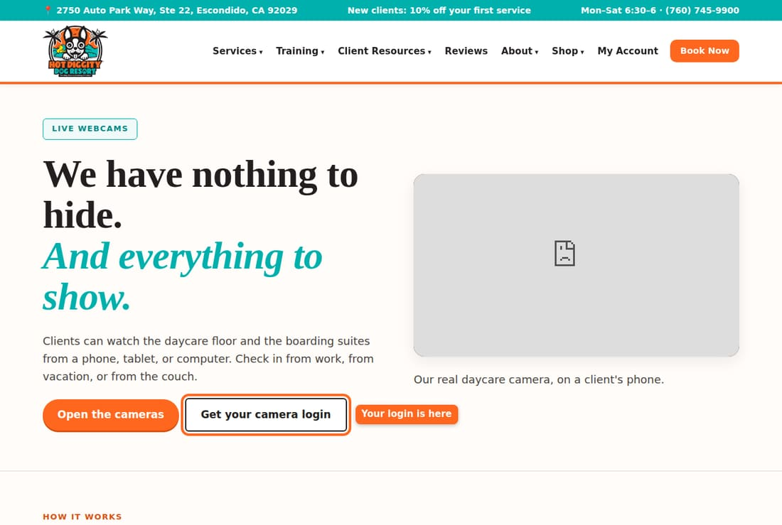
Good to know: The cameras don't mean staff are here at night. Our team is here Monday to Saturday, 6:30 am to 6:00 pm.
Good to know: Crates do not have cameras. You may not see your dog every minute. Want a quick check? Call the front desk.
Tip: The camera won't load? Try a different browser. Or turn Wi-Fi off and on.
Stuck? Call us at (760) 745-9900.

Text messages
What texts we send, how to answer them, and how to turn them on or off.
We can send you text messages about your dog. Texts are your choice. You still get emails if you say no to texts. Texts come from Hot Diggity Dog Resort.

Texts you may get
- You're booked: when you book online and it is confirmed right away.
- Confirmed: when we confirm your request.
- Reminder: the day before a visit, about 24 hours ahead. We only text between 8 am and 8 pm.
- Shot reminder: when a shot will run out soon.
- Almost ready: about 20 minutes before a groom is done.
- Ready for pickup: when your dog is all done.
- Spot open: when a groom spot opens for your waiting list day.
- Report card: how your dog's day went.
- Thanks for visiting: after your dog goes home.
- Now and then, a note that it is time for the next groom.
- Replies from our front desk when you text us.

Answer the 20-minute grooming text
- About 20 minutes before your dog's groom is done, we text you. It asks you to reply C.
- Reply with just the letter C.
- That tells our groomer you got it. Then head our way!
Tip: Don't reply C? We may call you to make sure you know.

Text words that do special things
- Text STOP to stop all texts from us.
- Text START to turn texts back on.
- Text HELP for help.
Good to know: A text that says only CANCEL also stops all texts. It does not cancel your booking! To cancel a booking, use the website or call us.
Tip: Any other text you send goes to our front desk. We text you back from there.

Turn texts on or off on the website
- Log in. Press My details in the menu.
- Scroll down to the box that starts with Text me booking confirmations, reminders, and pickup notices.
- Check it to get texts. Uncheck it to stop texts.
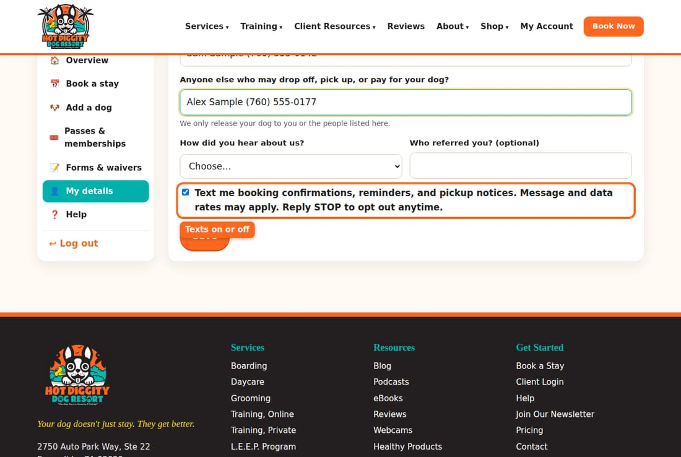
- Press Save.
Good to know: Texts go to the Mobile phone on My details. Check that the number is right.
Good to know: Message and data rates may apply. How many texts you get depends on how often you visit.
Stuck? Call us at (760) 745-9900.

Change your details or your dog's info
Keep your phone, emergency contact, photos, and dog info up to date.
Keep your info up to date. It helps us reach you fast. It also speeds up check-in.

Change your details
- Log in. Press My details in the menu.
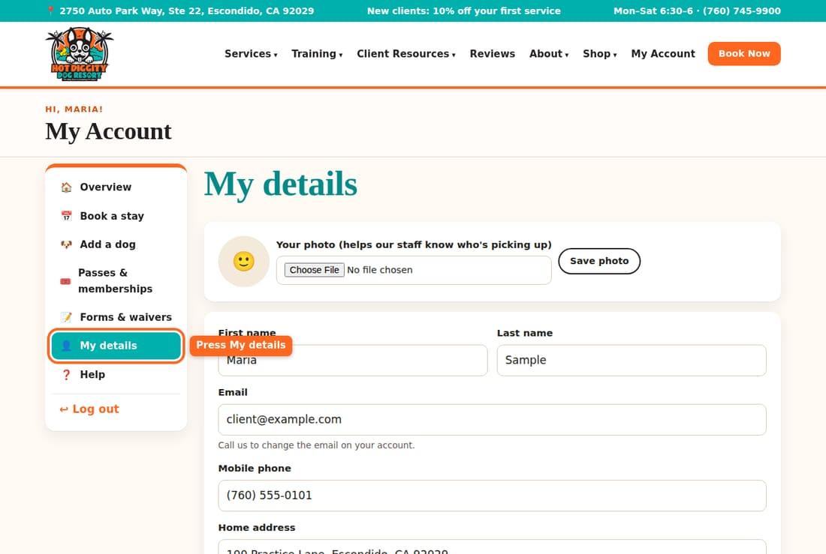
- Change your First name, Last name, or Mobile phone.
- Add your Home address and Other phone (home or work).
- Add an Emergency contact (name and phone).
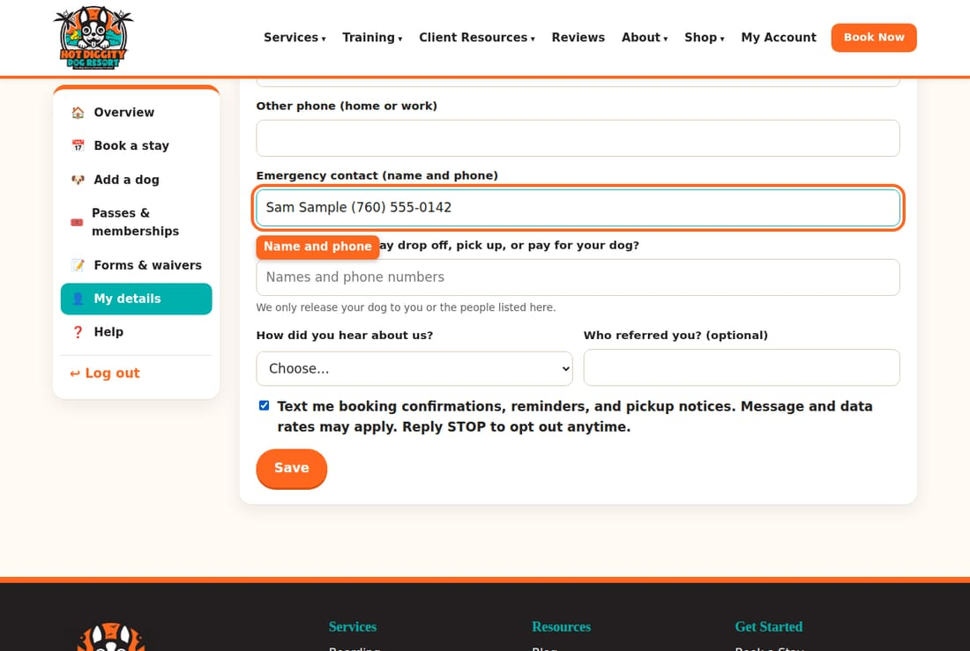
- In Anyone else who may drop off, pick up, or pay for your dog?, list names and phone numbers.
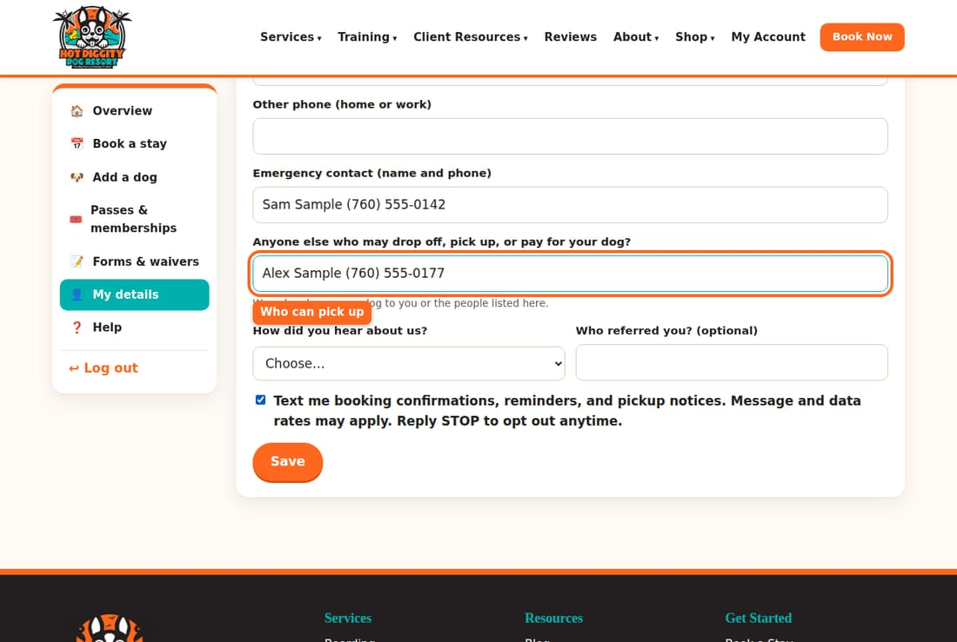
Good to know: We only let your dog go home with you or the people on this list.
- Press Save.
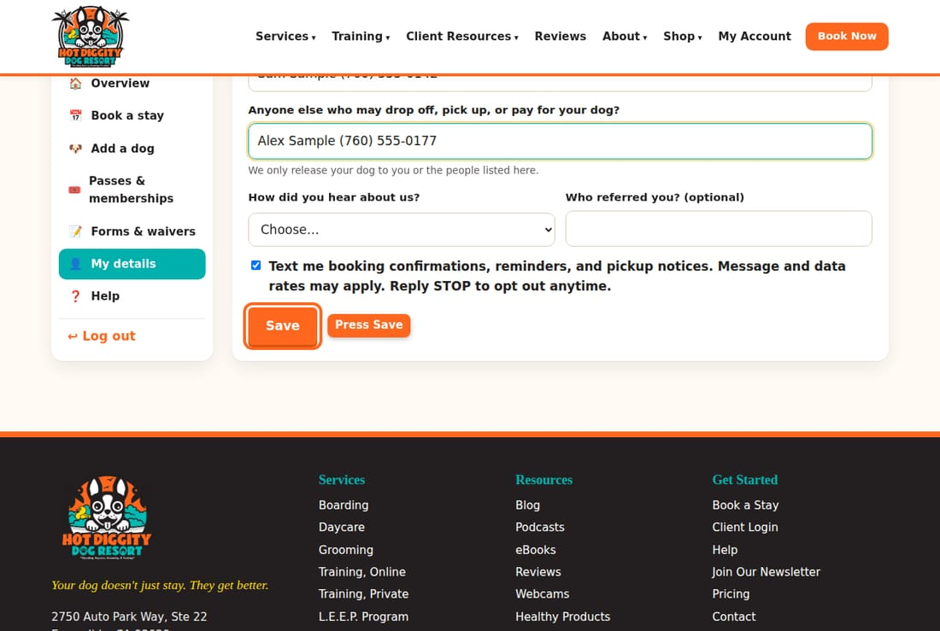
- You see "Saved."
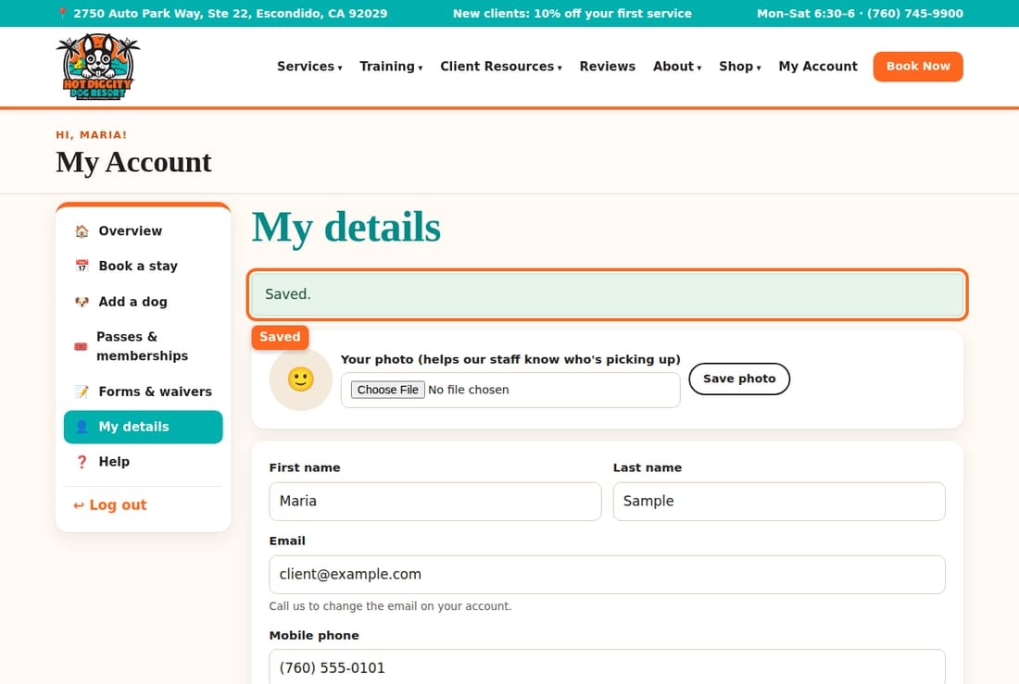
Good to know: You can't change your email here. Call us to change the email on your account.

Add your photo
A photo of you helps our team know who is picking up.
- On My details, find the photo box at the top.
- Press Choose File. Pick a photo of your face.
- Press Save photo.
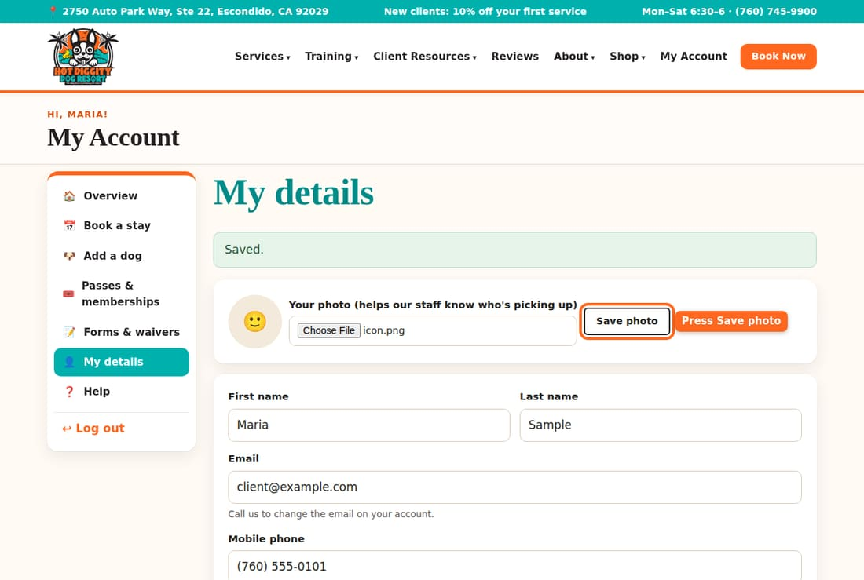

Change your dog's info
- On My Account, press your dog's name under My dogs.
- Scroll down to About your dog.
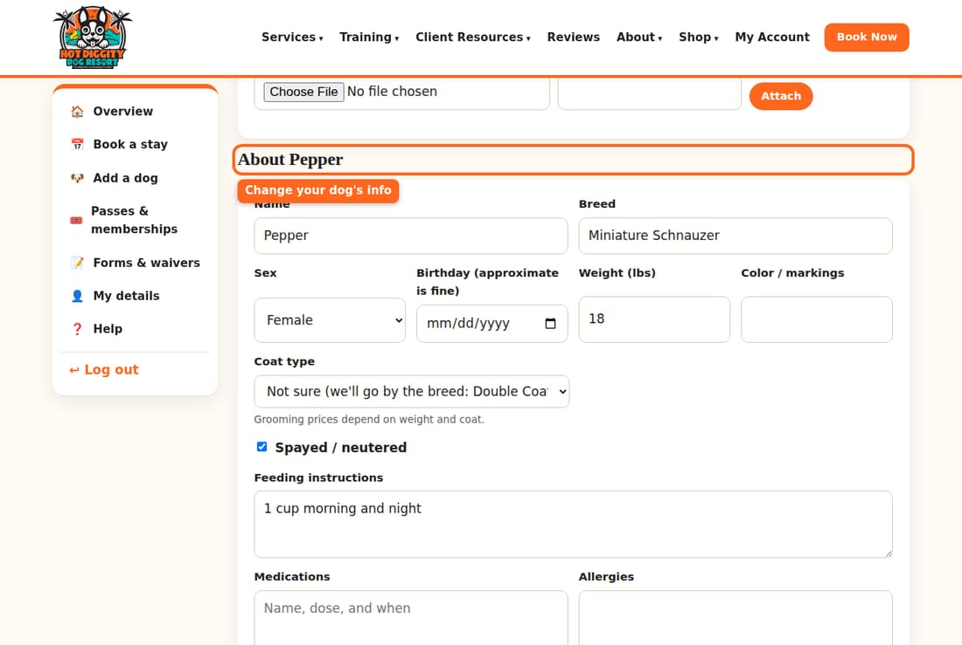
- Change what you need. Weight, food, medicine, and vet are all here.
- Press Save changes.
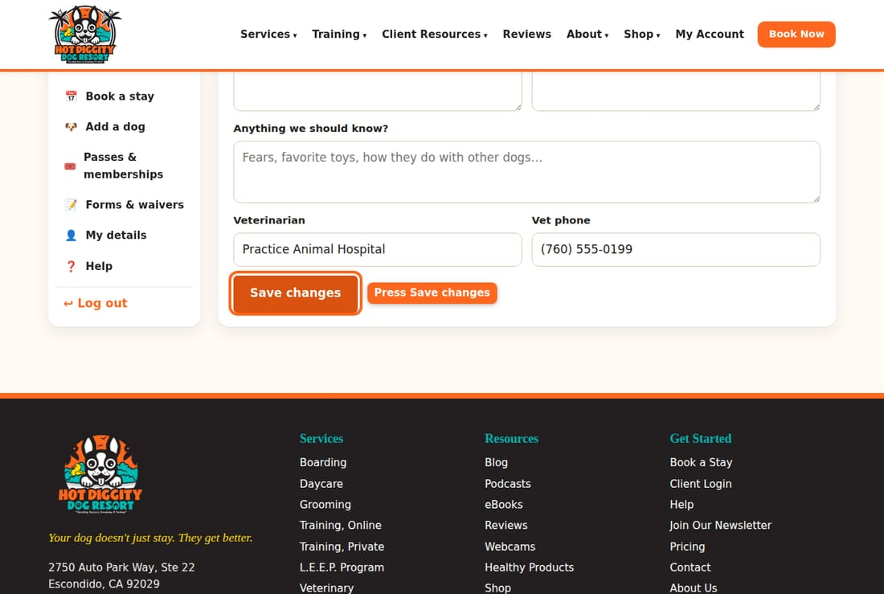
Tip: Update the weight when your dog grows. Prices depend on it.

Add your dog's photo
- Open your dog's page.
- At the top, next to Add a photo, press Choose File.
- Pick a photo of your dog.
- Press Save photo.
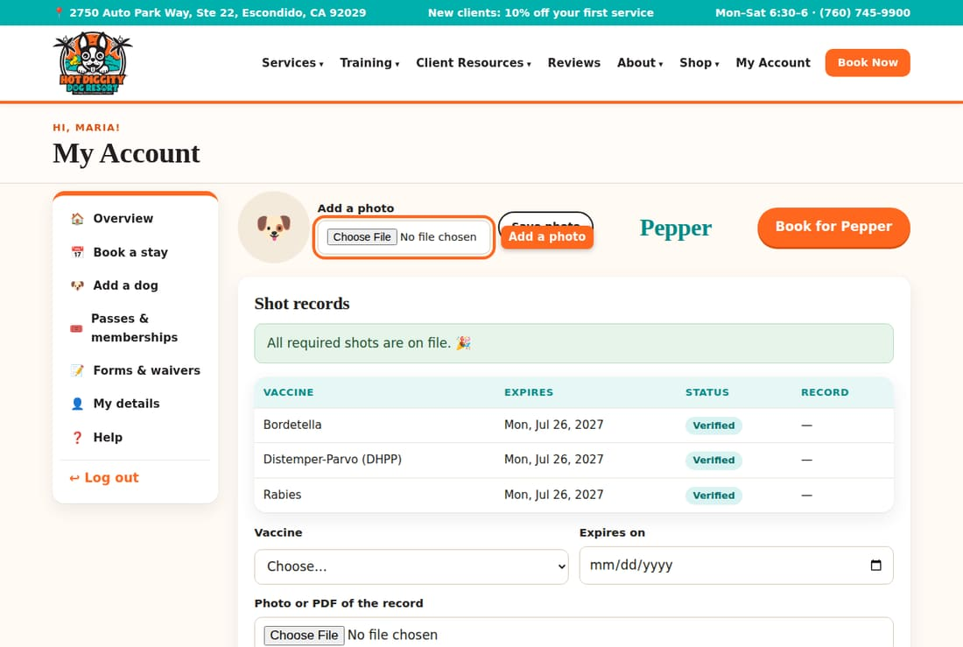
Good to know: There is no button to remove a dog. Did a dog pass away or move? Please call us, and we will take care of it.
Stuck? Call us at (760) 745-9900.

Coming from the old system
Used our old booking system? Here is how to get in and what moved.
We moved from our old system, EasyBusy, to this new website. Good news: you do not need to start over. Your account and your dogs came with you. You just need to make a new password the first time.

What came over
- Your name, phone, and address.
- Your dogs.
- Your dogs' shot records.
- Your signed waivers.
- Your upcoming bookings.
- Your visits from about the past year.
- Your daycare pass days that are left.
- Your L.E.E.P. Monthly membership.
Good to know: Please check it all! Look at your dogs, shots, and bookings. If something is wrong or missing, call us. We will fix it.

Log in the first time
Your old password did not come over. You make a new one. It takes two minutes.
- Go to our website. Press Log In at the top. On a phone, tap Menu first.
- Under the Log in button, press Forgot password, or first time since we switched systems?
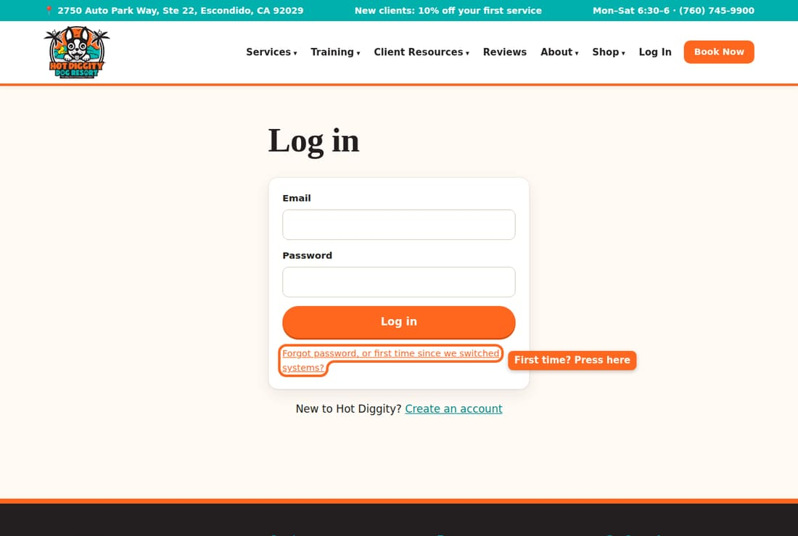
- Type the email you used with us before.
- Press Send me a link.
- Open your email. Look for a note from Hot Diggity Dog Resort. Check your spam folder too.
- Press the link in the email. It works for 2 hours.
- Type a New password. Use at least 8 letters or numbers.
- Press Save password.
- You are in! You see "Password set. Welcome back!"
Tip: Did you try to log in or sign up first? You may see "Your account came over from our old system." That is normal. You are on the right page. Just type your email and press Send me a link.
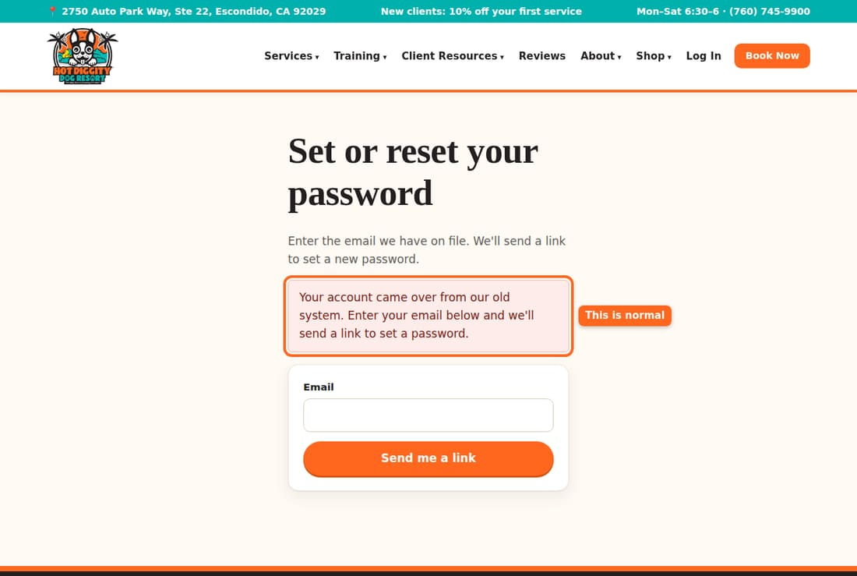
Good to know: Please don't make a second account. Use the same email as before. Then your dogs and records stay together.
Tip: No email came? We may have a different email for you. Call us, and we will check.

What is new or different
- Book online yourself. Daycare, boarding, grooming, and vet visits are all under Book a stay.
- Instant booking. Daycare and boarding can book right away if your dog came in the last 6 months. Otherwise, it is a request that we confirm.
- Pick your groom time. You see open times with our groomers and pick one.
- Forms online. Sign the waiver and forms on the site. See Sign forms.
- Shot records. Upload a photo from your phone. See Upload shot records.
- Price before you book. The booking page shows an estimated total.
- Webcam login. It is on My Account now, not on a public page.
- Texts. You can turn texts on or off in My details.
- L.E.E.P. Monthly is paid by card each month now. You may need to press Set up monthly auto-pay. See Daycare passes and L.E.E.P. Monthly.

Things to check after you log in
- Open My Account. Look at Finish your profile. Do the items there.
- Look at each dog under My dogs. Check the name, weight, and shots.
- Look at Upcoming. Make sure your bookings are right.
- Open My details. Check your phone and emergency contact. Check the text box too.
- Open Passes & memberships. Check your pass days and membership.
Stuck? Call us at (760) 745-9900.

Order from the shop
Order products online and pick them up at the front desk.
Our shop has treats, toys, gear, and more. You order and pay online. Then pick up your order at the front desk. Online training courses come by email.

Steps
- Press Shop at the top of the website. Then press Shop in the list.
- Scroll to In-store products.
- Found something you like? Press Add. Some items let you pick a size or color first.
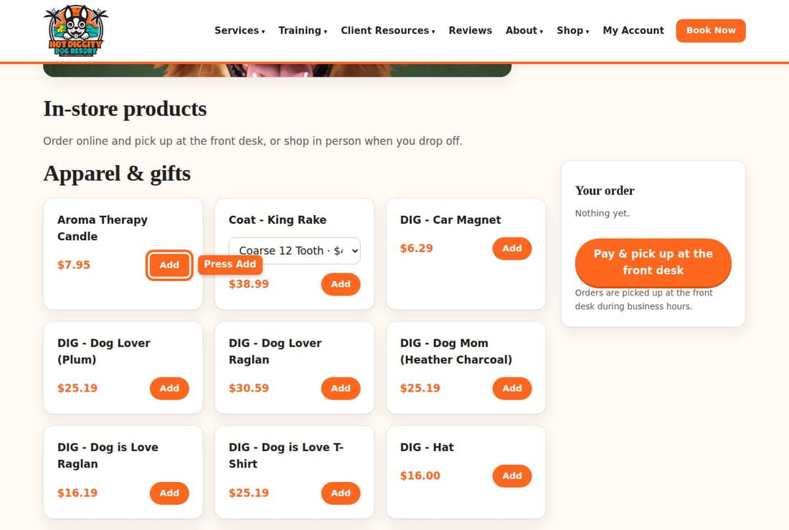
- Your items show in Your order. Press × to take one out.
- Not logged in? Press Log in to order.
- Press Pay now, pick up at the front desk. You pay by card first.
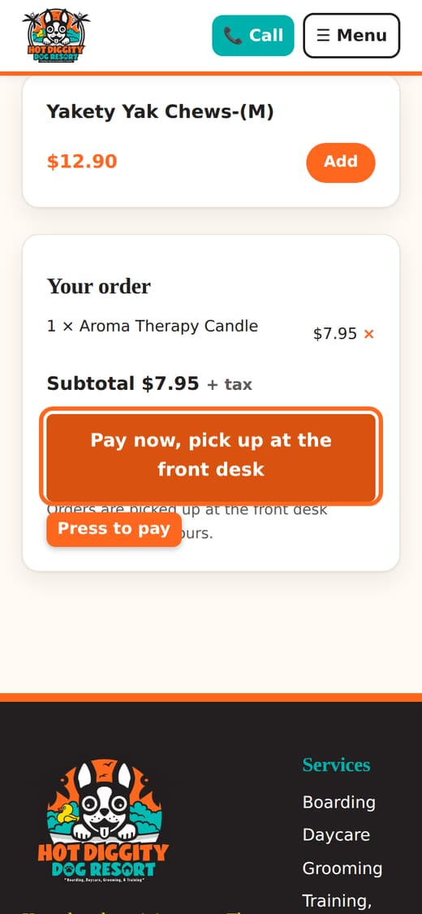
- A safe card page opens. Type your card and pay.
- You come back to the shop. It says your order is paid.
- Pick up your order at the front desk during business hours.
Good to know: You pay online first. The button says "at the front desk" because that's where you pick it up.
Tip: See "Online ordering isn't open yet"? Call us, or shop at the desk when you drop off.
Tip: Some items say Buy on another store. Those ship to your home from that store.
Stuck? Call us at (760) 745-9900.

Ask about in-home training
Send Penny a note about private training in your home.
Penny offers private dog training in your home. It is for people who live in North San Diego County. Fill out a short form. We will reach out within 24 to 48 hours. This is just to ask. It does not book or charge anything.

Steps
- Press Training at the top of the website. Then press In-Home Training Inquiry.
- Fill in Full name, Email, and Phone.
- Check how you like us to reach you.
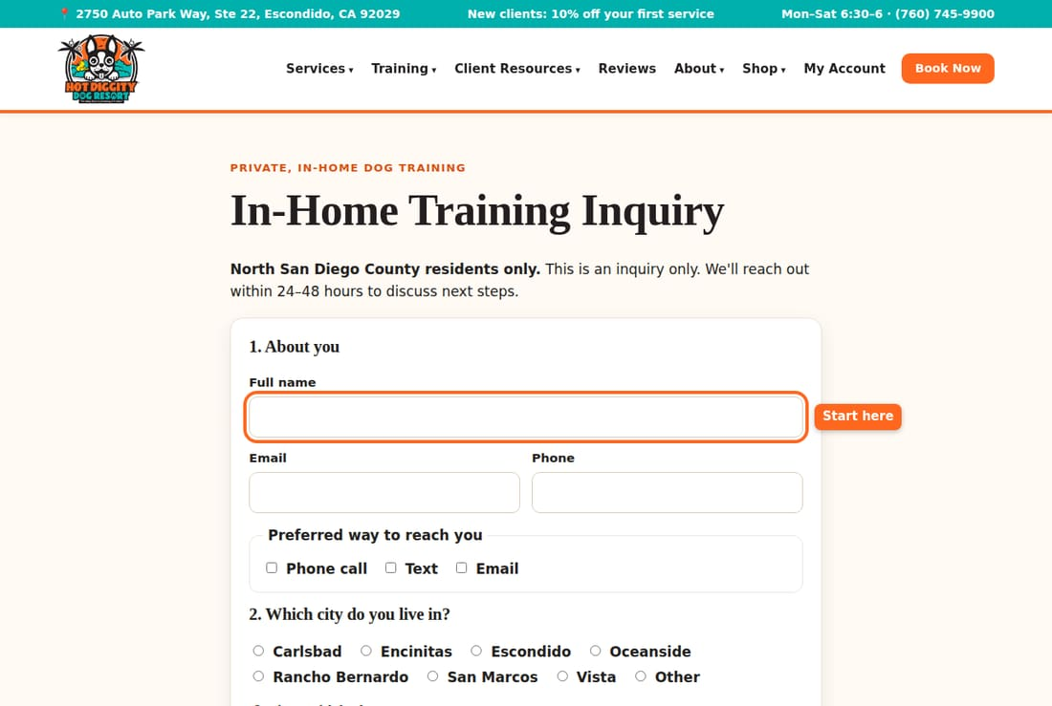
- Pick your city.
- Tell us about your dog: name, age, weight, breed, and sex.
- Check what you would like help with. Then tell us about your goals.
- Pick the days and times that work for you.
- At the bottom, check I confirm that I live in San Diego North County.
- Check I understand that training sessions are conducted in my home.
- Press Send inquiry.
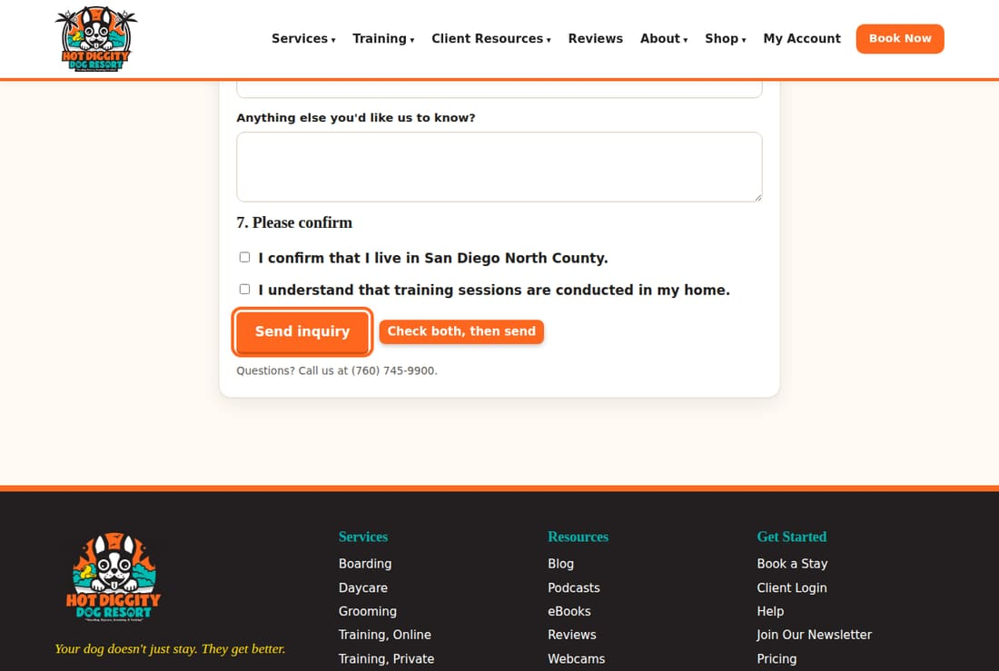
- You see "Thank you! We'll reach out within 24–48 hours."
Tip: You do not need to log in for this form.
Tip: Want to learn on your own? Penny also has online courses and eBooks in the shop.
Stuck? Call us at (760) 745-9900.

