Help for the Front Desk and Groomers
Hot Diggity Dog Resort · Front Desk guide · September 29, 2026

Start here
How to log in, find your way around the Front Desk, and read the red numbers.
Welcome! This is our new system. It takes the place of EasyBusy. You do all of your desk work on one website. This page shows you how to get in and where things are.

Steps
- Go to our website on the desk computer. Press Log In at the top.
- Type your work email and your password. Then press Log in.
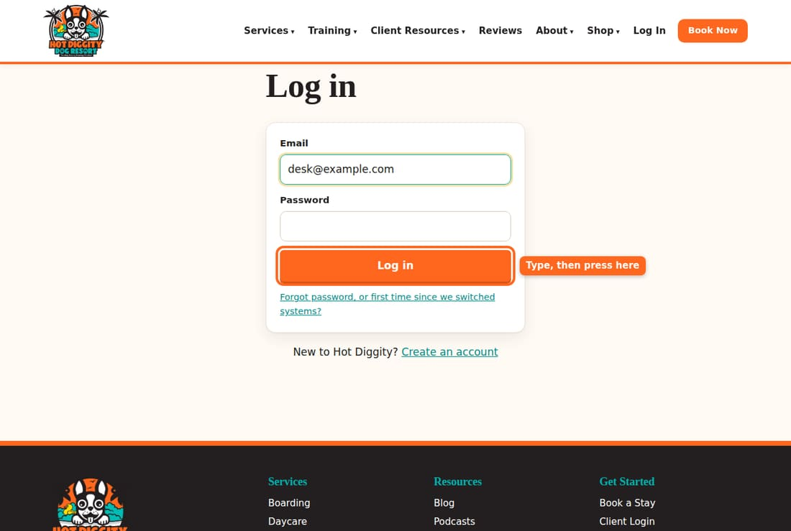
- Press Front Desk at the top of the page. You land on the Today page.
- Look at the menu on the left. It is the same on every Front Desk page.
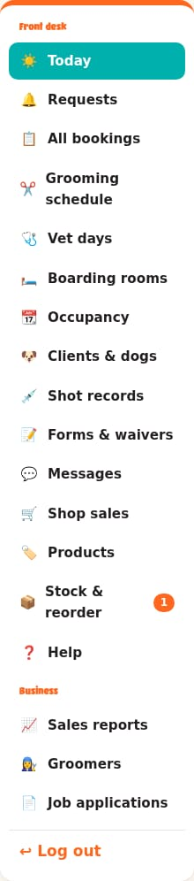
- Look for red numbers in the menu. A red number means there is work waiting. For example, the number by Requests is how many bookings need your answer.
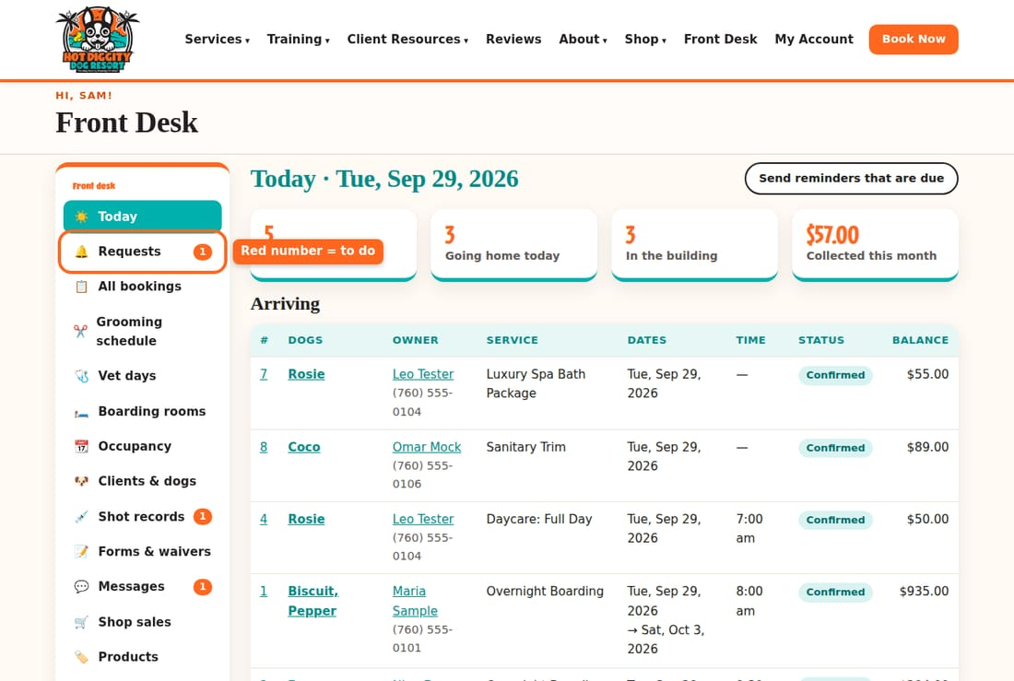
- Stuck? Press Help in the menu. Every guide is there.
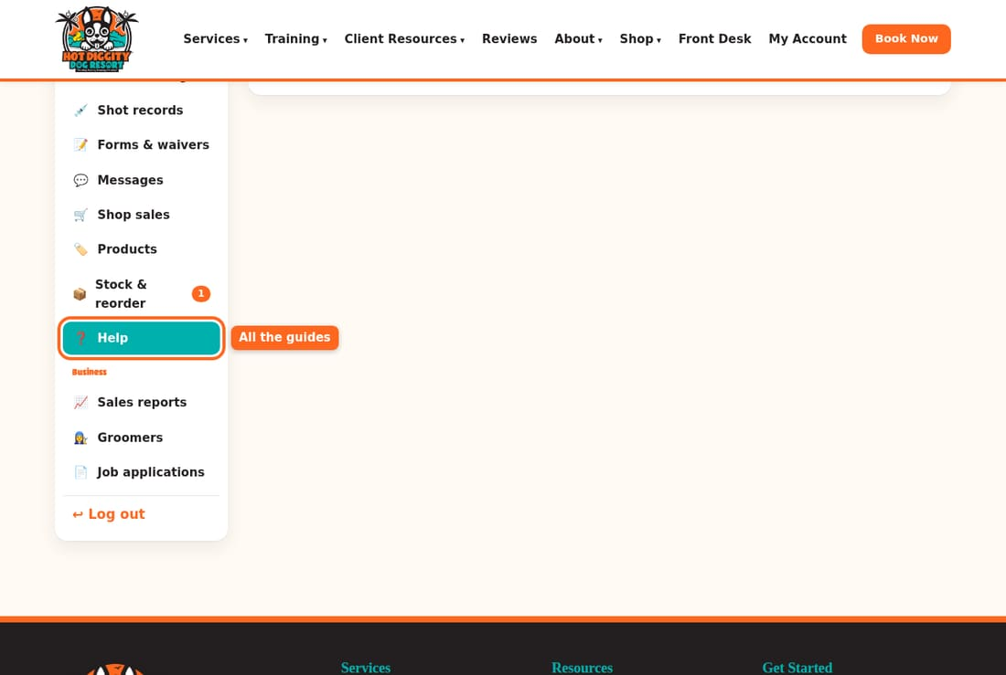
- When you leave for the day, press Log out at the bottom of the menu.

What each menu item is for
- Today: who comes in, who goes home, and who is here now.
- Requests: bookings you still need to say yes or no to.
- All bookings: find any booking. Search by owner, dog, or phone.
- Grooming schedule: the groomers' day, the 20-minute texts, and Done.
- Vet days: Dr. Moston's days and who is booked.
- Boarding rooms: which dog is in which suite each night.
- Occupancy: how full we are for the next six weeks.
- Clients & dogs: every owner and dog. Book for a client here.
- Shot records: new shot records to check.
- Forms & waivers: the forms clients sign.
- Messages: texts and emails with clients.
- Shop sales: ring up a sale at the desk.
- Products and Stock & reorder: what we sell and how many we have.
- Help: these guides.
- Sales reports: money we took in, and who still owes.
- Groomers: groomer hours and time off.
- Job applications: people who want to work here.

Red numbers
- Requests: bookings that need a yes or no.
- Shot records: new records a client sent us. Check them.
- Messages: new texts, plus notes from the website contact form.
- Stock & reorder: items that are low on the shelf.
- Job applications: new job forms.
Good to know: On a tablet or phone, the top menu turns into a Menu button. Press it to find Front Desk.
Good to know: Owners see a few more menu items, like Morning report. You don't need those.
If something goes wrong: Forgot your password? Press Forgot password, or first time since we switched systems? on the log in page. Still stuck? Ask David.

All the guides
- Your morning: the Today page
- Answer booking requests
- Check a dog in
- Check a dog out and take payment
- Book for a client at the desk
- Add a new client and dog
- Boarding rooms and suites
- The grooming schedule
- Groomers: the 20-minute text and Done
- Shot records
- Forms and waivers
- Messages and texts
- Shop sales
- Vet days
- Report cards and webcam logins
- Daycare passes and L.E.E.P.
- Cancel or change a booking
- End of the day
- Coming from EasyBusy
- Groomer hours and time off
- Temperament Assessment day
- Job applications

"Your morning: the Today page"
See who comes in, who goes home, and what needs your answer.
The Today page is your to-do list for the day. Open it first thing each morning. Come back to it all day.

Steps
- Press Today in the menu.
- Look at the four boxes at the top. They show how many dogs come in today, how many go home, how many are here now, and the money we took in this month.
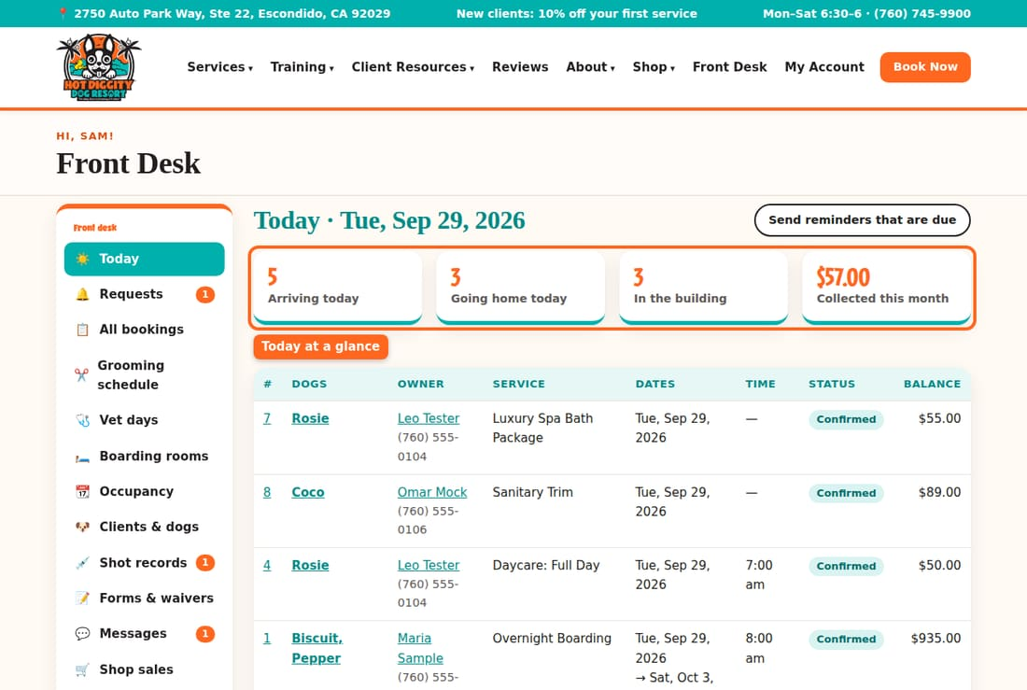
- Look at Arriving. These dogs come in today. The Time is when the owner said they will drop off.
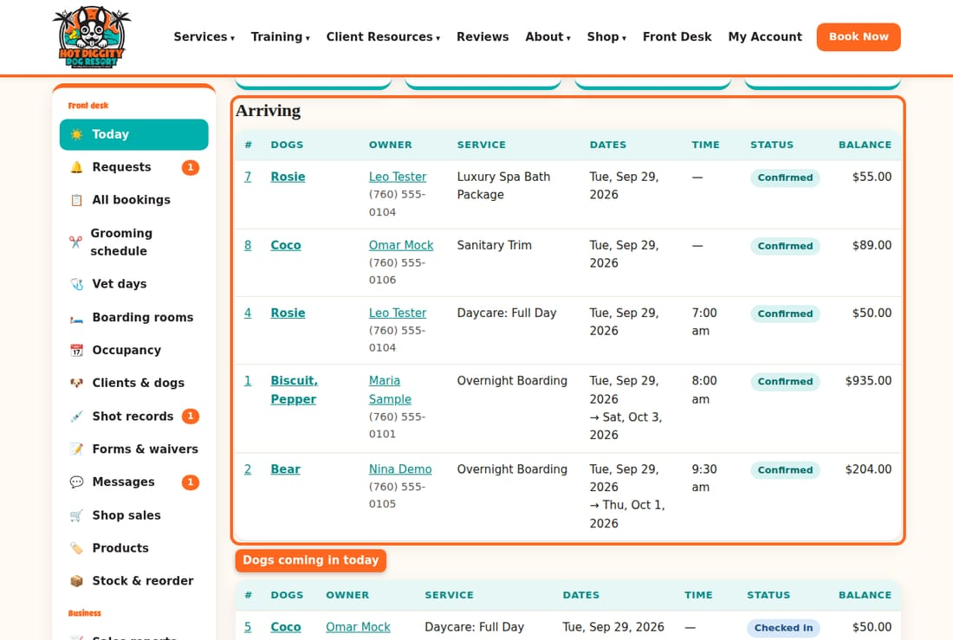
- Look at Going home. These dogs leave today. Check the Balance. That is what the owner still owes.
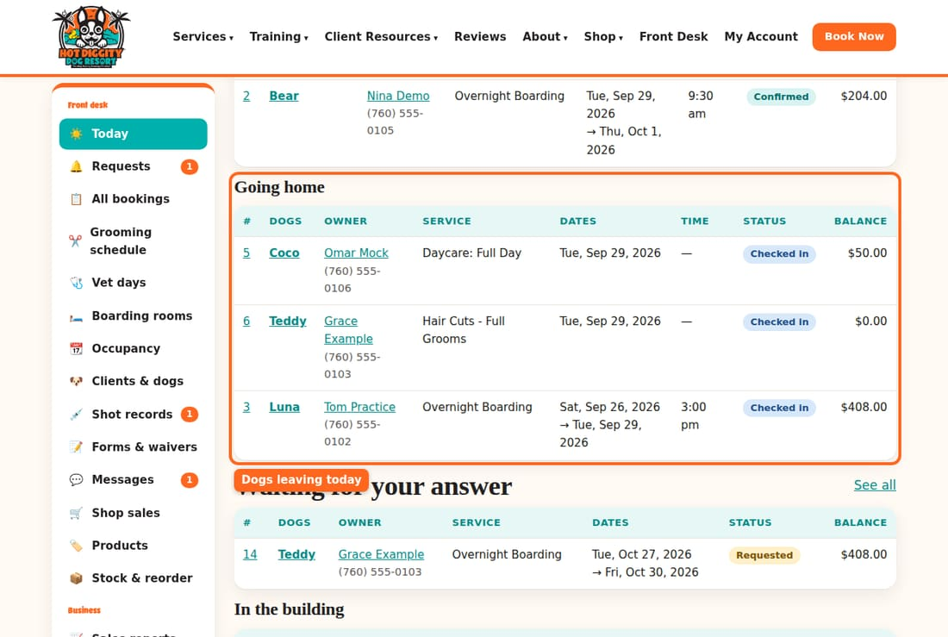
- Look at Waiting for your answer. These are requests. Answer them soon. See Answer booking requests.
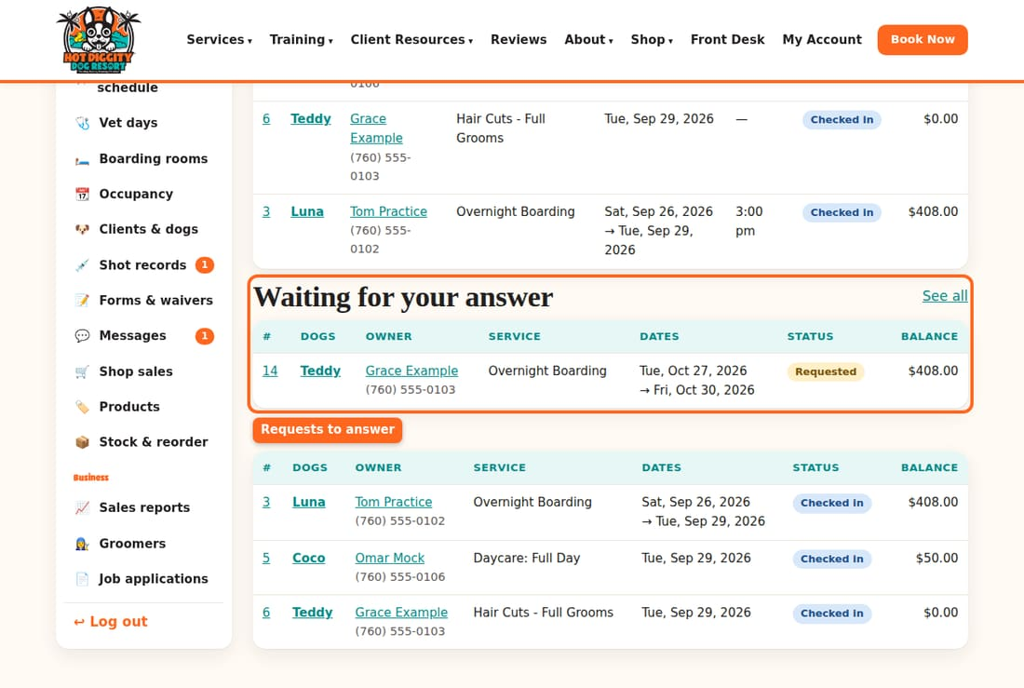
- Press Send reminders that are due once each morning. It sends the reminder emails and texts for coming visits. Anyone who already got one is skipped.
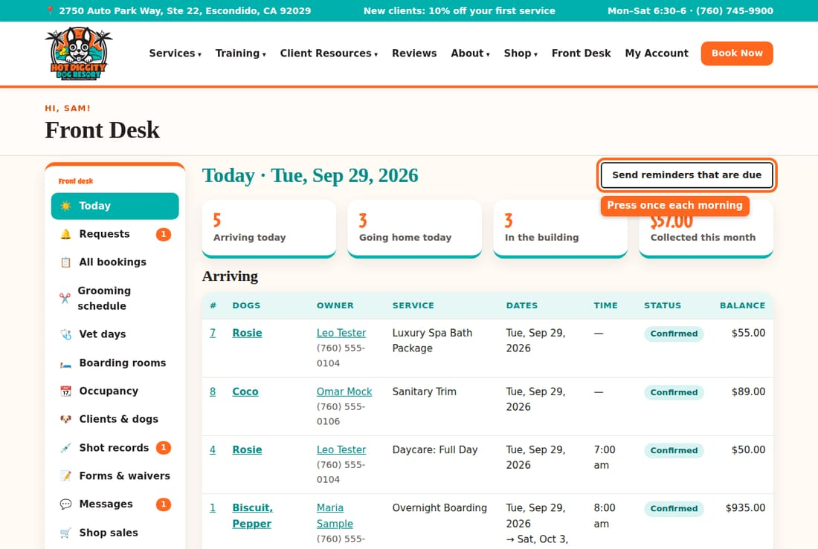
- To open a booking, press the dog's name.
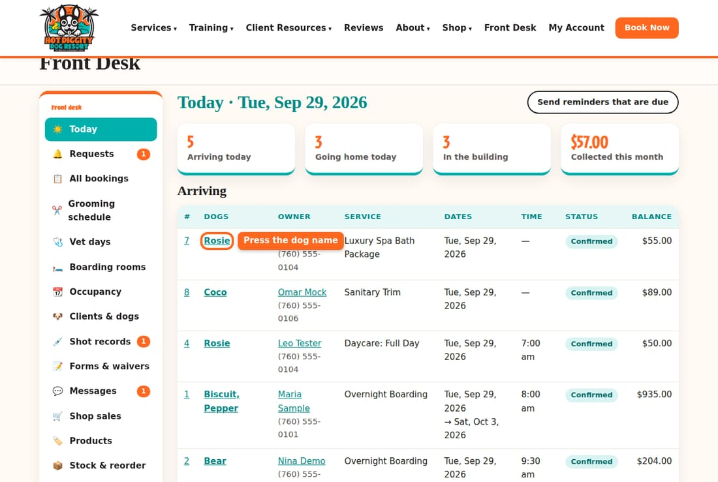

What else you may see
- In the building: every dog checked in right now.
- Shots expiring soon (booked dogs): a booked dog has a shot that runs out in the next two weeks. Call or text the owner. Ask them to upload the new record.
- A red box that says a dog is past the pickup date and still checked in. Find out why. Either check the dog out, or change the end date.
Tip: Press an owner's name to open their client page. Their phone number is right under the name.
Good to know: Grooms show up in Arriving too. The groomers work from the Grooming schedule.
Good to know: We open Monday to Saturday, 6:30 am to 6:00 pm. On Sundays and holidays, boarders only come or go by appointment, at 10 am or 4 pm.

Answer booking requests
Say yes (Confirm) or no (Decline) to a booking a client asked for.
Some bookings come in as a request. A request is not booked yet. You must say yes or no. The client gets a text or email either way.

Steps
- Press Requests in the menu. The red number shows how many are waiting.
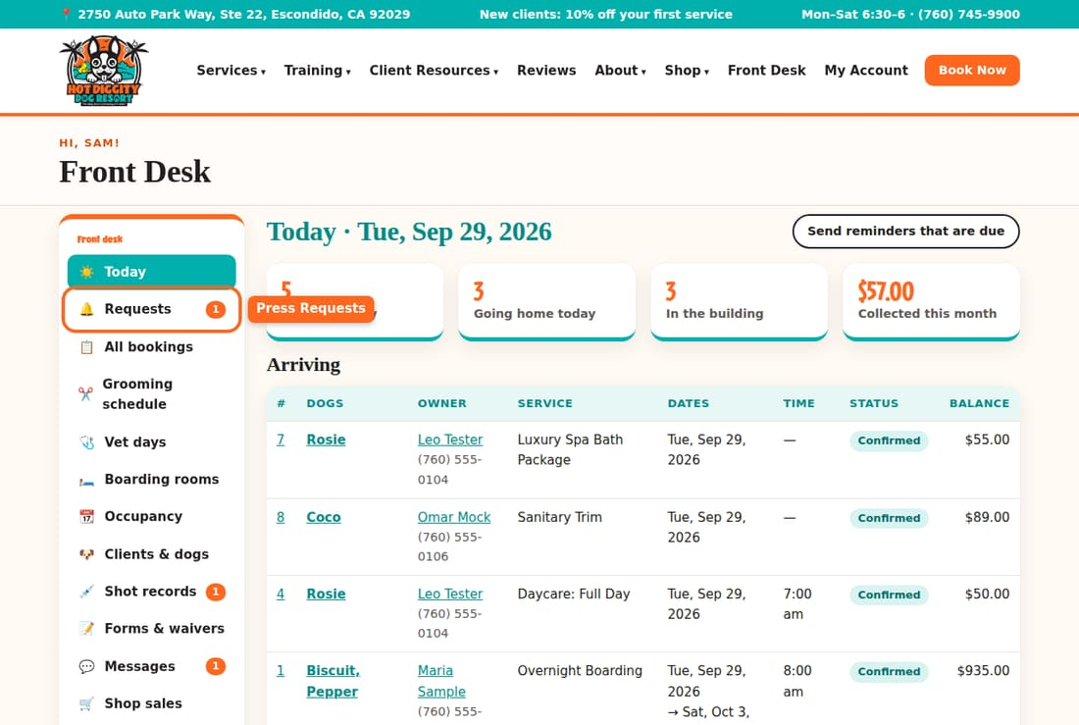
- Press the dog's name to open the request.
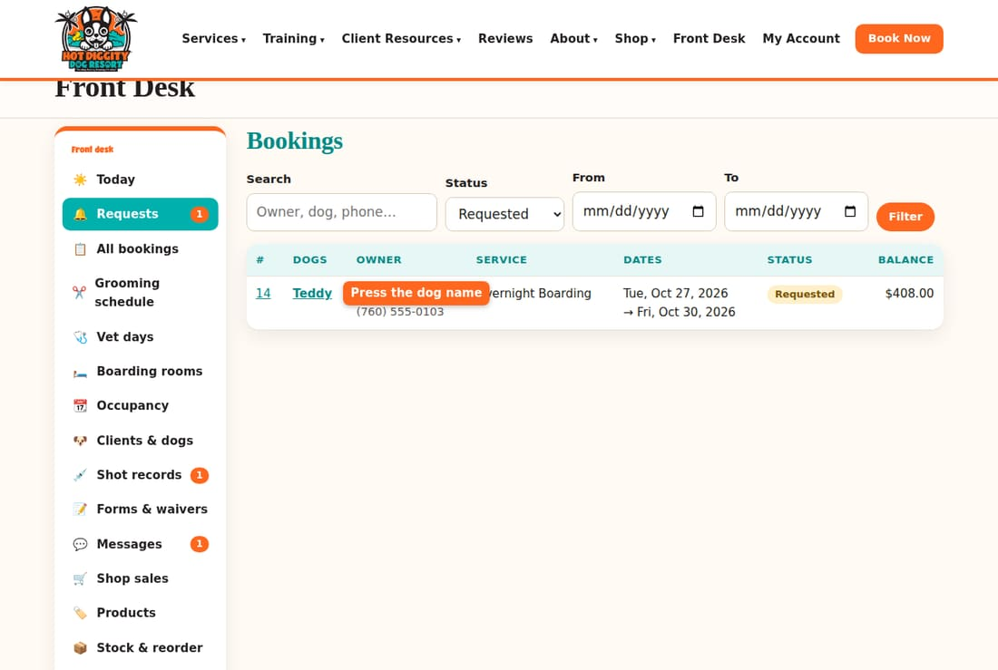
- Check the top. It says Requested. That means it is not booked yet.
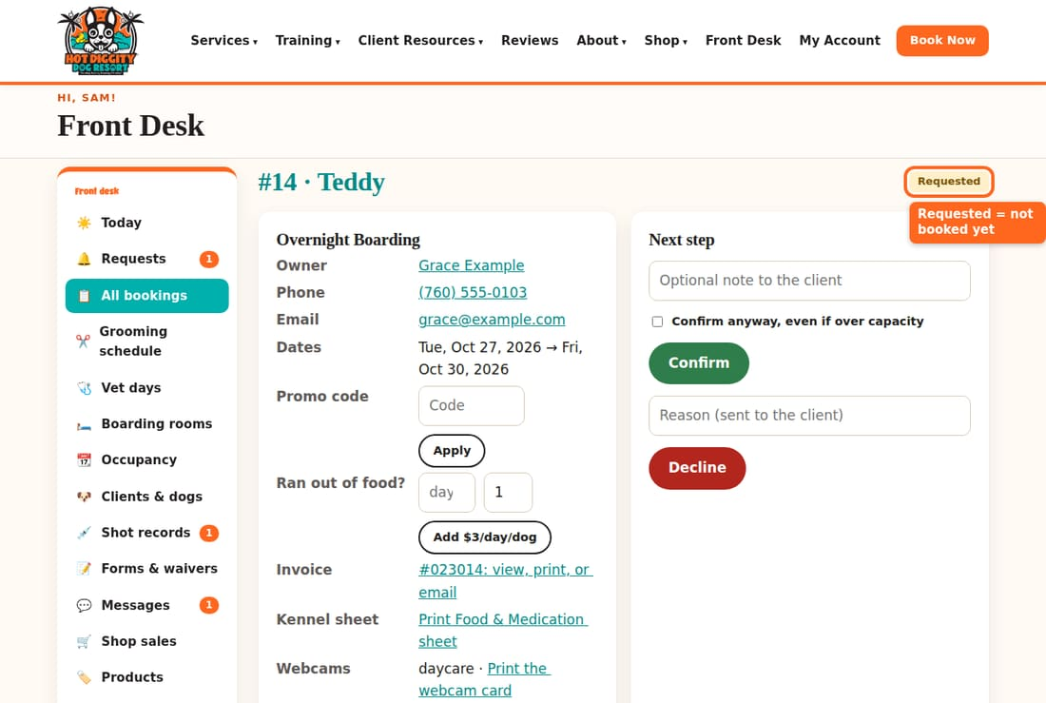
- Scroll down to Dogs on this booking. Check the colored boxes. Green means OK. Red means a shot is missing or out of date. Yellow means a shot is not checked yet, or the dog needs a Temperament Assessment.
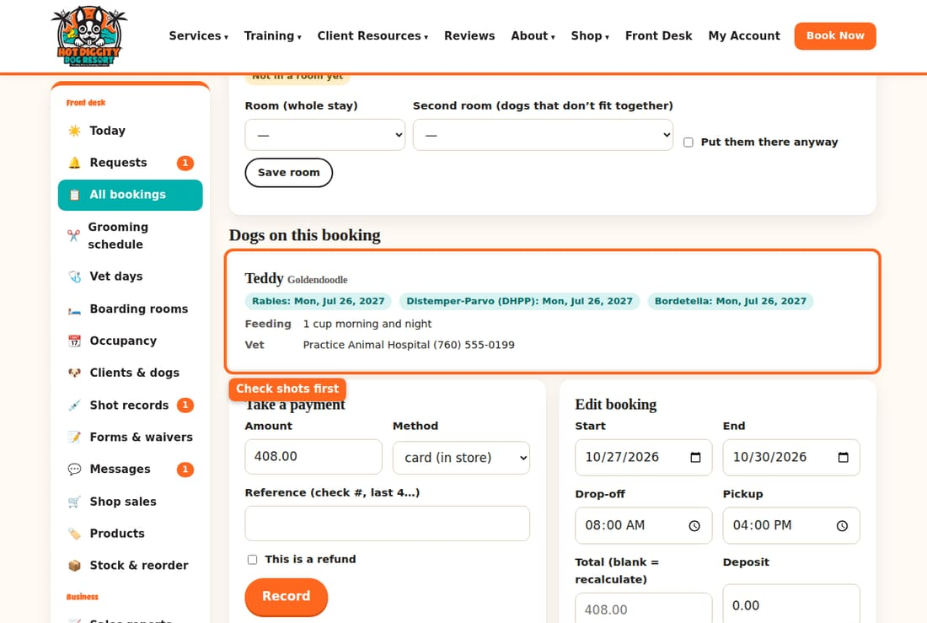
- To say yes, you may type a short note to the client. Then press Confirm.
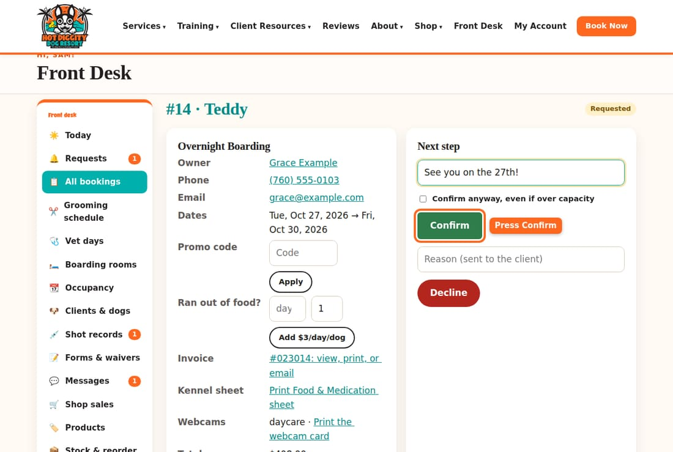
- To say no, type the reason in Reason (sent to the client). Then press Decline.
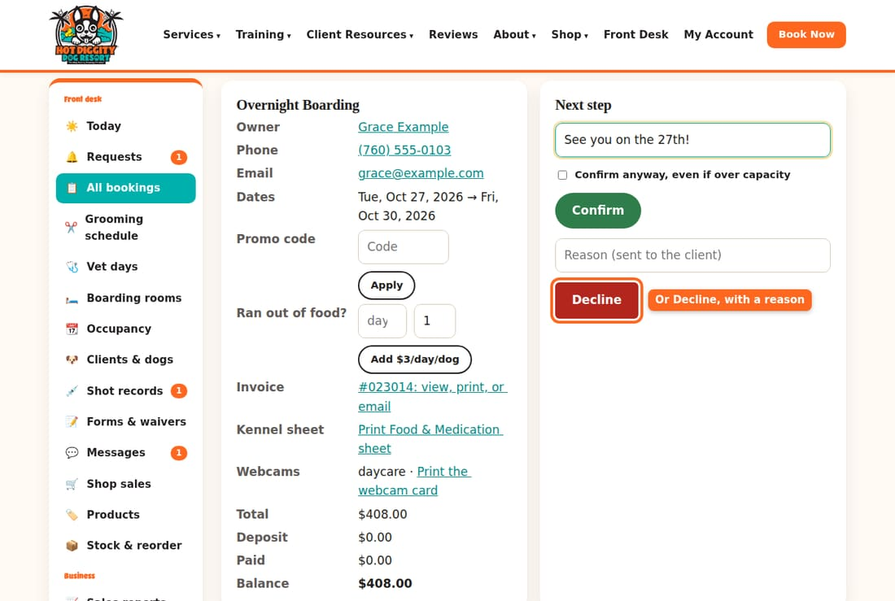
- Read the green box at the top. For boarding, it tells you which suite the dog got.
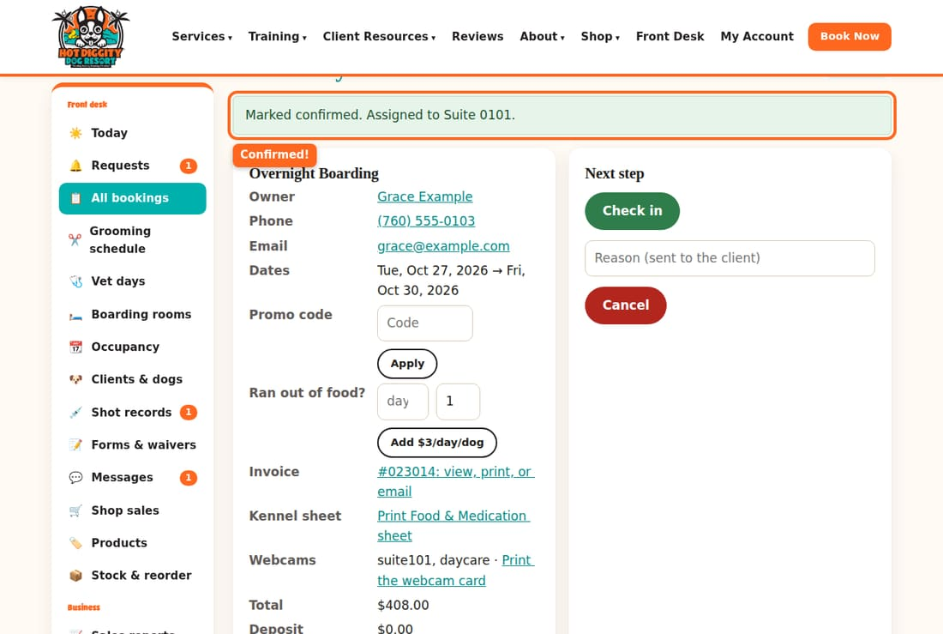

Why is it a request?
Daycare and boarding book right away online only when all of these are true:
- The dog passed the Temperament Assessment.
- The dog came to daycare or boarding in the last 6 months.
- For boarding, the suite is not shared with another family's dog.
If not, it comes to you as a request. Grooming can book online with no assessment.
Good to know: Never tell a client a request is "booked." It is only booked after you press Confirm.
Good to know: A dog needs Rabies, DHPP, and Bordetella on file before the first visit. A dog must be spayed or neutered before 8 months of age for daycare and boarding.
Tip: If the stay asked for a groom before pickup, it goes on the grooming schedule by itself when you confirm.
If something goes wrong: Does it say Over capacity? We are full that day. Ask David before you make room. If he says yes, tick Confirm anyway, even if over capacity and press Confirm again.

Check a dog in
Mark a dog as here when the owner drops off.
Check in every boarding and daycare dog when the owner drops off. Checked-in dogs show in In the building on the Today page.

Steps
- Press Today in the menu. Find the dog under Arriving. Press the dog's name.
- Scroll down to Dogs on this booking. Check the shot boxes. Green means OK.
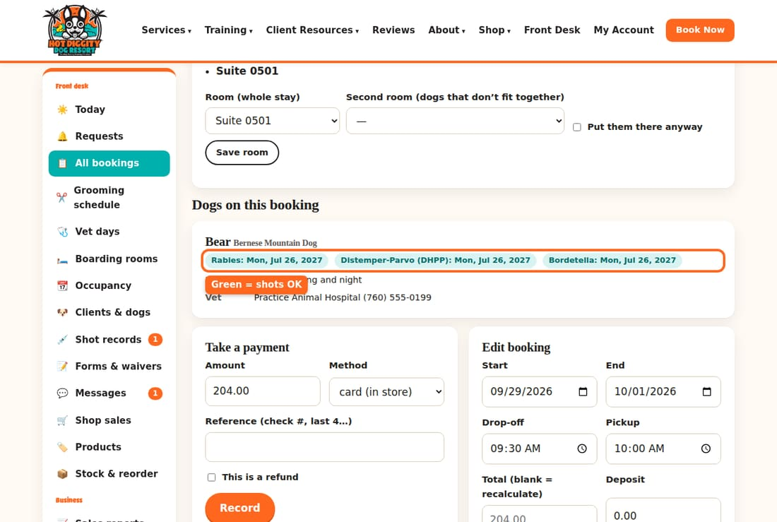
- Scroll back up. Under Next step, press Check in.
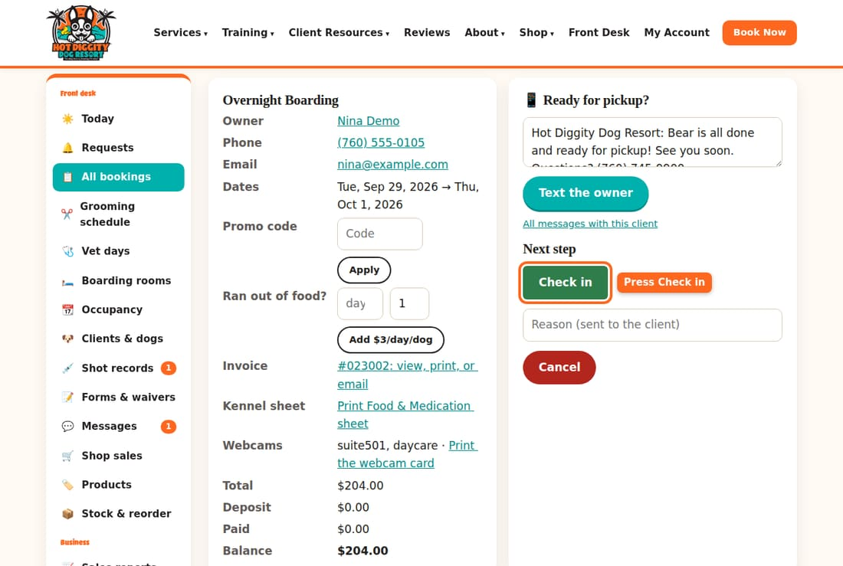
- Look for the green box at the top. It says Marked checked in.
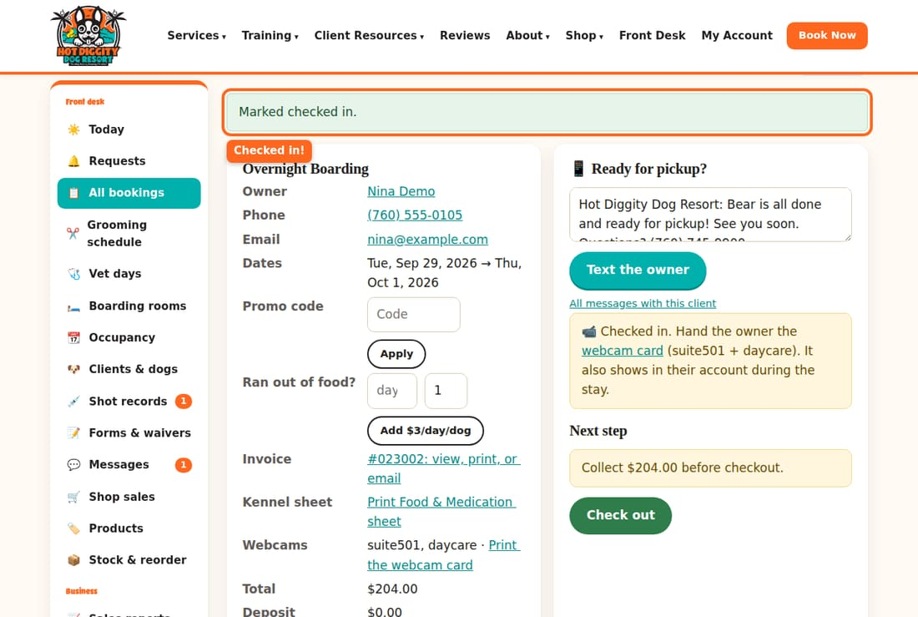
- For boarding, a yellow box tells you to hand the owner the webcam card. Press webcam card in that box.
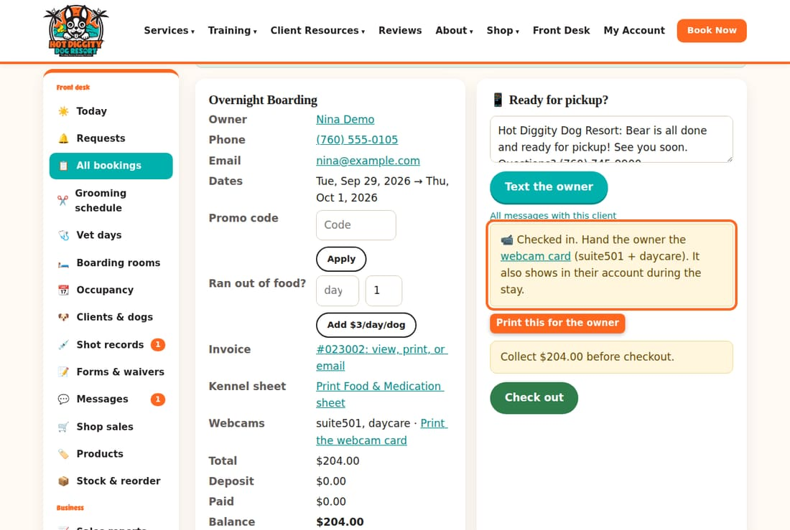
- Press Print the webcam card. Give the card to the owner.
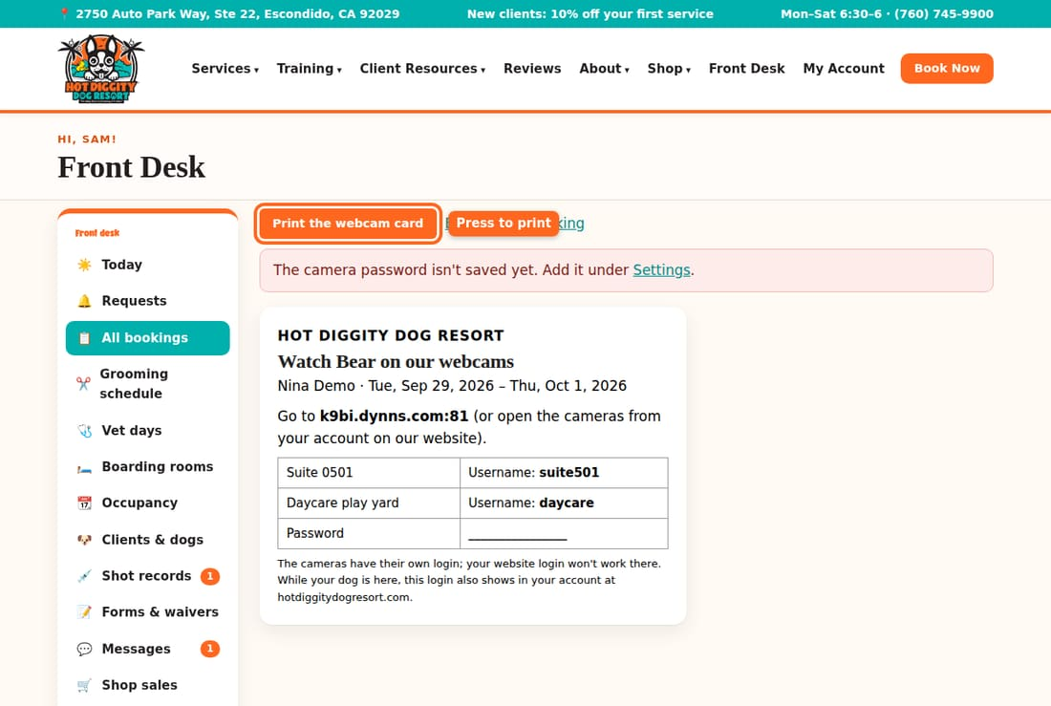
- For boarding, go back to the booking. Press Print Food & Medication sheet. Then press Print. Put the sheet with the dog's food.
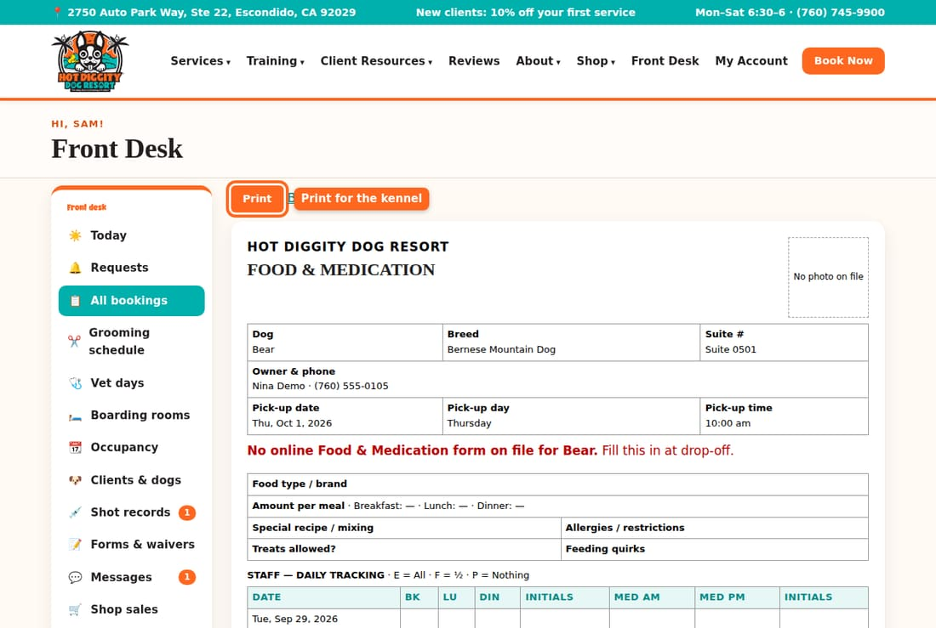
Good to know: A shot box can be red (missing or out of date) or say (unverified). Don't take the dog for daycare or boarding until the shots are OK. See Shot records.
Good to know: A yellow box that says Temperament Assessment needed means the dog has not passed yet. That dog can only come for a Temperament Assessment day. See Temperament Assessment day.
Tip: The Food & Medication sheet uses the owner's online form. If it says there is no form on file, fill it in by hand at drop-off.
Tip: Grooms don't need Check in. The groomer can still send the 20-minute text and press Done.
If something goes wrong: The webcam card shows only the daycare camera? The dog is not in a suite yet. Pick a suite first. See Boarding rooms and suites.

Check a dog out and take payment
Take the money, then mark the dog as gone home.
When an owner picks up, first take the payment. Then check the dog out. Do it in that order.

Steps
- Press Today in the menu. Find the dog under Going home. Press the dog's name.
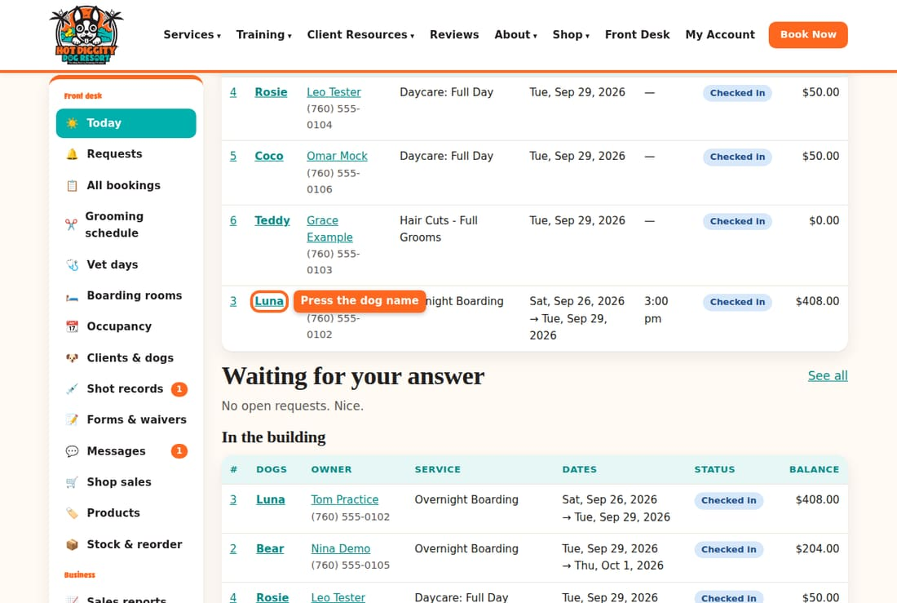
- Look at Balance. That is what the owner owes.
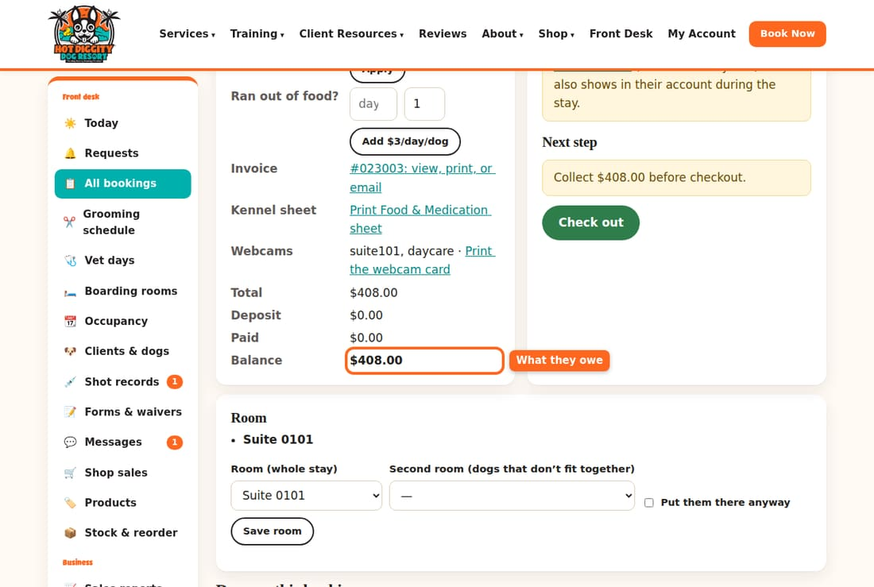
- Want to tell the owner the dog is ready? Check the words in the Ready for pickup? box. Press Text the owner. This step is optional.
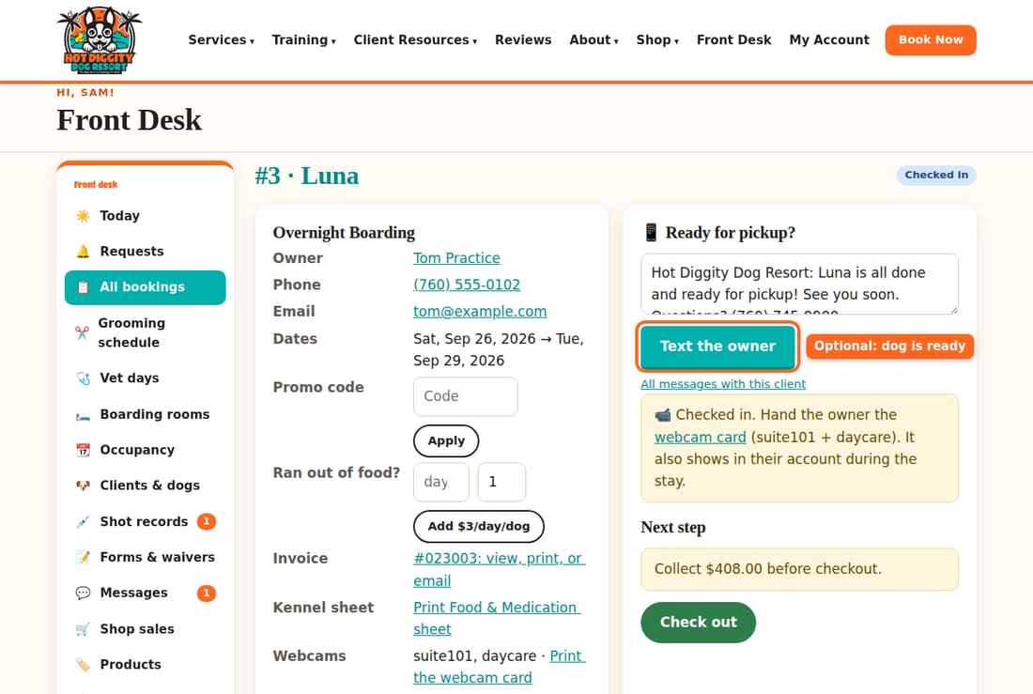
- Scroll down to Take a payment. The Amount is filled in with the balance. Change it if they pay only part.
- Pick how they paid in Method: card (in store), cash, check, Zelle, or gift card.
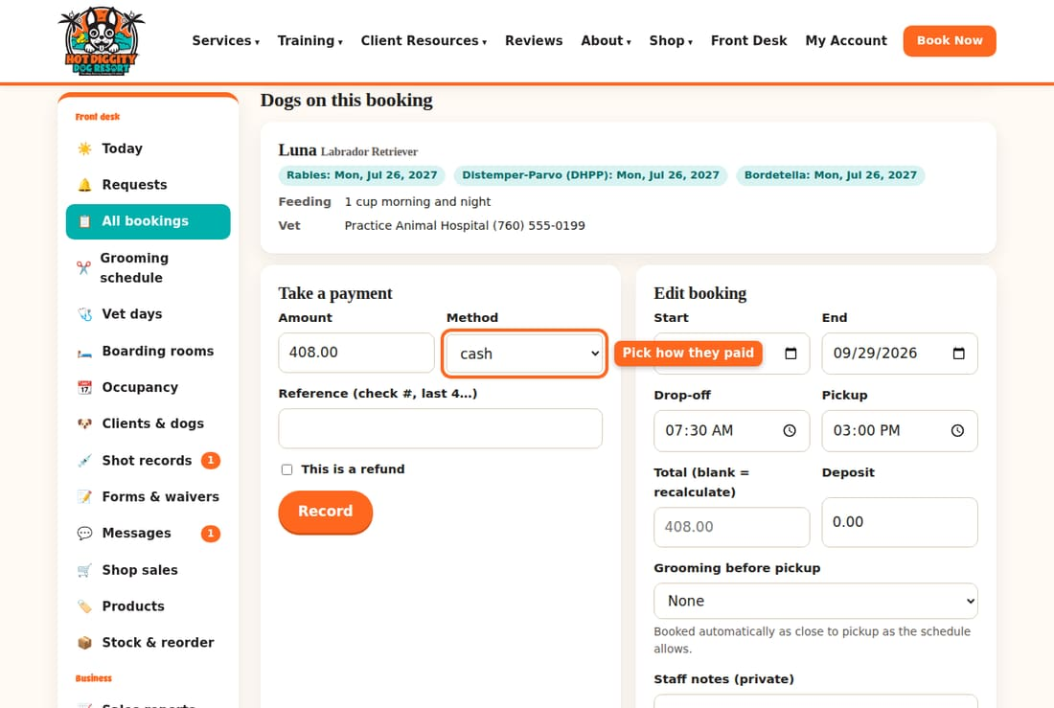
- Paid by check? Type the check number in Reference. For a card, you can type the last 4 numbers.
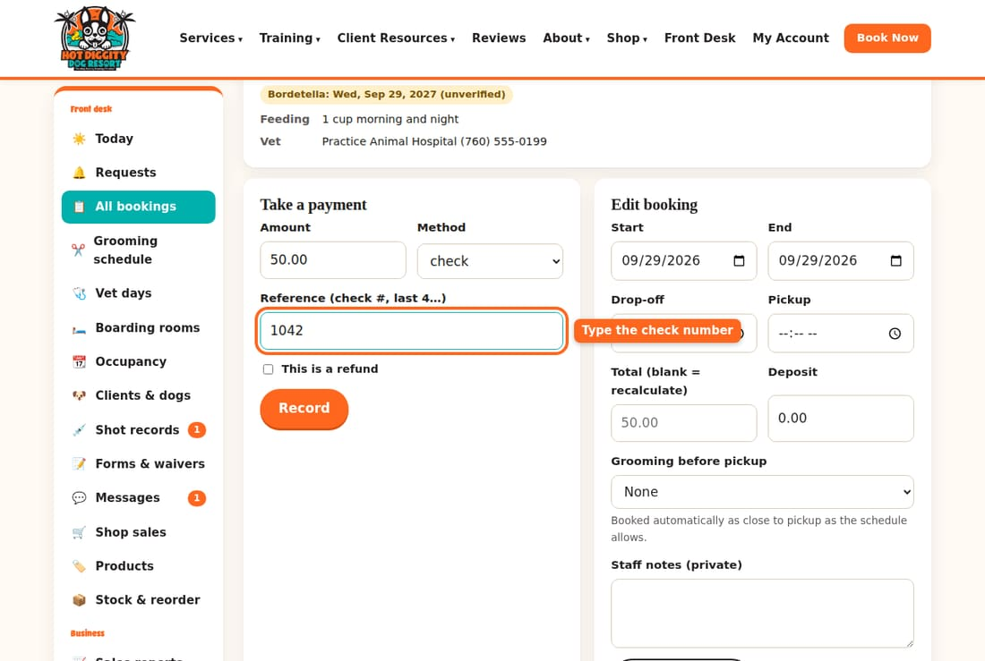
- Press Record.
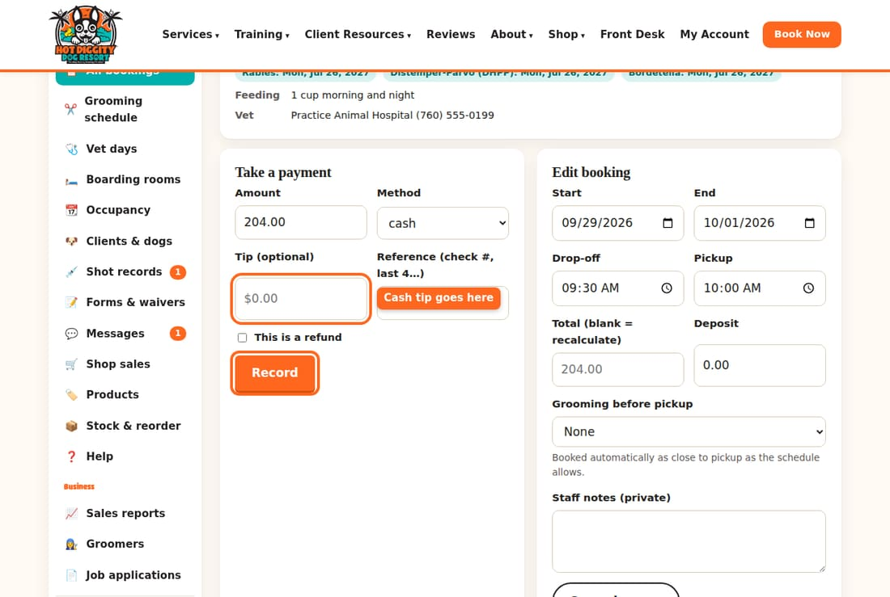
- Check that the payment shows under the button. The balance is now lower.
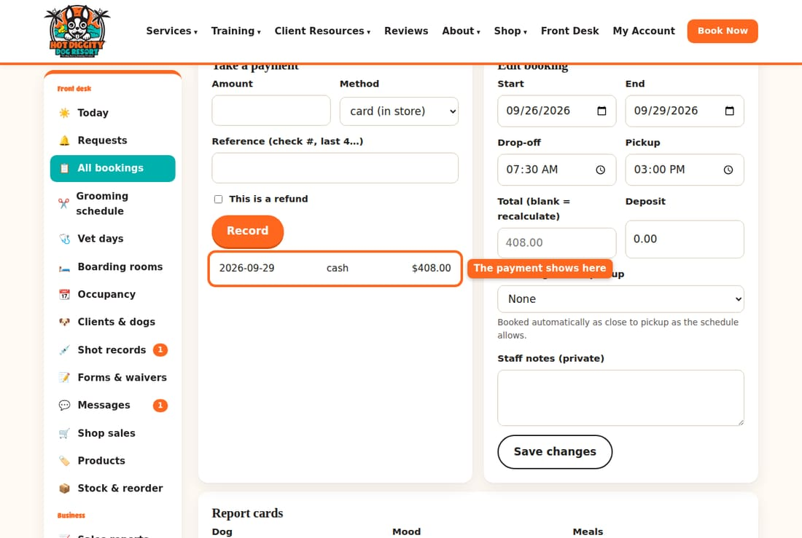
- Scroll up to Next step. Press Check out. The owner gets a thank-you text or email.
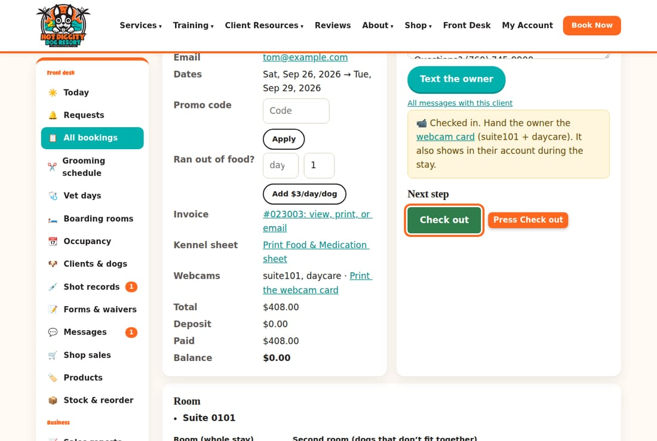
- It now says This booking is finished.
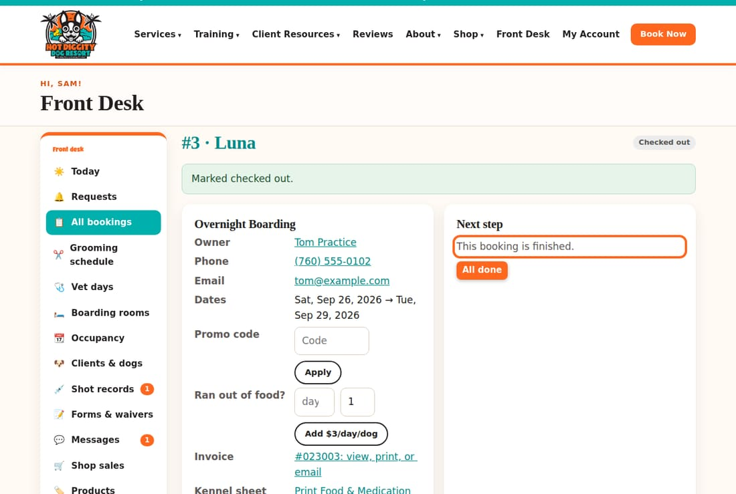
- Want a receipt? Press the Invoice link on the booking. Press Print, or press Email it to the client.
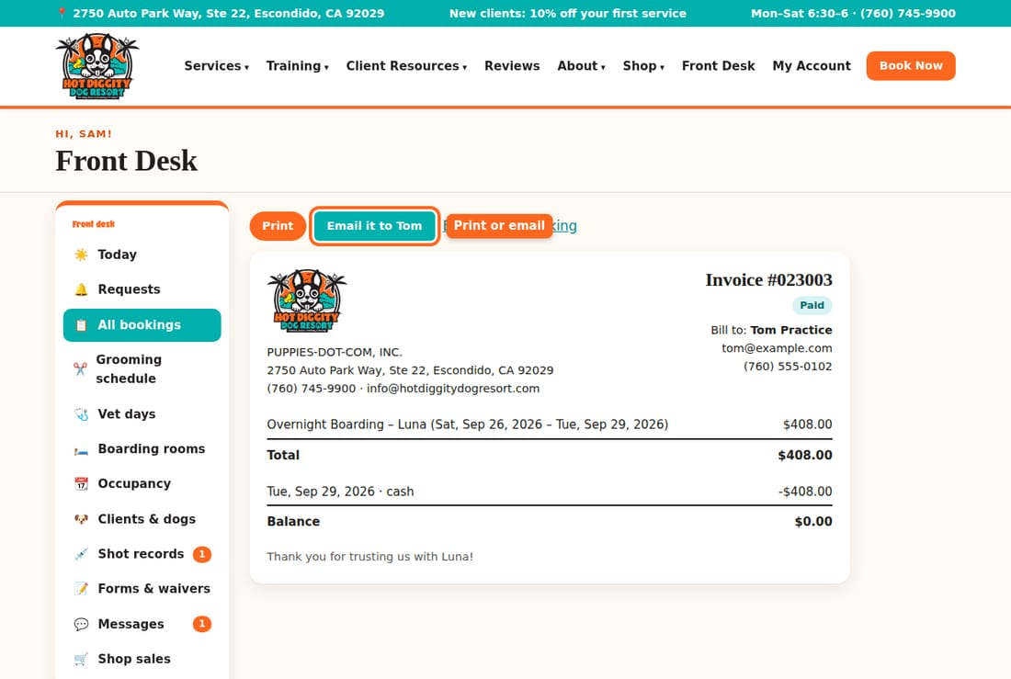

Paying by card
Once the card reader is set up, the booking shows a Charge on card reader button above the form.
- Check the Amount (before tip).
- Leave Show the tip screen ticked so the client can add a tip.
- Press Charge on card reader.
- Ask the client to pick a tip, then tap or put in their card.
- Wait. The screen says Paid when it goes through. The tip shows too.
If the client changes their mind, press Cancel. If the card reader is not set up yet, you will see No card reader set up yet. Then run the card on the other machine and record it as card (in store).
Good to know: Tips on the card reader are saved by themselves. A cash tip? Type it in the Tip box on the Record form. Tips go to the groomer on that appointment.
Good to know: The yellow box Collect $… before checkout is a reminder. The system lets you check out with money still owed. Please don't. Take the payment first.
Tip: Does the client have a daycare pass? Use it before you take money. See Daycare passes and L.E.E.P.
Tip: Did a boarder run out of food and eat ours? Before checkout, type the days in Ran out of food? and press Add $3/day/dog.
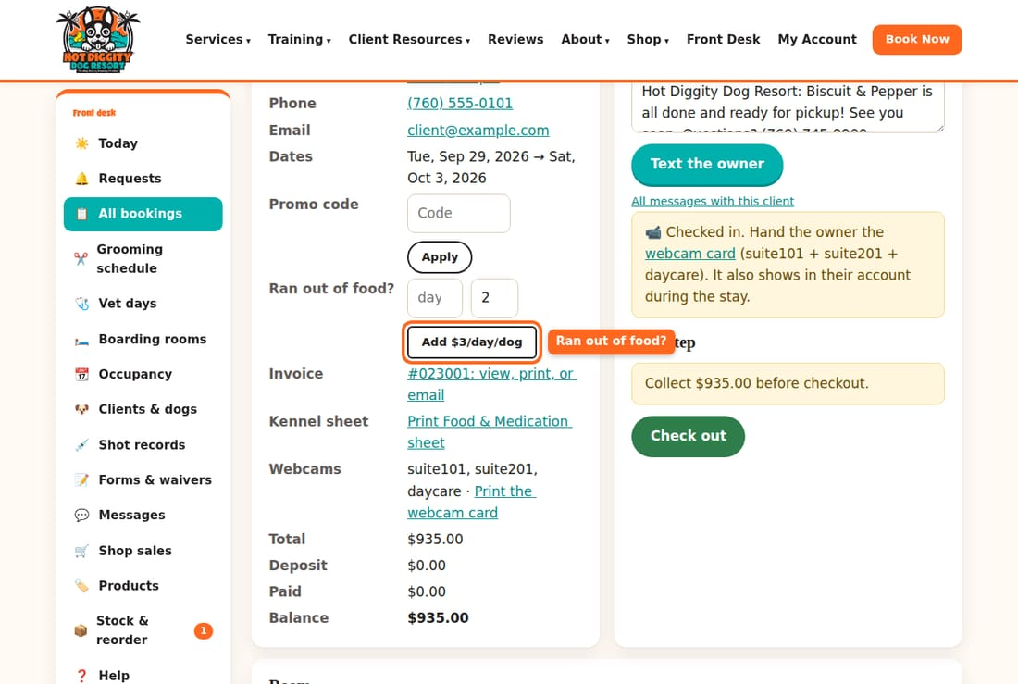
If something goes wrong: Typed the wrong amount? Record the same amount again with This is a refund ticked. Then record the right amount. Tell David so the books match.

Book for a client at the desk
Book daycare, boarding, or a groom for a walk-in or a phone call.
Clients can book online. But when they call or walk in, you book for them. You do it from the client's page.

Find the client
- Press Clients & dogs in the menu.
- Type the owner's name, dog's name, email, or phone. Press Search.
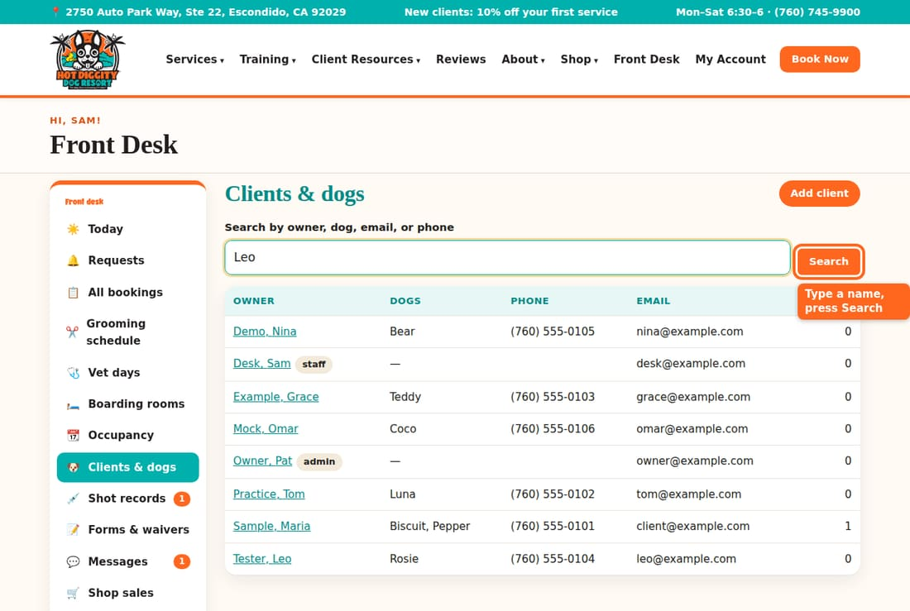
- Press the owner's name.
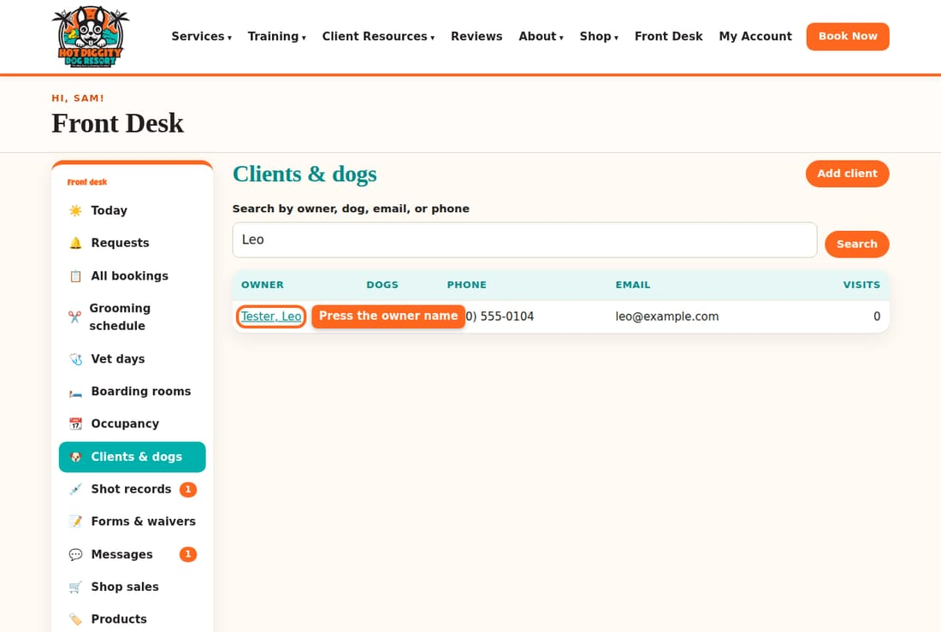
New client? Add them first. See Add a new client and dog.

Book daycare or boarding
- On the client page, scroll to Boarding, daycare & other bookings for the client.
- Pick the Service, like Daycare: Full Day or Overnight Boarding.
- Pick the Start date. For boarding, also pick the End date. That is the pickup day.
- Type the Drop-off time and Pickup time.
- Tick each dog that is coming.
- Leave Mark confirmed right away ticked. Then press Create booking.
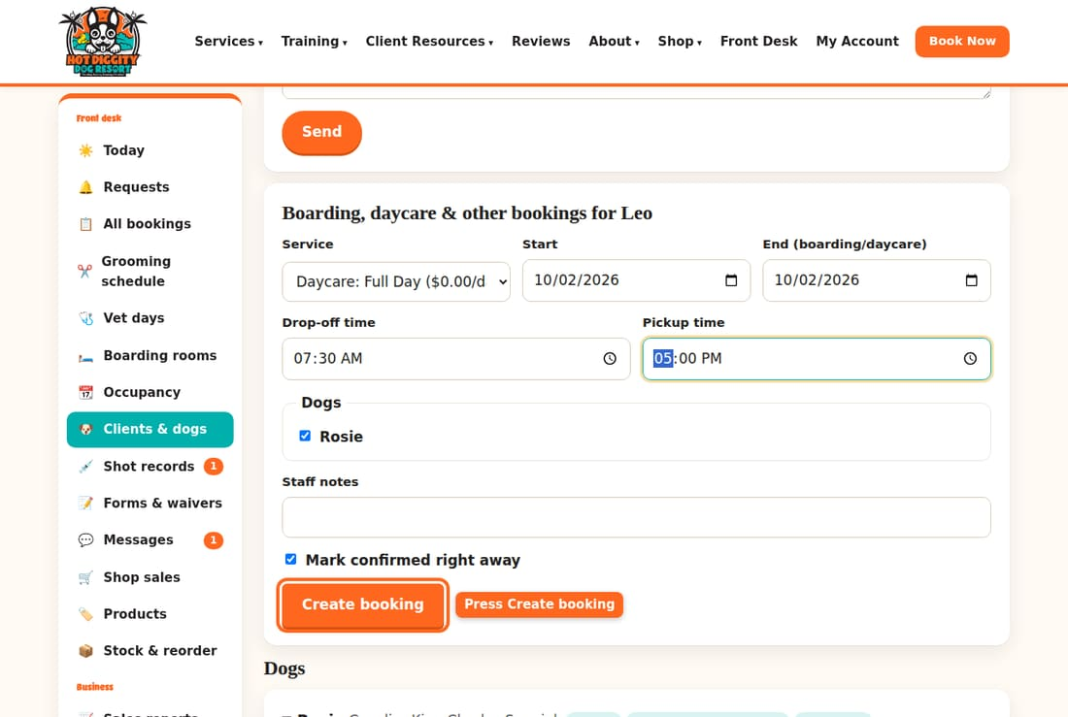
- The booking opens. It says Booking created.
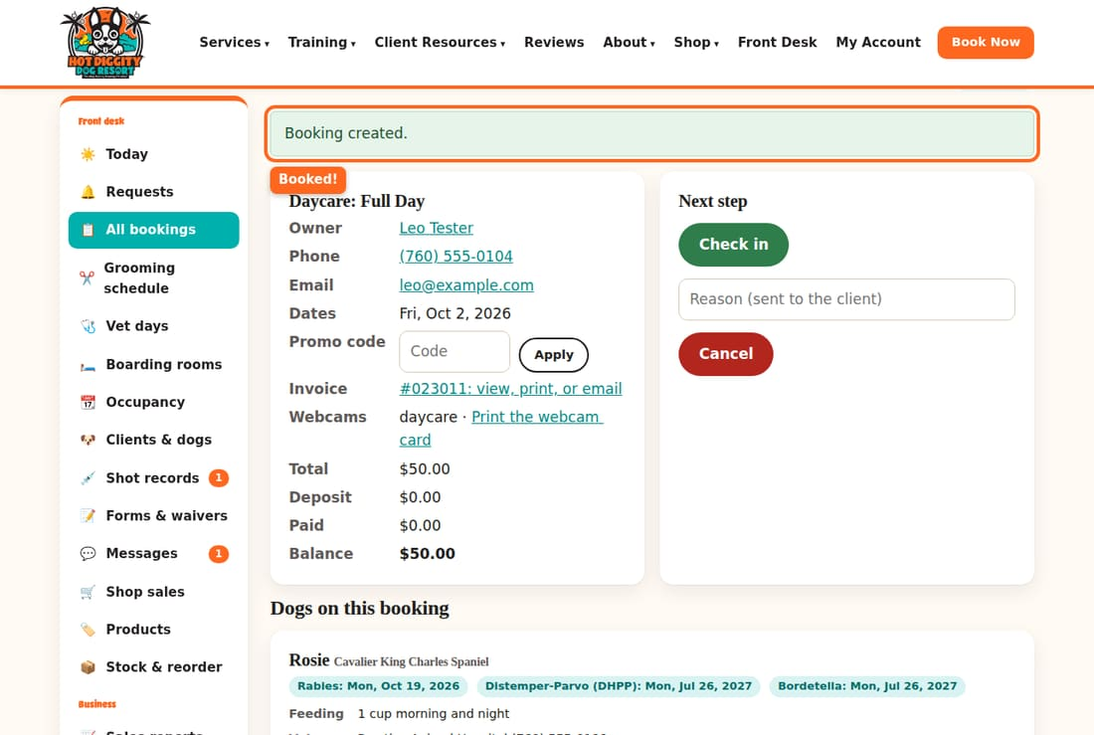
- For boarding you marked confirmed, the system picks a suite for you. The green message says which one. If no suite is free, it says so. Then pick one by hand under Room. See Boarding rooms and suites.
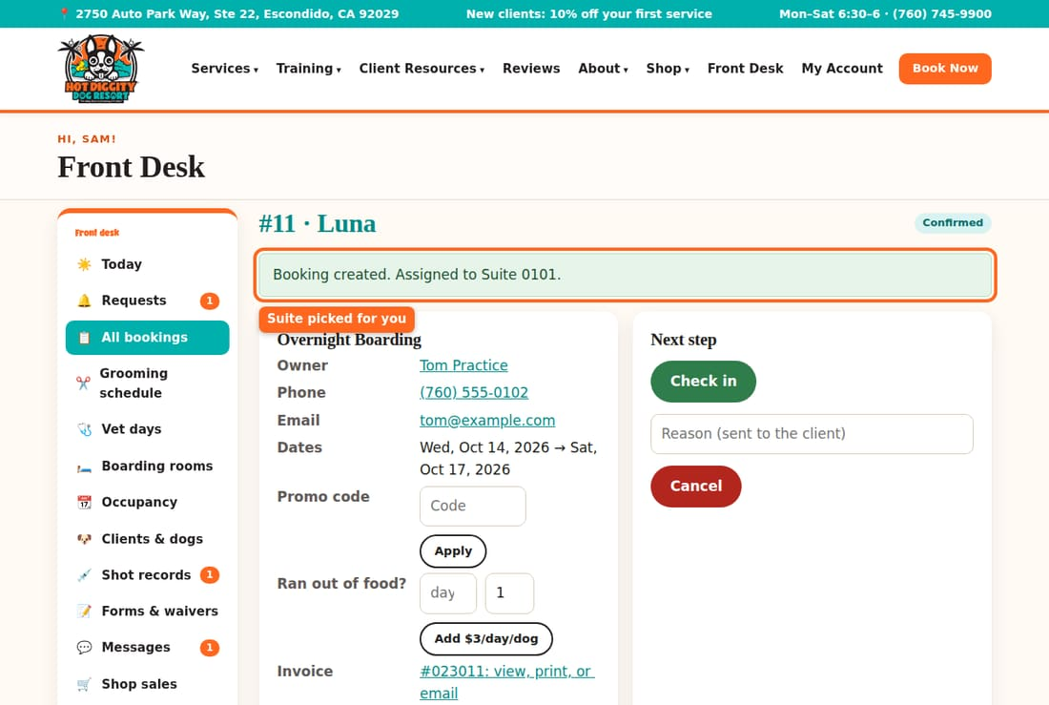
Good to know: Want to check with David first? Untick Mark confirmed right away. The booking is saved as a request.
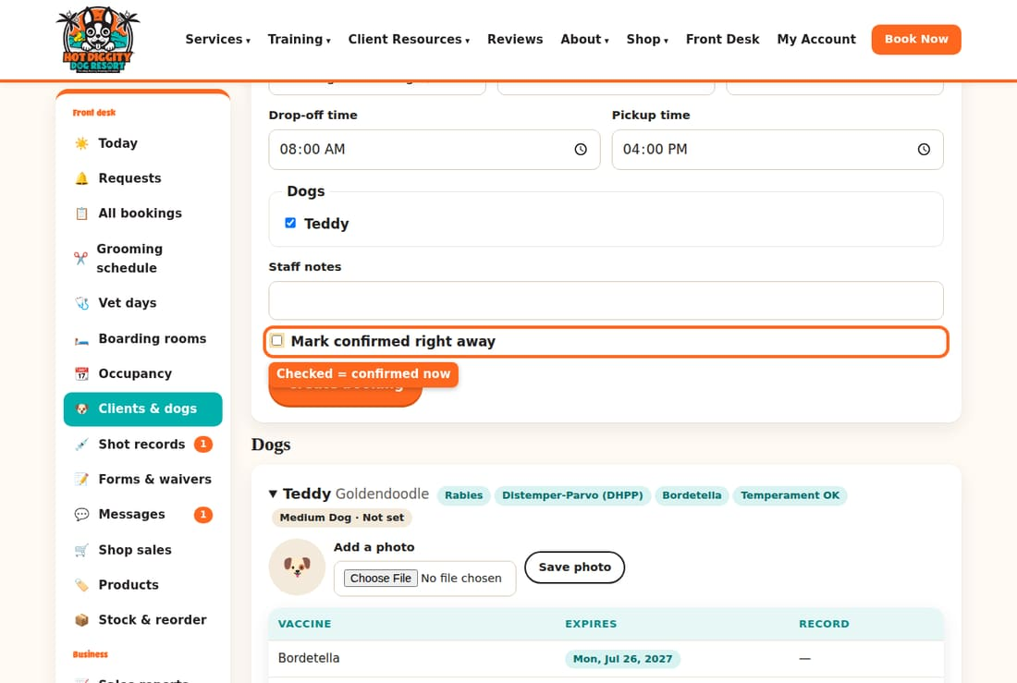
Good to know: The desk form does not check shots or the Temperament Assessment for you. Look at the dog's colored boxes before you book.

Book a groom
- On the client page, find Book a groom for the client. It is near the top.
- Pick the Dog, the Service, and any Add-ons. Pick the Day.
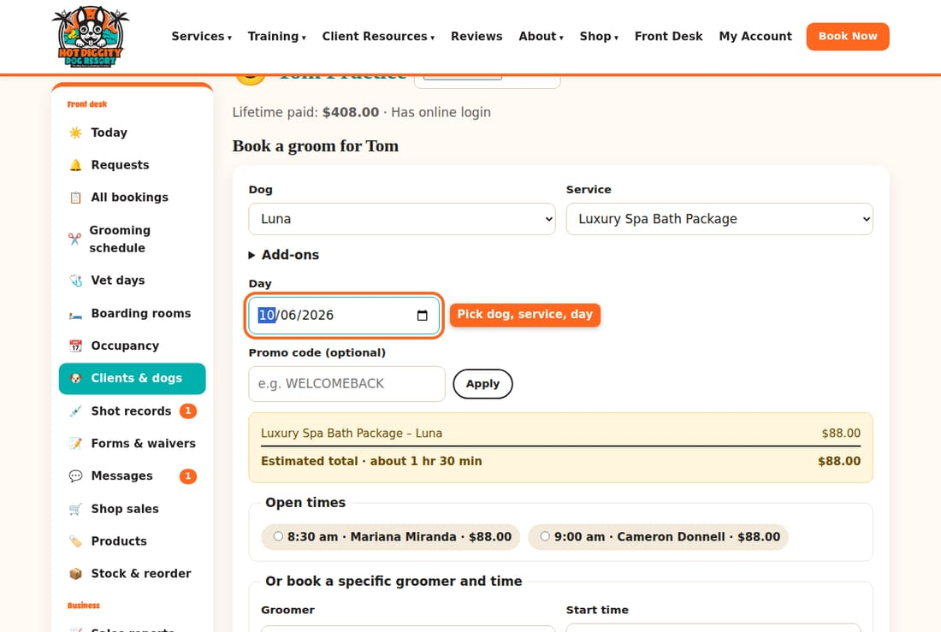
- Check the price and time in the yellow box.
- Under Open times, pick a time and groomer.
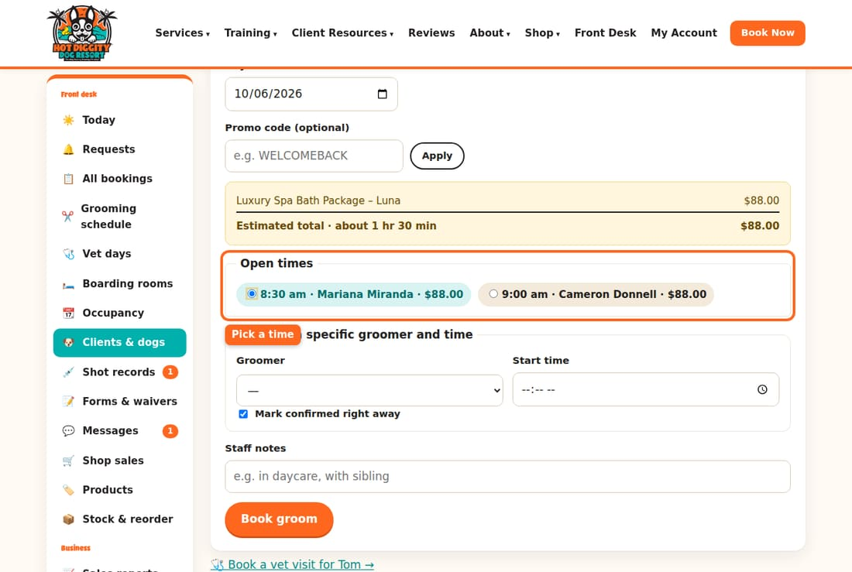
- No good time? Use Or book a specific groomer and time. Pick a Groomer and type a Start time.
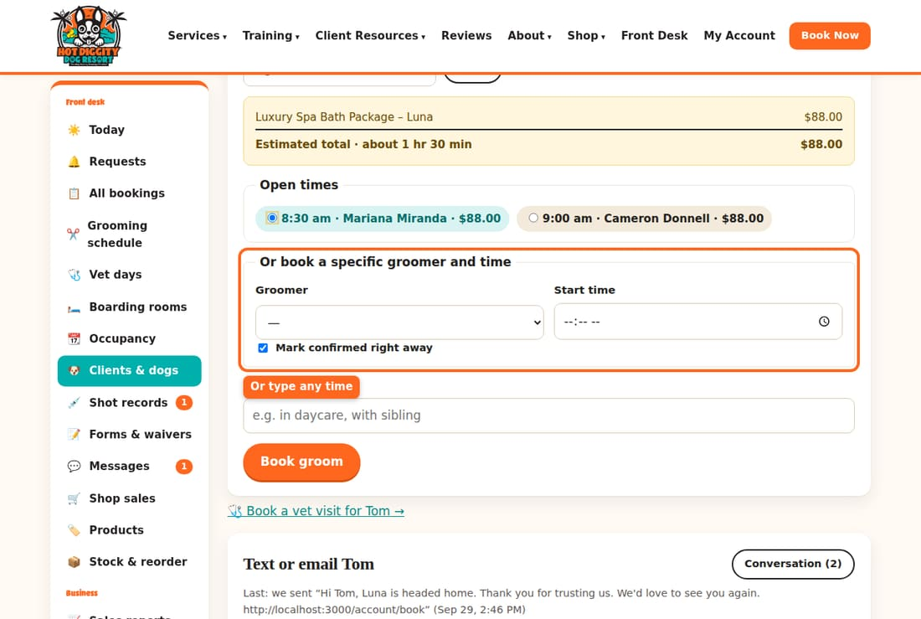
- Press Book groom.
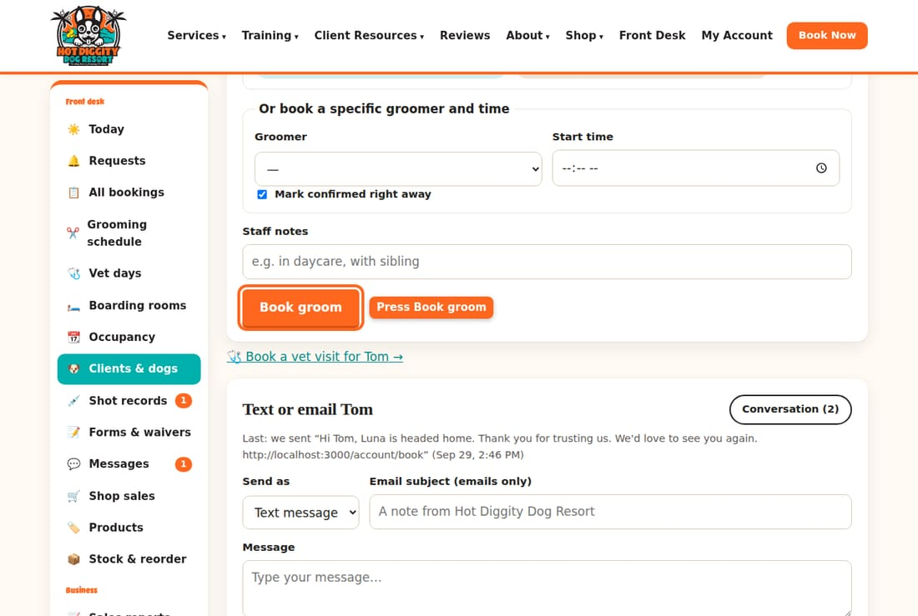
- The booking opens. It says Groom booked.
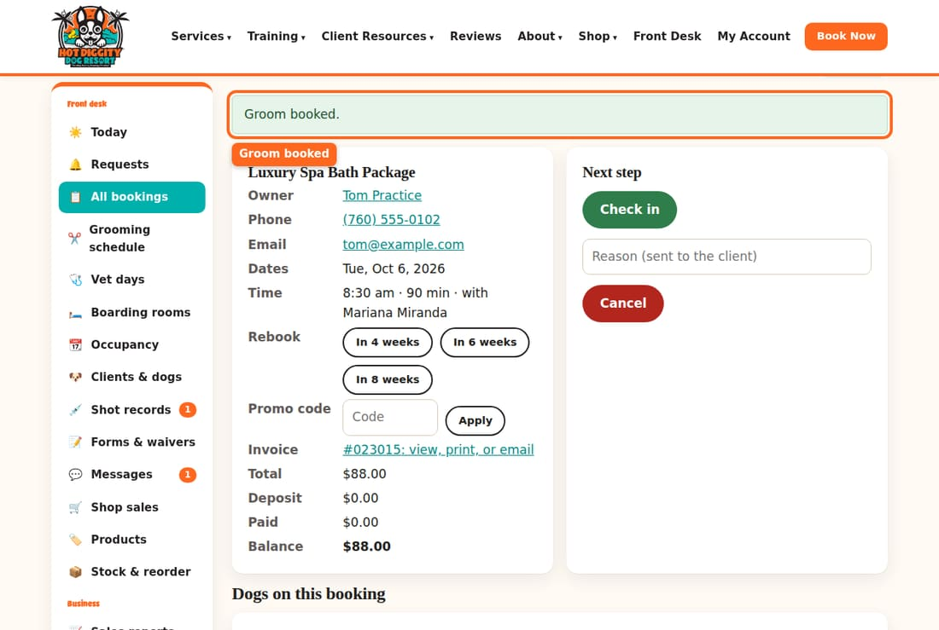
Tip: Booking the next groom as the dog leaves? On the groom's booking, press In 4 weeks, In 6 weeks, or In 8 weeks next to Rebook. The form fills in for you.
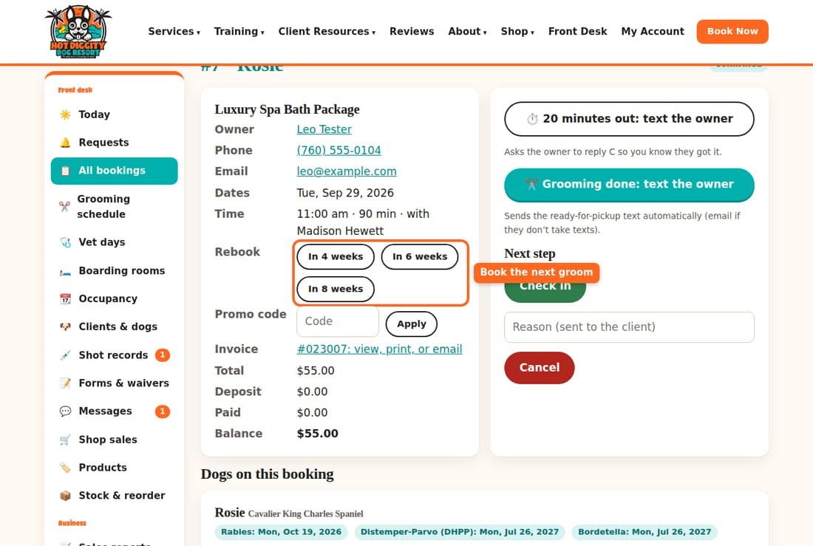
Good to know: Grooms and baths with a stay are done close to pickup, so dogs go home clean.
Good to know: Cancel rules to tell callers: boarding needs 48 hours' notice. Grooming and everything else needs 24 hours.
If something goes wrong: Red box that says Check the dates? The end date is before the start date. Fix it and try again.

Add a new client and dog
Make a profile for a new owner and their dog.
Most new clients sign up online. For a walk-in or a phone call, you can add them yourself.

Add the owner
- Press Clients & dogs in the menu. Search first, to make sure they are not already here.
- Press Add client.
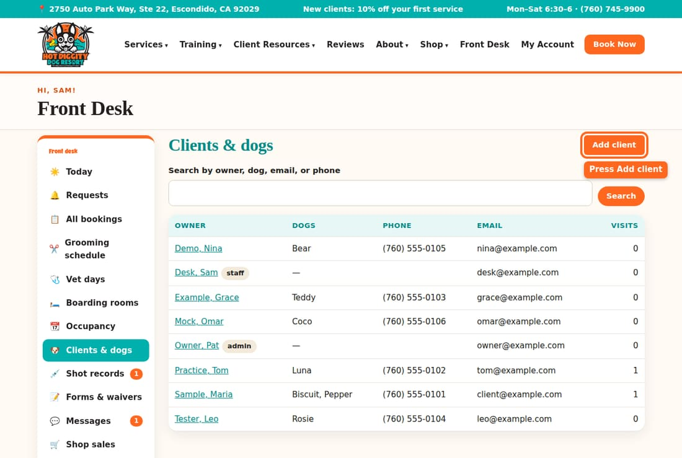
- Type the First name and Email. You must fill in both.
- Type the Mobile phone, Emergency contact, and anything else they tell you. Pick How they heard about us.
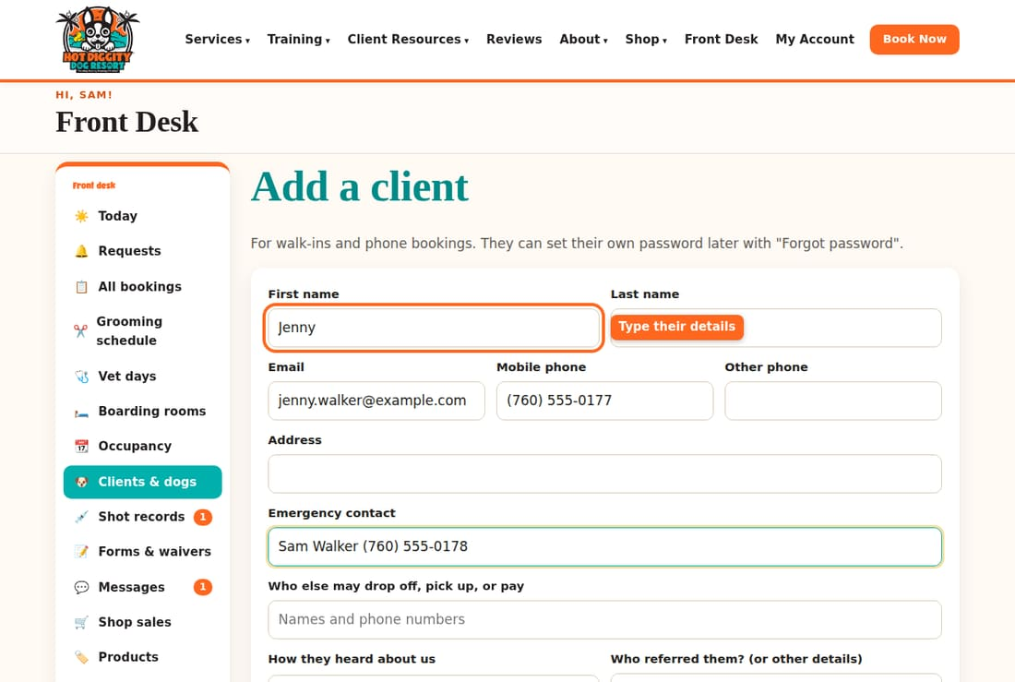
- Leave OK to text ticked if they want texts. Tick Military for active or retired military. They get 10% off.
- Press Add client.
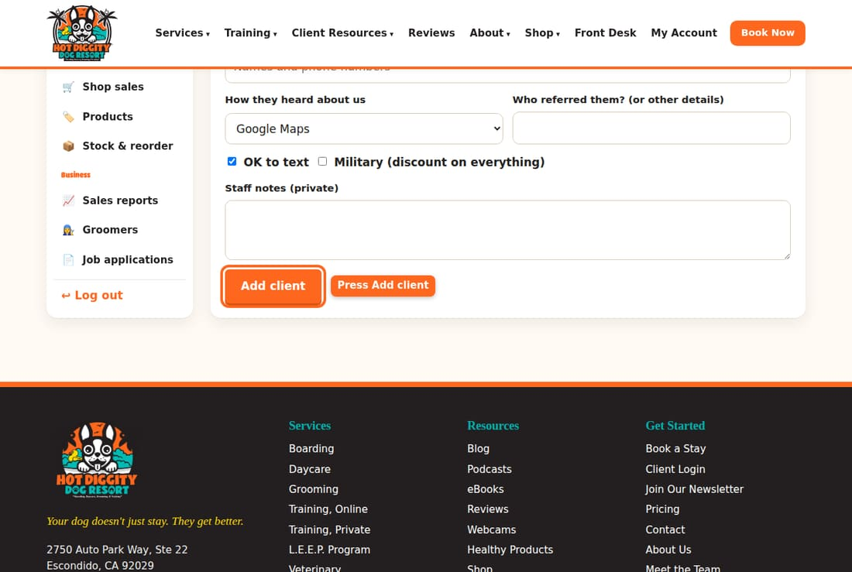
- Their page opens. The green box says Client added.
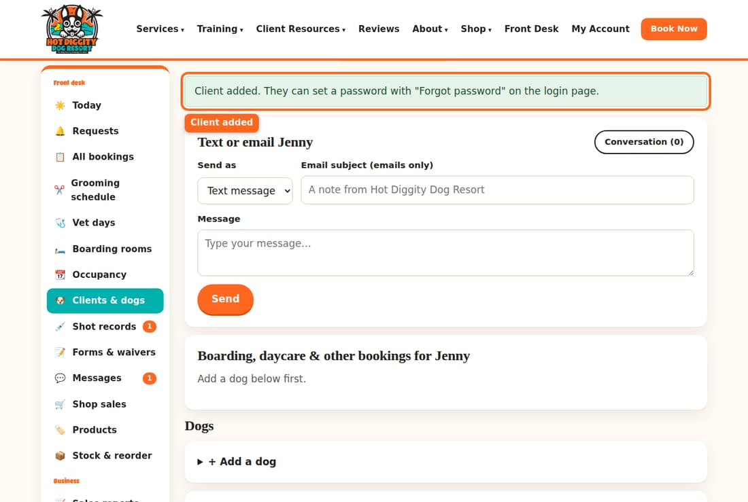

Add the dog
- On the client page, scroll down to Dogs. Press + Add a dog.
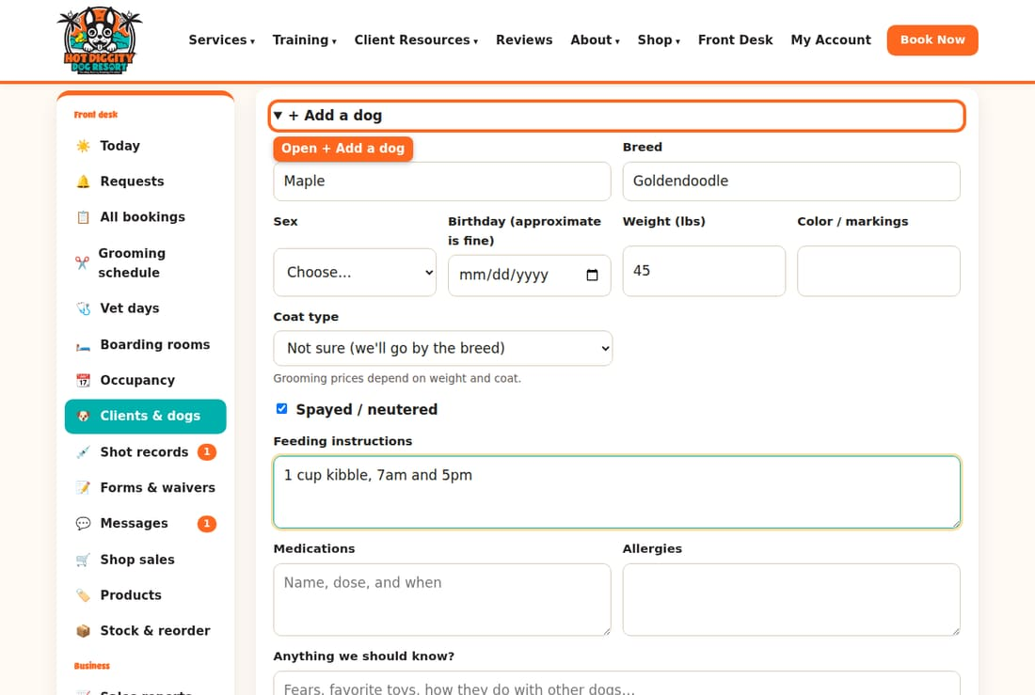
- Type the dog's Name, Breed, and Weight (lbs). Weight sets the price, so get it right.
- Tick Spayed / neutered if it is true. Fill in food, meds, and the vet.
- Press Add dog.
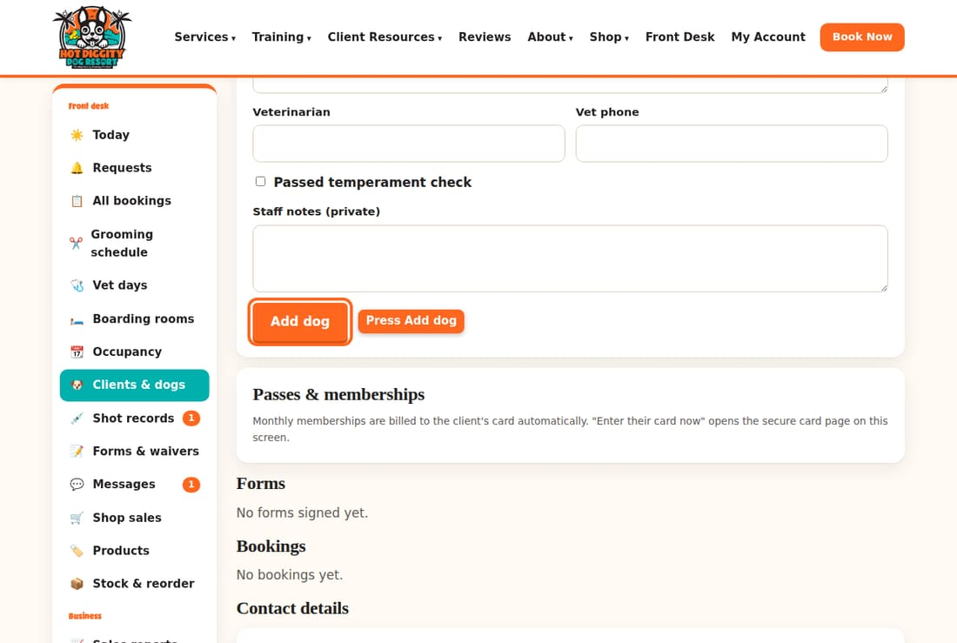
- The dog now shows under Dogs. Red boxes are shots we don't have yet.
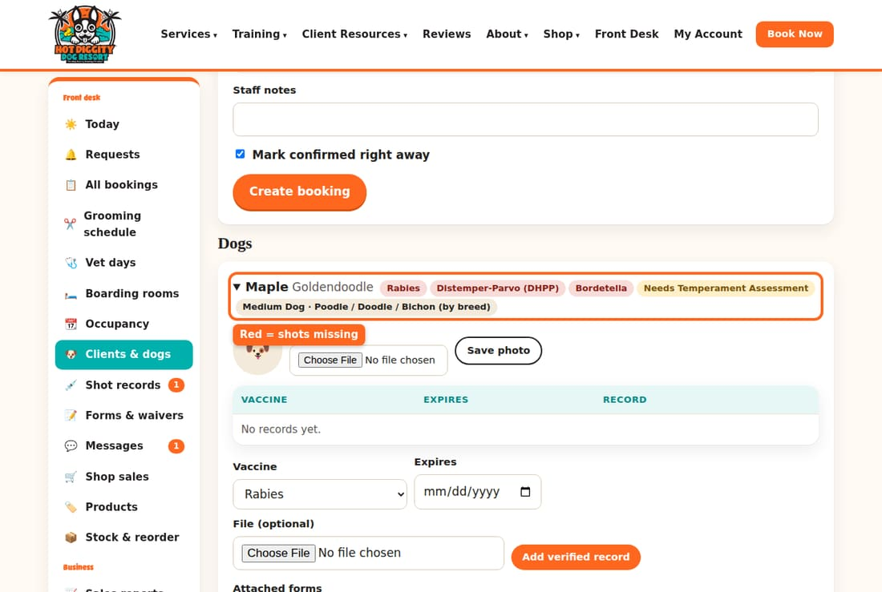
- Did they bring paper shot records? Add each one under the dog. See Shot records.
Good to know: Do not tick Passed temperament check for a new dog. A new dog must pass the Temperament Assessment day first.
Good to know: The client can log in later. They press Forgot password on the log in page to set a password.
Tip: Change a phone or email later in Contact details at the bottom of the client page. Press Save client.
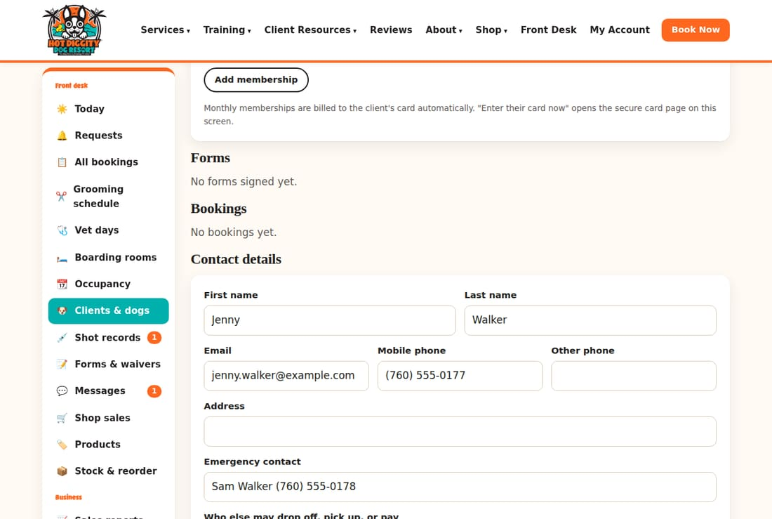
If something goes wrong: Red box that says the email already belongs to another client? They are already here. Search for that email instead.

Boarding rooms and suites
See which dog is in which suite, pick a suite, and move a dog.
We have 16 boarding suites. The system picks a suite when you confirm a request. You can pick or change it by hand.

See the rooms
- Press Boarding rooms in the menu. Each column is one night. Each row is a suite.
- The Suites used row shows how many suites are full each night.
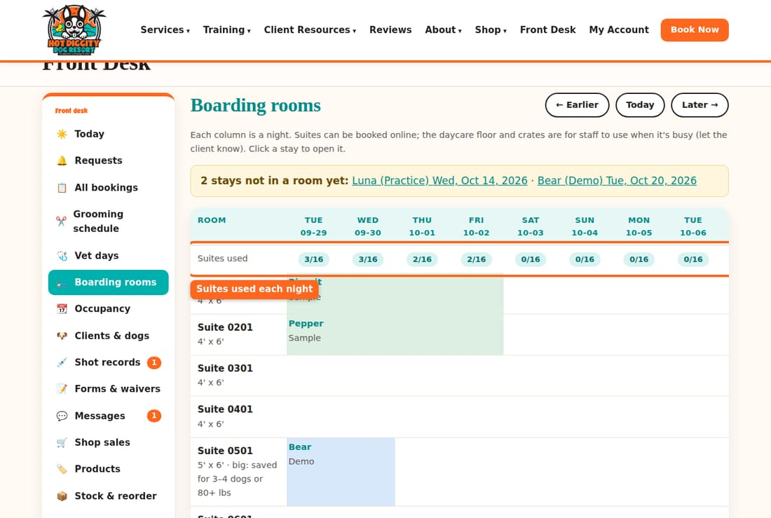
- Use ← Earlier and Later → to see other weeks. Press a dog's name to open the stay.
- A yellow box at the top lists stays not in a room yet. Press each one and give it a suite.
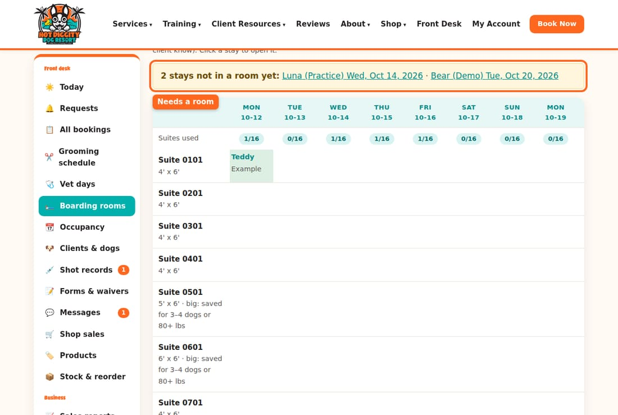

Pick or change a suite
- Open the boarding booking. Scroll to Room. It shows where each dog sleeps.
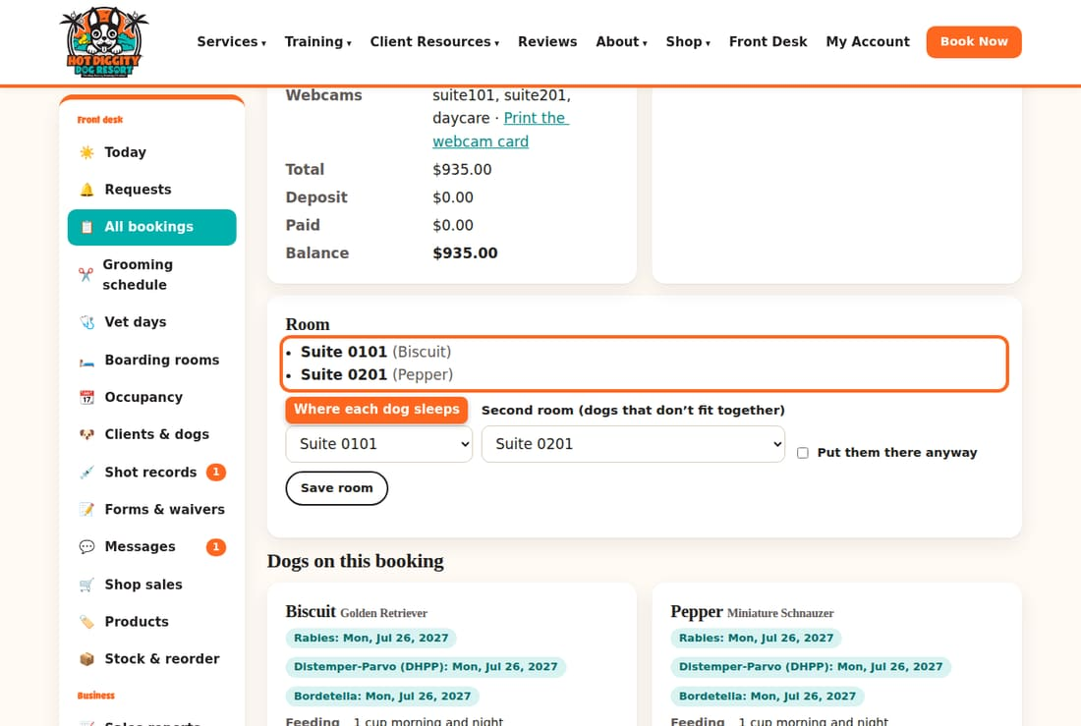
- Pick a suite in Room (whole stay).
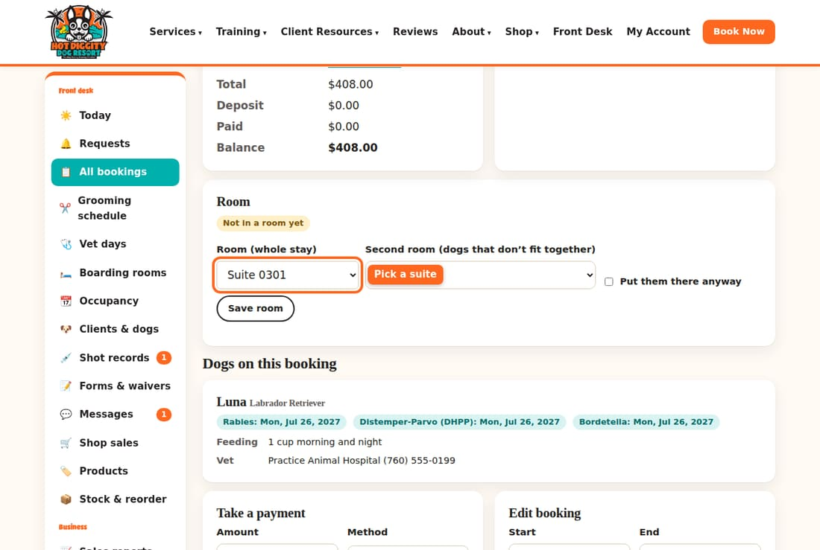
- Dogs that can't share? Pick a second suite in Second room (dogs that don't fit together).
- Press Save room.
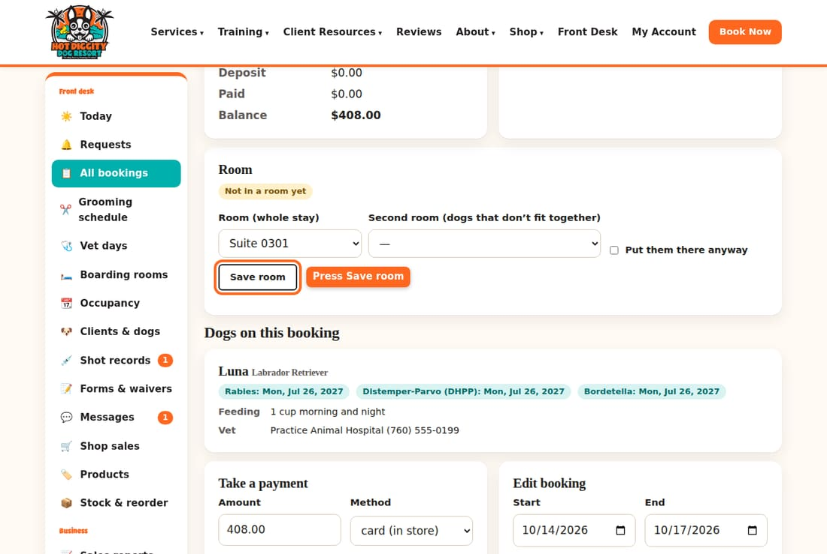
- The green box says Room saved.
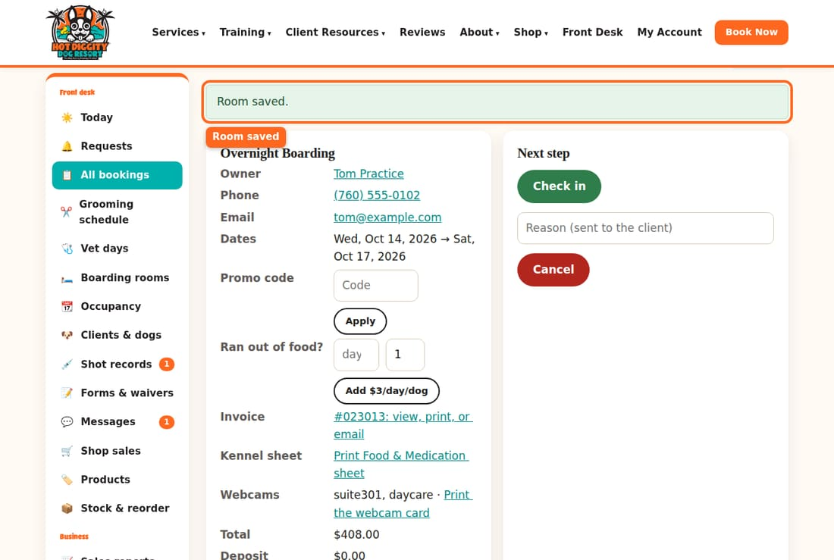
To move a dog, do the same steps. Pick the new suite and press Save room.

Sharing a suite
Only dogs from the same family share. A suite can hold:
- up to 4 dogs of 20 lbs or less, or
- 3 dogs of 30 lbs or less, or
- 2 dogs of 60 lbs or less.
The first dog pays full price. Each extra dog in the same suite is $5 off per night.
Good to know: Most suites are 4' × 6'. Suite 0501 is 5' × 6'. Suite 0601 is 6' × 6'. We save those two for 3 or 4 dogs sharing, or dogs over 80 lbs.
Good to know: A suite that says · taken is full for part of the stay. The system won't let you put a dog there. Tick Put them there anyway only if David says so.
Good to know: The Daycare Floor and the crates are for busy times. If you use one, tell the owner. The dog sleeps in a crate at night.
Tip: On busy holidays, a stay may be split. That means no one suite is free every night, so the dog changes suites partway. The move shows in a yellow Suite moves box on the rooms page.
Tip: Occupancy in the menu shows six weeks at a time. Use it when a caller asks, "Do you have room?"
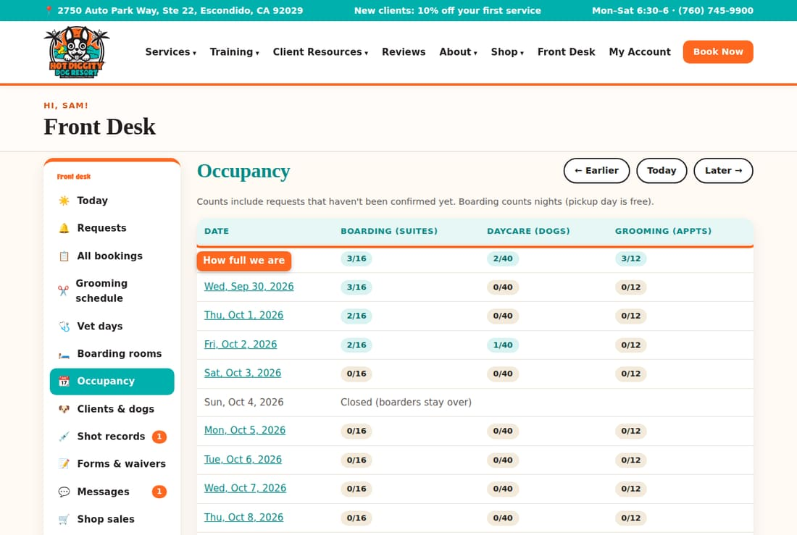
If something goes wrong: A booking is not in a suite? No suite was free for every night, or it is still a request. Pick one by hand.

The grooming schedule
Read the groomers' day, move grooms and lunches, block time, and use the waiting list.
The grooming schedule shows every groomer's day. Each groomer has a column. Grooms are colored blocks. Open time is green.

Read the board
- Press Grooming schedule in the menu. It opens on today.
- To see another day, press ← or →. Or pick a date and press Go. Press Today to come back.
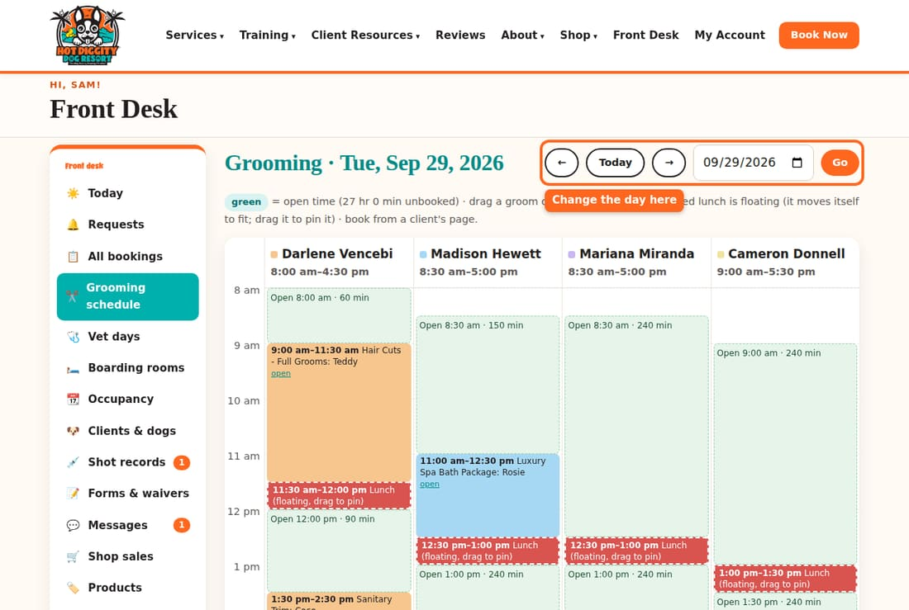
- Each column is one groomer. Their hours are under their name. A ★ means a Signature Groomer.
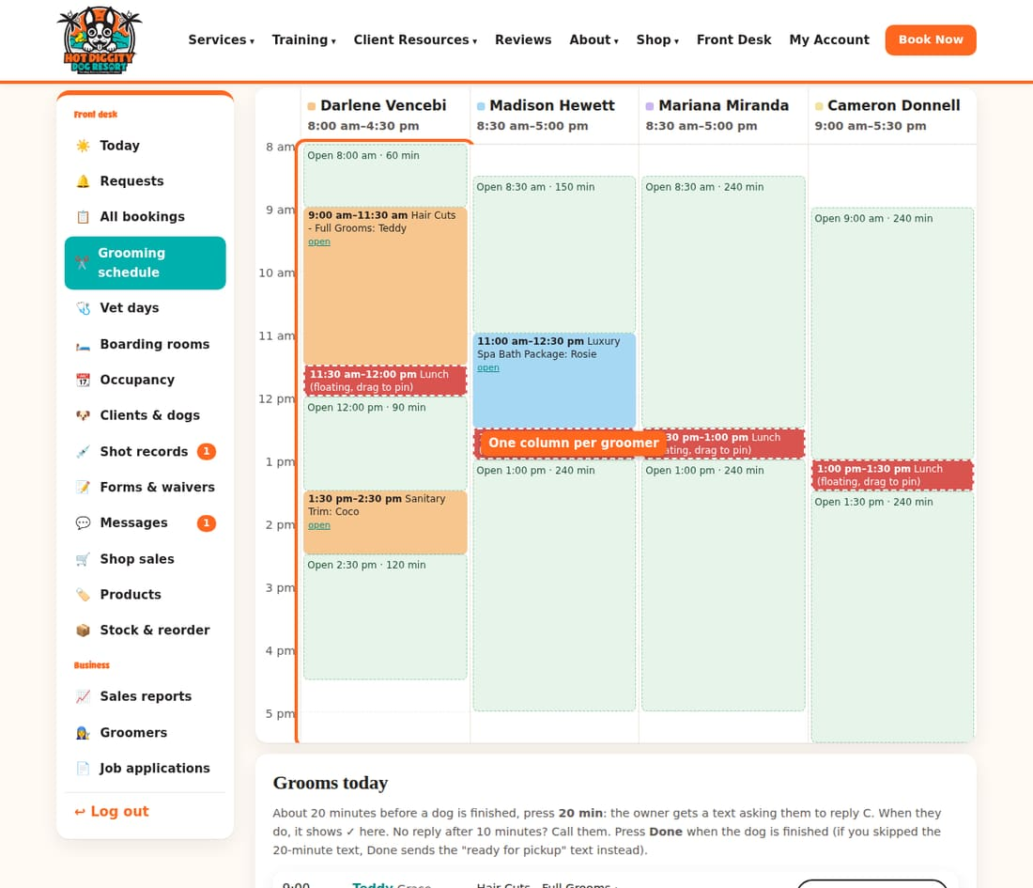
- Green boxes say Open with a time. That is time you can fill.
- Red blocks are lunch. A lunch with a dashed line is floating. It moves by itself to fit the day.
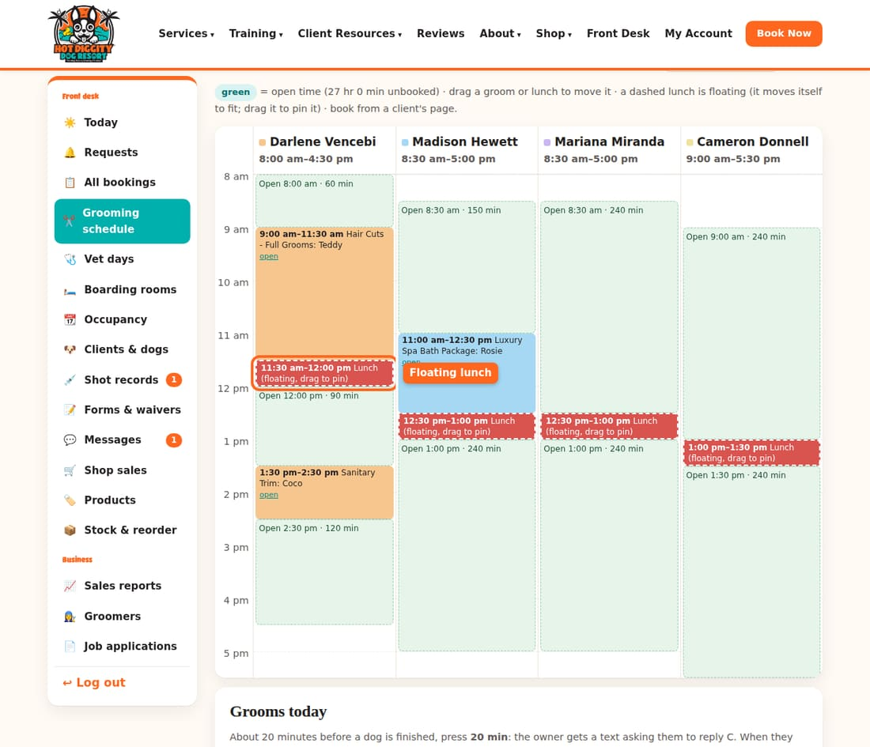
- Gray blocks are blocked time, like a meeting.

Move a groom or a lunch
- Drag a groom block to a new time or a new groomer. Let go.
- A note at the top says Moved to the new time. Or it tells you why it can't move.
- Drag a lunch up or down to pin it. A lunch stays with its groomer.
- To let a pinned lunch float again, press the button with the groomer's name, like Let Madison Hewett's lunch float.
You can also move a groom from its booking. Use Move this groom. Pick the Groomer, Day, and Start. Press Move.
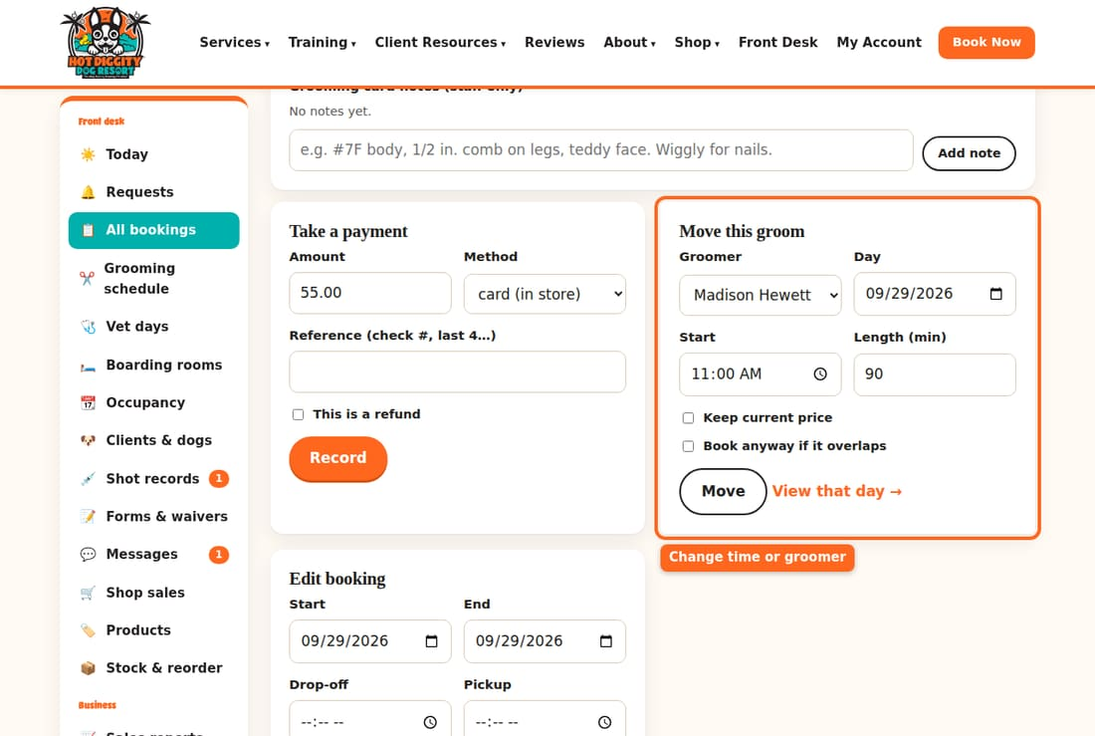

Block time
- Scroll to Block time.
- Pick the Groomer. Type From and To.
- Pick a Label: Lunch, Off schedule, Day off, or Meeting.
- Press Add.
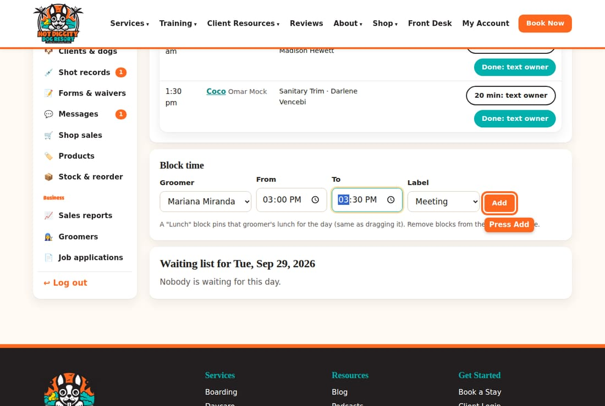

The waiting list
- Scroll to Waiting list for the day. It shows clients who want that day.
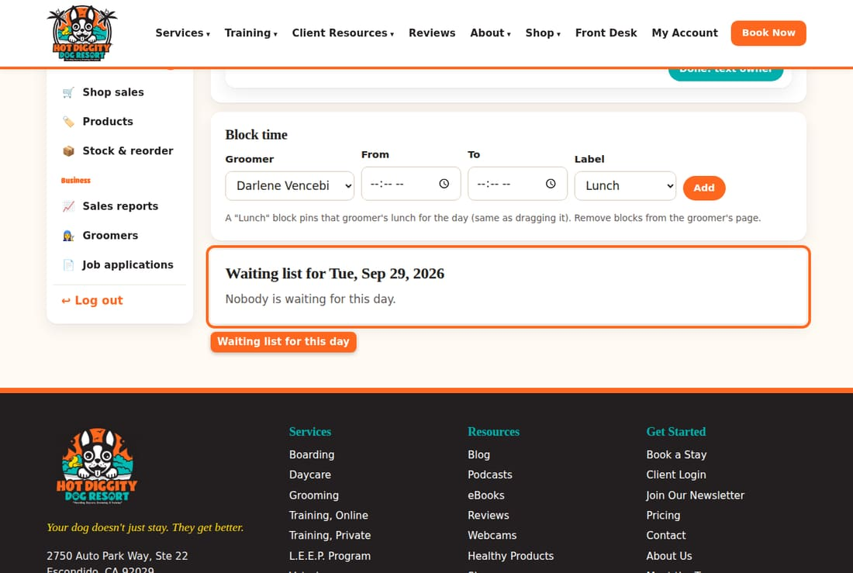
- A spot opened? Press Text: spot open. The client gets a text (or email).
- They took it? Book the groom. Then press Booked.
- They don't want it? Press Remove.
Good to know: A groom that moves to a different groomer can change price. The price follows the new groomer. Tick Keep current price on Move this groom to keep it the same.
Good to know: California law says lunch must start within the first 5 hours. The board warns you with no legal lunch if there is no room for it.
Tip: Double-click a groom block to open its booking. Or press open on the block.
Tip: Grooming card notes are on each groom's booking. Write the blade, style, and how the dog did. Press Add note.
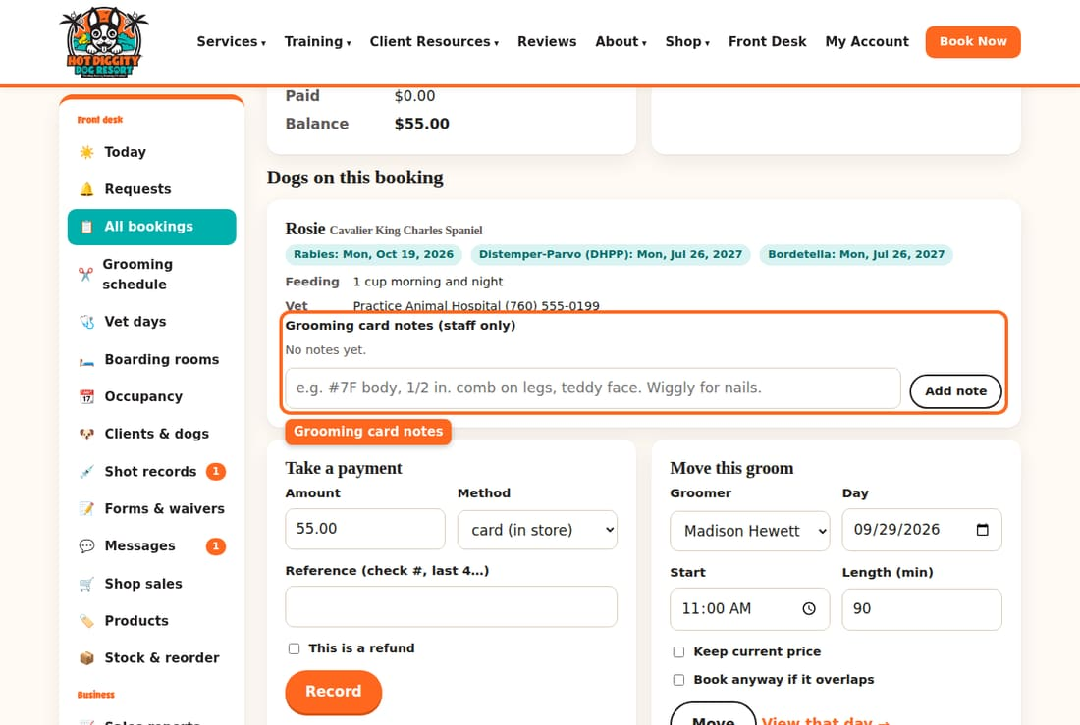
If something goes wrong: It says No groomers scheduled this day? Nobody has hours that day. Hours are set under Groomers. Ask David.

"Groomers: the 20-minute text and Done"
Text the owner 20 minutes before the dog is ready, then press Done.
This is new. About 20 minutes before a dog is done, you text the owner. The owner texts back C. A check mark shows up. When the dog is done, you press Done.

Steps
- Press Grooming schedule in the menu. Scroll down to Grooms today.
- About 20 minutes before the dog is done, find the dog. Press 20 min: text owner.
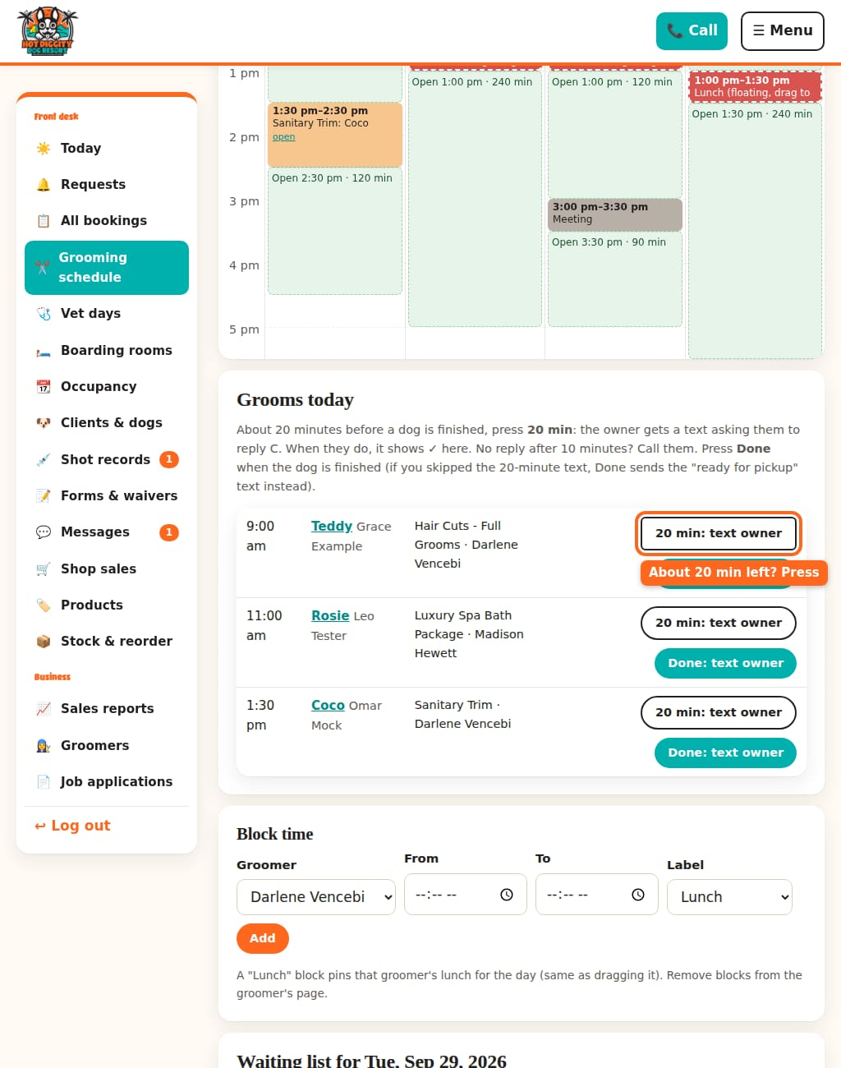
- The owner gets a text. It asks them to reply C. The row now says Texted and the time, waiting for C.
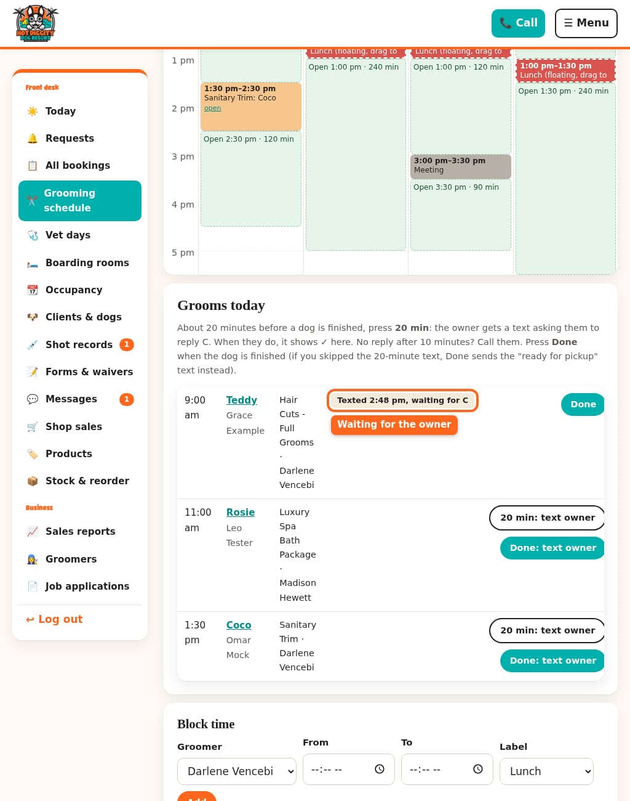
- When the owner texts back C, the row says ✓ Replied C and the time. Good! They know.
- No C after 10 minutes? The row turns yellow and says No reply: call with their phone number. Call the owner.
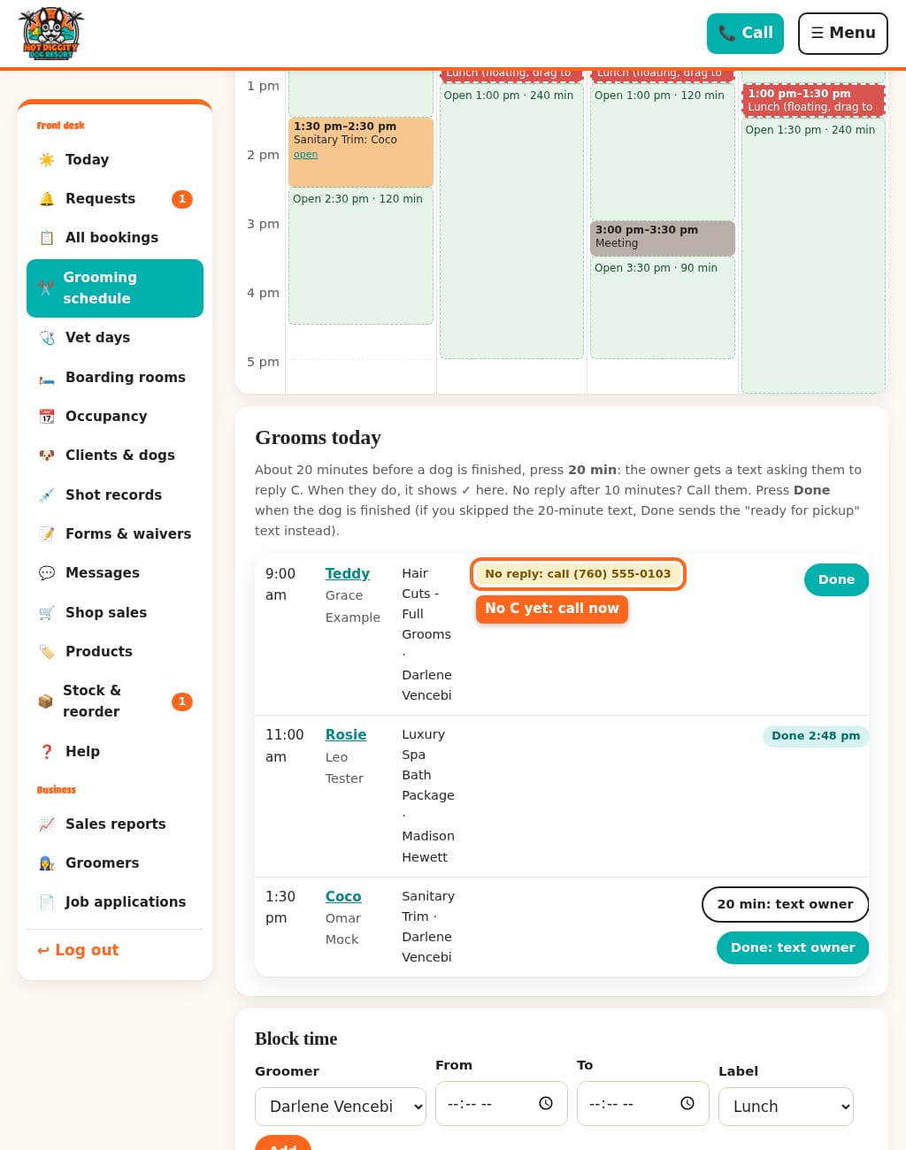
- When the dog is all done, press Done.
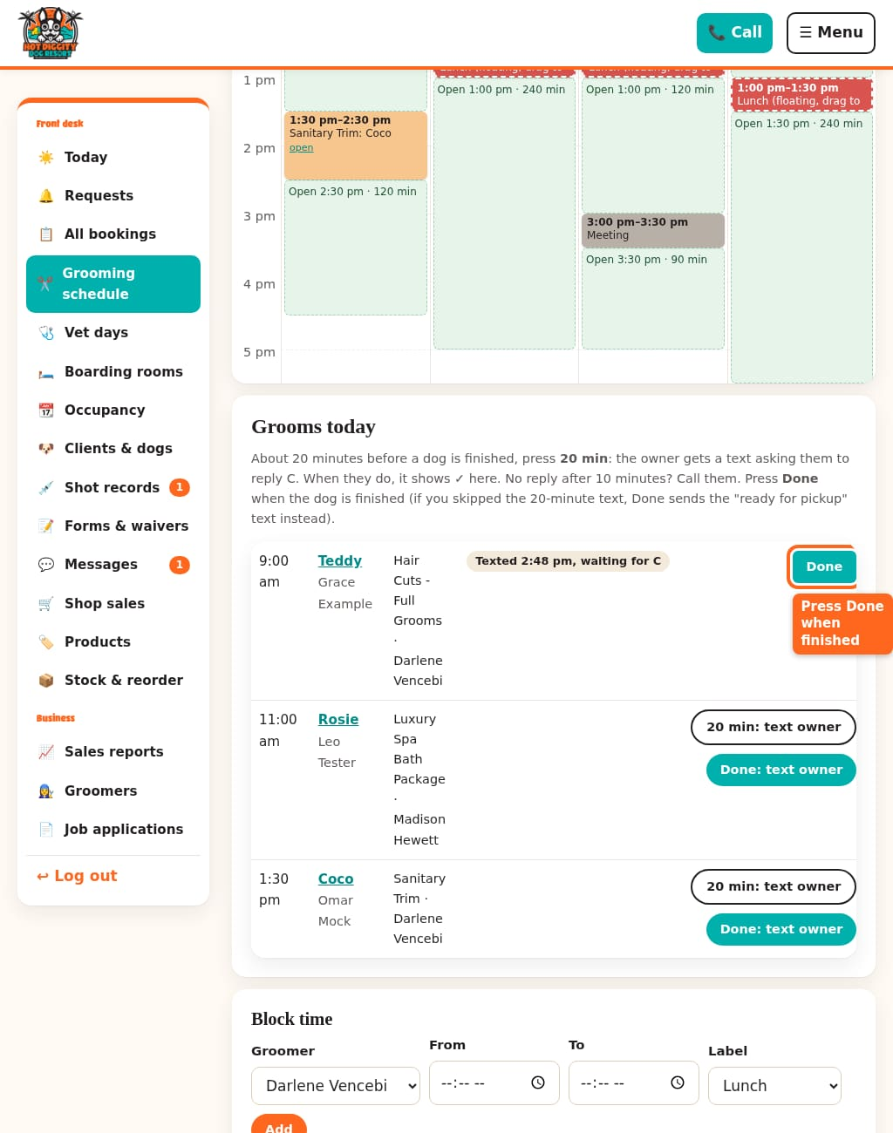
- The row now says Done and the time.
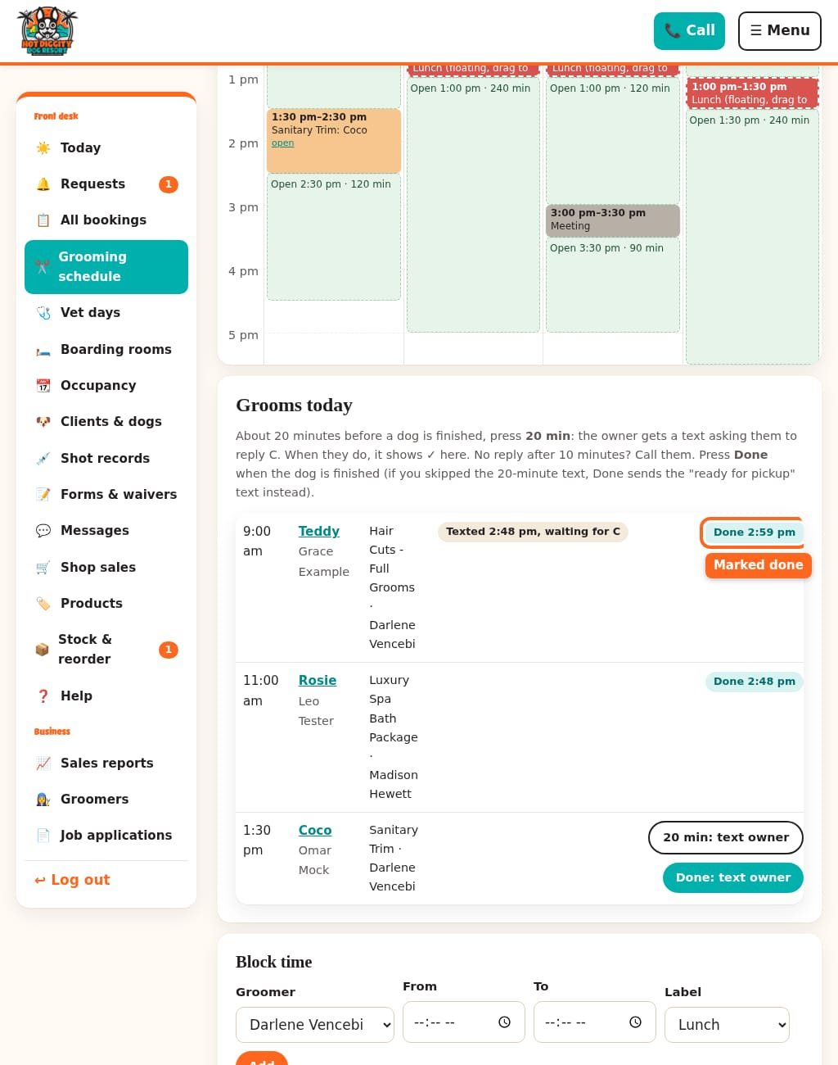

Forgot the 20-minute text?
That's OK. Press Done: text owner when the dog is ready. The owner gets a "ready for pickup" text right then.
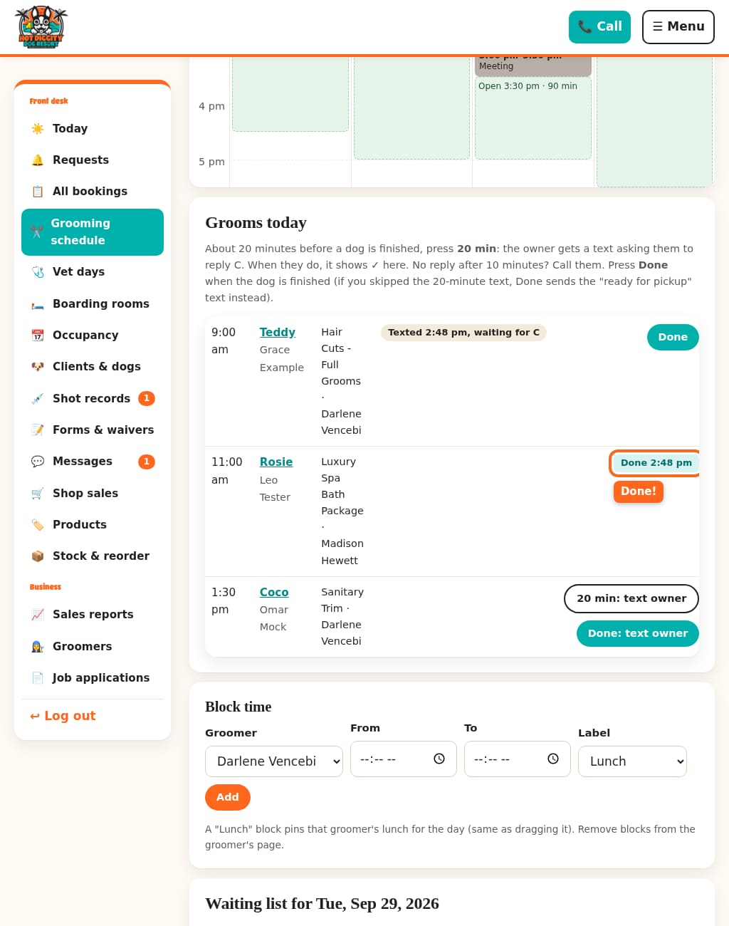

The same buttons on the booking
Open the groom's booking. You see ⏱️ 20 minutes out: text the owner and ✂️ Grooming done: text the owner. They work the same way.
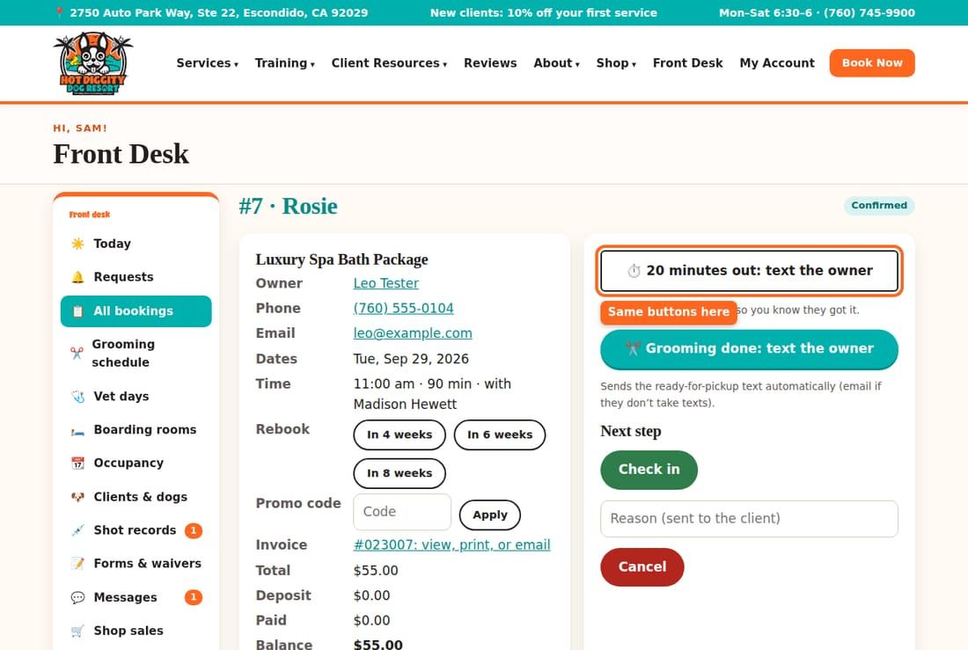
Good to know: The owner gets only one text from you. If you sent the 20-minute text, Done does not send a second one.
Good to know: Some owners don't take texts. They get an email instead. The row says Emailed. They can't reply C, so no call is needed.
Good to know: Is the dog staying on in boarding? Then there is no pickup. No text goes out. Just press Done.
Tip: On a tablet, the site's top menu is behind the Menu button. Press Menu, then Front Desk.
If something goes wrong: A red box says The 20-minute message didn't go out? The text failed. Call the owner instead.

Shot records
Check the shot records clients upload, and add paper ones.
Every dog needs Rabies, DHPP (Distemper-Parvo), and Bordetella on file. Clients upload photos of their records. You check each one.

Check new uploads
- Look at Shot records in the menu. A red number means new records are waiting.
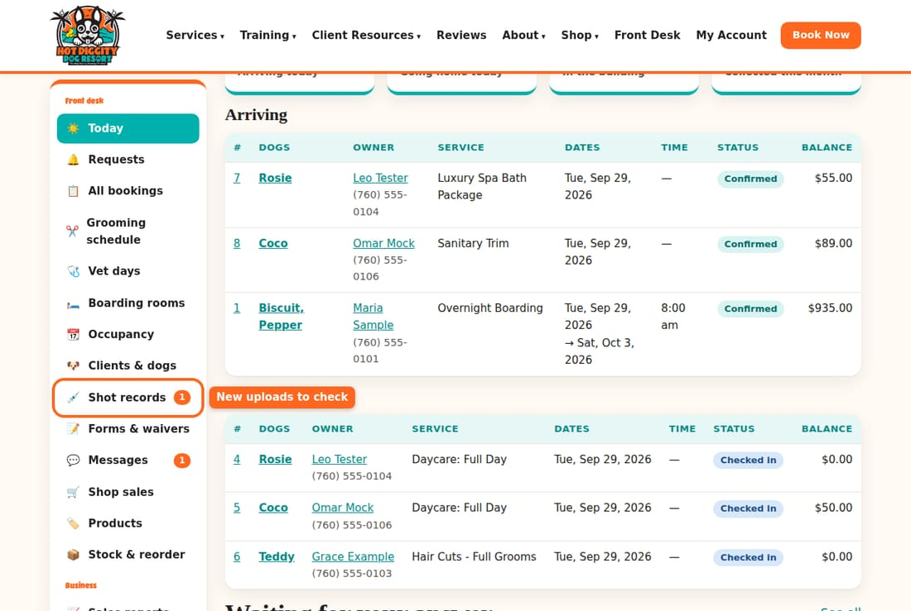
- Press Shot records. Each card is one record.
- Press Open the record to see the paper. It opens in a new tab.
- Look at the date the shot runs out. Does it match the box? If the client typed it wrong, fix the date.
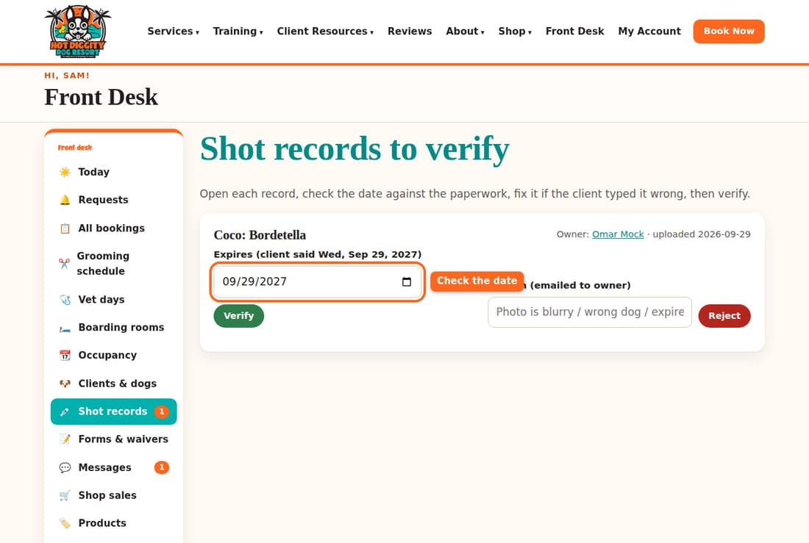
- If it is right, press Verify.
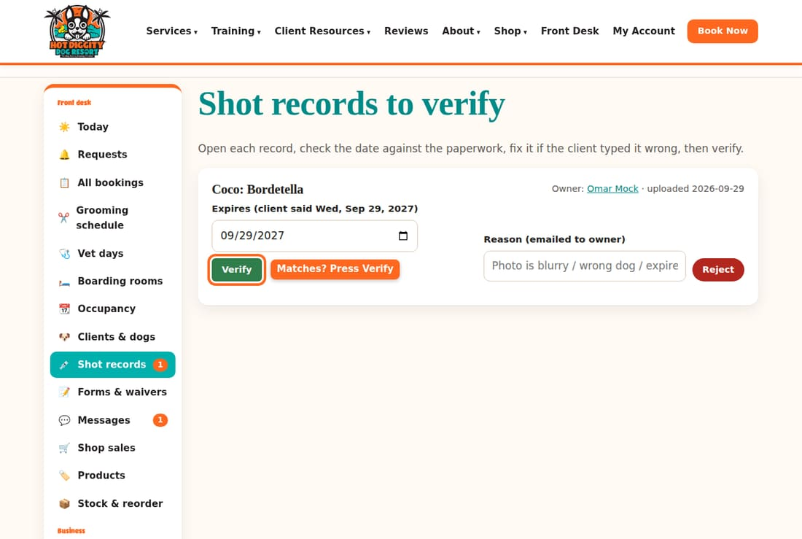
- If it is wrong (blurry, wrong dog, or out of date), type why in Reason (emailed to owner). Press Reject. The owner gets an email asking for a new copy.
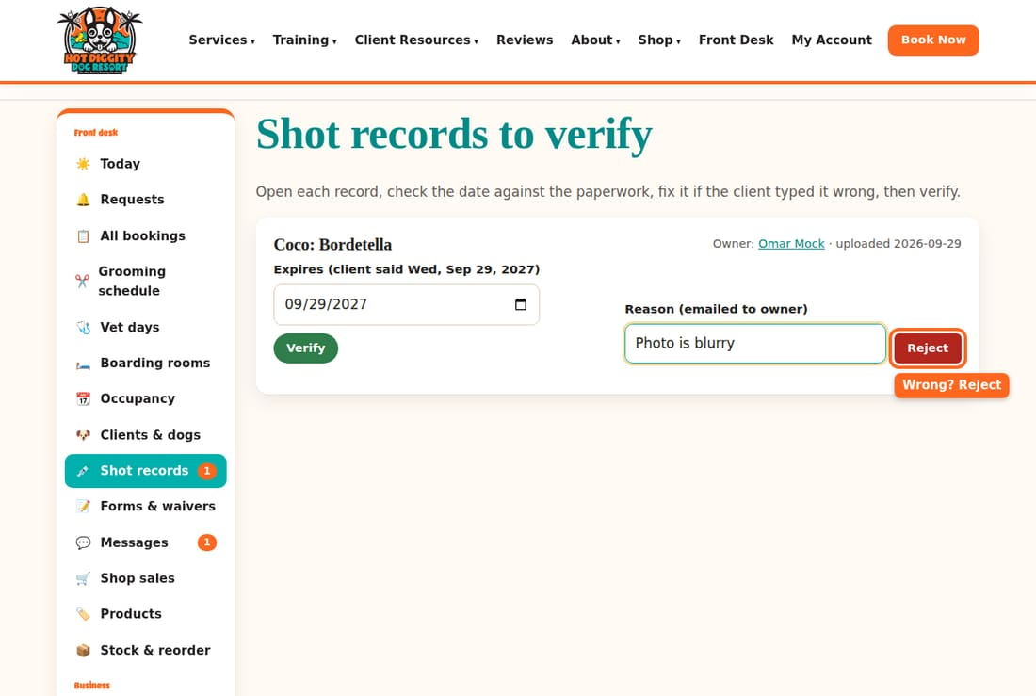
- When all are done, the page says All caught up.
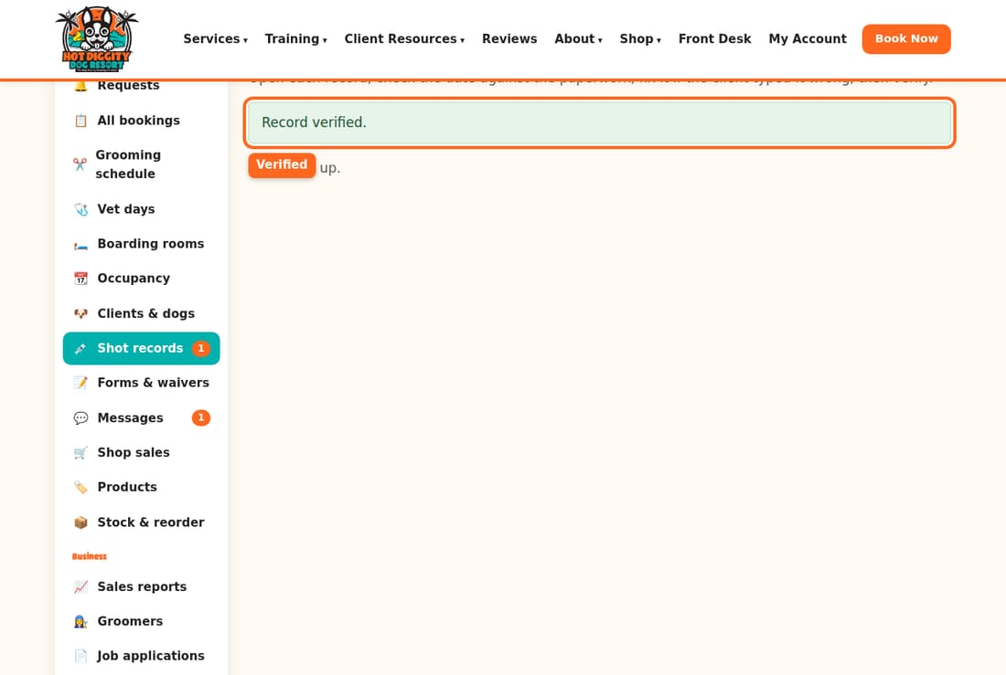

Add a paper record at the desk
- Open the client page. Open the dog under Dogs.
- Under the shot table, pick the Vaccine. Type the Expires date.
- If you can, add a photo or scan in File (optional).
- Press Add verified record.
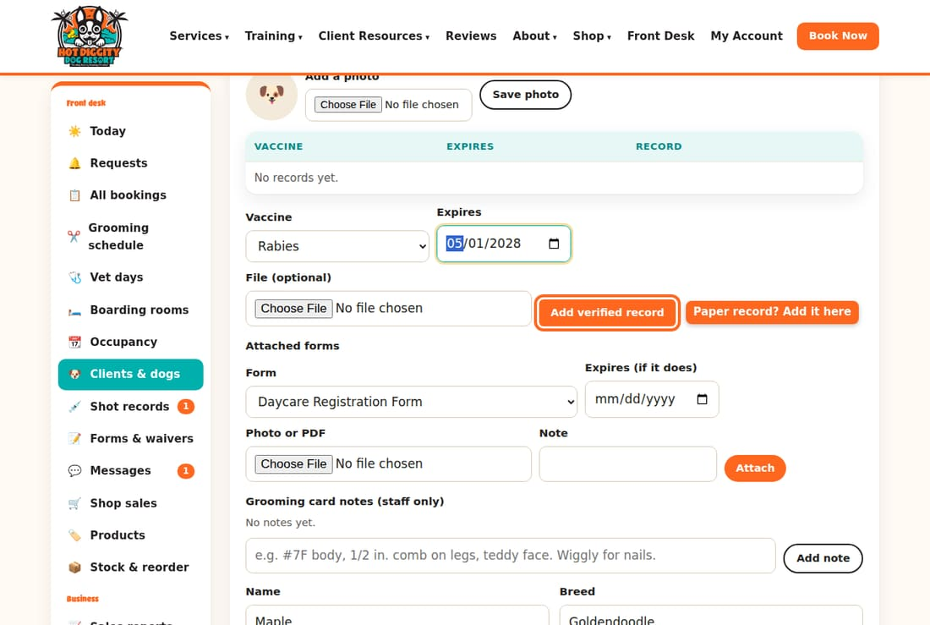

What the colors mean
- Green: on file, checked, and current.
- Yellow or (unverified): on file, but nobody checked it yet.
- Red or missing: out of date, or we don't have it.
Good to know: The Today page lists Shots expiring soon (booked dogs). These are booked dogs with a shot that runs out in the next 2 weeks. Ask the owner for the new record.
Good to know: No shots on file, no daycare or boarding. Shots must be current before the first visit.
If something goes wrong: Can't read the photo? Reject it with the reason "Photo is blurry." Or call the vet and ask them to email it.

Forms and waivers
See who signed, read a signed form, and add a paper form.
Clients sign our forms online, like the waiver and the Food & Medication form. They must sign before they can book. You can read every signed form.

Steps
- Press Forms & waivers in the menu. You see each form we use.
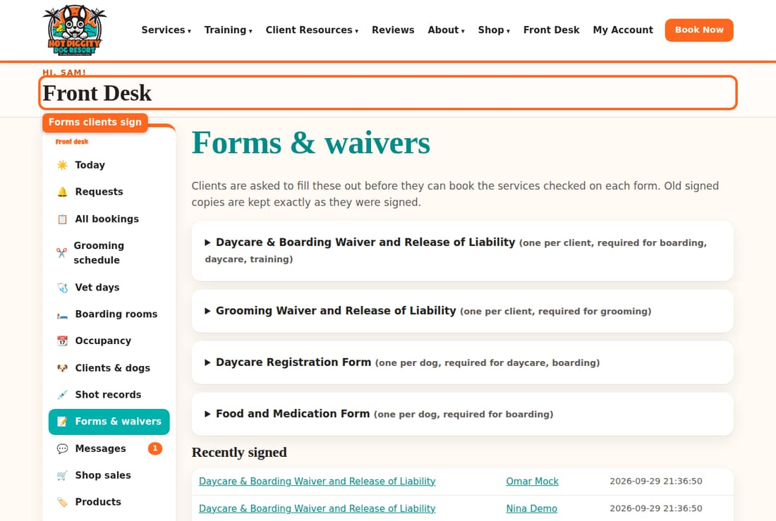
- Scroll to Recently signed. Press a form name to read it.
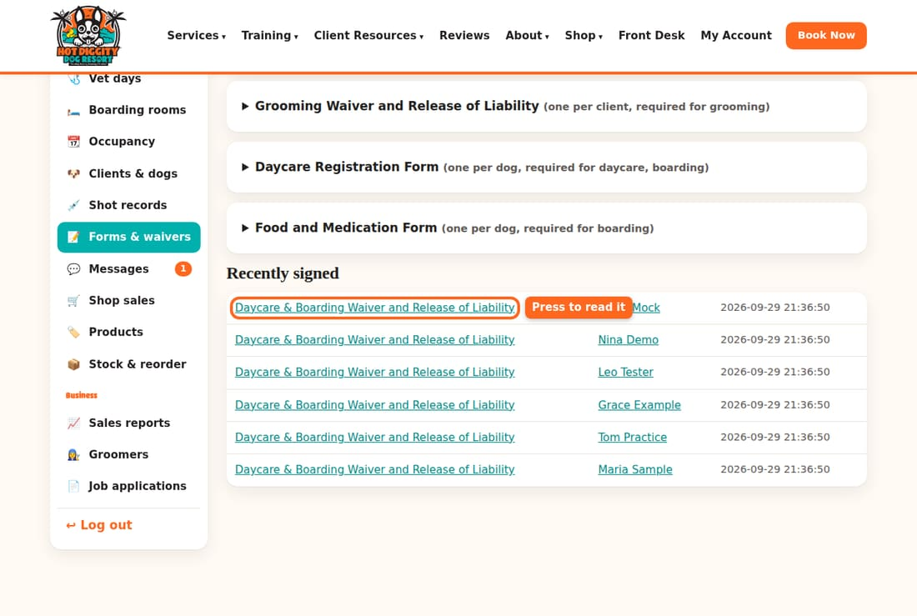
- The signed form shows the client, the dog, the date, and the name they signed with. Print it from the browser if you need paper. The time shown is in UTC, which is 7 or 8 hours ahead of our time.
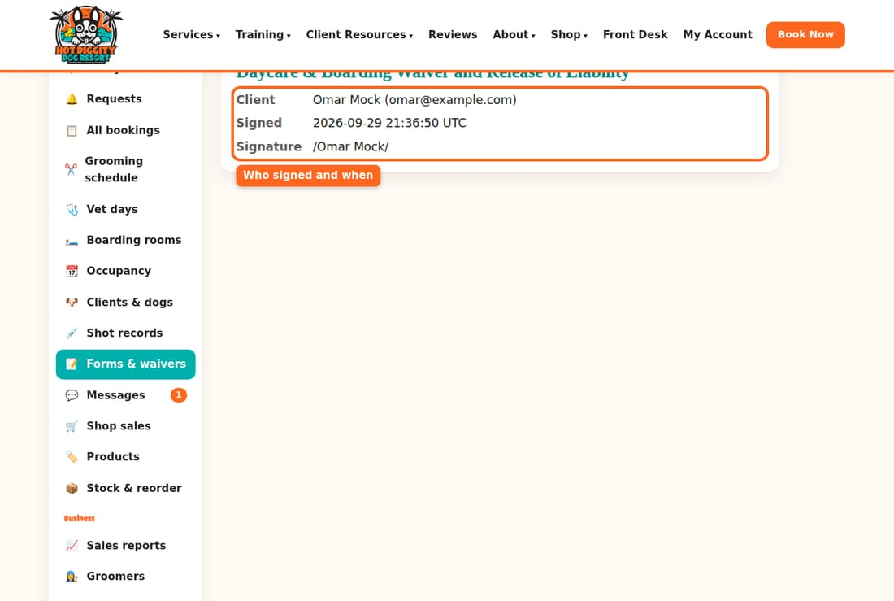
- To see one client's forms, open their client page. Scroll to Forms. current means it is still good. expired means they need to sign again.
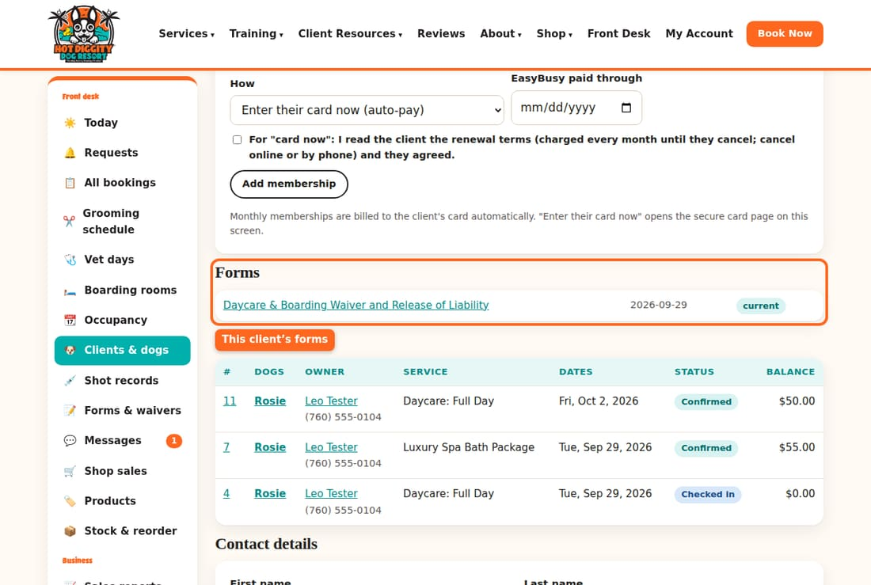

Add a paper form
Did a client fill out a paper form? Scan or take a photo of it.
- Open the client page. Open the dog under Dogs.
- Find Attached forms. Pick the Form.
- If it runs out, type the Expires date.
- Pick the photo or PDF in Photo or PDF. Add a Note if you want.
- Press Attach.
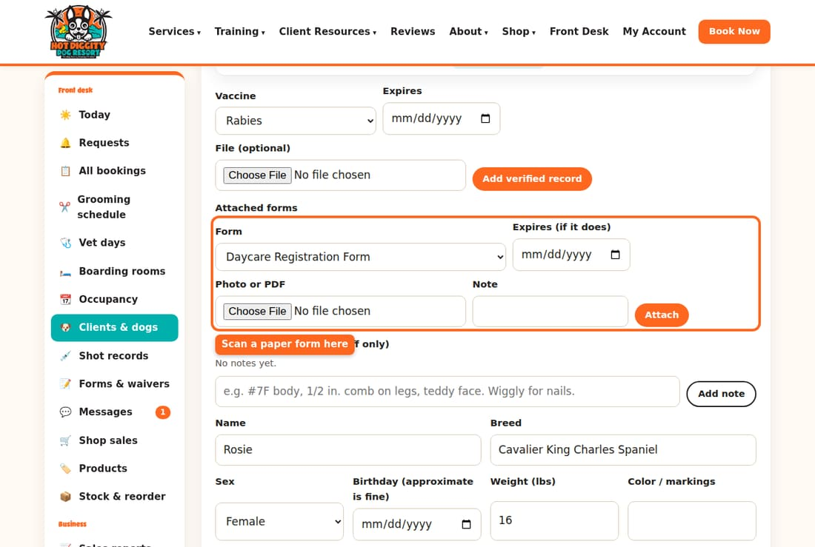
Good to know: Only David can change the words on a form. You can read them, but not edit them.
Good to know: Old signed forms never change. We keep them just as the client signed them.
Tip: No Food & Medication form for a boarder? The printed sheet says so. Fill it in by hand at drop-off.
If something goes wrong: A client says the site won't let them book because of a form? Ask them to log in to their account and sign it there. Then they can book.

Messages and texts
Read and answer client texts, and know what CANCEL and STOP do.
Clients can text our business number. Their texts show up in Messages. You answer from the website, not from your own phone.

Answer a text
- Look at Messages in the menu. A red number means something new.
- Press Messages. New ones are at the top, in bold, with a new tag.
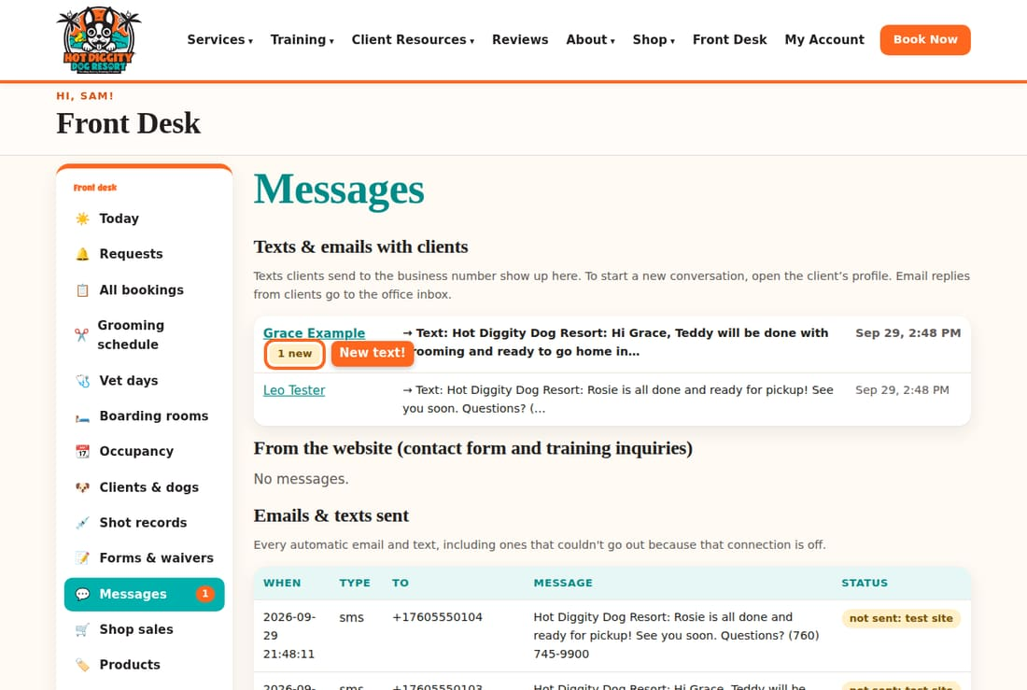
- Press the client's name. You see all the texts and emails, like a phone's messages app.
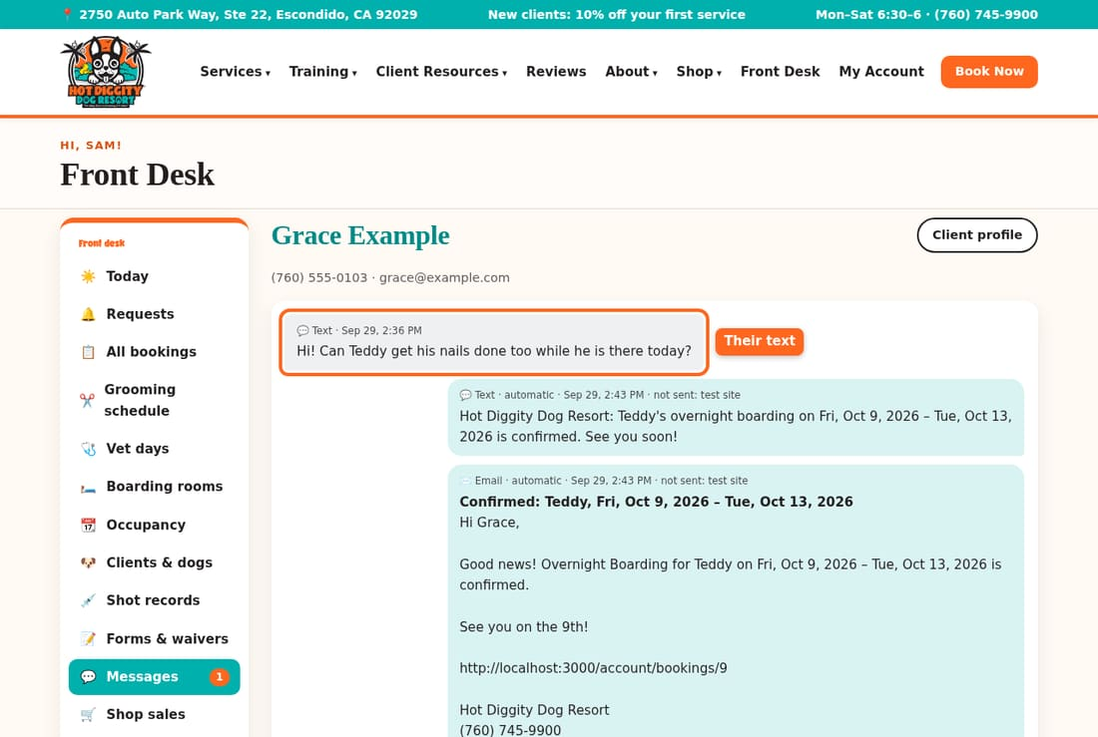
- Type your answer in Message. Leave Send as on Text message.
- Press Send.
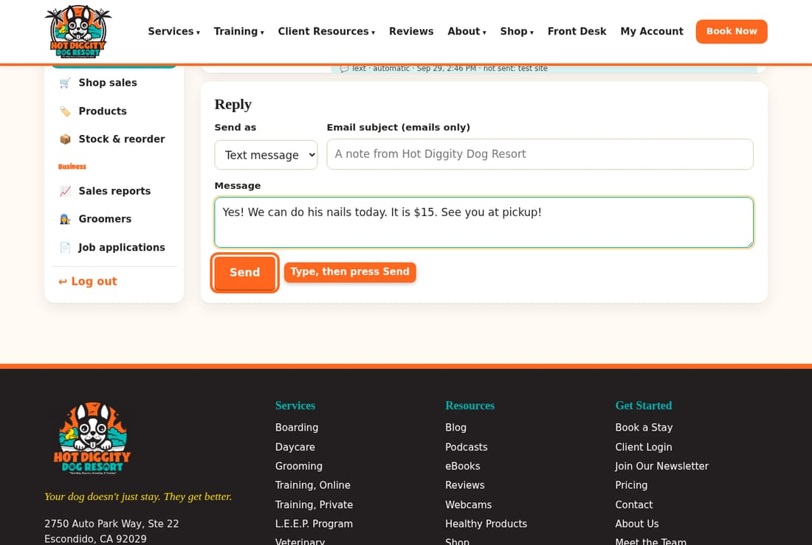
- Your answer shows at the bottom of the chat.
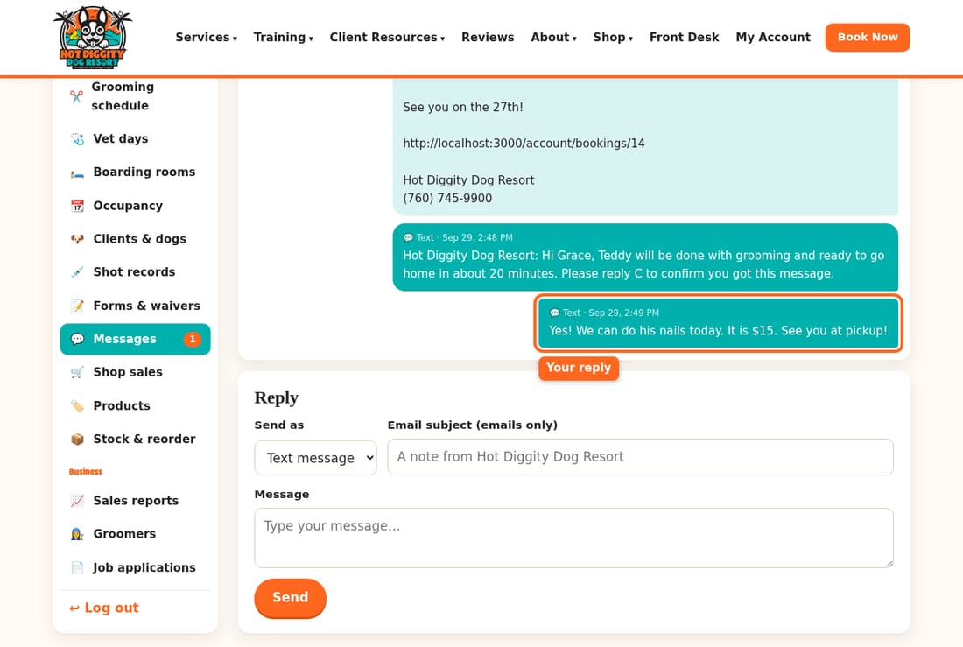

Start a new text
- Open the client page. Find Text or email the client.
- Type the message. Press Send.

Texts from a number we don't know
Sometimes a text comes from a number that isn't on any client. The page says so. Press Find or add the client. Put the number on their profile. Their next texts will show under their name.

CANCEL and STOP
If a client texts only the word CANCEL or STOP, the phone company turns their texts off. After that, we can't text them.
- A text that says only CANCEL shows a red box: "CANCEL" by itself turned this client's texts off. They may have meant their appointment. Please call them. Call them. Ask what they meant.
- When texts are off, the client page says (texts turned off). You can only send an email.
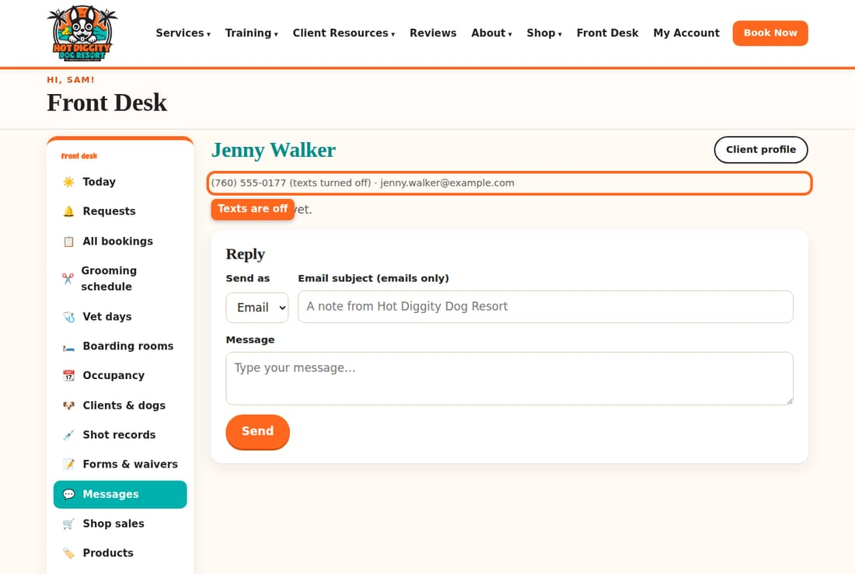
- To turn texts back on, the client texts START to our number.
Good to know: Don't tick OK to text again for a client who texted STOP. Only the client can turn texts back on, by texting START.
Good to know: Email replies from clients go to the office inbox, not here.
Tip: From the website lists notes from our contact form. Answer them, then press Mark handled.
Tip: Emails & texts sent lists every message the system sent by itself, like reminders.
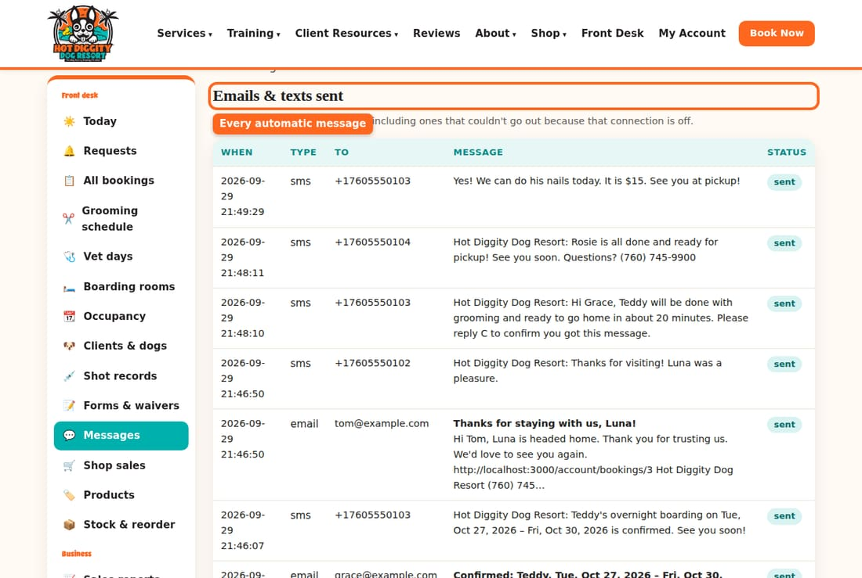
If something goes wrong: A red box says the client has turned off texts? Change Send as to Email and send it that way. Or call the client from the desk phone.

Shop sales
Ring up food, treats, and other items at the desk.
Use Shop sales to sell items at the desk. Sales take the items off the shelf count by themselves. Online orders that are ready for pickup show here too.

Ring up a sale
- Press Shop sales in the menu. Press New sale.
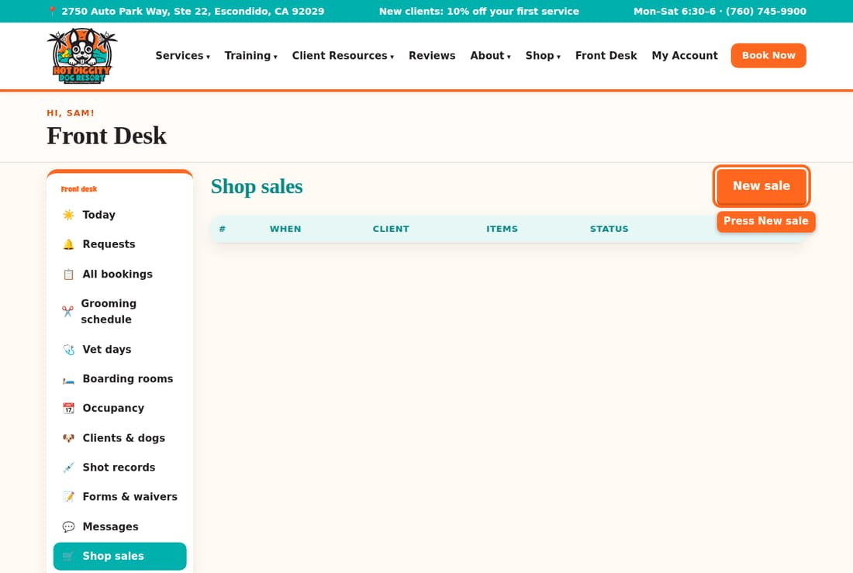
- In Add product, pick the item. Change Qty if they want more than one. Press Add.
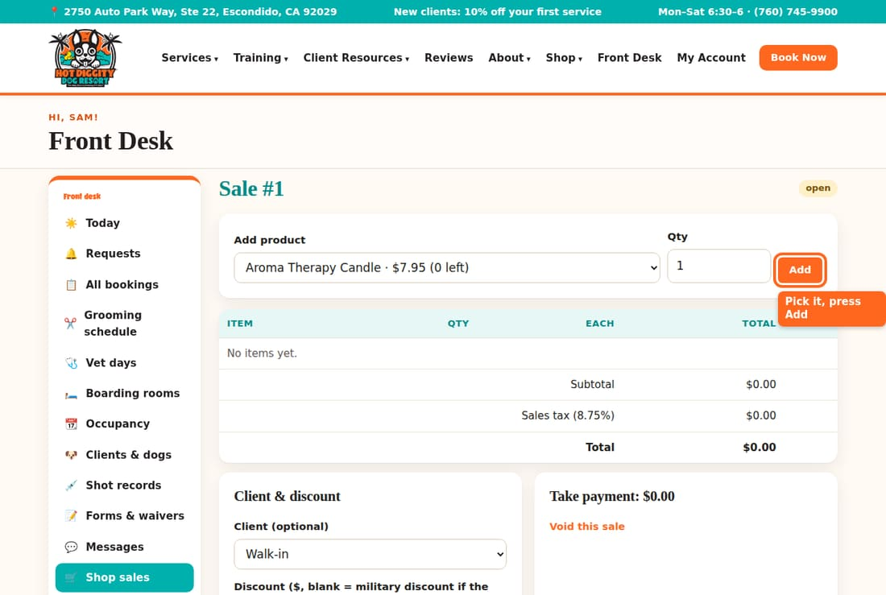
- Do it again for each item.
- Is it a client? Pick them in Client (optional). Press Save. Military clients get their discount by themselves.
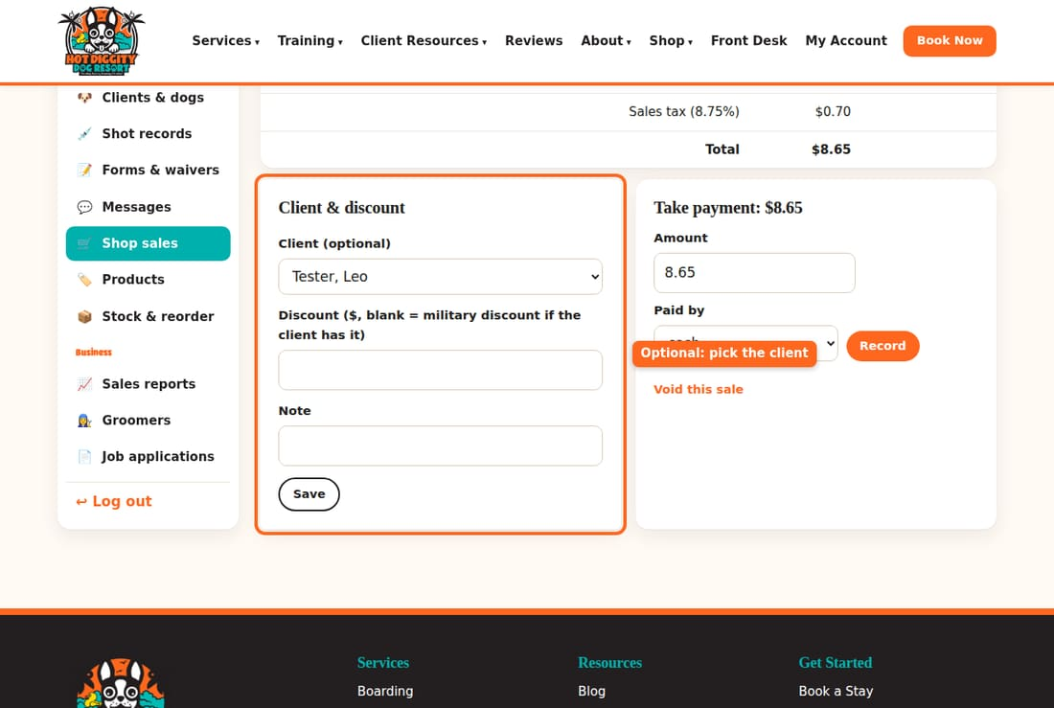
- Check the items, the tax, and the Total.
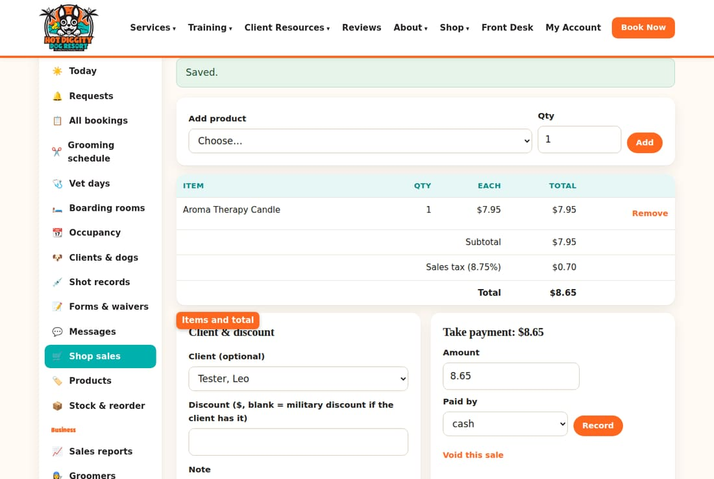
- Under Take payment, pick how they paid in Paid by. Press Record.
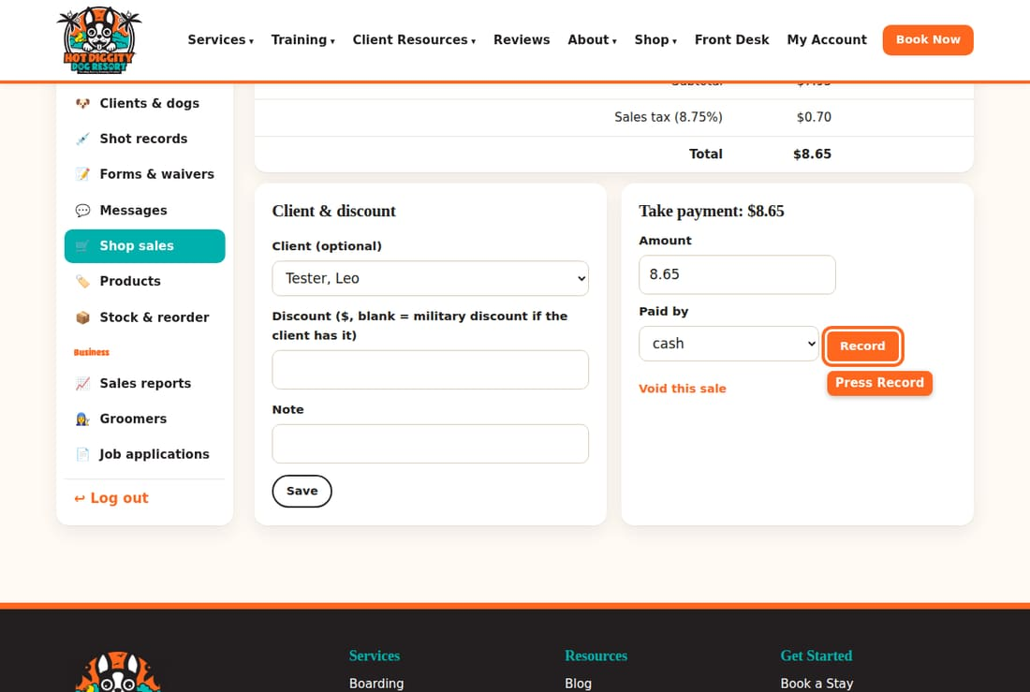
- The top now says paid.
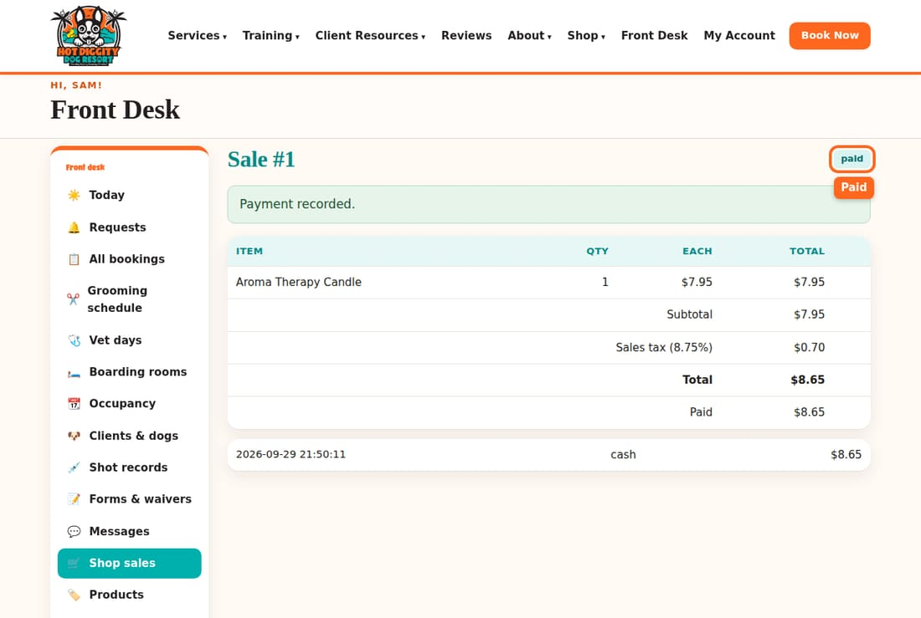

Online orders for pickup
- On the Shop sales page, look for the blue box Online orders waiting for pickup.
- Press the order. Hand the client their items.
- Press Mark picked up.

Look up stock
- Products shows each item, its price, and how many we have. Type in Search to find one.
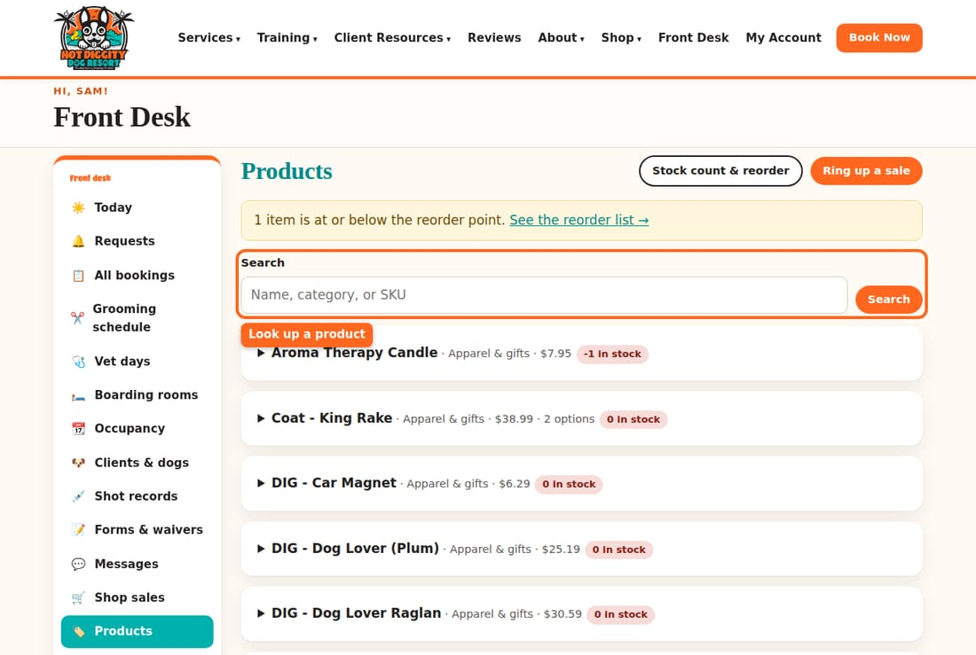
- Stock & reorder has the Reorder list and the Count sheet.
- When you count a shelf, type what is really there in New count. When a box comes in, type how many in Received. Press Save counts and deliveries.
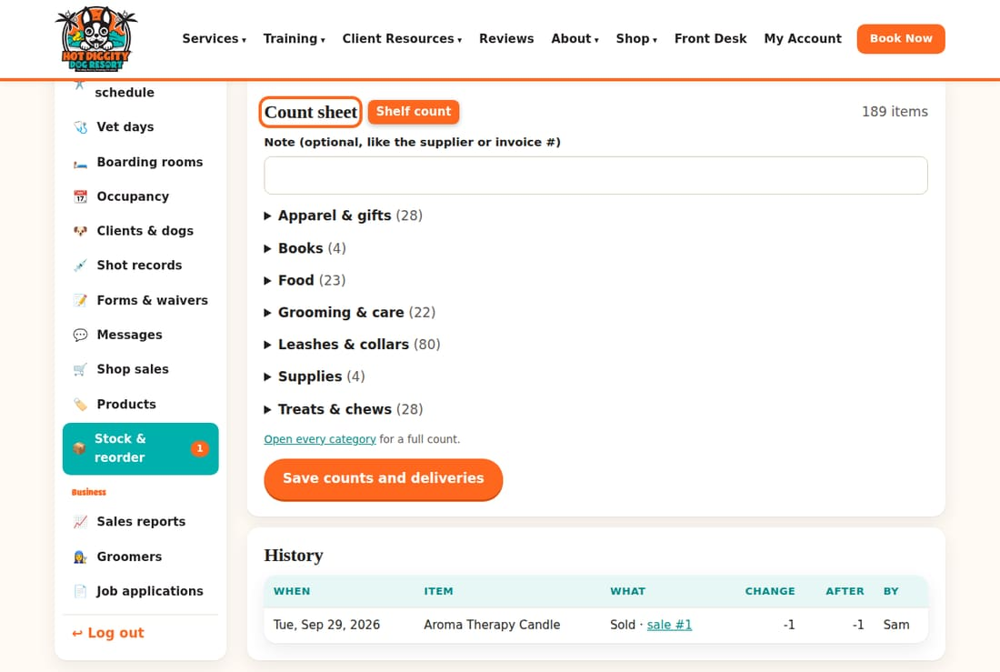
Good to know: Paid by card? Use the card reader if you see Charge on card reader. If not, run it on the other machine and pick card (other terminal).
Good to know: Only David can add products or change prices.
If something goes wrong: Added the wrong item? Press Remove next to it. Wrong sale, nothing paid yet? Press Void this sale.

Vet days
Book a teeth cleaning or shots with Dr. Moston.
Dr. Janet Moston comes every other Monday. She does teeth cleanings during the day. At 5:00 pm she has a shot clinic. You can book both from Vet days.

Book a vet visit
- Press Vet days in the menu.
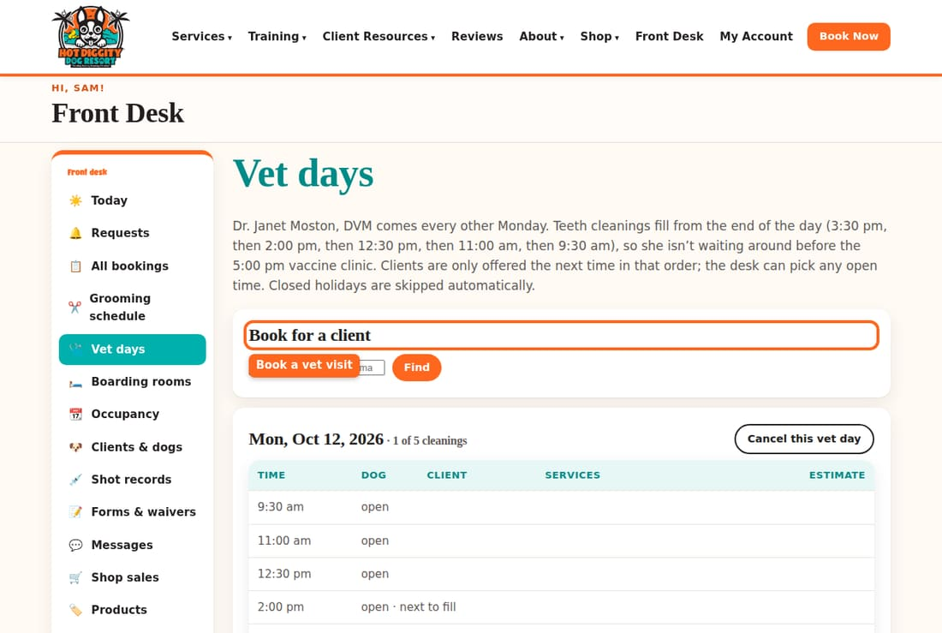
- Under Book for a client, type the client's name, phone, or email. Press Find.
- Press the client's name.
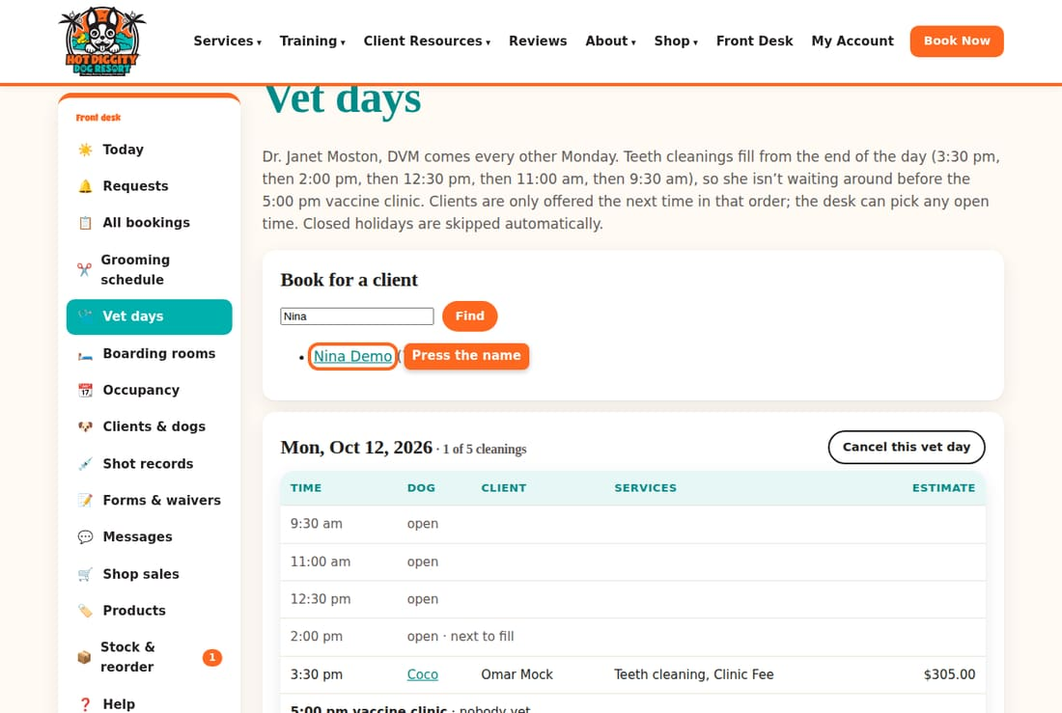
- Pick the Dog and the Vet day. The list shows the next open cleaning time.
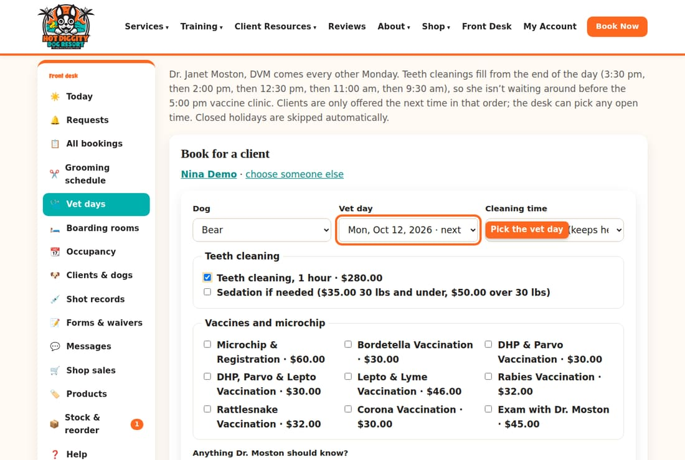
- For a cleaning, tick Teeth cleaning, 1 hour. Tick Sedation if needed only if the client wants it.
- Tick any shots or a microchip.
- Leave Confirm it now ticked. Press Book vet visit.
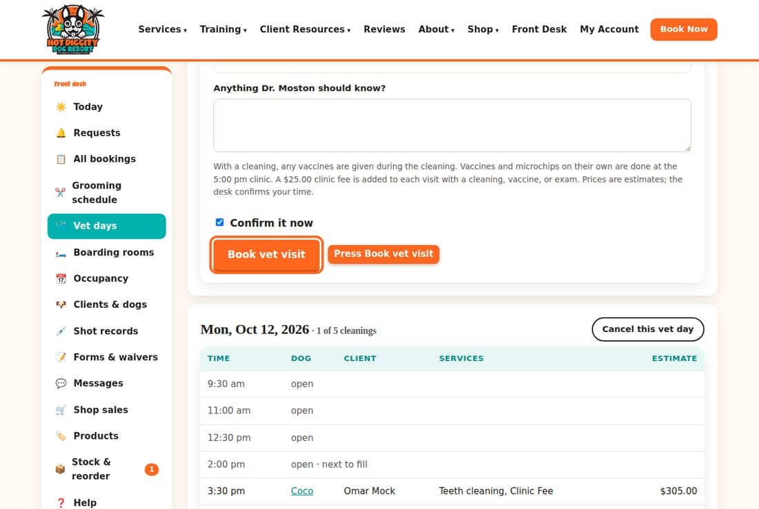
- The booking opens. It tells you the time.
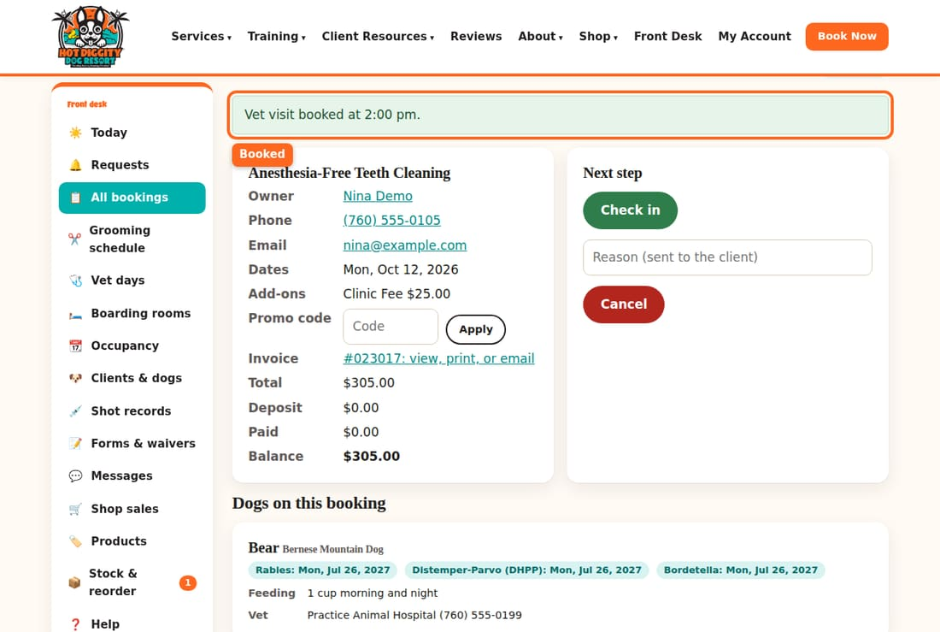

Read a vet day
Each vet day has its own box. It shows the cleaning times, who has each one, and the 5:00 pm vaccine clinic list.
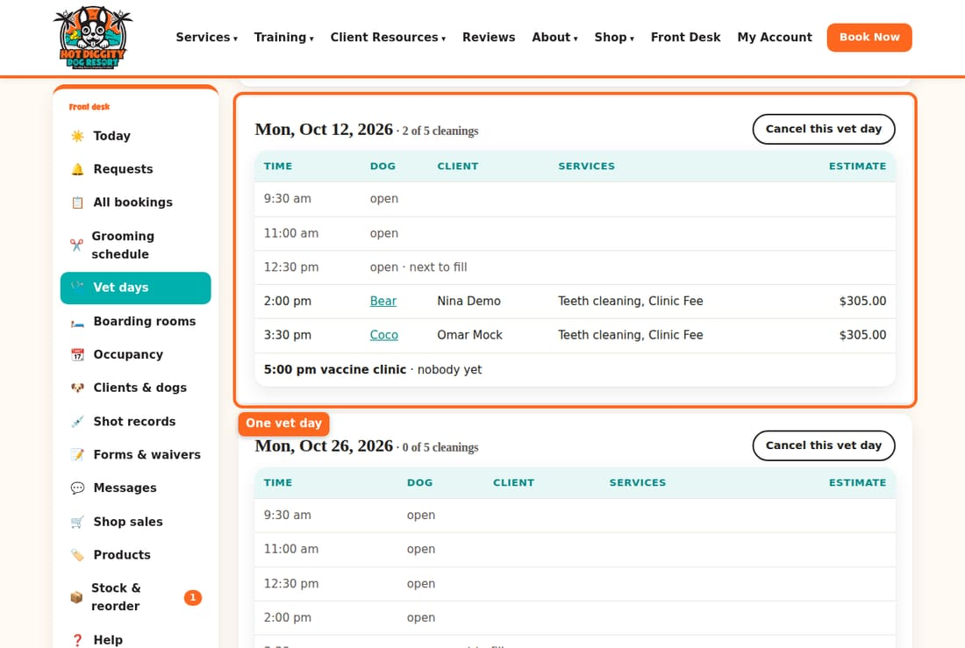
Good to know: Cleanings fill from the end of the day. The next one to fill says next to fill. You may pick any open time in Cleaning time. Leave it on Next open time unless the client needs a certain time.
Good to know: Shots with a cleaning are given during the cleaning. Shots by themselves are at the 5:00 pm clinic.
Good to know: Say "every other Monday." Vet days are skipped on closed holidays.
Good to know: The cleaning is done without general anesthesia. Light sedation is there if Dr. Moston thinks it is needed. Don't tell clients "no sedation ever."
If something goes wrong: Dr. Moston can't come? Only with David's OK, press Cancel this vet day. Clients can't ask for that day after that. To undo it, press Put back on.

Report cards and webcam logins
Send an owner a note about their dog's day, and give out camera logins.
While a dog is checked in, you can send the owner a report card. It tells them how the dog is doing. You can also give them the webcam login.

Send a report card
- Open the booking of a dog that is checked in. Scroll to Report cards.
- Pick the Dog. Type the Mood and Meals.
- Type a short Note to the owner.
- Leave Email/text it to the owner now ticked. Press Save report card.
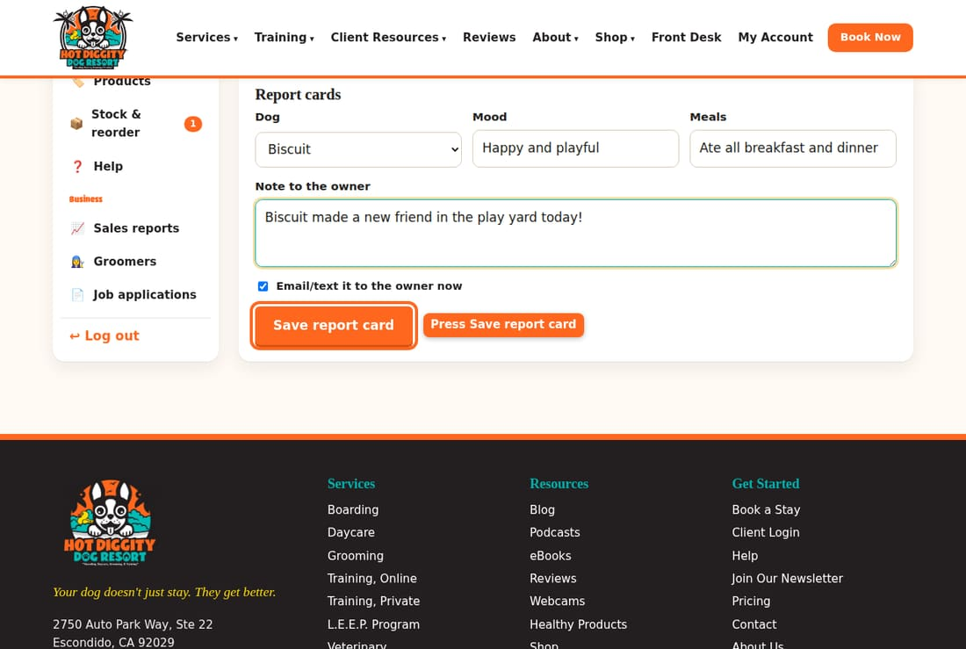
- The card shows under the form. The owner can see it in their account too.
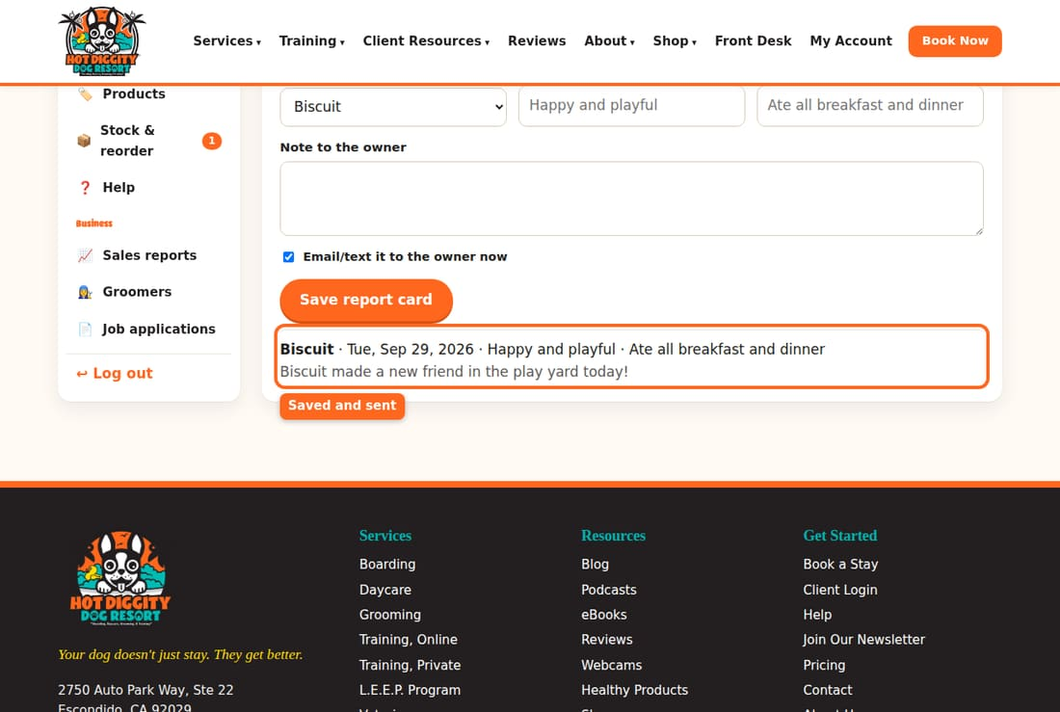

Give out a webcam login
- Open the booking. Look at Webcams. It lists the camera usernames.
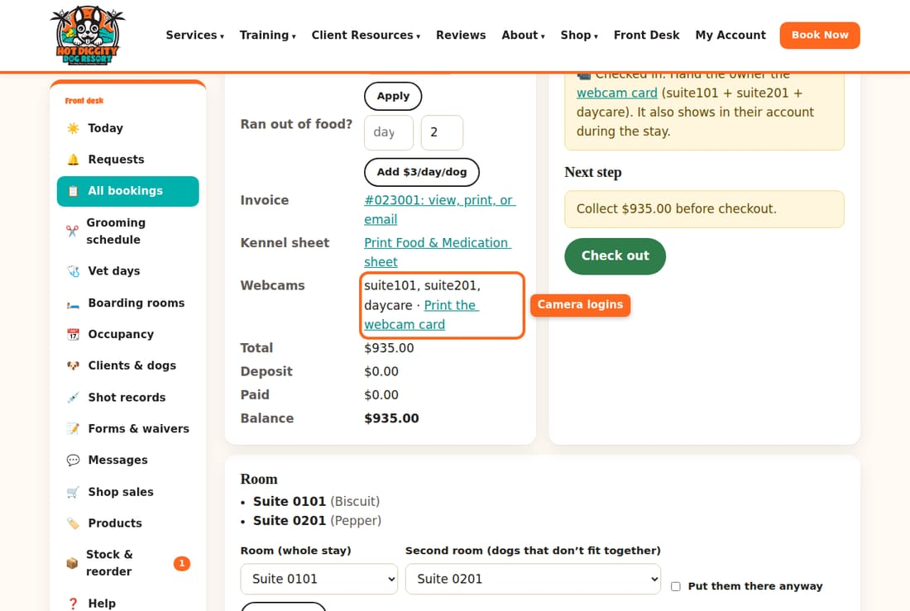
- Press Print the webcam card. Then press Print the webcam card at the top.
- Give the card to the owner. It has the web address, the username, and the password.
Good to know: Daycare has one camera login. Its username is "daycare." Each boarding suite has its own login. Its username is the suite number, like suite101.
Good to know: The camera password is not a secret. You may give it out on the phone.
Good to know: The cameras are not a way to watch dogs all night. There is no staff overnight. Never say we are open 24/7.
Good to know: Crates have no cameras.
If something goes wrong: The card says the camera password isn't saved yet? Tell David. He adds it in the settings.

Daycare passes and L.E.E.P.
Sell a daycare pass, use it at checkout, and sign a dog up for L.E.E.P.
A daycare pass is a bundle of daycare days paid up front. The 10-day pass is 5% off. The 20-day pass is 10% off. Each day used is one credit.

Sell a pass
- Open the client page. Scroll to Passes & memberships.
- In Sell a pass, pick the pass. Pick the Dog.
- In Paid by, pick how they paid.
- Press Add pass.
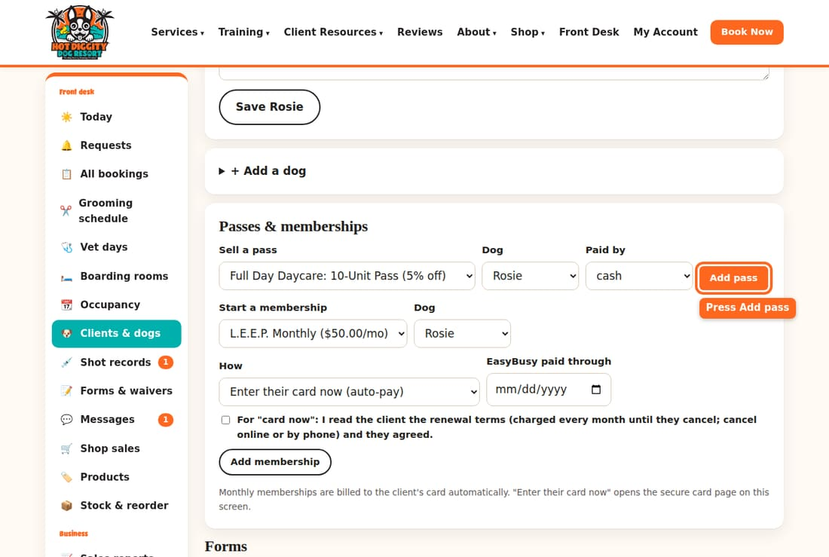
- The pass shows at the top of the box. It shows how many credits are left.
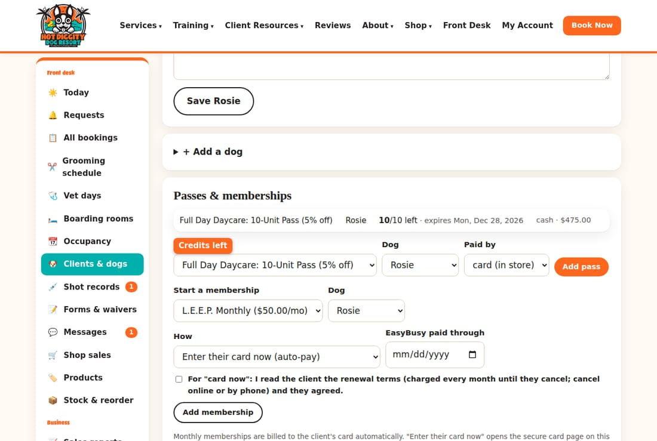

Use a pass at checkout
- Open the daycare booking. Scroll to Take a payment.
- A blue box says how many pass credits the client has. Press Use pass credits.
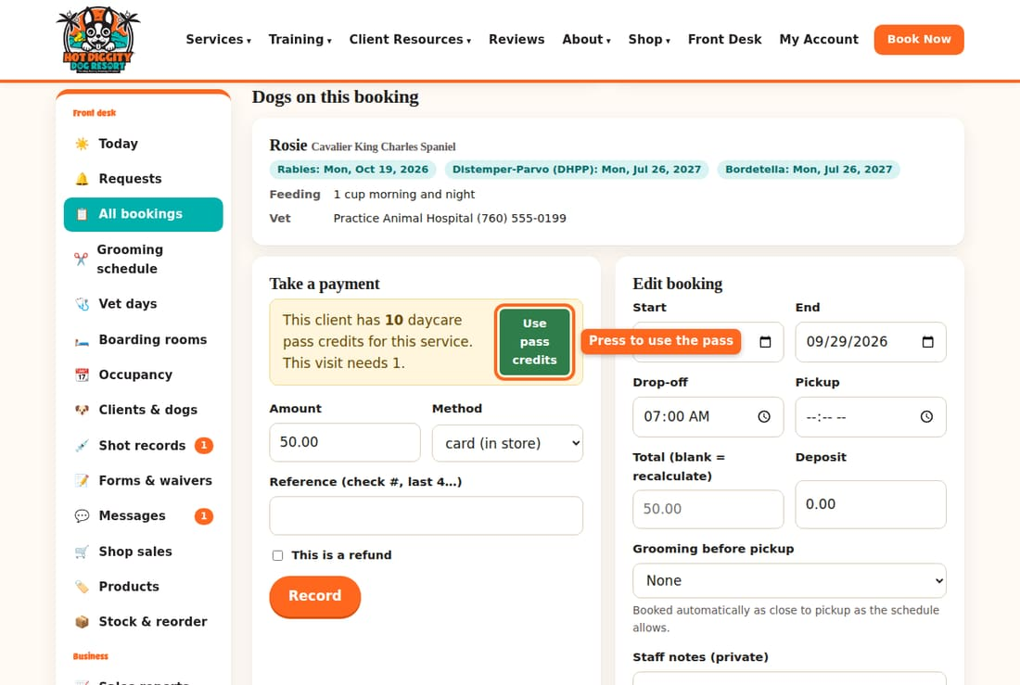
- The pass pays for the visit. It shows as daycare pass in the payments.
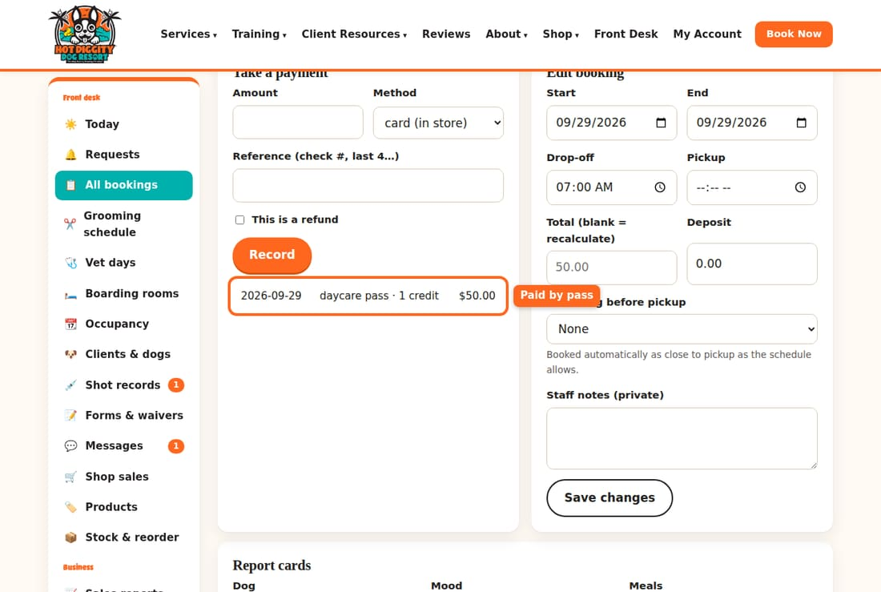
- Now check the dog out as usual.

L.E.E.P.
L.E.E.P. is our Life Enrichment Education Program. It is 15 minutes of one-on-one fun and learning during daycare or boarding. It is $10 a day, or $50 a month with L.E.E.P. Monthly.
To sign a dog up for L.E.E.P. Monthly:
- Open the client page. Scroll to Passes & memberships.
- In Start a membership, pick L.E.E.P. Monthly. Pick the Dog.
- In How, pick one:
  - Enter their card now (auto-pay). First read the client the renewal terms. They are charged every month until they cancel. They can cancel online or by phone. If they agree, tick the box that says you read them the terms.
  - Email them a sign-up link. They finish it at home.
- Press Add membership.
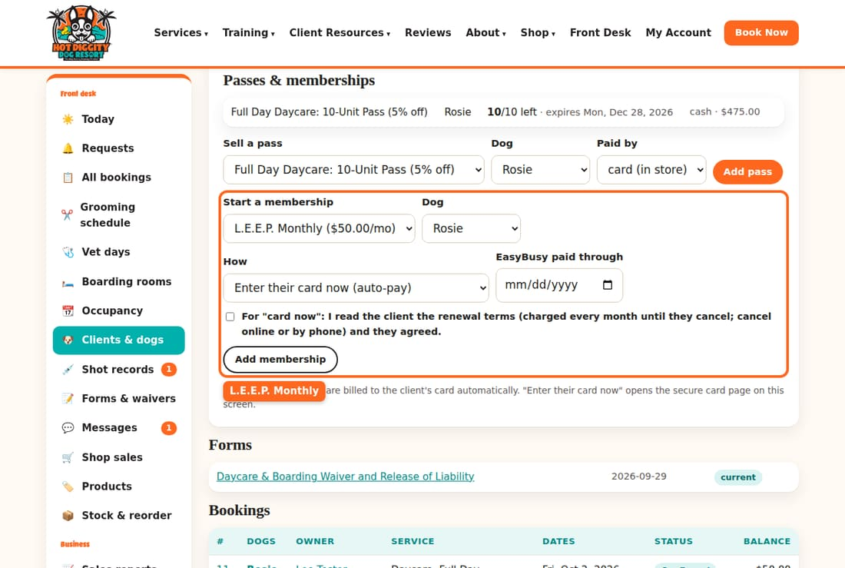
Members show an L.E.E.P. member tag on their bookings.
Good to know: The pass button only shows when the client has credits for that kind of daycare. A full-day pass works for full days. A half-day pass works for half days.
Good to know: Pressing Use pass credits twice does not use two credits. It works once per booking.
Good to know: Leave Still billed by EasyBusy and Comp / staff dog to David.
If something goes wrong: No pass button, but the client says they have a pass? Check that the pass is for the same dog. Also check that it has not expired.

Cancel or change a booking
Change dates or times, cancel a booking, and give a refund.
Plans change. You can change a booking's dates and times, or cancel it. Know the cancel rules before you do.

The cancel rules
- Boarding: the client must cancel at least 48 hours before.
- Grooming and everything else: at least 24 hours before.
- Cancel in time, and the payment is refunded.
- Late cancels and no-shows are not refunded. They may be charged a fee.
- Holidays may need more notice.

Change dates or times
- Open the booking. Scroll to Edit booking.
- Change the Start, End, Drop-off, or Pickup.
- Leave Total (blank = recalculate) empty. The price updates by itself.
- Press Save changes.
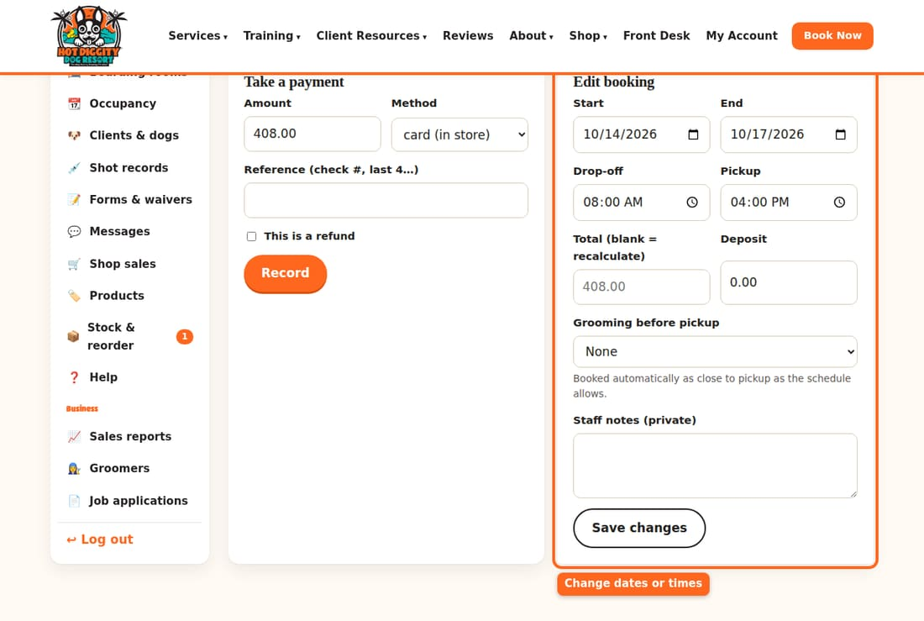
For a groom, use Move this groom instead. See The grooming schedule.

Cancel a booking
- Open the booking. Under Next step, type why in Reason (sent to the client).
- Press Cancel.
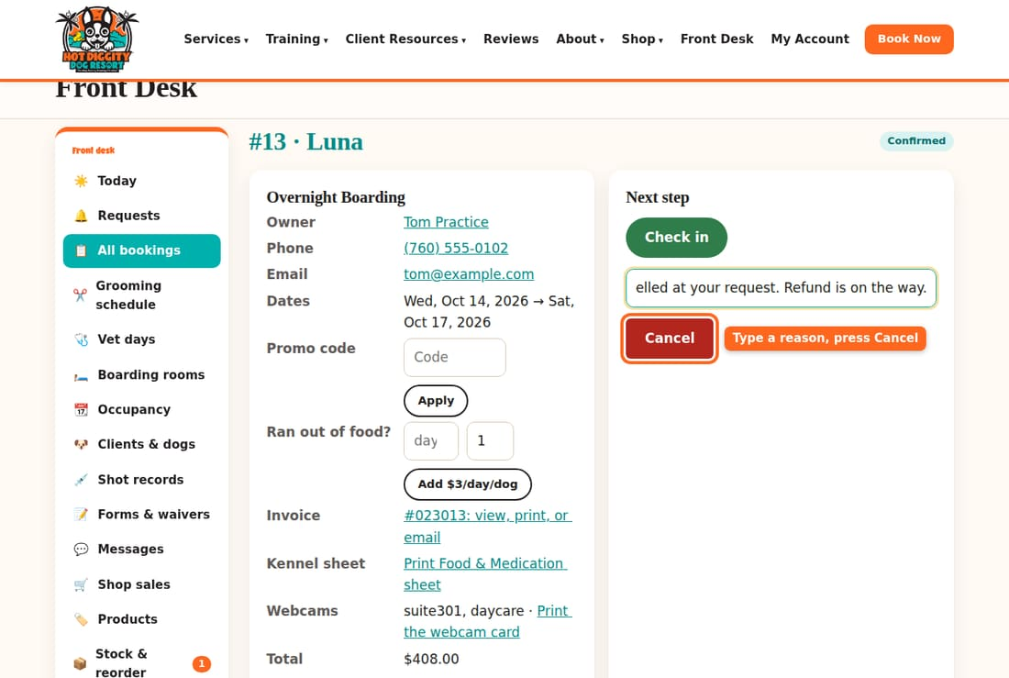
- The booking now says Cancelled. If you made a mistake, press Reopen. It goes back to a request.
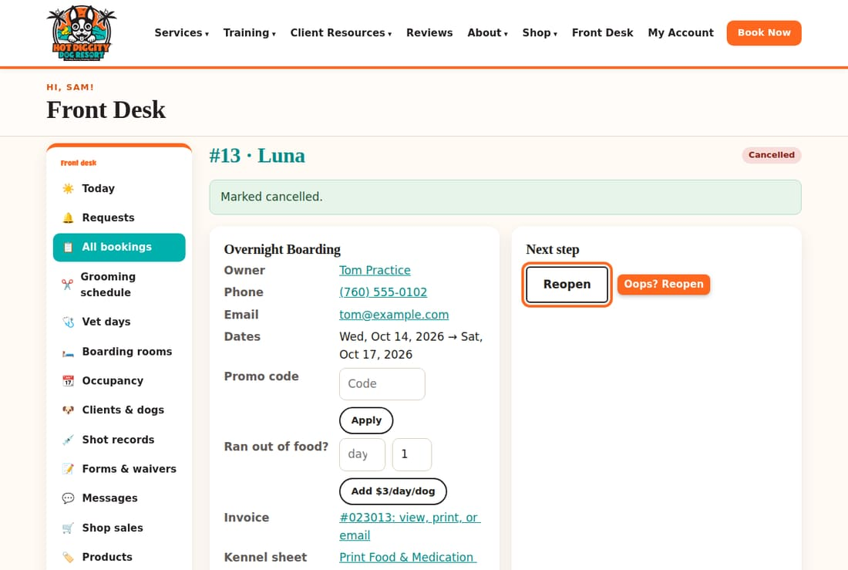

Give a refund
- Open the booking. Scroll to Take a payment.
- Type the refund amount. Pick the Method they paid with.
- Tick This is a refund. Press Record.
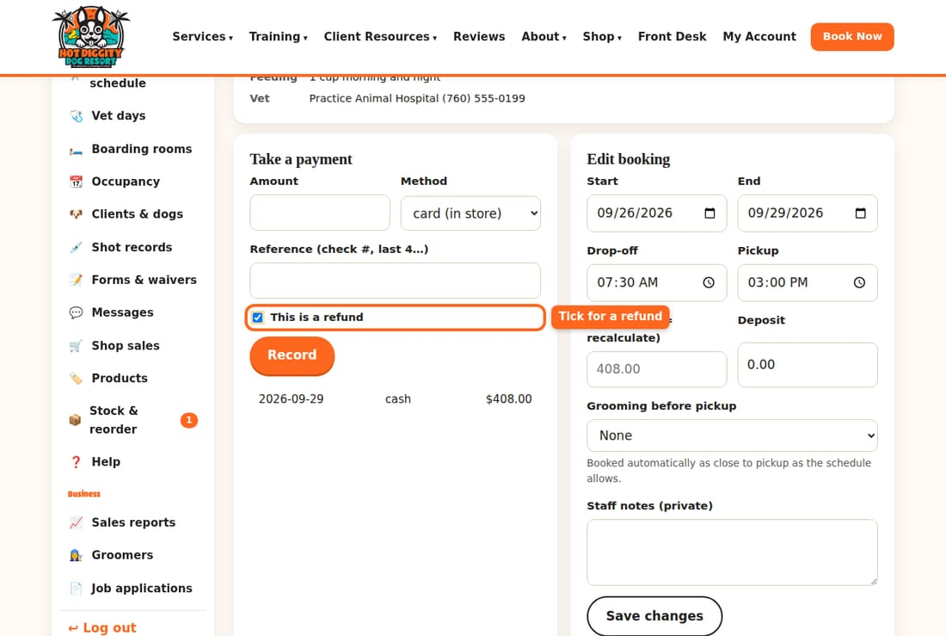
Good to know: Record with This is a refund only writes it down. It does not send money back. For cash, hand the money back. For a card, ask David to refund the card.
Good to know: If you type a reason, the client gets it by text or email. With no reason, no message is sent.
Tip: When a groom is cancelled, a waiting-list client may get that spot. Look at the waiting list on the grooming schedule.
If something goes wrong: Changed boarding dates and the suite changed? New dates can mean a new suite. Check the Room box after you save.

End of the day
A short list to check before you go home.
We close at 6:00 pm. Clients should arrive by 5:45 pm. Before you leave, do this list.

Steps
- Press Today. Look at Going home. Every dog on it should be checked out, with no balance.
- Look at In the building. These dogs stay tonight. Check that each one should be here.
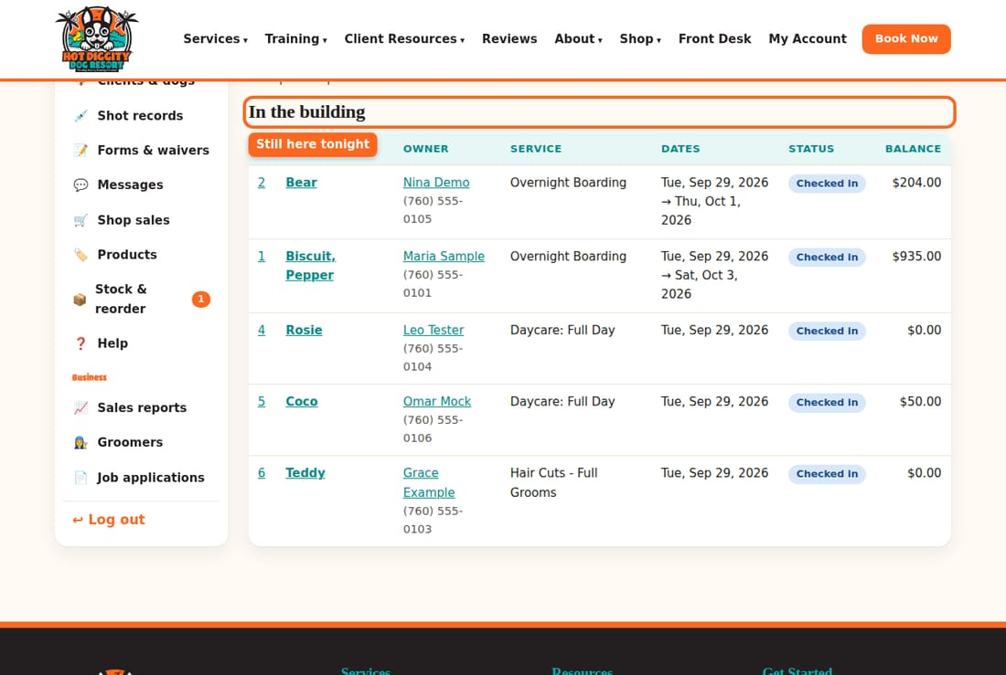
- Is there a red box about a dog past the pickup date and still checked in? Fix it now.
- Press Grooming schedule. Every groom in Grooms today should say Done.
- Press Messages. Answer any new texts.
- Press Requests. Answer what you can. Leave a note for the morning about the rest.
- Press Sales reports. Look at Outstanding balances. It lists who still owes us.
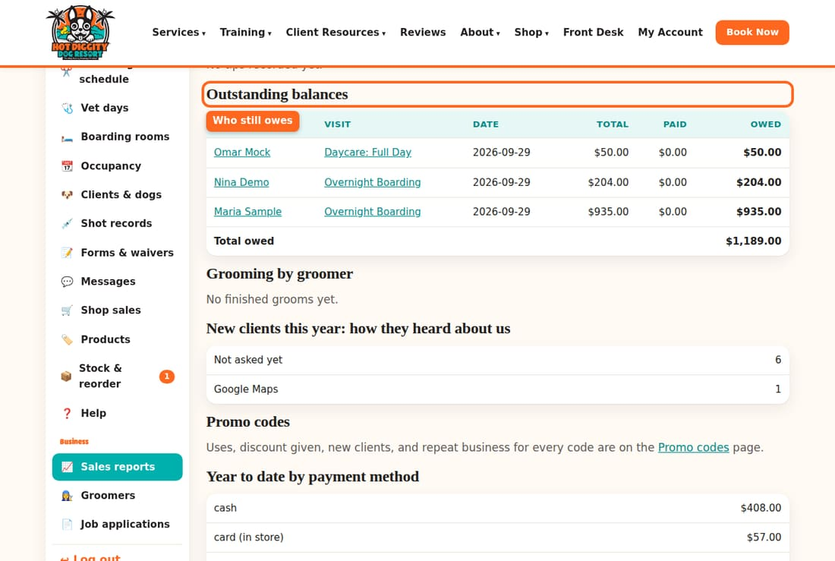
- Count the cash and checks. Put them away the way David shows you. There is no end-of-day cash report on this site yet.
- Press Log out at the bottom of the menu.
Good to know: There is no staff here overnight. Make sure every boarder has food, water, and meds as the sheet says.
Tip: Anything strange? Write it in the booking's Staff notes (private) box. Press Save changes. The next shift will see it.
If something goes wrong: A dog was not picked up? Call the owner. Call the emergency contact on the client page next. Tell David.

Coming from EasyBusy
Where things moved, and what works in a new way.
You already know how to run the desk. Only the screens are new. This page shows where your old jobs live now.

Where things are now
- The day's list: press Today. Arriving, going home, and in the building are all on one page.
- Find a client or dog: press Clients & dogs. Search by owner, dog, email, or phone.
- Find a booking: press All bookings. Search, or pick a Status and dates. Press Filter.
- New booking: open the client page. Grooms are at the top. Boarding and daycare are under it.
- Check in and check out: open the booking. Use the buttons under Next step.
- Take a payment: open the booking. Use Take a payment.
- Grooming book: press Grooming schedule.
- Kennel and room chart: press Boarding rooms.
- Shot records: press Shot records, or open the dog on the client page.
- Retail sales: press Shop sales.
- Grooming card notes: on the dog, and on each groom's booking.
- Old invoices from EasyBusy: on the client page, open EasyBusy history.

What is new or different
- Requests. Some online bookings wait for your yes or no. See Answer booking requests.
- Clients do more online. They sign up, add dogs, upload shots, sign forms, and book.
- Texts come to the website. Answer them in Messages, not on a phone.
- The 20-minute text. Groomers text the owner. The owner replies C. See Groomers: the 20-minute text and Done.
- Suites are picked for you when a booking is confirmed, at the desk or from Requests.
- Lunch floats. Groomer lunches move by themselves to fit the day. Drag one to pin it.
- Webcam cards print from the booking.
- Report cards go to the owner by text or email.
- Card reader tips go to the groomer on the appointment.
Good to know: Some L.E.E.P. Monthly members are still billed by EasyBusy until the switch is done. David handles that.
Tip: Not sure where something is? Press Help in the menu. Or ask David.

Groomer hours and time off
See each groomer's week, and add a day off or other time away.
The Groomers page shows who works which days. You can add time off. Only David can change a groomer's weekly hours.

See the groomers
- Press Groomers in the menu. Each row is one groomer. Works shows their days.
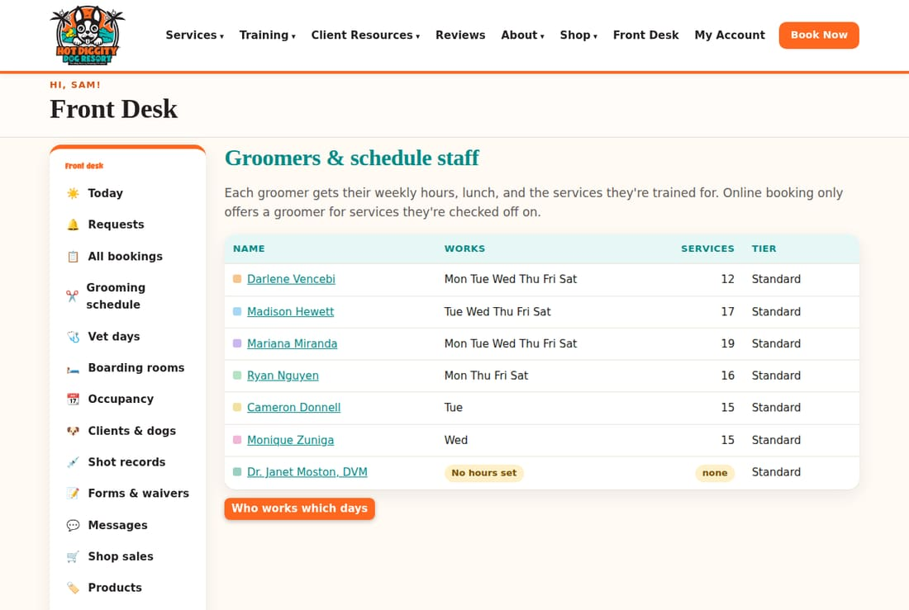
- Press a groomer's name to see their hours, lunch, and the services they are trained for.

Add time off
- Open the groomer. Scroll to Time off & one-off changes.
- Pick the Day. Type From and To.
- Type a Label, like "Day off" or "Vet appt."
- Press Add.
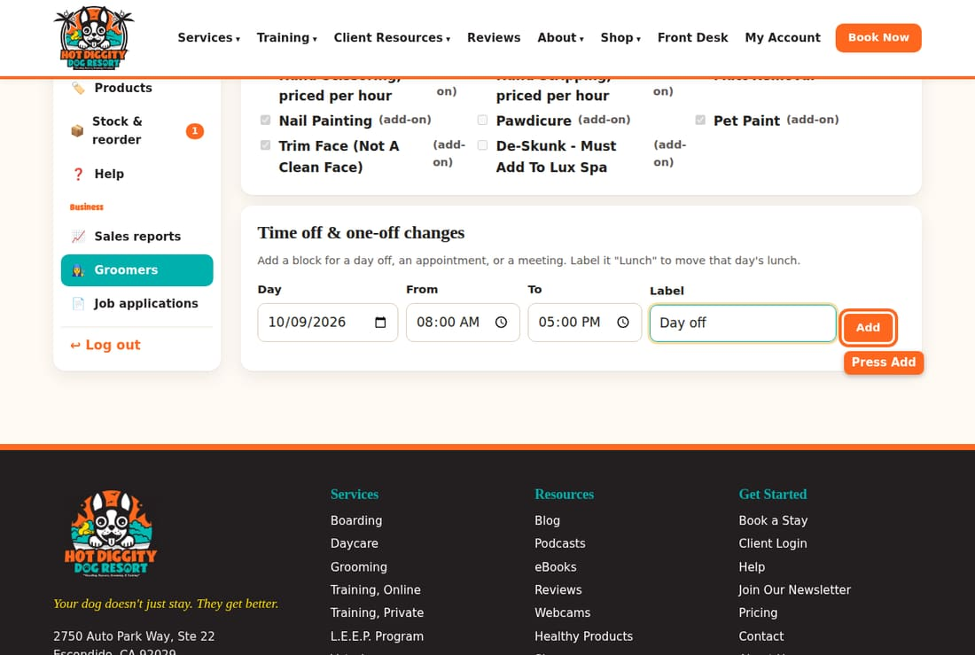
- The time off shows in the list. It also shows on the grooming schedule that day. To take it off, press Remove.
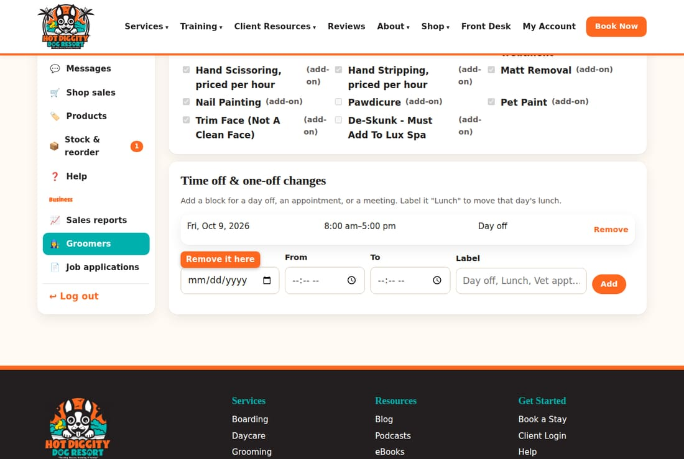
Good to know: Time off does not move grooms that are already booked. Look at that day on the grooming schedule. Move or call about any grooms in that time.
Good to know: Label a block "Lunch" to move that day's lunch.
Tip: Online booking only offers a groomer for the services they are trained for.

Temperament Assessment day
Book a new dog's first daycare day, then mark if the dog passed.
Every new dog starts with a Temperament Assessment. It is a full daycare day. Our team watches how the dog plays and acts. It costs the regular daycare rate.

Book it
- Open the client page. Go to Boarding, daycare & other bookings for the client.
- In Service, pick Temperament Assessment (first daycare day).
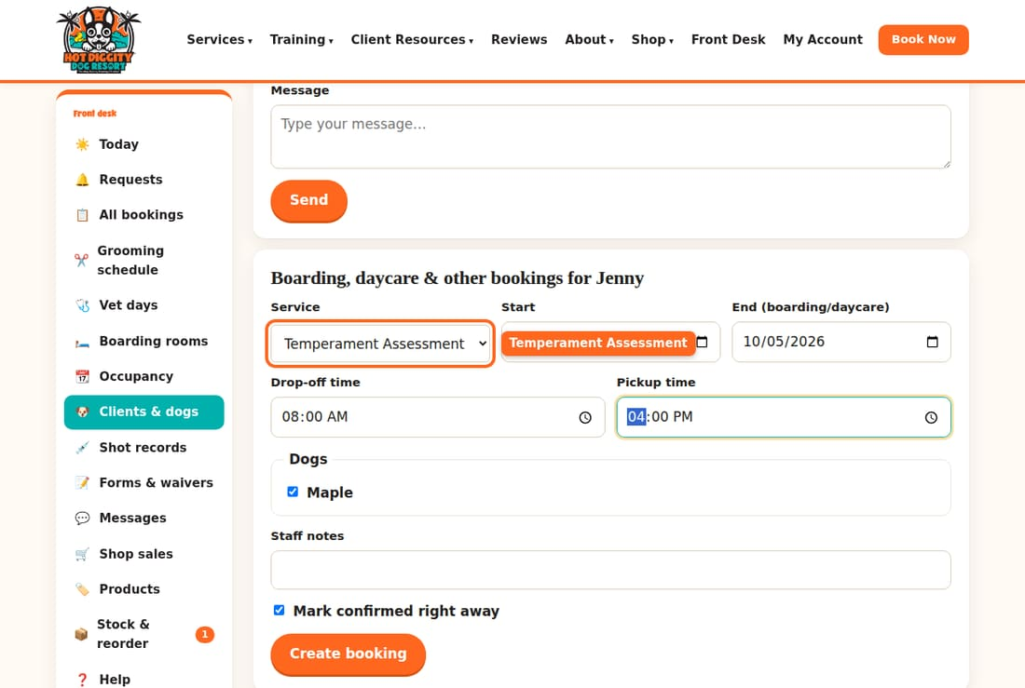
- Pick the date. Tick the dog. Press Create booking.

Rules to tell the client
- Drop off by 10:00 am. Drop-off can be as early as 6:30 am.
- Pick up no earlier than 3:00 pm.
- The dog needs Rabies, DHPP, and Bordetella on file.
- The dog must be spayed or neutered before 8 months of age.
- The dog needs a new assessment after six months away.

After the day
- Open the booking. Scroll to Dogs on this booking. Check the shot boxes.
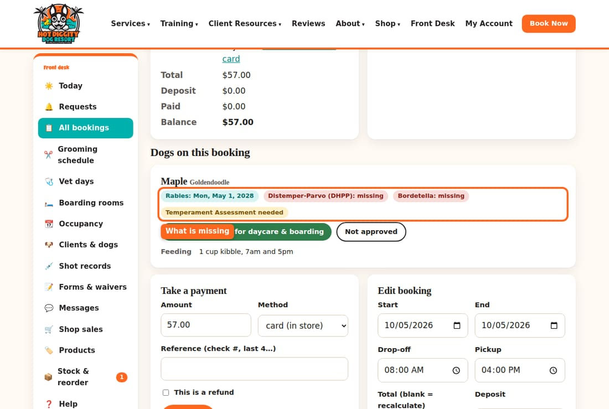
- Did the dog pass? Press Passed: approve for daycare & boarding.
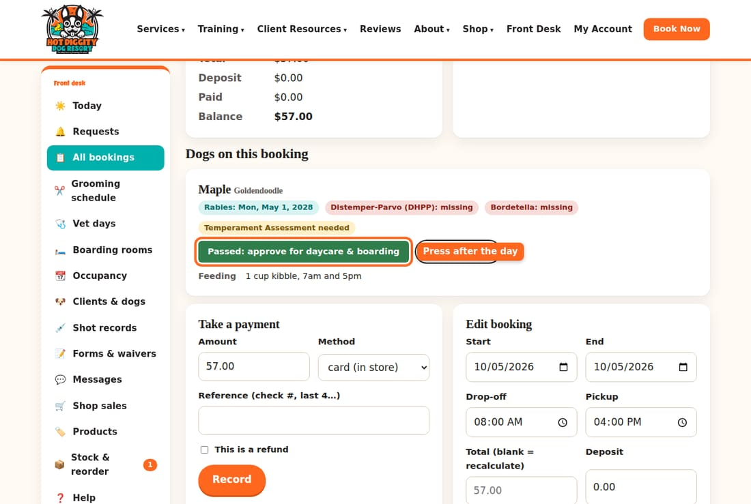
- Didn't pass? Press Not approved.
- A dog that passed shows Approved and the date.
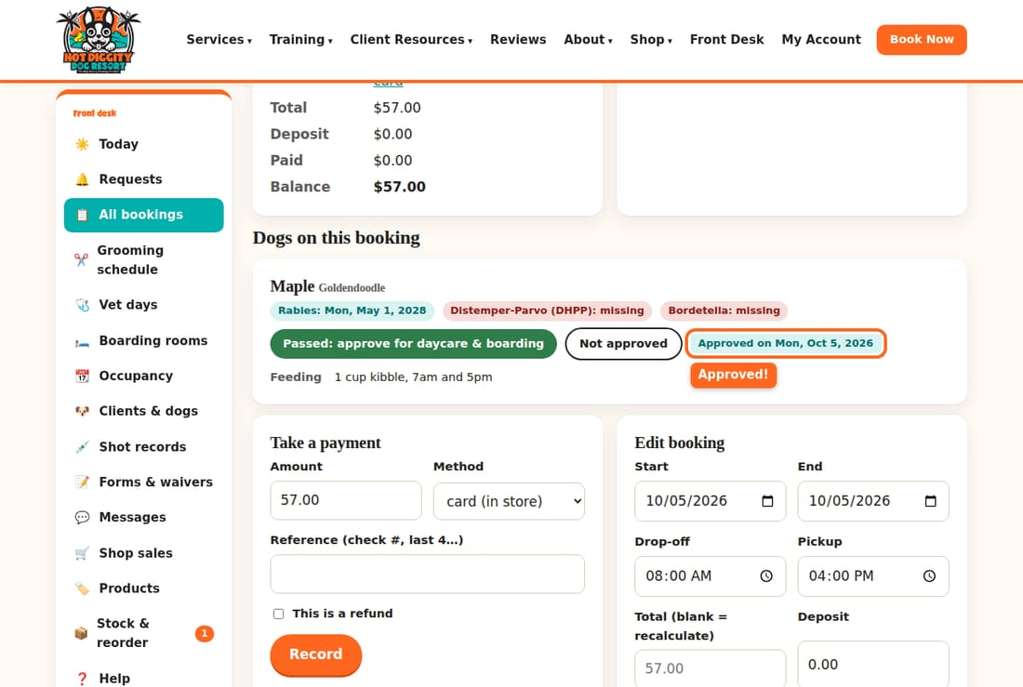
Good to know: Only a dog that passed can come for daycare or boarding. Grooming and training don't need it.
Good to know: We can't take bully breeds in boarding or daycare. Our insurance does not allow it. We also can't take dogs with a history of biting in daycare or boarding. Grooming and training are fine.
If something goes wrong: Not sure if the dog passed? Ask Penny or David before you press a button.

Job applications
Read job forms people send from our website.
People can apply for a job on our website. Their forms show up here.

Steps
- Look at Job applications in the menu. A red number means new ones came in.
- Press Job applications. New ones are in bold.
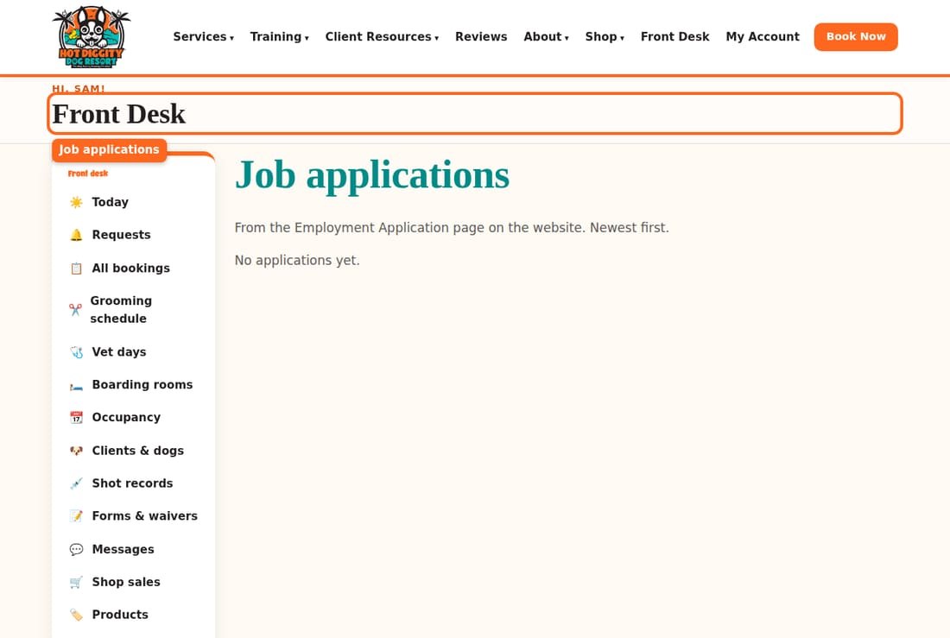
- Press a name to read the form. It is marked reviewed once you open it.
- To print it, press the print button at the top.
- Pick a Status: reviewed, interview, hired, or not a fit. Press Save.
Good to know: Job forms are private. Don't share them. Give them to David.

