Help for Owners
Hot Diggity Dog Resort · owner guide · September 29, 2026

Start here
What you can do as an owner, and where to find it.
You and Penny have owner logins. The system calls this role admin. Your team uses a staff login. You can do all the staff jobs, plus the owner jobs on this list.

Steps
- Log in and go to the Front Desk.
- Look at the menu on the left. The owner items are near the bottom. Your staff can't see them.
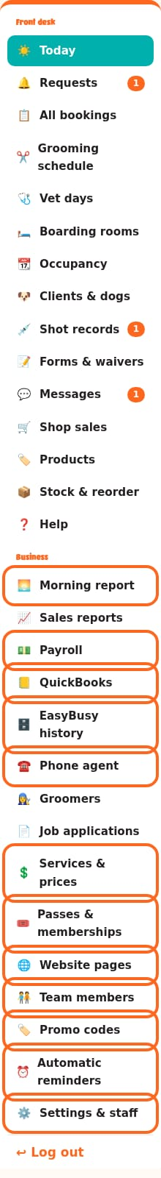

What only owners can do
- Morning report: how yesterday went, on one page. It can also come by email at 6 am.
- Services & prices: change prices, add or hide a service.
- Passes & memberships: daycare passes and L.E.E.P. Monthly.
- Website pages: change the words and photos on the website.
- Team members: the Meet the Team page.
- Promo codes: make and stop discount codes.
- Automatic reminders: the emails and texts that go out on their own.
- Settings & staff: webcam text, backups, how many dogs fit, shots we require, shop tax, and staff logins.
- Payroll: groomer pay for each pay period.
- QuickBooks: send your sales to QuickBooks, and get the sales tax summary.
- EasyBusy history: your old sales from EasyBusy.
- Phone agent: what the phone helper may say about your rules.
Good to know: Staff can see Groomers, but only you can change a groomer's hours or services. Staff can still add time off. Staff can also see Sales reports and Job applications.
Tip: Press ❓ Help in the menu any time. This guide is there, with pictures.
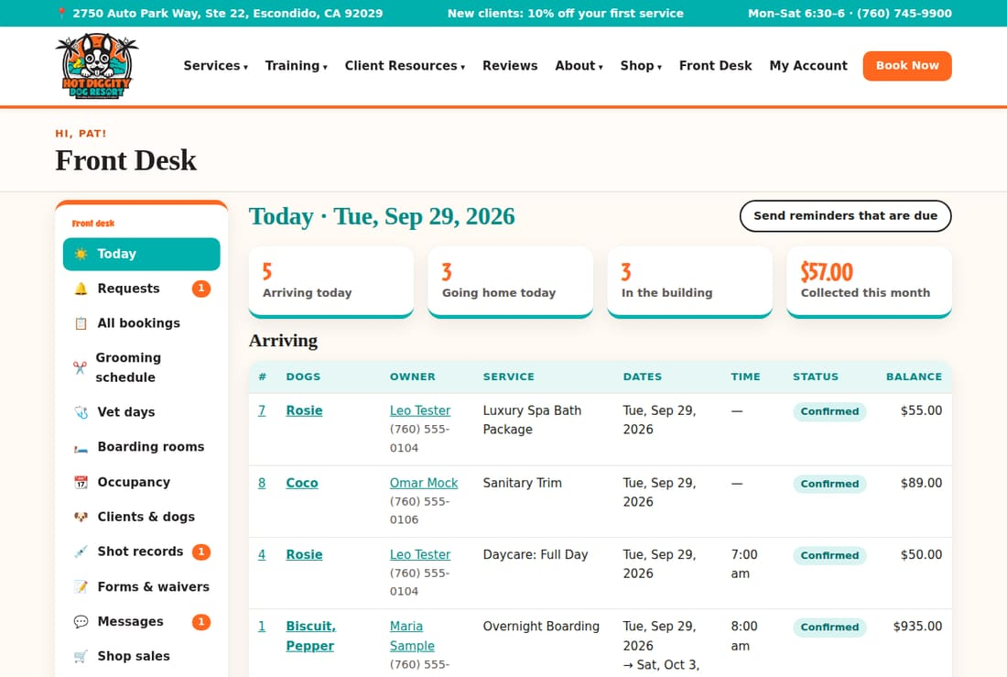

Topics in this guide
- Change a price or a service
- Grooming prices by size and coat
- Passes and L.E.E.P. memberships
- Promo codes
- Holiday fee and holiday rules
- Groomers: hours and services
- Staff logins
- Edit a website page
- The Meet the Team page
- Automatic reminders
- Webcam login and camera password
- Sales reports
- QuickBooks daily download
- Sales tax summary
- EasyBusy history
- Payroll
- Backups
- Phone agent
- Job applications
- How many dogs fit, and shots we require
- Shop tax and card readers
- Morning report

Change a price or a service
Change what a service costs, hide it, or add a new one.
Use this when a price goes up, or when you start or stop a service. The new price shows on the website and for new bookings right away.

Steps
- In the menu, click Services & prices.
- Find the service. They are grouped by type, like Boarding and Grooming.
- Click the service name. Its box opens.
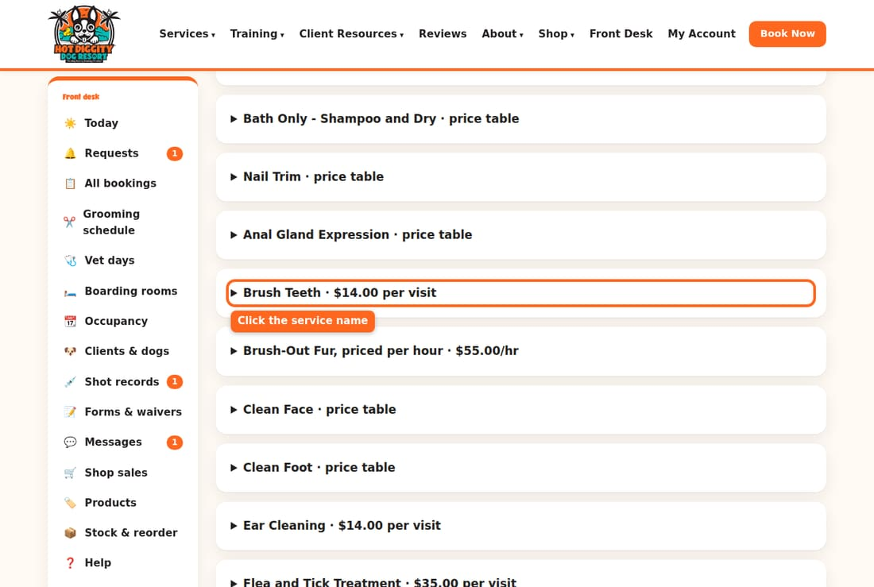
- Click in the Price ($) box. Type the new price.
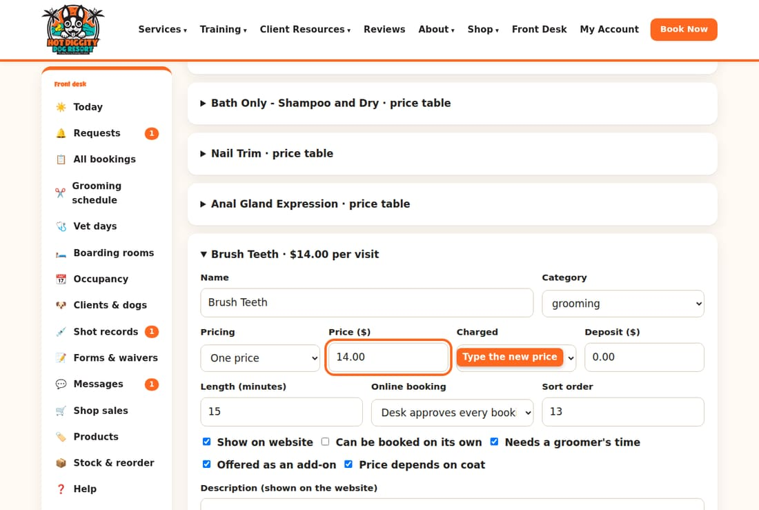
- Press Save at the bottom of the box.
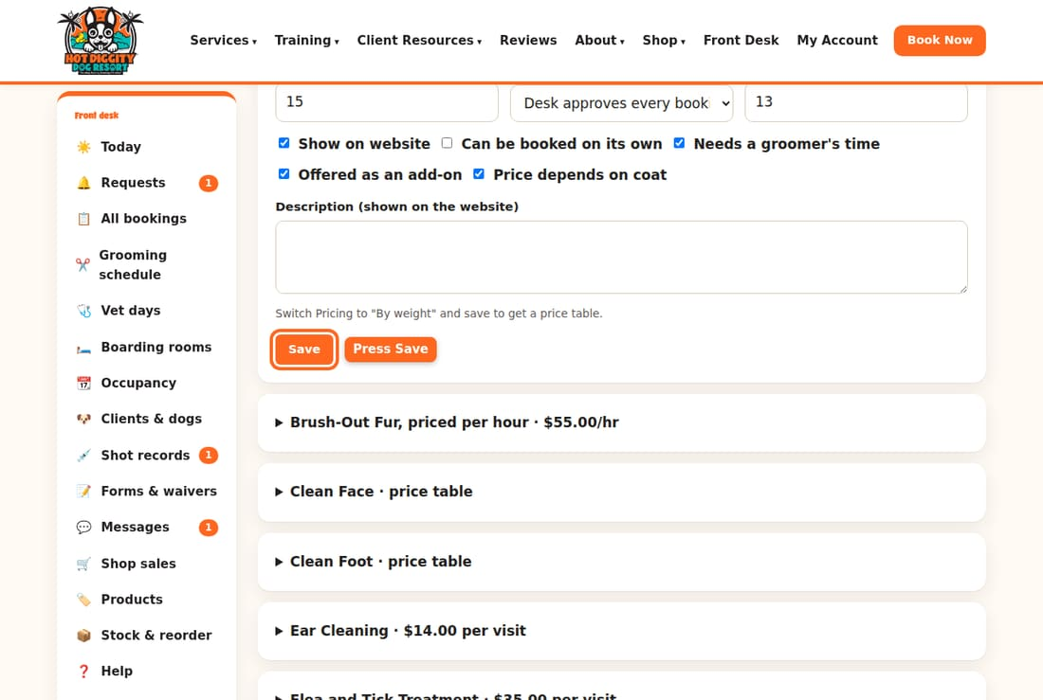
- Look for the green note at the top. It says the service was saved.
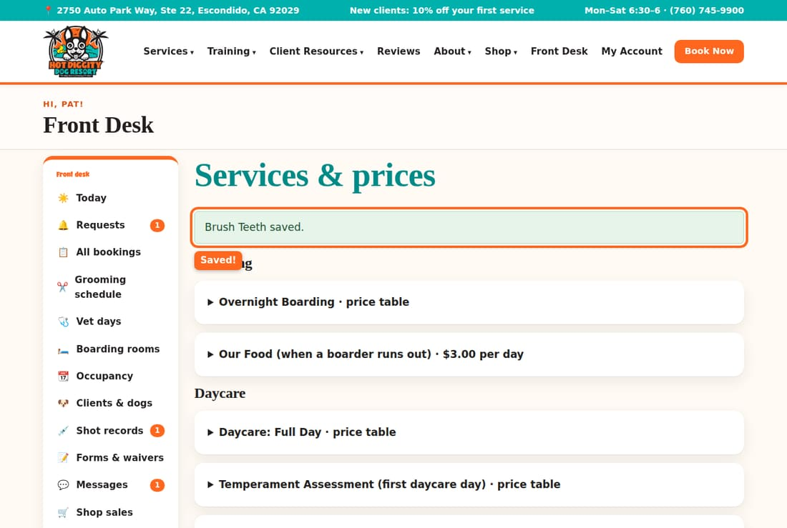
Careful: A new price is for new bookings. It does not change bookings that are already made.

Hide a service
- Open the service.
- Uncheck Show on website.
- Press Save.
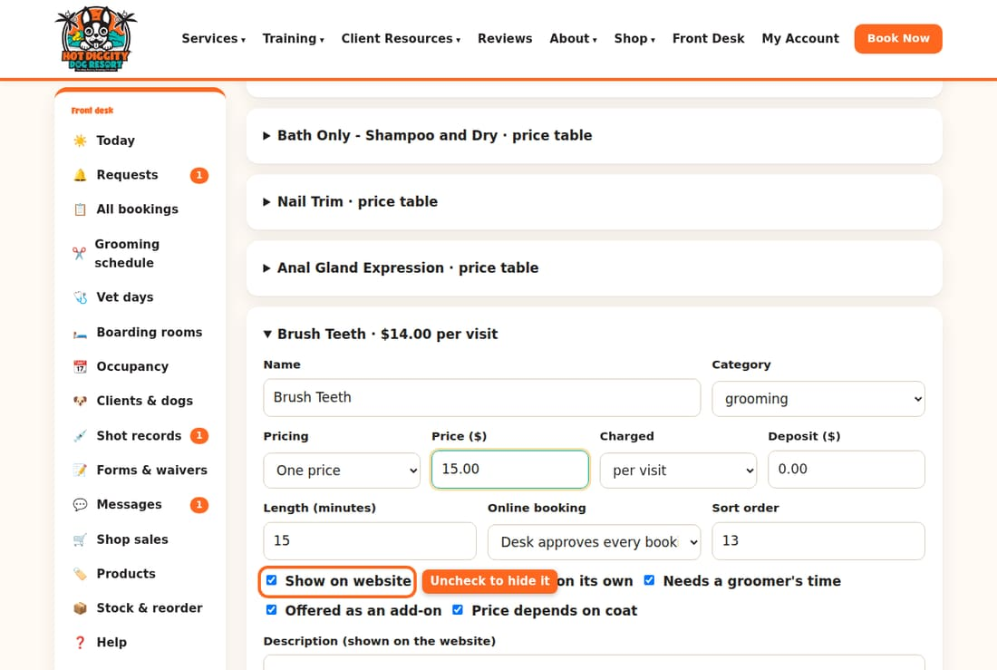

Choose who can book it online
- Open the service.
- Pick a choice in the Online booking list:
  - Regular clients book instantly: known dogs book on their own.
  - Desk approves every booking: every booking waits for the desk to say yes.
  - Staff only (not online): clients can't book it on the website.
- Press Save.
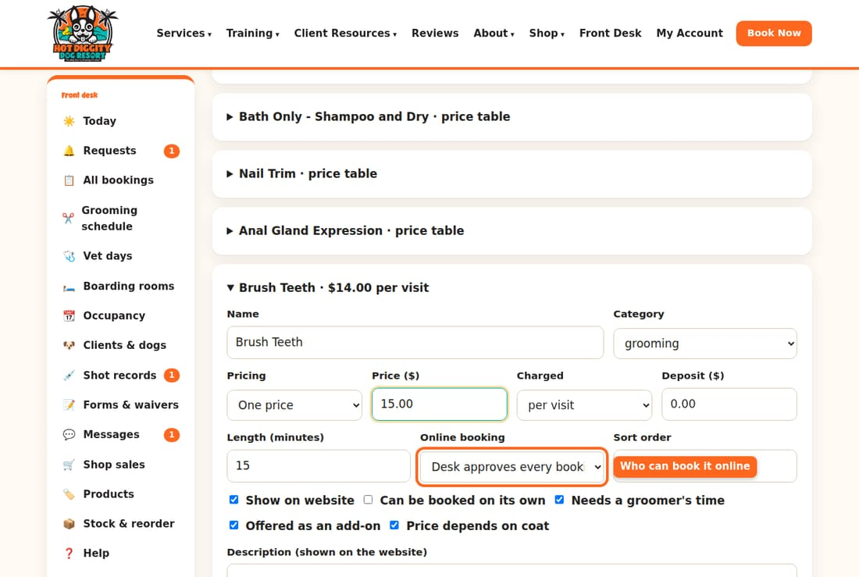
Good to know: For daycare and boarding, "book instantly" has rules. The dog must have passed the Temperament Assessment. It must also have been here in the last 6 months. If not, the booking comes in as a request.

Add a new service
- Scroll to the very bottom of the page.
- Click + Add a service.
- Type the Name. Pick the Category.
- Fill in the price and how it is Charged.
- Press Add service.
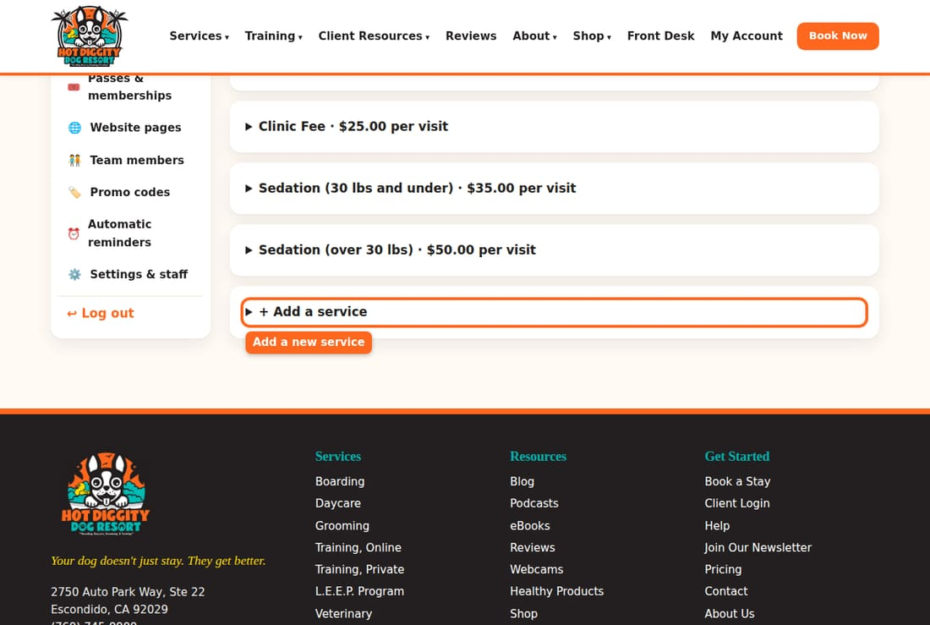
Tip: The Deposit ($) box sets how much a client pays up front. Leave it at 0 for no deposit.

Grooming prices by size and coat
Set the price and time for each dog size and coat type.
Most grooms cost more for bigger dogs and thicker coats. Each groom has a price table. The table also holds how long the groom takes. That time blocks the groomer's day.

Steps
- In the menu, click Services & prices.
- Click a groom, like Hair Cuts - Full Grooms. Its box opens.
- Scroll down to the table. Each row is a coat type. Each column is a dog size.
- The top number in a box is the price in dollars. Type the new price.
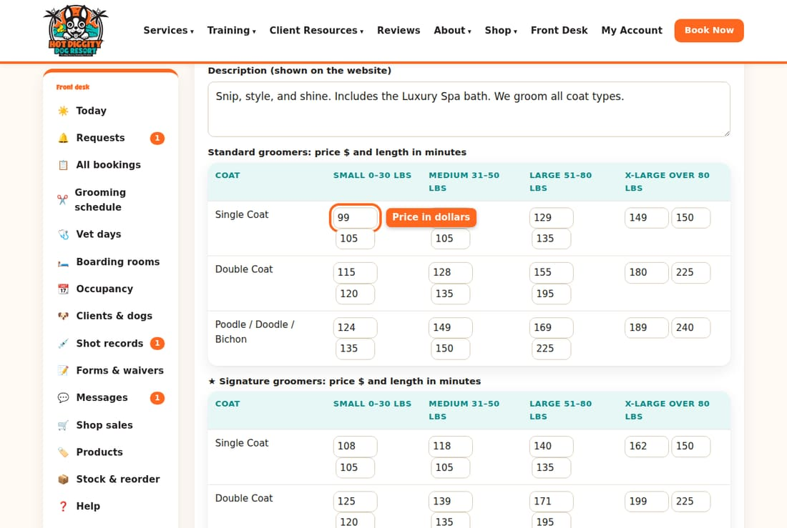
- The bottom number is the minutes the groom takes. Change it if needed.
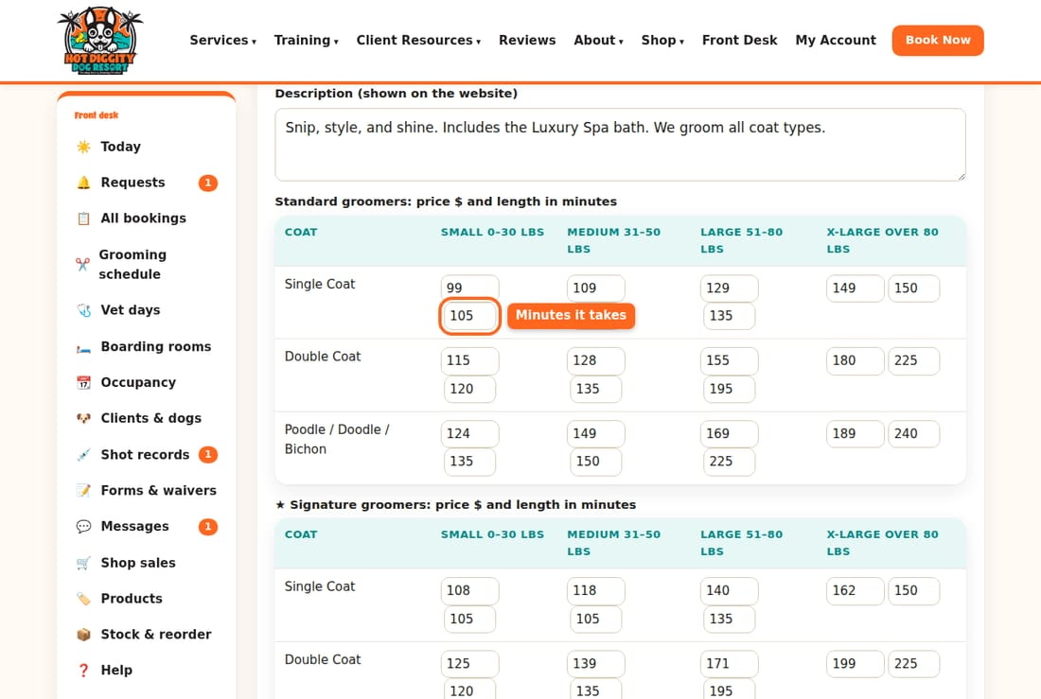
- Scroll down to the second table. It is for ★ Signature groomers. Change those prices too.
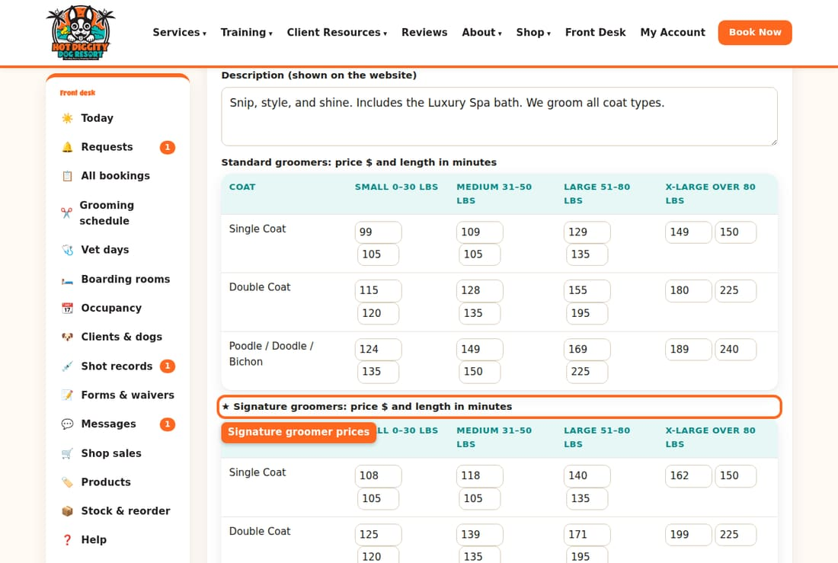
- Press Save at the bottom of the box.
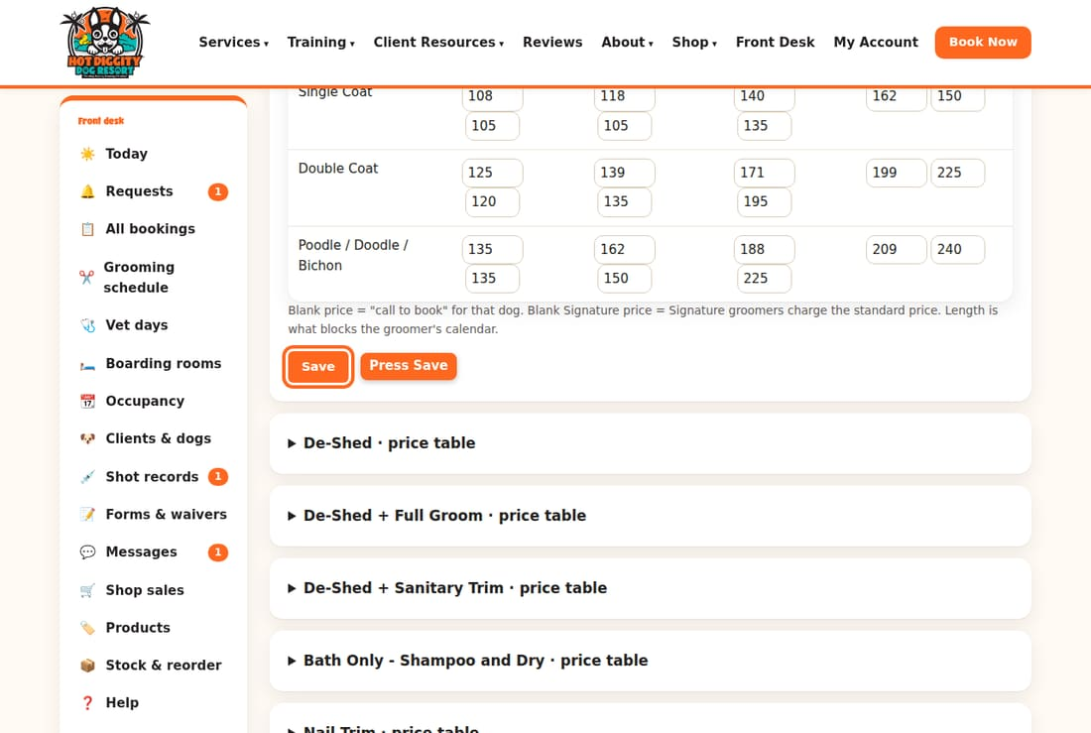

What the sizes mean
- Small: 0 to 30 lbs.
- Medium: 31 to 50 lbs.
- Large: 51 to 80 lbs.
- X-Large: over 80 lbs.
The coats are Single Coat, Double Coat, and Poodle / Doodle / Bichon.
Good to know: Leave a price box blank, and clients must call to book that dog. Leave a Signature price blank, and Signature groomers charge the standard price.
Careful: The minutes matter. Too few, and the groomer runs late. Too many, and the day has empty gaps.
Tip: Some add-ons are one price for every dog. They have no table. They just have one Price ($) box.

Passes and L.E.E.P. memberships
Change daycare pass discounts and the L.E.E.P. Monthly price.
A daycare pass is 10 or 20 days paid ahead, at a discount. L.E.E.P. Monthly is billed every month. You set both on one page.

Steps for daycare passes
- In the menu, click Passes & memberships.
- Find the Daycare passes box.
- To change the discount, type a new number in Discount %.
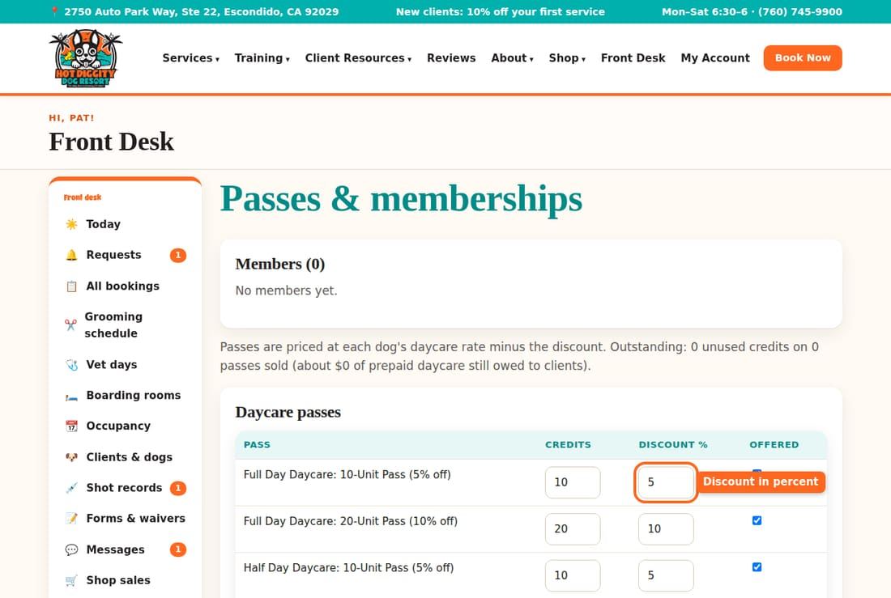
- The Offered box is checked when the pass is for sale. Uncheck it to stop selling it.
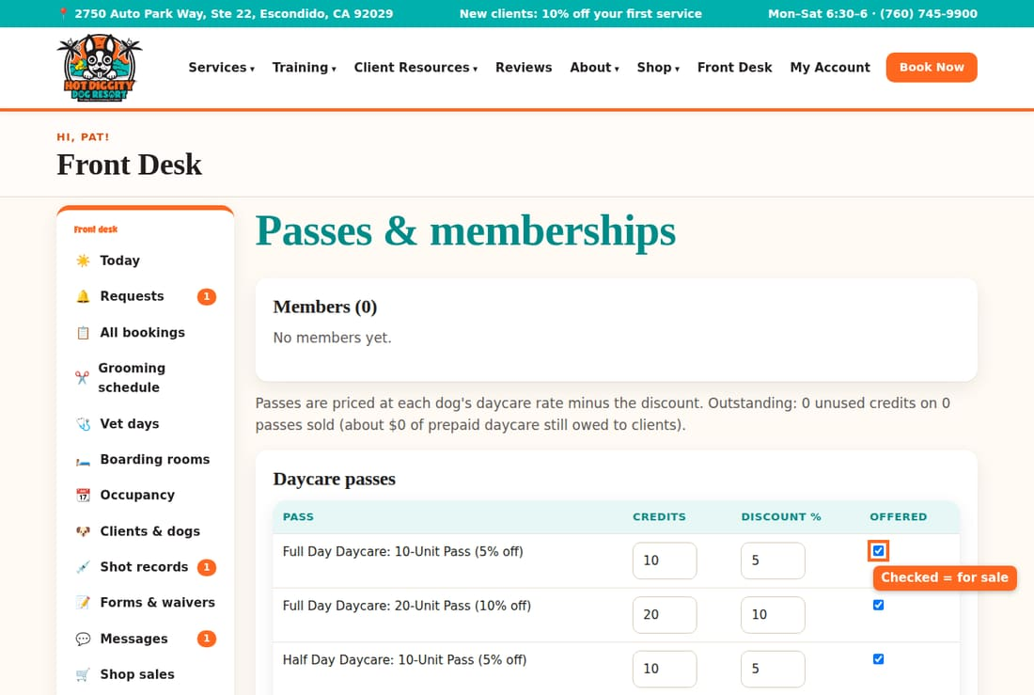
- Press Save at the bottom.
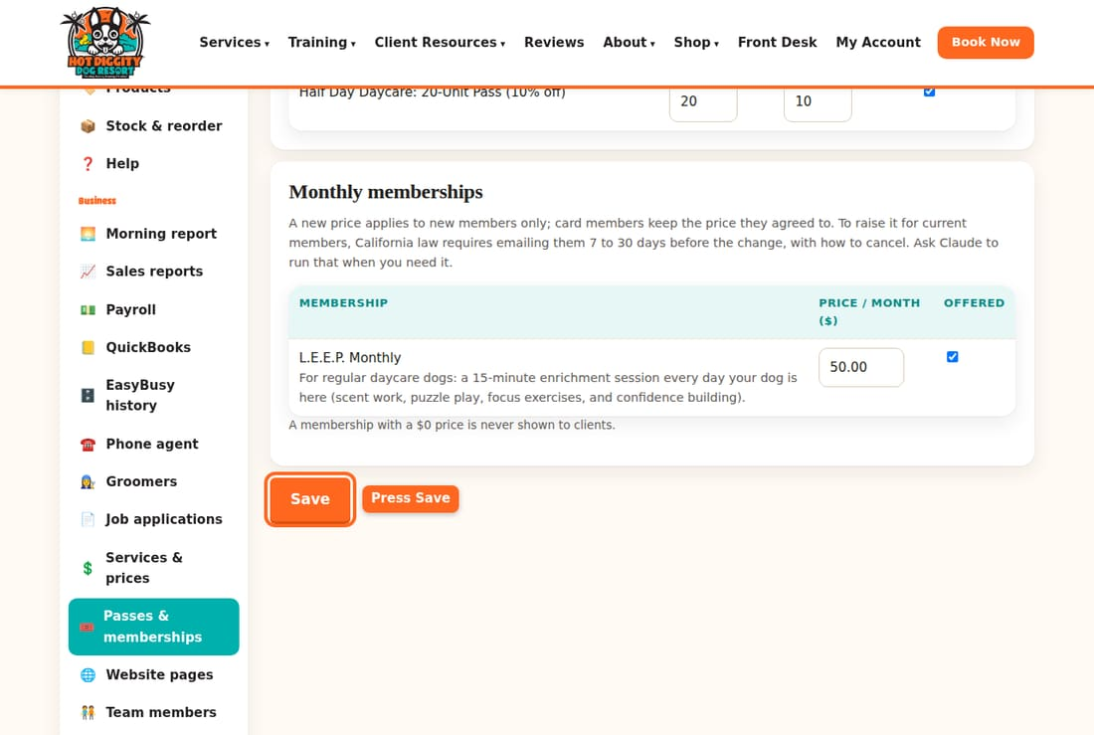
Good to know: A pass price is based on each dog's daycare price, minus the discount. You don't type a pass price.
Careful: The pass name has the discount in it, like "(5% off)". Changing the number does not change the name. Ask Claude to fix the name if you change a discount.

Steps for L.E.E.P. Monthly
- On the same page, find Monthly memberships.
- Type the new price in Price / month ($).
- Press Save.
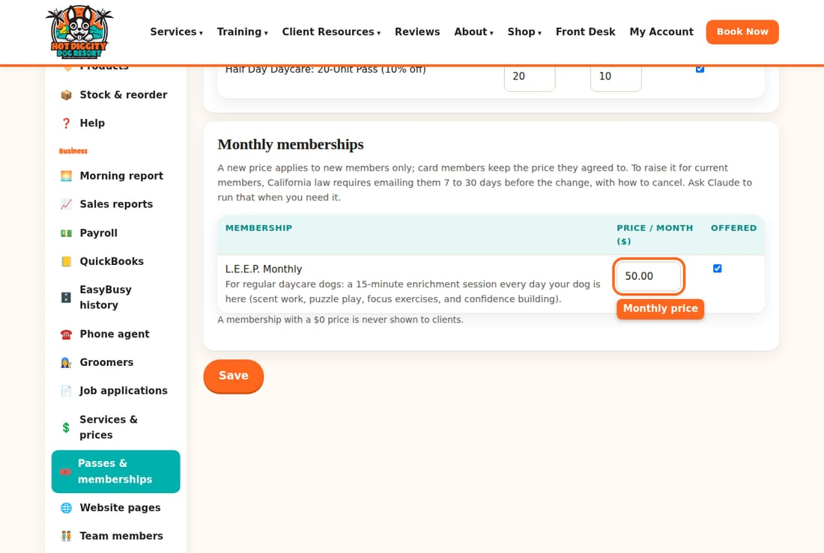
Careful: A new price is only for new members. Members who already pay by card keep their old price. California law says you must email them 7 to 30 days before you raise it. Ask Claude to do that for you.

See who is a member
The Members box at the top lists each member and their dog. The Billing column shows if their card is on auto-pay.
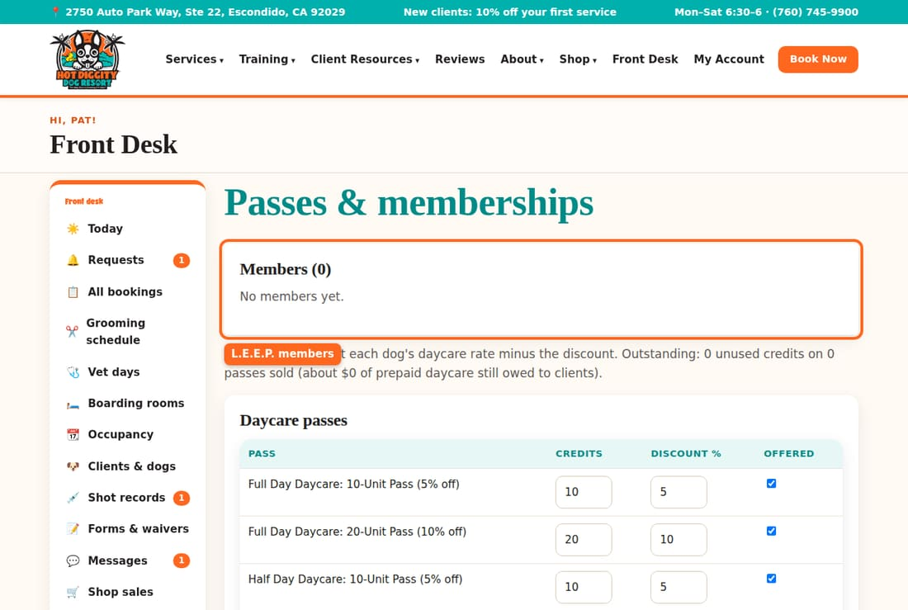
Tip: Some members may not be on auto-pay yet. Then you see a button that starts with Email the auto-pay link. Press it to email each of them a link to add a card.
Good to know: You set how long a pass lasts on Settings & staff. See topic 20.

Promo codes
Make a discount code, pause it, or delete it.
A promo code gives money off. Clients type it when they book online. The desk can also add it on a booking. Only one code works per booking.

Make a new code
- In the menu, click Promo codes.
- Find the New code box. Type the code in Code. Use letters and numbers, no spaces.
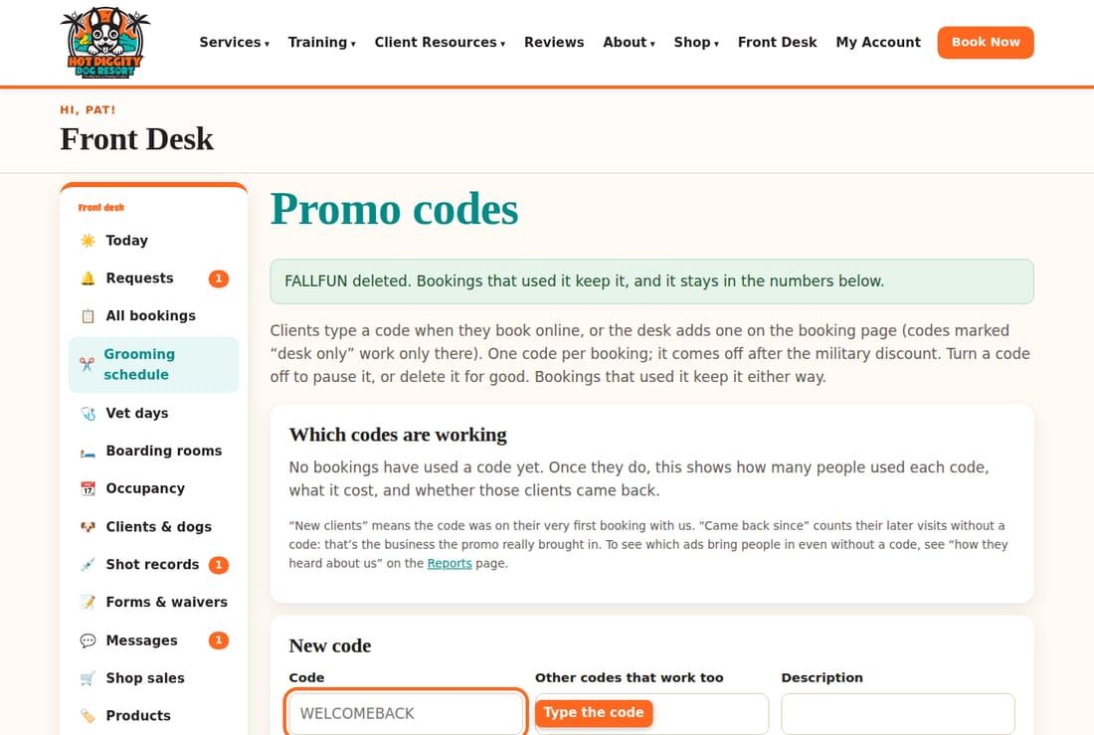
- Type a short Description, so you remember what it's for.
- Pick Percent off or Dollars off in Type. Then type the Amount (% or $).
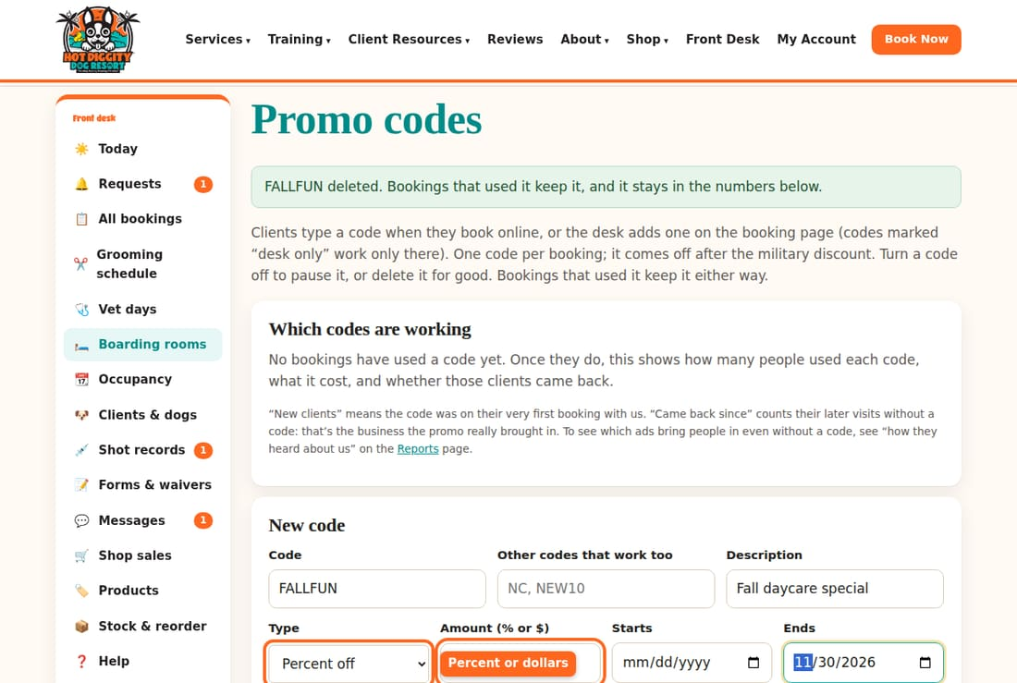
- Pick the Starts and Ends dates. Leave them blank for no date limit.
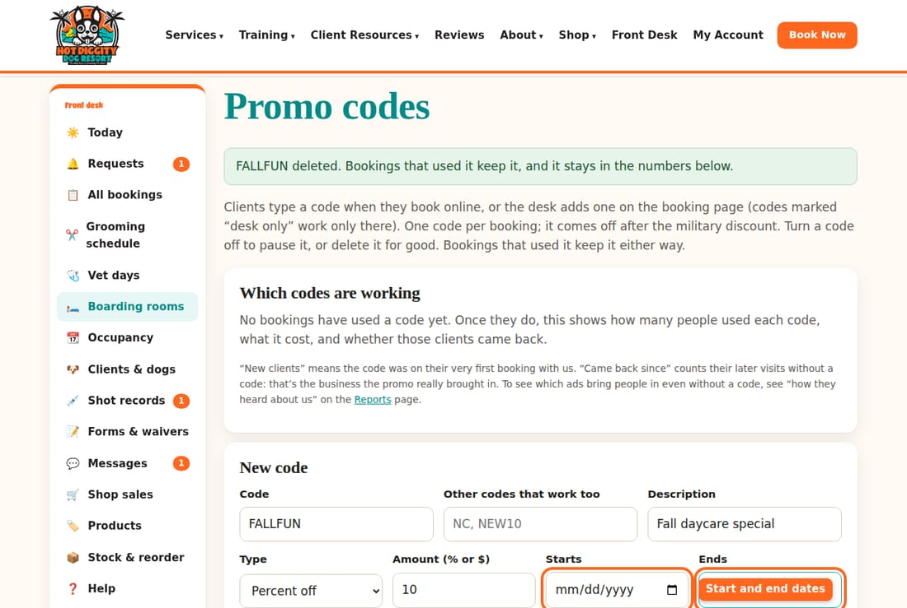
- Set Uses per client. The number 1 means each client can use it once. 0 means no limit.
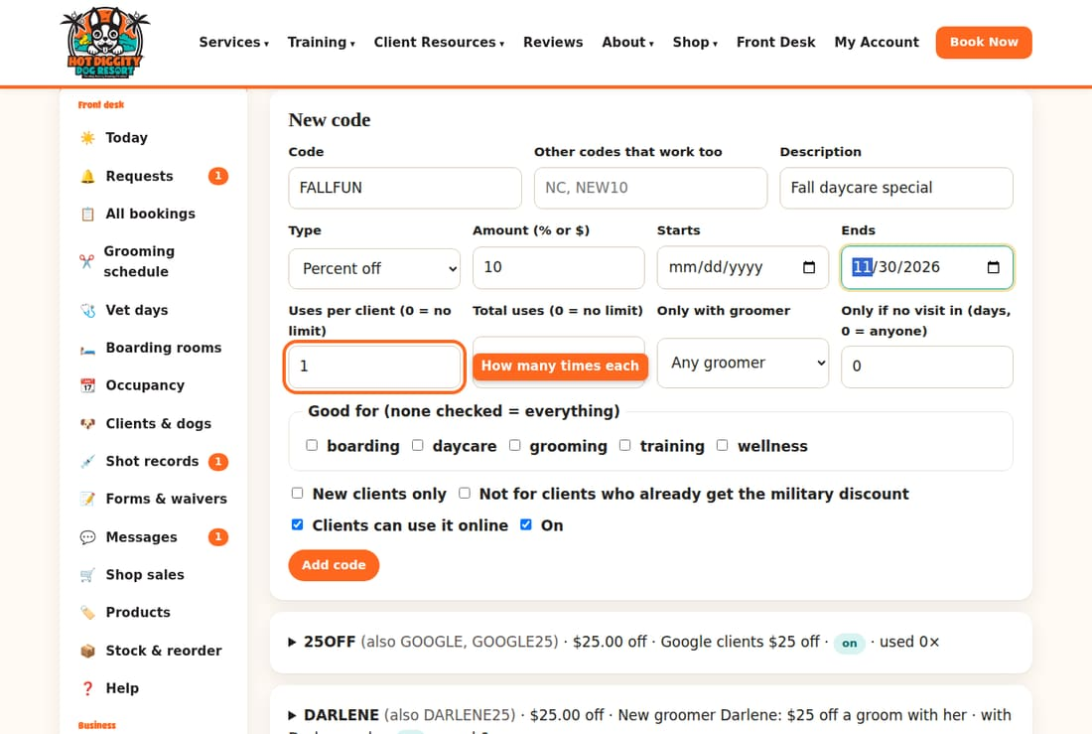
- Under Good for, check the services it works on. Check none, and it works on everything.
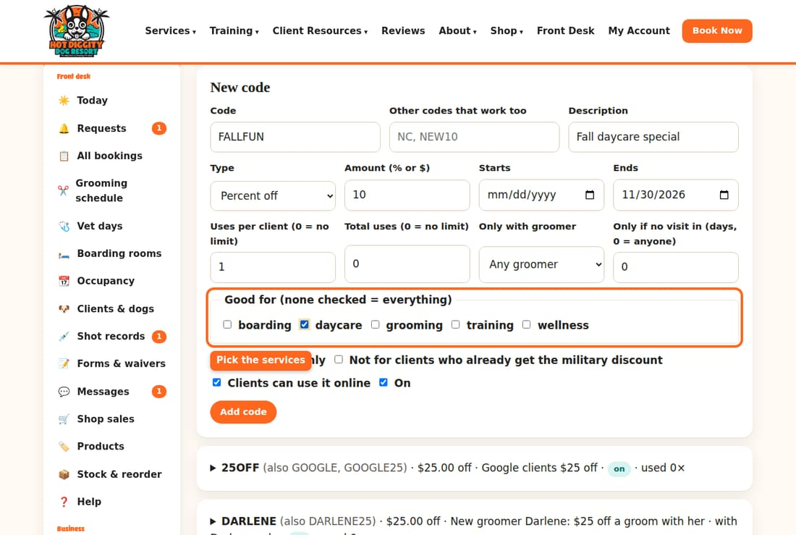
- Check or uncheck the boxes below. For example, uncheck Clients can use it online to make it a desk-only code.
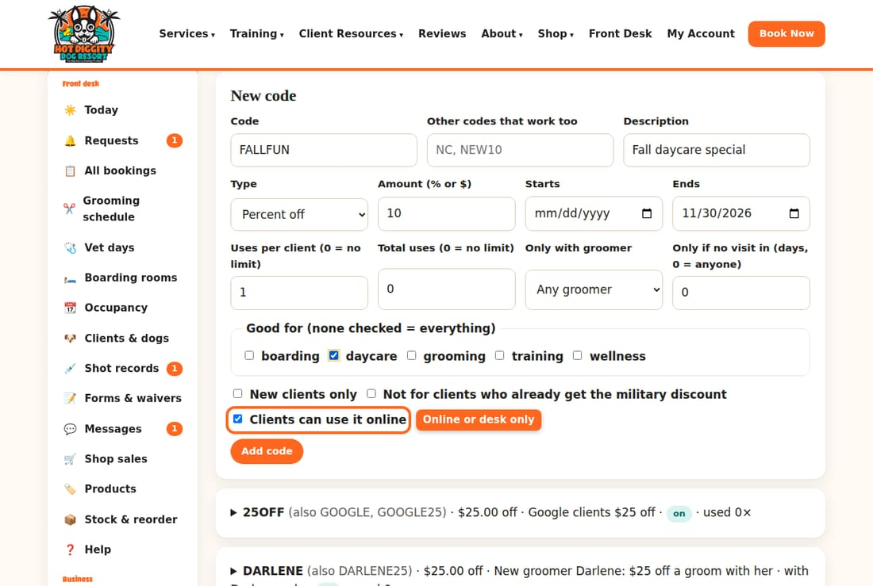
- Press Add code.
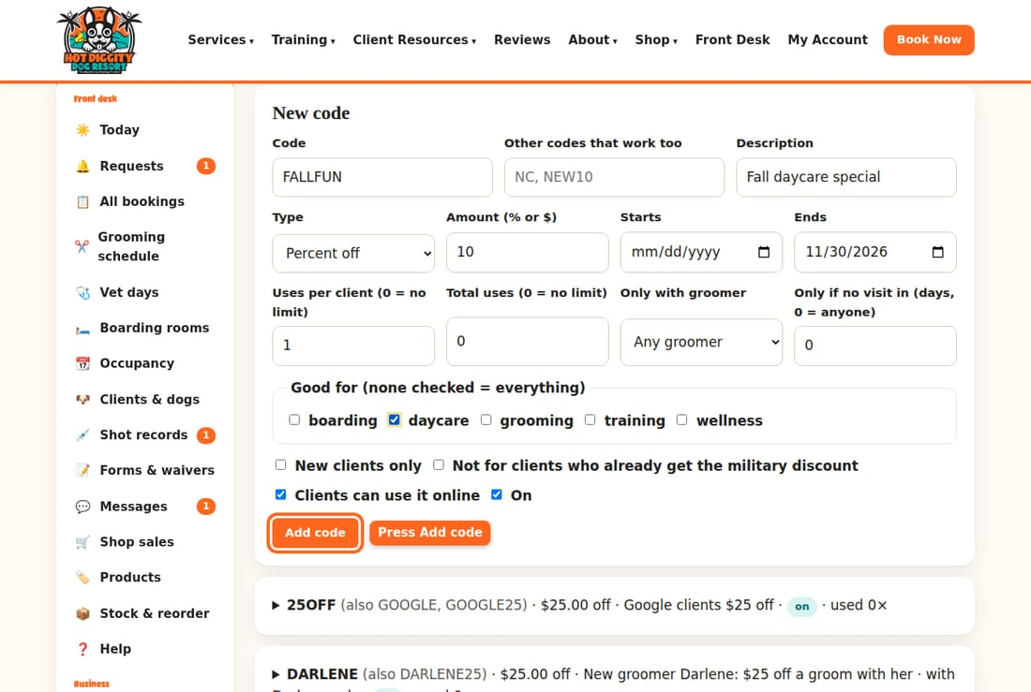
- Your code now shows in the list below.
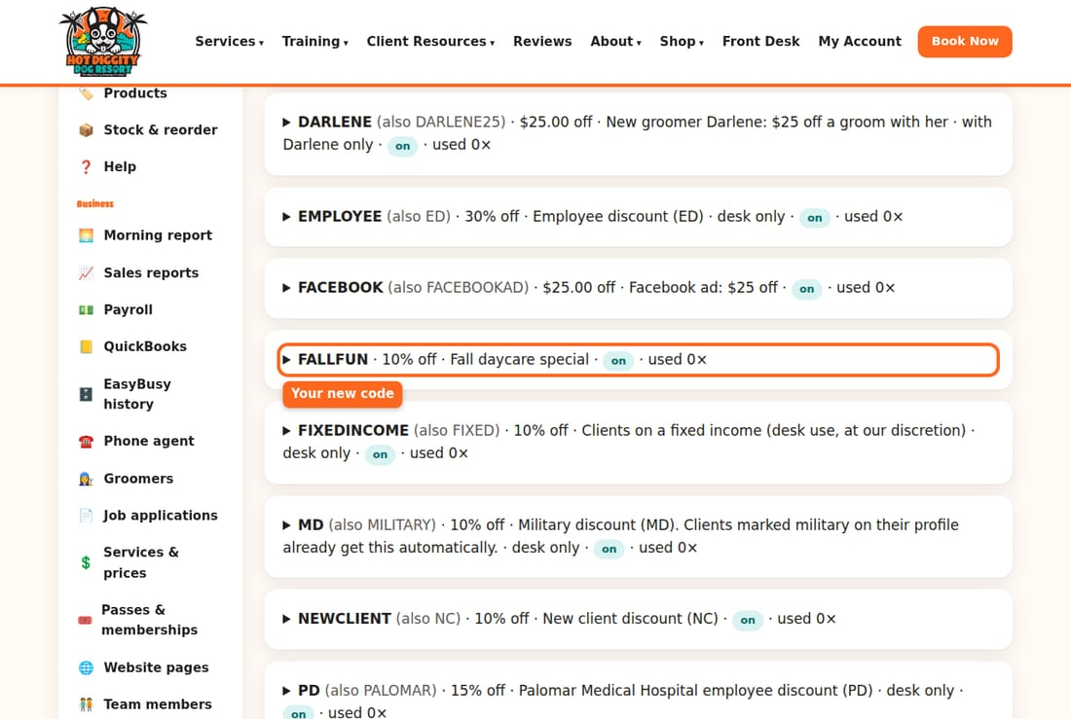
Careful: Clients can use a code as soon as it is On. Check the amount before you press Add code.

Pause a code
- Click the code in the list to open it.
- Uncheck On.
- Press Save.
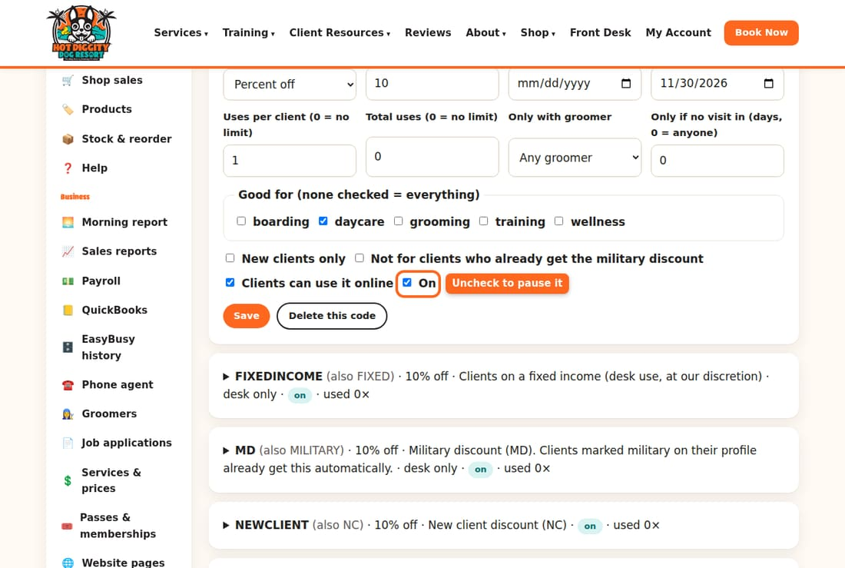

Delete a code
- Open the code.
- Press Delete this code.
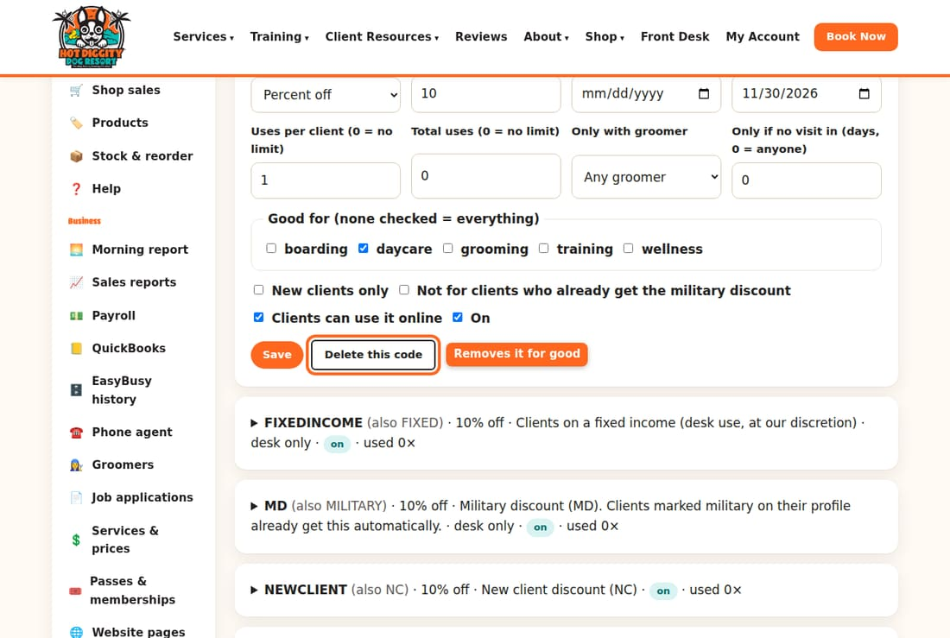
Good to know: Bookings that used a code keep it, even after you pause or delete it.

See which codes work
The Which codes are working box shows how many times each code was used. It shows the money it took off. It also shows if those clients came back.
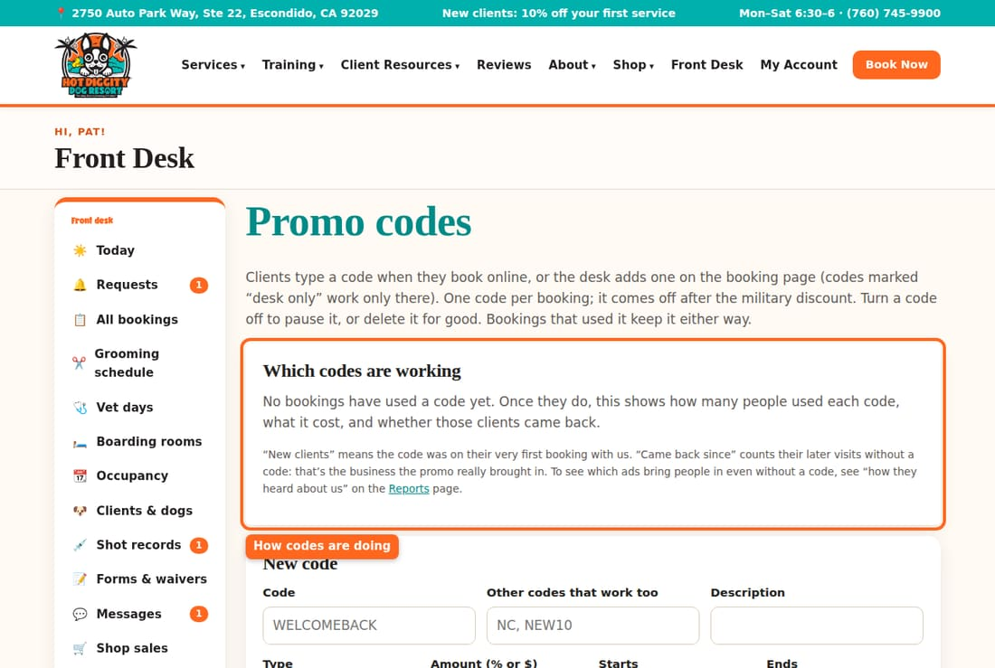
Tip: The military discount comes off first. Then the promo code comes off.

Holiday fee and holiday rules
Where the holiday fee, the 3-night rule, and the shared-suite $5 off are set.
The system adds holiday rules to boarding on its own. This page tells you what they are, where to change them, and where clients see them.

What the system does now
- Holiday fee: $35 per dog. It is added for each night that starts on a holiday.
- 3-night minimum: stays over Thanksgiving or Christmas Day must be at least 3 nights.
- Sharing a suite: the first dog pays full price. Each extra dog in the same suite gets $5 off per night.
The holiday fee days are New Year's Day, Easter, Memorial Day, Independence Day, Labor Day, Thanksgiving, Black Friday, Christmas Eve, Christmas Day, and New Year's Eve.

See what clients see
- Open the website's Policies page.
- Scroll to Holidays. The fee and the 3-night rule are shown there.
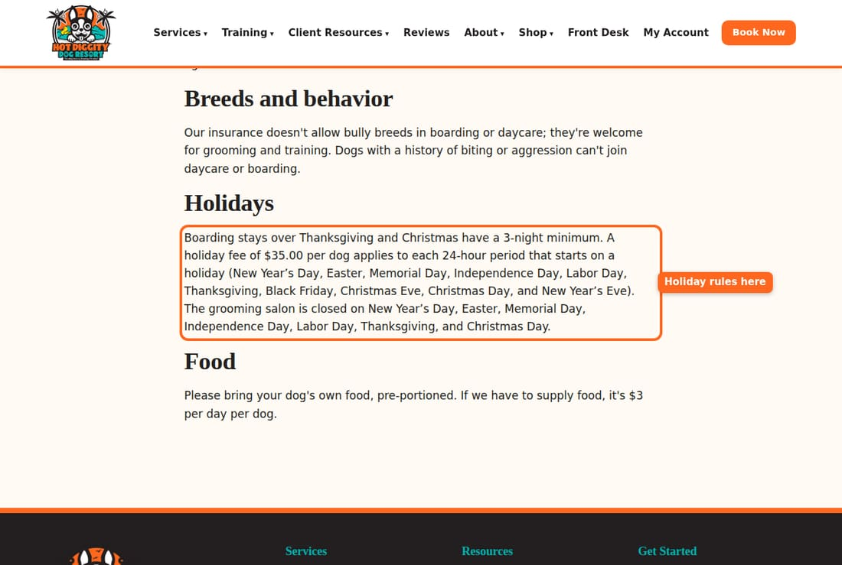
Good to know: The Policies page gets these numbers from the system. If the numbers change, the page changes too.

To change a number
- In Front Desk, press ⚙️ Settings & staff.
- Find the box Capacity & requirements.
- Type the new amount in Boarding holiday fee, per dog per night ($), Thanksgiving & Christmas minimum stay (nights), or Shared suite: off per extra dog per night ($).
- Press Save settings.
Careful: A change affects the price of new boarding bookings. Also tell the desk, so they give clients the right price.
Tip: The phone agent has its own words about holidays. If a rule changes, update that too. See topic 18.

Groomers' hours and services
Set each groomer's work hours, what they're trained for, and time off.
Online booking only offers a groomer when they work. It only offers the grooms they know how to do. Keep this up to date, and bookings land in the right place.

Change a groomer's hours
- In the menu, click Groomers.
- Click the groomer's name.
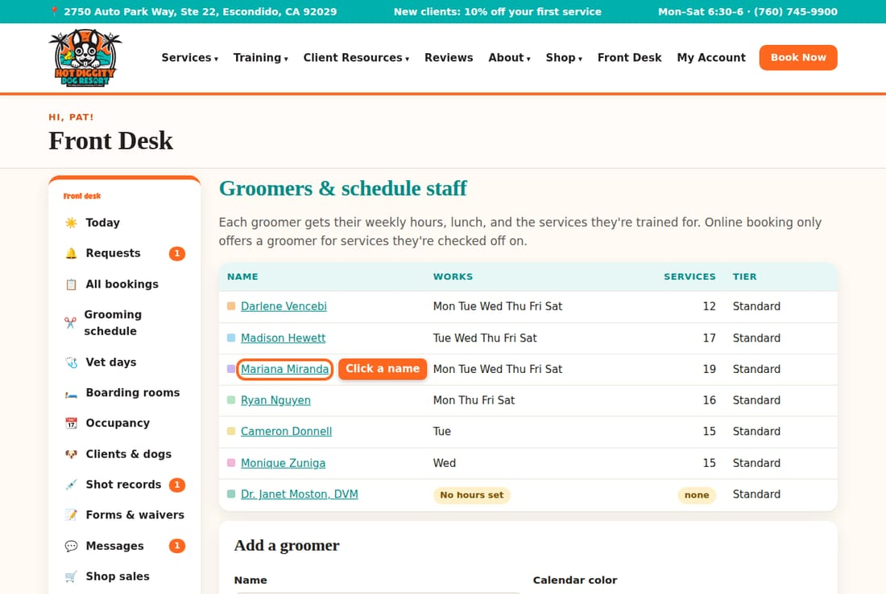
- Find Weekly hours. Type a Start and End time for each day they work.
- For a day off, leave the start time blank.
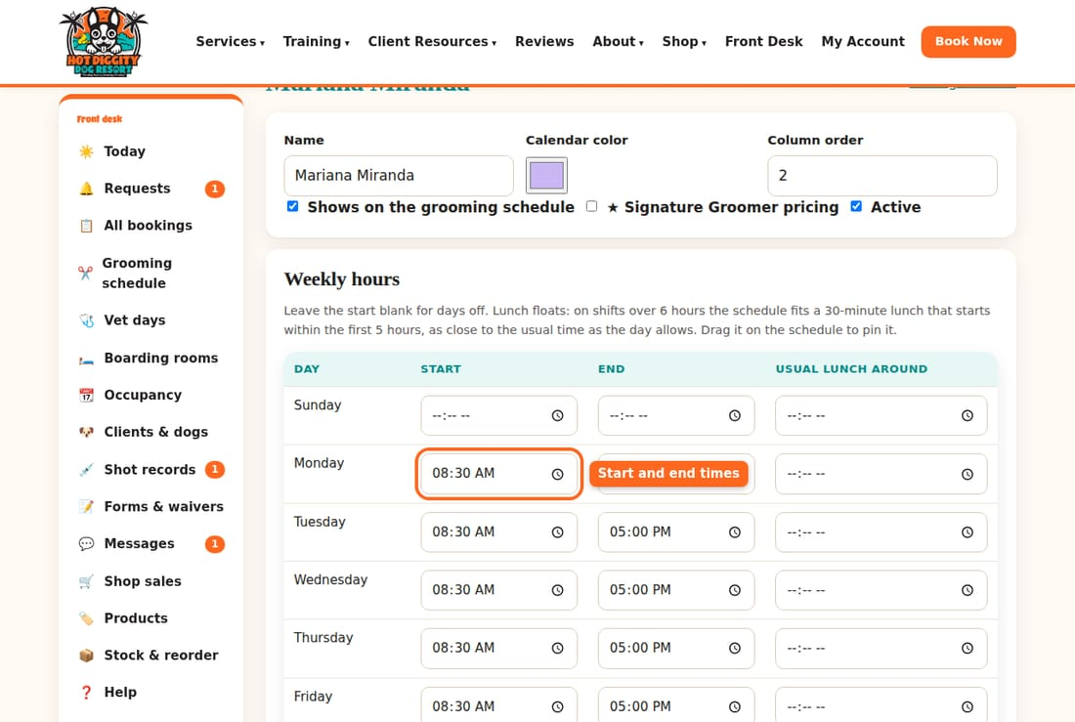
- Press the save button. It says Save and the groomer's name.
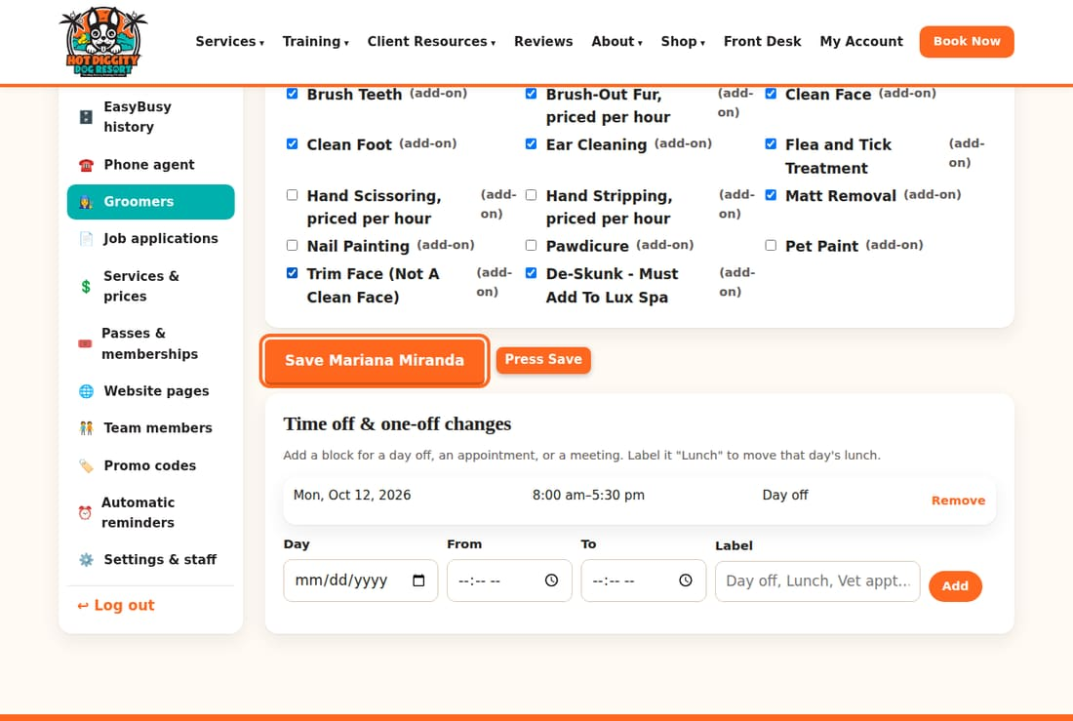
Good to know: The Usual lunch around box sets a lunch time. The system fits a 30-minute lunch into shifts over 6 hours.

Change what they are trained for
- On the groomer's page, find Trained for.
- Check each groom they can do. Uncheck the ones they can't.
- Press the save button.
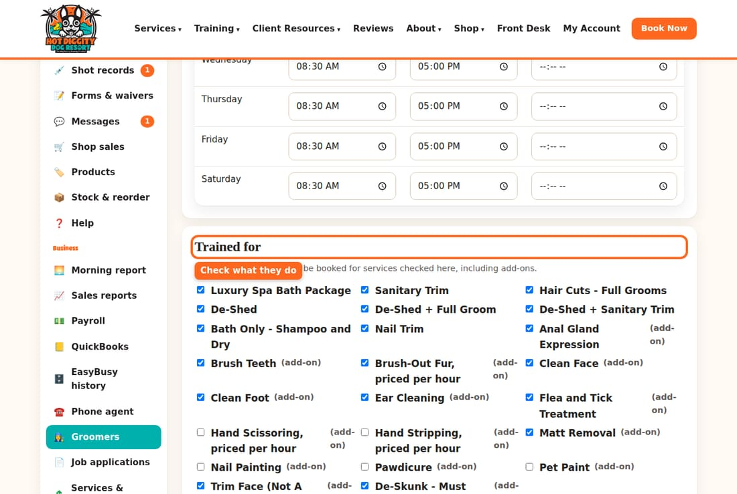

Signature groomers
Check ★ Signature Groomer pricing for a Signature groomer. Their clients then pay the Signature prices. Then press the save button.
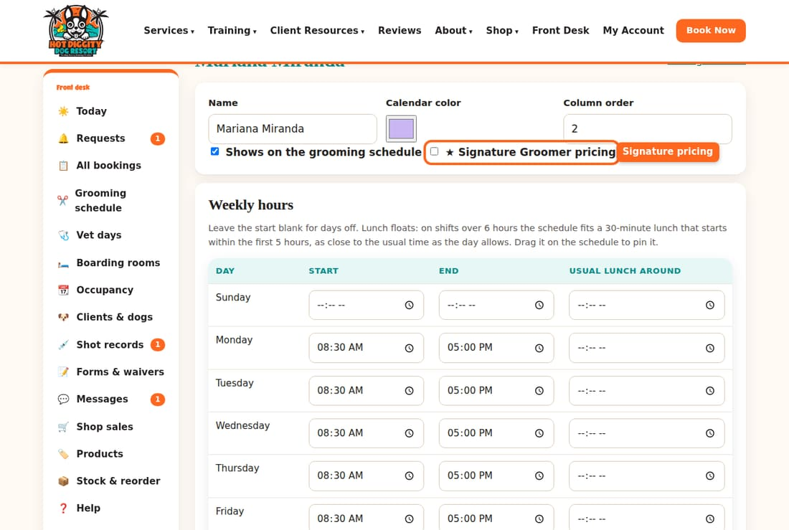

Add time off
- On the groomer's page, find Time off & one-off changes.
- Pick the Day, From, and To times.
- Type a Label, like "Day off."
- Press Add.
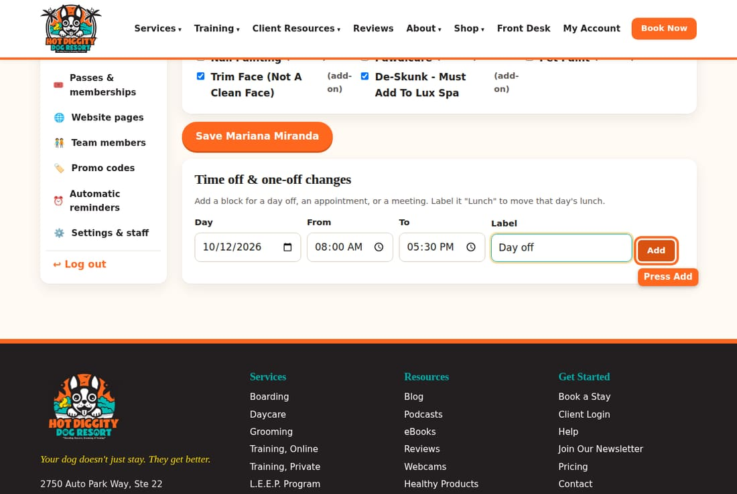
- To take it off, press Remove next to it.
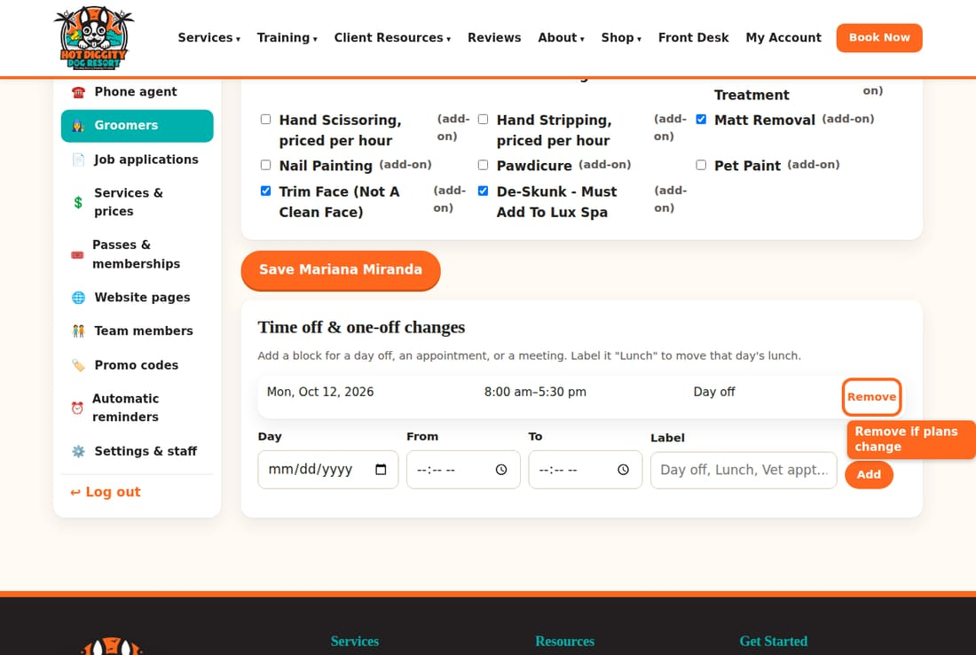
Tip: Label a block "Lunch" to move lunch that day.

Add a new groomer
- On the Groomers page, scroll to Add a groomer.
- Type the Name. Pick a Calendar color.
- Press Add, then set hours and services.
- Set their hours and services, as above.
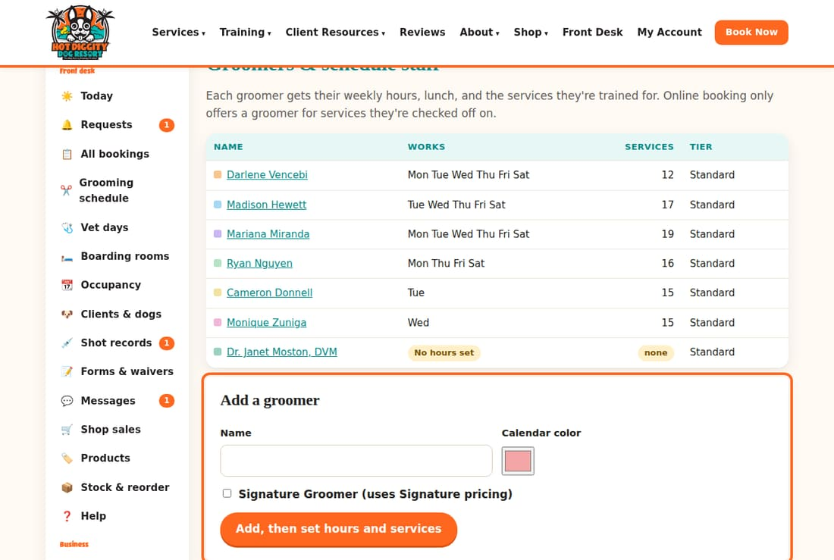

When a groomer leaves
- Open the groomer.
- Uncheck Active.
- Press the save button.
Careful: Check the Grooming schedule for their future grooms. Move those to another groomer.

Staff logins
Add a front desk login, make someone an owner, or take a login away.
Each person on your team needs their own login. All of this is in one box near the bottom of Settings & staff.

The three roles
- staff: runs the front desk.
- admin: an owner. Can also change prices, settings, and staff.
- customer: a client. Has no Front Desk access.

Add a front desk person
- In the menu, click Settings & staff.
- Scroll down to Staff accounts. The list shows everyone who has a login now.
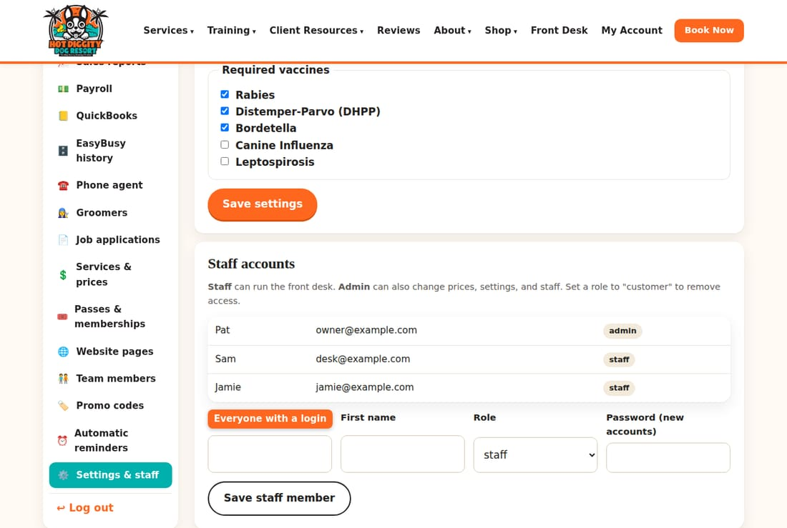
- Type their Email and First name.
- Pick staff in the Role list.
- Type a Password for them. It must be at least 8 letters or numbers.
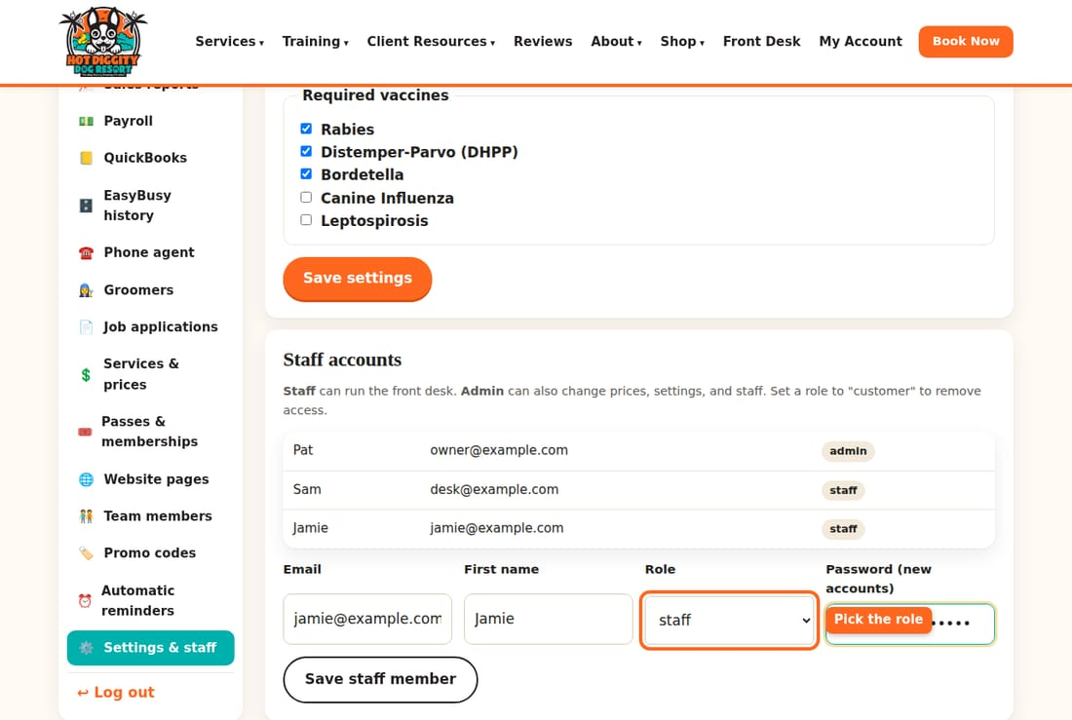
- Press Save staff member.
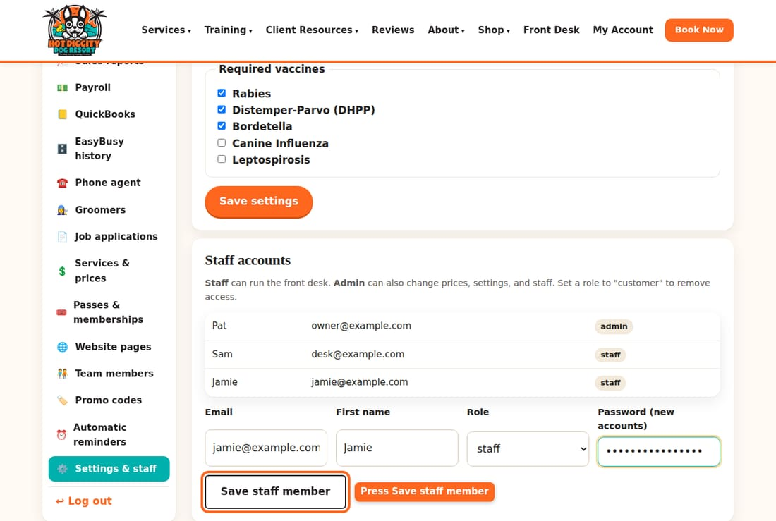
- A green note says the email "is now staff."
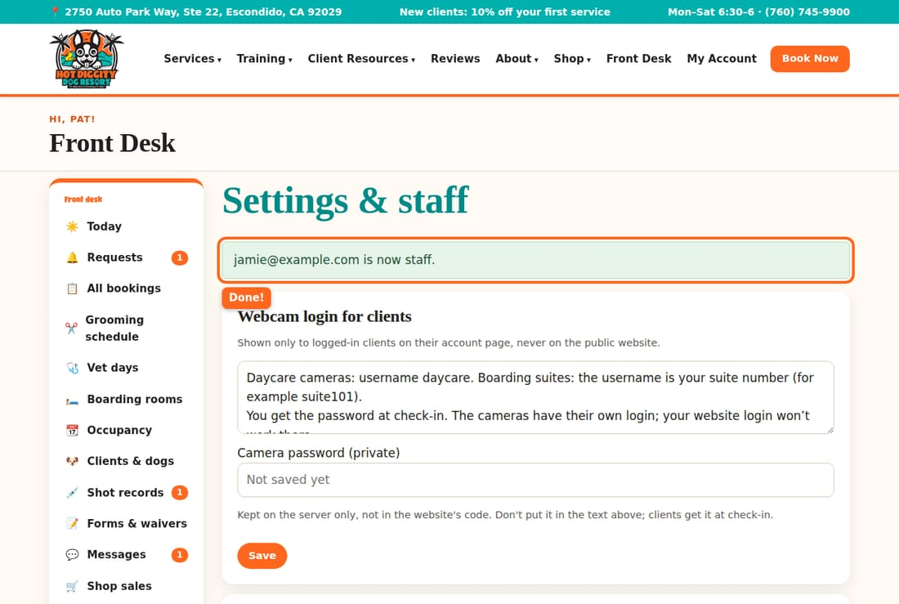
- Tell the person their email and password.

Make someone an owner
- In Staff accounts, type their email.
- Pick admin in the Role list.
- Leave the password blank. That keeps their old password.
- Press Save staff member.
Careful: An admin can change prices, promo codes, and pay. Only give it to people you trust with money.

Take a login away
- In Staff accounts, type their email.
- Pick customer in the Role list.
- Press Save staff member.
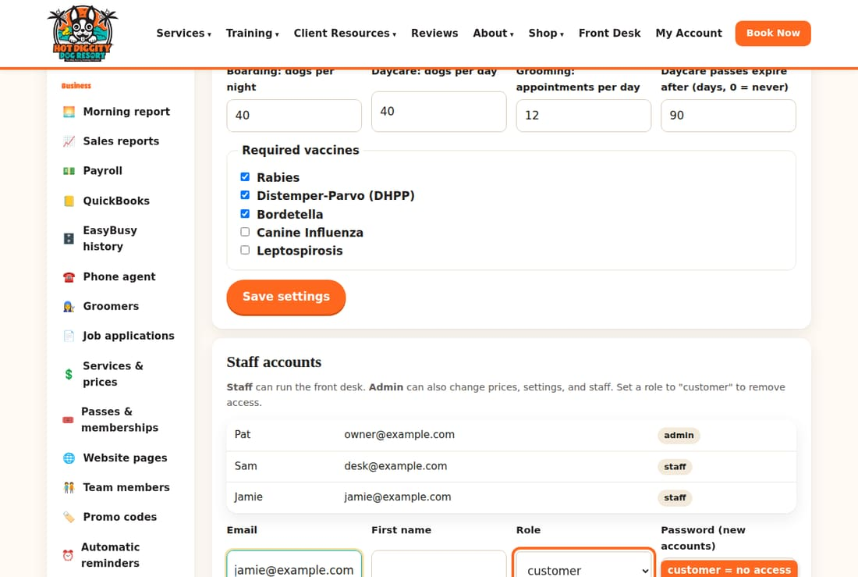
They drop off the list, and can't open the Front Desk anymore.
Careful: Do this on their last day. Never set your own email to customer, or you will lock yourself out.
Tip: To give someone a new password, type their email and the new password. Keep their role the same. Then press Save staff member.

Edit a website page
Change words, add a photo, preview, go live, and undo.
You can change the words and photos on any page of your website. Every save is kept. So you can always go back.

Open the page
- In the menu, click Website pages.
- Find the page in the list. Press Edit on its row.
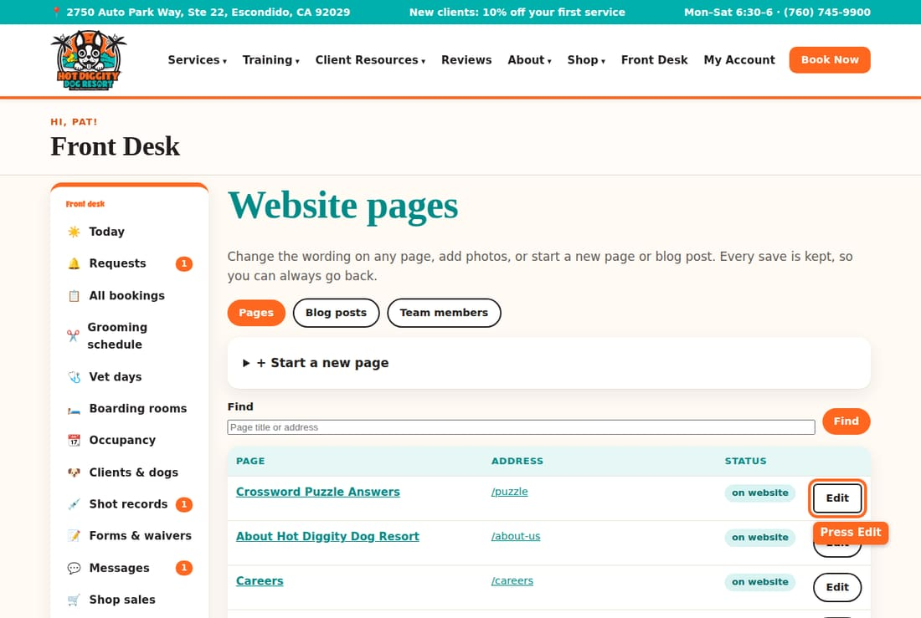
Tip: Blog posts are under the Blog posts button at the top.
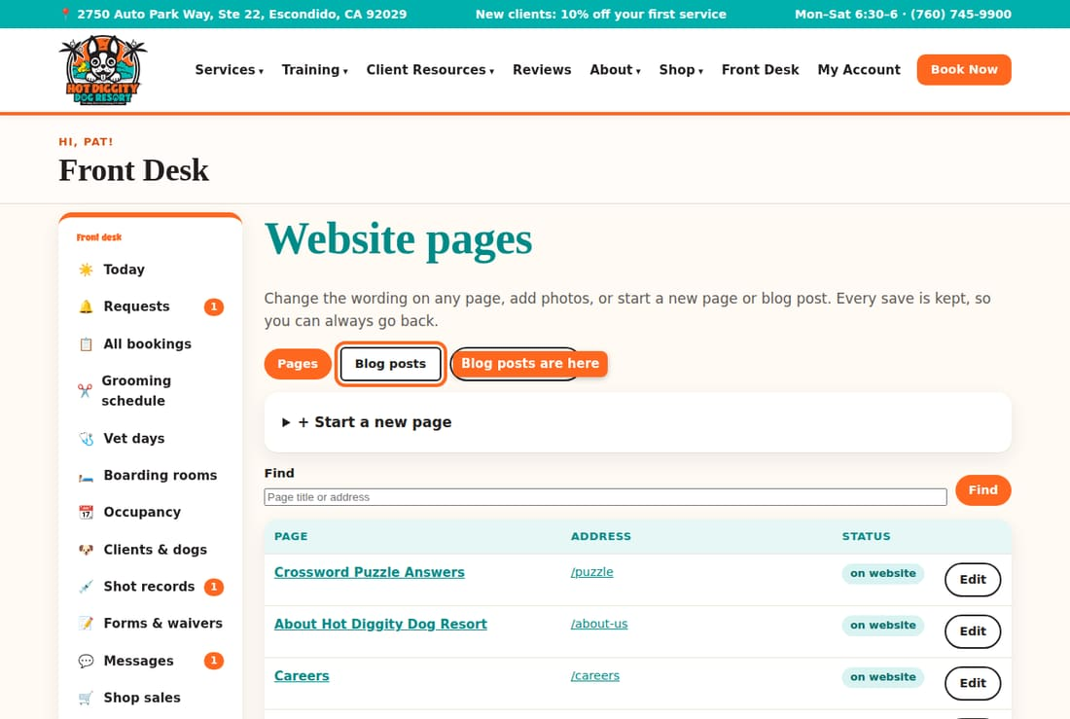

Change the words
- The page's words are in the big box. Click in the box.
- Change the words you want. Type like you would in an email.
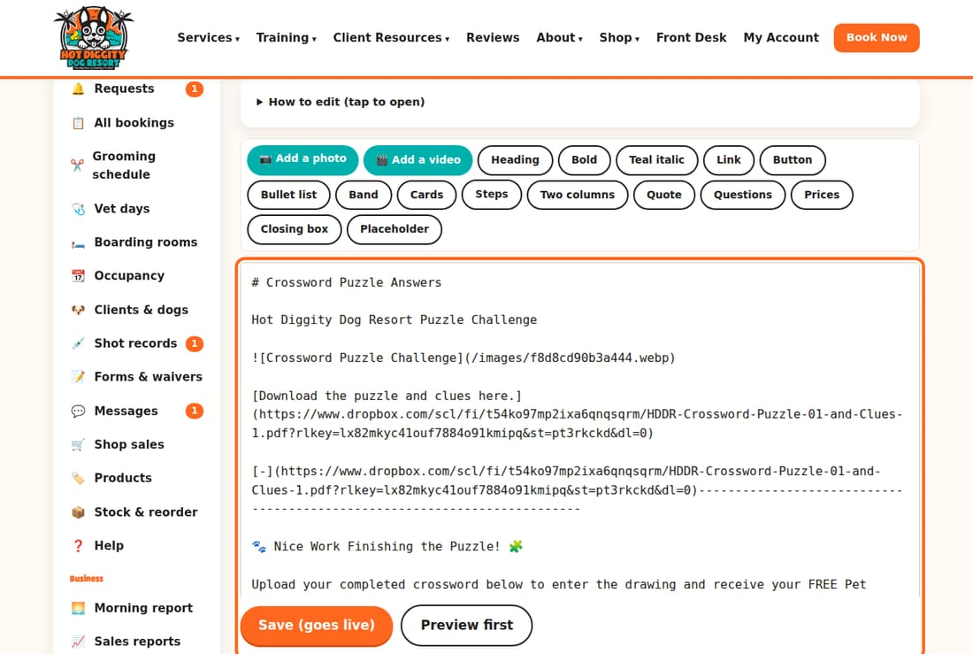
Good to know: Some lines have marks like ##, **, or :::. They set up headings and designs. Change the words next to them. Leave the marks alone.
Tip: Click How to edit (tap to open) for a short help list.
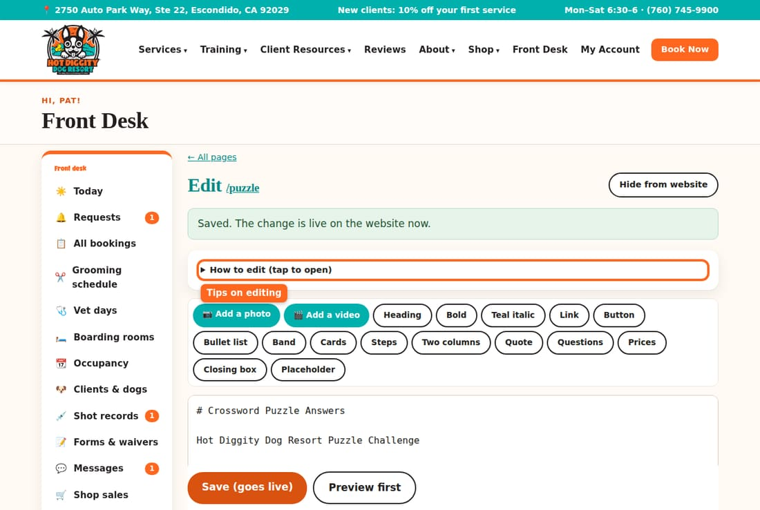

Add a photo
- Click in the box where you want the photo.
- Press 📷 Add a photo.
- Pick the photo from your computer or phone.
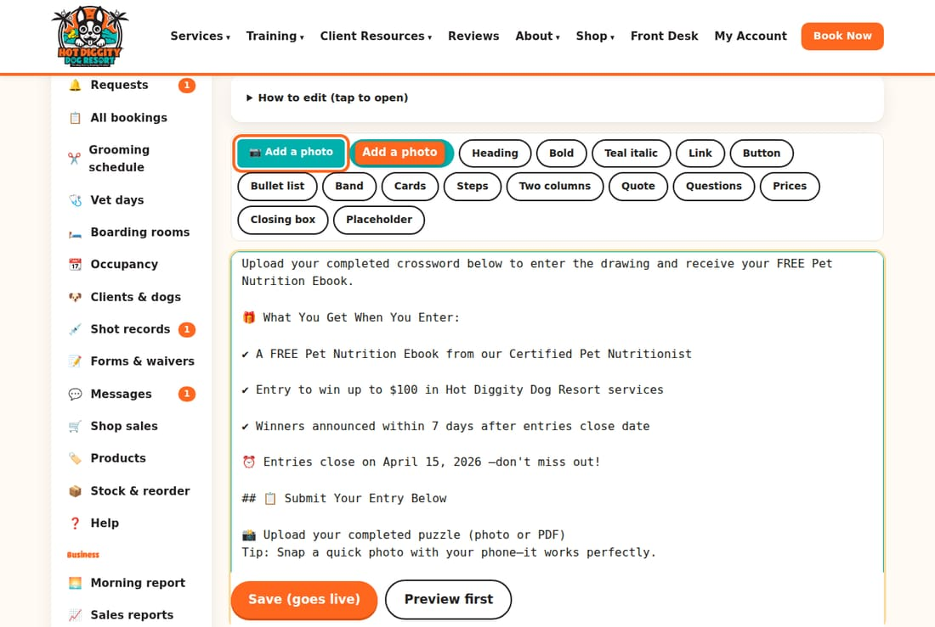
- A note says "Photo added." A new line shows up in the box. It has words in square brackets, like [Describe this photo...].
- Change the words in the brackets to say what the photo shows.
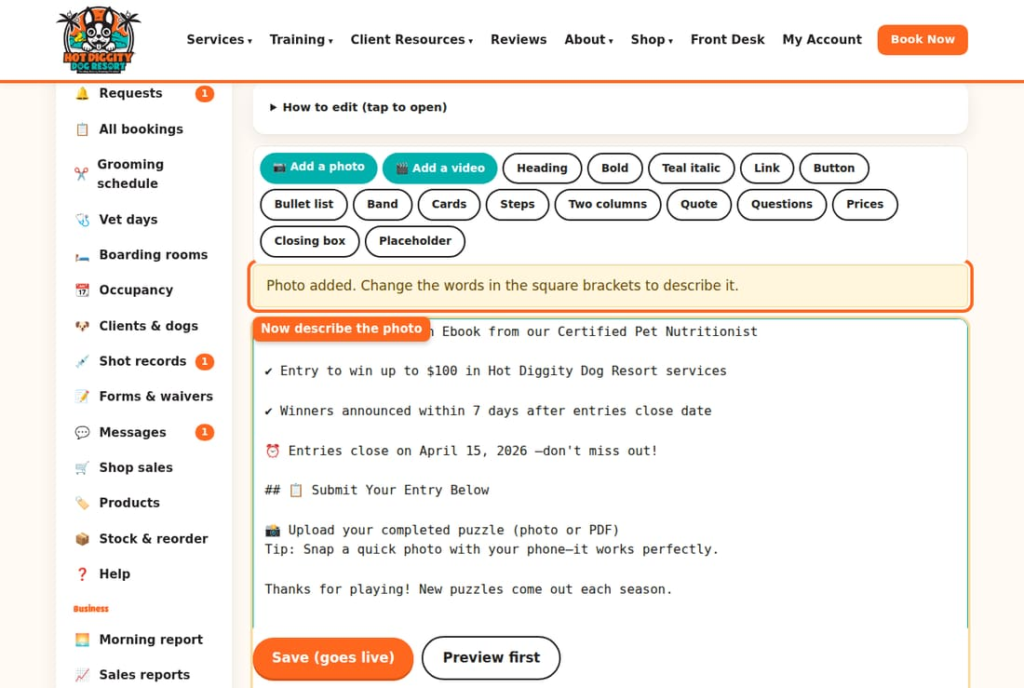
Tip: The other buttons add a heading, a button, a list, cards, and more. Press 🎬 Add a video to add a YouTube or Vimeo video.
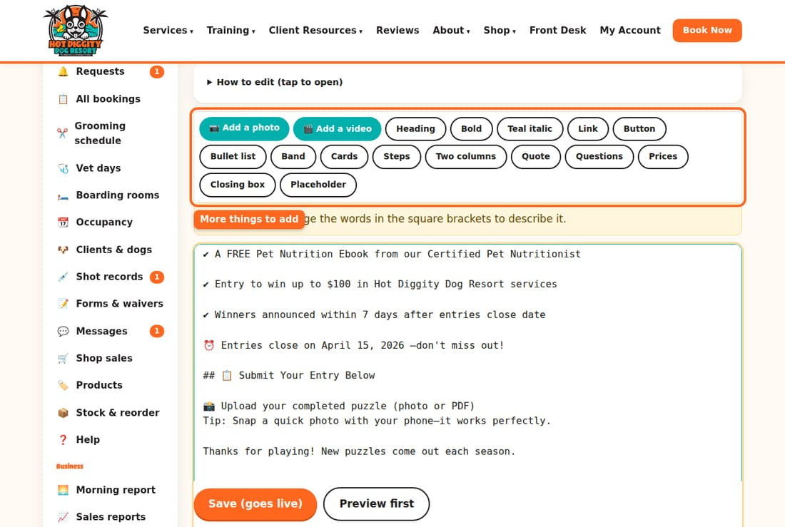

Look before it goes live
- Type a short note in What did you change? This helps you find it in the history later.
- Press Preview first.
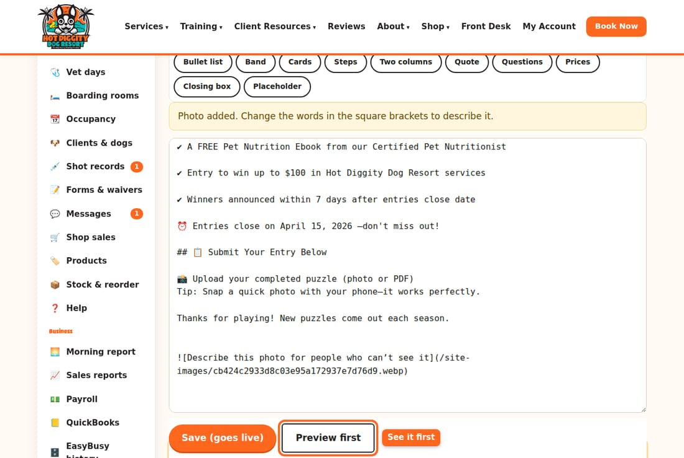
- You see the page just as visitors will. The yellow bar says Preview: not live yet.
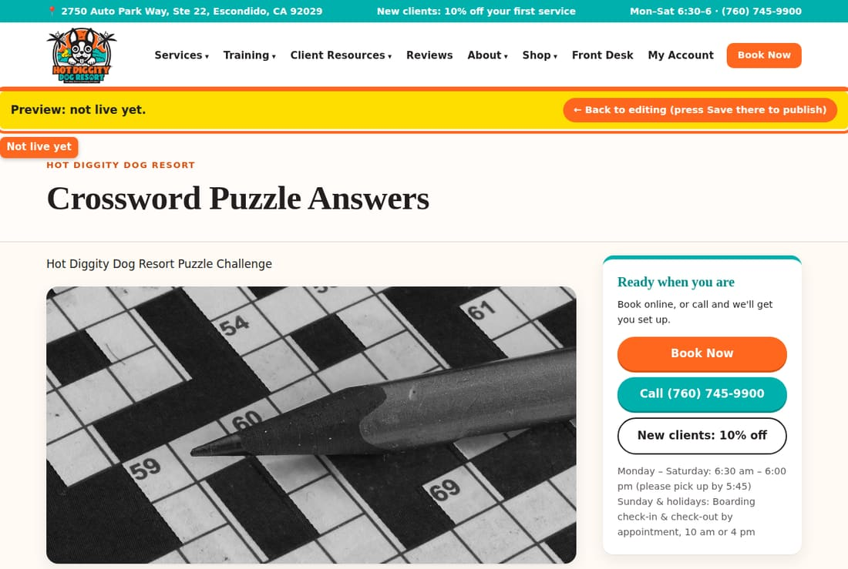
- Press ← Back to editing in the yellow bar.
- A note says you have unsaved changes. They are still in the box.
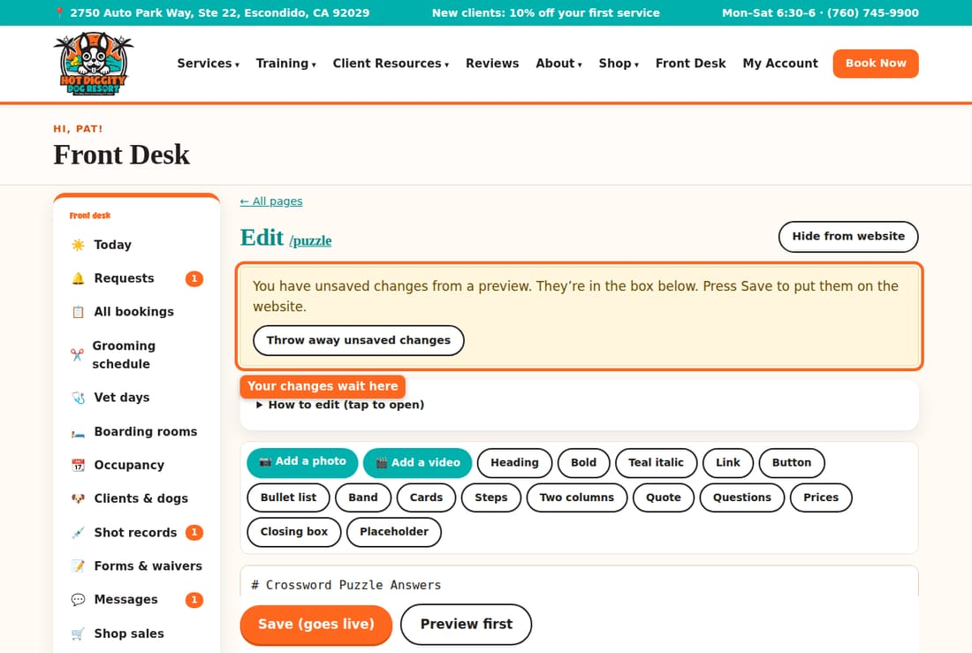
Tip: Don't like it? Press Throw away unsaved changes.

Put it on the website
- Press Save (goes live).
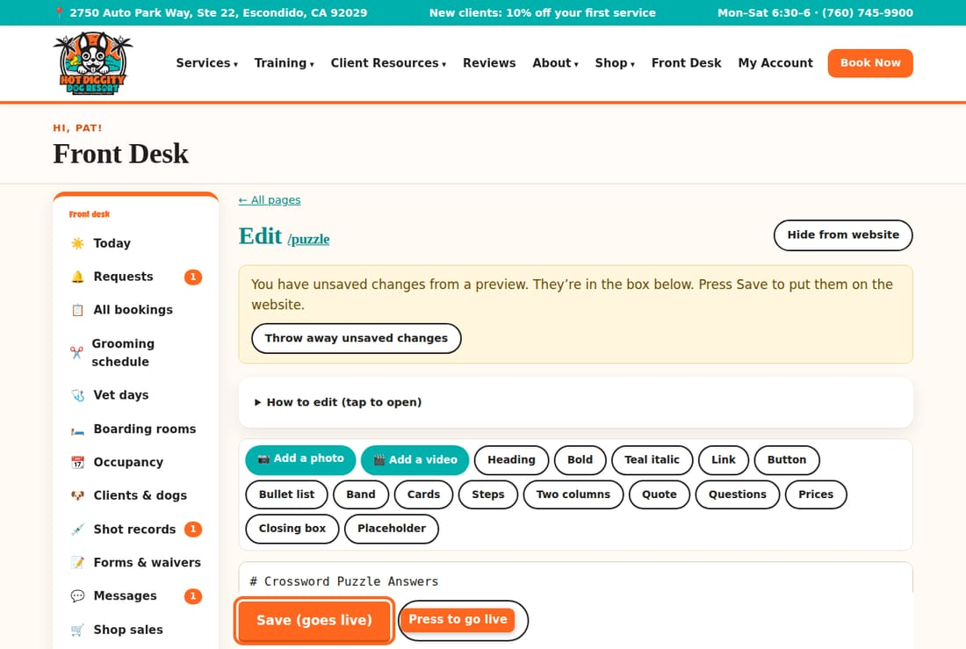
- A green note says the change is live now.
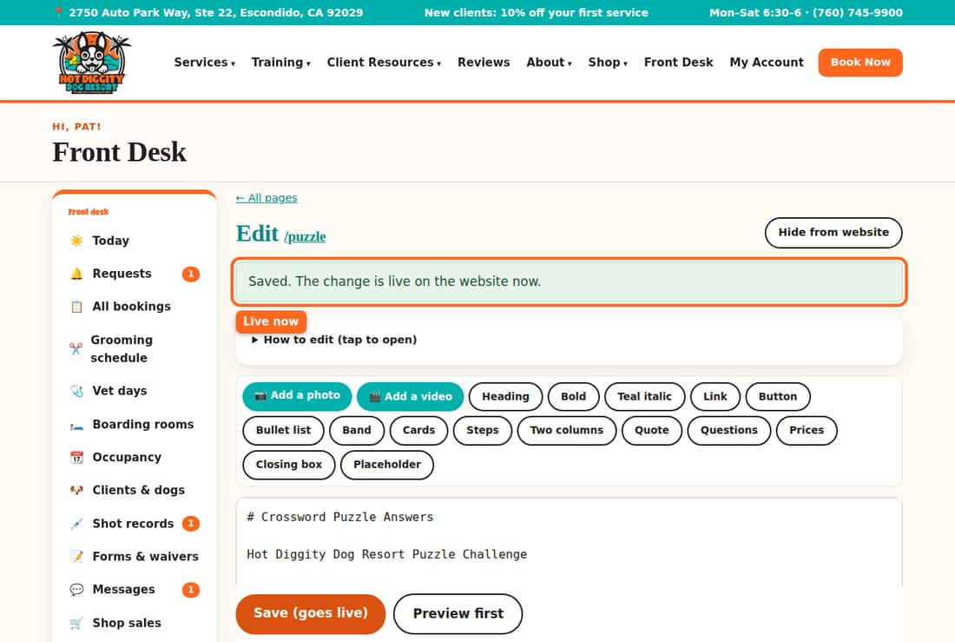
Careful: Save (goes live) changes the real website right away. Everyone can see it.

Undo a change
- Scroll down to History. Each save is a row.
- Find the one you want back. Press Restore.
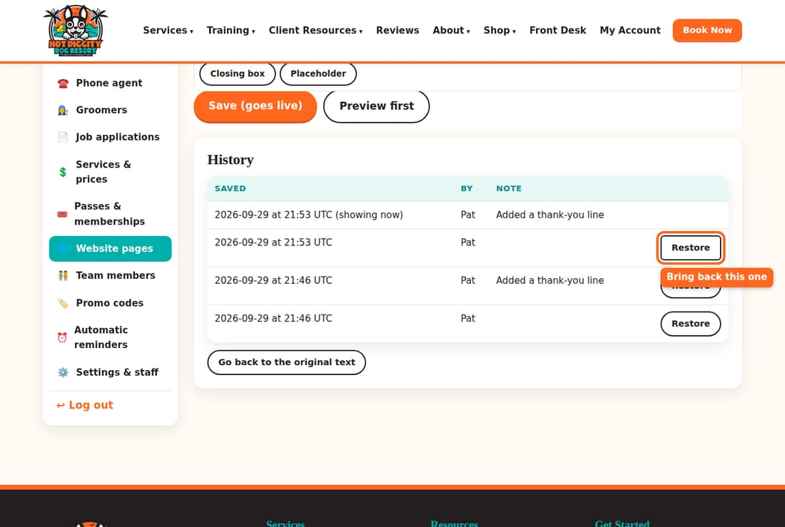
- To undo every change, press Go back to the original text.
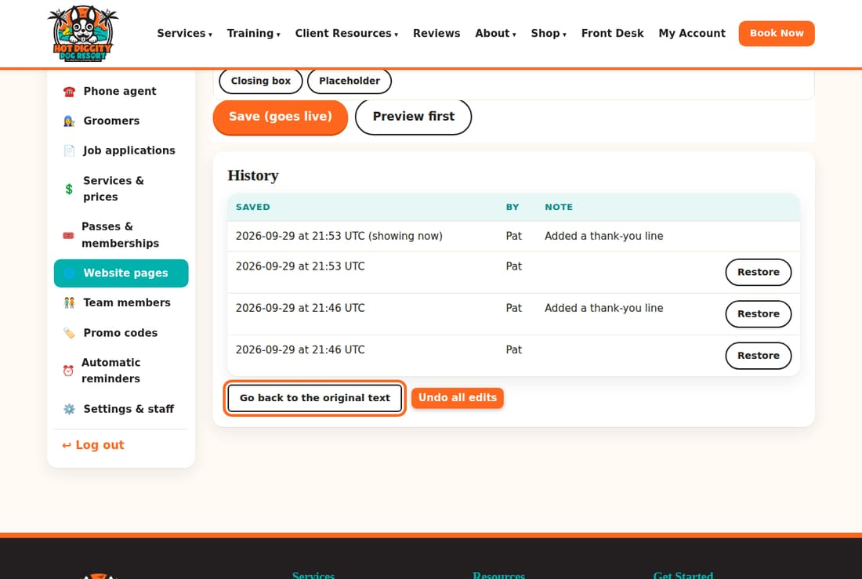
Good to know: The times in History are in UTC. That is 7 hours ahead of California in summer, and 8 in winter.

Hide a page
Press Hide from website at the top of the page. Visitors then see "page not found." Press Show on website to bring it back.
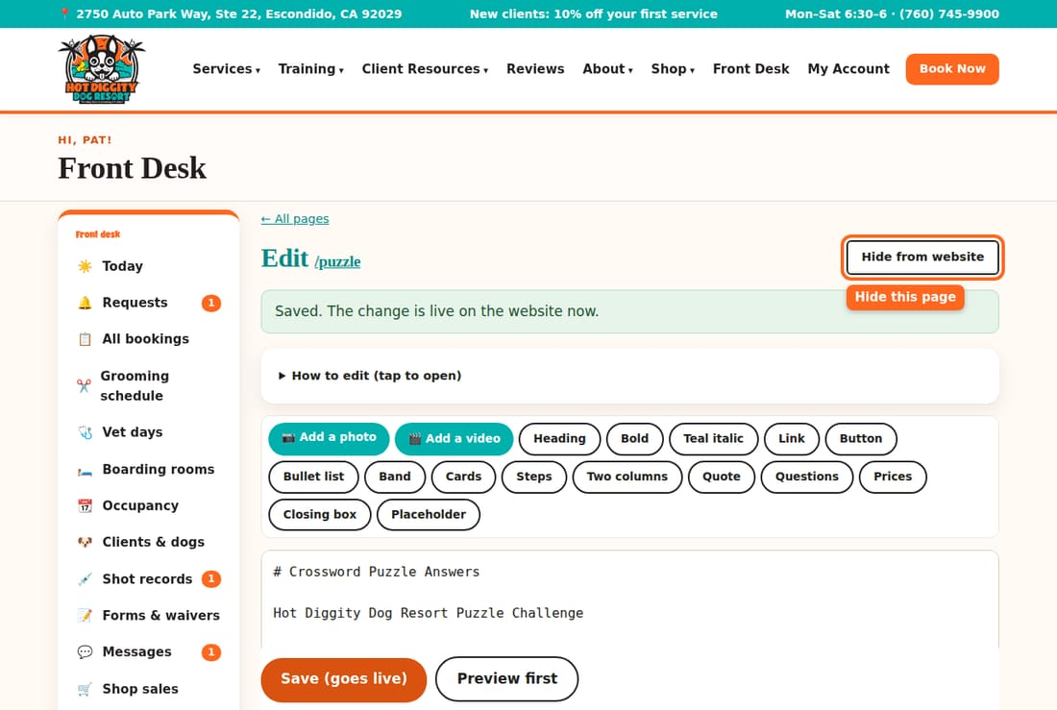

Start a new page
- On Website pages, click + Start a new page.
- Type a Title. Press Create.
- Write the page. Press Save (goes live).
- Press Show on website when it's ready.
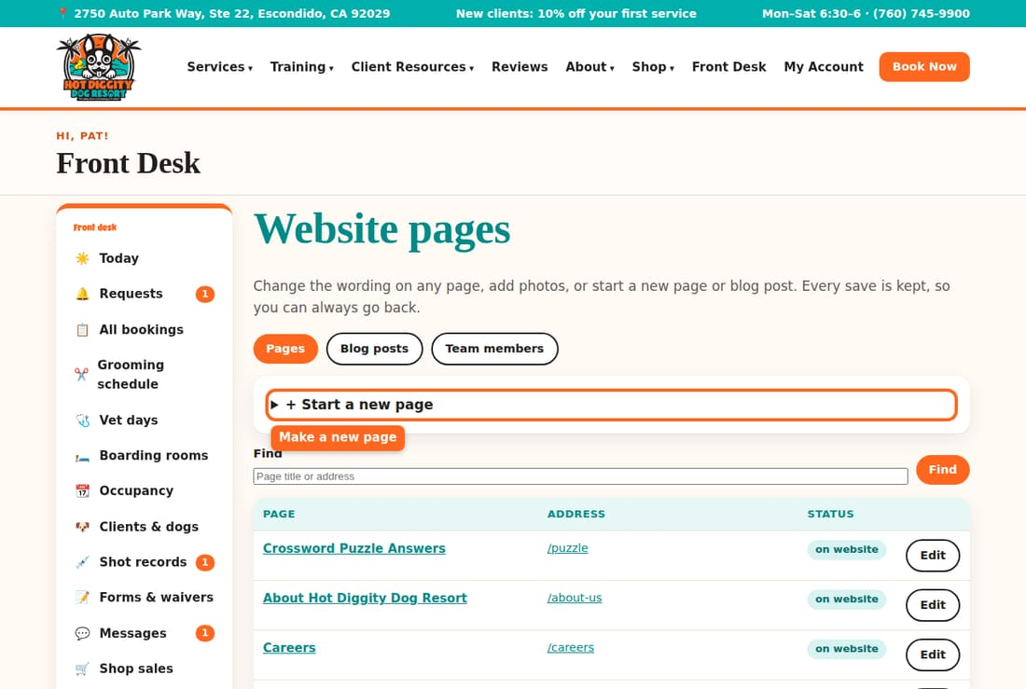
Good to know: New pages start hidden. They are not in the top menu of the website. Ask Claude to add them to the menu.

The Meet the Team page
Change a team member's photo, title, or words, or add someone new.
The Meet the Team page on the website shows your team. You change it here. The website updates right away.

Change a person
- In the menu, click Team members.
- Click the person's name. Their box opens.
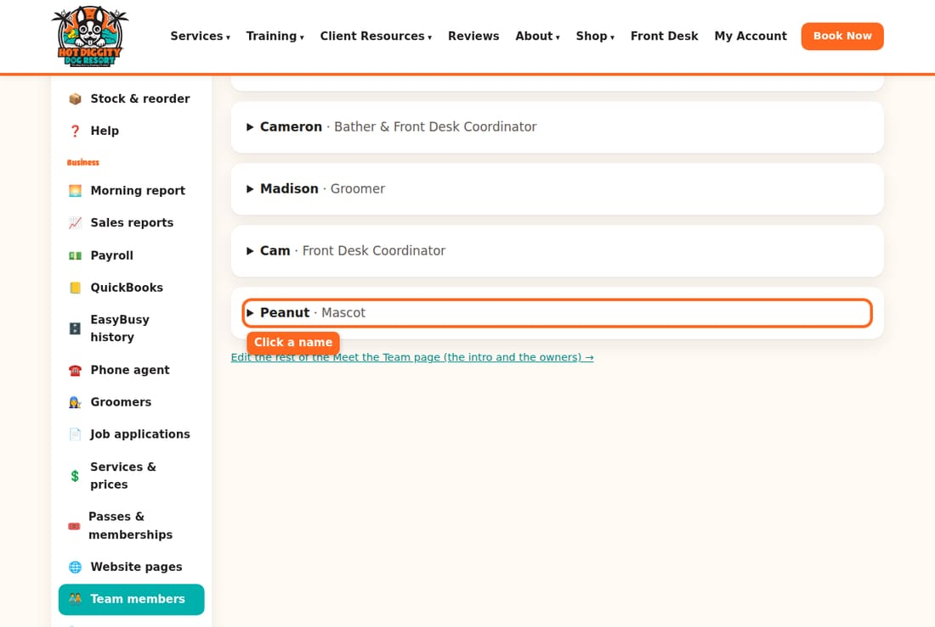
- To change their photo, press Change photo. Pick a new photo.
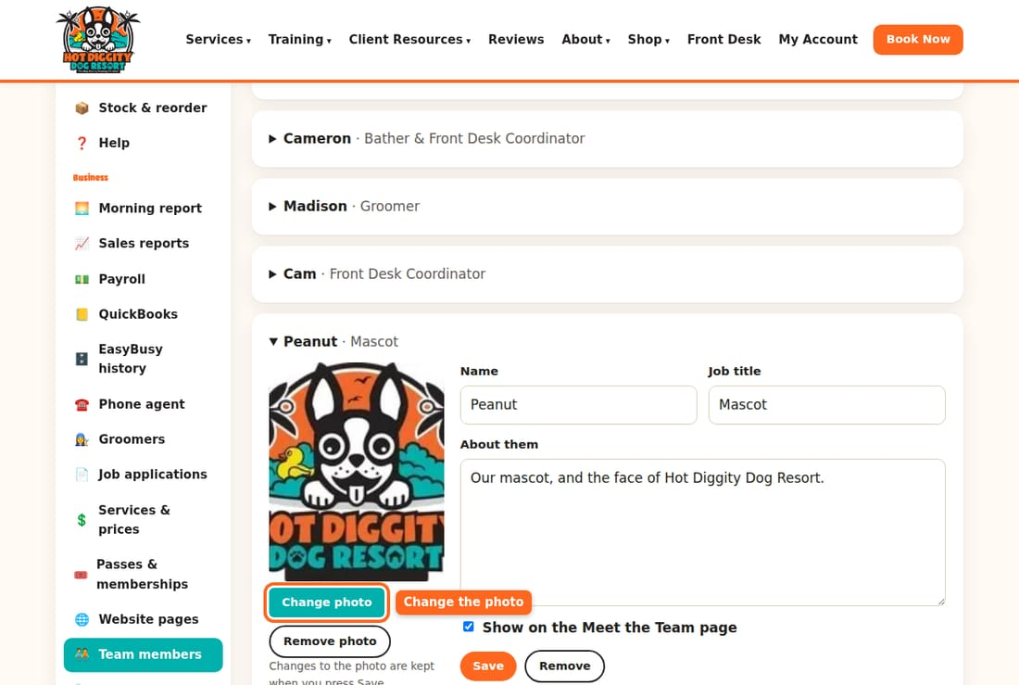
- Change the Job title or the About them words.
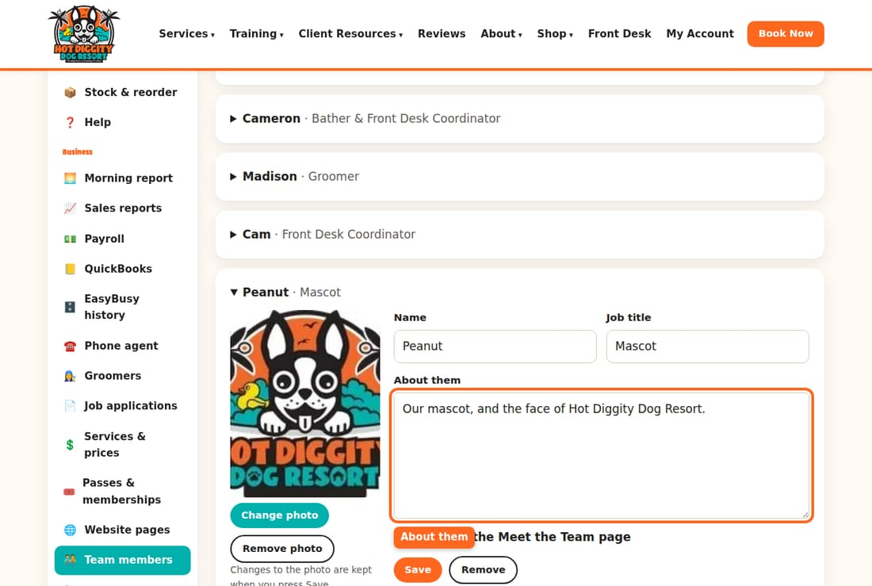
- Press Save.
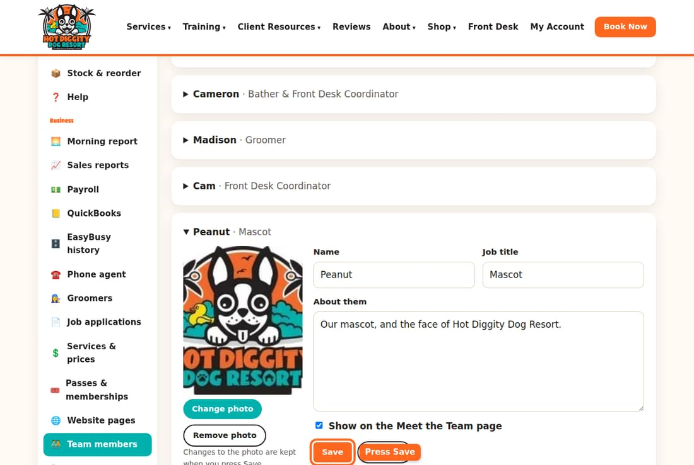

Take someone off the page
- Open their box.
- Uncheck Show on the Meet the Team page.
- Press Save.
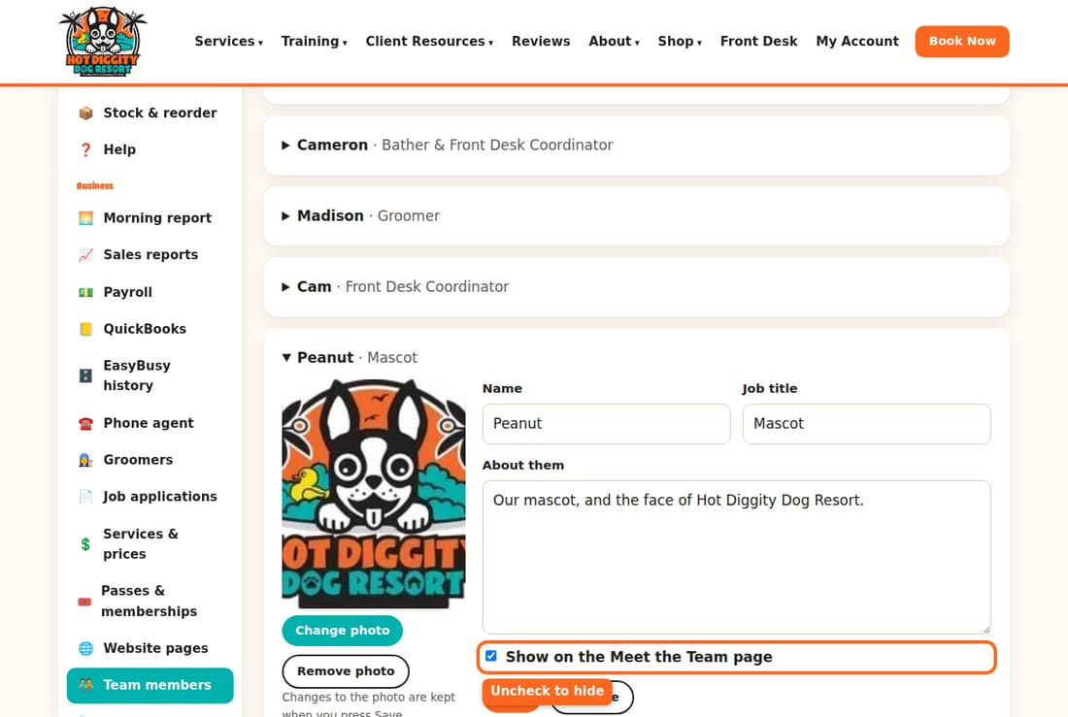
Tip: This hides them but keeps their words. The Remove button deletes them for good.
Careful: Check this list when someone leaves. Uncheck Show for anyone who is gone.

Add a new person
- Click + Add someone to the team.
- Add a photo. Type the Name, Job title, and About them.
- Press Add to the team.
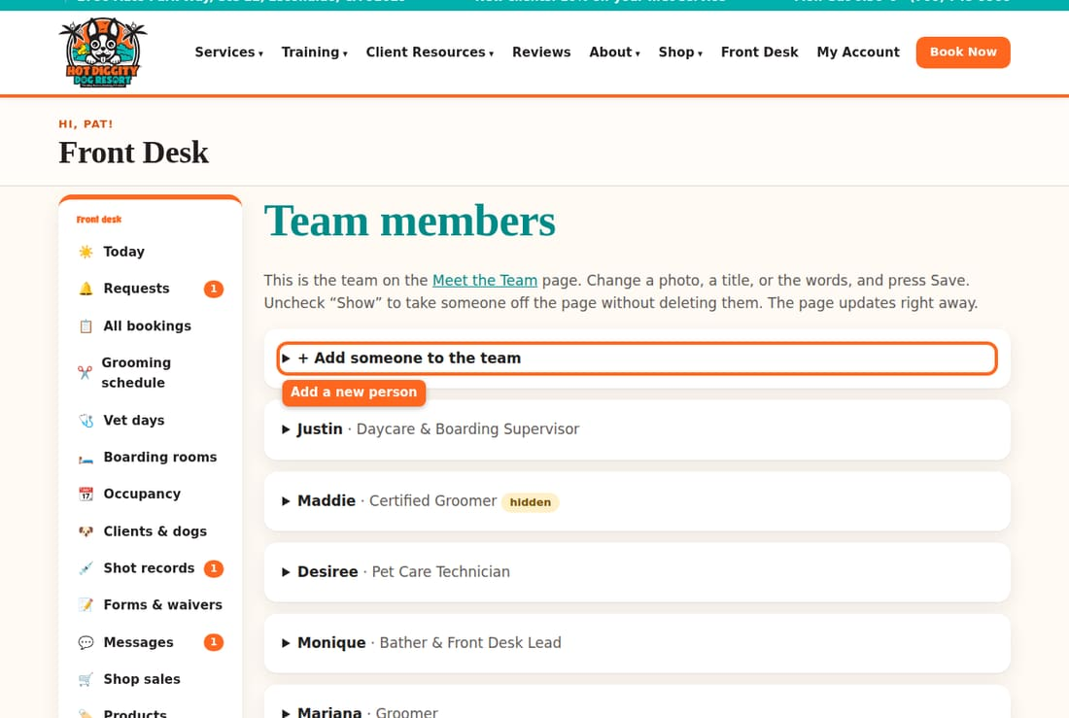

Change the order
Open a person. Press ↑ Move up or ↓ Move down.
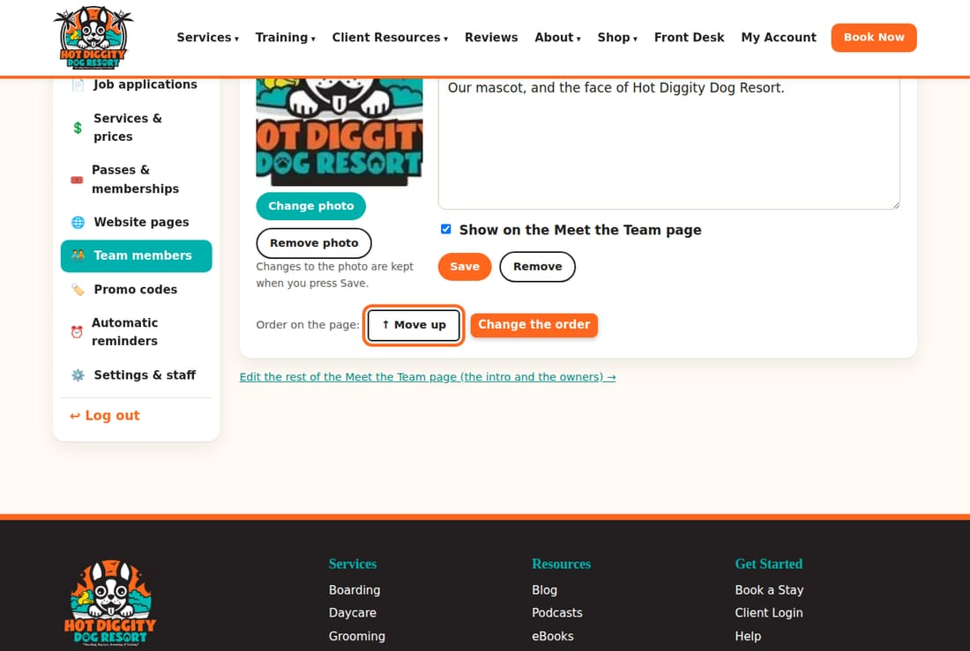
Good to know: Your part and Penny's part are on the page itself. Use the link at the bottom, Edit the rest of the Meet the Team page. See topic 8.

Automatic reminders
Turn reminders on or off, change when they go out, and change the words.
The system sends some emails and texts by itself. For example, it reminds clients of a booking. It tells them when a shot is about to run out. You choose which ones run, and what they say.

The reminders
- Appointment reminder email (48 hours before)
- Appointment reminder text (24 hours before)
- Vaccine expiring soon
- Time for the next groom (4+ weeks)
- Teeth cleaning reminder (6 months)
- Membership yearly reminder (required by California law)
- Review request (day after a visit)

Turn one on or off
- In the menu, click Automatic reminders.
- Find the reminder. Check On to use it. Uncheck it to stop it.
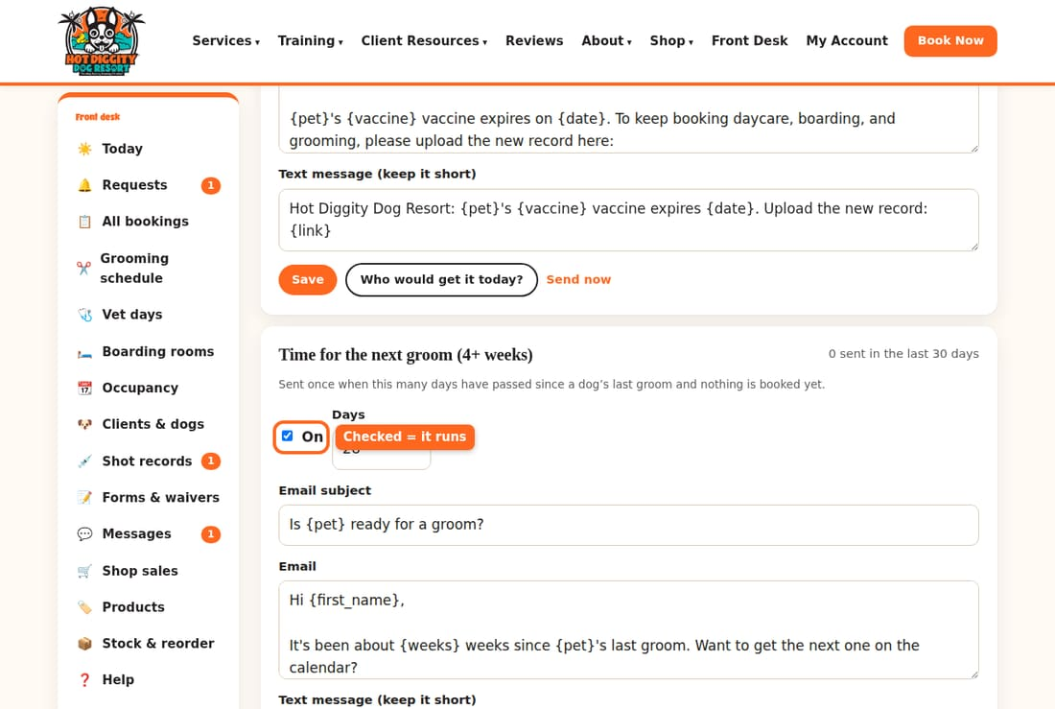
- Press Save in that box.
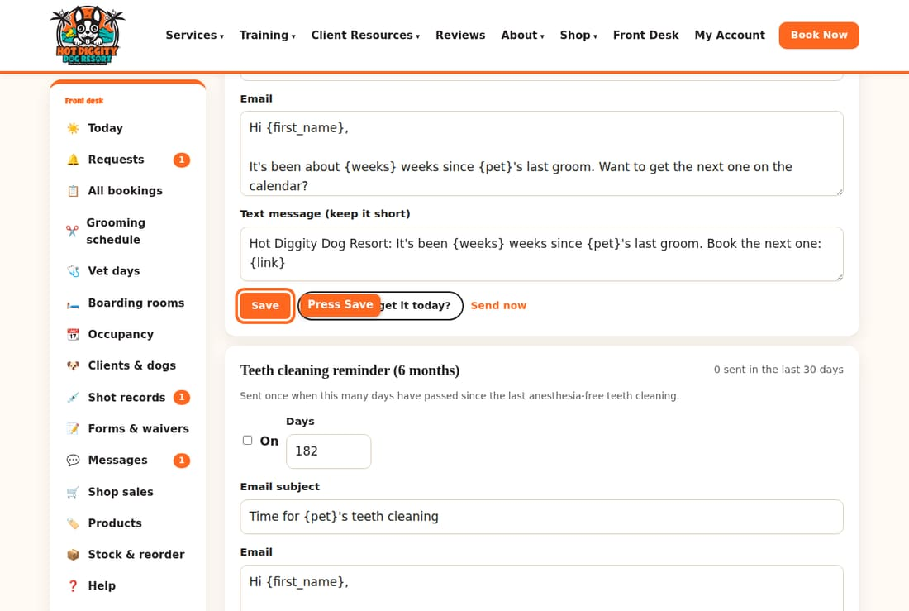

Change when it goes out
- Find the Days box. The two appointment reminders say Hours before instead.
- Type a new number.
- Press Save.
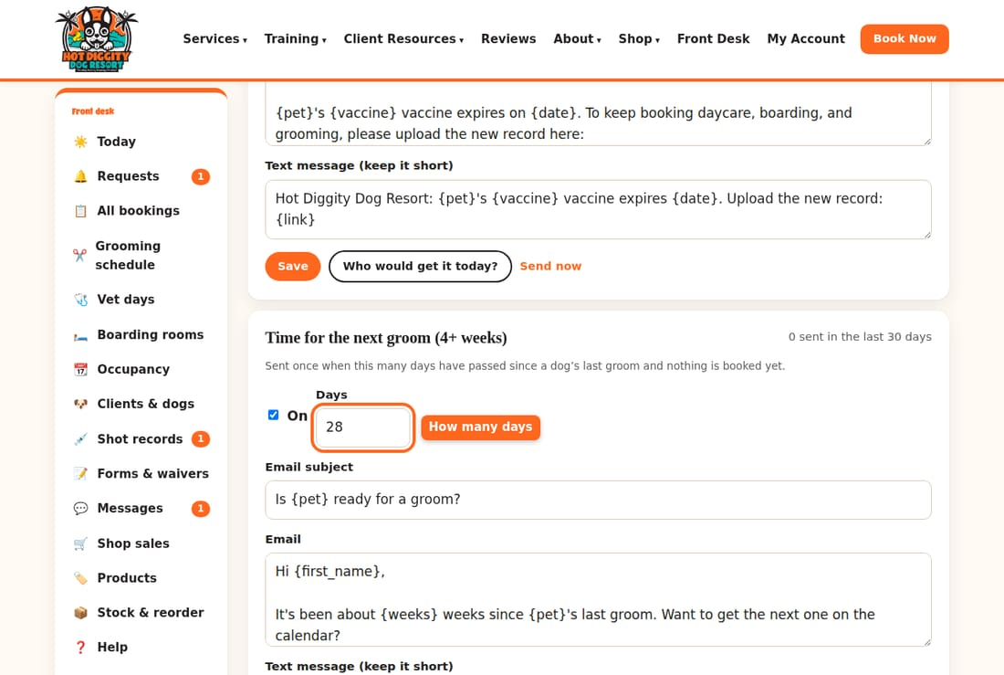

Change the words
- Change the Email subject, Email, or Text message boxes.
- Leave the words in braces, like {first_name} and {pet}. The system fills in the real name.
- Press Save.
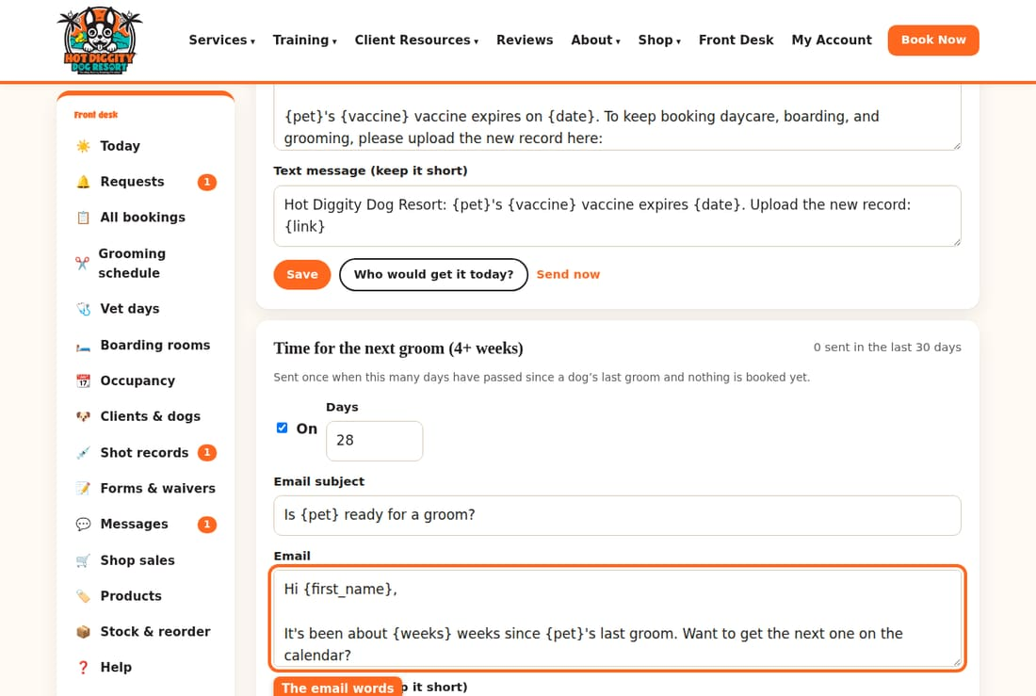
Tip: Keep texts short.

See who would get it
- Press Who would get it today?
- A note lists the clients. It does not send anything.
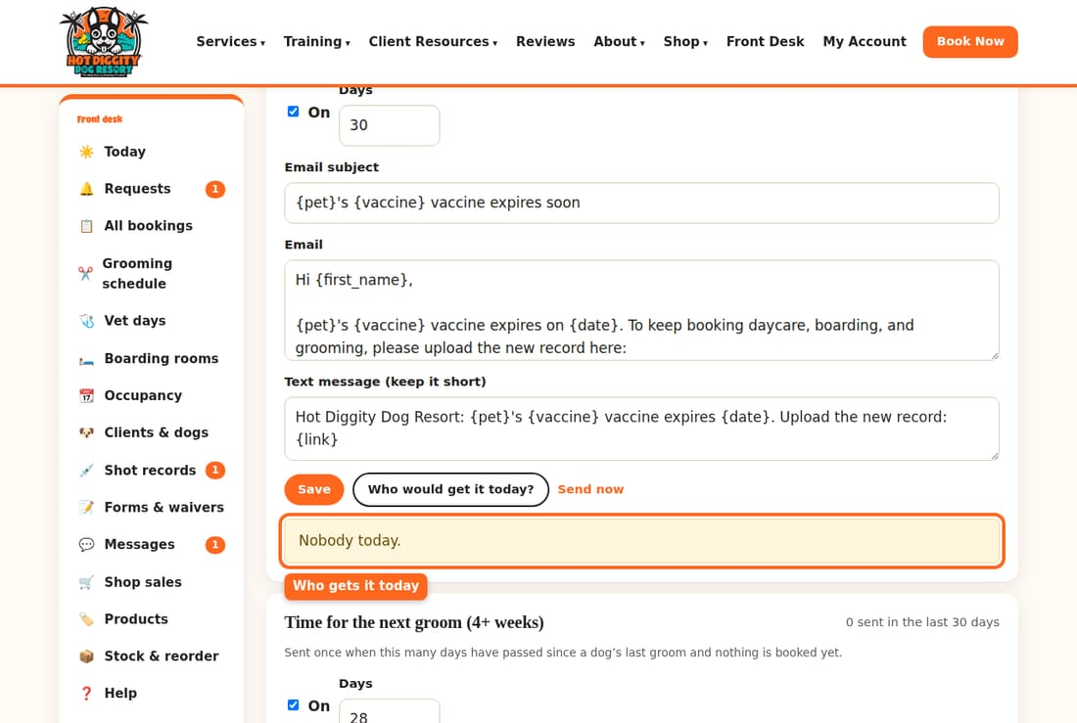

Send it now
Press Send now to send that reminder right away.
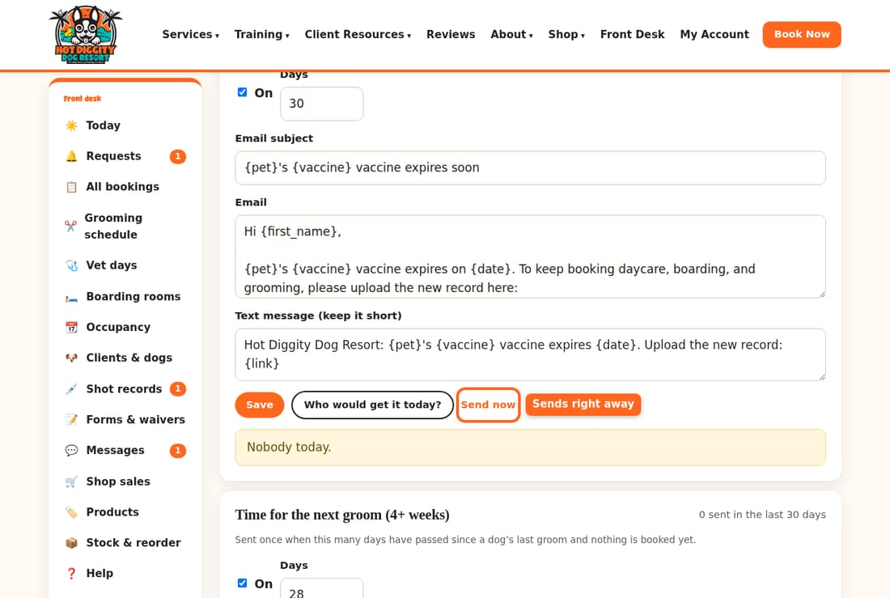
Careful: Send now sends real emails and texts to clients. It sends even if the reminder is turned off. Press Who would get it today? first.

Review requests
The review request needs your Google review link. Paste it in the box at the top. Press Save.
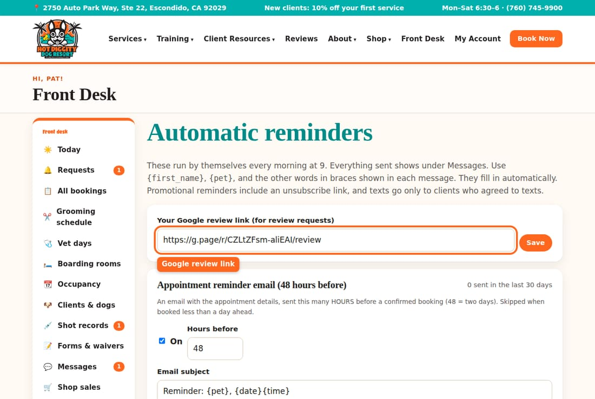
Good to know: Most reminders run each morning at 9. The appointment ones are checked all day. Texts only go out between 8 am and 8 pm. They only go to clients who said yes to texts. Everything sent shows under Messages.

Webcam login and camera password
Change the webcam help words and the camera password.
Clients watch their dogs on the webcams. The cameras have their own login. You keep the help words and the password in Settings & staff.

How the logins work
- Daycare camera: the username is daycare.
- Each suite: the username is the suite number, like suite101.
- Crates: have no camera.
- One password works for all of them.

Change the help words
- In the menu, click Settings & staff.
- Find Webcam login for clients. Change the words in the box.
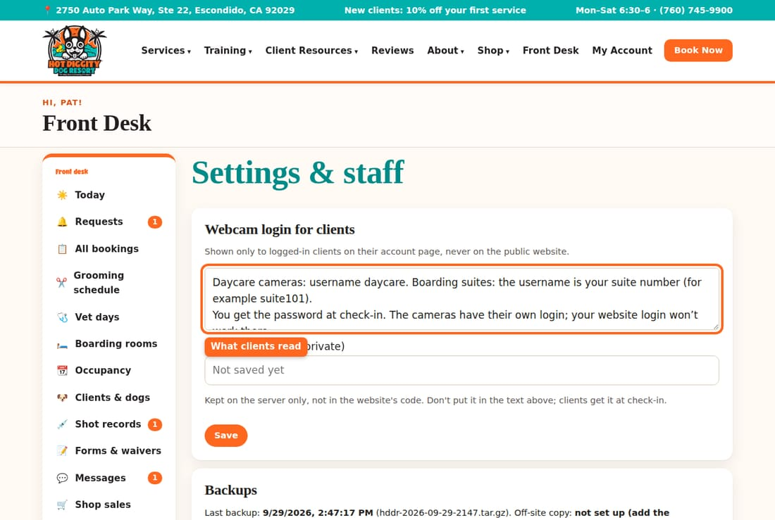
- Press Save.
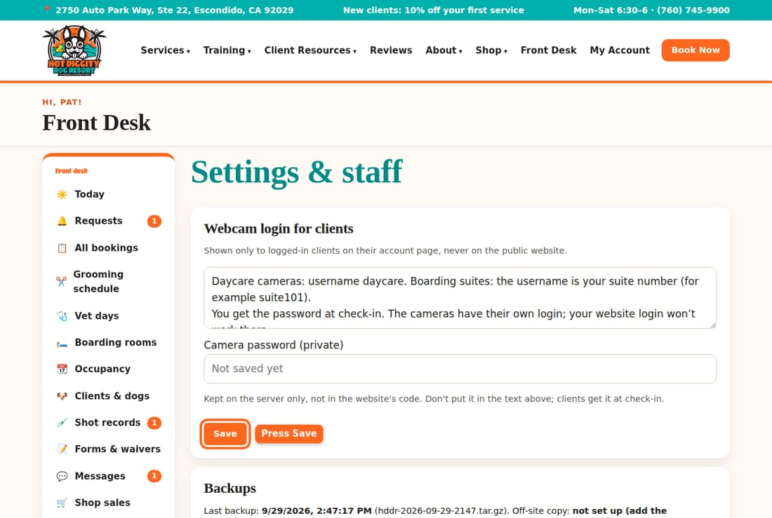
Good to know: Clients see these words on their account page. They are not on the public website.

Change the camera password
- In the same box, click Camera password (private).
- Type the new password. It shows as dots.
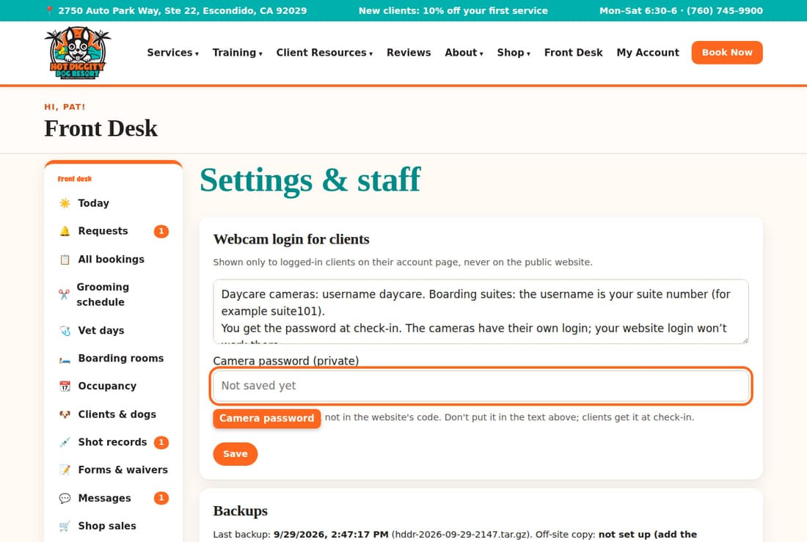
- Press Save.
Careful: Change it here any time you change it on the camera system (Blue Iris). If not, clients get the wrong one.
Tip: Leave the password box empty to keep the old one. Don't type the password in the help words box.

How clients get the password
- A dog checks in for boarding or daycare.
- The booking page shows Print the webcam card. It lists the logins and the password. Hand it to the owner.
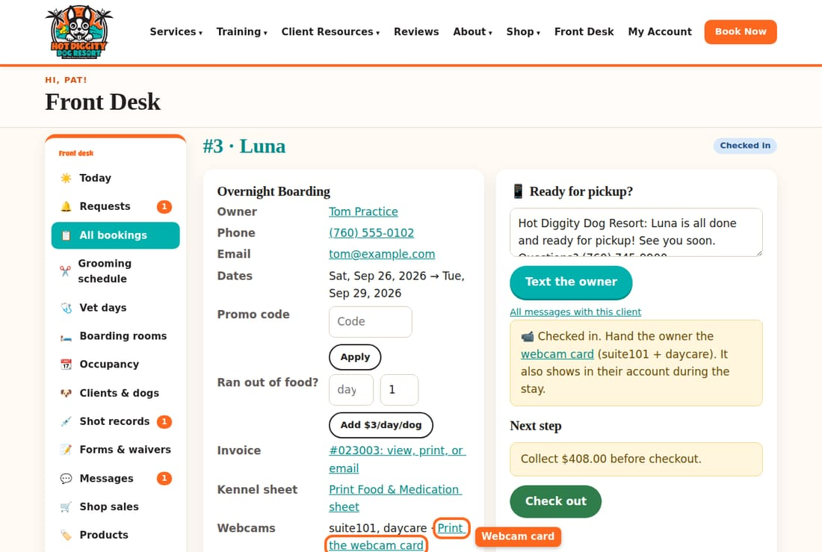
- The logins also show in the client's account, but only while the dog is here.
Good to know: The password isn't a secret. Staff and the phone agent may give it out.

Sales reports
See money in, work booked, who owes, and how clients found you.
Sales reports shows your numbers month by month. It only counts money taken in the new system. Old EasyBusy sales are in EasyBusy history.

Steps
- In the menu, click Sales reports.
- Collected by month shows the money that came in each month.
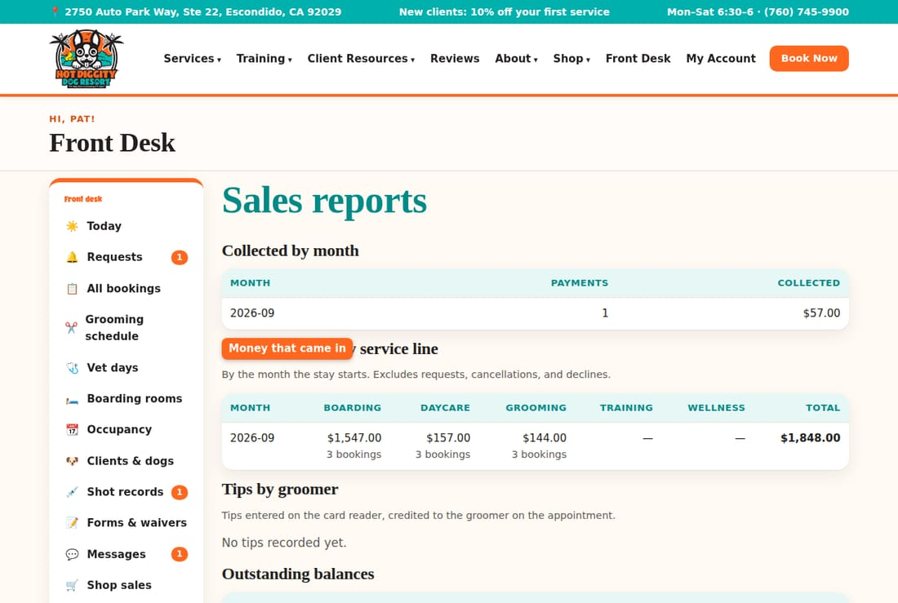
- Booked revenue by service line shows the work booked each month. It is split into boarding, daycare, grooming, training, and wellness.
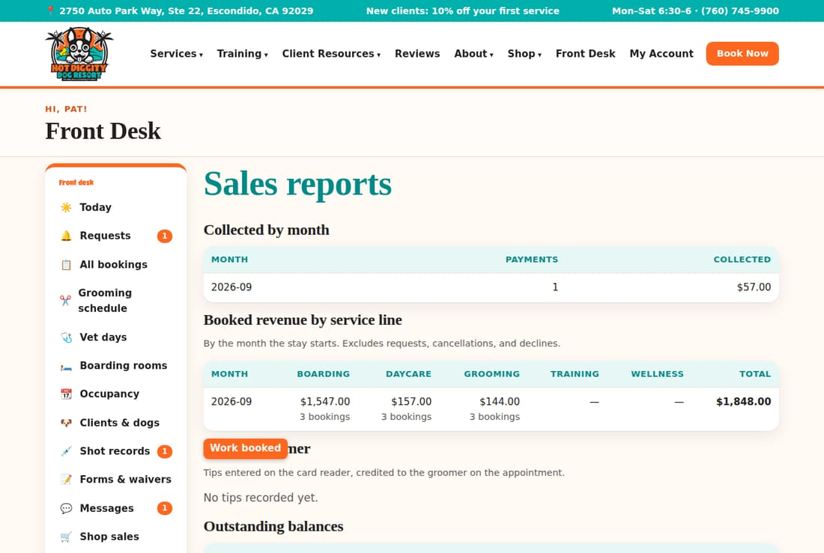
- Outstanding balances shows who still owes money. Click a name to open the client.
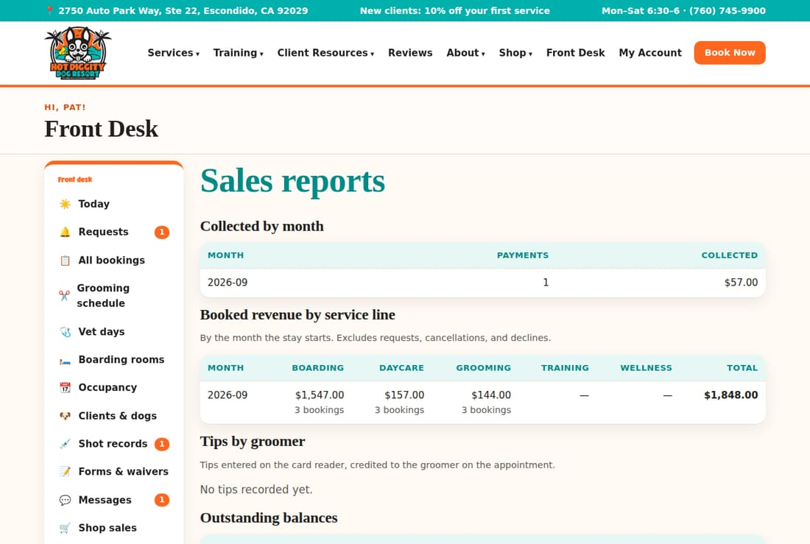
- Near the bottom, see how new clients heard about you this year.
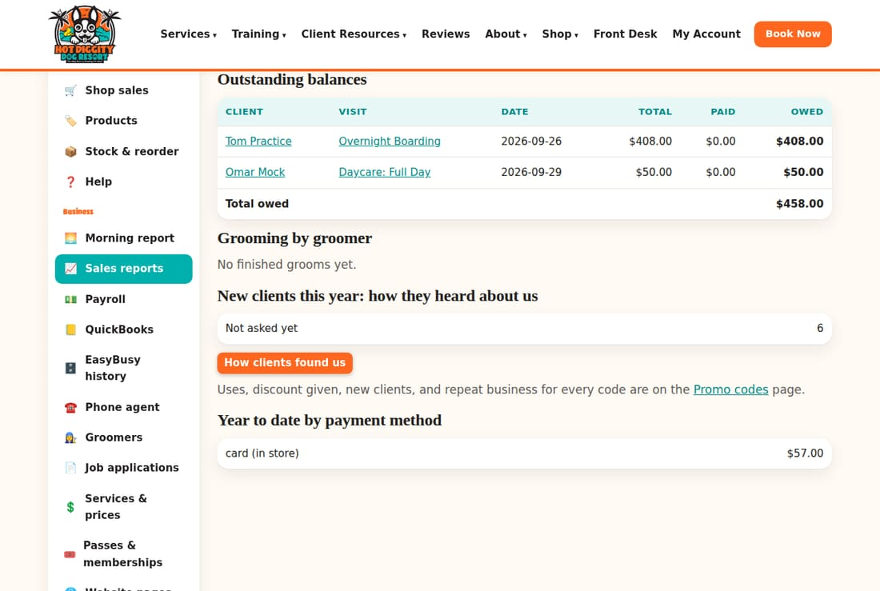

Other parts of the page
- Tips by groomer: tips from the card reader, by groomer.
- Grooming by groomer: finished grooms and their value.
- Year to date by payment method: card, cash, check, and more.
Good to know: "Collected" is money in the bank. "Booked" is work on the books. They are not always the same number.
Tip: For your books, use the QuickBooks page. See topic 13.

QuickBooks
Send your sales to QuickBooks on their own, or download a file as a backup.
The system can send your sales to QuickBooks Online by itself. Each checkout, refund, shop sale, and Stripe deposit goes in within about two minutes. There is also a download. Use it only as a backup.

First, a one-time setup
The automatic sending needs a free Intuit app. Claude sets it up with you. It will walk you through each step. Until that is done, the box at the top says Not set up yet.
- In the menu, click QuickBooks.
- Look at the top box, Send to QuickBooks automatically.
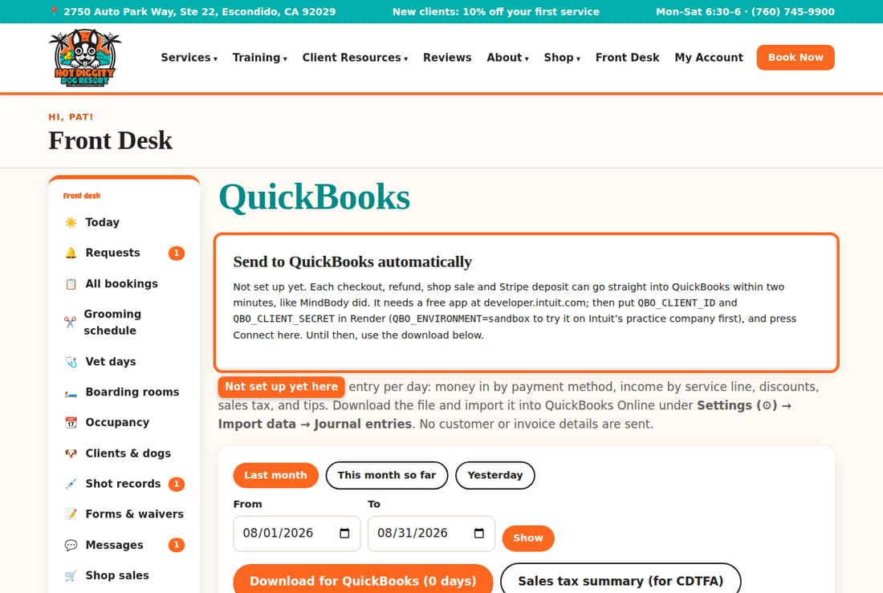
Good to know: The practice site has no Intuit app. So it always says Not set up yet there.

Connect QuickBooks
Once the Intuit app is ready, the box shows a Connect to QuickBooks button.
- Press Connect to QuickBooks.
- Sign in to QuickBooks. Pick the Hot Diggity company.
- You come back to this page. The box now says On and "Connected to" your company.

Pick the start day
- Find Send money taken on or after.
- Pick the day the new system goes live.
- Press Save next to it.
Careful: Use the go-live day. Then money EasyBusy already put in your books is not counted twice.

Missing accounts
QuickBooks may not have an account the system uses. Then a yellow note lists it.
- If you see Create it next to a name, press it. QuickBooks makes the account.
- If there is no button, make the account in QuickBooks. Or change the name at the bottom of this page.
Entries that need a missing account wait until it exists.

Entries that didn't go
A table may show things that didn't reach QuickBooks. It lists the Day, What it was, and Why it didn't go. Fix the problem. Then press Send now.

The buttons
- Send now: send anything waiting, right now.
- Pause: stop sending for a while. The button then says Resume.
- Disconnect: stop sending for good. You would need to connect again.

Stripe deposits
When Stripe puts card money in your bank, that goes in on its own too:
- Your bank account gets the money that arrived.
- The Stripe fee goes to 533 Credit Card Processing Fees.
- POS Clearing - Stripe goes back down, toward zero.

Your account names
The system puts money into your QuickBooks accounts. The names already match your chart of accounts. Look them over once.
- Scroll down. Click Your QuickBooks account names (set once).
- Check that each name matches QuickBooks exactly.
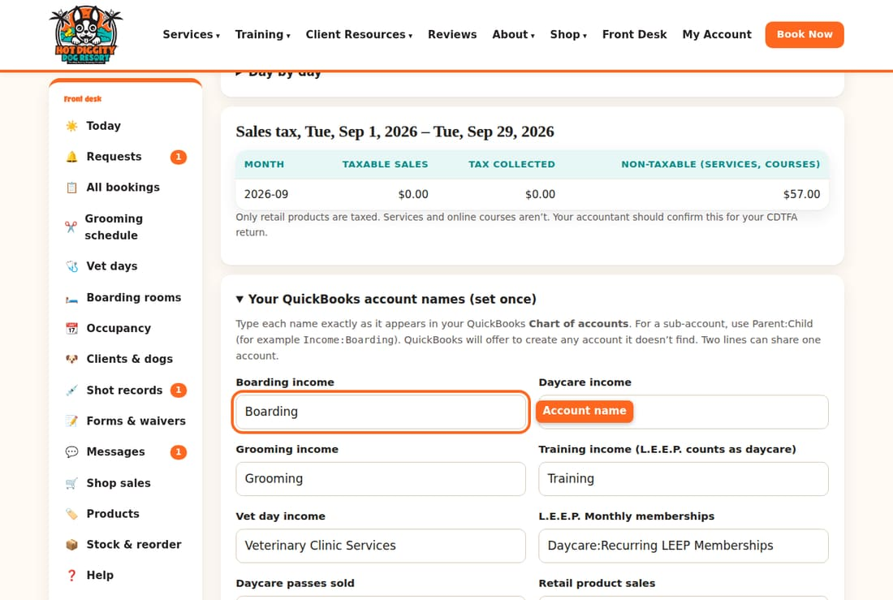
- Under Daycare passes, leave the first choice picked. That is cash basis, which is what Hot Diggity uses.
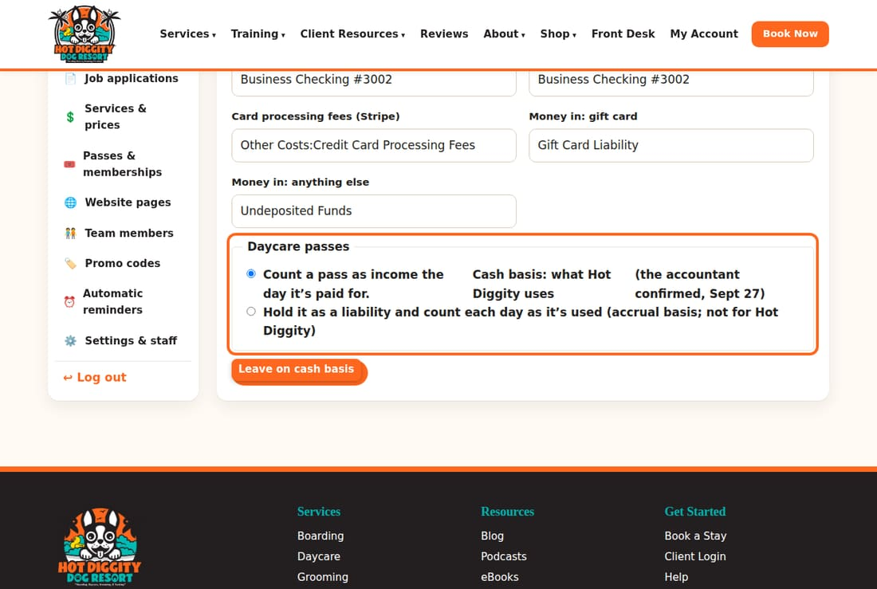
- Press Save account names.
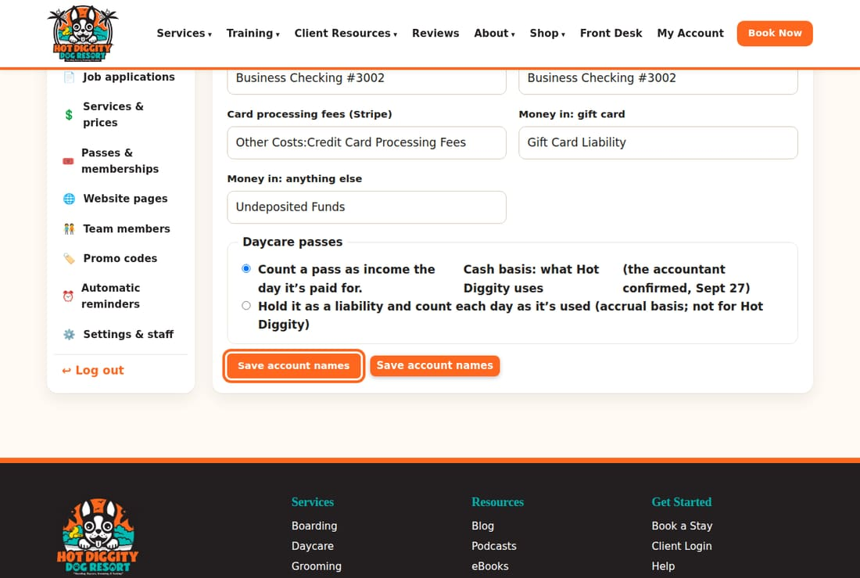
Tip: For an account inside another account, type both names with a colon. For example: Daycare:Daycare Discount Packages.

The backup way: download a file
Use this only when automatic sending is not on.
- Pick the days. Press Last month, This month so far, or Yesterday. Or type dates in From and To, and press Show.
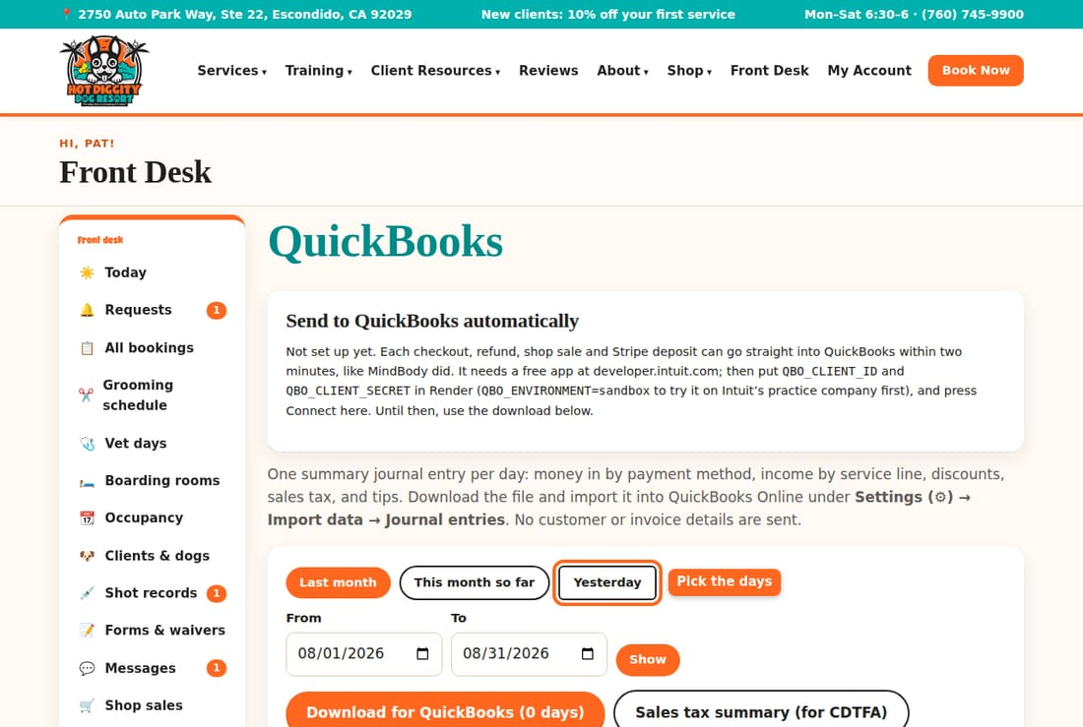
- Look over the table. It shows each account and its total.
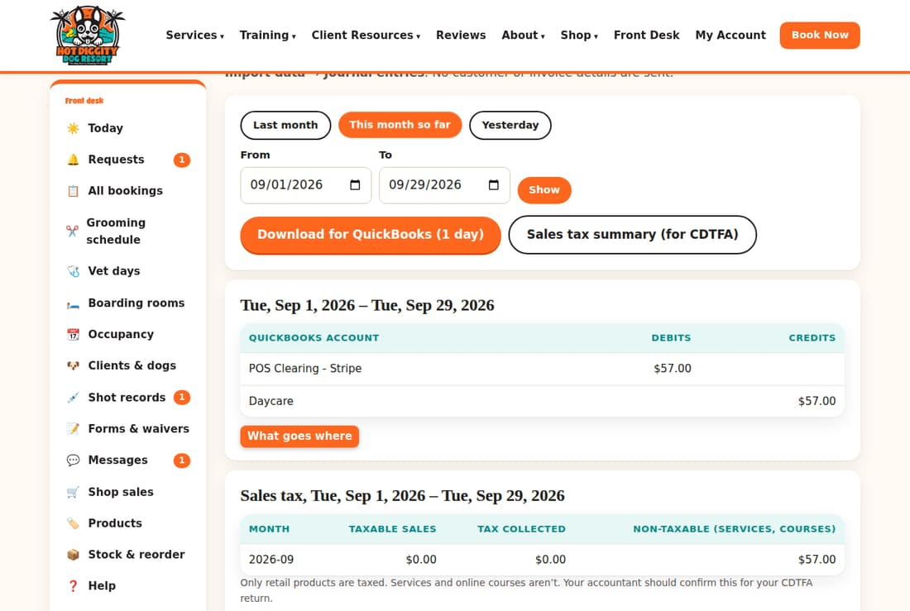
- Press Download for QuickBooks. A file saves to your computer.
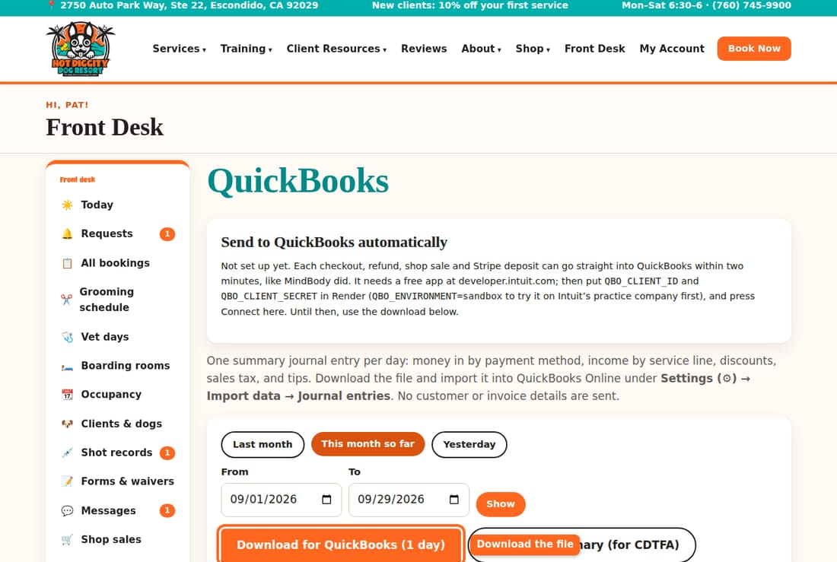
- In QuickBooks Online, click Settings (the gear). Then click Import data. Pick Journal entries, and choose the file.
Careful: Never bring in a download for days that were already sent on their own. QuickBooks would count that money twice.
Careful: Don't bring in the same days twice, either. The page warns you when your dates overlap a past download.
Good to know: Cash basis means money counts on the day it comes in. Only money taken in the new system goes to QuickBooks. Older money stays in EasyBusy history.

Sales tax summary
Get your taxable sales and tax collected, month by month, for the state.
You pay sales tax to the state (CDTFA) on shop products. Services like grooming and boarding are not taxed. This summary gives you the numbers for your return.

Steps
- In the menu, click QuickBooks.
- Pick the days, like Last month. Or type dates in From and To, and press Show.
- Scroll down to the Sales tax box. It shows each month.
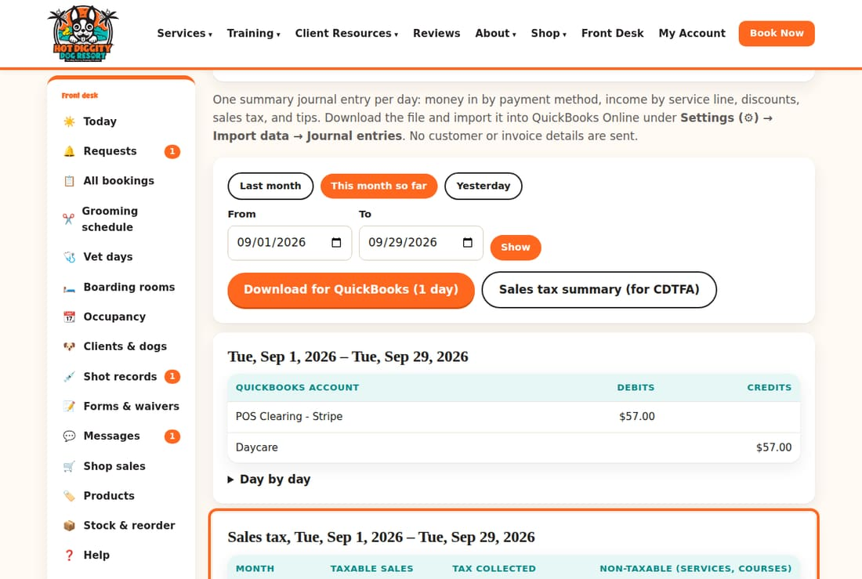
- To get a file, scroll back up. Press Sales tax summary (for CDTFA).
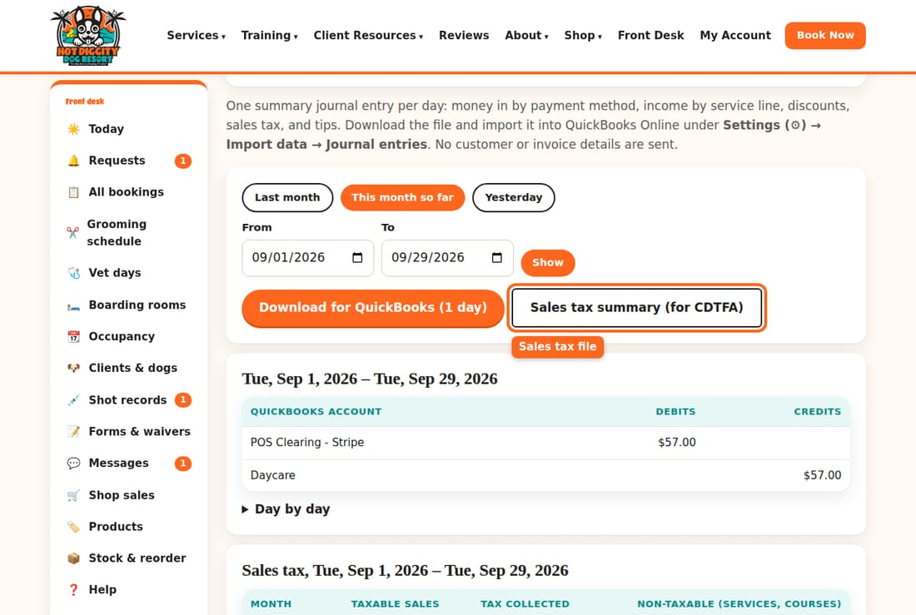

What the columns mean
- Taxable sales: shop products that are taxed, after discounts.
- Tax collected: the tax clients paid.
- Non-taxable: services and online courses.
Careful: Have your accountant check the numbers before you file.
Good to know: Sales tax goes to its own account in QuickBooks, "Sales Tax Payable - HDDR." So file from this summary, not from the QuickBooks sales tax center.
Tip: The shop's tax rate is set on Settings & staff. See topic 21.

EasyBusy history
Look up your old sales and invoices from EasyBusy.
Your old sales from EasyBusy are kept in the new system. You can look them up and download them. You can't change them.
Good to know: The practice site has no EasyBusy history. It only shows a note. The real site fills in once the EasyBusy copy is loaded.
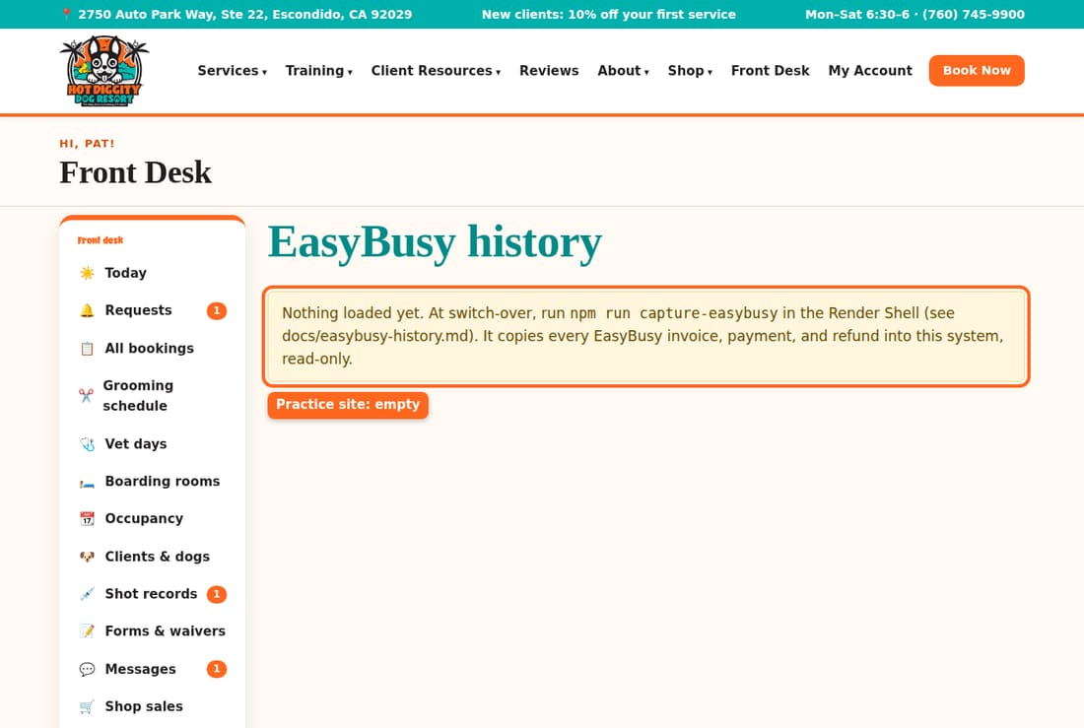

Steps
- In the menu, click EasyBusy history.
- Press a year button to pick a year. Or press All years.
- Money received by month shows money in, refunds, tips, and sales tax.
- Sales by category shows sales for boarding, grooming, and more. Click By service for each service.
- Sales tax by quarter shows the tax for each three-month period.
- Refunds lists every refund. Click it to open the list.

Download a report
Each box has a download button. On Money received by month, you can pick:
- Download monthly summary
- Every payment and refund
- Every invoice
- Every line item
The other boxes have a Download button.

Find an old invoice
- Scroll to Find an invoice.
- Type an invoice number, a client, or a dog's name.
- Press Search.
- Click the invoice number to see it.
Good to know: Money counts on the day it came in. That is cash basis. California says to keep sales tax records at least 4 years.
Tip: Some future bookings from EasyBusy may have no price yet. Then a yellow note shows at the top. Press Price them from the price list.

Payroll
See what each groomer earned for a pay period, and download it.
The Payroll page adds up each groomer's grooms for a pay period. It works out hourly pay and commission. It does not pay anyone. You send the numbers to your payroll service or accountant.

Steps
- In the menu, click Payroll.
- The page opens on this pay period. Periods are the 1st to the 15th, and the 16th to the end of the month.
- To pick other days, type From and To dates. Press Show. Or press ← Previous period.
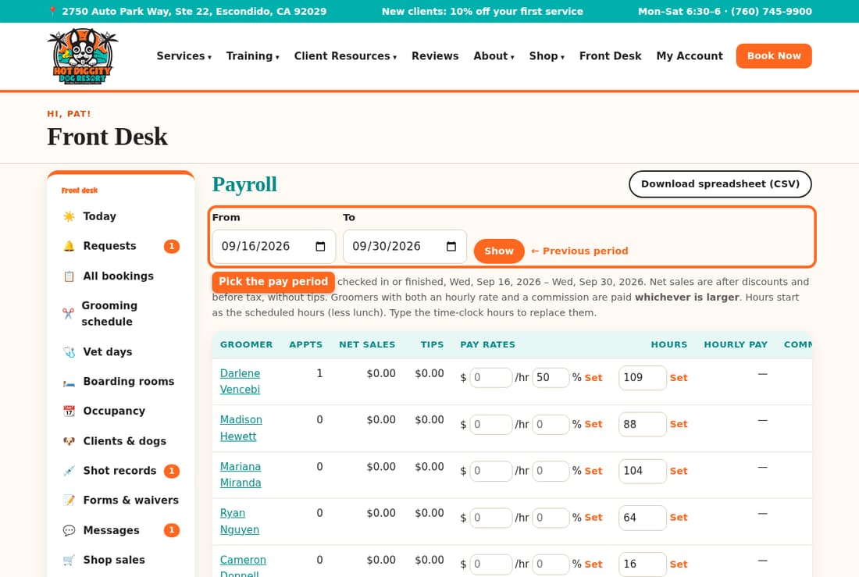
- Set each groomer's pay. Type an hourly rate in the $ /hr box. Type a commission in the % box. Press Set next to them.
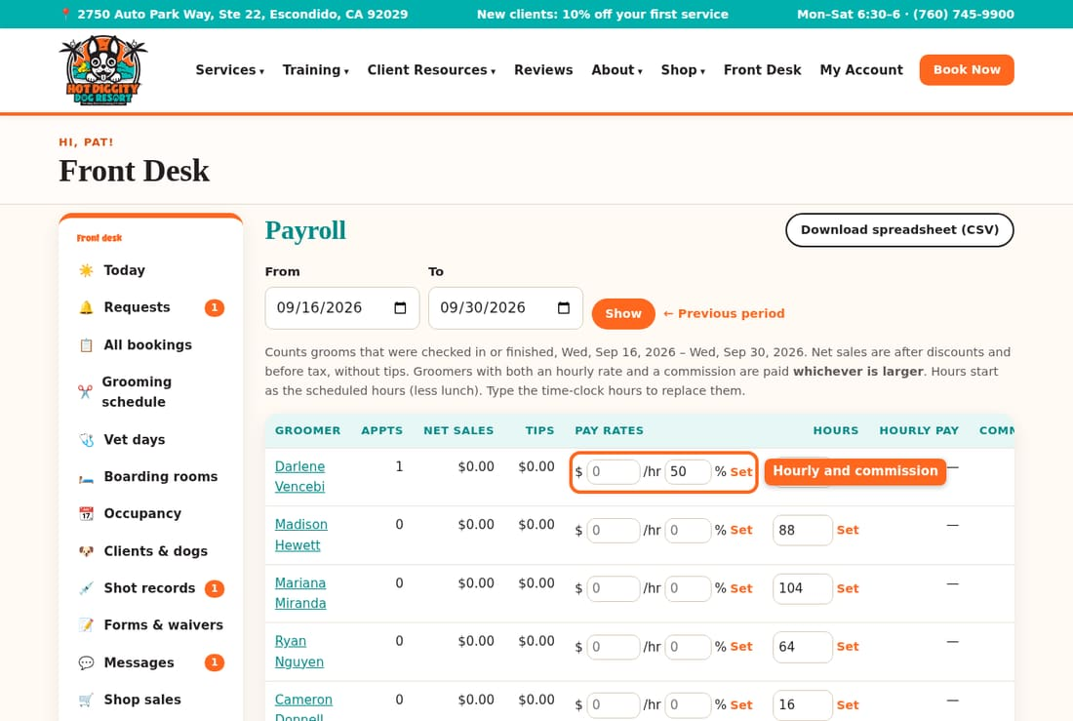
- The Hours box starts with their scheduled hours, less lunch. Type their real time-clock hours. Press Set.
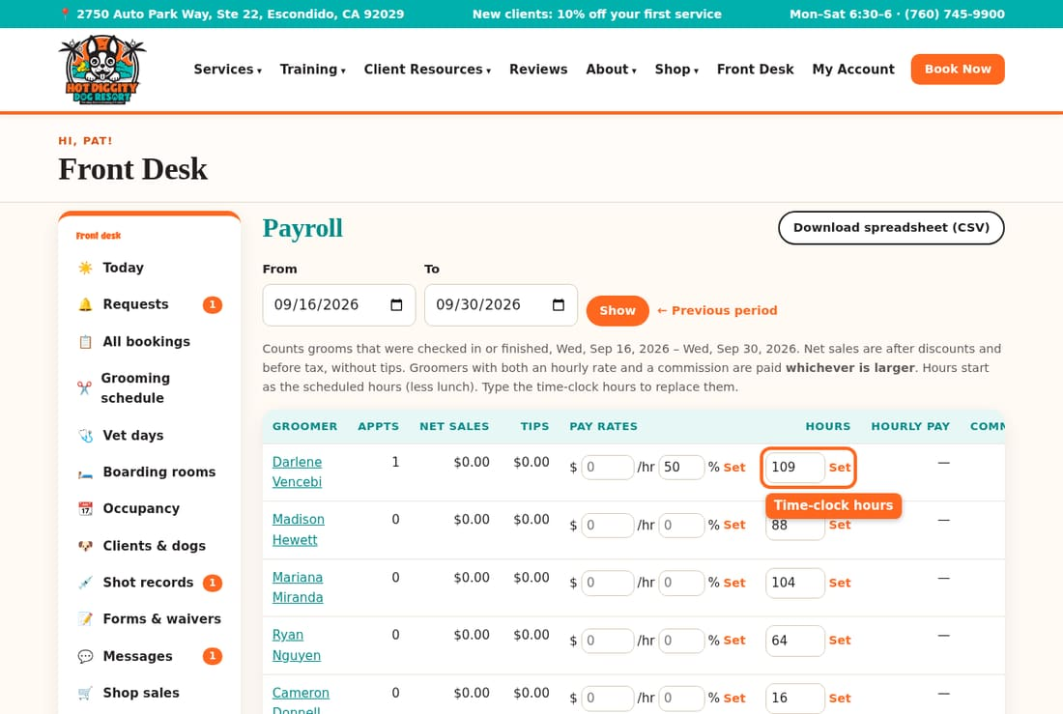
- The Pay column shows what they earned.
- Press Download spreadsheet (CSV) to get a file.
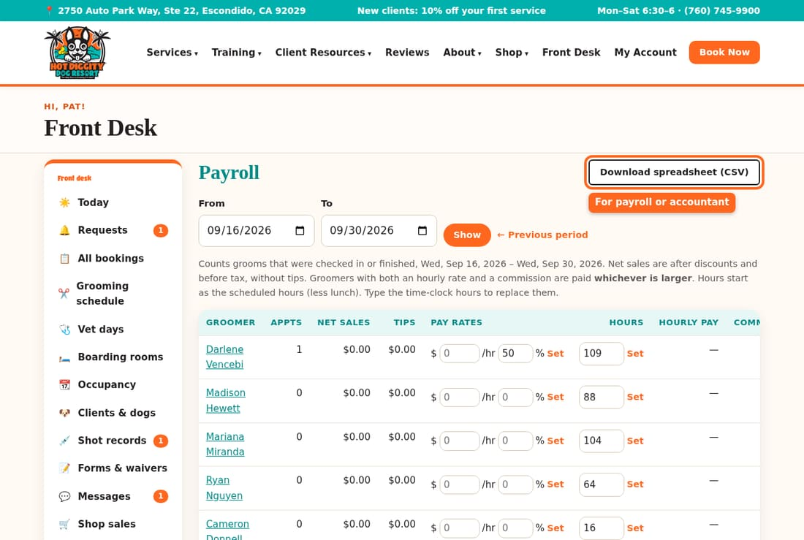

See each groom
Click a groomer's name. A list of each groom shows below the table.
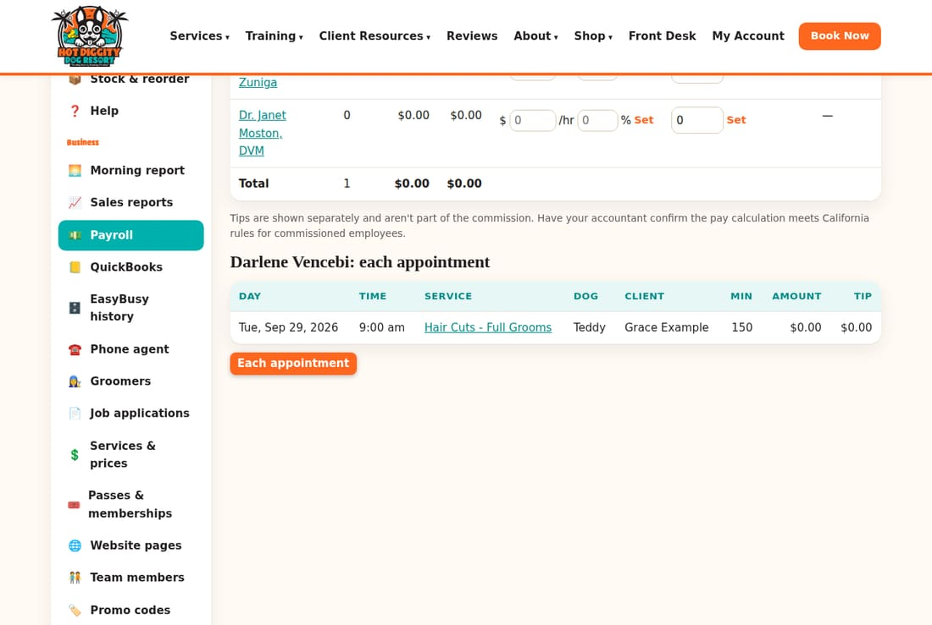
Good to know: A groomer with both an hourly rate and a commission gets whichever is more. Tips are shown on their own. They are not part of the commission.
Careful: Have your accountant check the pay math. California has special rules for pay by commission.
Tip: Only grooms that were checked in or finished count.

Backups
What gets saved each night, and how to make a backup yourself.
A backup is a spare copy of all your records. It has clients, dogs, bookings, and payments. If something goes wrong, the records can come back from a backup.

What runs each night
- About 2 am, the system saves a copy on the server. It keeps the last 7.
- It then sends the copy off-site to Backblaze. That is storage you own, away from the server.
- New files, like shot records, are sent off-site too.
- Render, your web host, also saves its own copy of the disk each day.

Check the last backup
- In the menu, click Settings & staff.
- Find Backups. It shows the time of the Last backup.
- Look at Off-site copy. On the real site, it should say uploaded.
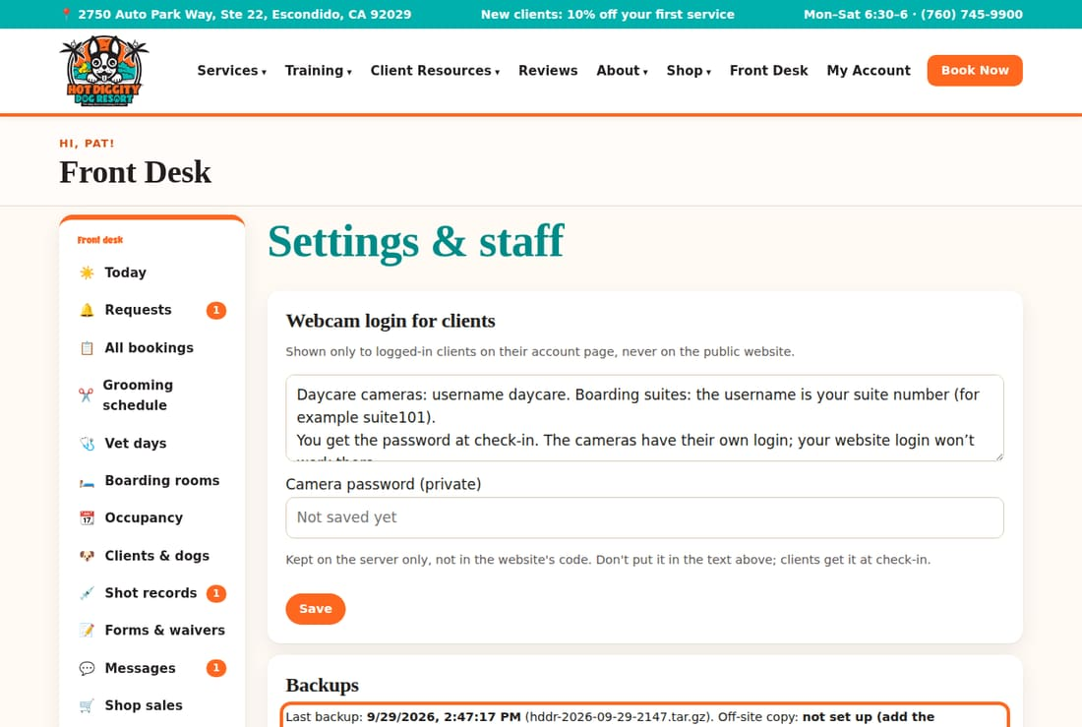
Good to know: "Uploaded" means the copy reached Backblaze. The practice site says "not set up." That is normal there. It has no off-site storage.

Make a backup now
- Press Back up now.
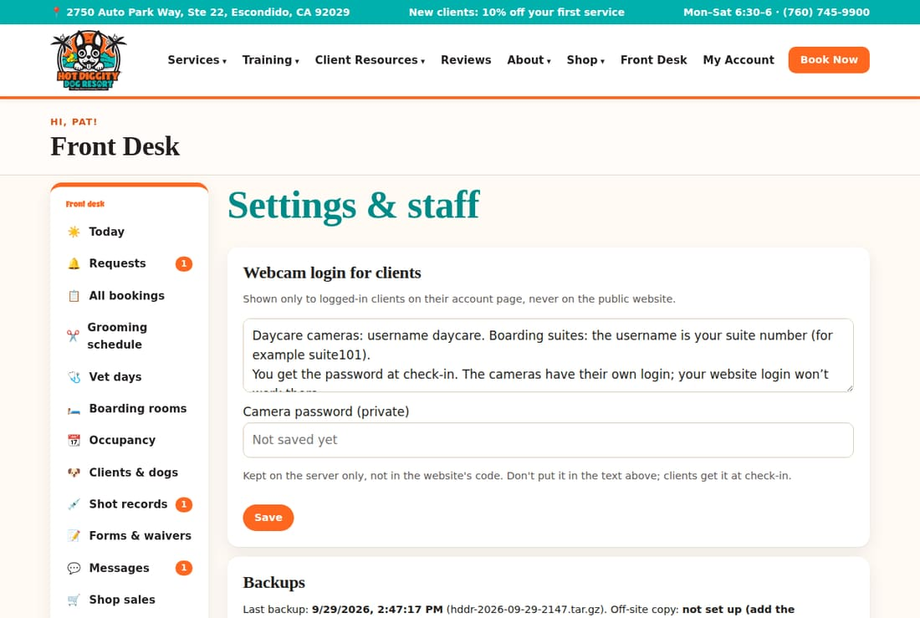
- Wait a moment. A note says Backup saved, and tells you about the off-site copy.
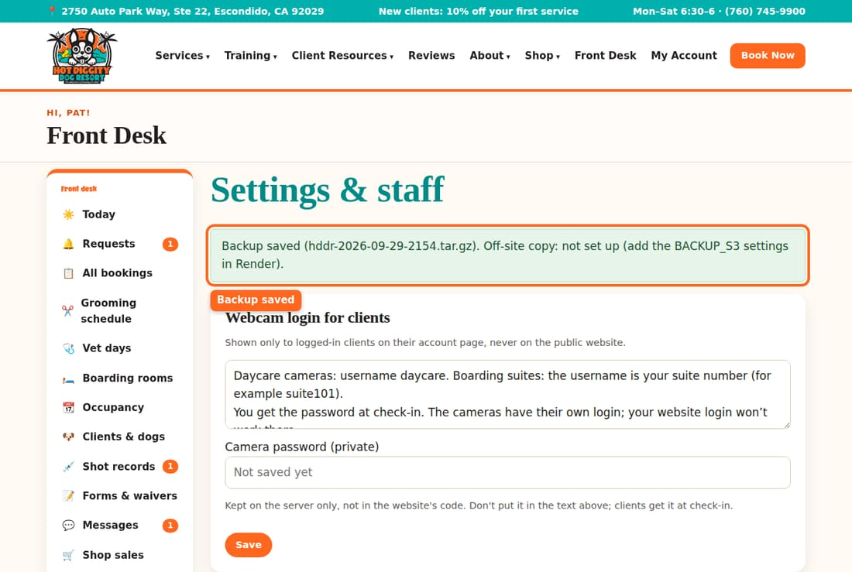
Tip: Press Back up now before a big change, like new prices for the year.
Careful: If the note says FAILED, the off-site copy did not work. Tell Claude. If a nightly off-site copy fails, the staff alert inbox gets an email.

The Connections box
Connections shows what is hooked up: card payments, email, texts, the staff alert inbox, and off-site backups. Each says On or Off.
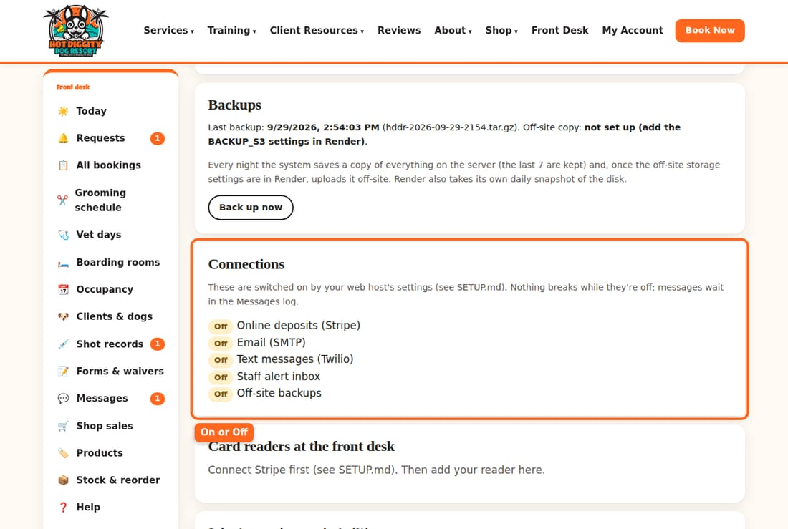

Phone agent
Change what the phone helper may say about your rules.
The phone agent is a computer helper that answers calls. It gets your hours, prices, and holidays from this system. On this page, you write the rules it may explain, like cancellations and shots.

Check that it's connected
- In the menu, click Phone agent.
- The box at the top says if the connection is on or off.
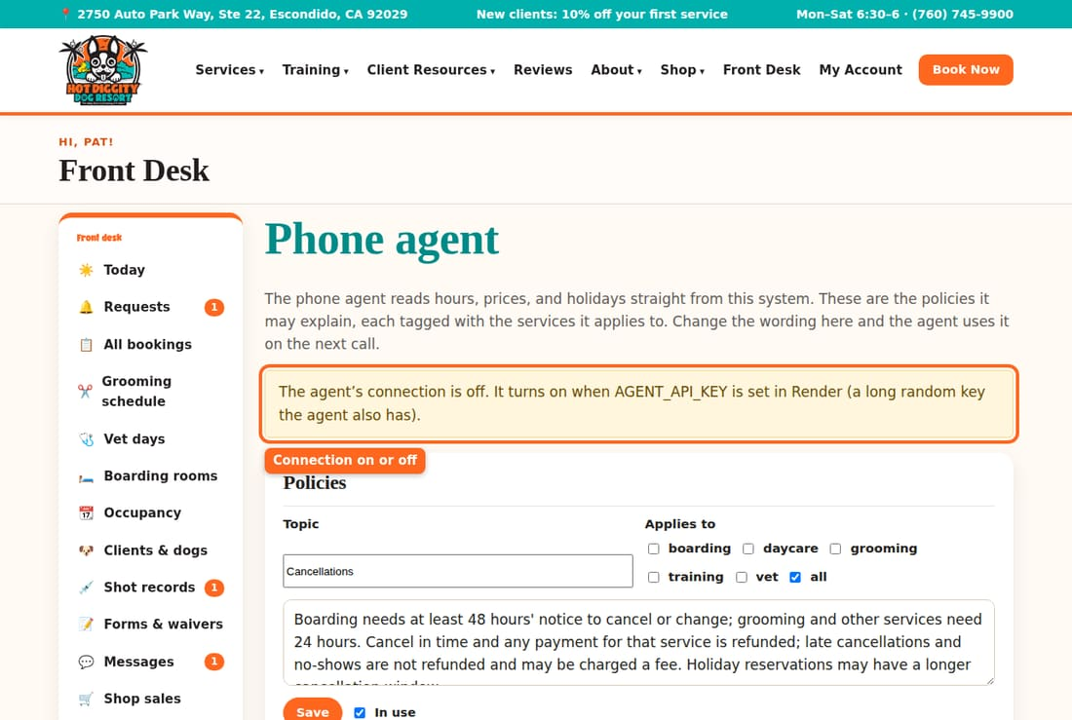
Good to know: The connection is turned on in Render, your web host. You can't turn it on from this page.

Change a rule
- Find the rule under Policies. Each one has a Topic, like "Holidays."
- Change the words in the big box.
- Under Applies to, check the services the rule is for.
- Press Save under that rule.
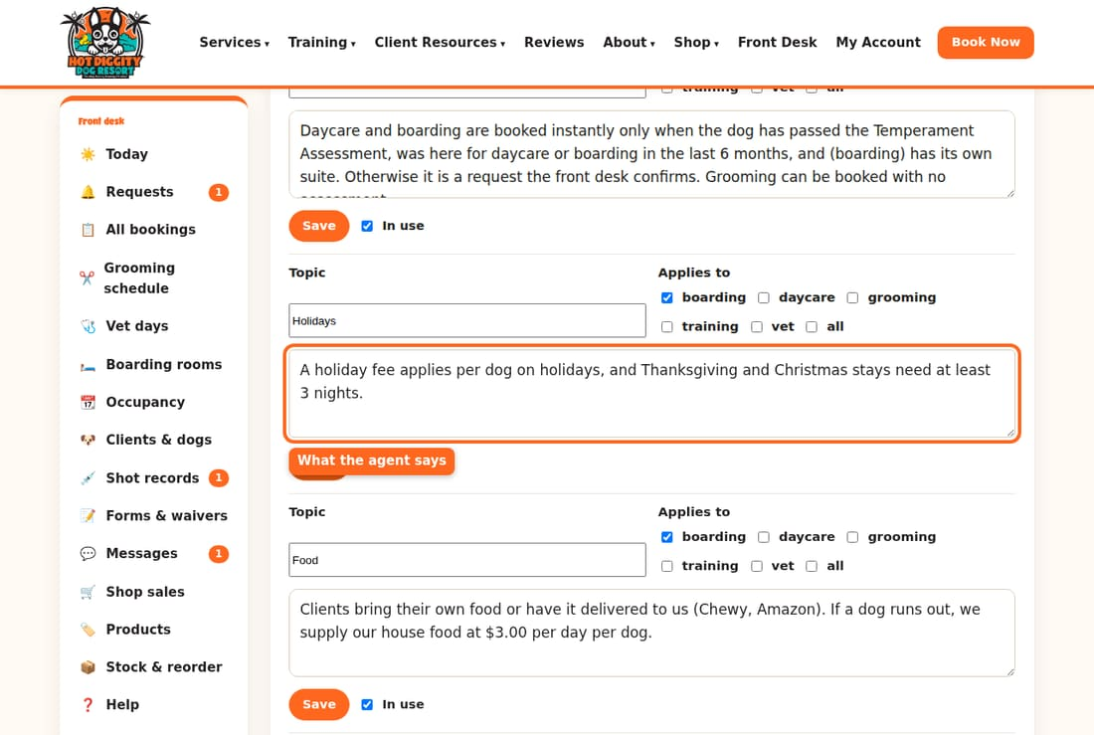
The agent uses the new words on its next call.
Careful: Callers hear these words. Write only what is true. Keep them the same as your Policies page.

Stop using a rule
- Uncheck In use under the rule.
- Press Save.
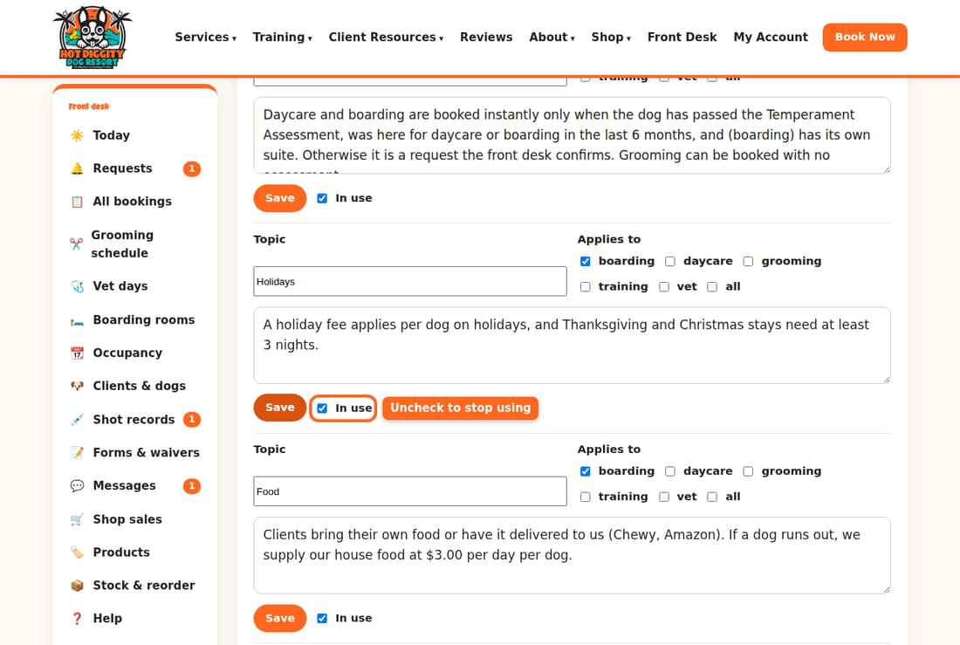

Add a new rule
- Scroll to the last rule. It says New policy: topic.
- Type a topic and the words.
- Check the services it applies to.
- Press Add policy.
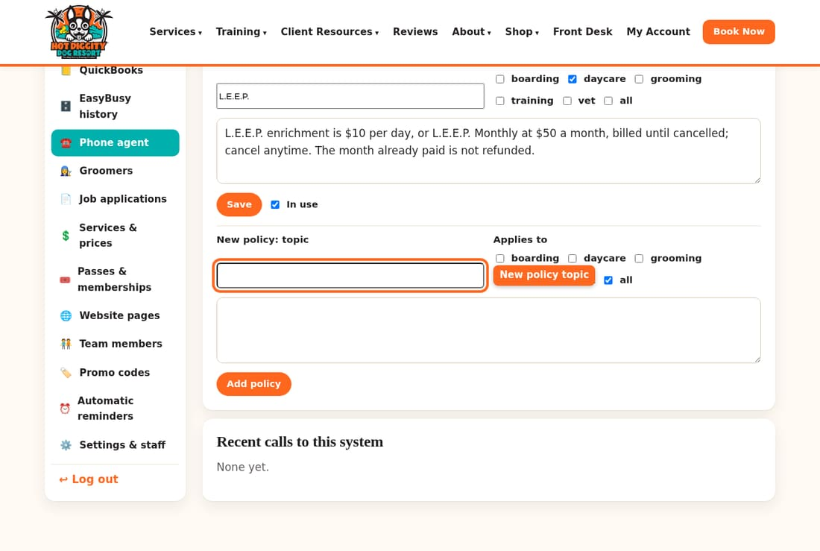

See what it looked up
Recent calls to this system lists the last 50 times the agent asked this system for something.
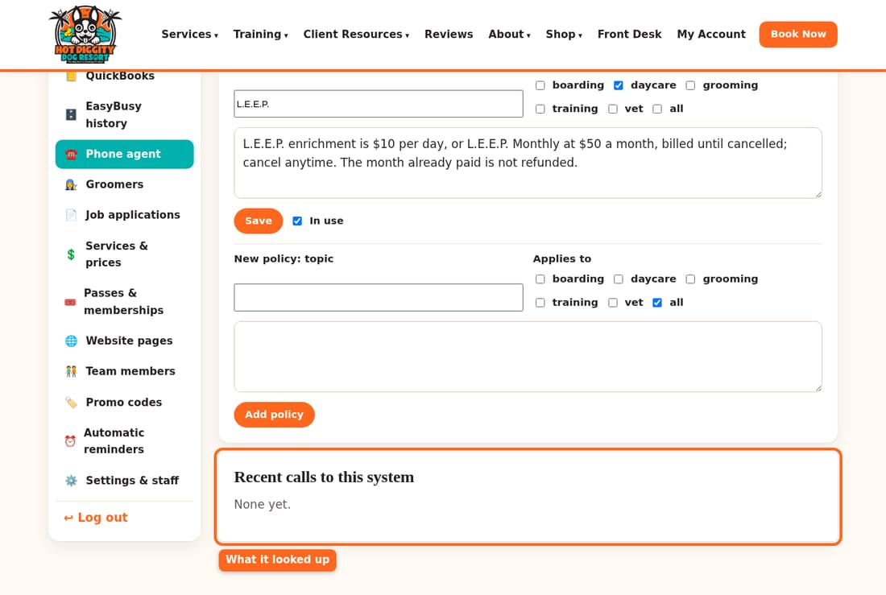
Tip: Prices come from Services & prices. You don't type prices here.

Job applications
Read job applications from the website and mark where each one stands.
People apply for jobs on the website's Employment Application page. Each one comes here. Your staff can see this page too.

Steps
- In the menu, click Job applications. A number in the menu shows new ones.
- New ones are in bold. Click a name to read it.
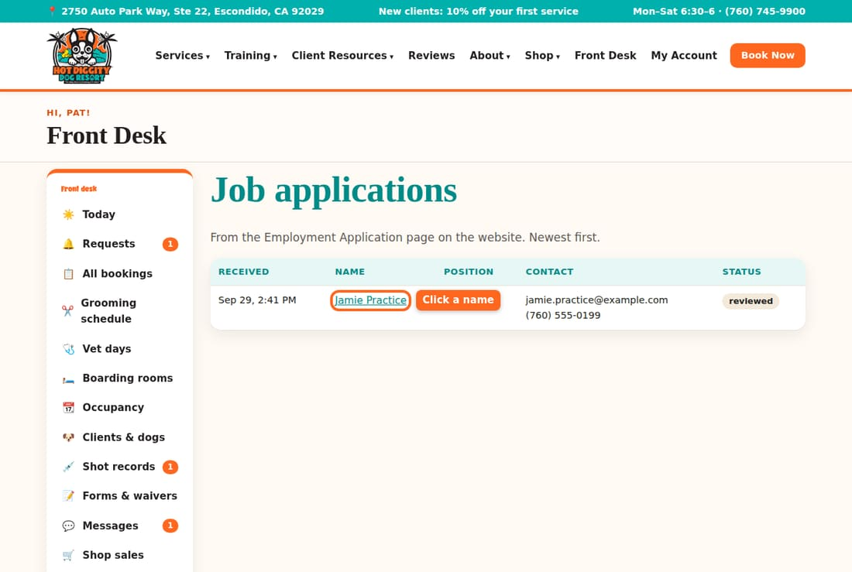
- Read the answers. The top line has their email and phone. Click either to reach them.
- Pick a Status: reviewed, interview, hired, or not a fit.
- Press Save.
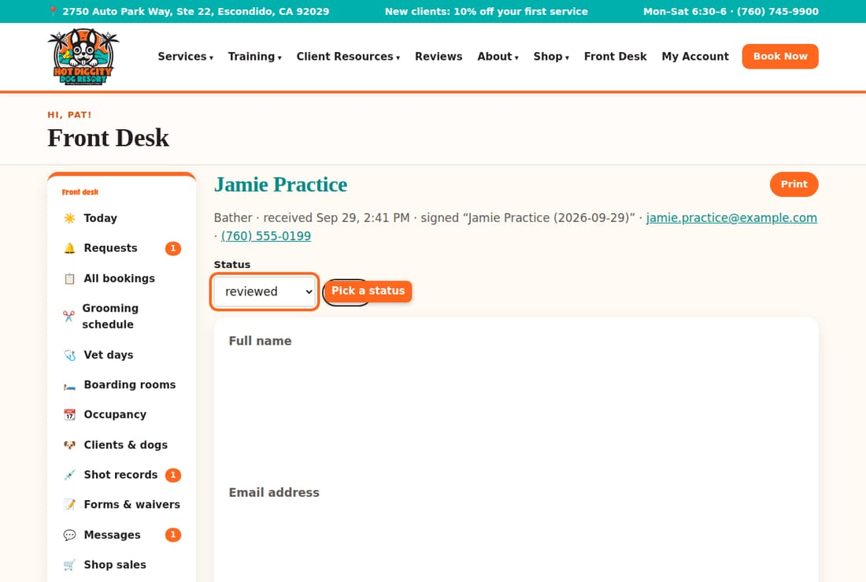
- To print it, press Print.
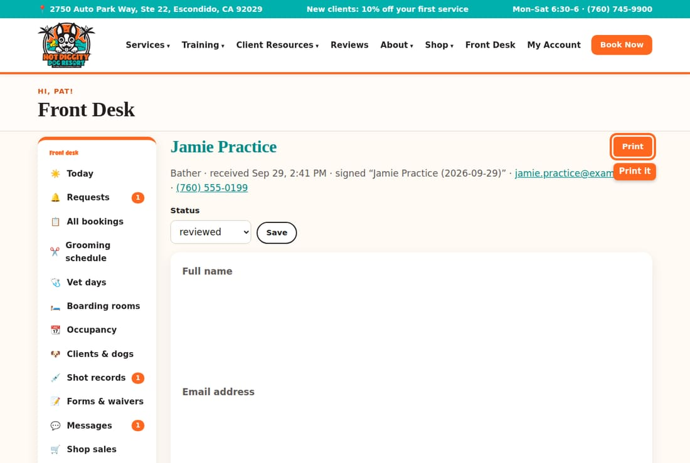
Good to know: When you open a new one, its status changes to "reviewed" on its own.
Careful: Applications hold private facts, like a home address. Keep printed copies somewhere safe.
Tip: Hired someone? Give them a login. See topic 7. Add them to the team page later. See topic 9.

How many dogs fit, and shots we require
Set the most dogs per day, how long passes last, and the shots you require.
These settings stop you from booking too many dogs. They also set which shots every dog must have.

Steps
- In the menu, click Settings & staff.
- Scroll to Capacity & requirements.
- Boarding: dogs per night is the most boarding dogs at once.
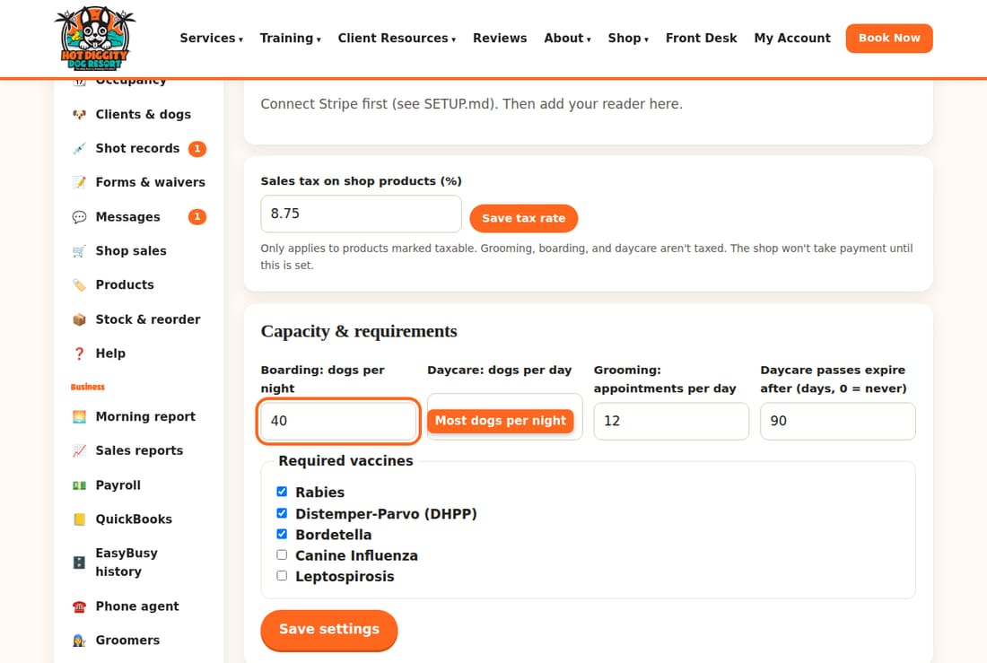
- Also set Daycare: dogs per day and Grooming: appointments per day.
- Daycare passes expire after sets how many days a pass lasts. Type 0 for never.
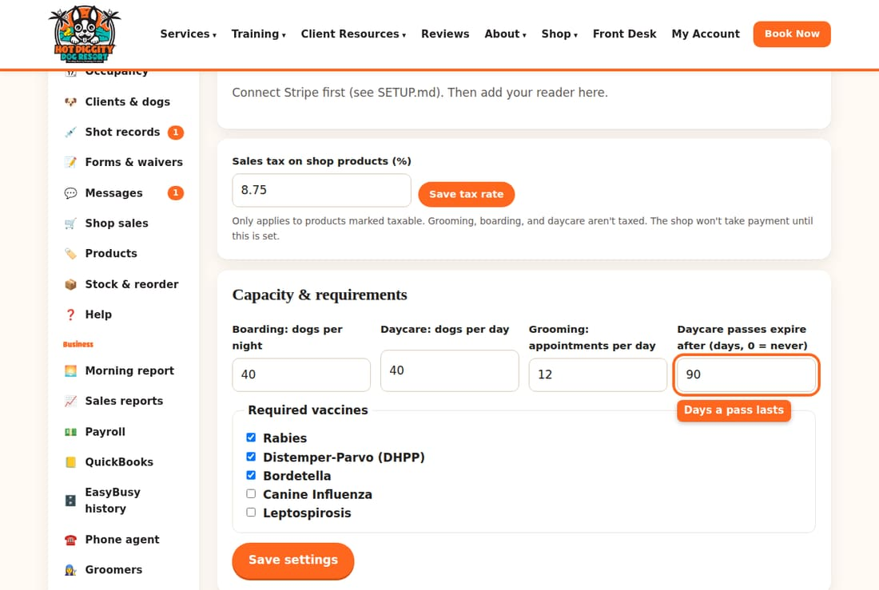
- Under Required vaccines, check each shot every dog must have.
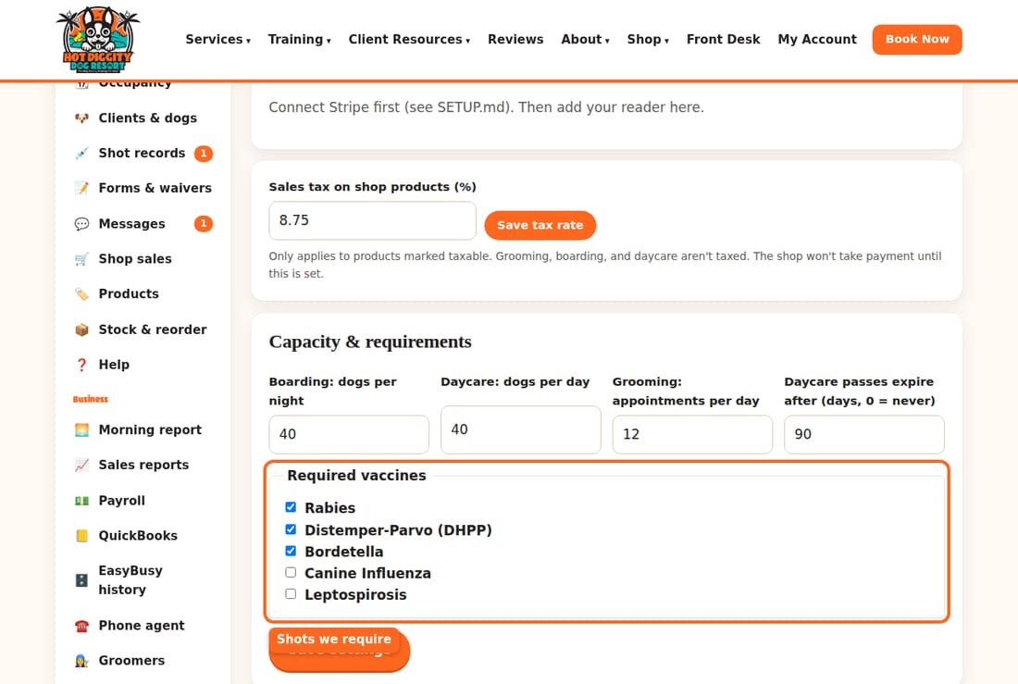
- Press Save settings.
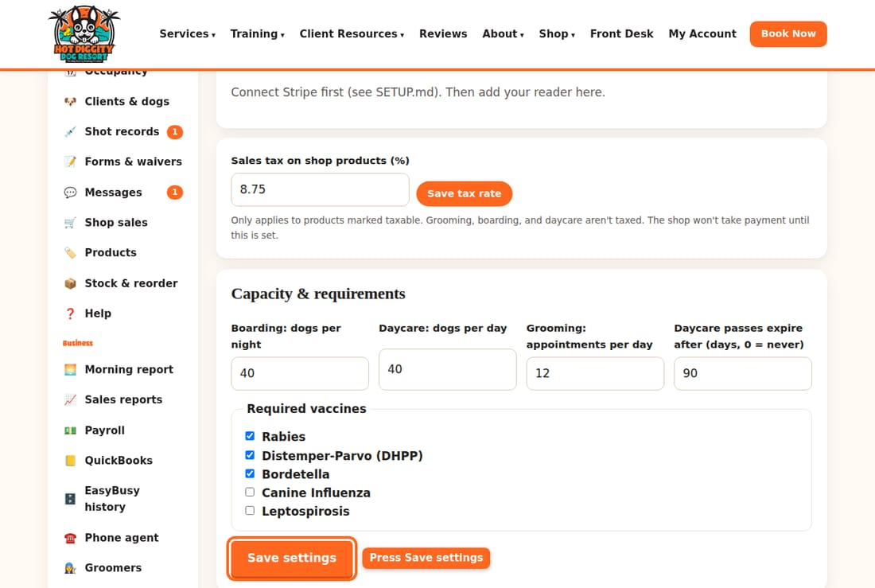
Careful: A required shot must be good through the last day of a stay. If you add a shot, dogs without it can't book.
Good to know: The desk can still go over the limit when they need to.

Shop tax and card readers
Set the sales tax for shop products, and connect a card reader.
Shop products need a sales tax rate. The front desk card reader is set up on the same page.

Set the shop tax rate
- In the menu, click Settings & staff.
- Find Sales tax on shop products (%). Type the rate, like 8.75.
- Press Save tax rate.
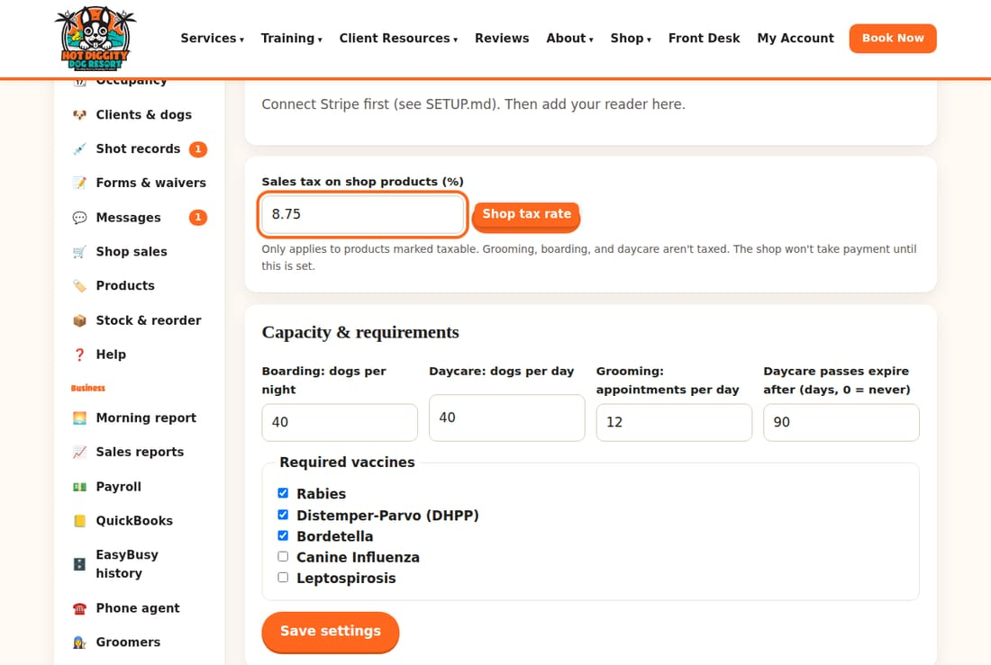
Good to know: The tax only goes on products marked taxable. Grooming, boarding, and daycare aren't taxed.
Careful: The shop won't take payment until a rate is set. Ask your accountant for the right rate.

Connect a card reader
- On the card reader, open Settings. Pick Generate pairing code.
- On Settings & staff, find Card readers at the front desk.
- Type the code in Pairing code. Give it a Name, like "Front desk."
- Press Connect reader.
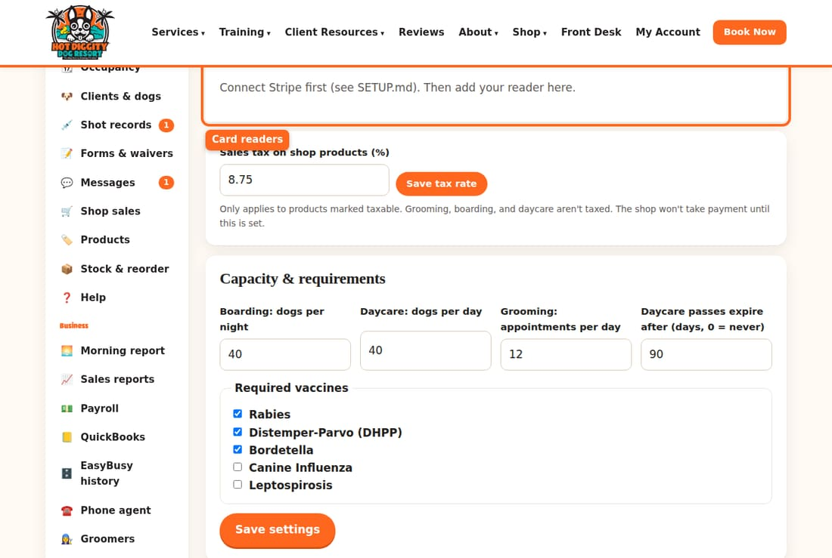
Good to know: The practice site has no card payments hooked up. So it only says "Connect Stripe first." On the real site, you see the pairing code box.

Change the tip choices
Under the reader, set Option 1, Option 2, and Option 3. These are the tip percents clients see on the reader. Press Save tip screen.
Tip: To stop using a reader, press Remove next to it. It stays in your Stripe account.

Morning report
See how yesterday went on one page, or get it by email at 6 am.
The Morning report shows where things stood when you closed yesterday. It shows money in, today's dogs, and anything that needs you. Only owners can see it.

Open it
- In the menu, click 🌅 Morning report.
- The top of the page says the day it covers. For example: "As of close Mon, Sep 28."

The four boxes at the top
- Money in yesterday: all the money that came in yesterday.
- Month to date: money in from the 1st of the month through yesterday.
- Card money on its way from Stripe: card money not in your bank yet.
- Dogs in the building now: dogs checked in right now.
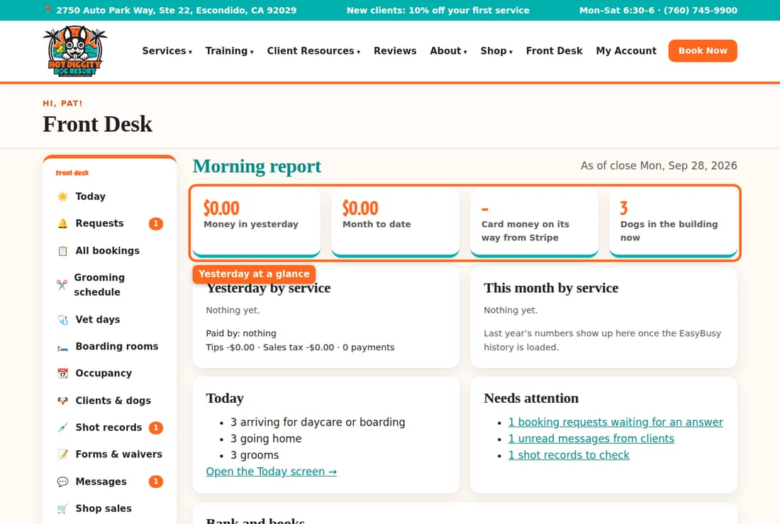
Good to know: A green or red tag compares a number with last year. It shows up once the EasyBusy history is loaded.

Money by service
Yesterday by service shows the money from each service, like boarding or grooming. Below that, it shows how clients paid. It also shows tips and sales tax. This month by service does the same for the whole month.
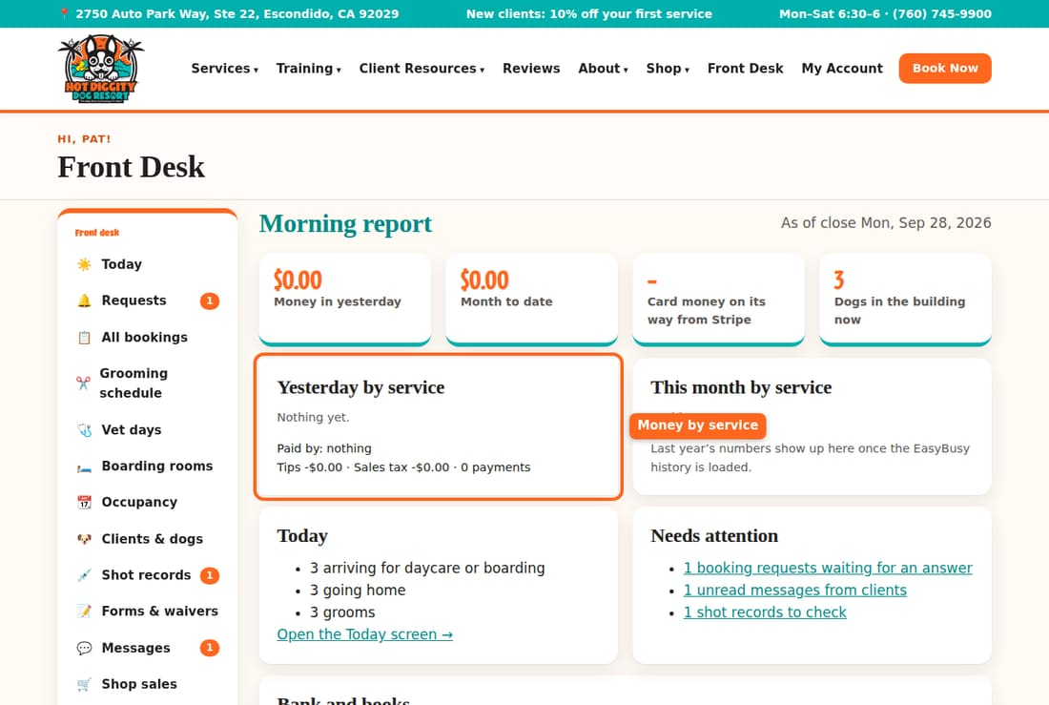

Today and Needs attention
- Today counts the dogs arriving, going home, and the grooms.
- Needs attention lists things to handle. For example: booking requests, unread messages, and shot records to check. Click a line to go there.
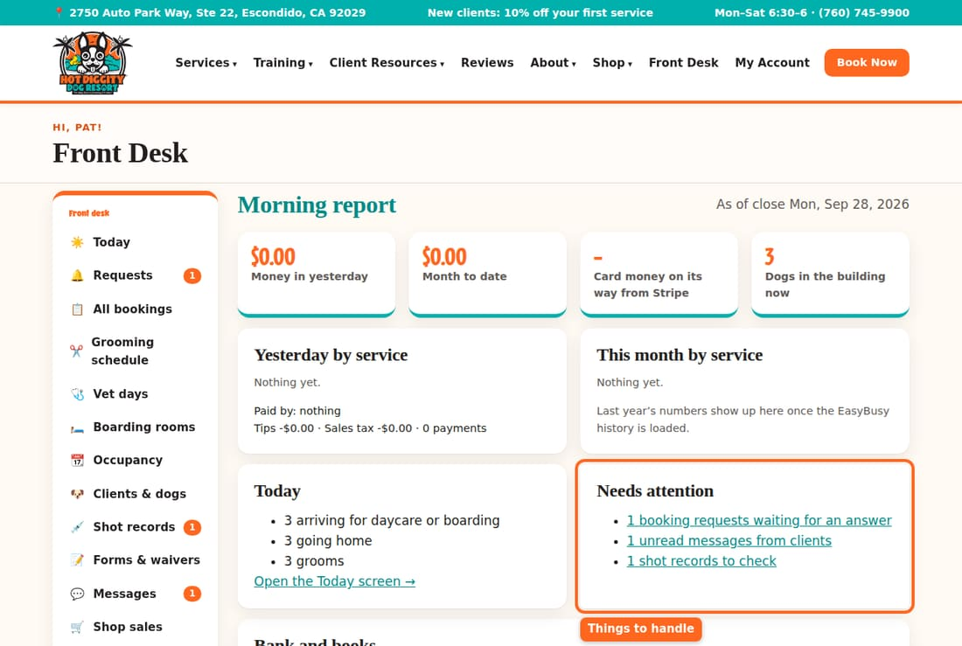

Bank and books
This box says if a Stripe deposit came in yesterday, and its fees. It also says if QuickBooks is up to date. If something didn't go, click See why.
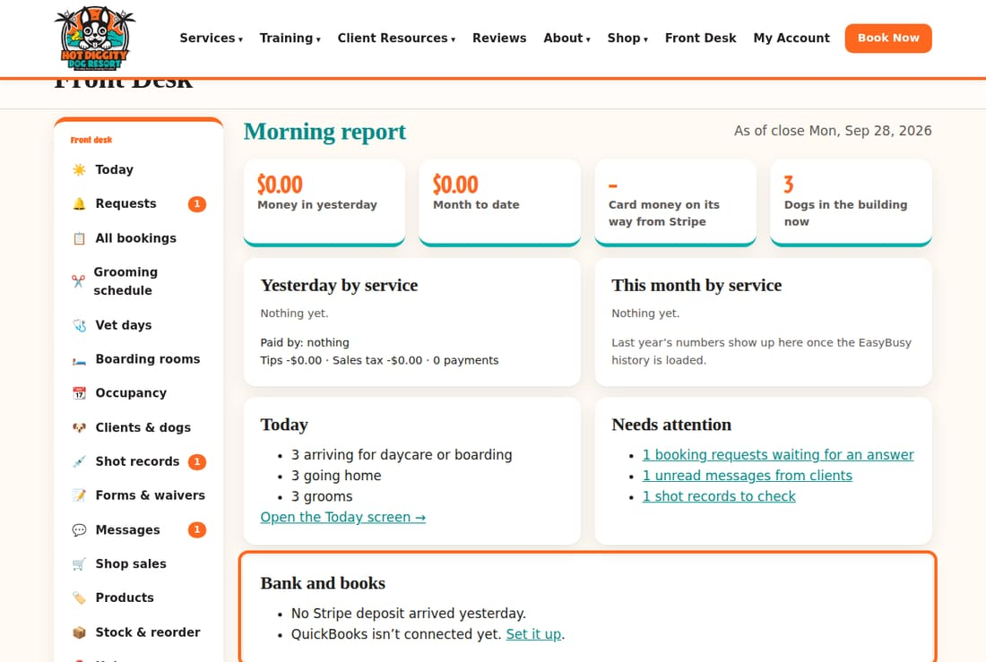

Get it by email every morning
- Scroll to Email this to me every morning.
- Check Send it at 6 am.
- In To, type your email.
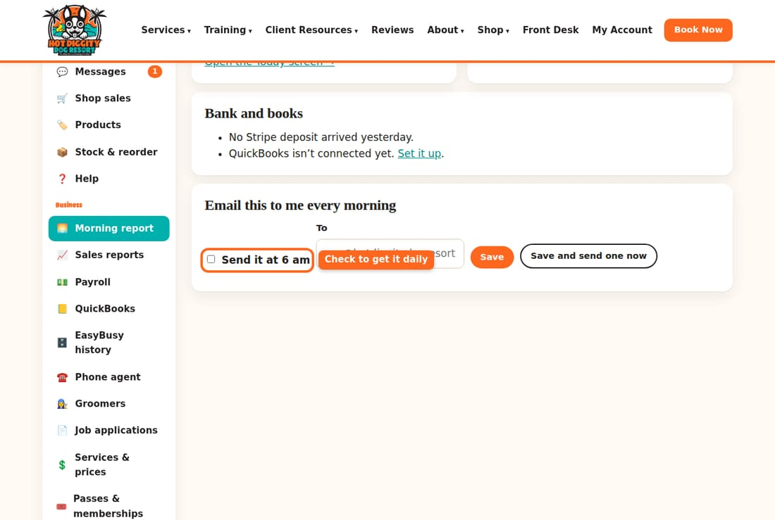
- Press Save. Or press Save and send one now to get one right away.
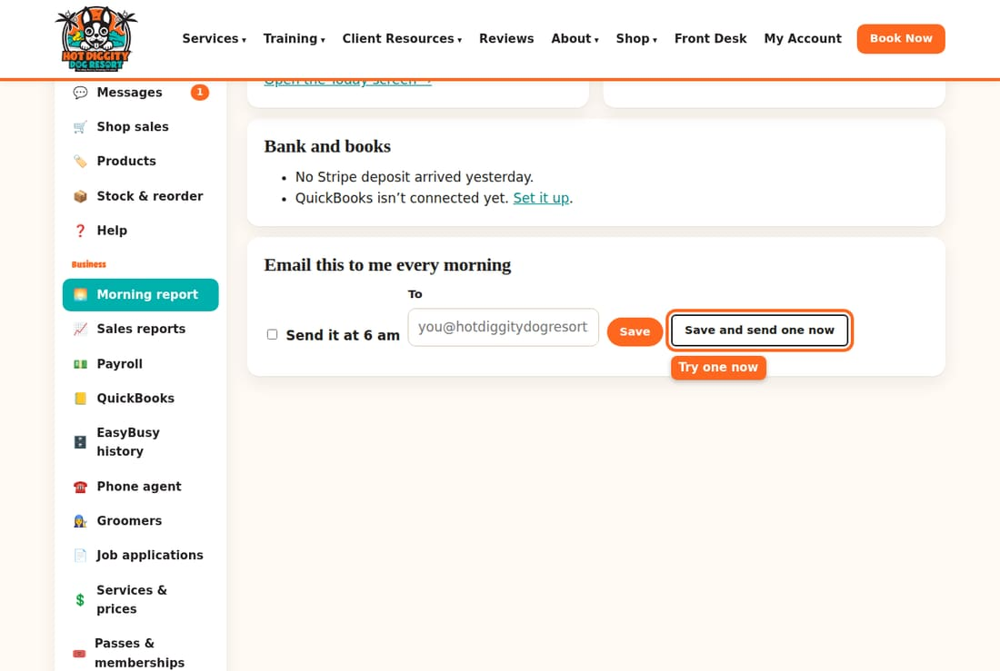
Tip: Leave To blank, and it goes to the staff alert inbox.
Good to know: The email has the same numbers as the page. It comes once a day, soon after 6 am.

