
BIT4133: Natural Language Processing
Logbook Report
Student Name: NDIKUMANA DON DE DIEU
Admission Number: BSCCS/2024/34481
Course/Class:
Unit Code: BIT4133
Unit Name: Natural Language Processing
Lecturer Name:
Semester/Year: Sem II ,Year IV

Project Title: AI Chatbot for Student Academic
assistance

Technologies: Python, NLTK, spaCy, Jupyter Notebook, TensorFlow .
GitHubRepository:https://github.com/cde123-sudo/Natural-language-processing-/tree/main

TABLE OF CONTENTS
Contents | Page
Cover Page | i
Table of Contents | ii
Week 1: Introduction to NLP and Applications | 1
1.1 NLP Concepts Learned | 1
1.2 Applications of NLP | 3
1.3 Python Installation | 4
1.4 Jupyter Notebook Setup | 4
1.5 NLTK Installation | 5
1.6 Tokenization Output | 5
1.7 Stopword Removal Output | 6
1.8 NLP Application Research Evidence | 7
1.9 Weekly Reflection | 8
Week 2: N-Gram Models and POS Tagging | 9
2.1 Bigram/Trigram Output | 9
2.2 Part-of-Speech (POS) Tagging | 10
2.3 Python Code for POS Tagging | 11
2.4 Language Prediction Example | 12
2.5 Sentence Analysis Output | 13
2.6 Weekly Explanation | 14
Week 3: Hidden Markov Models and Sequence Labeling | 15
3.1 Sequence Labeling Code | 15
3.2 Hidden Markov Model Output | 16
3.3 Named Entity Recognition | 17
3.4 Sentence Labeling Output | 18
3.5 Training Dataset | 19
3.6 Weekly Reflection | 20
Week 4: Syntactic and Semantic Analysis | 21
4.1 Practical Task 1: Dependency Parsing Using spaCy | 21
4.2 Practical Task 2: Semantic Similarity Analysis | 25
4.3 Class Assignment 1 | 28
4.4 Class Assignment 2 | 30
Week 5: CAT 1 Preparation and Mini NLP Projects | 33
5.1 Practical Task 1: NLP Text Preprocessing Pipeline | 33
5.2 Practical Task 2: Mini Chabot Simulation | 36
Week 6: Word Embeddings and Distributed Representations | 39
6.1 Installing Gensim | 39
6.2 Importing Libraries | 40
6.3 Word2Vec Implementation | 41
6.4 Finding Similar Words | 42
6.5 Word Similarity Score | 43
6.6 Visualizing Word Embeddings | 44
Week 7: Neural Language Models and Deep Learning for NLP | 45
7.1 Class Demonstrations | 45
7.2 Class Activity 1: Language Model Comparison | 49
7.3 Class Activity 2: Neural Network Components | 50
7.4 Class Activity 3: Applications of Neural Language Models | 51
7.5 Practical Task 1: Mini Text Prediction System | 52
7.6 Practical Task 2 | 53
7.7 Practical Task 3: Weekly Reflection | 55
Week 8: Natural Language Processing with Deep Learning | 58
8.1 Installing Required Libraries | 58
8.2 Sentiment Analysis | 59
8.3 Text Generation | 62
8.4 Class Exercise 1 | 64
8.5 Class Exercise 2 | 66
8.6 Practical Task 1: Sentiment Analysis Program | 68
8.7 Practical Task 2: GPT-2 Text Generator | 70

WEEK 1: INTRODUCTION TO NLP AND APPLICATIONS
Title:
Introduction to NLP Concepts and Text Processing

NLP Concepts Learned in Week 1

1. Natural Language Processing (NLP)
Natural Language Processing is a branch of Artificial Intelligence that enables computers to understand, analyze, process, and generate human language. NLP combines AI, Machine Learning, Linguistics, and Deep Learning to allow computers to communicate with humans through text and speech.

2. Syntax
Syntax refers to the grammatical structure of a sentence. It helps computers understand how words are arranged and how they relate to each other within a sentence.

3. Semantics
Semantics focuses on the meaning of words and sentences. It helps NLP systems determine the correct meaning of a word based on context. For example, the word "bank" may refer to a financial institution or the side of a river.

4. Pragmatics
Pragmatics deals with context and intended meaning. It helps computers understand what a user actually means rather than only interpreting the literal words.

5. Tokenization
Tokenization is the process of breaking text into smaller units called tokens. These tokens can be words, phrases, or sentences. It is one of the first steps in NLP preprocessing.
Example:
Natural Language Processing
Output:
["Natural", "Language", "Processing"]

6. Stopword Removal
Stopword removal involves removing common words such as "the", "is", and "and" that do not contribute much meaning to text analysis. This improves processing efficiency.

7. Stemming
Stemming reduces words to their root form.
Example:
running → run

8. Lemmatization
Lemmatization converts words into their meaningful dictionary form.
Example:
better → good

Applications of NLP
Examples of NLP applications include:
- ChatGPT
- Google Translate
- Siri
- Spam filtering
- Search engines
- Speech recognition systems

Figure 1: Python Installation
Caption: Screenshot showing successful installation of Python on the computer.
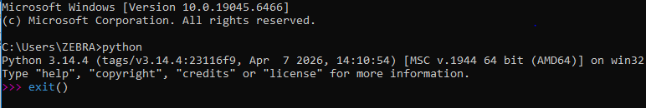

Figure 2: Jupyter Notebook Setup
Caption: Screenshot showing Jupyter Notebook or Google Colab environment ready for coding.

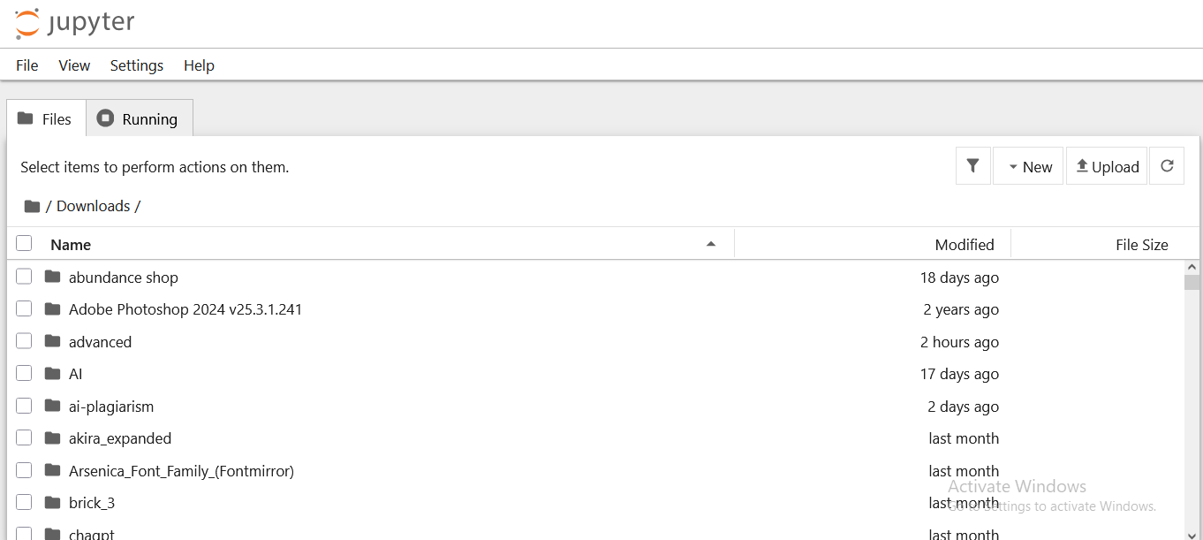
Figure 3: NLTK Installation
Caption: Screenshot showing successful installation of the NLTK library using pip.
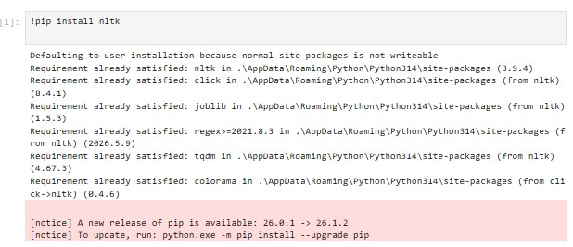

Figure 4: Tokenization Output
Caption: Screenshot showing text tokenization using NLTK.
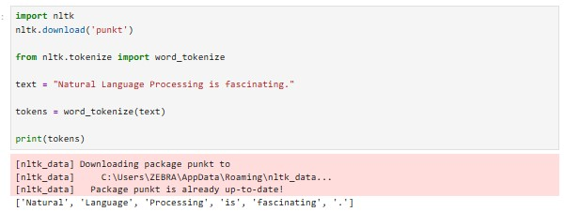

Figure 5: Stopword Removal Output
Caption: Screenshot showing stopwords removed from a sample sentence.
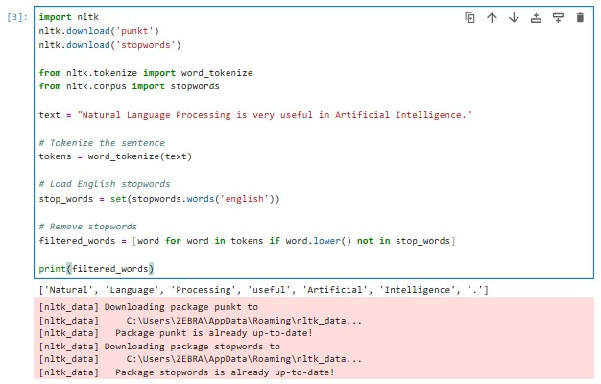

Figure 6: NLP Application Research Evidence

Screenshot showing an AI chatbot interacting with a user through natural language. Chatbots use NLP techniques to understand user input and generate meaningful responses.
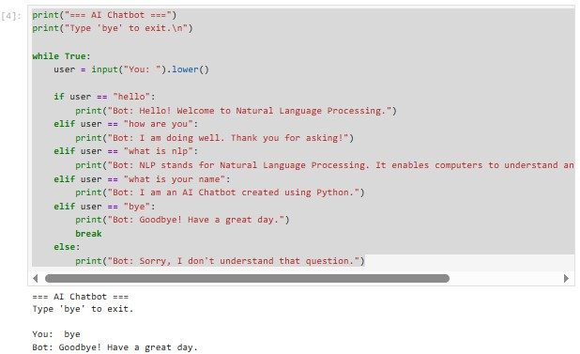
During Week 1, I learned the fundamentals of Natural Language Processing (NLP) and its applications in artificial intelligence. I installed Python, set up Jupyter Notebook, and worked with the NLTK library. I performed tokenization and stopword removal to understand how text is prepared for machine learning models. The practical activities demonstrated how computers process human language and highlighted the importance of preprocessing in NLP tasks. These concepts form the foundation for developing intelligent systems such as chatbots, translation systems, and virtual assistants.

Week 2: N-gram models and POS tagging
• figure 1: biogram or trigram output

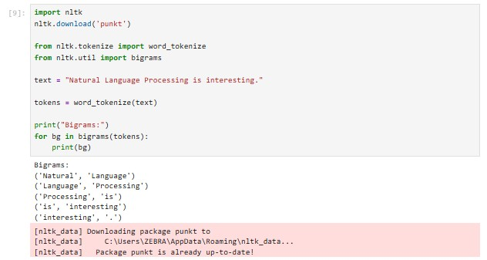

figure 2: Part-of-Speech (POS) Tagging

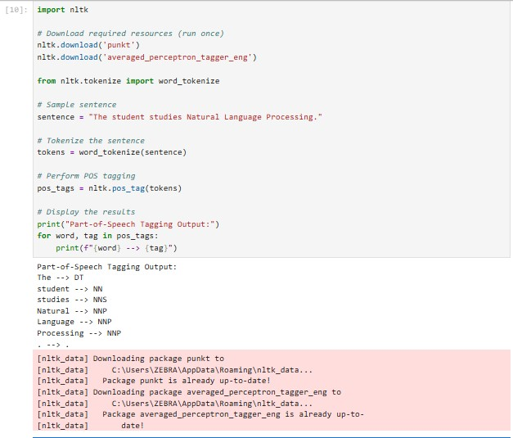

figure 3:python code for pos tagging

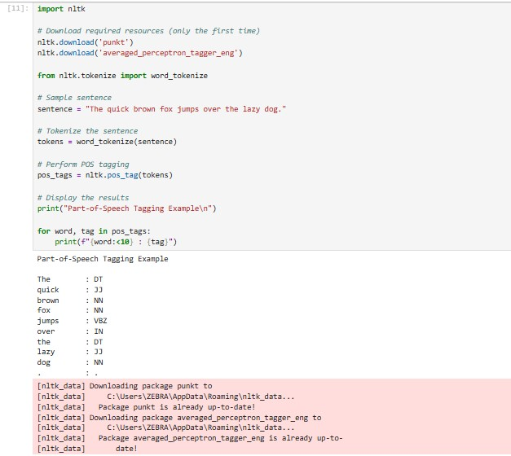

• figure 4: language prediction example

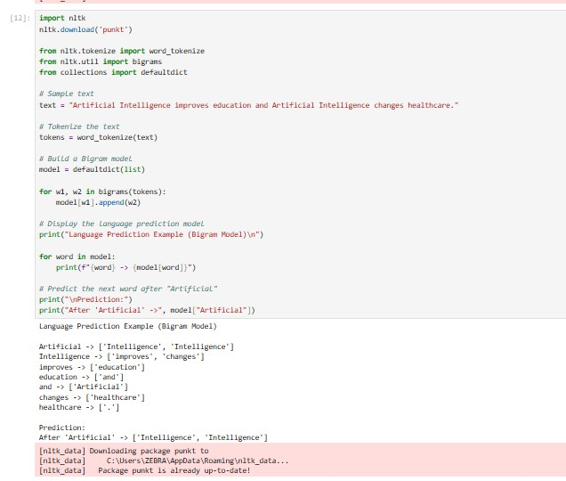
figure 5: sentence analysis output

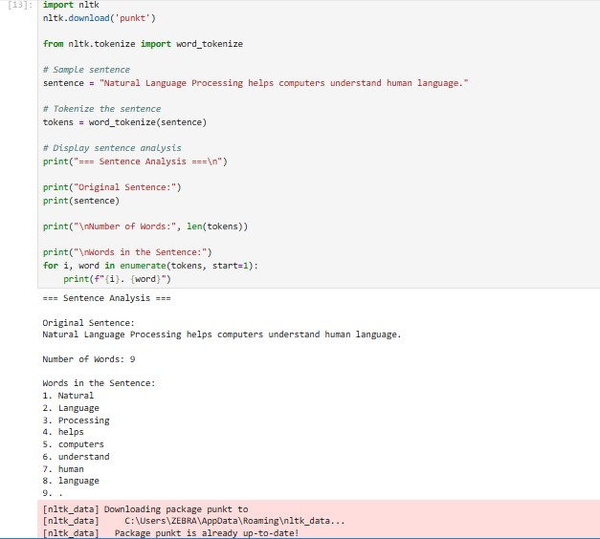

Explanations:
Sentence analysis is the process of examining the components and structure of a sentence. It helps identify words, sentence length, and linguistic patterns that can be used in NLP applications such as chatbots, machine translation, sentiment analysis, and text classification.

Week 3: Hidden Markov Models and Sequence labeling

Figure 1: Sequence Labeling Code
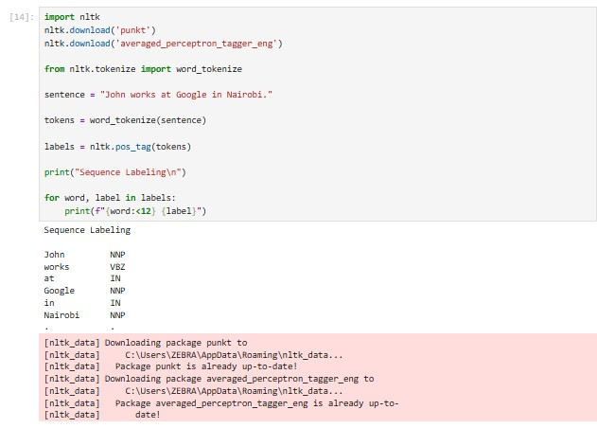
• figure 2: hidden markov model output

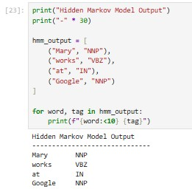
figure 3:named entity recognition

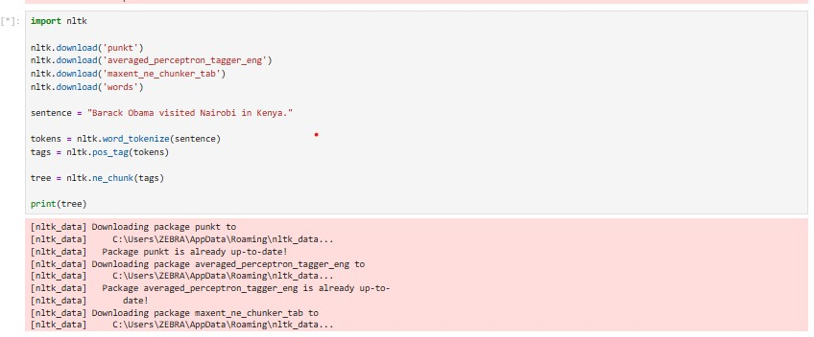
Figure 4: sentence labeling output
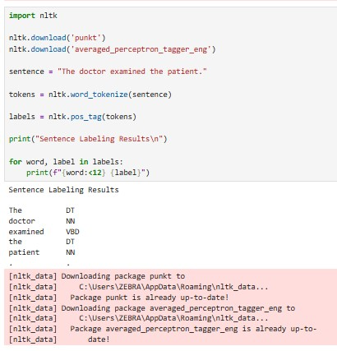
Figure 5: database used for training
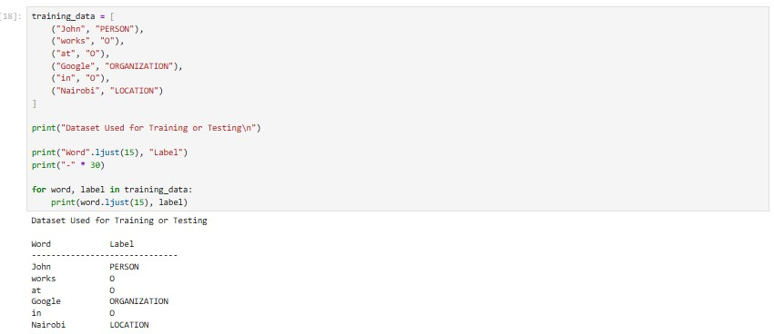
Explanations:
During Week 3, I learned about Sequence Labeling, Hidden Markov Models (HMMs), Named Entity Recognition (NER), and Sentence Labeling in Natural Language Processing. I understood how words and sentences can be assigned labels to help computers interpret human language. Through practical exercises in Python and NLTK, I explored how HMMs are used to model language sequences and how NER identifies important entities such as people, organizations, and locations. I also learned the importance of training datasets in building NLP models. These concepts improved my understanding of how intelligent systems such as chatbots and virtual assistants process and understand user input

WEEK 4: SYNTACTIC AND SEMANTIC ANALYSIS

PRACTICAL TASK 1

Dependency Parsing Using spaCy

Objective
To analyze the grammatical structure of a sentence by identifying the relationships between words using the spaCy Natural Language Processing (NLP) library.

Step-by-Step Guide

Step 1: Install spaCy
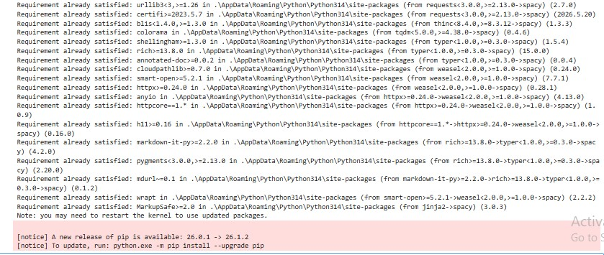

Step 2: Download Language Model
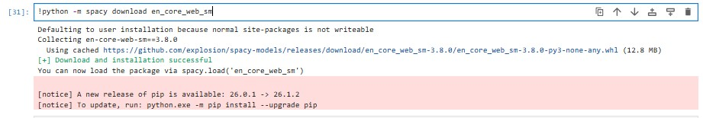

Step 3: Write Program
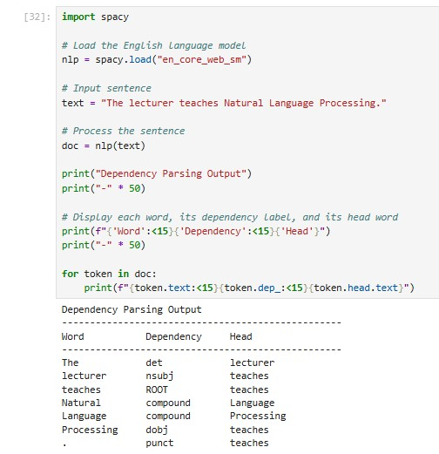

Explanation
Dependency parsing is an NLP technique used to analyze the grammatical structure of a sentence by identifying the relationships between words. It helps determine how each word depends on another to convey meaning. In this practical, spaCy was used to parse the sentence "The lecturer teaches Natural Language Processing." The output showed that "lecturer" is the subject (nsubj), "teaches" is the main verb (ROOT), and "Processing" is the direct object (dobj). The words "Natural" and "Language" were identified as compound modifiers that form the complete object "Natural Language Processing."
Understanding these relationships enables NLP systems to interpret sentence structure accurately, which is important for applications such as chatbots, virtual assistants, machine translation, grammar checking, and information extraction. Dependency parsing provides a foundation for semantic analysis by showing not only what words appear in a sentence but also how they are connected to express meaning.

PRACTICAL TASK 2

Objective
To compare the semantic similarity between two sentences and determine how closely their meanings are related using the spaCy Natural Language Processing li

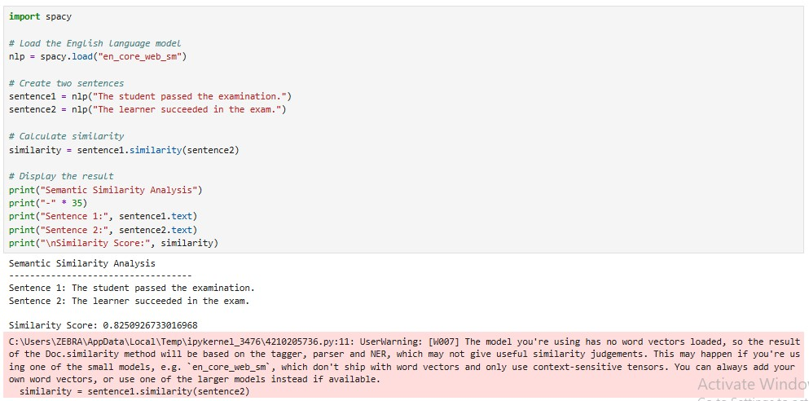

Explanation
Semantic similarity analysis is an NLP technique used to determine how closely two sentences are related in meaning, even if they use different words. In this practical, spaCy calculates a similarity score between two sentences based on their semantic representations. A score closer to 1.0 indicates that the sentences have very similar meanings, while a score closer to 0.0 indicates little or no semantic relationship. This technique is widely used in applications such as search engines, chatbots, recommendation systems, question-answering systems, and plagiarism detection.

CLASS ASSIGNMENT

Assignment 1

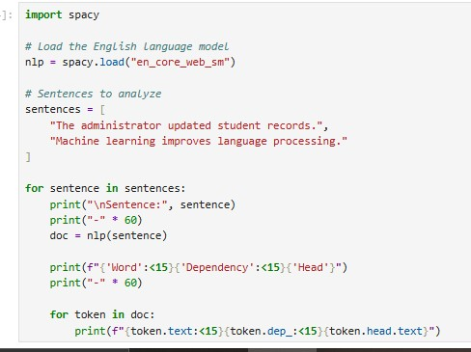

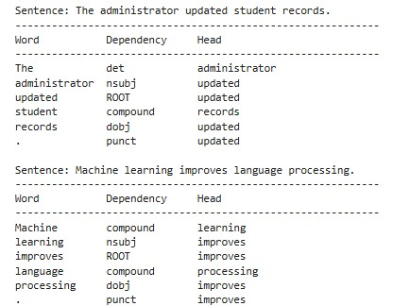

Explanation of Dependencies
- Machine → compound: Modifies the noun learning.
- learning → nsubj: Subject performing the action.
- improves → ROOT: Main verb of the sentence.
- language → compound: Modifies the noun processing.
- processing → dobj: Direct object receiving the action.
- . → punct: Indicates the end of the sentence.

Assignment 2

Objective
To compare the semantic similarity between two pairs of sentences and explain why one pair has a higher similarity score than the other.

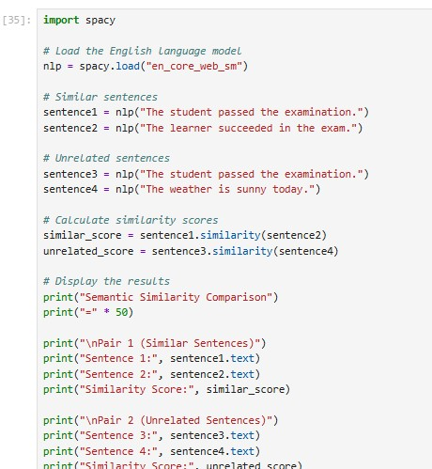

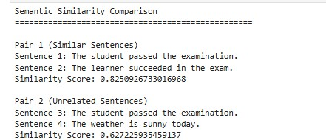

Explanation

Which pair has the higher similarity?
The first pair has the higher similarity score because both sentences describe the same event. Although they use different words, such as student/learner, passed/succeeded, and examination/exam, they convey the same meaning.
The second pair has a much lower similarity score because the sentences discuss different topics. One sentence is about a student's examination, while the other is about the weather. As a result, there is very little semantic relationship between them.

WEEK 5: CAT 1 PREPARATION AND MINI NLP PROJECTS

Objective
To build a simple Natural Language Processing (NLP) pipeline that performs text preprocessing through tokenization, stopword removal, and Part-of-Speech (POS) tagging

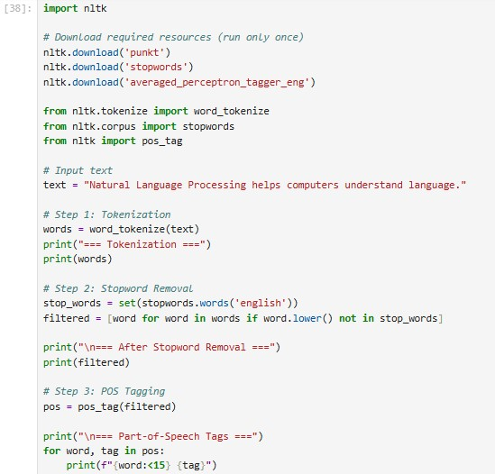

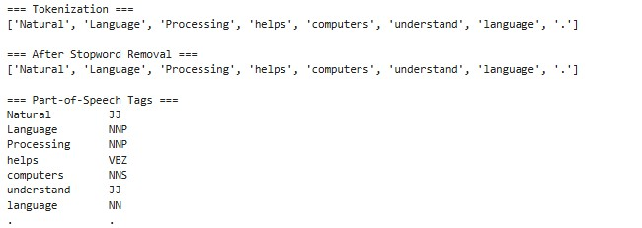

PRACTICAL TASK 2

Mini Chatbot Simulation

Objective

Objective
To develop a simple rule-based chatbot that accepts user input, processes basic text, and generates predefined responses. The practical demonstrates how Natural Language Processing techniques can be used to simulate human-computer interaction through a conversational interface.

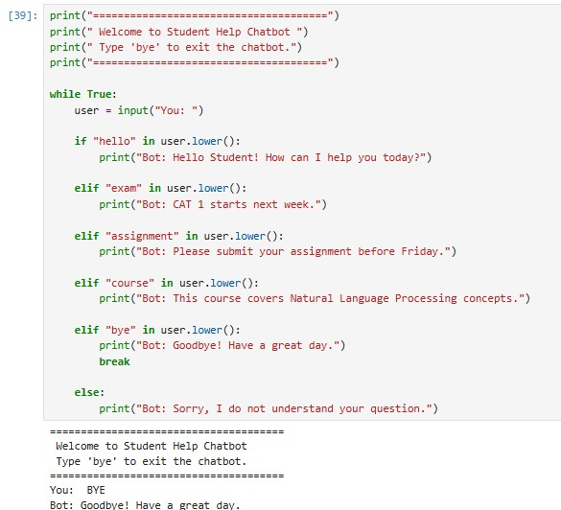

Explanation
The chatbot successfully processed the user's input by converting it to lowercase using the lower() method. Although the user entered "BYE" in uppercase, the chatbot recognized it as "bye" and executed the corresponding response. After displaying the farewell message, the chatbot terminated the conversation using the break statement. This demonstrates that the chatbot can handle user input regardless of letter case, making the interaction more user-friendly.

WEEK 6: Word Embeddings and Distributed Representations

Step 1: Install Gensim

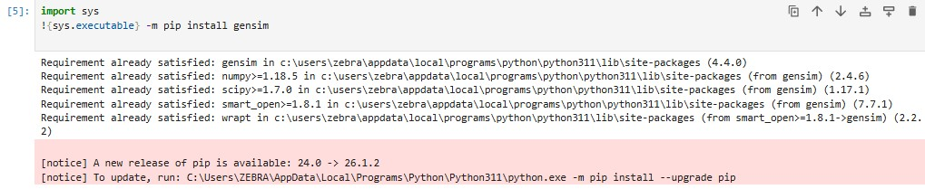

Step 2: Import Libraries

Run Word2Vec code

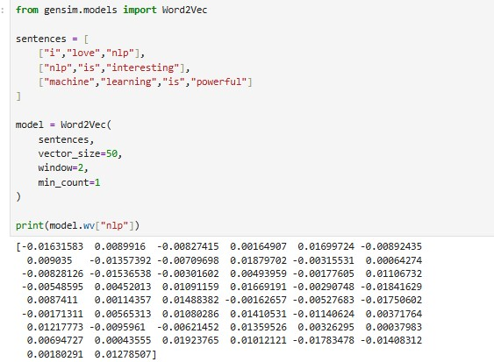

Step 3 : Findind similar words

Step 4 :word similarity score

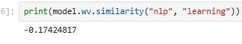

Step 5 : visualizing word embeddings

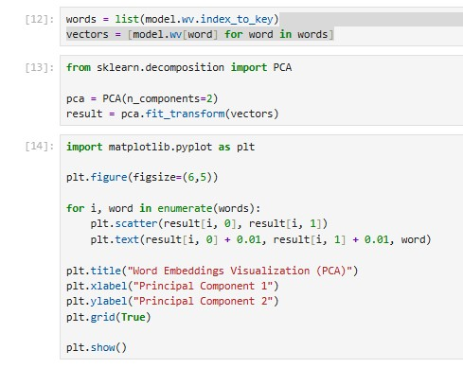

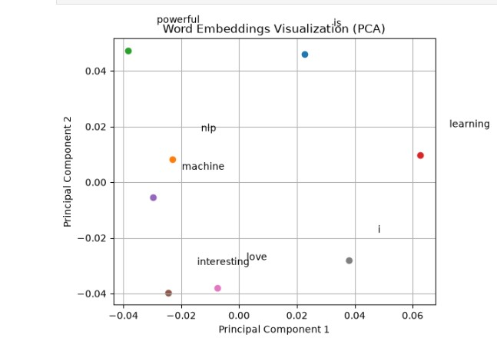

Week 7: Neural Language Models and Deep Learning for NLP

Class Demonstration 1

Installing TensorFlow
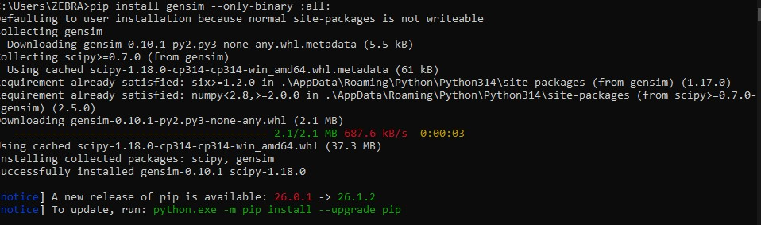
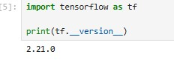

Class Demonstration 2

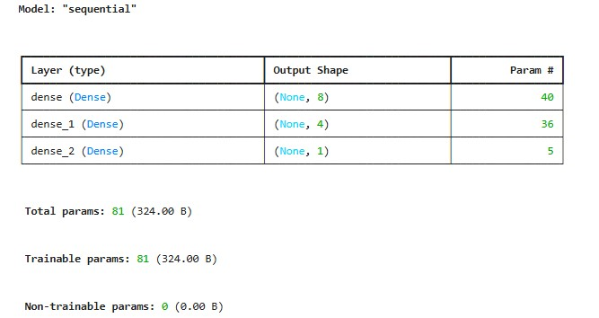

Class Demonstration 3
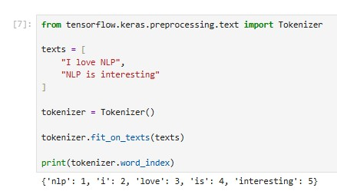

Class Demonstration 4

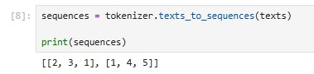

Class Demonstration 5

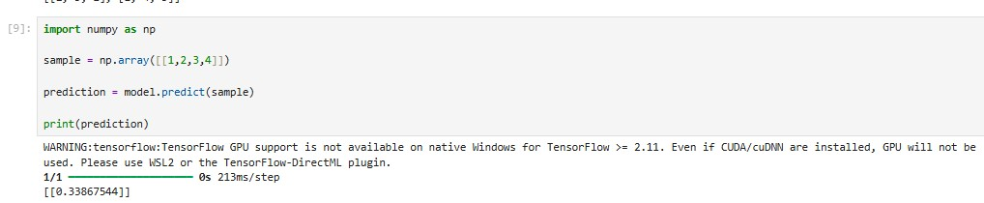

Class Activity 1

Language Model Comparison
Feature | N-Gram Model | Neural Language Model
Context Understanding | Limited | Excellent
Memory Usage | High | Lower after training
Semantic Learning | No | Yes
Prediction Accuracy | Moderate | High

Class Activity 2
Identify the Neural Network Components
Input Layer
↓
Hidden Layer
↓
Hidden Layer
↓
Output Layer
Explanation
Input Layer :Receives input data.
Hidden Layers : Learn patterns.
Output Layer : Predicts the next word.

Class Activity 3
How Neural Language Models Improve NLP

Translation Systems
Understand sentence context for better translations.

Chatbots
Generate more natural responses.

Search Engines
Understand the user's intent.

Voice Assistants
Convert speech into meaningful text.

Practical Task 1

Mini Text Prediction System
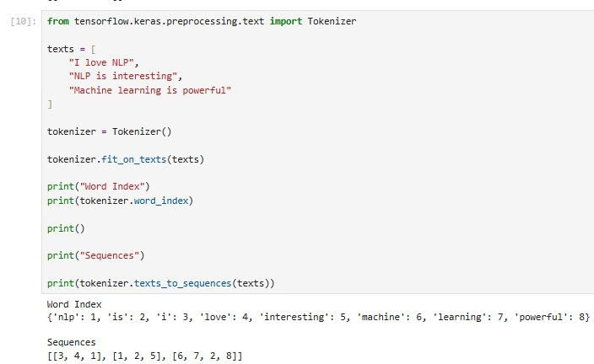

Practical Task 2
:

1. What is a Neural Language Model?
A Neural Language Model uses neural networks to predict words based on context. Unlike traditional language models, it learns semantic relationships automatically.

2. Difference Between N-Grams and Neural Language Models
N-Gram | Neural Language Model
Counts words | Learns patterns
Limited context | Long context
Poor semantic understanding | Good semantic understanding

3. Advantages
- Better prediction
- Learns meaning
- Handles large vocabularies
- Supports deep learning

4. Applications
- Chatbots
- Machine Translation
- Search Engines
- Voice Assistants
- Large Language Models

Practical Task 3

Weekly Reflection Answers

1. What is a Neural Language Model?
A Neural Language Model predicts the next word using neural networks.

2. Why are N-Grams limited?
They cannot understand context well and struggle with unseen word combinations.

3. What is Deep Learning?
Deep Learning is a branch of machine learning that uses multi-layer neural networks to learn complex patterns from data.

4. What is an Artificial Neural Network?
An Artificial Neural Network is a computational model inspired by the human brain, consisting of interconnected layers of neurons.

5. What are Hidden Layers?
Hidden layers process input data and learn complex features before producing an output.

6. What is the role of embeddings?
Embeddings convert words into dense numerical vectors that capture semantic meaning and relationships.

7. What is Softmax?
Softmax converts model outputs into probabilities that sum to 1, making it suitable for predicting the next word.

8. How do Neural Language Models improve NLP?
They improve NLP by learning context, semantics, and long-range relationships, resulting in more accurate predictions and better performance in applications like chatbots and translation.

WEEK 8: NATURAL LANGUAGE PROCESSING WITH DEEP LEARNING

Class Demonstration 1

Install the required libraries
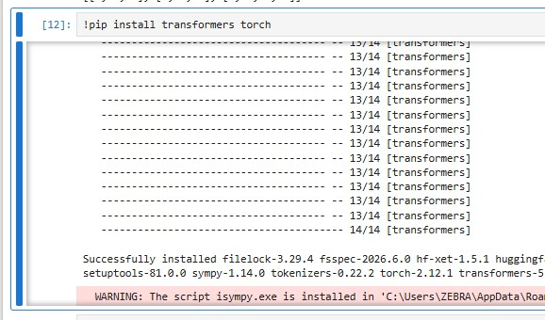

Class Demonstration 2

Sentiment Analysis
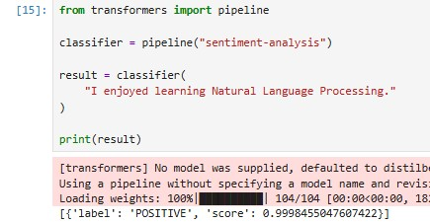

Positive

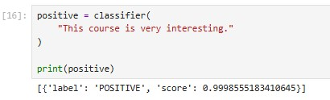

Negative

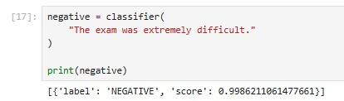

Neutral

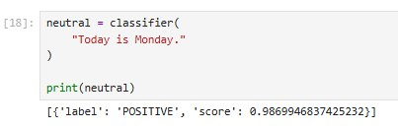

Class Demonstration 3

Text Generation
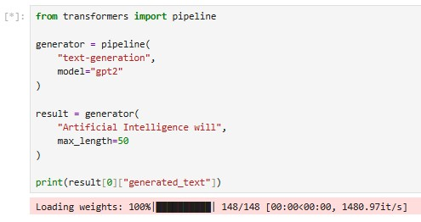
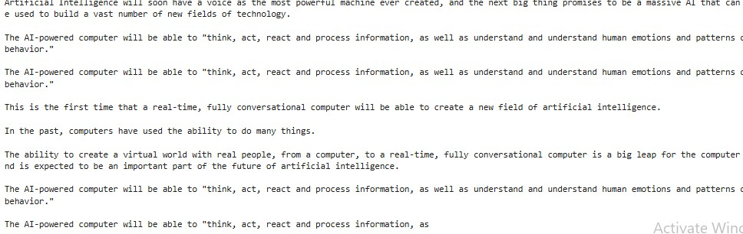
DIFFERENT PROMPTS
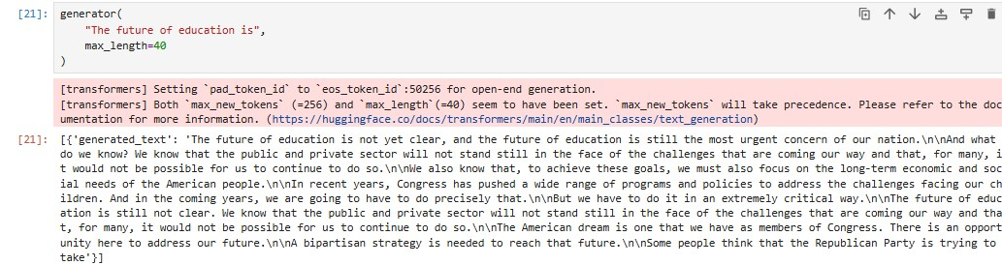

Class Exercise 1

1. Why is a Transformer suitable for answering student questions?
Because Transformers understand the context of questions, allowing them to generate accurate, coherent, and relevant responses. They can process long conversations and retrieve meaningful information from large datasets.

2. Role of Attention Mechanisms
Attention mechanisms help the model focus on the most relevant words in a sentence while ignoring less important ones. This improves understanding of context and relationships between words.

3. Three Benefits over RNNs
- Transformers process words in parallel, making training faster.
- They capture long-range dependencies more effectively.
- They achieve higher accuracy in many NLP tasks.

Class Exercise 2
Sentence:
"The doctor informed the patient that she would recover soon."

1. How self-attention determines "she"
Self-attention analyzes the entire sentence and learns that "she" most likely refers to "the patient" because the phrase "would recover soon" is logically associated with the patient rather than the doctor.

2. Words receiving high attention
- doctor
- patient
- she
- recover

3. Importance of Context
Context helps the model correctly interpret ambiguous words and pronouns, leading to more accurate language understanding.

Practical Task 1

Sentiment Analysis Program
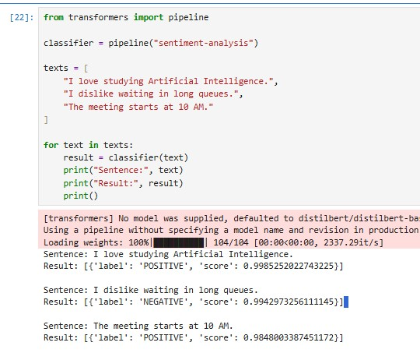

Interpretation
- The first sentence should be classified as POSITIVE.
- The second sentence should be classified as NEGATIVE.
- The third sentence may be classified as NEUTRAL or receive a low-confidence positive/negative label depending on the model.

Practical Task 2

GPT-2 Text Generator
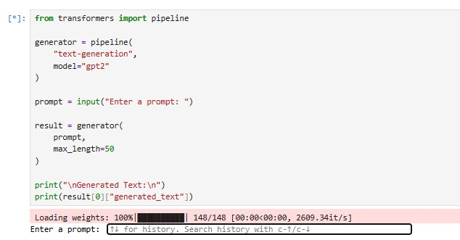

Advantages of Transformers
- Faster training through parallel processing.
- Better understanding of long-range context.
- High accuracy on NLP tasks.
- Scalable to very large datasets.
- Foundation of modern AI systems such as GPT and BERT.

Challenges of Transformers
- Require large amounts of training data.
- Computationally expensive.
- Often require GPUs for efficient training.
- Can inherit biases from the training data

