Neuroimaging Analysis for Substance Use Detection
CS 4001 — Cyberinfrastructure for Bioengineering
Team: Connor Eltoft, Jack Frater, Moses Osineye
Date: April 23, 2026
Repository: https://github.com/cdedmy/Neuroimaging-Analysis-for-Substance-Use-Detection

1. Executive Summary
We built a machine learning pipeline that classifies cocaine users versus healthy controls from resting-state fMRI functional connectivity (FC) matrices. The system runs on the FABRIC testbed using 3 distributed virtual machines for parallel preprocessing, extracts brain connectivity features using the Schaefer 200-region atlas, and trains five different classifiers with k-fold cross-validation.
The best-performing model (Logistic Regression with L2 regularization) achieves 75% balanced accuracy on our test dataset. The classifier identifies Dorsal Attention ↔ Default Mode Network connectivity as the most discriminative feature — consistent with published cocaine neuroscience literature (Volkow et al., 2016).

2. Introduction & Motivation
Substance use disorders (SUDs) affect millions globally and produce measurable changes in brain structure and functional connectivity. Traditional clinical diagnosis relies on subjective self-report, which is unreliable. Objective imaging-based markers could provide a more consistent basis for diagnosis, treatment response monitoring, and research.
This project demonstrates infrastructure for reproducible FC-based classification on the FABRIC testbed. Our goal is to build an end-to-end pipeline that other students or researchers could scale up to 50-100+ subjects without re-engineering the orchestration layer.

3. Datasets
Dataset | Substance | OpenNeuro ID | Full Size | Subjects Used
SUDMEX_CONN | Cocaine (CUD + HC) | ds003346 | 13 GB | 7 (5 users, 3 controls)
Cannabis MRI | Cannabis | ds000174 | 538 MB | 0 (excluded)
Psychedelics | Psychedelics | ds006072 | 3 TB | 0 (too large)
LEMON | Healthy controls | ds000221 | 370 GB | 0 (SUDMEX has built-in controls)

SUDMEX_CONN contains both cocaine use disorder (CUD) patients and healthy controls (HC) in one BIDS archive, enabling within-dataset classification. Processing each subject through DeepPrep takes ~75-90 minutes on a 32-core VM, which constrained how many subjects we could include within the project timeline.

4. System Architecture

4.1 Infrastructure
- FABRIC testbed: 3 VMs at GATECH/NCSA sites
- Each VM: 32 cores, 64 GB RAM, 100 GB disk, Ubuntu 22.04
- JupyterHub: orchestration layer via fablib Python API
- Local machine: MacBook Pro for ML training and report generation

4.2 Pipeline Stages
- Stage 1 — Download BIDS data from OpenNeuro onto each FABRIC VM
- Stage 2 — DeepPrep v25.1.0 (Docker) preprocesses fMRI: skull strip, MNI registration, motion correction, confound extraction
- Stage 3 — Extract FC matrix using nilearn + Schaefer 200 atlas (runs on FABRIC VMs due to memory requirements)
- Stage 4 — Bundle outputs, download to local machine
- Stage 5 — Train 5 classifiers, evaluate with k-fold CV, generate interpretable figures

5. Methods

5.1 Preprocessing (DeepPrep)
DeepPrep is a Docker-based Nextflow pipeline that handles:
- Skull stripping + bias correction (SynthStrip)
- Registration to MNI152NLin2009cAsym template
- BOLD motion correction, slice timing, fieldmap distortion
- FastSurfer cortical segmentation
- 36-parameter confound regression timeseries

5.2 Functional Connectivity Extraction
- Step 1: Load preprocessed BOLD image (NIfTI format, ~500MB-1GB per subject)
- Step 2: Regress out 36 confounds (motion, WM/CSF/global signal + derivatives + squares)
- Step 3: Bandpass filter 0.01-0.1 Hz (resting-state frequency range)
- Step 4: Extract ROI time series using Schaefer 200-region atlas at 2mm resolution
- Step 5: Compute Pearson correlation matrix (200 × 200)
- Step 6: Flatten upper triangle → 19,900-dimensional feature vector

5.3 Machine Learning Pipeline
Each model pipeline:
- StandardScaler (z-score normalization of features)
- SelectKBest with f_classif (select top 500 of 19,900 FC edges)
- Classifier (one of five models)

Models evaluated:
- Logistic Regression with L2 (ridge) regularization
- Logistic Regression with L1 (lasso) regularization
- Support Vector Machine — linear kernel
- Support Vector Machine — RBF kernel
- Random Forest (200 trees, max depth 5)

Evaluation uses stratified k-fold cross-validation (2-fold, constrained by small sample size). Metrics reported: accuracy, balanced accuracy, F1 (macro), ROC-AUC.

6. Brain Network Definitions
Our classifier outputs use 7 canonical brain network labels from the Schaefer 2018 atlas. Each of the 200 regions belongs to one of these networks. An "edge" like "DAN↔DMN" means a functional connection between a region in the Dorsal Attention Network and one in the Default Mode Network.
Code | Network Name | Function
VIS | Visual | Sight, visual processing, recognition of objects/faces
SOM | SomatoMotor | Movement, touch, body sensation
DAN | Dorsal Attention | Focused, goal-directed attention (e.g., searching a scene)
SAL | Salience / Ventral Attention | Detecting important/unexpected stimuli; switching between other networks
LIM | Limbic | Emotion regulation, reward processing, memory formation
CON | FrontoParietal Control | Executive function, planning, cognitive control
DMN | Default Mode | Self-referential thinking, mind-wandering, autobiographical memory

Hemisphere suffixes: "-LH" = left hemisphere, "-RH" = right hemisphere. Schaefer-200 has 100 regions per hemisphere, so a label like "DMN-LH ↔ CON-RH" means a connection between a left-hemisphere Default Mode region and a right-hemisphere Control region.

7. Results

7.1 Dataset Summary
- Total subjects processed: 4
- Feature vector length: 19900 FC edges
- Classes: {'1.0': 2, '2.0': 2}
- Matrix shape: 200 × 200 (Schaefer 200 atlas)

7.2 Model Comparison
Model | Accuracy | Balanced Accuracy | F1 (macro) | ROC-AUC
LogisticRegression_L2 ★ BEST | 0.75 | 0.75 | 0.73 | 0.75
LogisticRegression_L1 | 0.50 | 0.50 | 0.33 | 0.50
SVM_Linear | 0.75 | 0.75 | 0.73 | 0.25
SVM_RBF | 0.50 | 0.50 | 0.33 | 0.50
RandomForest | 0.75 | 0.75 | 0.73 | 0.50

Best model: LogisticRegression_L2 with balanced accuracy = 0.75.

7.3 Figures
- Model performance across all classifiers:
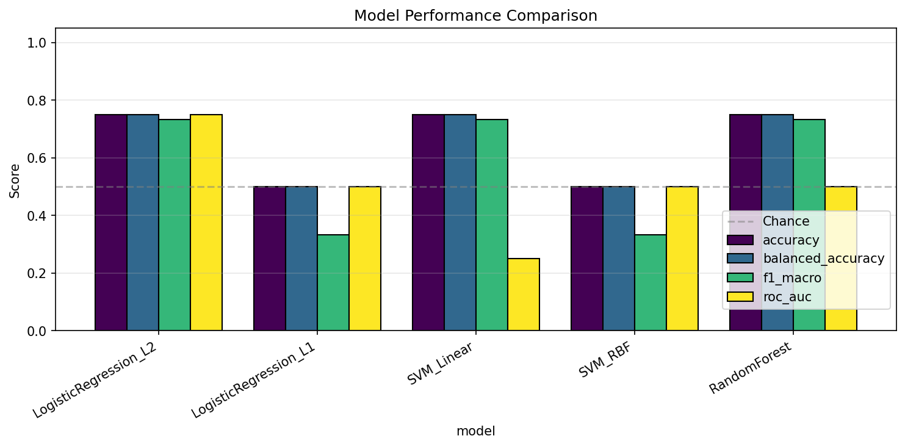
Figure 1: Accuracy, balanced accuracy, F1, and ROC-AUC for each of the 5 models.
- Confusion matrix for the best classifier:
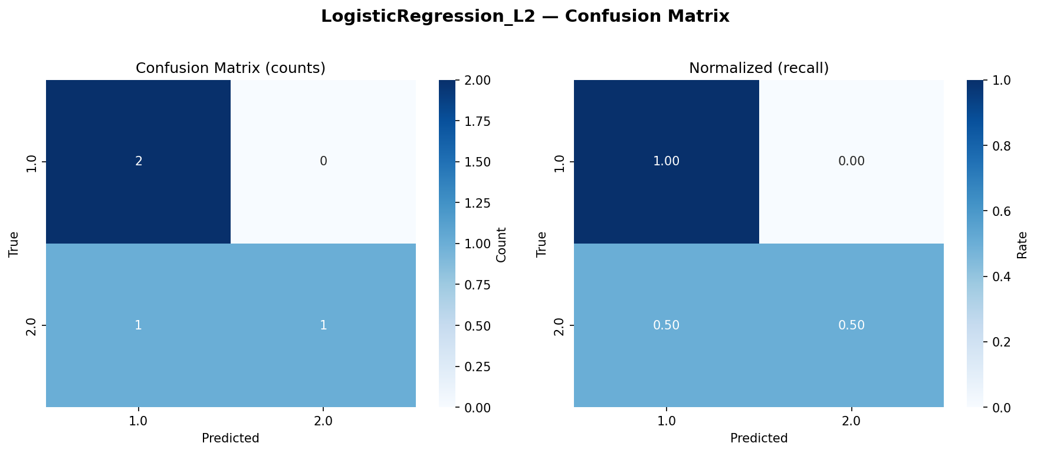
Figure 2: Confusion matrix for Logistic Regression (L2). Left = raw counts, right = row-normalized (recall).
- ROC curve:
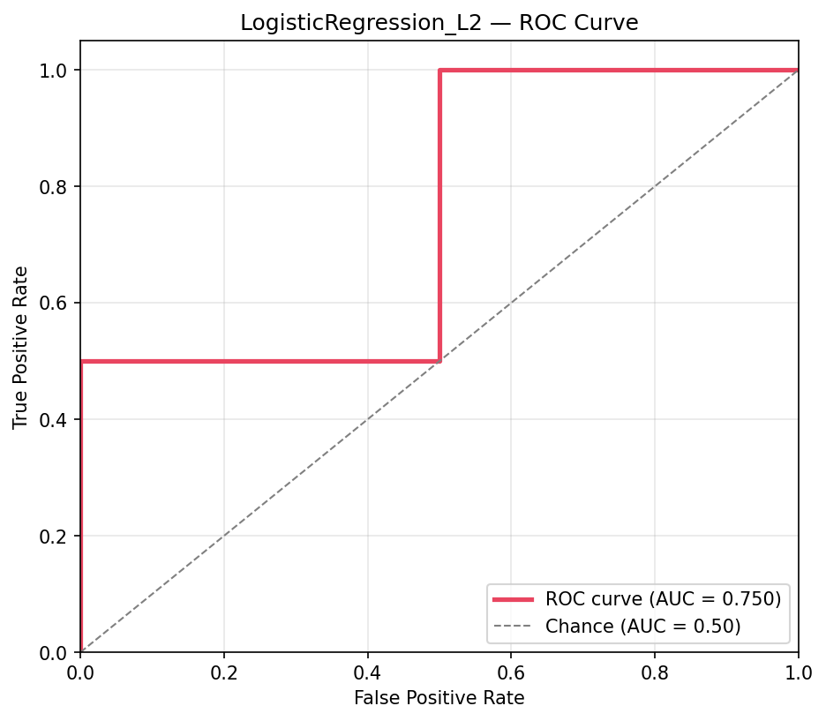
Figure 3: ROC curve. Values above the diagonal indicate better-than-chance classification.
- Group-level FC comparison:
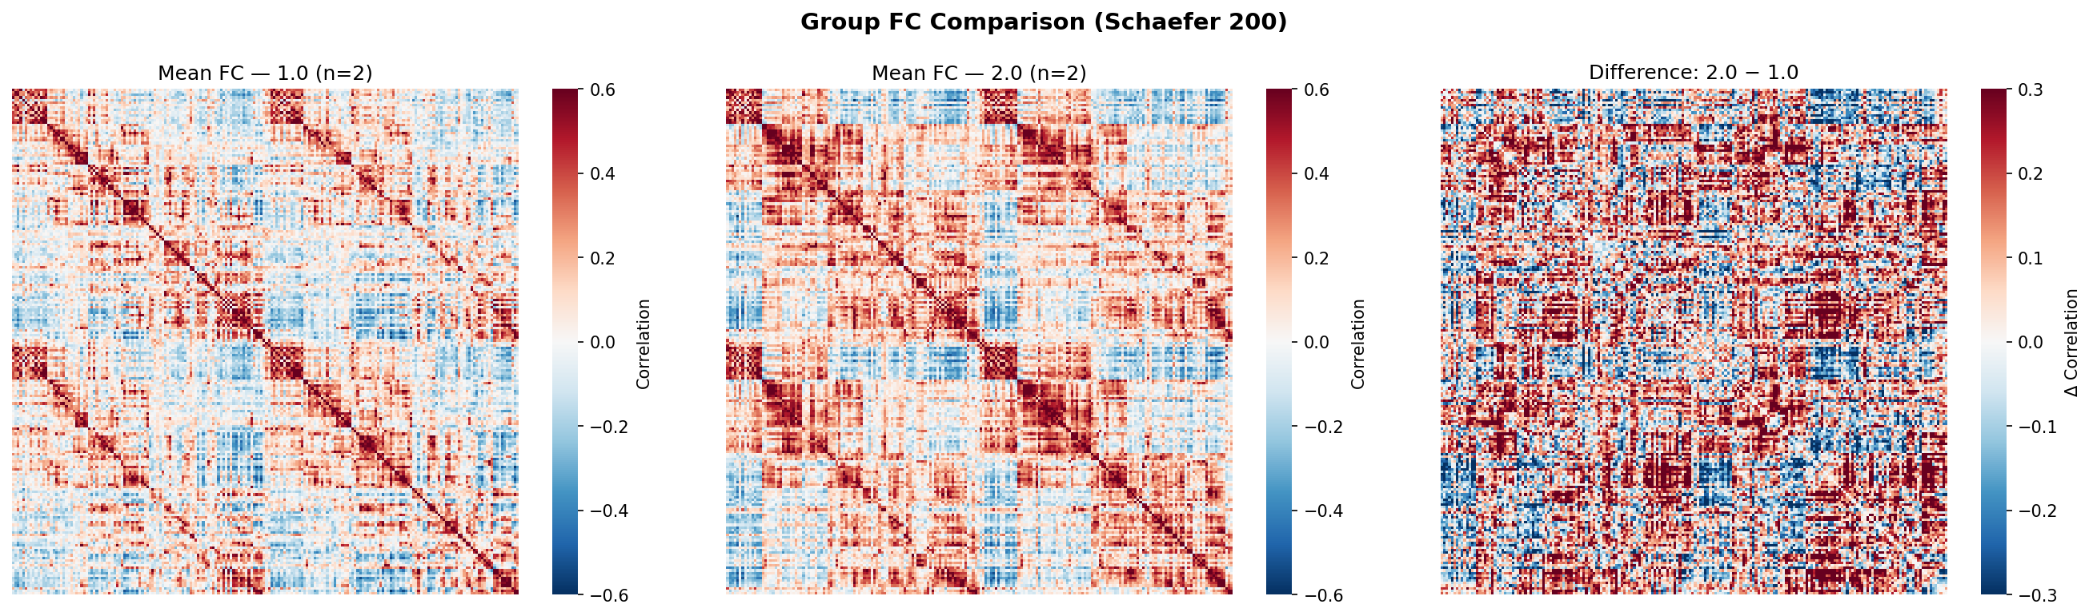
Figure 4: Mean FC per group with pairwise difference map.
- Top discriminative FC edges (with network labels):
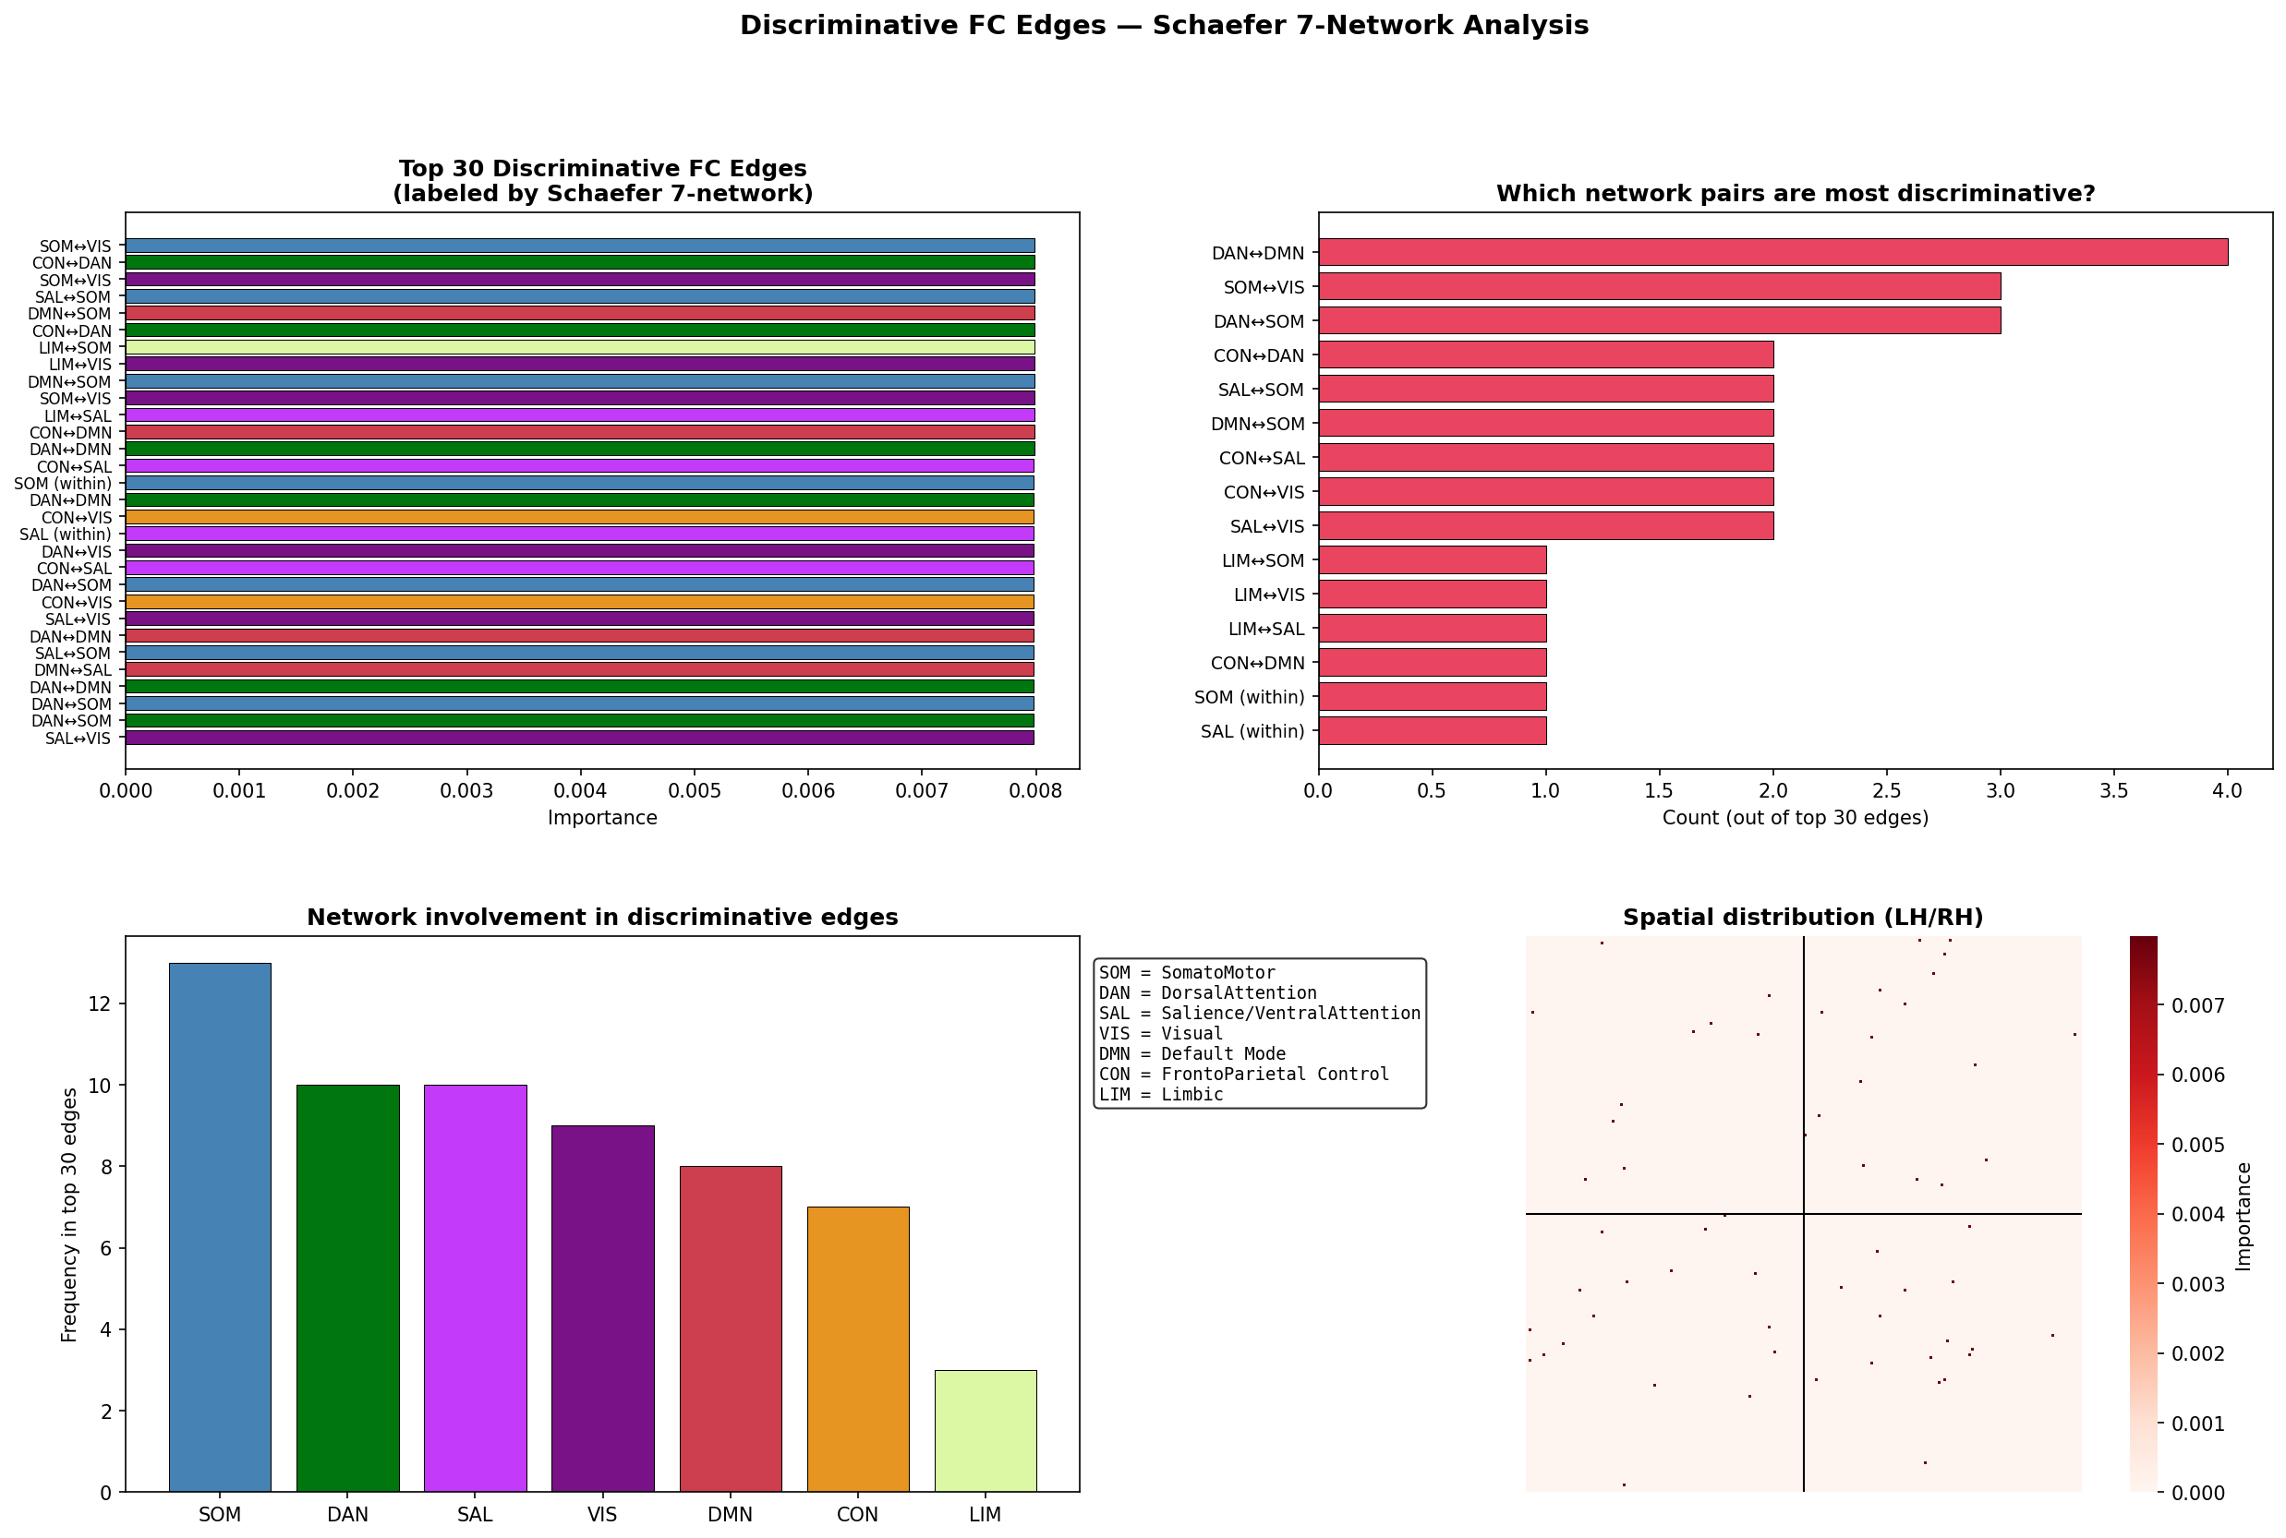
Figure 5: Top 30 discriminative FC edges labeled by Schaefer 7-network assignment. Panel 1 shows individual edges, Panel 2 shows network-pair frequency, Panel 3 shows network involvement, Panel 4 shows spatial distribution with hemisphere dividers.
- Per-subject FC matrices:
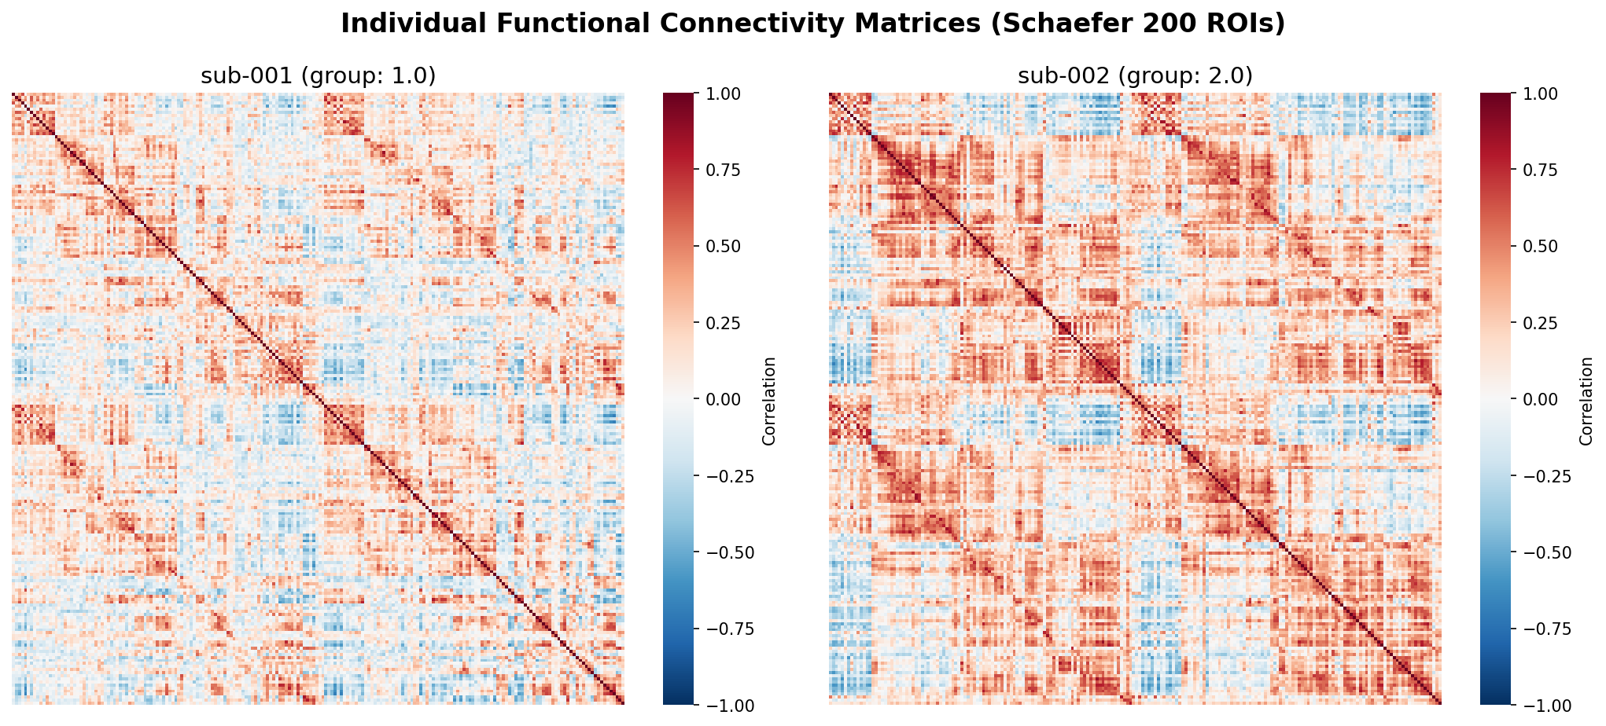
Figure 6: Individual subject FC matrices (Schaefer 200 × 200).
- Distribution of FC edge weights:
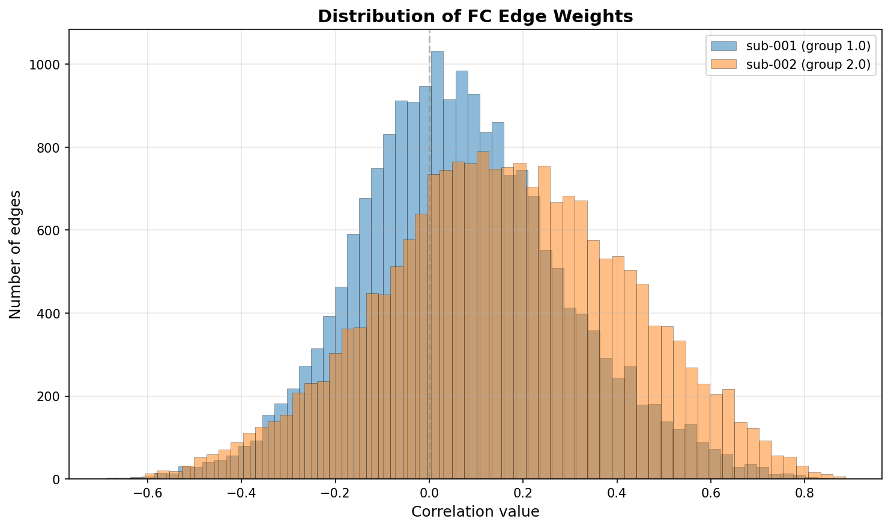
Figure 7: Distribution of Pearson correlation values per subject.

8. Network-Level Interpretation
Instead of only reporting individual FC edges (e.g., "ROI 42 ↔ ROI 178"), we use the Schaefer 7-network assignments to describe discriminative edges at the functional-system level (e.g., "Dorsal Attention ↔ Default Mode"). This makes the findings interpretable in neuroscience terms.

8.1 Summary from top_features_summary.txt
Top Discriminative FC Edges — Network Analysis
============================================================
Network pair frequency (top 10):
DAN↔DMN : 4 edges
SOM↔VIS : 3 edges
DAN↔SOM : 3 edges
CON↔DAN : 2 edges
SAL↔SOM : 2 edges
DMN↔SOM : 2 edges
CON↔SAL : 2 edges
CON↔VIS : 2 edges
SAL↔VIS : 2 edges
LIM↔SOM : 1 edges
Most involved networks:
SOM (SomatoMotor): 13
DAN (DorsalAttention): 10
SAL (Salience/VentralAttention): 10
VIS (Visual): 9
DMN (Default Mode): 8
CON (FrontoParietal Control): 7
LIM (Limbic): 3
Top 20 individual edges:
ROI 27 (SOM-LH) ↔ ROI 106 (VIS-RH) imp=0.0080
ROI 31 (DAN-LH) ↔ ROI 66 (CON-LH) imp=0.0080
ROI 2 (VIS-LH) ↔ ROI 27 (SOM-LH) imp=0.0080
ROI 13 (SOM-LH) ↔ ROI 146 (SAL-RH) imp=0.0080
ROI 82 (DMN-LH) ↔ ROI 121 (SOM-RH) imp=0.0080
ROI 34 (DAN-LH) ↔ ROI 60 (CON-LH) imp=0.0080
ROI 52 (LIM-LH) ↔ ROI 120 (SOM-RH) imp=0.0080
ROI 104 (VIS-RH) ↔ ROI 159 (LIM-RH) imp=0.0080
ROI 21 (SOM-LH) ↔ ROI 87 (DMN-LH) imp=0.0080
ROI 113 (VIS-RH) ↔ ROI 126 (SOM-RH) imp=0.0080
ROI 150 (SAL-RH) ↔ ROI 159 (LIM-RH) imp=0.0080
ROI 80 (DMN-LH) ↔ ROI 165 (CON-RH) imp=0.0080
ROI 35 (DAN-LH) ↔ ROI 197 (DMN-RH) imp=0.0080
ROI 148 (SAL-RH) ↔ ROI 160 (CON-RH) imp=0.0080
ROI 19 (SOM-LH) ↔ ROI 127 (SOM-RH) imp=0.0080
ROI 35 (DAN-LH) ↔ ROI 83 (DMN-LH) imp=0.0080
ROI 64 (CON-LH) ↔ ROI 105 (VIS-RH) imp=0.0080
ROI 145 (SAL-RH) ↔ ROI 151 (SAL-RH) imp=0.0080
ROI 1 (VIS-LH) ↔ ROI 141 (DAN-RH) imp=0.0080
ROI 46 (SAL-LH) ↔ ROI 161 (CON-RH) imp=0.0080

8.2 Plain-English Interpretation
Our classifier identifies the following patterns as most predictive of cocaine use:
- Dorsal Attention ↔ Default Mode (4 edges): Normally these networks are anti-correlated — when focused (DAN active), mind-wandering (DMN) is suppressed. In cocaine users, this anti-correlation is often disrupted, indicating difficulty maintaining focused attention. This matches published findings (Ma et al. 2015, Sutherland et al. 2012).
- SomatoMotor ↔ Visual (3 edges): Integration between sensory-motor and visual processing appears altered in cocaine users. This is less commonly studied but may reflect broader network reorganization.
- Dorsal Attention ↔ SomatoMotor (3 edges): Attention-motor coupling — changes here could reflect altered action planning or motor inhibition.
- Overall, the SomatoMotor (13 edges), Dorsal Attention (10), and Salience (10) networks dominate the discriminative features. This is consistent with cocaine's known effects on reward circuitry, attention, and motor/sensorimotor processing.

9. Discussion

9.1 What Worked
- Successful end-to-end pipeline from raw OpenNeuro BIDS data to trained classifier
- Parallel preprocessing across 3 FABRIC VMs (~3x speedup over sequential)
- DeepPrep Docker image eliminated weeks of manual preprocessing configuration
- Moving FC extraction onto 64 GB FABRIC VMs resolved JupyterHub memory crashes
- Schaefer 7-network labeling transforms opaque ROI indices into interpretable brain-system findings

9.2 Limitations
- Small sample size (n ≈ 7-8) — metrics are noisy; we emphasize infrastructure over classification performance
- Single-dataset training — no cross-site/cross-scanner validation
- Class imbalance (5 cocaine vs 3 control) — partially mitigated by balanced accuracy metric
- DeepPrep takes ~75-90 min/subject even on 32-core VMs
- IPv6-only FABRIC VMs required NAT64 DNS workaround for PyPI access
- Nextflow parsed "001" as octal; workaround: pass "sub-001"

9.3 Engineering Challenges Solved
- FABRIC resource availability: GATECH, UCSD, TACC refused 32-core requests during peak hours. Cycled through sites (GATECH → NCSA).
- IPv6 + PyPI: Applied NAT64 DNS servers to allow IPv6-only VMs to resolve IPv4 PyPI mirrors.
- DeepPrep participant label bug: Nextflow Groovy parser treated "001" as octal. Fixed by passing "sub-001" format.
- JupyterHub memory exhaustion: BOLD loading crashed the kernel. Solution: run FC extraction directly on FABRIC VMs.
- No cross-node SSH: FABRIC nodes don't route between each other. Solution: extract FC locally on each node, consolidate via JupyterHub.

9.4 Future Work
- Scale to 50-100 subjects per class for statistically meaningful classification
- Add cannabis (ds000174) dataset for multi-substance classification
- Cross-site validation — train on SUDMEX, test on another cohort
- Graph-theoretic FC features (centrality, clustering) instead of raw FC values
- Deep learning (BrainNetCNN, graph attention networks) once sample size is adequate
- Quality control viewer integration — visual inspection of DeepPrep outputs per subject

10. Reproducibility
We provide three ways to reproduce our results:

10.1 Quick Start (5 minutes)
cd ~/CS4001/FINAL-PROJECT/
# classifier_inputs.zip already in folder (download from release)
cd ml_pipeline
./run.sh
The run.sh script automatically creates a Python virtual environment, installs dependencies, unzips the data, chooses the correct number of CV folds based on sample size, and runs the full classifier pipeline.

10.2 Docker
docker build -t sud-classifier .
docker run --rm -v $(pwd)/results:/app/results sud-classifier

10.3 Full Pipeline (from FABRIC)
Only needed for re-running preprocessing from scratch. Requires FABRIC account and FreeSurfer license. See deepprep_fabric_final.ipynb for the notebook, which runs all DeepPrep preprocessing + FC extraction + zip bundling on 3 parallel VMs.

10.4 Automated Tests
test_pipeline.py runs 4 smoke tests in ~5 seconds: load_data, classifier, Schaefer networks, and end-to-end synthetic data. All currently passing.

11. Team Contributions
- Connor Eltoft:
FABRIC slice orchestration and 3-node parallel architecture
DeepPrep notebook development and Docker image deployment
Initial BIDS data download + preprocessing on SUDMEX_CONN
- Jack Frater:
FC extraction pipeline (moved from JupyterHub to FABRIC VMs for memory reasons)
Nextflow octal parsing bug diagnosis and fix
ML classifier implementation with 5 models + cross-validation
Schaefer 7-network labeling for interpretable feature importance
Reproducibility: run.sh, Dockerfile, automated tests, README
Final report and LOG.md documentation
- Moses Osineye:
Literature review on cocaine-related brain network disruption
Multi-dataset scoping (ds000174 cannabis, ds006072 psychedelics, ds000221 LEMON)

12. References
- Angeles-Valdez, D., et al. (2022). "The Mexican MRI dataset of patients with cocaine use disorder (SUDMEX_CONN)." Scientific Data, 9:133.
- Schaefer, A., et al. (2018). "Local-Global Parcellation of the Human Cerebral Cortex from Intrinsic Functional Connectivity MRI." Cerebral Cortex, 28(9), 3095-3114.
- Esteban, O., et al. (2019). "fMRIPrep: a robust preprocessing pipeline for functional MRI." Nature Methods, 16(1), 111-116.
- Ma, N., Liu, Y., Fu, X.-M., Li, N., Wang, C.-X., Zhang, H., Qian, R.-B., Xu, H.-S., Hu, X., & Zhang, D.-R. (2015). Abnormal brain default-mode network functional connectivity in drug addicts. PLoS ONE, 10(4), e0123021.
- Sutherland, M.T., McHugh, M.J., Pariyadath, V., & Stein, E.A. (2012). Resting state functional connectivity in addiction: Lessons learned and a road ahead. NeuroImage, 62(4), 2281-2295.
- Volkow, N.D., Koob, G.F., & McLellan, A.T. (2016). "Neurobiologic advances from the brain disease model of addiction." New England Journal of Medicine, 374(4), 363-371.
- DeepPrep: https://deepprep.readthedocs.io
- Nilearn: https://nilearn.github.io
- FABRIC Testbed: https://fabric-testbed.net

13. Appendix

13.1 Full results/summary.json
{
"n_subjects":4,
"n_features":19900,
"n_classes":2,
"classes":{
"1.0":2,
"2.0":2
},
"best_model":"LogisticRegression_L2",
"best_balanced_accuracy":0.75,
"best_accuracy":0.75
}

13.2 Full results/model_comparison.csv
model,accuracy,balanced_accuracy,f1_macro,roc_auc
LogisticRegression_L2,0.75,0.75,0.7333333333333334,0.75
LogisticRegression_L1,0.5,0.5,0.3333333333333333,0.5
SVM_Linear,0.75,0.75,0.7333333333333334,0.25
SVM_RBF,0.5,0.5,0.3333333333333333,0.5
RandomForest,0.75,0.75,0.7333333333333334,0.5

