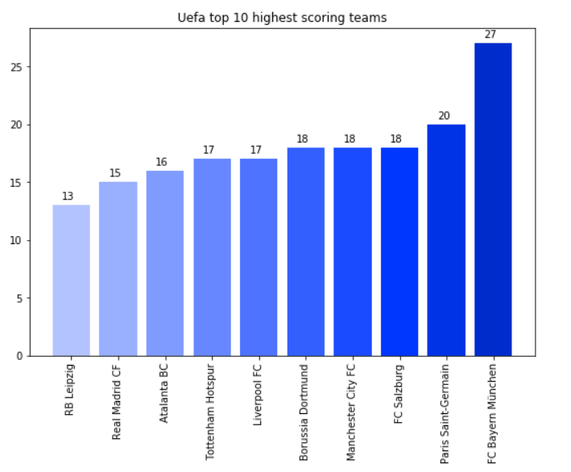

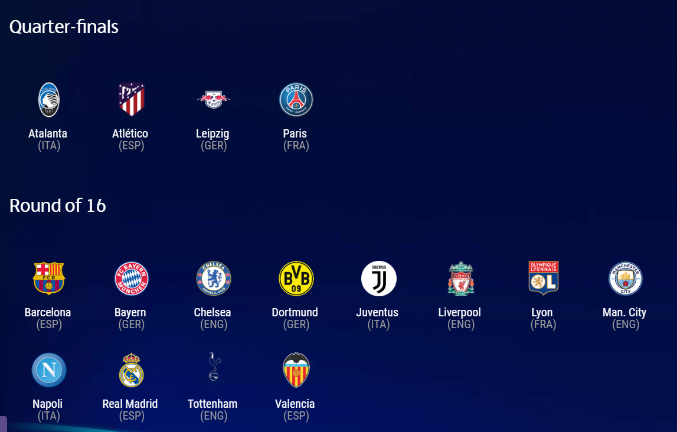In this bar graph (axis x - teams, axis y-goals) we can see the best teams have between 13 and 27 goals, from right to left we have FC Bayern München leading with 27 goals, followed by Paris Sant- Germain with 20 goals, we have FC Salzburg, Manchester City FC and Borussia Dortmund that are tied at 18 goals, Liverpool FC and Tottenham Hotspur also tie their goals at 17 and from there we descended with Atlanta BC who has 16, Real Madrid 15 and RB Leipzig has 13 goals. We can see that this graph has nothing to do with the qualification of the teams, since in the Quarter-finals there are some like Atlanta or Atlético de Madrid who are not the top scorers, or how most of the scoring teams are in Round of 16.

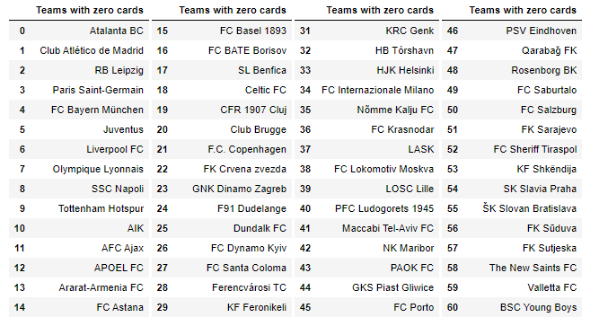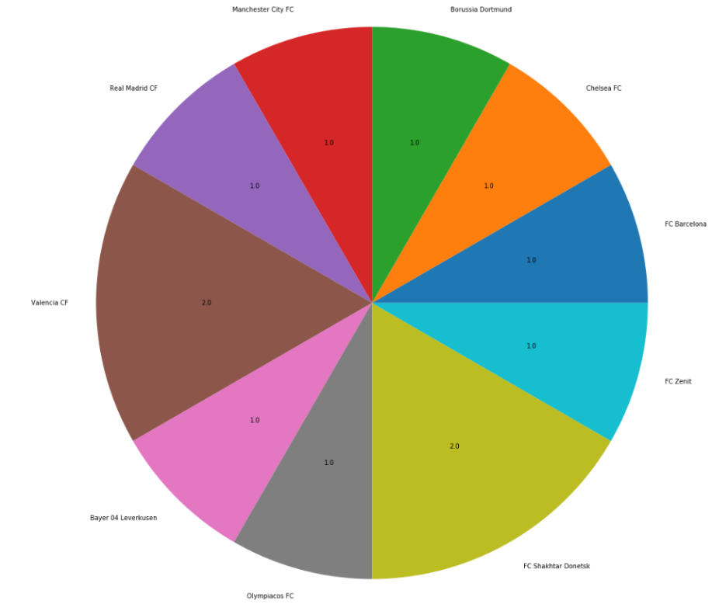

In the following graph we can see the red cards of each team, all the teams have between 0-2 cards, in the piechart we can see all those that have cards, there being 2 teams with two red cards and 8 teams with a single red card.

The table shows the 60 teams without red cards.

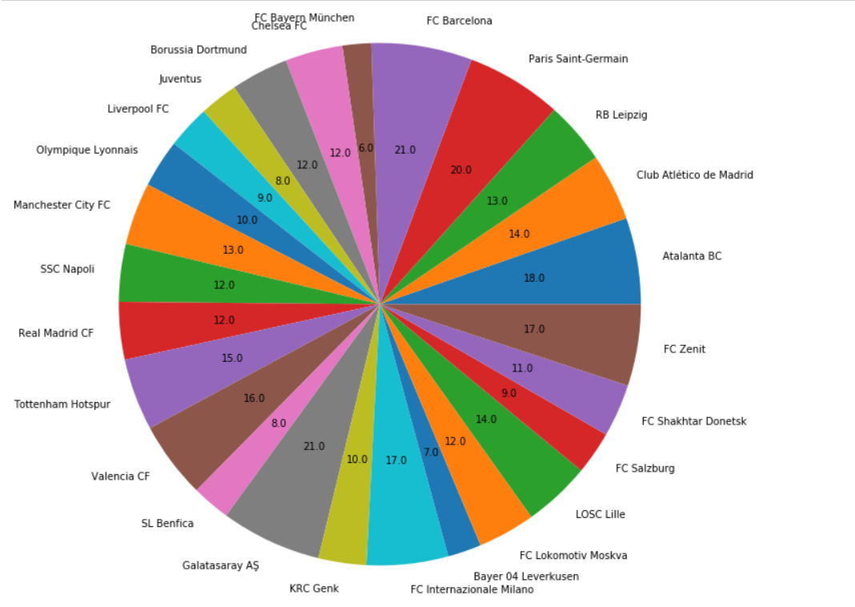

In the last piechart, we see the teams that have more than 4 yellow cards, in this case we can see that they go from 6 to 21 yellow cards, in the lead for example we can see teams like FC Barcelona and in the end with 6 cards is the FC Bayern München, looking at this graph we can see that there is no team with 1, 5 or 19 cards.

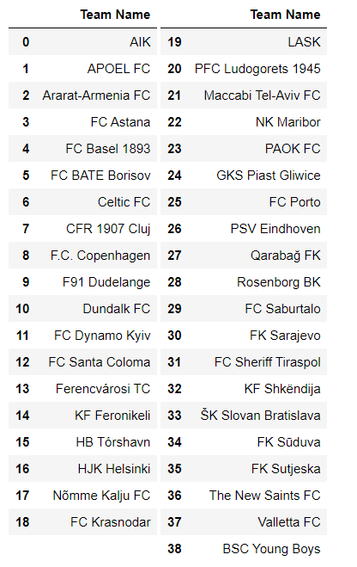Table 1 with 39 results, shows the teams with 0 yellow cards.

Table 2 shows the 4 results of teams with 2 yellow cards.

Table 3 contains the 2 search results for teams with 3 yellow cards.

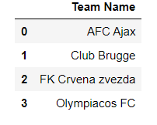

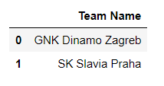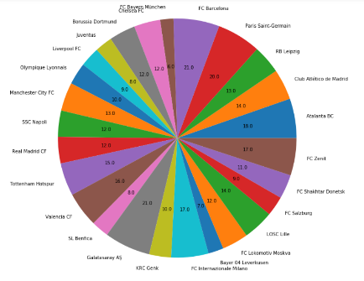

Table 2

Table 3

Table 1