HIVE, INC. · CONFIDENTIAL
InsightOut Enneagram Assessment
UI Design Specification · v1.0
June 2026 · Cai Delumpa & Monique Breault
This document is the authoritative UI specification for the InsightOut assessment interface redesign. It covers visual design, chrome system, pre-assessment screens, interstitials, stage screens, and the thank you screen. All implementation work in assessment.js, app.js, and styles.css should reference this document. Engine logic, scoring, and AI calls are out of scope — see hive_typing_engine_spec_v2_0.docx.

LOGO PLACEHOLDER: All reference mockups in this document use a simplified placeholder for the Hive logo. This is a rendering limitation of the mockup generation environment. All implementation must use the canonical HIVE_LOGO_SVG const from app/renderer.js (line 1580), or docs/hive_logo.svg. See hive_logo_svg_reference.docx for full usage notes including the critical clipPath namespacing requirement.

0 · Welcome Screen
The welcome screen is the first screen every client sees. It has no chrome — no progress bar, no sub-progress strip, no Save button. Its sole job is to orient the client, set the right expectation, and make starting feel inviting.
This screen is structurally distinct from all stage screens in Sections 3–6. It has no progress chrome, no Continue button gating, and no footer Save link. The only interactive element is the Start Assessment CTA.

0.1 Layout
Topbar | White, centered logo only. No divider, no product name label, no Save link. Logo sized at 140px wide (desktop) and 80px wide (mobile) via explicit SVG width and height attributes — no class attribute on the SVG element.
Body | Centered column, white-space-driven vertical rhythm. No card wrapper. Background #F4F6F8.
Footer | Standard copyright footer — same as all stage screens. "© Copyright 2026 Hive, Inc. All rights reserved." centered, #C8D0D9, 10px desktop / 8px mobile.

0.2 Content (top to bottom)
Eyebrow | "INSIGHTOUT ENNEAGRAM ASSESSMENT" — 11px desktop / 10px mobile, weight 500, uppercase, letter-spacing 0.12em, Hive Blue #00B2D9. Margin-bottom 16px desktop / 12px mobile.
Headline line 1 | "Discover your" — weight 300 (light), 38px desktop / 26px mobile, color #1E2A35.
Headline line 2 | "Enneagram type." — weight 600 (bold), same size, same color, displayed as a separate block beneath line 1.
Tagline | "Welcome to an experience that reveals why you think, feel, act the way you do." — 16px desktop / 13px mobile, color #6B7785, line-height 1.6, max-width 460px desktop / 260px mobile, centered.
Report carrot | Small envelope icon (Hive Blue SVG, 14px desktop / 12px mobile) inline-left + "When you're done, a personalized Enneagram report lands in your inbox." (desktop) / "When you're done, a personalized report lands in your inbox." (mobile) — weight 500, 14px desktop / 12px mobile, color #1E2A35. Sits between tagline and meta row. Slightly heavier weight than surrounding text to give it presence without competing with the headline.
Meta line | "15–20 minutes · No right or wrong answers · Go with your first instinct" — 13px desktop / 11px mobile, color #9AA3AD. Full text on both viewports.
Pre-CTA | "Now, find a quiet moment and…" — 14px desktop / 12px mobile, italic, color #6B7785. Sits immediately above the CTA button.
CTA button | "Start Assessment" — Hive Blue #00B2D9, white text, 16px desktop / 14px mobile, weight 500, border-radius 10px desktop / 8px mobile, padding 15px 52px desktop / 12px 36px mobile. No locked state — always active.

0.3 Reference mockup
Welcome screen · No chrome · Report carrot added · Desktop (left) and Mobile (right)
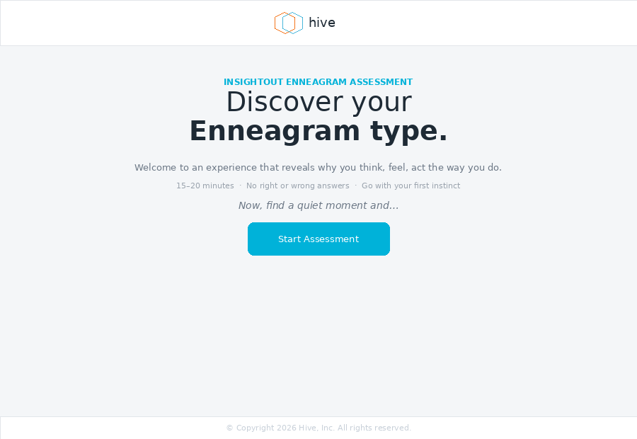 | 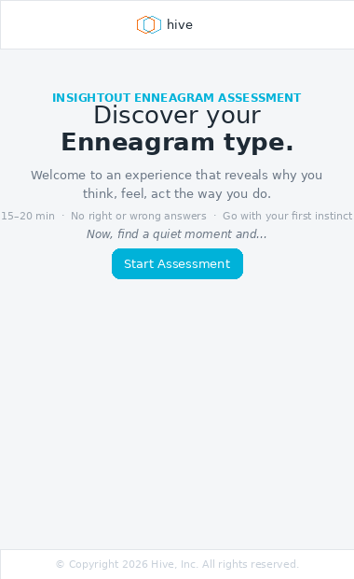
Desktop (left) · Mobile (right)

0.4 Implementation notes for CC
Logo sizing: set both width and height explicitly as SVG element attributes (e.g. width="140" height="44") — do NOT use a class attribute or CSS to size the logo on this screen. The class="logo" attribute present in the HIVE_LOGO_SVG const conflicts with environment stylesheets and causes unpredictable sizing. Strip it for assessment UI usage.

clipPath ids: the welcome screen inlines one logo instance, so no namespacing is required unless the logo also appears elsewhere on the same HTML page. If two instances appear on the same page, namespace each instance's clipPath ids — see hive_logo_svg_reference.docx for the pattern.

No chrome on this screen: do not render the progress bar, sub-progress strip, Save link, or Back button on the welcome screen. The Start Assessment button links directly to Stage 0 screen 1.
The welcome screen has no Back button. It is always the entry point. The Save/resume flow begins on Stage 0 screen 1 where the token gate is in effect.

0A · Profile Confirmation Screen (Returning Clients)
Shown only to returning clients who already have intake data on file. New clients skip this screen entirely and go straight to Section 0B (Intake Form). This screen has no progress chrome.
Routing rule: if the client token resolves to an existing record with first_name, last_name, email, and coach populated, show this screen. Otherwise show the Intake Form (Section 0B). Never show both in sequence.

0A.1 Layout
Topbar | White, logo + divider + product name. No Save link in topbar — Save and continue later moves to the nav row (see below).
Body | Left-aligned content, max-width 400px form area. Background #F4F6F8.
Footer | Standard copyright footer.

0A.2 Content (top to bottom)
Heading | "Welcome back, [first name]." — 26px desktop / 18px mobile, weight 500, color #1E2A35. Uses client first name from record.
Subhead | "We found your details on file. Confirm everything looks right before you begin." — 14px desktop / 12px mobile, color #6B7785.
Profile card | White card, 0.5px #E2E6EA border, border-radius 10px desktop / 8px mobile. Four read-only rows: Name (first + last combined), Email, Organization, Coach. Each row has a muted uppercase label (10px, #9AA3AD) and a value (14px desktop / 12px mobile, #1E2A35). Rows separated by 0.5px #F0F2F4 hairlines.
Edit link | "✎ Edit your profile" — 13px desktop / 11px mobile, Hive Blue #00B2D9. Pencil icon inline. Clicking navigates to the Intake Form (Section 0B) prepopulated with current values. Sits below the card.
Nav row | Continue button (Hive Blue, always unlocked — nothing to gate) + Save and continue later ghost button. Desktop: side by side. Mobile: stacked full-width, Continue above Save.

0A.3 Reference mockup
Profile confirmation · Read-only · Desktop (left) and Mobile (right)
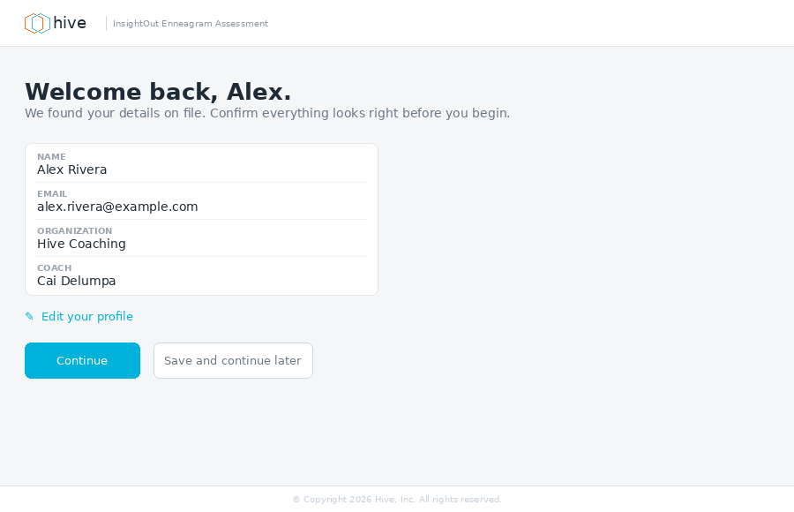 | 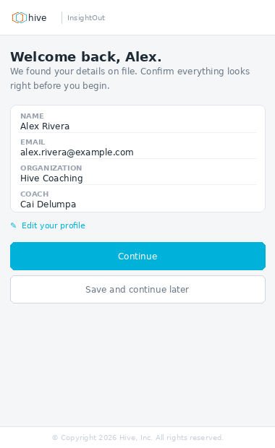
Desktop (left) · Mobile (right)

0A.4 Implementation notes for CC
Organisation field: if the client has no organisation on file, omit the Organisation row from the profile card entirely — do not show an empty row.

Edit your profile link: navigates to the Intake Form with all fields prepopulated from the existing record. On submit, the record is updated in place. On cancel/back, returns to this screen with unchanged data.
Continue is always unlocked on this screen. There is no gate condition — the client either confirms and proceeds or clicks Edit. Do not add any gate logic here.

0B · Intake Form (New Clients and Edit Flow)
Shown to new clients on their first visit, and to returning clients who clicked "Edit your profile" on the Profile Confirmation screen. Has no progress chrome.

0B.1 Layout
Topbar | White, logo + divider + product name. No Save link in topbar — Save and continue later moves to the nav row.
Body | Left-aligned, max-width 400px form area (desktop). Fields stack single-column on mobile; First name and Last name display side-by-side on desktop.
Footer | Standard copyright footer.

0B.2 Fields
Field | Type / Spec
First name * | Text input. Required. Side-by-side with Last name on desktop, stacked on mobile.
Last name * | Text input. Required. Side-by-side with First name on desktop, stacked on mobile.
Email address * | Text input, type="email". Required. Full width.
Organization | Text input. Optional — label shows "(optional)" suffix in muted text. Full width.
Select your coach * | Dropdown / select. Required. Populated from the coach roster. Full width.

0B.3 Field styles
Label | 10px, weight 600, uppercase, letter-spacing 0.09em, color #5A6472. Required fields show an orange asterisk (*) after the label at #F68625.
Input / select | White bg, 1px #B8C8D4 border, border-radius 7px. 14px desktop / 13px mobile. Padding 10px 13px desktop / 9px 11px mobile.
Select arrow | Custom SVG caret at right-13px. Native appearance reset via -webkit-appearance: none.

0B.4 Continue button gate
Gate condition | All required fields non-empty AND a coach is selected. Continue is locked (#B8E8F3, no pointer-events) until all four required fields are satisfied.
Organization | Optional — does not affect gate.

0B.5 Nav row
Desktop | Continue button (gated) + "Save and continue later" ghost button side by side, left-aligned within the 400px form column.
Mobile | Continue button full-width, "Save and continue later" ghost button full-width directly below. Both within standard side padding.

0B.6 Reference mockup
Intake form · Filled state · Desktop (left) and Mobile (right)
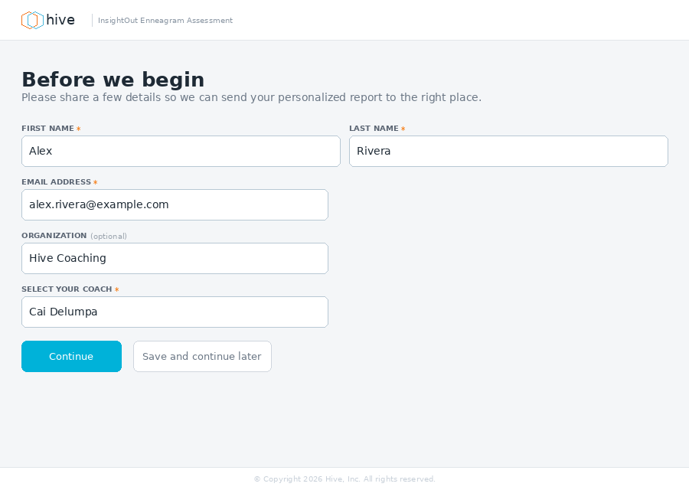 | 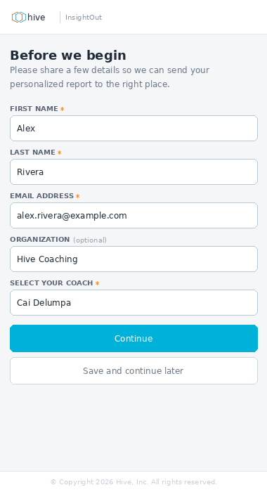
Desktop (left) · Mobile (right)

0B.7 Implementation notes for CC
On submit: POST intake data, create or update the client record, then navigate to Stage 0 screen 1. Do not navigate before the POST resolves.

Edit flow: when arriving from "Edit your profile", prepopulate all fields from the existing record. The heading and subhead remain "Before we begin" — no special copy for the edit flow.

Coach dropdown: populated from the active coach roster. If only one coach is in the roster, pre-select it and disable the dropdown (client cannot change it). If multiple coaches, show a blank default option "Select your coach" and require selection.
Save and continue later on this screen saves whatever has been entered so far and sets the resume token. A partially completed intake can be resumed — the fields repopulate from the saved draft on return.

0C · Orientation Interstitial
Shown after Profile Confirmation (or Intake Form) and before Stage 0 screen 1. Orients the client to the 4-part structure, flags Part 1 as the heaviest lift, and gives tips for the two most distinctive interaction types: open responses (Warmup) and sliders (Part 1).
This screen has no progress chrome — no progress bar, no sub-progress strip. Chrome is topbar (logo + divider + product name) and standard footer only. Continue only — no Back, no Save. There is nothing to save or return to at this point.

0C.1 Layout
Topbar | Logo + divider + product name only. No Save link.
Body | Single scrollable column, 28px padding desktop / 14px mobile. Max content width unconstrained — content reads full width within padding.
Footer | Standard copyright footer.

0C.2 Content (top to bottom)
Lead paragraph | "Here's what to expect — 4 parts, about 15–20 minutes total. Part 1 is the most involved, but it's also where the most insight comes from. Take it at your own pace." — 18px desktop / 13px mobile, weight 500, color #1E2A35.
Part pills row | 4 pills in a flex row: Warmup, Part 1 ★, Part 2, Parts 3 & 4. Each pill shows the part label, screen/question count, and interaction type. Part 1 pill is highlighted in Hive Blue (#EBF9FD bg, #00B2D9 border). All others white with #E2E6EA border. Border-radius 8px desktop / 6px mobile.
Divider | 0.5px #E8ECF0 hairline between each section.
Warmup tip section | Muted blue badge ("WARMUP", bg #8ABEC9) + section title. Two bullet tips — see 0C.3.
Part 1 tip section | Hive Blue badge ("PART 1", bg #00B2D9) + section title. Two bullet tips — see 0C.3.
Closing line | "Ready? The first question is a warm-up — just a chance to find your voice before the real work begins." — italic, 13px desktop / 11px mobile, color #6B7785.
CTA button | "Let's begin" — Hive Blue, always unlocked. No locked state.

0C.3 Tip copy (verbatim)
Section | Tip
Warmup — tip 1 | "No wrong answers — a few words is plenty, but feel free to say more. The richer the detail, the more we have to work with."
Warmup — tip 2 | "Think about your life in general, not just how you've been lately or at work."
Part 1 — tip 1 | "Move the slider even if you're not sure — an uncertain answer is more useful than a blank one. You can't get this wrong."
Part 1 — tip 2 | "Go with your gut. If a statement makes you pause, ask yourself: would my closest friend say this is true of me?"
These are Mo-approved copy. Do not paraphrase or shorten in implementation. Render verbatim.

0C.4 Reference mockup
Orientation interstitial · Desktop (left) and Mobile (right)
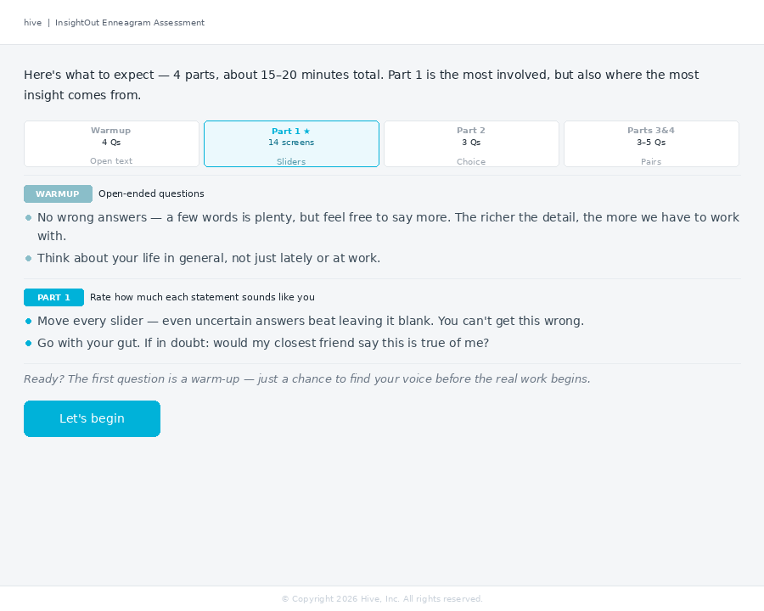 | 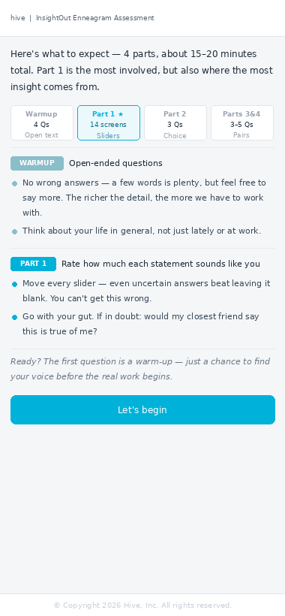
Desktop (left) · Mobile (right)

0C.5 Implementation notes for CC
NEW SCREEN — This screen does not currently exist in the codebase. It requires a new render function (e.g. renderOrientationInterstitial()) and a new phase constant. It should be inserted into the assessment flow between the intake/profile confirmation phase and Stage 0 screen 1.

This screen is shown only once per assessment session — on the initial run through. It is not shown when a client resumes a saved assessment mid-flow.

CTA label: "Let's begin" not "Continue". This is the only screen in the flow with this label — it marks the transition from setup to assessment. All other forward navigation uses "Continue".

Part pill counts: the pill counts (14 screens, 3–5 questions) are approximate and informational. They do not need to be dynamically computed from state — hard-code the display values from the spec.
Logo rendering note: do not inline the HIVE_LOGO_SVG const on this screen. Reference the logo PNG asset (docs/hive_logo_desktop.png or hive_logo_mobile.png) or use the same img tag pattern established for the pre-assessment screens. The full SVG inline with clipPath ids causes rendering failures in the widget environment.

0D · Part 1 Complete Interstitial (Mid-Assessment)
Shown immediately after Stage 1 (Part 1) completes and before Stage 2 (Part 2) begins. This screen has two distinct states driven by the AI round-trip that happens between Stage 1 and Stage 2.
NEW SCREEN — This screen replaces the existing mid-assessment reminders screen (screen_07). The existing screen should be retired. This new version has two async states (A and B) and requires the Continue button to be locked until the AI response resolves.

0D.1 Chrome
Topbar | Logo + divider + product name. No Save link in topbar.
Progress bar | Global progress bar only — no sub-progress strip. Label reads "PART 1 COMPLETE" in Hive Orange (not blue). Percentage: 42%. This is the only screen where the progress label uses orange — it signals completion rather than navigation.
Footer | Standard copyright footer.

0D.2 Two-state design
State | Trigger
A — Loading | Screen renders immediately on entering this phase
B — Ready | AI round-trip resolves (Call #1 response received)
The lock reason in State A is system readiness, not user input. CC must implement this as an async state toggle, not an input gate. The tips and all other content remain stable across both states — only the status indicator row and button state change.

0D.3 Content (stable across both states)
Headline | "Great work — Part 1 is done." — weight 600, 22px desktop / 16px mobile, color #1E2A35.
Subhead | "That was the heaviest lift. From here it should take you 5–10 more minutes to complete the assessment." (desktop) / "…5–10 more minutes." (mobile) — 14px desktop / 12px mobile, color #6B7785.
Status row | Spinner (State A) or checkmark (State B) with accompanying text. See 0D.2.
Divider | 0.5px #E8ECF0 hairline below status row.
Tips label | State A: "In the meantime, a few tips for what's ahead" · State B: "A few tips for what's ahead" — 10px, weight 600, uppercase, #9AA3AD.
Tips | Three bullets — see 0D.4.
Continue button | State A: locked. State B: unlocked. Full-width on mobile, contained on desktop.

0D.4 Tip copy (verbatim)
Tip | Desktop copy
1 | "Answer from the arc of your life, not just what's true right now. If you get stuck, think about how your 25-year-old self would respond."
2 | "In the paired comparisons coming up, you'll choose between two descriptions of a person. Pick the one that sounds more like you — even if both feel partly true."
3 | "Trust your gut and keep moving — overthinking usually leads away from your true type, not toward it."
Tip copy is Mo-approved. Do not paraphrase or shorten beyond the mobile condensed versions above. Render verbatim.

0D.5 Reference mockups
State A — Loading · Continue locked · Desktop (left) and Mobile (right)
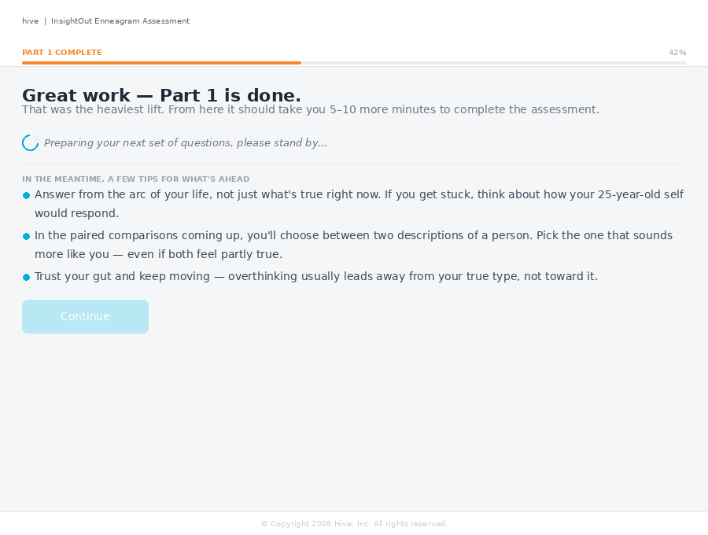 | 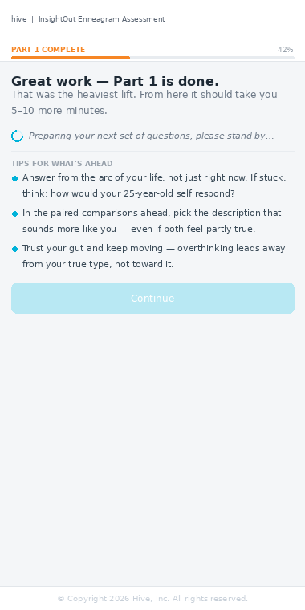
Desktop (left) · Mobile (right)
State B — Ready · Continue unlocked · Desktop (left) and Mobile (right)
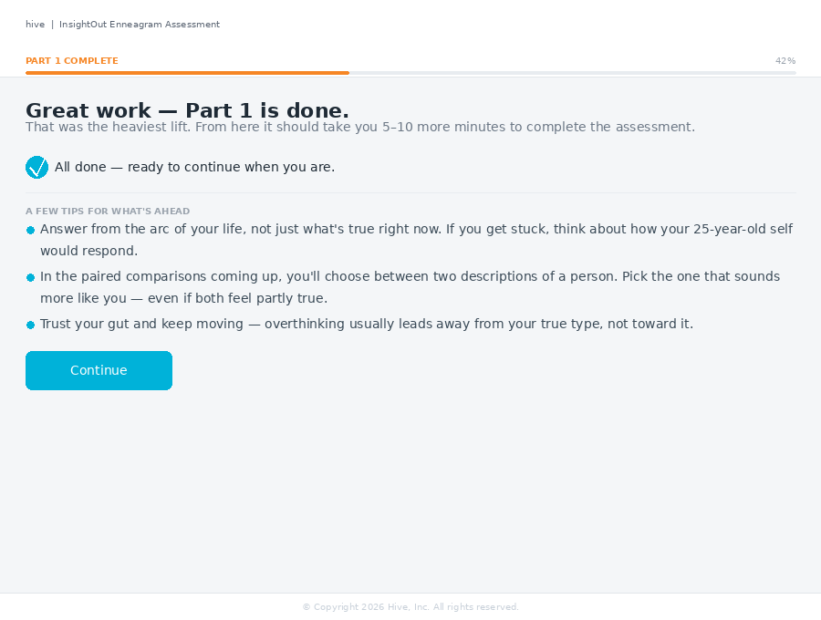 | 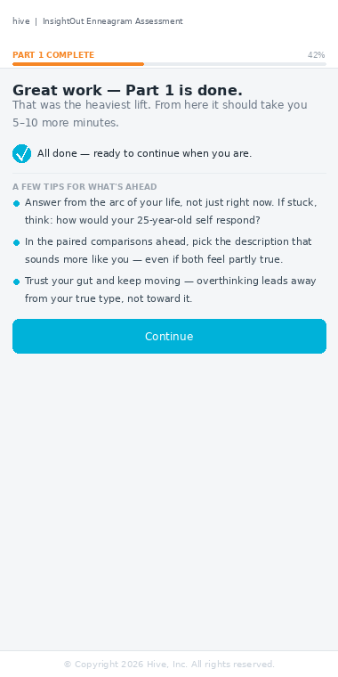
Desktop (left) · Mobile (right)

0D.6 Implementation notes for CC
This screen replaces the existing renderMidAssessmentReminders() function and screen_07. The existing screen should be removed from the flow and replaced with this two-state version.

Async state management: render State A immediately when the phase is entered. Fire the AI Call #1 request in parallel. When the response resolves, transition to State B: swap the spinner for the checkmark, update the status text, and unlock the Continue button. Do not navigate automatically — the client controls when to proceed.

If the AI call resolves before the client reaches this screen (e.g. fast connection): render State B directly, skipping State A entirely.

If the AI call errors: do not show an error state on this screen. Log the error silently and unlock Continue so the client can proceed. The engine has fallback logic for missing Call #1 output.
The "PART 1 COMPLETE" progress label uses Hive Orange (#F68625) instead of the usual Hive Blue. This is intentional and specific to this screen only. Do not apply the orange label treatment to any other progress bar.

0E · Thank You Screen (Assessment Complete)
Shown immediately after the client submits the final open response. This is the last screen of the assessment. No AI processing is surfaced here — the client is simply thanked and directed to their inbox.
This is a terminal screen. There is no Continue button, no navigation forward, and no progress chrome. The assessment is over. The only action available is closing the browser tab.

0E.1 Chrome
Topbar | Centered logo only — same pattern as the Welcome screen (Section 0). No divider, no product name, no Save link. This creates a deliberate bookend with the opening screen.
Progress bar | None. The assessment is complete.
Footer | Standard copyright footer.

0E.2 Content (top to bottom)
Checkmark badge | 56px desktop / 44px mobile circle. Gradient fill from #00B2D9 to #49B7DB. White checkmark SVG centered inside. Centered horizontally. Margin below: 24px desktop / 18px mobile.
Eyebrow | "ASSESSMENT COMPLETE" — 11px desktop / 10px mobile, weight 600, uppercase, letter-spacing 0.12em, Hive Blue #00B2D9.
Headline line 1 | "You did it." — weight 300, 34px desktop / 24px mobile, color #1E2A35.
Headline line 2 | "Thank you." — weight 600, same size, same color, displayed as a separate block. (Same typographic structure as the Welcome screen headline.)
Body copy (desktop) | "That took real honesty and self-reflection — and it shows. Your personalized Enneagram report is on its way and should arrive shortly. If you don't receive your report, please reach out to your coach."
Body copy (mobile) | "That took real honesty. Your personalized Enneagram report is on its way and should arrive shortly. If you don't receive it, please reach out to your coach."
Inbox card | White card, 0.5px #E2E6EA border, border-radius 10px. See 0E.3.

0E.3 Inbox card
Icon | 32px desktop / 26px mobile square, #EBF9FD background, border-radius 8px / 6px. Email envelope SVG in Hive Blue.
Title | "Check your inbox" — 13px desktop / 11px mobile, weight 600, color #1E2A35.
Sub-copy (desktop) | "Your report will arrive from info@hiveleadership.com. Your coach will reach out soon to schedule your debrief."
Sub-copy (mobile) | "Your report will arrive from info@hiveleadership.com. Your coach will reach out soon."
Spam note | "Can't find it? Check your spam or junk folder." — 11px desktop / 9.5px mobile, color #9AA3AD.

0E.4 Reference mockup
Thank you screen · No chrome · Desktop (left) and Mobile (right)
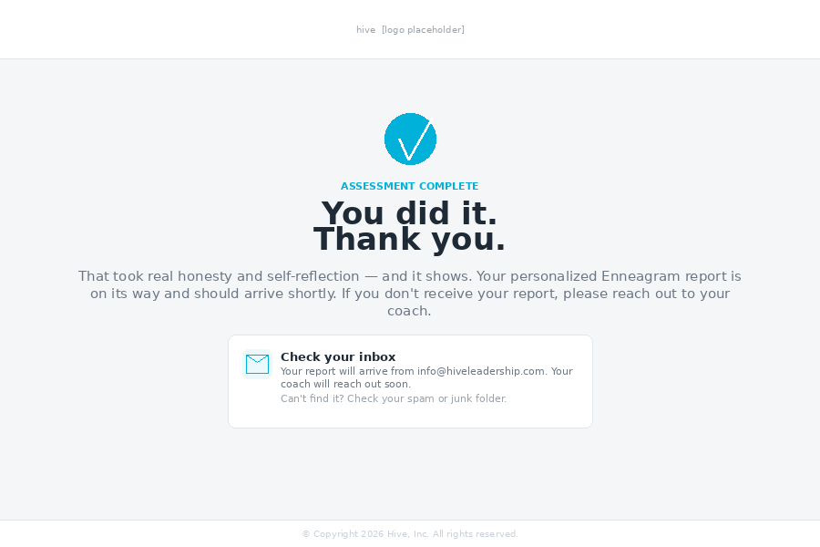 | 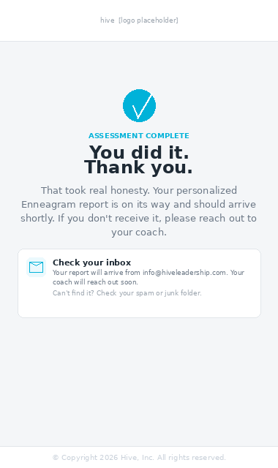
Desktop (left) · Mobile (right)

0E.5 Implementation notes for CC
NEW SCREEN — This screen does not currently exist in the codebase. It requires a new render function (e.g. renderThankYou()) and a new terminal phase constant. It fires immediately when the final open response is submitted — no async wait, no spinner.

Email address: info@hiveleadership.com. Render this verbatim in the inbox card.

No back navigation. Once the client reaches this screen, the assessment is complete. The phase should be marked complete in the DB on submit before navigating here.
The centered logo-only topbar on this screen mirrors the Welcome screen (Section 0). This is intentional — it creates a visual bookend. Do not add the product name divider or Save link to this topbar.

0F · Part 2 Complete Interstitial
Shown immediately after Stage 2 (Part 2) completes and before Stage 3 (Part 3) begins. Follows the same two-state spinner/ready pattern as Section 0D, but lighter in content — Part 2 is only 3 questions so there is no "heavy lift" acknowledgment. The primary job is to orient the client to paired comparisons, prime the final open question, and surface any server-side delay gracefully.
NEW SCREEN — This screen does not currently exist in the codebase. It requires a new render function (e.g. renderPart2Complete()) and a new phase constant, inserted between Stage 2 and Stage 3 in the assessment flow.

0F.1 Chrome
Topbar | Logo + divider + product name. No Save link in topbar.
Progress bar | Global progress bar only — no sub-progress strip. Label reads "PART 2 COMPLETE" in Hive Orange. Percentage: 68%.
Footer | Standard copyright footer.

0F.2 Two-state design
State | Trigger
A — Loading | Screen renders immediately on entering this phase
B — Ready | Server-side question selection resolves
Same async state pattern as Section 0D. If selection resolves before the client reaches this screen, render State B directly. If it errors, fail silently and unlock Continue.

0F.3 Progress map (part pills)
Warmup | Grayed out (#F0F2F4 bg, #E2E6EA border). Checkmark circle. Label "Done".
Part 1 | Grayed out. Same treatment.
Part 2 | Grayed out. Same treatment.
Parts 3 & 4 → | Highlighted (#EBF9FD bg, #00B2D9 border). Label "Up next". Sub-label "Paired comparisons". Parts 3 and 4 are combined into one pill since they run back-to-back.

0F.4 Content (stable across both states)
Headline | "Nearly there — three parts down." — weight 600, 22px desktop / 16px mobile, color #1E2A35.
Subhead | "Parts 3 and 4 are the final stretch. They're shorter and more focused — and end with one last open question." (desktop) / "Parts 3 and 4 are shorter and more focused — and end with one last open question." (mobile) — 14px desktop / 12px mobile, color #6B7785.
Primer box | Single white card (#fff, 0.5px #E2E6EA border, border-radius 10px). Two labeled sections separated by a 0.5px #F0F2F4 hairline. See 0F.5.
Status row | Spinner (State A) or checkmark (State B). See 0F.2.
Continue button | State A locked, State B unlocked. Full-width mobile, contained desktop.

0F.5 Primer box content (verbatim)
Section | Label
1 | "HOW PAIRED COMPARISONS WORK"
2 | "THE FINAL QUESTION"
Primer copy is Mo-approved. Render verbatim. Do not paraphrase beyond the mobile condensed versions above.

0F.6 Reference mockups
State A — Loading · Continue locked · Desktop (left) and Mobile (right)
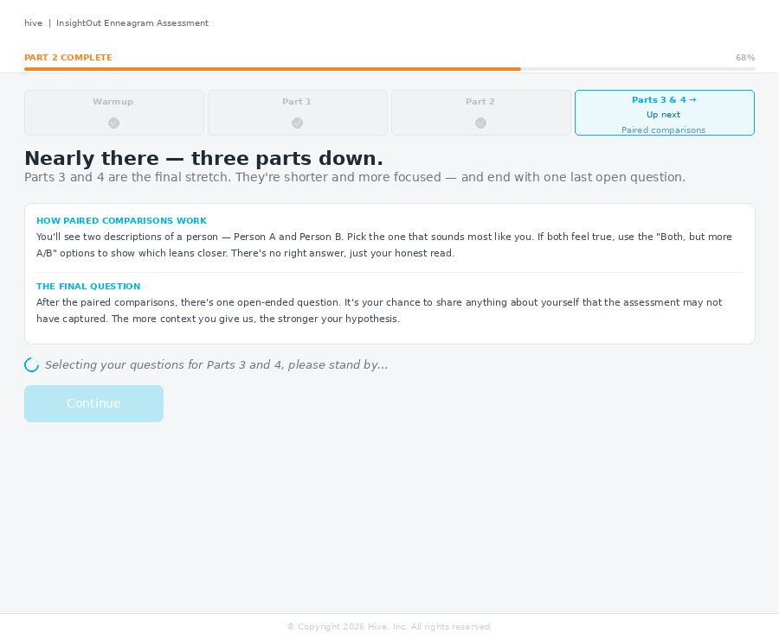 | 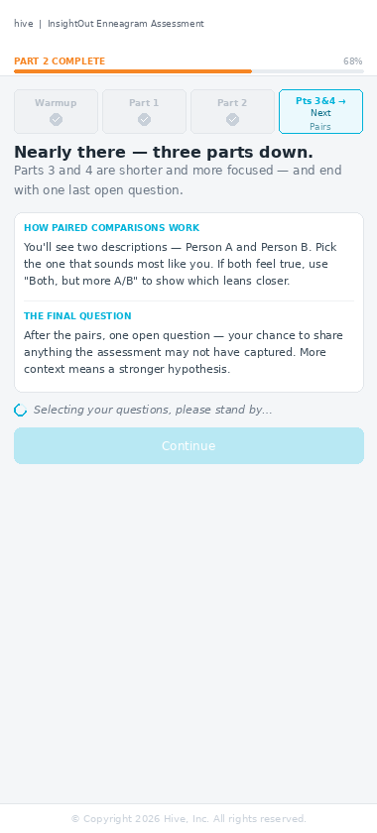
Desktop (left) · Mobile (right)
State B — Ready · Continue unlocked · Desktop (left) and Mobile (right)
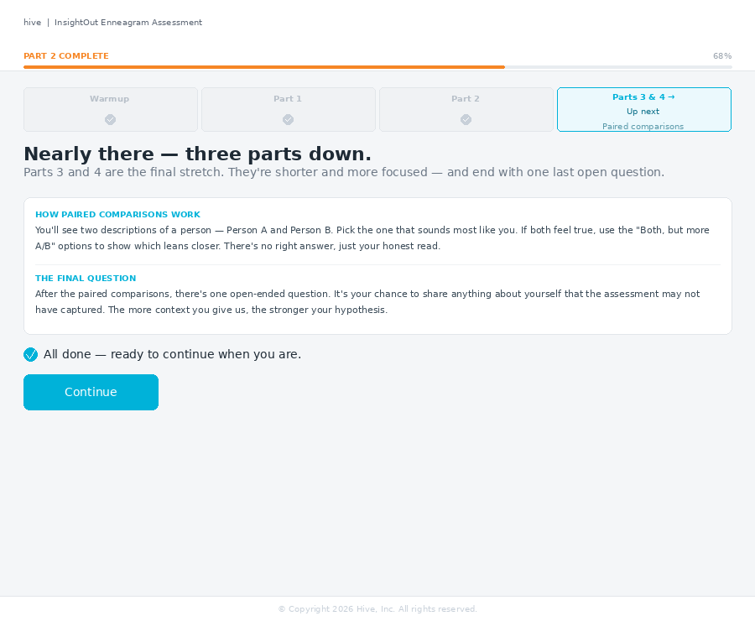 | 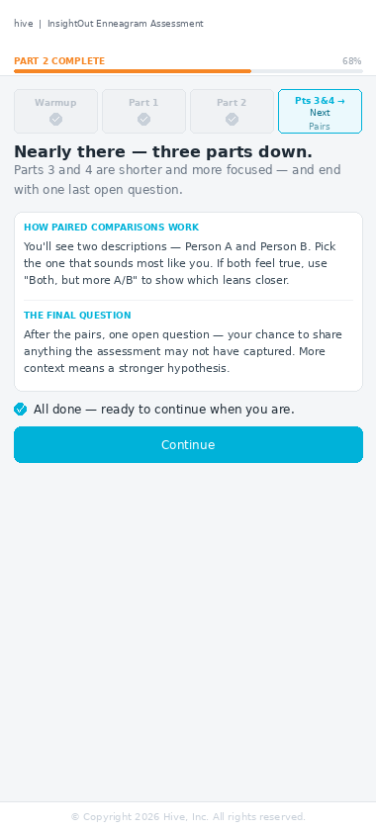
Desktop (left) · Mobile (right)

0F.7 Implementation notes for CC
This screen shares the same async state pattern as Section 0D (Part 1 Complete). The server-side operation here is question selection for Parts 3 and 4 — a deterministic lookup, not an AI call. It should be fast under normal conditions but may slow under load, hence the defensive spinner.

The "PART 2 COMPLETE" progress label uses Hive Orange (#F68625), consistent with Section 0D. Progress percentage is 68%.

Parts 3 and 4 are combined into a single highlighted pill ("Parts 3 & 4 →") since they run back-to-back without an interstitial between them. Do not split into two separate pills.

0G · Resume Screen
Shown when a returning client clicks their saved assessment link and has a session in progress. This screen replaces the generic welcome flow for mid-assessment returnees — they skip the Welcome, Intake Form, Profile Confirmation, and Orientation Interstitial entirely and land here instead.
NEW SCREEN — Does not currently exist in the codebase. Requires a new render function (e.g. renderResume()) triggered when a token resolves to a client with a non-terminal session_state. The token gate logic already exists (client_tokens table); this screen is the missing UI for that path.

0G.1 Chrome
Topbar | Logo + divider + product name. No Save link — there is nothing to save yet, the session is already saved.
Progress bar | None. This is a re-entry point, not a question screen.
Footer | Standard copyright footer.

0G.2 Content (top to bottom)
Heading | "Welcome back, [first name]." — 26px desktop / 19px mobile, weight 500, color #1E2A35. Uses client first name from record.
Subhead | "You've got a saved assessment in progress. Pick up right where you left off." — 14px desktop / 12px mobile, color #6B7785.
Progress card | White card, 0.5px #E2E6EA border, border-radius 10px desktop / 8px mobile. See 0G.3.
Continue button | "Continue where I left off" — Hive Blue, always unlocked. Full-width mobile, contained desktop (220px). No secondary action — no Start Over link.
No "Start over" option. Resetting a session would require clearing session_state, invalidating the token, and potentially creating a new client record. This is a coach-mediated action, not a self-serve one. If a client wants to restart, they contact their coach.

0G.3 Progress card
Eyebrow | "YOU LEFT OFF AT" — 9px desktop / 8px mobile, weight 600, uppercase, #9AA3AD.
Stage label | Current stage name — e.g. "Part 1 — Sliders". 14px desktop / 12px mobile, weight 600, #1E2A35. Derived from session_state.phase.
Screen label | Current screen within stage — e.g. "Screen 8 of 14". 12px desktop / 10px mobile, #6B7785.
Progress badge | Overall % complete — e.g. "42% complete" (desktop) / "42% done" (mobile). Orange treatment: #FFF3E8 bg, #F68625 border, #C45E00 text. Pill shape, top-right of card.
Segmented progress bar | Four segments, proportionally weighted. See 0G.4.
"You are here" line | Orange dot + plain-text label: "You are here — screen 8 of 14 in Part 1" (desktop) / "Screen 8 of 14 in Part 1" (mobile). 10px desktop / 8.5px mobile, #F68625.

0G.4 Segmented progress bar color scheme
Segment state | Color
Completed parts | #C8D0D9 (gray)
Current part (in progress) | Background: #FFE0BC (light orange) · Fill: #F68625 (Hive Orange)
Upcoming parts | #B8E8F3 (light blue)
Segment flex weights: Warmup = 1 · Part 1 = 3 · Part 2 = 1 · Parts 3 & 4 = 1.5. These reflect the relative screen counts of each part and should be hard-coded. The partial fill percentage within the current segment is computed from (screens_completed / total_screens_in_part).

0G.5 Reference mockup
Resume screen · Example state: Part 1, screen 8 of 14 (42%) · Desktop (left) and Mobile (right)
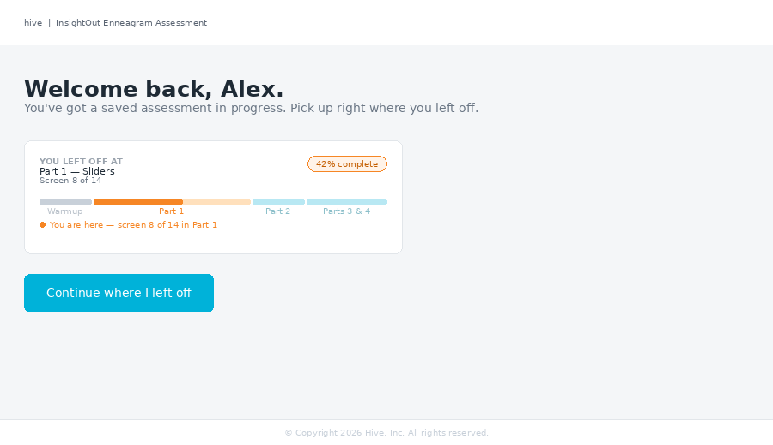 | 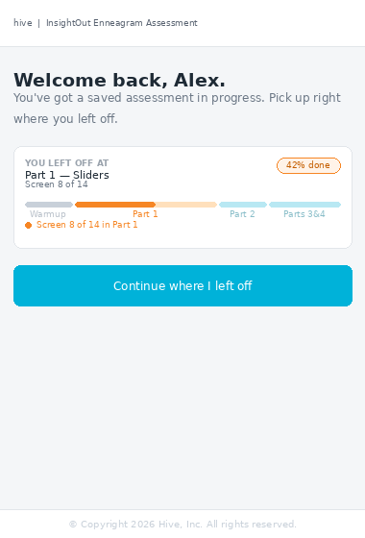
Desktop (left) · Mobile (right)

0G.6 Implementation notes for CC
Routing: when a token resolves to a client with session_state.phase not in ['welcome', 'intake', 'confirmation', 'results'], render this screen instead of starting from the beginning. Terminal phases (confirmation, results) should route directly to the Thank You screen or results view.

Dynamic values: the stage label, screen label, and progress percentage must be derived from session_state at render time. The segmented bar partial fill is computed as (screens_completed_in_current_part / total_screens_in_current_part). These values come from session_state, not from hard-coded example values.

The "Continue where I left off" button navigates directly to the screen within the assessment where the client left off. It does not replay any previous screens or interstitials.
The orientation interstitial (Section 0C) is NOT shown on resume. Per Section 0C.5: "This screen is shown only once per assessment session — on the initial run through." The resume flow goes directly from this screen into the assessment at the saved position.

1 · Scope and Target Viewports
This specification covers all client-facing screens of the Hive Typing Engine assessment UI. It does not cover engine logic, scoring, AI calls, or the admin/coach dashboards.

Target viewports
Viewport | Dimensions
Desktop | 1280 × 900 px
Mobile | 390 × 844 px (iPhone 14 standard)
Mobile breakpoint | ≤ 600 px — single-column layout, pole labels above track

Out of scope
- Engine scoring logic and AI call flow
- Stage 1 STATEMENT_KEYS order and scoring aggregation (see typing engine spec)
- Admin and coach dashboard screens
- Report generation and rendering

2 · Design Tokens
All colors, typography, and sizing reference the values below. Do not introduce new values without a design review.

Color palette
Token | Value / Usage
Hive Blue | #00B2D9 — progress bar active dots, selected states, links, stage labels
Hive Orange | #F68625 — progress bar fill, completed dots
Dark text | #1E2A35 — question text, headings
Body text | #2D3A45 — option card text, statement text
Muted text | #8A96A3 — labels, secondary text, progress %
Sub-progress bg | #F7FDFF — sub-progress strip background
Sub-progress border | #D8F3FA — sub-progress strip border
Sub-progress text | #5A9AAA — "Screen N of N" label
Selected card bg | #EBF9FD — option/pair card selected background
Selected card text | #0A6E88 — option card selected text
Continue locked | #B8E8F3 — Continue button when gate not met (no pointer-events)
Continue unlocked | #00B2D9 — Continue button when gate met
Footer text | #C8D0D9 — copyright line
Border default | #E2E6EA — card borders, dividers

Typography
Element | Spec
Question text | Arial, 18–22px, weight 500, color #1E2A35
Option / statement text | Arial, 14–15px, weight 400, color #2D3A45
Labels (stage, sub-progress) | Arial, 10–11px, weight 500, uppercase, letter-spacing 0.07em
Footer | Arial, 9–10px, weight 400, color #C8D0D9

Logo
Use the HIVE_LOGO_SVG const defined at app/renderer.js line 1580. This is the single canonical source. Never inline a second copy or approximate the logo. viewBox: 0 0 420.551 132.143. Size via CSS height only (preserve aspect ratio). Desktop header: height 28px. Mobile header: height 20px.
CRITICAL: The SVG uses clipPath ids clip-0…clip-5. When inlining more than one copy on a page, namespace the ids per instance (e.g. hivelogo-a-clip-0) to prevent collisions.

3 · Chrome System
Every assessment screen (except interstitials) shares the same chrome structure. The chrome is fixed — it does not scroll with content.

3.1 Desktop chrome structure (top to bottom)
Layer | Spec
Topbar | height 52px, white bg, 0.5px #E2E6EA bottom border. Left: HIVE_LOGO_SVG + 1px divider + product name. Right: "Save and continue later" ghost button.
Global progress bar | white bg, 0.5px border below. Stage label (left, Hive Blue uppercase) + % complete (right, muted). 3px orange fill bar.
Sub-progress strip | #F7FDFF bg, 0.5px #D8F3FA border below. "Screen N of N" label left. Dot trail right. Only shown during active stages (not on interstitials).
Content area | Scrollable. #F4F6F8 bg. 28px horizontal padding.
Footer | white bg, 0.5px border above. "© Copyright 2026 Hive, Inc. All rights reserved." centered, #C8D0D9, 9px.

3.2 Mobile chrome structure
Layer | Spec
Brand header | Stacked center-aligned: HIVE_LOGO_SVG (20px) + product name (8px uppercase muted). Collapses on scroll (see 3.3).
Global progress bar | Same as desktop, smaller text. Stage label + %. 2px bar.
Save button | "Save and continue later" full-width ghost button below progress bar. Collapses on scroll with brand header.
Sub-progress strip | Same as desktop. DOES NOT collapse — always visible.
Content area | Scrolls beneath fixed chrome. 14px horizontal padding.
Footer | Fixed at bottom. Same as desktop, 6.5px text.

3.3 Mobile collapse behavior
Trigger: user scrolls down > 20px.
- Brand header (logo + product name) collapses: max-height 0, opacity 0, padding 0. Transition: 0.3s ease.
- Save button row collapses simultaneously with brand header.
- Sub-progress strip remains pinned — never collapses.
- Re-expand: user scrolls back to top (scrollTop ≤ 4px). Full header and save button restore.
Implementation note: Account for iOS safe-area-inset-bottom on the footer so it clears the home indicator bar on notched devices. Use env(safe-area-inset-bottom) in CSS padding.

3.4 Stage labels (global progress bar)
Stage | Global bar label
Stage 0 | Warmup
Stage 1 (type + instinct sliders) | Part 1
Stage 2 (framework questions) | Part 2
Stage 3 (pairwise) | Part 3
Stage 4 (stress / security / habit) + final open | Part 4

4 · Stage and Screen Inventory
The sub-progress strip dot count is set dynamically per stage. Fixed counts are shown below; dynamic counts depend on runtime routing.

Stage | Part label
Stage | Part label | Screens | Dots | Notes
Stage 0 — Warmup | Warmup | 4 | 4 (fixed) | Q1–Q4 open text
Stage 1 — Type sliders | Part 1 | 9 | 14 (fixed) | 5 stmts/screen, 9 type screens
Stage 1 — Type open response | Part 1 | 1 | 14 (fixed) | Screen 10 of 14
Stage 1 — Instinct sliders | Part 1 | 3 | 14 (fixed) | SP / SO / SX, screens 11–13
Stage 1 — Instinct open response | Part 1 | 1 | 14 (fixed) | Screen 14 of 14
Stage 2 | Part 2 | 3 | 3 (fixed) | Hornevian / Harmonic / Centers
Stage 3 | Part 3 | 1 or 2 | 1 or 2 (dynamic) | Q2 fires on gap=tight pairs — set dot count after routing resolves
Stage 4 | Part 4 | 2 or 3 | 2 or 3 (dynamic) | Habit of Mind conditional — set dot count after sequence is built
Final open response | Part 4 | 1 | Shares Stage 4 count | Last screen of Part 4 dot trail
The Stage 1 screen order follows the Narrative pairing sequence: [3,6] [9,1] [4,2] [8,5] [7]. Type 7 is alone on screen 5. No type or instinct labels are visible to the client — those are beta-only elements hidden in production CSS.

4.2 Full screen inventory
One row per screen (or screen group). Status column: New = does not exist, must be built; Modified = exists, needs changes; Replaces = net replacement of an existing screen; Existing = present, apply new chrome only; Retire = delete.
Screen name | Spec § | Phase | Chrome | Status
Welcome screen | § 0 | welcome | Centered logo · no progress · no save | Modified — add report carrot
Profile confirmation | § 0A | profile-confirm | Full topbar · no progress | New — renderProfileConfirm()
Intake form | § 0B | intake | Full topbar · no progress | Modified — save moves to nav row
Orientation interstitial | § 0C | orientation | Full topbar · no progress | New — renderOrientationInterstitial()
Resume screen | § 0G | (token routing) | Full topbar · no progress | New — renderResume()
Part 1 complete (State A/B) | § 0D | part1-complete | Full topbar · global bar · orange label | Replaces screen_07
Part 2 complete (State A/B) | § 0F | part2-complete | Full topbar · global bar · orange label | New — renderPart2Complete()
Warmup Q1–Q4 (open text) | § 6.1 | stage0 | Full chrome | Modified — skip removed
Type sliders × 9 screens | § 6.2 | stage1 | Full chrome | Modified — 5 sliders, no eyebrow
Type open response | § 6.2 | stage1 | Full chrome | Modified — skip removed
Instinct sliders × 3 screens | § 6.2 | stage1 | Full chrome | Modified — 5 sliders/screen
Instinct open response | § 6.2 | stage1 | Full chrome | Modified — skip removed
Framework Q1–Q3 | § 6.3 | stage2 | Full chrome | Existing — new chrome only
Pairwise 1–2 screens (dynamic) | § 6.4 | stage3 | Full chrome | Existing — new chrome only
Pairwise 2–3 screens (dynamic) | § 6.5 | stage4 | Full chrome | Existing — new chrome only
Final open response | § 6.5 | finalopen | Full chrome | Modified — skip removed, required
Thank you screen | § 0E | confirmation | Centered logo · no progress | New — renderThankYou()
Expired link | § 10.2 | (pre-auth) | Centered logo · no progress | New — renderExpiredToken()
Invalid link | § 10.3 | (pre-auth) | Centered logo · no progress | New — renderInvalidToken()
Mid-assessment reminders (screen_07) | § 7 | mid-assessment-reminders | n/a — retiring | Retire — replaced by § 0D
Stage 1 complete debug screen | § 7 | stage1complete | n/a — retiring | Retire — dead code

5 · Continue Button Specification
The Continue button is disabled (locked state) until its gate condition is satisfied. This applies to every screen type without exception.

Visual states
State | Background
Locked | #B8E8F3 (light blue)
Unlocked | #00B2D9 (Hive Blue)

Gate conditions by screen type
Screen type | Gate condition
Open text (Stage 0, open responses) | textarea.value.trim().length > 0 — at least one non-whitespace character
Single-select (Stage 2) | One option has been selected
Pairwise (Stage 3, Stage 4) | One card (Person A, Person B, Both A, Both B) has been selected
Sliders (Stage 1) | All N sliders on the current screen have been touched (grabbed at least once). An untouched midpoint-50 does NOT satisfy the gate.
Final open response | textarea.value.trim().length > 0 — same as open text

The final open response screen uses Continue as the submit button (no separate Submit button). Skip button has been removed — all open-ended questions are required. Mo to confirm this applies to the final open response before shipping.

Transition
When the gate condition is first met, transition the button: background #B8E8F3 → #00B2D9. No animation required — a clean instant swap is fine. Re-lock if the condition becomes unmet (e.g. user clears a textarea).

6 · Screen-by-Screen Specifications with Reference Mockups
Each section below covers one screen type with its gate condition, nav row, and reference mockups. Desktop is shown left, mobile right in each pair.

6.1 Warmup — Stage 0 (Open Text)
Stage 0 · Q2 of 4 · Filled state (Continue unlocked)
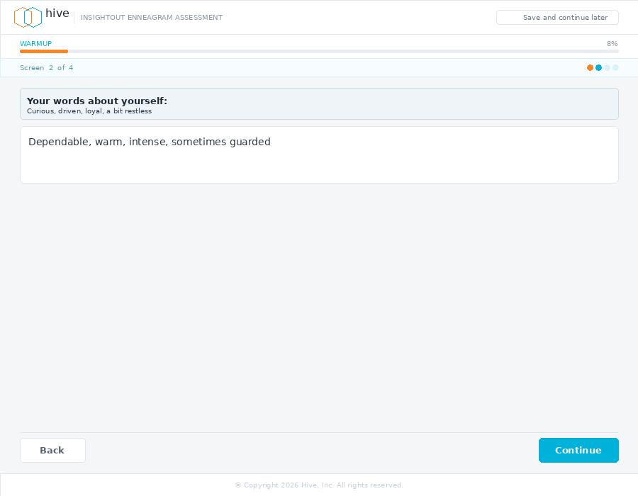 | 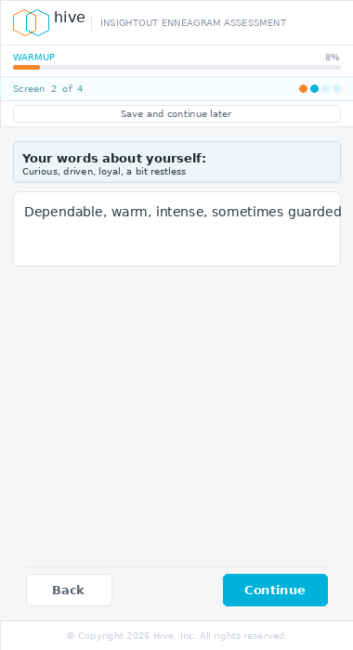
Desktop (left) · Mobile (right)
Gate condition | textarea.value.trim().length > 0
Nav row — Q1 (first screen) | Continue only (no Back button)
Nav row — Q2–Q4 | Back + Continue
Q3 and Q4 | Show reference box above textarea echoing Q1 and Q2 answers
Textarea placeholder | "Type your response here..." in #B8C0C9 italic
Continue state | Locked on load, unlocks on first non-whitespace keystroke

6.2 Part 1 — Stage 1 (Sliders)
Stage 1 · Screen 4 of 14 · Locked state (0 of 5 answered)
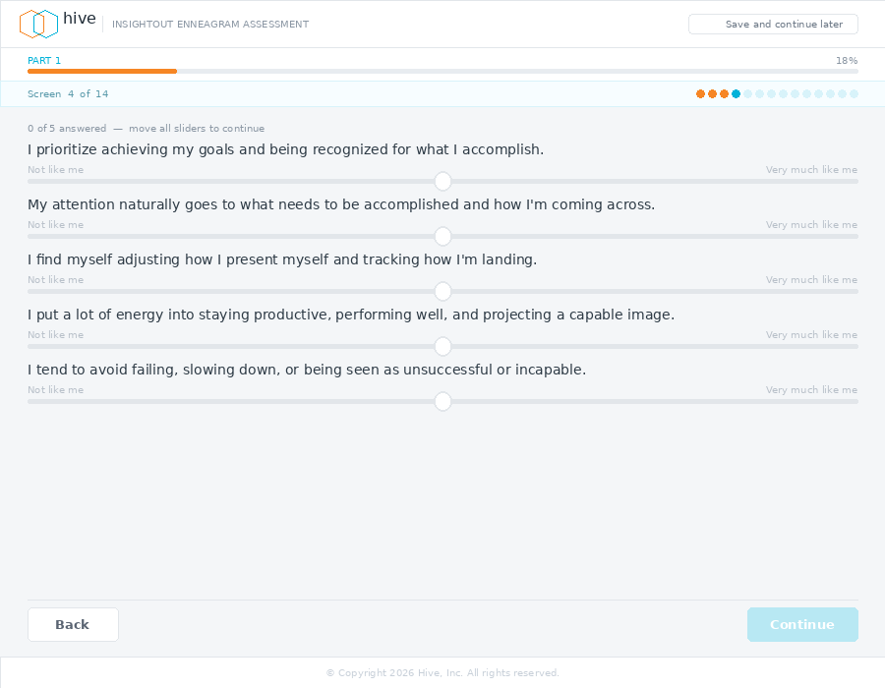 | 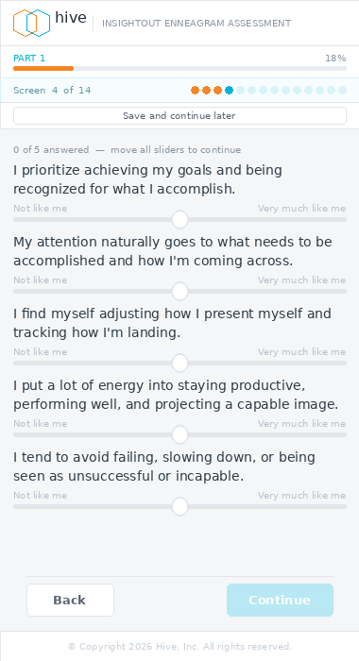
Desktop (left) · Mobile (right)
Screens | 9 type screens (5 sliders each) + 1 type open response + 3 instinct screens + 1 instinct open response = 14 total
Sliders per screen | 5 — this is a change from the current 10-per-screen layout
assessment.js change | STAGE1_TYPE_SCREEN_ORDER must be updated from 5 paired screens to 9 individual screens. Scoring is order-independent — no scoring logic changes required.
Answered counter | "N of 5 answered — move all sliders to continue" while N < 5. Drops hint text when N = 5.
Slider initial state | Bar handle (3px wide, 26px tall) at 50%. No color. Transforms to circle on first touch per the slider component spec.
Gate condition | All 5 sliders grabbed at least once (grabbed[i] === true for all i). Untouched midpoint does not count.
Progress bar | Nudges slightly as sliders are answered — gives momentum feedback.
Eyebrow label | Removed. Question text is sufficient orientation.
Type/instinct labels | Hidden in production CSS (.type-hdr { display:none }). Beta-only diagnostic elements remain in DOM.
Open response screens | Same gate as Stage 0 open text (trim().length > 0). No slider counter shown.
STATEMENT_KEYS order critical check: confirm the statement key order in the rendering code exactly matches STAGE1_TYPE_STATEMENTS and STAGE1_INSTINCT_STATEMENTS before any scoring aggregation. A mismatch silently corrupts type scores.

6.3 Part 2 — Stage 2 (Single-Select)
Stage 2 · Q2 of 3 · Selected state (Continue unlocked)
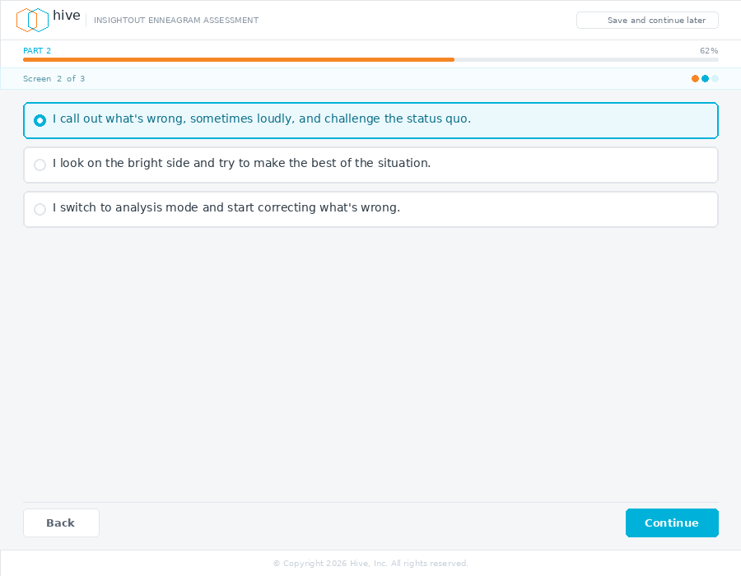 | 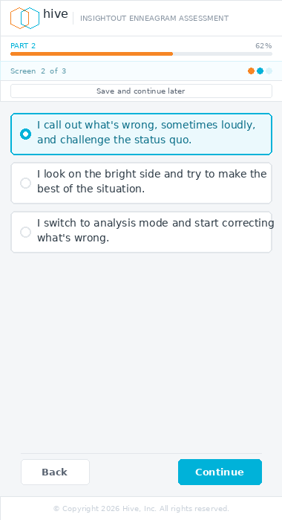
Desktop (left) · Mobile (right)
Gate condition | One option card selected
Option card — default | White bg, 1.5px #E2E6EA border, border-radius 9px
Option card — selected | #EBF9FD bg, 1.5px #00B2D9 border. Text color #0A6E88, weight 500.
Radio indicator | 14px circle. Default: white fill, #C8D0D9 border. Selected: #00B2D9 fill with 5px white inner dot.
Screens | 3 — Q1 Hornevian, Q2 Harmonic, Q3 Centers (ranking component — see note)
Q3 Centers | Ranking component (1st / 2nd / 3rd buttons per item) — distinct from single-select. Gate: all three items ranked. Continue unlocks when no item remains NOT YET RANKED.

6.4 Part 3 — Stage 3 (Pairwise)
Stage 3 · Q1 of 1 or 2 · Locked state (no selection)
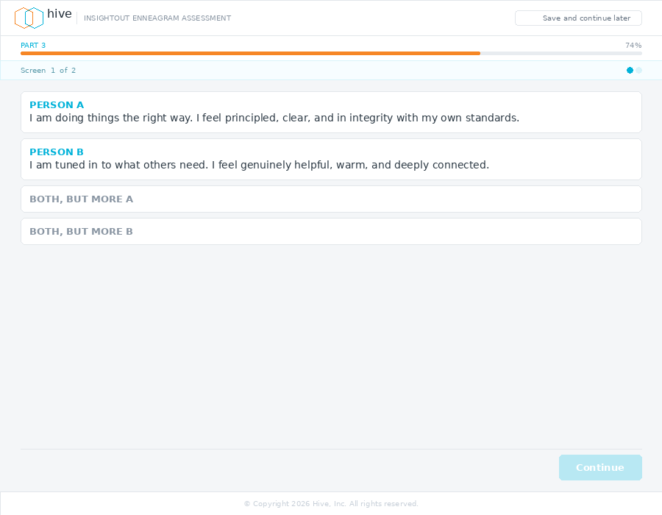 | 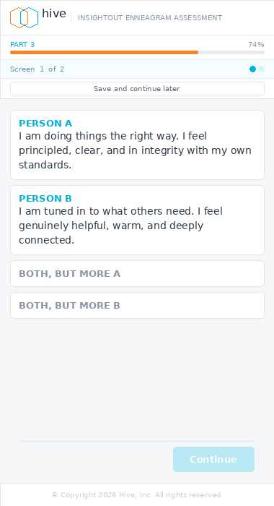
Desktop (left) · Mobile (right)
Gate condition | One of the four cards selected (Person A, Person B, Both but more A, Both but more B)
Screen count | Dynamic: 1 screen (Q1 only) or 2 screens (Q1 + Q2). Q2 fires on gap=tight for 10 high-ambiguity pairs. Set dot count after routing resolves — not at stage entry.
Person A / B cards | Full paragraph content. Label in Hive Blue uppercase, body text below.
Both but more A/B cards | Label only (no body text). Label color #8A96A3 (muted) when unselected, #00B2D9 when selected.
Selected card | #EBF9FD bg, 1.5px #00B2D9 border. Label color #0A6E88.
CT mode | Counter-type comparative uses same 4-card layout. Q2 never fires in CT mode.

6.5 Part 4 — Stage 4 (Pairwise) and Final Open Response
Stage 4 · Screen 1 of 2 or 3 · Unlocked state (selection made)
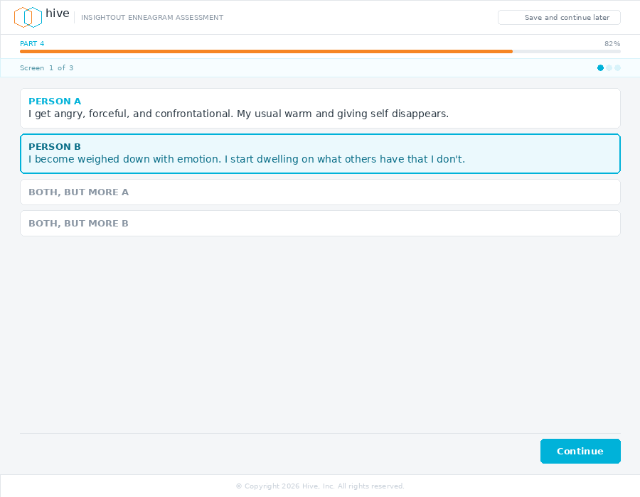 | 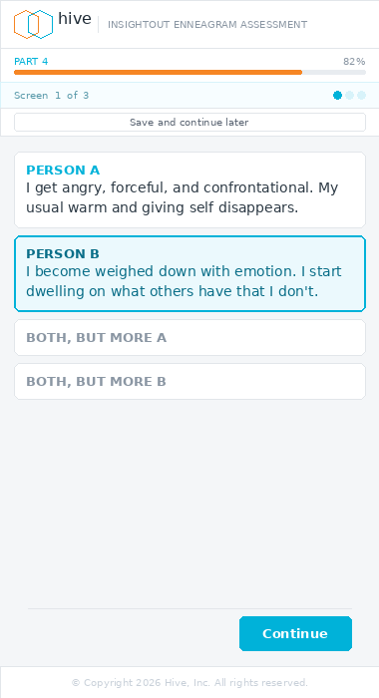
Desktop (left) · Mobile (right)
Gate condition | One of the four cards selected (same as Stage 3)
Screen count | Dynamic: 2 screens (Stress + Security) or 3 screens (+ Habit of Mind). Habit fires conditionally. Set dot count after Stage 4 sequence is built.
Instruments | Stress, Security, and conditional Habit of Mind. Each uses pairwise B format (head-to-head lead vs. second candidate).
Layout | Identical to Stage 3 pairwise layout.

Final Open Response · Last screen of Part 4 · Locked state (empty)
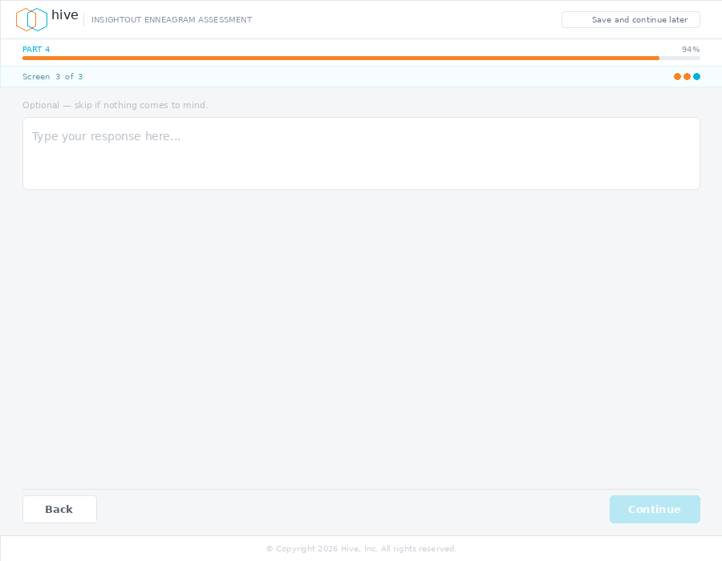 | 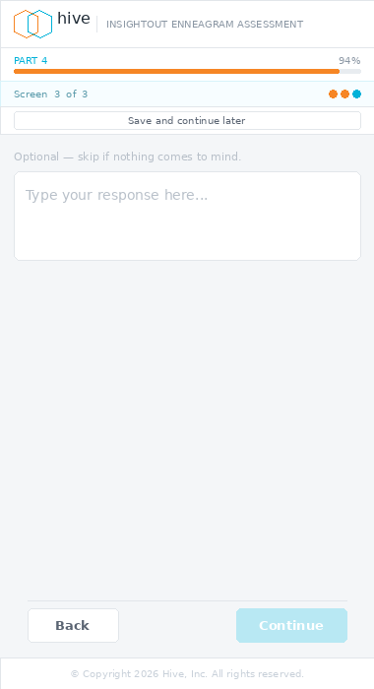
Desktop (left) · Mobile (right)
Gate condition | textarea.value.trim().length > 0
Button label | Continue (not Submit — keeps button label consistent across all screens)
Skip button | Removed — this question is required. Pending Mo confirmation.
Position in dot trail | This is the last dot in the Part 4 sequence (e.g. Screen 3 of 3). Seeing the dot trail fully filled is intentional — it signals completion of the assessment.
Textarea placeholder | "Type your response here..." in #B8C0C9 italic

7 · Removed Elements
The following elements exist in the current codebase and must be removed or disabled before alpha.

Element | Action required
Skip buttons (Stage 0 Q1, final open response) | Remove from renderStage0(), renderFinalOpen(). All open-ended questions are now required.
stage1complete debug screen | Delete the renderStage1Complete() function and all references. It displays false information ("Stages 2, 3, and 4 are under construction") and throws under real v2 scores. Dead code.
Eyebrow label on slider screens | Remove the section eyebrow ("Your motivations and worldview") above the slider screen question. Question text is sufficient.
10-slider layout | Replace with 5-slider layout (see Section 6.2). Update STAGE1_TYPE_SCREEN_ORDER in assessment.js.
Progress bar denominator | Recalibrate the 23-question progress bar (ui.js) to reflect the new screen count. The type block now has 9 screens instead of 5, adding 4 screens. New total: ~27 screens across the full assessment (exact count depends on Stage 3/4 dynamic routing).

8 · Implementation Notes for CC
Read this section in full before writing any code.

- All work branches from main. Never push directly to main. Run tests with absolute paths using sp4 and sx7 fixtures after each change.
- Read assessment.js and app.js in full before writing any rendering code. The chrome system touches render(), not the per-screen renderX() functions — understand both before modifying either.
- The Save and Continue Later button is injected by render() (assessment.js:1449–1467), gated on SAVE_LATER_PHASES.has(state.phase) AND state.intake.token. Screenshots showed it missing because the token gate was not set in the harness — not a bug. Preserve this gating logic.
- HIVE_LOGO_SVG at renderer.js:1580 is the single source. Import or reference it — never inline a copy. Namespace clipPath ids if multiple instances appear on one page.
- STATEMENT_KEYS order is a critical check (see Section 6.2). Confirm key order matches STAGE1_TYPE_STATEMENTS and STAGE1_INSTINCT_STATEMENTS before any scoring aggregation.
- Stage 3 and Stage 4 dot counts are dynamic. Do not hardcode them. Read the resolved screen count from state after routing completes, then build the dot trail.
- safe-area-inset-bottom: add env(safe-area-inset-bottom) to the mobile footer padding so it clears the iOS home indicator.
- Mo must confirm: (1) all open-ended questions required (Skip removed), (2) final open response required before submit. Do not ship these changes until Mo confirms.

9 · Assessment Timing Feature
This feature captures how long each client took to complete the assessment — from the first Stage 0 answer to the final Submit — and surfaces it in the admin dashboard via a clock icon and modal. Scoped as its own PR.
NEW FEATURE — No timing data is currently captured or stored. This section covers the full implementation: DB schema changes, server-side capture logic, and admin UI. CC should treat this as a standalone PR separate from the assessment UI redesign work.

9.1 Database schema changes
Add four new columns to the assessments table. Read db.js SCHEMA_SQL before writing any migration — follow the existing column pattern exactly.
Column | Type
assessment_started_at | TIMESTAMPTZ
assessment_completed_at | TIMESTAMPTZ
elapsed_seconds | INTEGER
session_days | INTEGER
Wall-clock time is intentional. It includes any idle time between screens, which is meaningful signal — a client who pauses mid-assessment tells a different story than one who blazes through in 12 minutes. Active-time tracking can be added in a future iteration if needed.

9.2 Server-side capture logic
Event | Location
Stage 0 Q1 first answer | assessment.js — Stage 0 answer handler
Final open response Submit | assessment.js — finalopen submit handler (phase → processing transition)
Both writes go to the assessments table via the existing DB update pattern in db.js. Do not add new query functions — extend the existing updateAssessment() or equivalent pattern. Confirm the exact function name by reading db.js before writing any code.

9.3 Admin dashboard UI changes
9.3.1 Clock icon in the date column
Property | Spec
Position | Inline-left of the date text in the DATE column. Sits flush against the date string with a 5px gap.
Icon | Tabler outline ti-clock, 14px, Hive Blue #00B2D9, opacity 0.75. Hover: opacity 1.0.
Visibility | Only render the icon when the row status is Complete AND elapsed_seconds IS NOT NULL. Do not show the icon on in-progress, error, or incomplete rows.
Interaction | Click opens the timing modal (see 9.3.2). The icon is a <button> element with title="View completion time" for accessibility.

9.3.2 Timing modal
Element | Spec
Trigger | Click on clock icon. Opens as a centered fixed-position overlay modal.
Header | ti-clock icon (Hive Blue, 18px) + "Completion time" label. Close button (ti-x) top-right.
Body copy — single day | "[Full name] completed their assessment in a single sitting."
Body copy — multi-day | "[Full name] saved their progress and returned to complete the assessment."
Stat cards | Two metric cards side by side: (1) Duration — Math.round(elapsed_seconds / 60) minutes. Unit label "min". Minimum display: 1 min. (2) Days — session_days value. Unit label "day" (singular) or "days" (plural).
Footer line | Muted 12px text showing raw timestamps. Same-day: times only (e.g. "Started 10:04 AM · Completed 10:22 AM"). Multi-day: full date + time for both (e.g. "Started Jun 7, 2026 at 2:14 PM · Completed Jun 8, 9:19 AM").
Dismiss | Close button click, outside-overlay click, or Escape key.

9.4 Suggested admin queries
Purpose | SQL
Average completion time | SELECT ROUND(AVG(elapsed_seconds) / 60.0, 1) AS avg_minutes FROM assessments WHERE elapsed_seconds IS NOT NULL;
Single vs multi-day breakdown | SELECT session_days, COUNT(*) FROM assessments WHERE session_days IS NOT NULL GROUP BY session_days ORDER BY session_days;
Fastest and slowest completions | SELECT c.first_name, c.last_name, a.elapsed_seconds / 60 AS minutes, a.session_days FROM assessments a JOIN clients c ON a.client_id = c.id WHERE a.elapsed_seconds IS NOT NULL ORDER BY a.elapsed_seconds;

9.5 Implementation notes for CC
Branch name: feature/assessment-timing. Standalone PR — do not mix with the assessment UI redesign work.

Schema: add four nullable columns to assessments with no default. Read db.js SCHEMA_SQL before writing. Do not alter any existing columns.

Start time guard: before writing assessment_started_at, check if it is already set. If set, skip the write. A resume must never overwrite the original start time.

Elapsed seconds to minutes: use Math.round(elapsed_seconds / 60) — not Math.floor. 65 seconds = 1 min, not 0 min.

Test: add fixture coverage verifying (1) assessment_started_at sets on Stage 0 Q1, (2) not overwritten on resume, (3) elapsed_seconds and session_days correctly computed on completion.
The admin modal should use position:fixed in implementation (unlike the spec mockup which uses a faux viewport for rendering). Standard fixed overlay, z-index above the admin table. Dismiss on Escape key and outside click.

10 · Error States
Two error screens handle invalid or expired assessment tokens. Both use the centered-logo-only topbar — no progress chrome, no navigation forward. Both are terminal screens with a single instruction: contact your coach.
NEW SCREENS — Neither exists in the codebase. Both are rendered by the token validation middleware before the assessment flow begins. Routing logic: (1) token not found in client_tokens → render Invalid Link screen. (2) token found but expires_at < NOW() → render Expired Link screen. (3) token valid → proceed to Resume or welcome flow as normal.

10.1 Shared chrome and structure
Element | Spec
Topbar | Centered logo only — same pattern as Welcome (§ 0) and Thank You (§ 0E). No divider, no product name, no save link.
Progress bar | None.
Footer | Standard copyright footer.
No CTA button | No forward navigation. No retry button. The only action is closing the tab or contacting the coach.
Icon circle | 56px desktop / 44px mobile. See per-screen specs.
Coach card | White card, 0.5px #E2E6EA border, border-radius 10px / 8px. Person silhouette icon (#9AA3AD). Title: "Reach out to your coach". Sub-copy varies — see below.

10.2 Expired link screen
Element | Spec
Trigger | Token found in client_tokens but expires_at < NOW().
Icon | 56px circle, #FFF3E8 bg, #F68625 border 1.5px. Clock SVG in #F68625.
Eyebrow | "LINK EXPIRED" — uppercase, weight 600, #F68625.
Headline | "This link is no longer active." — 26px desktop / 19px mobile, weight 500, #1E2A35.
Body (desktop) | "Assessment links are valid for 30 days. Yours has expired, but your progress is safe — your coach can send you a fresh link to pick up where you left off."
Body (mobile) | "Your link has expired, but your progress is safe. Ask your coach to send a fresh link."
Coach card sub-copy | "Ask them to resend your assessment link. Your saved responses will still be there."
"Your progress is safe" is deliberate. Session state is preserved server-side. A client who completed Stage 1 before their link expired must know that work is not lost.

10.3 Invalid link screen
Element | Spec
Trigger | Token not found in client_tokens table.
Icon | 56px circle, #F4F6F8 bg, #D0D6DE border 1.5px. Broken link X SVG in #9AA3AD.
Eyebrow | "LINK NOT RECOGNIZED" — uppercase, weight 600, #9AA3AD.
Headline | "We couldn't find that link." — 26px desktop / 19px mobile, weight 500, #1E2A35.
Body (desktop) | "This link doesn't match any assessment in our system. It may have been copied incorrectly. Your coach can send you the correct link."
Body (mobile) | "This link doesn't match any assessment in our system. Your coach can send you the correct one."
Coach card sub-copy | "Ask them to resend your link directly from the Hive admin dashboard."
Do not attempt to identify the client on this screen. The token is invalid — no record to draw from. No name, coach name, or personalised content.

10.4 Reference mockups
Expired link · Desktop (left) and Mobile (right)
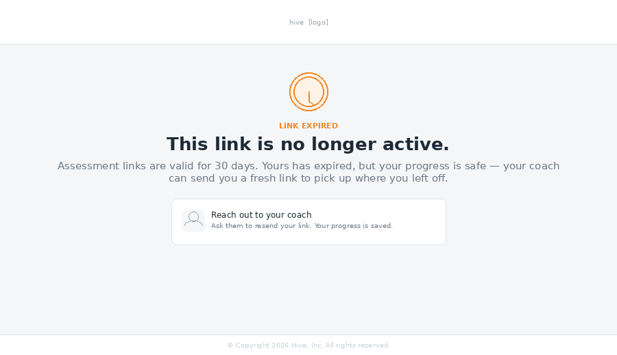 | 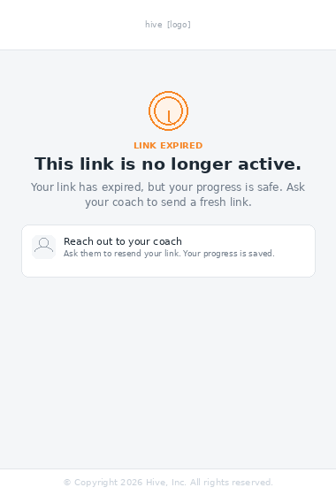
Desktop (left) · Mobile (right)
Invalid link · Desktop (left) and Mobile (right)
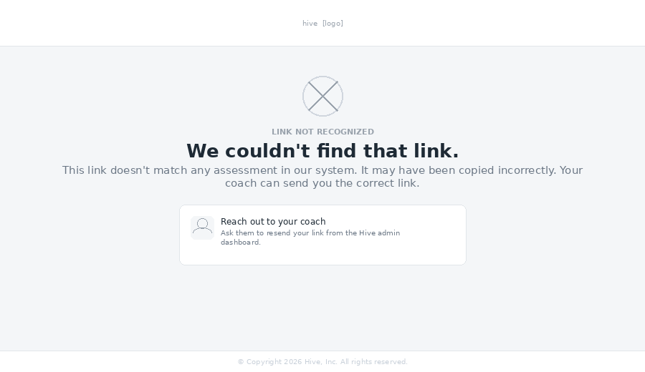 | 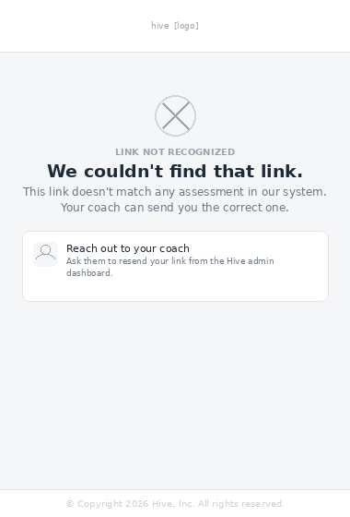
Desktop (left) · Mobile (right)

10.5 Implementation notes for CC
Add renderExpiredToken() and renderInvalidToken() functions. Both require no state beyond the token string. Render before any session state is loaded.

The expired screen may optionally personalise: "Reach out to [coach first name]" if the token resolves to a record. Optional for alpha — generic copy is sufficient.

No retry button or token re-entry on either screen. The fix path is always "contact your coach." A retry mechanism creates false hope and unnecessary complexity.
No extra logging of invalid token attempts beyond what already exists. Do not add noise to error logs for typos or stale bookmarks.

© 2026 Hive, Inc. · CONFIDENTIAL · For internal use only

