ITEC 4200 Advanced Databases Semester Project

Student Name: **Christan de Luna**

Semester: **Fall 2017**

Name of Project: **ITEC 4200 Semester Project**

Email: [**cdeluna@ggc.edu**](mailto:cdeluna@ggc.edu)

Phone Number: **(770) 910-2701**

PART I: EXECUTIVE SUMMARY

**Objective**

This database is designed to help **Art Galleries** track various art museums, pieces of art, and artists.

**Goals**

The goal of this project is to provide a simple and organized way to store and retrieve pieces of art and their artists from every famous museum around the world. This project will outline a series of components, including design, implementation, queries, and reports, all of which will provide an easy-to-use interface to search by archivists, curators, and other museum workers.

**Solution**

The solution to this project is the creation of multiple database tables including various relationships between said tables. They are ***Museum***, ***Artwork***, ***Artist***, ***Museum-Artist***,and ***Artwork-Artist***. These tables represent main entities, which contain links that define the relationships between entities. From here, we can create queries and reports that will provide relevant information useful to the art museums. This database will be implemented in *Oracle 11g Express*.

**Benefits to Users**

This database serves as a valuable tool for providing information in a convenient and reliable manner, which will help streamline operations and make art organization quick and easy.

**Project Outline**

This project will contain the following:

* Schema designs
* Entity-relationship diagrams
* Table implementation
* Queries
* Reports

PART II: SCHEMA AND ER DIAGRAMS

**MUSEUM** (MuseumID, MuseumName, Fee, PhoneNumber, City, Country, FoundedDate)

**ARTWORK** (ArtworkID, ArtworkName, ArtistName, Medium, Year, MuseumID)

FK MuseumID -> MUSEUM

**ARTIST** (ArtistID, ArtistName, Origin, DateOfBirth, Movement)

**MUSEUM-ARTIST** (MuseumID, ArtistID)

FK MuseumID 🡪 MUSEUM

FK ArtistID 🡪 ARTIST

**ARTWORK-ARTIST** (ArtworkID, ArtistID)

FK ArtworkID 🡪 ARTWORK

FK ArtistID 🡪 ARTIST

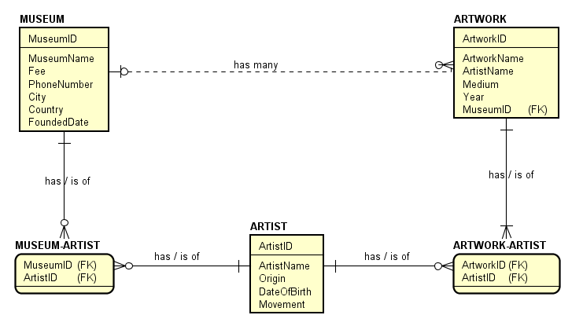

PART III: TABLE IMPLEMENTATION

-- DROP statements

DROP TABLE artwork_artist;

DROP TABLE museum_artist;

DROP TABLE artist;

DROP TABLE artwork;

DROP TABLE museum;

-- CREATE statements

CREATE TABLE MUSEUM (

museum_id NUMBER(6),

museum_name VARCHAR2(30) NOT NULL,

fee NUMBER(8,2),

phone_num VARCHAR2(10),

city VARCHAR2(20),

country VARCHAR2(40),

founded_date DATE,

CONSTRAINT museum_museum_id_pk PRIMARY KEY (museum_id)

);

CREATE TABLE ARTWORK (

artwork_id NUMBER(6),

artwork_name VARCHAR2(30) NOT NULL,

artist_name VARCHAR(30) NOT NULL,

medium VARCHAR(30),

year NUMBER(4),

museum_id NUMBER(6),

CONSTRAINT artwork_artwork_id_pk PRIMARY KEY (artwork_id),

CONSTRAINT artwork_museum_id_fk FOREIGN KEY (museum_id)

REFERENCES museum(museum_id)

);

CREATE TABLE ARTIST (

artist_id NUMBER(6),

artist_name VARCHAR(30) NOT NULL,

origin VARCHAR(40),

date_of_birth DATE,

movement VARCHAR(30),

CONSTRAINT artist_artist_id_pk PRIMARY KEY (artist_id)

);

CREATE TABLE MUSEUM_ARTIST (

museum_id NUMBER(6),

artist_id NUMBER(6),

-- CONSTRAINT museum_artist_pk PRIMARY KEY (museum_id, artist_id),

CONSTRAINT museum_artist_museum_id FOREIGN KEY (museum_id)

REFERENCES museum(museum_id),

CONSTRAINT museum_artist_artist_id FOREIGN KEY (artist_id)

REFERENCES artist(artist_id)

);

CREATE TABLE ARTWORK_ARTIST (

artwork_id NUMBER(6),

artist_id NUMBER(6),

-- CONSTRAINT artwork_artist_pk PRIMARY KEY (artwork_id, artist_id),

CONSTRAINT artwork_artist_artwork_id FOREIGN KEY (artwork_id)

REFERENCES artwork(artwork_id),

CONSTRAINT artwork_artist_artist_id FOREIGN KEY (artist_id)

REFERENCES artist(artist_id)

);

-- INSERT into MUSEUM

INSERT INTO museum

VALUES (1, 'High Museum of Art', 17, '4047334400', 'Atlanta', 'United States of America', TO_DATE('05-OCT-1905', 'DD-MM-YYYY'));

INSERT INTO museum

VALUES (2, 'Louvre', 24, '140205050', 'Paris', 'France', TO_DATE('10-AUG-1793', 'DD-MM-YYYY'));

INSERT INTO museum

VALUES (3, 'Metropolitan Museum of Art', 18, '8006623397', 'New York City', 'United States of America', TO_DATE('13-APR-1870', 'DD-MM-YYYY'));

INSERT INTO museum

VALUES (4, 'British Museum', 12, '2073238299', 'London', 'England', TO_DATE('07-JUN-1753', 'DD-MM-YYYY'));

INSERT INTO museum

VALUES (5, 'Vatican Museums', 8, '0669884676', 'Vatican City', 'Vatican City', TO_DATE('14-JAN-1506', 'DD-MM-YYYY'));

INSERT INTO museum

VALUES (6, 'Museo Reina Sofia', 14, '917741000', 'Madrid', 'Spain', TO_DATE('10-SEP-1992', 'DD-MM-YYYY'));

INSERT INTO museum

VALUES (7, 'Museum of Modern Art', 19, '2127089400', 'New York City', 'United States of America', TO_DATE('07-NOV-1929', 'DD-MM-YYYY'));

INSERT INTO museum

VALUES (8, 'Art Institute of Chicago', 15, '3124433600', 'Chicago', 'United States of America', TO_DATE('22-NOV-1879', 'DD-MM-YYYY'));

-- INSERT into ARTWORK

INSERT INTO artwork

VALUES (1, 'The Persistence of Memory', 'Salvador Dali', 'Oil on canvas', 1931, 7);

INSERT INTO artwork

VALUES (2, 'Guernica', 'Pablo Picasso', 'Oil on canvas', 1937, 6);

INSERT INTO artwork

VALUES (3, 'Mona Lisa', 'Leonardo da Vinci', 'Oil on poplar panel', 1503, 2);

INSERT INTO artwork

VALUES (4, 'The Creation of Adam', 'Michelangelo', 'Fresco', 1512, NULL);

INSERT INTO artwork

VALUES (5, 'The Starry Night', 'Vincent van Gogh', 'Oil on canvas', 1889, 7);

INSERT INTO artwork

VALUES (6, 'Interchange', 'William de Kooning', 'Oil on canvas', 1955, 8);

INSERT INTO artwork

VALUES (7, 'Moscow Courtyard', 'Vasily Polenov', NULL, 1878, NULL);

INSERT INTO artwork

VALUES (8, 'Number 17A', 'Jackson Pollock', 'Oil on fiberboard', 1948, 7);

-- INSERT into ARTIST

INSERT INTO artist

VALUES (1, 'Salvador Dali', 'Spain', TO_DATE('11-05-1904', 'DD-MM-YYYY'), 'Surrealism');

INSERT INTO artist

VALUES (2, 'Pablo Picasso', 'Spain', TO_DATE('08-10-1881', 'DD-MM-YYYY'), 'Surrealism');

INSERT INTO artist

VALUES (3, 'Leonardo da Vinci', 'Italy', TO_DATE('15-04-1452', 'DD-MM-YYYY'), 'High Renaissance');

INSERT INTO artist

VALUES (4, 'Michelangelo', 'Italy', TO_DATE('11-05-1904', 'DD-MM-YYYY'), 'High Renaissance');

INSERT INTO artist

VALUES (5, 'Vincent van Gogh', 'Netherlands', TO_DATE('30-03-1853', 'DD-MM-YYYY'), 'Post-Impressionism');

INSERT INTO artist

VALUES (6, 'William de Kooning', 'Netherlands', TO_DATE('24-04-1904', 'DD-MM-YYYY'), 'Abstract Expressionism');

INSERT INTO artist

VALUES (7, 'Vasily Polenov', 'Russia', TO_DATE('01-06-1844', 'DD-MM-YYYY'), NULL);

INSERT INTO artist

VALUES (8, 'Jackson Pollock', 'United States of America', TO_DATE('28-01-1912', 'DD-MM-YYYY'), 'Abstract Expressionism');

-- INSERT into MUSEUM_ARTIST

INSERT INTO museum_artist

VALUES (1, NULL);

INSERT INTO museum_artist

VALUES (2, 3);

INSERT INTO museum_artist

VALUES (3, NULL);

INSERT INTO museum_artist

VALUES (4, NULL);

INSERT INTO museum_artist

VALUES (5, NULL);

INSERT INTO museum_artist

VALUES (6, 2);

INSERT INTO museum_artist

VALUES (7, 1);

INSERT INTO museum_artist

VALUES (8, 6);

-- INSERT into ARTWORK_ARTIST

INSERT INTO artwork_artist

VALUES (1, 1);

INSERT INTO artwork_artist

VALUES (2, 2);

INSERT INTO artwork_artist

VALUES (3, 3);

INSERT INTO artwork_artist

VALUES (4, 4);

INSERT INTO artwork_artist

VALUES (5, 5);

INSERT INTO artwork_artist

VALUES (6, 6);

INSERT INTO artwork_artist

VALUES (7, 7);

INSERT INTO artwork_artist

VALUES (8, 8);

-- Save script

COMMIT;

Table ARTWORK_ARTIST dropped.

Table MUSEUM_ARTIST dropped.

Table ARTIST dropped.

Table ARTWORK dropped.

Table MUSEUM dropped.

Table MUSEUM created.

Table ARTWORK created.

Table ARTIST created.

Table MUSEUM_ARTIST created.

Table ARTWORK_ARTIST created.

1 row inserted.

1 row inserted.

1 row inserted.

1 row inserted.

1 row inserted.

1 row inserted.

1 row inserted.

1 row inserted.

1 row inserted.

1 row inserted.

1 row inserted.

1 row inserted.

1 row inserted.

1 row inserted.

1 row inserted.

1 row inserted.

1 row inserted.

1 row inserted.

1 row inserted.

1 row inserted.

1 row inserted.

1 row inserted.

1 row inserted.

1 row inserted.

1 row inserted.

1 row inserted.

1 row inserted.

1 row inserted.

1 row inserted.

1 row inserted.

1 row inserted.

1 row inserted.

1 row inserted.

1 row inserted.

1 row inserted.

1 row inserted.

1 row inserted.

1 row inserted.

1 row inserted.

1 row inserted.

Commit complete.

PART IV: QUERIES

-- Get and run formatting in command line

SET LINESIZE 150

SET FEEDBACK OFF

-- Query 1:

-- Display a list of artworks, their artists, and

-- their media whose artists are of Spanish descent,

-- namely Salvador Dali and Pablo Picasso.

SELECT aw.artwork_name "Artwork Name",

aw.artist_name "Artist Name",

at.origin "Origin",

aw.medium "Medium of Art"

FROM artwork aw

JOIN artist at

ON aw.artwork_id = at.artist_id

WHERE aw.artist_name LIKE '%Dali'

OR aw.artist_name LIKE '%Picasso'

OR at.origin = 'Spain'

ORDER BY 1;



-- Query 2:

-- Display each museum, city,

-- and describe its fee in three levels:

-- high, medium, and low.

SELECT museum_name "Museum Name",

city "City",

(CASE WHEN fee > 18 THEN 'High'

WHEN fee BETWEEN 12 AND 18 THEN 'Medium'

ELSE 'Low'

END) AS "Fee Level"

FROM museum

ORDER BY 3;

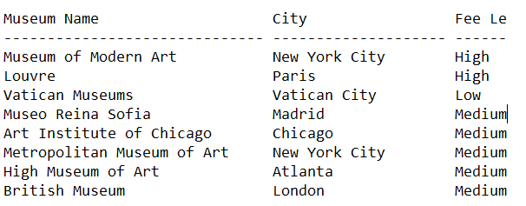

-- Query 3:

-- Display each museum and its minimum fee,

-- where it's less than 15.

SELECT museum_name "Museum Name",

MIN(fee) "Fee"

FROM museum

GROUP BY museum_name

HAVING MIN(fee) <= 15

ORDER BY 2;

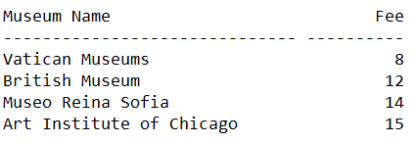

-- Query 4:

-- Display the artwork's name, artist's name, origin, and movement

-- from both the ARTWORK and ARTIST tables.

SELECT aw.artwork_name "Artwork Name",

at.artist_name "Artist Name",

at.origin "Origin",

at.movement "Movement"

FROM artwork aw

JOIN artist at

ON aw.artwork_id = at.artist_id

ORDER BY 1;

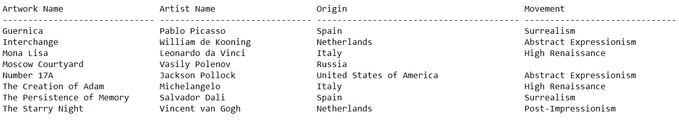

-- Query 5:

-- Display what museum and its locations

-- the painting 'Guernica' is originally in display.

SELECT museum_name "Museum Name",

city "City",

country "Country"

FROM museum

WHERE museum_id =

(SELECT museum_id

FROM artwork

WHERE artwork_name = 'Guernica')

ORDER BY 1;



-- Query 6:

-- Display all dates later in the 1900s in 'YYYY' format

-- from the MUSEUM and ARTIST tables.

SELECT TO_CHAR(founded_date, 'YYYY') "Dates"

FROM museum

WHERE TO_CHAR(founded_date, 'YYYY') > '1900'

UNION

SELECT TO_CHAR(date_of_birth, 'YYYY')

FROM artist

WHERE TO_CHAR(date_of_birth, 'YYYY') > '1900'

ORDER BY 1;



-- Query 7:

-- Display all artists' names

-- and how long it's been in years and months

-- since their birth.

SELECT artist_name "Artist Name",

ROUND((SYSDATE - date_of_birth) / 365) "Number of years since birth",

TRUNC(MONTHS_BETWEEN(SYSDATE, date_of_birth)) "Number of months since birth"

FROM artist

ORDER BY 2;

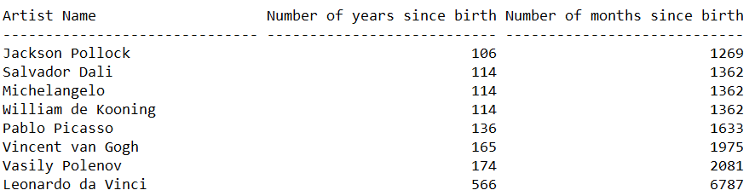

-- Query 8:

-- Display all museum names, their fees in US dollars,

-- and their founded dates in an appropriate format.

SELECT museum_name "Museum Name",

TO_CHAR(fee, 'fmL9,999') "Fee in converted US dollars",

TO_CHAR(founded_date, 'fmMonth Ddth, YYYY') "Formatted founded date"

FROM museum

ORDER BY 1;

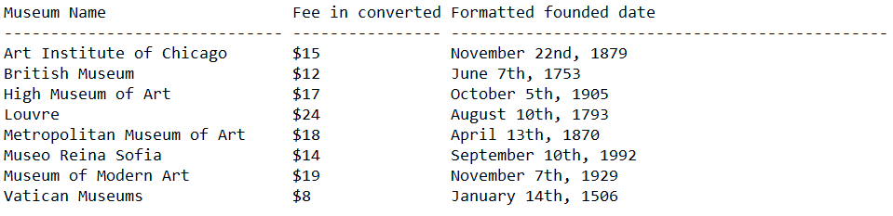

-- Query 9:

-- Display any museums that may contain an artwork

-- whose medium is an oil-based painting.

SELECT museum_name "Museum Name",

city "City",

country "Country"

FROM museum

WHERE museum_id IN

(SELECT museum_id

FROM artwork

WHERE medium LIKE 'Oil%')

ORDER BY 1;

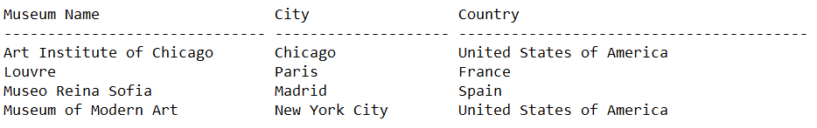

-- Query 10

-- Find a list of artwork

-- that may not exist in some museums

-- and vice versa using a FULL OUTER JOIN.

SELECT m.museum_name "Museum Name",

aw.museum_id "Museum ID",

aw.artwork_name "Artwork Name"

FROM museum m

FULL OUTER JOIN artwork aw

ON m.museum_id = aw.museum_id

ORDER BY 1;

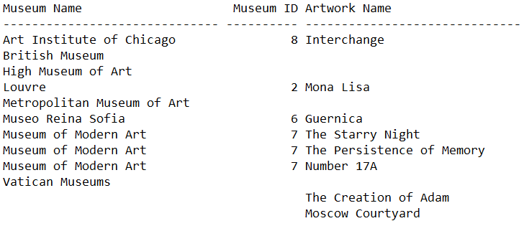

PART V: REPORT

SET PAGESIZE 25

SET LINESIZE 80

SET FEEDBACK OFF

TTITLE 'Semester Project - Report|Art Galleries Database'

BTITLE 'By - Christan de Luna'

BREAK ON artwork_id SKIP 1

COL artwork_id HEADING 'Artwork ID' FORMAT 99

COL artwork_name HEADING 'Artwork Name' FORMAT A30

COL artist_name HEADING 'Artist Name' FORMAT A20

-- SQL Statement

-- Selects each artwork ID, name, and their artist.

SELECT artwork_id,

artwork_name,

artist_name

FROM artwork

ORDER BY 1;

SQL> get C:\Oracle\Project\Report1

1 -- Christan de Luna

2 -- Semester Project: Report

3 SET PAGESIZE 25

4 SET LINESIZE 80

5 SET FEEDBACK OFF

6 TTITLE 'Semester Project - Report|Art Galleries Database'

7 BTITLE 'By - Christan de Luna'

8 BREAK ON artwork_id SKIP 1

9 COL artwork_id HEADING 'Artwork ID' FORMAT 99

10 COL artwork_name HEADING 'Artwork Name' FORMAT A30

11 COL artist_name HEADING 'Artist Name' FORMAT A20

12 -- SQL Statement

13 -- Selects each artwork ID, name, and their artist.

14 SELECT artwork_id,

15 artwork_name,

16 artist_name

17 FROM artwork

18* ORDER BY 1;

19 @ C:\Oracle\Project\Report1

Thu Nov 16 page 1

Semester Project - Report

Art Galleries Database

Artwork ID Artwork Name Artist Name

---------- ------------------------------ --------------------

1 The Persistence of Memory Salvador Dali

2 Guernica Pablo Picasso

3 Mona Lisa Leonardo da Vinci

4 The Creation of Adam Michelangelo

5 The Starry Night Vincent van Gogh

6 Interchange William de Kooning

7 Moscow Courtyard Vasily Polenov

8 Number 17A Jackson Pollock

By - Christan de Luna

SQL> spool off