**Process for testing Patients Under Investigation (PUI) for COVID-19**

1. **Patient selection:**

* Clinicians should use their judgment to determine if a patient has signs and symptoms compatible with COVID-19 and whether the patient should be tested in accordance with CDC guidance for PUI.
* Decisions on which patients receive testing should be based on the local epidemiology of COVID-19, as well as the clinical course of illness. Most patients with confirmed COVID-19 have developed fever and/or symptoms of acute respiratory illness (e.g., cough, difficulty breathing).
* Clinicians are strongly encouraged to test for other causes of respiratory illness, including infections such as influenza.

1. **Isolation Precautions:**

Immediately implement infection prevention and control practices for any suspected case.

1. **Obtaining the proper specimens / proper collection media:**

* For initial diagnostic testing for SARS-CoV-2, CDC recommends collecting and testing upper respiratory tract specimens (nasopharyngeal AND oropharyngeal swabs in separate vials).
* CDC also recommends testing lower respiratory tract specimens, if available. For patients who develop a productive cough, sputum should be collected and tested for SARS-CoV-2. The induction of sputum is not recommended

After patient has been approved for sample collection:

LabCorp

2019 Novel Coronavirus (COVID19), NAA

Test code #139900

Turn-around time is 3-4 days

Nasopharyngeal swab [see picture] in Universal Viral Transport Medium [see photo] AND OP swab

Samples are stable refrigerated for 72 hours. Transport chain will need to be determined at each site.

Providers [physician, APC] should collect specimen using CDC/public health department guidelines, below.

Quest Diagnostics

SARS-CoV-2 RNA, Qualitative Real-Time RT-PCR

Test code #39433

Turn-around time approximately 2 days

1 nasopharyngeal AND oropharyngeal swab in M4, V-C-M or UTM media

Refrigerated: 72 hours, stability

If sample is being shipped directly to the performing laboratory by an overnight air courier, then transport it frozen on dry ice. **Specimens must not be left in lock boxes.**

* To obtain the swab, request TWO RVP-type swabs from the lab. Do not use the standard blue or green top swabs on the units.
* To collect the sample, please wear full PPE including N95 or PAPR and eye protection, gown and gloves
* Double bag the samples, ensuring that the outermost bag is not contaminated
* See CDC guidelines for donning & doffing PPE
* Have a red bag available to discard PPE
* Room used must be quarantined for 4 hours
* Wipe down stethoscope, thermometer & pulse ox with appropriate cleansing wipes after use

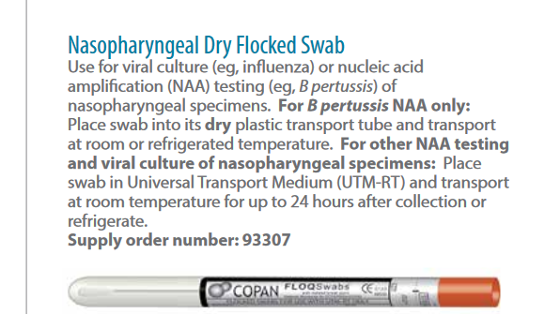

*Use the nasopharyngeal swab with plastic wand only

After sampling transfer to viral culture transport tube.

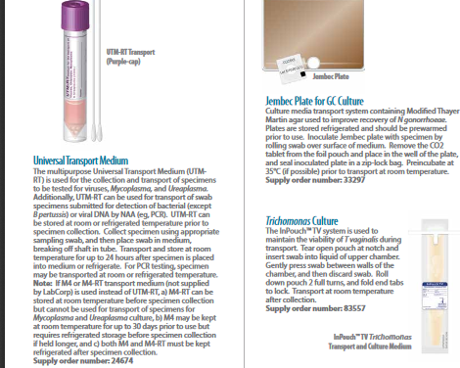**USE THIS SWAB FOR OP TESTING- place in a separate UTM viral transport tube

**TECHNIQUE for NASOPHARYNGEAL SAMPLE COLLECTION:**

1. If possible, have the patient clear their airway
2. Tilt the patient’s head back and instruct them to close their eyes
3. Insert the swab until the nasopharynx is felt

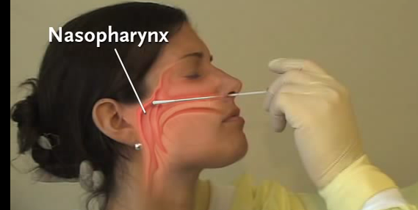

1. Rotate the swab along the nasopharyngeal mucosa for 10-15 seconds to obtain an adequate sample

**TECHNIQUE for OROPHARYNGEAL SAMPLE COLLECTION:**

Place swab into the back of the mouth into the posterior pharynx, swabbing both tonsillar areas, being careful to avoid the tongue, teeth and gums.

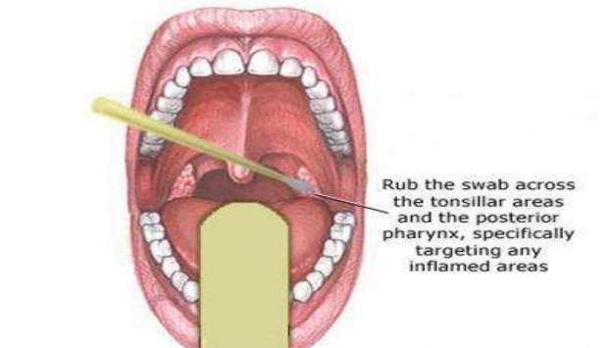

1. **Test Result:**

Upon Public Health Department or lab verifying the result at their end, a report is sent to the laboratory’s secured fax. It is then scanned into the patient’s chart/ PAQ.

If positive, the Local Health Department must be notified if not already aware- forms on their websites.

Also notify Medical Directors, the manager and regional director when a positive case has been identified at your office. We will need to know for HR purposes in the case that employees have signs and symptoms and would also need testing. Remembering that patient confidentiality is always of the utmost importance.

1. **Obtaining approval for testing/reporting:**

Clinician (MD / APC) to call Orange County Healthcare Agency (OCHCA) to obtain approval for testing or reporting.

During work hours: (714) 834-8180; after hours: (714) 628-7008

**Los Angeles County DPH Acute Communicable Disease Control**:

• Weekdays 8:30am–5pm: call 213-240-7941.

• After-hours: call 213-974-1234 and ask for the physician on call.

**Long Beach Health and Human Services**:

• Weekdays 8am-5pm: call 562-570-4302.

• After hours: call the Duty Officer at 562-500-5537.

Or San Diego County: **Phone: (619) 692-8499; Fax: (858) 715-6458**

**Urgent Phone for pm/weekends/holidays: (858) 565-5255**

OCHCA does not need to be informed of every suspect case who is tested for COVID-19 infection using a commercial laboratory. But to assist with investigation and potential patient isolation, OCHCA should be informed of any symptomatic patient who fits any of the following criteria:

* Develops symptoms within 14 days of returning from a country of risk (including China, Italy, Iran, South Korea, and Japan)
* Is a contact of a confirmed case (including health care workers)
* Resides at a skilled nursing facility