R Example #1

# Objects and Functions

R objects store information. We can create objects using assignment operators (= or <-). Note that R is case sensitive.

R functions do things.

y = c(1, 2, 3, 4)  
y

## [1] 1 2 3 4

mean(y)

## [1] 2.5

Y <- 20  
Y

## [1] 20

# Working with Data

For this example, we will load a “built-in” data set.  
ALWAYS look at the data!

data(chickwts)  
str(chickwts)

## 'data.frame': 71 obs. of 2 variables:  
## $ weight: num 179 160 136 227 217 168 108 124 143 140 ...  
## $ feed : Factor w/ 6 levels "casein","horsebean",..: 2 2 2 2 2 2 2 2 2 2 ...

# Summary Statistics and Graphics

We will use this data to illustrate some basic analysis in R. The goal is to get started using R instead of focusing on specific R functions.

For this example, we will ignore the “feed” info.

Use $ to reference a specific column within a data.frame. R requires code to exactly match the column names in the data.frame.

mean(chickwts$weight)

## [1] 261.3099

median(chickwts$weight)

## [1] 258

hist(chickwts$weight)

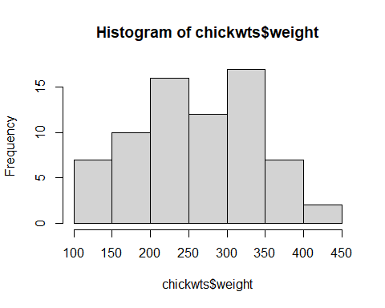

boxplot(chickwts$weight)

