Abstract
In recent years, energy harvesting from renewable sources has experienced increasing demand. Wind turbines, as a key source of renewable energy, are characterized by considerable energy losses and structural weight constraints that limit their overall efficiency and performance. This study aims to optimize a three-stage gearbox utilized in wind turbines, designed for a rated power of 1 MW and a total transmission ratio of 1:70. The target is the reduction of the overall weight of the gearbox and minimization of power losses, benchmarking against results from existing literature. A single-objective optimization approach was adopted by applying the weighted sum method to aggregate the objective functions. The most important design variables include gear geometrical characteristics; number of planets used at every stage and topological configurations. More specifically, the algorithm can select either a simple or planetary stage and can define the component that operates as the power input and output, at the possibility of a planetary option. This choice corresponds to a specific, independent design parameter for each stage. The bending and the pitting strength endurance of the gearbox are calculated by AGMA standards and are included as constraints. Percentages of reduction- results. The study demonstrates the importance of topological parameters in gearbox optimization and suggests further investigation into more complex stage assemblies to enhance the performance of WTGs.

Introduction
Probably add more “general references” – reach 25
Nowadays, gear systems are widely used in wind turbine applications due to their high-power density, reliability, and ability to achieve large gear ratios in compact configurations [1]. For power ratings exceeding 3 MW, planetary stages become necessary for high torque density and as a result current market trends show a clear dominance of three-stage gearboxes, which account for 60–90% of the industry. Single and double-planetary configurations representing 28% and 36% of global installations, respectively [2] . Although, the gearbox is a major contributor to mechanical losses and overall system weight, and it significantly affects the efficiency and durability of wind turbine generators (WTGs). The performance of these systems is strongly influenced by both conventional design parameters and the underlying topological configuration of the gears [3]. Optimizing planetary gearboxes to reduce power losses and system mass is critical for improving overall efficiency, reducing the cost of wind energy systems and creating lighter structures [4].
Several studies have addressed gearbox power loss prediction and efficiency improvement investigated tribological effects and friction coefficients in gear contacts [5] and [6], while others provided analytical formulations for tooth friction losses in both external and internal gears [7]. The benchmark for this study optimized a 3-stage wind turbine gearbox with certain topological characteristics under multi-objective criteria and scuffing limitations [8].
In general, studies for multi-objective optimization on helical and planetary gearboxes, considering efficiency and load constraints have been attempted, however, most available ones focus on single-stage or fixed-topology designs. The influence of topological configuration (simple vs. planetary) and its interaction with geometrical parameters in multi-stage wind turbine gearboxes remains insufficiently explored. Addressing this gap motivates the present study, which combines geometric and topological optimization to enhance gearbox performance in large-scale WTGs. In more detail, this research investigates the influence of topological variables on the design optimization of a three-stage planetary gearbox with an overall gear ratio of 70 and a rated power input of 1 MW.
A single-objective Genetic Algorithm (GA) implemented in MATLAB is employed for the optimization, with a weighted sum of system mass and total power loss as the objective function. Multiple numerical experiments are conducted to generate a Pareto front of optimal solutions, allowing a comprehensive assessment of the influence of topological variables. The effect of pressure angles on system performance is also evaluated. Finally, the results of optimization are discussed to highlight the effectiveness of the approach and the key factors governing planetary gearbox design. More specific when the results are written ?

Methodology
- Explanation of algorithm + variables + variable topological implementation
- Objective functions – Weight
- Gear tooth integrity (equations)
Presentations of the Algorithm
The process of optimization has as goal to minimize the total mass of the system () and the power losses of the system. The problem is defined as a multi objective optimization through a single objective function defined with equation (x)
$$\begin{aligned}F=w_{1}M+w_{2}P_L\#\left(1\right)\end{aligned}$$
Moreover, the weights $w_{1}$ and $w_{2}$ are positive and selected to respect equation (x+1)
$$\begin{aligned}w_{1}+w_{2}=1\#\left(2\right)\end{aligned}$$
There are also several constraints that are set to reassure the structure’s integrity and the noise being produced by the planetary system. These are explained more analytically in [].
Table y shows the design variables taken to define and design each stage, as the range of each value:
Caption of Table y: Design Variable of each Stage and the Limits of the Variables
Variables | Module m [mm] | Number of Sun’s Teeth $Z_{S}$ [-] | Number of Planet’s Teeth $Z_{P}$ [-] | Number of Planets N [-] | Stage of the Mode M [-] | Width Coefficient $K_{b}$[-] | Pressure angle α [$°$] | Helix angle β [$°$]
Upper Limit | 3.25 | 20 | 30 | 1 | 1 | 10 | 14.5 | 0
Lower Limit | 30 | 70 | 80 | 9 | 4 | 40 | 35 | 30

Variable morphology implementation
Kinematic characteristics of the speed-increasing gearbox
The fundamental kinematic equations governing a planetary gear system are:
$$ω_{1}r_{1}=ω_{4}r_{1}+ω_{2}r_{2} () \\ ω_{3}\left(r_{1}+2r_{2}\right)=ω_{4}\left(r_{1}+2r_{2}\right)-ω_{2}r_{2} ()$$
where $ω_{i}$denotes the angular velocities, $r_{i}$the radii, and $z_{i}$ the number of teeth of the gears. The index takes value 1 when the quantities refer to the sun gear, 2 to the planet gears, 3 to the ring gear, and 4 to the planet carrier of the corresponding planetary system. Additionally, to determine under which conditions a planetary gear train achieves an increase in the rotational speed of the output shaft relative to the rotational speed of the input shaft—that is, when the system functions as a speed increaser—we distinguish the following cases, shown in Table 1.1:

Case A:
$ω_{3}=0$and $ω_{in}=ω_{1}$, then $ω_{out}=ω_{4}⇒i_{A}=2(1+\frac{z_{2}}{z_{1}})$
Case B:
$ω_{3}=0$and $ω_{in}=ω_{4}$, then $ω_{out}=ω_{1}⇒i_{B}=\frac{1}{i_{A}}$
Case C:
$ω_{4}=0$and $ω_{in}=ω_{1}$, then $ω_{out}=ω_{3}⇒i_{C}=-\frac{1}{1+2\frac{z_{2}}{z_{1}}}$
Case D:
$ω_{4}=0$and $ω_{in}=ω_{3}$, then $ω_{out}=ω_{1}⇒i_{D}=\frac{1}{i_{C}}$
Case E:
$ω_{1}=0$and $ω_{in}=ω_{4}$, then $ω_{out}=ω_{3}⇒i_{E}=\frac{1+2\frac{z_{2}}{z_{1}}}{2(1+\frac{z_{2}}{z_{1}})}$
Case Z:
$ω_{1}=0$and $ω_{in}=ω_{3}$, then $ω_{out}=ω_{4}⇒i_{Z}=\frac{2(1+\frac{z_{2}}{z_{1}})}{1+2\frac{z_{2}}{z_{1}}}$
We know that when the transmission ratio is positive, the input and output angular velocities are in the same rotational direction. In this case, if $i>1$the system functions as a speed reducer, whereas if $i<1$it functions as a speed increaser.
If the transmission ratio is negative, the rotational directions are opposite, and for $i>-1$the system acts as a speed increaser, while for $i<-1$it acts as a speed reducer.
By plotting the diagrams for the six cases above (Figures 1.2 and 1.3), we conclude that the cases suitable for use in the wind turbine transmission system are A, D, and E. It is noted that in Figure 1.3, Case Z has a transmission ratio slightly greater than unity, making it a reducer even though this is not clearly visible due to the scale. An enlarged view is also provided in Figure 1.3. better quality diagrams
Figure 1.2: Transmission ratios for the speed-increasing cases (i_B, i_D, i_E) for different values of $z_{2}/z_{1}$
Figure 1.3: Transmission ratios for the speed-reducing cases ($i_{A}$, $i_{C}$, $i_{Z}$) for different values of $z_{2}/z_{1}$
We therefore set in the evolutionary algorithm—whose implementation and development are analyzed in Chapter 2—as independent variables the cases B, D, and E. We also add the option of a simple stage gear couple, because in the WTGs industry for low power applications the third stage can usually be a simple stage.
We denote these respectively as mode 1, mode 2, mode 3 and Mode 4 respectively (Table 1.2). They constitute the initial parameters, i.e., selectable options, of the program developed to determine the optimal kinematic characteristics of each stage.
Mode | Case | Fixed element | Input | Output
Mode 1 | Case B | Ring gear | Planet carrier | Sun gear
Mode 2 | Case D | Planet carrier | Ring gear | Sun gear
Mode 3 | Case E | Sun gear | Planet carrier | Ring gear
Mode 4 | Simple Stage | Carier | Sun | Planet
Table 1.2: Mode options

Gear tooth integrity
Gear Tooth integrity
The stresses in the gear teeth were calculated using the standards provided by AGMA. Specifically, the meshing teeth experience both bending stresses and surface contact stresses (Hertzian contact stresses) during operation. The corresponding formulas were taken from ANSI/AGMA 2001-D04 and ANSI/AGMA 2003-C10:
For Bending strength in the foot of the teeth, eq():
$$Πληκτρολογήστε την εξίσωση εδώ.$$
And, for pitting strength in the contacting surfaces, eq():
$$Πληκτρολογήστε την εξίσωση εδώ.$$
These equations have been implemented in the algorithm as non-linear constraints. The associated coefficients were calculated according to ANSI/AGMA 2001-D04, except for the geometric factors related to pitting resistance and bending strength, denoted by $I$ and $J$respectively, which were determined following the methodology given in AGMA 908-B89.
Some of the coefficient expressions above were treated as constants, based on the application assumptions (smooth loads) and the required accuracy of the algorithm, as well as because certain coefficients depend on case-specific characteristics. The values adopted for these coefficients are summarized in Table X.
Symbol | Name | Value
$$K_{o}$$ | Overload Factor | 1.0
$$K_{v}$$ | Dynamic Factor [] | 1.05
$$K_{s}$$ | Size Factor | 1.0
$$K_{B}$$ | Rim Thickness Factor | 1.0
$$K_{A}$$ | Application Factor | 1.0
$$Y_{N}$$ | Stress Cycle Factor for Pitting Resistance | 1.0
$$Y_{θ}$$ | Temperature Factor | 1.0
$$Y_{z}$$ | Reliability Factor | 1.0
$$Z_{w}$$ | Hardness Ratio Factor | 1.0
$$Z_{N}$$ | Stress Cycle Factor for Pitting Resistance | 1.0
$$Z_{r}$$ | Surface Condition Factor | 1.0
$$Z_{E}$$ | Elastic Coefficient | 189.95
$$S_{f}$$ | Bending Safety Factor | 1.56
$$S_{h}$$ | Pitting Safety Factor | 1.25
$$S_{fp}$$ | Allowable Bending Stress Number | 301[MPa]
$$S_{hp}$$ | Allowable Contact Stress Number | 1088[MPa]

Power losses analysis
According to Höhn et al. (2009), power losses can be separated into categories such as gear, bearing, seal, and auxiliary losses, which can be further classified as load-dependent or load-independent. The most significant categories are gear and bearing losses, which represent ~ 98% of the overall power losses. The scope of this study is mainly to optimize the gear characteristics; thus, only gear losses are computed, as they represent the main losses of the WTGs’ gearbox.
Gear losses are considered load-dependent [1] and their calculation is based on Ohlendorf’s approximation, according to Eq. (1),
$$P_{vzp}=P_{IN}∙μ_{mz}∙{Hv}_{ohl,k} \{(1)\}$$
, where $Hv_{ohl}$ represents the tooth loss factor and $μ_{mz}$ is coefficient of friction.
Although Ohlendorf (1958) did not consider $β_{b}$, the following approximation is largely valid for spur gears (Wimmer, 2006) [2] but also be used, with acceptable accuracy for helical gears. For meshing between two gears with external teeth, the tooth loss factor is calculated as follows:
$${Hv}_{ohl,e}=\left(\frac{1}{Z_{1}}+\frac{1}{Z_{2}}\right)∙\frac{π}{cos(β_{b})}∙\left(1-ε_{a}+ε_{1}^{2}+ε_{2}^{2}\right)\{(2)\}$$
And for external – internal meshing, it is usually calculated with an open form, as shown in the following formula:
$$H_{v}=\frac{1}{P_{b}}⋅∫_{0}^{b}∫_{A}^{E}\frac{F_{N}(x,y)}{F_{bt}}⋅\frac{V_{g}(x,y)}{V_{tb}}dxdy$$
However, for the purposes of the algorithm, a closed-form expression is used, as stated in …
$${Hv}_{ohl,i}=\left(\frac{Ζ_{2}}{Ζ_{1}^{2}}+\frac{1}{Z_{1}}\right)∙\frac{π}{cos(β_{b})}∙\left(1-ε_{a}+ε_{1}^{2}+ε_{2}^{2}\right)\{(3)\}$$
The parameters that are represented with $ε_{1}$, $ε_{2}$ are the addendum contact ratios of pinion and gear respectively, which are computed with Eq.4
$$ε_{i}=±\frac{Z_{i}}{2π}∙\left(\sqrt{{\left(\frac{D_{t}}{D_{b}}\right)}^{2}-1}-tan(a_{ws})\right)\{(4)\}$$
For every meshing between two gears, $ε_{a}$ represents the transverse contact ratio. If it is considered two gears 1 and 2 with $ε_{1}$, $ε_{2}$ respectively then the transverse contact ratio is sum of the addendum contact ratio of each meshing gear, as shown in Eq.(5), regardless of whether the gears have internal or external teeth or the type of the gears.
$$ε_{α}=ε_{1}+ε_{2}$$
In the calculations, the lubricant is assumed to be mineral oil [3]. The corresponding lubricant parameter, $X_{L}$, is load-dependent and it is calculated using Eq. (6):
$$X_{L}=\frac{1}{F_{b}^{d}}\{(6)\}$$
, for mineral oil d = 0.0651. Derived from Schlenk’s work, the following formula was used to approximate the coefficient of friction between meshing gears [1], as given in Eq. (7).
$$μ_{mz}=0.048∙{\left(\frac{{F_{bt}}/b}{V_{c}∙ρ_{eq,c}}\right)}^{0.2}∙η^{-0.05}∙R_{a}^{0,25}∙X_{L}\{(7)\}$$

Total mass assessment
-

Results:
The proposed genetic algorithm was evaluated using [reference study citation] as a benchmark case. The resulting Pareto front, shown in Figure 1, demonstrates the trade-off associated with the simultaneous minimization of mass and power losses. All solutions shown in Figure 1 dominate the reference case with respect to both objectives.
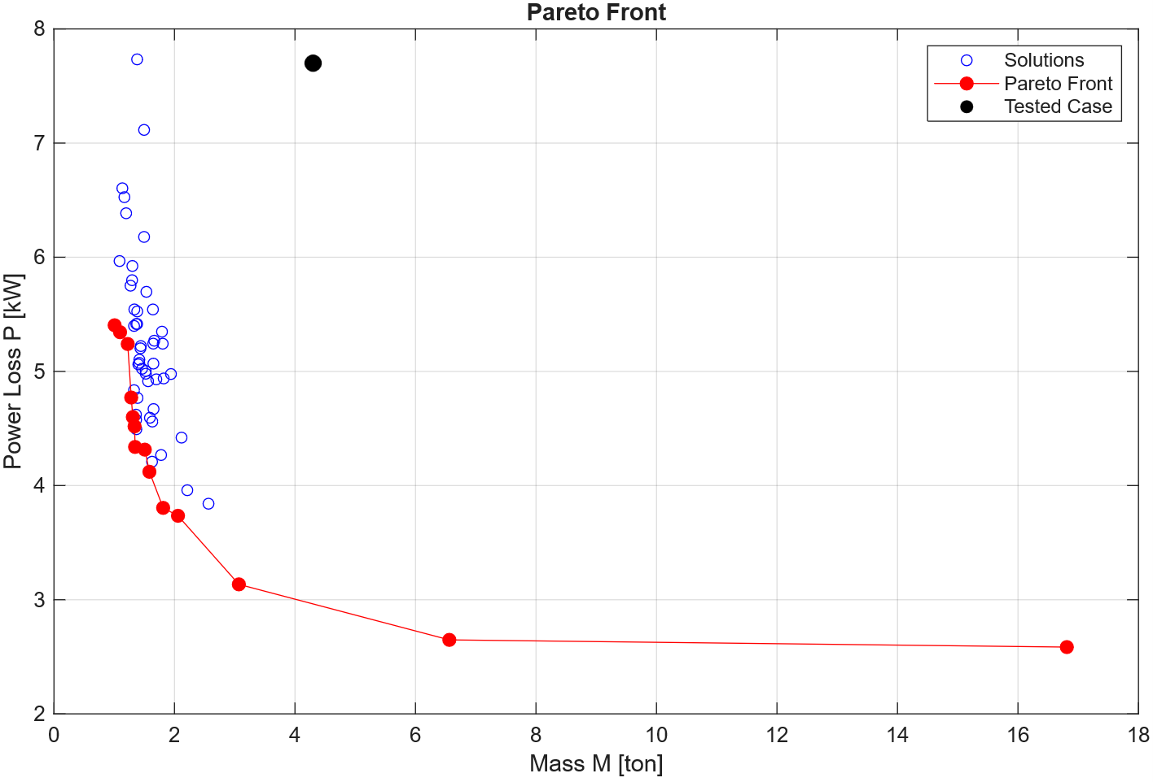
Figure 1: Pareto front for the optimization of mass and power losses.
As shown in Figure 1, most of the obtained solutions are located close to the Pareto front, indicating the effectiveness of the algorithm in identifying near-Pareto-optimal solutions. The distribution of the solutions is biased toward lower mass values within the trade-off space. Higher mass values are observed in cases where the weighted average approach was used with low mass weighting factors (w = 0 and w = 0.1). In these cases, mass was effectively excluded from the optimization objective. Consequently, these cases favor the reduction of power losses at the expense of higher mass.
The influence of topological design variables is assessed by comparing the baseline solution shown in Figure 1 with three cases in which pressure angle and helix angle are kept fixed rather than treated as design variables : (α,β) = {(20°,20°), (25°,20°), (30°,20°)}. Figure 2 presents the resulting Pareto fronts together with the obtained solutions.
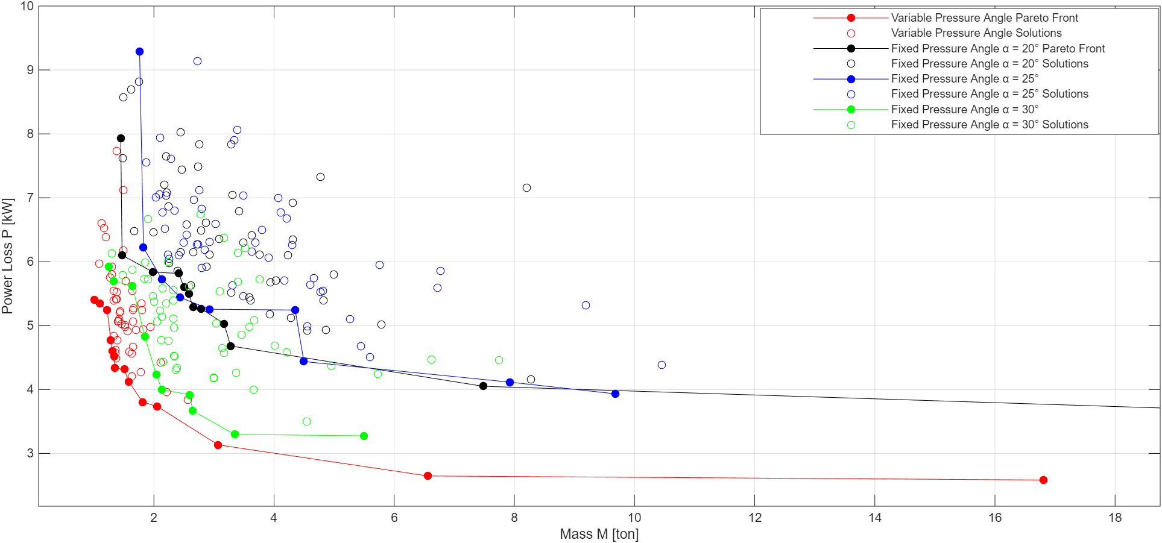
Figure 2: Comparing the Pareto Fronts for fixed and variable pressure and helix angle
The results in Figure 2 show that the topological design variables affect both the shape of the Pareto front and the quality of the solutions obtained. Solutions with comparable mass and power-loss performance by keeping the pressure and helix angles fixed. Allowing the pressure and helix angles to vary as design variables yields solutions with better objective values but are computationally more expensive due to the increased number of design variables. When the pressure angle is fixed at $a=30°$ the algorithm tends to identify solutions with lower mass and power losses than those obtained for pressure angles of $20°$ or 25$°$.
The influence of power input is evaluated by comparing the baseline case with $P_{in}$ ∈ {1, 2, 2.5, 3, 3.5, 4, 5, 7.5, 10, 15} MW, while keeping pressure and helix angle constant at (α, β) = (20$°$ , 10$°$). The corresponding results are presented in Figure 3. To enable a meaningful comparison between cases with different input power levels, the power losses are expressed as a percentage of the corresponding input power
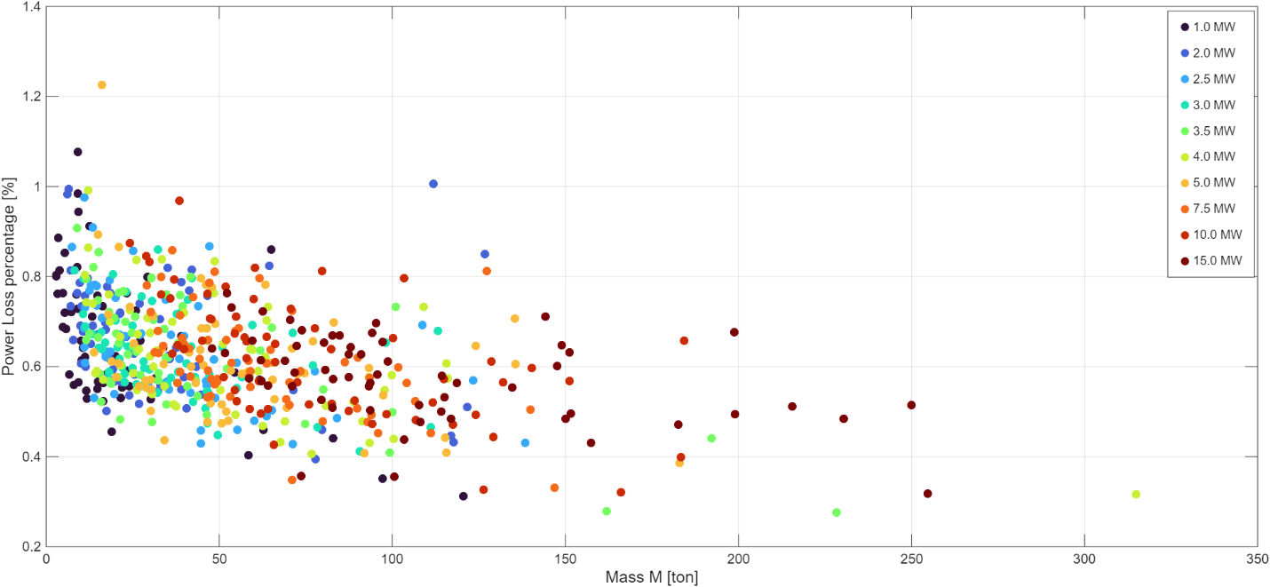
Figure 3: Comparing Pareto solutions of turbine gearbox for increasing power ratings
It can be observed from Figure 3 that increasing the power level results in solutions with higher mass. However, the percentage of input power lost remains approximately constant across the investigated input power levels. This indicates that the relative power loss is largely independent of the input power, although the absolute power loss increases with increasing input power.
The role of the topological variables is further illustrated in Figure 4, where the solutions are classified according to the mode selected for each stage. The data used to construct the pie charts in Figure 4 are obtained from the solutions presented in Figures 1 and 2.
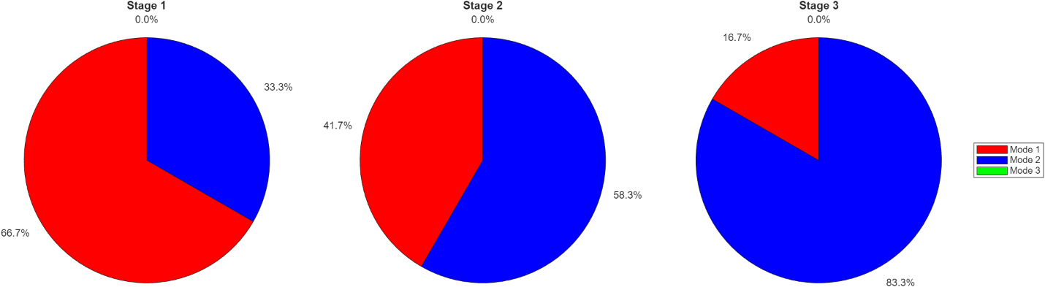
Figure 4: Distribution of selected modes for each stage
As shown in Figure 4, Mode 1 is predominant in the first stage, whereas Mode 2 is predominant in the third stage. Yet, for the second stage Modes 1 and 2 are selected with comparable frequencies. Mode 3 does not appear in any of the solutions considered, indicating that configurations involving this mode are either infeasible because they violate the imposed constraints or less favorable in terms of the optimization objectives than those involving Modes 1 and 2.

Bibliography
[1] C. M. C. G. Fernandes, M. Hammami, R. C. Martins, and J. H. Seabra, “Power loss prediction: Application to a 2.5 MW wind turbine gearbox,” Proceedings of the Institution of Mechanical Engineers, Part J: Journal of Engineering Tribology, vol. 230, no. 8, pp. 983–995, Aug. 2016, doi: 10.1177/1350650115622362.
[2] C. Seyfeftd, R. Lutherd, and A. Igartua’, “IRIBOIOGY AGMA Technical Paper,” ELSEVIER, 2006. [Online]. Available: www.elsevier.com/locate/triboint
[3] P. Velex and F. Ville, “An analytical approach to tooth friction losses in spur and helical gears-influence of profile modifications,” Journal of Mechanical Design, vol. 131, no. 10, pp. 1010081–10100810, 2009, doi: 10.1115/1.3179156.
[4] A. Parmar, P. Ramkumar, and K. Shankar, “Macro geometry multi-objective optimization of planetary gearbox considering scuffing constraint,” Mech. Mach. Theory, vol. 154, Dec. 2020, doi: 10.1016/j.mechmachtheory.2020.104045.
[5] M. Patil, P. Ramkumar, and K. Shankar, “Multi-objective optimization of the two-stage helical gearbox with tribological constraints,” Mech. Mach. Theory, vol. 138, pp. 38–57, Aug. 2019, doi: 10.1016/j.mechmachtheory.2019.03.037.

