Promoting Peace Amid Group Conflict: An Intergroup Contact Field Experiment in Nigeria

Christopher Grady

June 21, 2020

# Abstract

Cooperative intergroup contact, originally designed as a tool for prejudice reduction, offers a promising means to resolve group conflict. Evidence for contact-based interventions is sparse, however, and violent conflict may nullify the effects of contact. We test the ability of a contact-based intervention to promote peace between conflicting groups with a field experiment in Nigeria, where farmer and pastoralist communities are embroiled in a deadly conflict over land use. We evaluate the program with surveys, direct observation of behavior in markets, and a behavioral game. We find that participation in the program increases intergroup trust, feelings of physical security, and voluntary intergroup contact measured both will self-reports and observed behavior in markets. Many of the program’s effects also diffuse to group members who did not directly participate in the program but who lived alongside participants. The program had no effect on a placebo outcome, attitudes towards violence, that one would expect to improve if the survey results were affected by social desirability bias. These results suggest that reducing barriers to peace between conflicting groups is possible, and that structured intergroup contact is a promising method to do so.

Thanks to Jake Bowers, Jim Kuklinski, Justin Rhodes, Cara Wong, Caglayan Baser, Ekrem Baser, Nuole Chen, Alice Iannantuoni, Betsy Rajala, Charla Waeiss, and Donald Beaudette for useful conversations and feedback on earlier drafts of this paper. Thanks to Danjuma Dawop, Lisa Inks, Rebecca Wolfe, and the Mercy Corps Nigeria team for their work implementing the peacebuilding project. Thanks to Tahiru Ahmadu, Ibrahim Hassan, and the enumeration teams for their excellent work interviewing farmers and pastoralists. Thanks to Hadiza Nuhu and Israel Okpe for their work as the main contact people and mobilizers in farming and pastoral communities.

# 1 Introduction

How can groups in conflict improve intergroup relations? Violent group conflict has caused 2 million deaths since the year 2000 (Sundberg and Melander 2013), forcibly displaced over 70 million people from their homes in 2018 (UNHCR 2019), threatens food supplies in numerous countries (Verwimp and others 2012), and extracts a psychological toll on participants and victims (Schomerus and Rigterink 2018). Intergroup animosity perpetuates conflict long after the original grievance is immaterial or forgotten (Deutsch 1973; McDonnel 2017; Tajfel and Turner 1979), so improving intergroup relations is vital to stem the human, economic, social, and psychological costs of violent group conflict.

Scholars and practitioners consider *cooperative* intergroup contact – contact in which members of two groups work together to achieve common goals – to be one of the most effective tools for improving intergroup relations.[1] Evidence for the hypothesis that contact improves intergroup relations, known as the contact hypothesis (Allport 1954), goes as far back as the 1950s and motivated integrated public housing (Deutsch and Collins 1951) and workplace and school desegregation (Cook 1985; Cook, Wrightsman, and Wrightsman 1971; Slavin and Cooper 1999) in the United States. More recent studies demonstrated the prejudice-reducing effects of contact by leveraging random assignment to college dorms (Marmaros and Sacerdote 2006), college roommates (Boisjoly et al. 2006; Burns, Corno, and La Ferrara 2015; Van Laar et al.

2005), schools (Rao 2019.), U.S. Air Force groups (Carrell, Hoekstra, and West 2015), mixed sports teams (Ditlmann and Samii 2016; Mousa 2018), job training programs (Scacco and Warren 2018), and medical doctors (Weiss 2019). The contact hypothesis also increasingly motivates policy interventions, especially peacebuilding programs (Ditlmann, Samii, and Zeitzoff 2017; Lemmer and Wagner 2015).

Despite contact’s many successes, scholars know little about the effects of contact-based interventions for people actively participating in and personally victimized by a violent conflict, or even for interventions directed at improving adults’ attitudes towards racial or ethnic groups (Paluck, Green, and Green 2019). Cooperative intergroup contact has only recently been tested in the field, and never programmatically with communities who are currently perpetrating violence against each other. If one of the goals of cooperative contact is to mitigate violent conflict, then contact-based interventions must be tested between participants and victims in violent conflict.

Ongoing violence poses the most difficult test for contact and could interfere with mechanisms through which contact improves relations. The mechanisms through which contact improves relations assume that negative attitudes result from unfamiliarity, and that “familiarity breed[s] liking” (Pettigrew and Tropp 2006, 766). We posit that familiarity through cooperative contact allows groups to identify latent shared interests by providing positive interactions towards achieving a common goal. Those positive interactions counter existing negative beliefs and create cognitive dissonance (Festinger 1962; Tavris and Aronson 2008). Attitudes improve when that cognitive dissonance is resolved by rejecting negative beliefs rather than justifying negative beliefs (Gubler 2013). However, by reinforcing negative beliefs and obscuring shared interests, violent conflict could dull, prevent, or even reverse the predicted positive effects of contact.

Despite these reasons for caution, there are reasons to expect cooperative contact to improve intergroup relations even in contexts of ongoing violence. Even in contexts of group violence, it is often in each group’s shared interest to reach a peaceful compromise because fighting is costly (Fearon 1995). Cooperative contact to achieve a common goal provides groups with an example of cooperation towards a shared interest, and that experience can make groups imagine future interactions for shared benefit. Cooperative contact can also remove the psychological barriers to identifying shared interests, such as stereotypes and feelings of threat and anxiety. Lastly, cooperation that benefits the group should generate group pressure to cooperate, thus creating cooperative social norms.

To learn about whether cooperative contact can improve intergroup relations amidst violent group conflict, we conducted a field experiment with conflicting farmer and pastoralist communities in Nigeria. More than an occupational difference, farmers who cultivate crops and pastoralists who graze cattle define a major social cleavage in many parts of the world. These groups conflict over land rights, which define both of their livelihoods. Farmer-pastoralist conflict has escalated throughout the Sahel in recent years, and nowhere more than in Nigeria. The most recent conflict escalation has caused 7,000 deaths from 2014-2019, displaced hundreds of thousands of people from their homes, and costs $13 billion annually in lost economic productivity (Akinwotu 2018; Daniel 2018; Harwood 2019; McDougal et al. 2015). In our sample, some members of each community had been killed by members of the other community in the year before the project began. Ongoing violence, occupational and ethnic differences, and fighting over resources necessary for livelihoods all make this context a hard test for contact theory.

We randomly assigned communities with ongoing farmer-pastoralist violence to receive a contactbased intervention or serve as a control group. The intervention formed mixed-group committees and provided them with funds to build infrastructure that would benefit both communities; committees then collaboratively chose and constructed infrastructure projects.[2] The program also provided mediation training to each community’s leaders and held forums where the groups discussed the underlying drivers of conflict. To measure the effects of the intervention, we conducted pre- and post-intervention surveys, a post-intervention natural public goods behavioral game,[3] and twelve months of systematic observations in markets and social events during the intervention.

We find that the program increased intergroup affect, intergroup contact outside of the intervention, and perceptions of physical security. We see signs of the positive effects in fieldwork as well as in data: in one of the treatment sites, farmers defended pastoralists from a group of anti-pastoralist vigilantes, rather than assist the vigilantes in removing the pastoralists and claiming their land. Our results also show that the intervention affected communities as a whole, not just community members directly involved in the intergroup contact. Individuals who directly engaged in intergroup contact changed the most positively from baseline to endline, but we also observe positive spillovers of trust to group members for whom we did not exogenously increase intergroup contact.

This study expands our knowledge about group conflict in two main ways. First, this study teaches us about the capacity of intergroup contact to improve intergroup relations and reduce conflict. Peacebuilding organizations implement numerous contact-based interventions in violent contexts each year, but its efficacy to improve intergroup attitudes amid real-world conflict is an open question (Ditlmann, Samii, and Zeitzoff 2017; Paluck, Green, and Green 2019). To our knowledge this is the first field experimental test of a contact-based peacebuilding intervention implemented during an active conflict. The results suggest that contact-based peacebuilding programs can effectively improve relationships between conflicting groups and is especially relevant to conflict resolution in the cases of intergroup and intercommunal conflicts.

Second, we contribute to the literature about informal structures, such as social norms, in solving commitment problems. Many scholars have identified group conflict as a commitment problem that is most likely to be solved by an outside actor enforcing commitments (Fearon 1994). While strong outside actors can resolve conflict by solving commitment problems, this study suggests that they are not a necessary condition for resolving conflict. Many communities in our treatment group significantly improved their relations without a strong actor to enforce commitments. Our results suggest that cooperative intergroup contact helped groups strengthen their own conflict resolution structures.

# 2 Improving Intergroup Relations Through Cooperative Intergroup Contact

Cooperative intergroup contact has long been posited as a means to improve intergroup relations. Popularized by Gordon Allport (1954), the contact hypothesis assumes that negative stereotypes cause intergroup animosity. Stereotypes, natural mental shortcuts that help an individual understand his/her experiences, are especially likely to go awry and create animosity when an individual has little or no experience with members of another group. Without intergroup experience, stereotypes will misrepresent groups, create imagined differences between ingroup and outgroup members, and obscure shared interests. To remove these negative stereotypes new experiences must override them, allowing an individual to re-conceptualize the outgroup.

Allportandsubsequentauthorsspecifiedfourconditionsunderwhichcontactwillremovestereotypes and improve intergroup relations. First, the contact must involve ongoing personal interaction between members of both groups. Second, both groups must have equal status in the interaction. Third, the interaction must involve cooperation towards a common goal. And fourth, the intergroup interaction must have the support of, or at least not be punished by, institutions and authorities. These conditions ensure positive interactions between group members.

Allport argued that contact works by enhancing knowledge and overriding negative stereotypes about the outgroup, and subsequent scholarship has identified three additional mechanisms through which contact improves attitudes. First, contact reduces the feelings of threat and anxiety that arise from fear of the unknown (Page-Gould, Mendoza-Denton, and Tropp 2008; Stephan and Stephan 1985). Second, contact enables perspective-taking so that ingroup members empathize with the outgroup (Batson et al. 1997; Broockman and Kalla 2016). And third, contact makes salient a shared identity based on the groups’ similarities and interests (Gaertner and Dovidio 2014; Gaertner et al. 1993). Through these mechanisms group members can experience positive cross-group interactions, which triggers cognitive dissonance against the preexisting negative attitudes. Attitudes improve when that dissonance is resolved by rejecting, rather than justifying, negative attitudes towards the outgroup (Gubler 2013).

These mechanisms support the reduction of group-based prejudice for individuals involved in the intergroup interaction, but the positive effects of contact must diffuse to individuals not involved in the interaction for intergroup contact to meaningfully improve intergroup relations. This diffusion to other group members occurs through changing social norms about cross-group interaction (Christ et al. 2014; Paluck

2009) and through the knowledge that other ingroup members had positive contact with outgroup members (Wright et al. 1997). Norms and awareness of cross-group cooperation shows that cross-group interaction is safe and socially encouraged. It also creates the expectation of future interaction with outgroup members, which motivates individuals to see the outgroup more positively (Klein and Kunda 1992; Van Dessel, Hughes, and De Houwer 2019). Through social diffusion cooperative contact improves attitudes even for ingroup members with no cross-group contact.

Taken together, the existing literature suggests that cooperative contact improves intergroup relations through four steps. First, cooperative contact provides positive interactions that remove the psychological barriers – negative stereotypes, feelings of outgroup threat, and a lack of empathy – that bias perceptions of the other side. Second, without these perceptual biases groups can identify shared interests, and cooperative contact facilitates the identification of shared interests by having the groups cooperate towards a common goal. Third, positive interactions and the identification of shared interests challenge pre-existing negative beliefs and trigger cognitive dissonance. Attitudes improve when that dissonance is resolved by rejecting preexisting negative attitudes in lieu of new positive experiences. Fourth, positive attitudes diffuse to other group members through awareness of cross-group cooperation and changing social norms. **2.1 Cooperative intergroup contact in the context of violent group conflict**

Violent group conflict poses a hard test for cooperative intergroup contact to improve attitudes.

First, in the context of ongoing violent conflict, even cooperative contact towards a joint goal may not provide group members with a subjectively positive cross-group interaction. Due to psychological biases, individuals perceive cross-group interactions negatively so that those interactions conform to pre-existing beliefs; individuals also more readily store and recall negative interactions that confirm pre-existing attitudes than positive interactions that are dissonant with pre-existing attitudes (Nickerson 1998; Ward et al. 1997). If individuals perceive cooperative contact negatively, contact could make attitudes worse, not better (Barlow et al. 2012; Paolini, Harwood, and Rubin 2010; Stark, Flache, and Veenstra 2013).

Even if contact succeeds in providing positive experiences with outgroup members, the resulting cognitive dissonance may not be resolved by embracing positive attitudes. Participation in and victimization by violence motivates group members to justify their existing attitudes (Kunda 1990). Existing attitudes are harder to reject once an individual has acted on them (Festinger 1962; Tavris and Aronson 2008). Once an attitude is acted upon, rejection of the attitude threatens an individual’s self-identity because the the individual must come to terms with his or her own immoral behavior. Likewise, individuals are less likely to reject existing attitudes when they have personal experiences that reinforce those attitudes. In the case of prejudice, prejudiced attitudes are least likely to be rejected when an individual has harmed or been harmed by the outgroup. Instead of rejecting negative attitudes, violent experiences can lead individuals to resolve cognitive dissonance by justifying previous attitudes (Gubler 2013) or, at best, by differentiating “good” outgroup members from typical outgroup members (Doosje, Spears, and Koomen 1995).

Beyond past violent, ongoing group violence provides negative experiences with outgroup members that counter the positive experiences provided by cooperative contact. These negative experiences bolster the psychological barriers to groups’ identifying their shared interests. Rather than dispelling stereotypes and alleviating feelings of threat, negative experiences reinforce negative stereotypes and justify feelings of threat. Taking the perspective of the other side will not improve cross-group relations if taking their perspective reveals incentives for belligerence (Kertzer, Brutger, and Quek 2018). And far from revealing common identities and interests, group violence perpetuates opposing group identities and interests (Fearon and Laitin 2000). To overcome preexisting negative beliefs, individuals need strong and consistent information that counters those existing beliefs – a signal that the object of their belief has changed (Nickerson 1998). For that reason, some scholars believe group reconciliation cannot begin until conflict is resolved (Bar-Tal 2000).

Social norms are a potent means to change attitudes and behavior, but in contexts of group violence social norms prevent rather than facilitate attitude change (Bar-Tal 2007; Bar-Tal and Avrahamzon 2017). These pre-existing norms self-perpetuate by discouraging ingroup members with positive attitudes from displaying those attitudes, either through talking about or engaging in cross-group interaction publicly. Group members who do not conform to these norms risk being branded as traitors (Bornstein 2003). With no opportunities to hear about or observe positive cross-group interaction, the effects of contact cannot extend to ingroup members without contact.

But these barriers do not mean that contact cannot improve intergroup relations for groups in violent conflict. Conflicting groups share an interest in obtaining peace because fighting is costly (Fearon 1995), and cooperative contact can make that shared interest salient. Though existing norms likely support negative attitudes, successful cross-group cooperation can generate cooperative social norms because cooperation and peace are in the interest of both groups. Cooperative contact also shows that the outgroup is composed of differentiated individuals (Rimé et al. 2011), opening the possibility that past negative experiences with a few outgroup members do not characterize the entire outgroup.

# 3 Farmer-pastoralist conflict in Nigeria’s Middle Belt

Nigeria’s Middle Belt is plagued by violent conflict over land use. Farmers, who claim land for agricultural production, and pastoralists, who claim land for animal grazing, increasingly clash over claims to the same land. Both groups depend on land for their livelihoods, but their divide is also cultural, ethnolinguistic, and, in some locations, religious. The pastoralists are almost homogeneously of the Fulani ethnic group, speak Fulfulde as their primary language, and practice Islam. They maintain a semi-nomadic way of life, belonging to a home community but traversing vast distances to secure access to pastureland and water as seasons change. The farmers live in sedentary villages and exploit land for agriculture. The ethnic group, language, and religion change by village. In our study, farmers came from more than a dozen ethnic groups, often residing in the same village.

Historically, these communities cooperated through trade and sharing land that was abundant relative to populations. Pastoralists would graze their animals on crop residue after harvests and follow migration paths away from farmland during planting seasons. The groups were complementary: pastoralists gained food for their animals and farmers gained animal manure/urine to replenish soil; farmers bought milk and meat from pastoralists and pastoralists bought grains and vegetables from farmers. There were tensions, but these were typically overcome by negotiation and violence seems to have been rare. The Middle Belt came to be known as Nigeria’s “food basket” due to the abundance of foodstuffs coming out of the region, like beef, dairy, yam, and cassava[4].

In recent years, this relationship has been stressed by populations booms and climate change. Nigeria’s population at independence in 1960 was about 50 million; Nigeria’s population in 2019 is estimated around 200 million. At the same time, the Sahara’s size expanded over 10%, decreasing land available for farming and grazing (Okpara et al. 2015; Thomas and Nigam 2018). As the number of farmers, pastoralists, and mouths to feed increased, the amount of land available to produce food declined. These factors also pushed pastoralists southward, towards farming communities with whom the pastoralists had no pre-existing relationship. Land scarcity and new migrants jeopardize traditional cooperative agreements that have managed farmer-pastoralist interactions for decades (Cotula et al. 2004; Kuusaana and Bukari 2015). Sharing land is easier when people are scarce and land is plentiful; it is not so easy when land is scarce and people are plentiful.

Government policies exacerbated the issues caused by demographic and geographic changes. Land privatization encouraged farmers to plant crops that occupy land continuously, like orchards, and effectively nullified farmer-pastoralist land sharing agreements (Bassett 2009). Official cattle reserves for moving herds are rarely enforced by the government, leading farmers to plant crops in once-protected areas and further limiting pastoralists’ available grazing space. The “indigene versus settler” policy limits economic and political rights to certain ethnic groups in each state, often denying the “settler” pastoralists the ability to own land and run for political office (Network 2014).

These stressors have sparked violent conflict between farmers and pastoralists in recent years (Ilo,

Ier, and Adamolekun 2019). The most recent conflict escalation, beginning roughly in 2014, has caused

7,000 deaths (Harwood 2019) and displaced hundreds of thousands of people from their homes (Akinwotu 2018; Daniel 2018). The scale of economic damage is unknown, but farmer-pastoralist conflict *before* this escalation cost Nigeria $13 billion annually in lost economic productivity (McDougal et al. 2015). This violence has impeded food production, leading to an impending food crisis (Hailemariam 2018; Ilo, Ier, and Adamolekun 2019; Unah 2018). Compounding matters, state governments’ response to the conflict has been to enact anti-grazing laws. These laws spark more violence because many pastoralists reasonably viewed the law as biased against their way of life. In the state of Benue, the government mobilized state-sanctioned vigilante groups called “livestock guard” to enforce the law, but the livestock guard have sometimes sought out pastoralists, rather than guard farmland (Duru 2018).

Though we have discussed the conflict as between two large and cohesive groups (“Farmers” and

“Pastoralists”), the conflict occurs between numerous small, independent farming and pastoral groups. The groups typically reside a couple miles from each other – like people from the next town over. These independent groups are aware of the broader context of farmer-pastoralist conflict, but their concerns are local and mostly unrelated to what happens in distant villages. Different versions of the same story initiate and sustain the local conflicts. First, cattle graze on farmland.[5] Next, a farmer retaliates by stealing cattle from the pastoralists (because the farmer does not know *which* herd grazed on his land, the stolen cattle do not necessarily come from the transgressing herd). This cycle continues and eventually explodes when a member of one side physically attacks a member of the other side. From there, a little war often breaks out. As one reporter noted, “The countryside is littered with the charred ruins of homes, schools, police stations, mosques and churches.” (McDonnel 2017).

Farmer-pastoralist conflict poses a tough test for intergroup contact to improve group relations. The material, social, and psychological incentives of these groups are opposed. They want the same land for different purposes and their livelihoods depend on that land. The groups are involved in a bloody, violent, and escalating conflict for land in which thousands of farmers and thousands of pastoralists have been killed by members of the other group. Within an individual’s community, several people will have been attacked or killed; several others will have attacked or killed members of the other side. To justify killing, groups create collective myths about the retaliatory/defensive nature of their belligerent action and the iniquity and inhumanity of the other side. Despite their physical proximity, the groups have little to bond over; they are distinct culturally, ethnically, linguistically, and often religiously. And finally, government favoritism of farmers over pastoralists creates a power disparity between the groups.

Despite the forces pushing these groups into conflict, their interests are not completely misaligned. Peace is in the interest of both groups because fighting is costly, both materially and psychologically. The conflict has destroyed billions of dollars in agricultural produce, animal products, and physical infrastructure. Crops have been destroyed, cattle stolen, homes burned, and neighbors murdered. Farmers fear violence when working in their fields; pastoralists fear violence when grazing their cattle. Peace can end the economic, social, and human costs. Moreover, the groups formerly maintained mutually beneficial trade agreements: farmers trade the crop residue left on their fields for animal manure/urine to replenish soil; farmers traded grains and vegetables in exchange the pastoralists’ milk and meat. Peace rekindles the possibility of these mutually-beneficial trade agreements. Cooperative intergroup contact should improve group relations by revealing these shared interests.

Farmer-pastoralist conflict is not confined to Nigeria’s Middle Belt. Farmer-pastoralist clashes are a persistent problem throughout the Sahel and savanna areas of Africa, including Mali, the Ivory Coast (Bassett 1988, 2009), Niger (Thebaud and Batterbury 2001), and Ghana (Tonah 2002). Farmer-pastoralist clashes are destabilizing to these countries politically, socially, and economically. Similar group dynamics exist in Europe with Roma, an outgroup viewed as culturally, ethnically, and linguistically distinct and apart from the rest of the polity. Similar conflict dynamics exist between Jews and Arabs, who also conflict over land that both groups claim. Scholars can learn about intergroup conflict generally from farmer-pastoralist conflict in Nigeria’s Middle Belt.

## 3.1 Intervention: Engaging Communities for Peace in Nigeria

To address farmer-pastoralist conflict, peacebuilding NGO Mercy Corps implemented a four-year, USAID-funded program titled Engaging Communities for Peace in Nigeria (ECPN) in Middle Belt sites embroiled in violent conflict. The main objective of the program was to foster positive contact between farmers and pastoralists, improve attitudes, improve intergroup relations, and ameliorate conflict. Mercy Corps implemented the project in two Middle Belt states, Benue and Nassarawa, which have been focal points for farmer-pastoralist conflict.

The intervention formed mixed-group committees with equal numbers of farmers and pastoralists and provided them with funds to build infrastructure that would benefit both communities; committees then collaboratively chose and constructed infrastructure projects. It started with separate farmer and pastoralist community meetings to avoid negative contact experiences. These intra-community meetings eventually built up to joint decision-making meetings with the two groups together. Each joint project committee included an even number of farmers and pastoralists, as well as women and youth representatives, and totaled between 12 and 15 members. Each committee received two grants, one for quick-impact projects, of approximately $2,000, and one for joint projects, of approximately $25,000.

The quick-impact projects were conceived as a trust-building initiative, intended to let community members see that cooperation was possible. Projects, managed by both farmers and pastoralists, included hand pumps; construction or rehabilitation of market stalls, schools, and health centers; and construction of fences along grazing routes to protect farmlands and avoid accidental crop damage. The joint economic development projects aimed to address an underlying issue related to the conflict: sharing of resources that impact livelihoods. Pollution of water, affecting both farming and livestock, was the primary issue people raised. As a result, each site chose to build a new borehole well, with members of both farmer and pastoralist communities helping to construct the wells.

To ensure support of authorities, the program involved community leaders from both sides in all aspects of the project. They were involved in the quick-impact projects and joint economic development projects. We also provided mediation training to each community’s leaders and held forums where the groups discussed the underlying drivers of conflict.

These projects were designed with the conditions of Contact Theory in mind. Groups (1) cooperated with (2) equal status to achieve (3) shared goals with (4) support of local authorities. These projects were meant to help the groups solve, through intergroup cooperation, problems relevant to both groups. This would reveal to groups that they shared many of the same struggles and that cooperation could help them overcome these struggles. Collectively, these project give groups the opportunity so send costly signals about their

willingness to cooperate (Kydd 2000, @rohner2013war).

In the next section we describe the research design to determine the effects of intergroup contact on

intergroup attitudes and behaviors.

# 4 Research Design

We evaluate the effects of Engaging Communities for Peace in Nigeria (ECPN) with a site-level field experiment. Each site contains two communities, one of farmers and one of pastoralists. The communities within a site engaged in deadly clashes within one year of our scoping exercise.[6] We identified fifteen sites eligible for the study and surveyed ~50 randomly selected respondents per community. We then randomly selected the communities in ten of fifteen sites to receive the ECPN program, blocking by state so that an equal proportion of sites in Benue and Nassarawa received the program. After 18 months, we surveyed another ~50 randomly selected respondents and ~10 respondents from the baseline survey per community. In between the surveys, we monitored farmer-pastoralist interactions in markets and at social events.[7]

This designs gives us two datasets to analyze. First, we aggregate the randomly-sampled individuals to compare communities before and after ECPN. The main goal of this analysis is to learn about the effect of implementing ECPN in a community. Communities were randomly assigned to receive ECPN or function as a control group, which allows us to determine the causal effect of ECPN at a community-level. This comparison between communities that received or did not receive ECPN is our main analysis.

Second, we supplement the community-level analysis by creating a dataset of ~10 respondents per community before and after ECPN. The main goal of this analysis is to learn about the effect of participating directly in ECPN committees, and thus directly experiencing intergroup contact, relative to the effect of living in communities where ECPN was implemented but not participating in committees, and thus only experiencing indirect intergroup contact. From our baseline random sample, we identified and resurveyed

(1) ECPN committee participants, (2) respondents who lived in intervention sites but did not participate in ECPN committees, and (3) respondents from the control group, who neither participated in ECPN committees nor lived in communities where ECPN was implemented. We then compare the change of participants and nonparticipants in intervention sites to the change in control respondents. Our ability to make generalizable causal claims about participation is limited, though, because individuals in intervention sites were not randomized into participation or nonparticipation with ECPN committees.[8]

In total, we randomly sampled 1539 respondents at baseline in 2015. 1027 of those respondents were in intervention sites and 512 were in control sites. At endline, we resurveyed 287 of those respondents. 74 of those respondents directly participated in ECPN, 121 were in intervention sites but did not participate, and 92 were in control sites. At endline, we also randomly sampled 1523 respondents, 1028 in intervention sites and 295 in control sites. **4.1 Estimation**

Here we describe our estimation procedure for the community-level analysis and the individual-level analysis. For both analyses we estimate one-tailed tests because our hypotheses are that the change in outcomes for treatment units will be *greater than* control, not that the change in outcomes for treatment units will be *different* than control. Both analyses also use randomization inference for *p*-values and bootstrapping for standard errors. The specifics of each procedure are described in Appendix A.

We use two estimators to estimate the treatment effect of ECPN. When treatment groups are balanced on the baseline outcome, we use the baseline outcome as a covariate to predict the endline outcome, as seen in equation 1. When treatment groups are not balanced on the baseline outcome, we use the change score of the outcome as Y, as seen in equation 2.[9]



Where *i* is the community in state *j*, *Z* is the treatment indicator, *X* is the outcome at baseline, and *Y* is the outcome at endline. *δ* is a fixed effect for the state *j* in which the community belongs.



Where *i* is the community in state *j*, *Z* is the treatment indicator, and *Y* is the change in outcome from baseline to endline. *δ* is a fixed effect for the state *j* in which the community belongs.

We use randomization inference for *p*-values and bootstrapping for standard errors because our units of analysis, communities and individuals, are clustered in sites and we have only fifteen sites. Analytic standard errors may underestimate the uncertainty of our causal estimate. Bootstrapping yields a distribution of possible treatment effects given the observed data, and the 95% confidence interval is between the coefficients at the 2.5th percentile and the 97.5th percentile.

## 4.2 Outcomes

We measured three outcomes to estimate the effect of ECPN: (1) intergroup attitudes, (2) intergroup contact, and (3) insecurity. If ECPN improved intergroup relations, we would expect respondents to report better attitudes towards the outgroup, more intergroup contact and willingness to engage in intergroup contact, and reduced insecurity due to violence. We also measured three mechanisms from the contact literature through which contact could affect outcomes: (1) empathy/perspective-taking, (2) perceived threat, and (3) ingroup expansion. Lastly, we measured a placebo outcome that may be affected by social desirability: attitudes about violence. We measured these outcomes with survey self-reports, survey experiments, a natural-field behavioral game, and monitoring of farmer-pastoralist interaction in markets and social events.

For most survey self-reports, we combine together several survey questions to create an index. We create both additive indices and inverse-covariance weighted indices. Inverse-covariance weighting constructs an index by down-weighting index questions that are correlated with other index questions and up-weighting those that are uncorrelated with other questions. This approach maximizes the amount of unique information the index takes from each question and prevents “double counting” when two questions measure the same underlying concept. We report results using inverse-covariance weighted indices, but results hold with additive indices. Results with additive indices are included in Appendix B.

### 4.2.1 Primary outcomes

**Intergroup affect**: Our first outcome is affect towards the other side. A primary goal of our contact intervention, and of much previous contact research, was for individual’s attitudes to improve, Changing attitudes towards the other side is one pathway towards improving intergroup relations and changing behavior, though not the only pathway (Paluck 2009; Scacco and Warren 2018).

We measure intergroup affect with survey self-reports and an endorsement experiment. The survey questions include two measures of intergroup trust and a five item social distance scale created for the farmer-pastoralist context.

In an endorsement experiment, respondents are asked how much they support a hypothetical policy. In the treatment condition, the policy is ‘endorsed’ by a group that the respondent has a positive or negative opinion about. In the control condition, the policy is not endorsed by any group. The average difference in support between the endorsed and unendorsed policy represents the change in support for the policy because of the group’s endorsement. In our case, we asked respondents how much they would support a water policy if it was endorsed by a farmer organization (asked of pastoralists), if it was endorsed by a pastoralist organization (asked of farmers), or if no endorsement was mentioned (the control condition posed to both pastoralists and farmers). Support was measured on a 5-point scale, where high values indicated support and low values indicated opposition.

**Intergroup contact**: Our second outcome is intergroup contact that occurs outside of the intervention. Natural, voluntary intergroup contact provides behavioral evidence that farmer-pastoralist relations are improving. We measure intergroup contact with survey self-reports, monitoring of farmer-pastoralists interactions in markets and social events, and a survey experiment.[10]

The self-reports and behavioral observations tell us the real, descriptive change in intergroup contact. The survey self-reports ask if and how often the respondent interacted with the other group in the past month. The respondents are asked about interaction in markets, at public social events, in the respondent’s own home, at the home of a member of the other group, and in any other way. The responses are then ranked, scaled from 0-1, and combined into an index. The behavioral observations provide a measure of contact independent of response biases.

In the markets, we measured interactions related to buying and selling market goods, such as the number of farmer and pastoralist sellers present and the number of farmer and pastoralist buyers. We then create a farmers index and a pastoralist index to measure the presence of farmers and pastoralists in the market. At social events, we measured the number of members of the other group in attendance and the number who ate or drank anything[11], both in absolute numbers and as a percentage of total attendees. We then create measures for the number of farmers and pastoralists attending social events and the number of farmers and pastoralists eating at social events.[12]

A survey experiment, which we are calling the *percent experiment*, tells us about respondents’ willingness to engage in contact. It asks respondents two questions about their willingness to interact with members of the other side. We asked respondents if they would (1) join a group and (2) live in a community with some percentage of the other group. The percentage is randomized between 5%, 25%, 50%, and 75%; the percentage is the same for those two questions but varies across individuals. We take the mean response so that a respondent saying yes to both is assigned a 1, a respondent saying yes to one is assigned a 0.5, and a respondent saying no to both is assigned a 0. These questions allow us to determine if treatment communities become more willing to interact with outgroup members and if treatment communities become less sensitive to higher proportions of the outgroup.[13]

**Insecurity**: Our third outcome is feelings of insecurity due to conflict. The end goal of ECPN is to reduce conflict between farmers and pastoralist. The disaggregated and diffuse nature of the conflict makes obtaining an accurate measure of violent conflict extremely difficult.[14] Instead, we measured the effect that violent conflict has on individuals. We ask respondents if they avoid any areas during the day or night due to insecurity and if insecurity restricted them from engaging in various activities, such as grazing their animals, working on their farms, fetching water for their families, and working for wages. We combined these ten insecurity questions into an index, with high values indicating low perceptions of insecurity and low values indicating high perceptions of insecurity.

**Violence Placebo**: Several of our outcomes are survey self-reports, and all self-reports could be affected by social desirability bias. Our survey results are suspect if respondents in treatment communities learned the “correct” answers better than respondents in control communities. If social desirability accounts for the effect in survey self-reports, we would also expect differences between treatment and control for other normatively desirable attitudes. To test social desirability effects, we conduct a placebo analysis using attitudes about violence as a placebo. Attitudes about violence are a good candidate for a placebo because intergroup contact should not affect general attitudes about violence, but respondents may feel social pressure to answer violence questions in a desirable way. We measure attitudes about violence with a six question index asking respondents if it is always, sometimes, rarely, or never justified to use violence in certain situations, such as retaliating against violence or bringing criminals to justice.

### 4.2.2 Mechanisms

The primary outcomes of intergroup affect, intergroup contact, and insecurity tell us if ECPN worked but provide no evidence for how the program worked. Previous work on contact specified three mechanisms through which contact affects attitudes: empathy/perspective-taking, threat/anxiety, and ingroup expansion (Al Ramiah and Hewstone 2013; Dovidio et al. 2017; Pettigrew and Tropp 2008). We do not manipulate these mechanisms directly, and so cannot make causal claims about the mediating role of these variables for ECPN. But we can provide exploratory evidence that these mechanisms played a role if (1) ECPN affects these mechanisms and (2) these mechanisms affect intergroup affect, intergroup contact, and insecurity.

**Threat**: We use three self-report survey questions to measure threat felt by the outgroup. These questions ask if the outgroup is a threat to the respondent’s community, believe in different morals than the respondent’s community, and overly influence the respondent’s community.[15].

**Empathy/Perspective-taking**: We measure empathy with two questions and perspective-taking with one question. For empathy, one question asks if the respondent’s group would help a member of the other side if something unfortunate happened to that person, like a serious illness or the death of a parent. The second questions is the same but asks if someone from the other group would help someone from the respondent’s group. For perspective-taking, the question asks who the respondent believes is responsible for the violence between their community and the other community: the other group or both groups.

**Ingroup expansion**: We measured respondents’ recategorization of their ingroup to include outgroup members with eight survey self-reports and a public goods game. Five survey questions ask respondents to answer questions about “people in this area, including people from the other group”, such as if the groups share the same morals and if the groups work together to achieve common goals. Three more questions ask the respondent about the groups working together on specific goals, such as repairing a road or solving a

water supply problem.

We also used a natural-field public goods game to measure the ability of the groups to cooperate to achieve a common goal. If ECPN causes respondents to incorporate the former outgroup into their ingroup, then we expect those communities to better cooperate in a public goods game. Compared with lab-based behavioral games, whose choice-making situations are necessarily artificial, the choice-making situation of a natural-field game is akin to the choices people make in their lives (Harrison and List 2004); Winking and Mizer (2013)]. Because these communities often decide how to contribute to some public good, such as repairing a borehole or a market, we chose to use a natural-field public goods game (PGG) as a realistic behavioral measure of cooperation.[16]

These designs and measurements put us in a strong position to identify effects if effects exist. First, we have data at the community-level and individual-level. If the two analyses show similar relationships, we can be more sure that those relationships are not spurious. Second, both community and individual-level analyses use a baseline/endline + control group design to differentiate a secular trend from a treatment effect. Many changes occurred in the social environment between the beginning and the end of ECPN that could change intergroup relations, such as the economic downturn in Nigeria and the anti-grazing law in Benue. By comparing the change in the treatment group to the change in the control, we are more certain that differences are due to ECPN and not other factors. Third, outcomes are measured using survey self-reports, survey experiments, a behavioral game, and monitoring of social behavior. If we observe similar relationships across multiple modes we can be more certain that the relationship is not spurious.

# 5 Results

Our major finding is that the program improved intergroup attitudes, spurred intergroup contact outside of the program, and reduced feelings of insecurity. The program had the largest impact on respondents who participated on ECPN committees, but the effect extended to respondents who did not participate with ECPN. We use coefficient plots to report average treatment effects in our community-level data and in our individual-level data. We also use coefficient plots to show differences between participants, nonparticipants, and controls in our individual-level data. All coefficient plots show bootstrapped 95% confidence intervals and standardized coefficients.

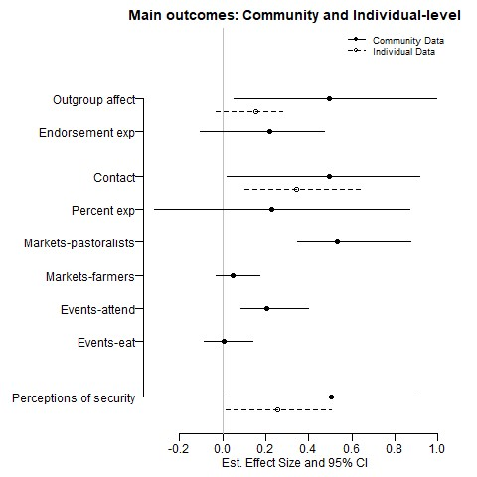

**Figure 1: Effect of treatment assignment on outcomes in community-level and individual-level data.** Points are average treatment effects versus control estimated using OLS. Lines are bootstrapped 95% confidence intervals. Solid lines are effects in the community-level data, dashed lines are effects in the individual-level data. The first set of effects concern intergroup affect; the second set concern voluntary contact; the last concerns insecurity. Effects in the figure are positive if ECPN improved outcomes and negative if ECPN worsened outcomes.

Figures 1 and 2 shows ECPN’s effect on all primary outcomes. Figure 1 shows the main analyses, where the solid lines are the community-level data and the dashed lines are the individual-level data. Figure 2 shows participants and nonparticipants compared to controls. From top to bottom, the outcomes are ordered to correspond with: (1) intergroup attitudes, (2) intergroup contact, and (3) insecurity. Some outcomes – observations in markets and at social events, survey experiments – are only possible in the community-level analysis.

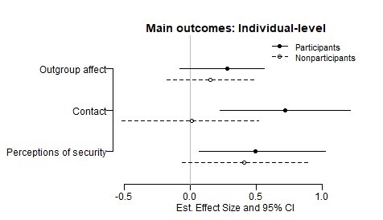

**Figure 2: Effect of treatment assignment on participants and nonparticipants.** Points are average treatment effects versus control estimated using OLS. Lines are bootstrapped 95% confidence intervals. Solid lines are effects among participants, dashed lines are effects among nonparticipants living in treatment communities. Effects in the figure are positive if ECPN improved outcomes and negative if ECPN worsened outcomes.

## 5.1 Intergroup Affect

ECPN bolstered intergroup affect in treatment communities. Compared to control communities, respondents in treatment communities report more trust in the other group and are more comfortable engaging in various relationships with the outgroup, such as trading goods and intermarriage. Intergroup affect as measured by the endorsement experiment also improves more in the treatment group than the control group, though the difference is not statistically significant at conventional levels.

Figures 3a and 3b show the descriptive change in affect for treatment and control communities. Affect in control communities decreased from baseline to endline, while intervention communities improved over the same time period. As measured by the endorsement experiment, affect declines in both treatment and control communities, but declines more in control communities. Both measures suggest that ECPN improved affect towards the outgroup.

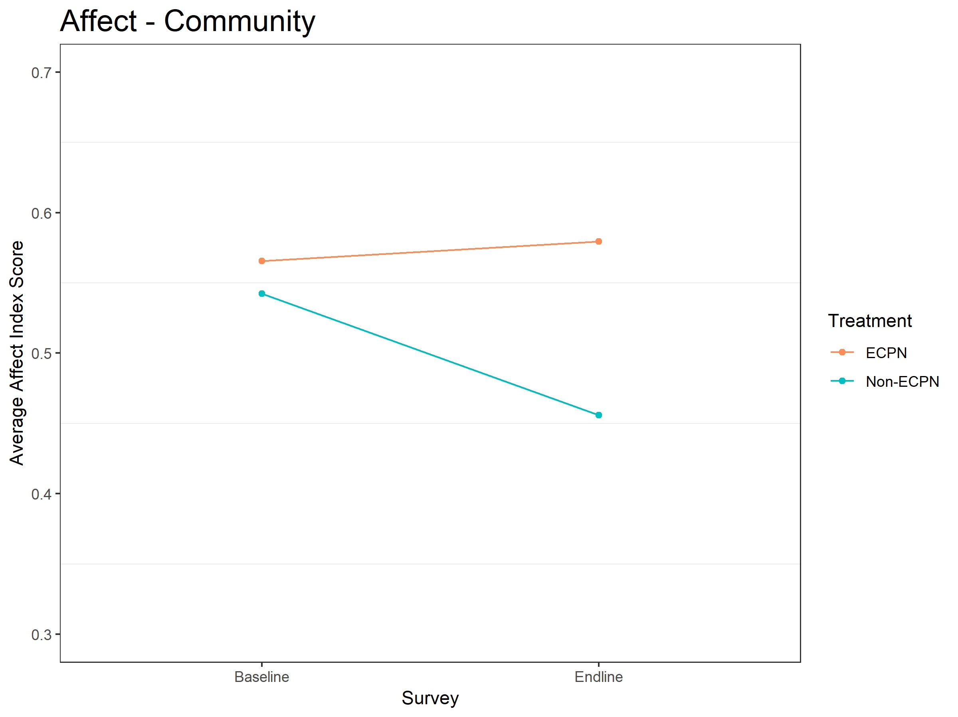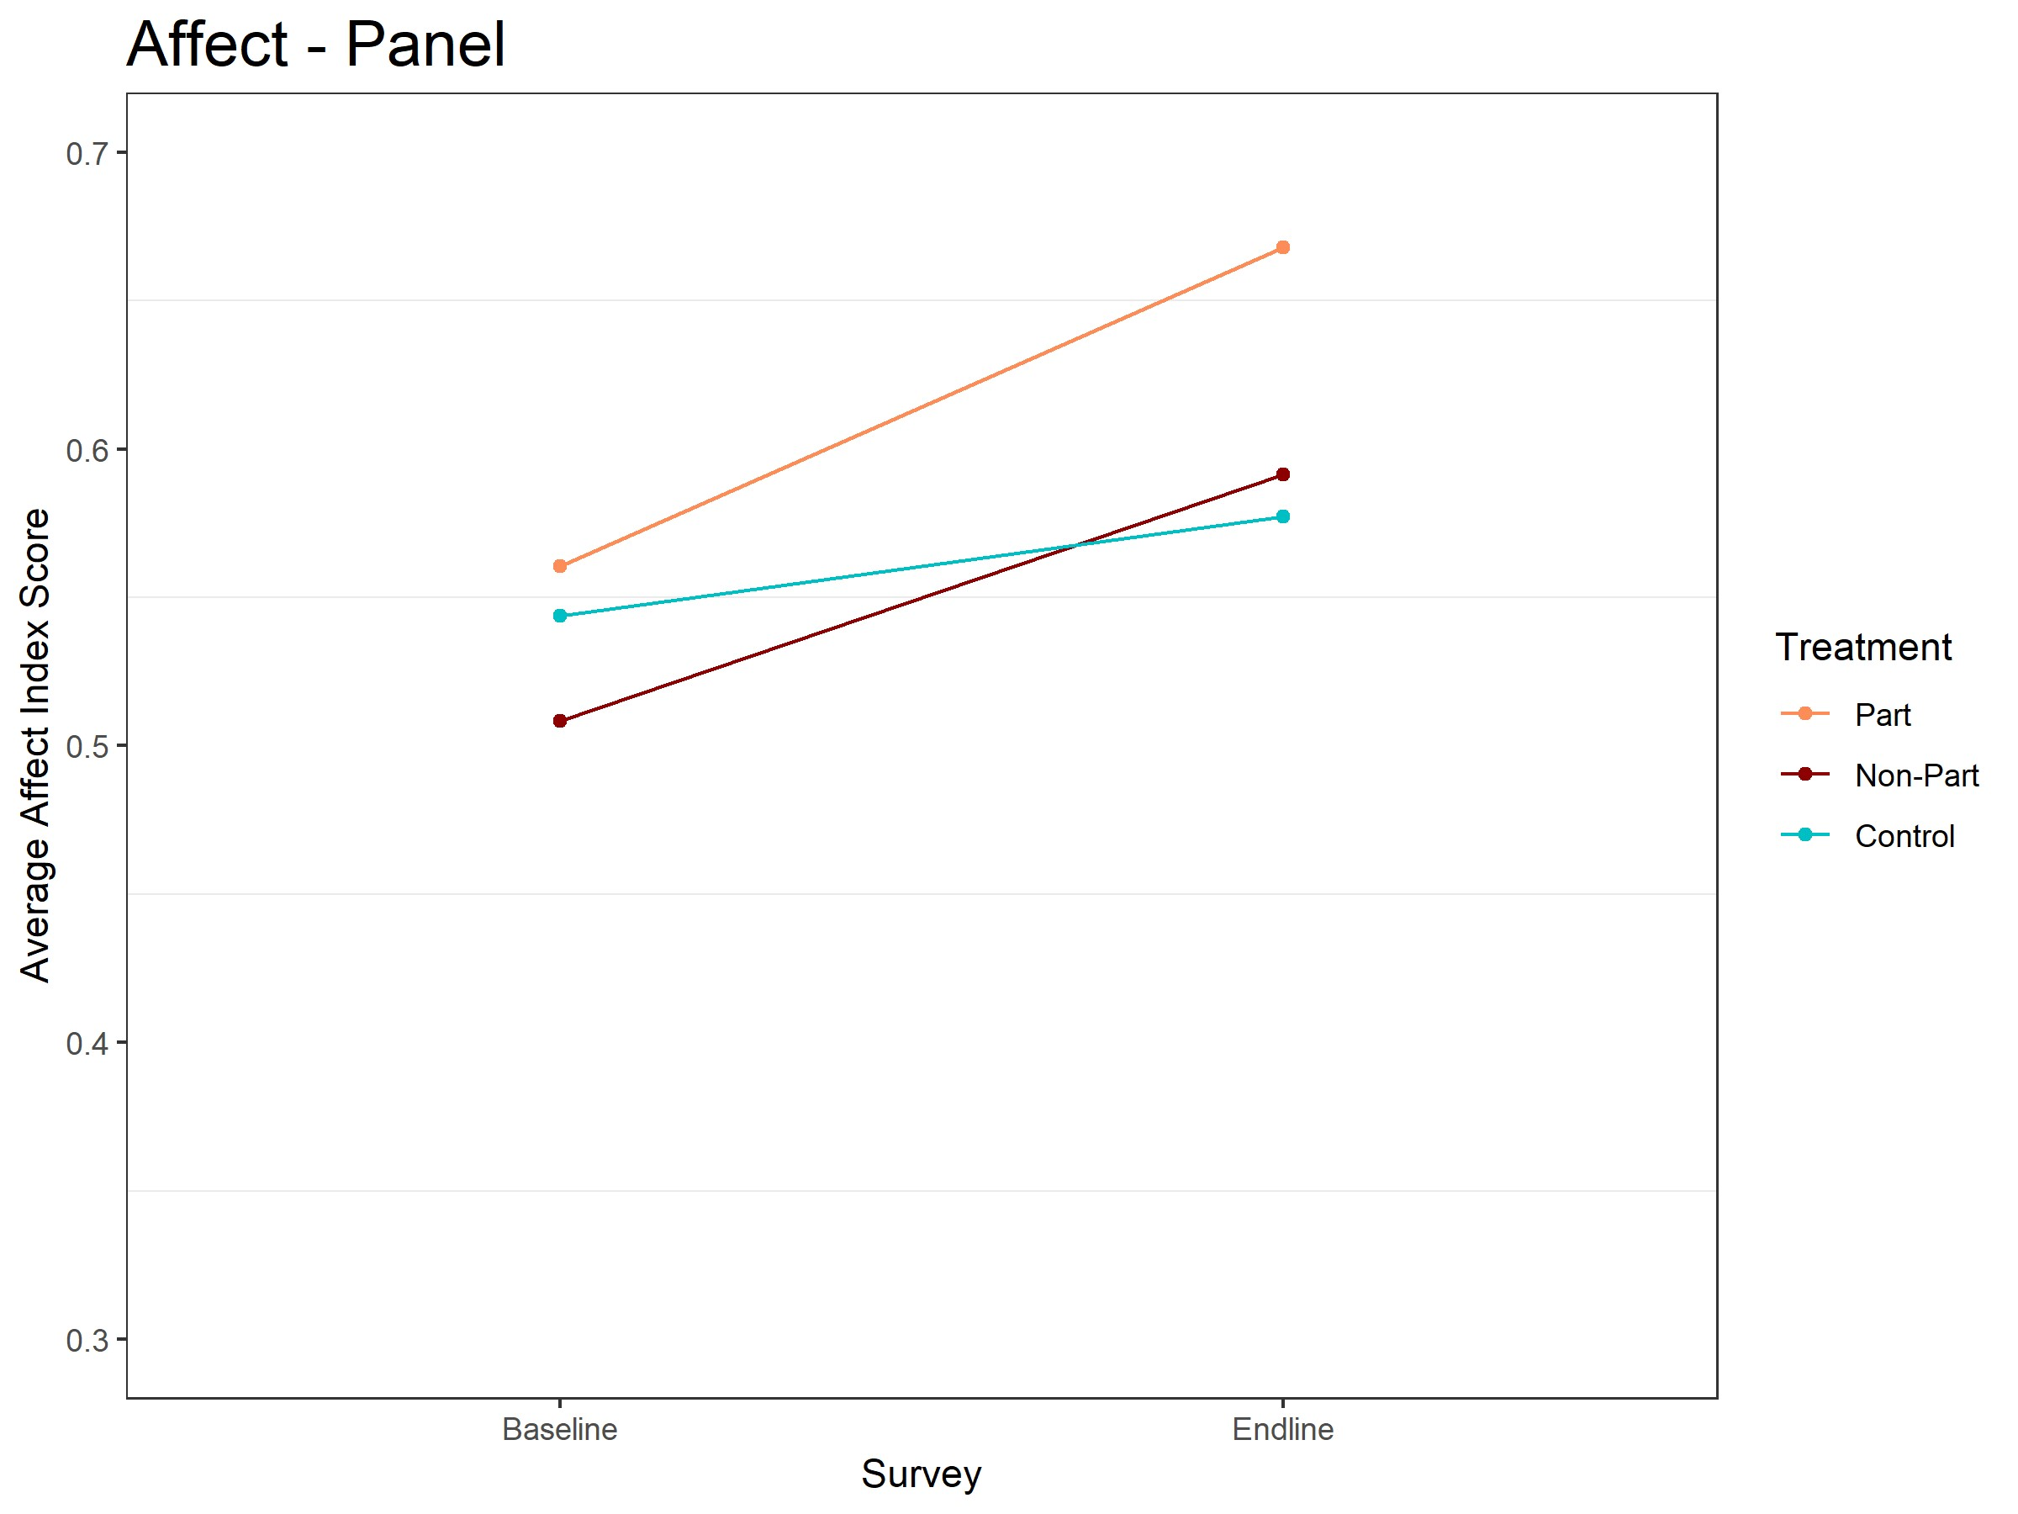

**(a) Descriptive change in community-level intergroup affect from baseline to endline.** Red line is treatment site average, **(b) Descriptive change in individual-level intergroup affect** blue line is control site average. Moving up the Y-axis indicates **from baseline to endline.** Red line is participant average, dark improved affect between groups. red line is nonparticipant average, blue line is control average. **Figure 3:** Intergroup Affect

## 5.2 Contact

The effect of ECPN on contact is substantial. Respondents in treatment communities report more contact and more willingness to engage in contact at all levels of the percent experiment; we also observe more pastoralists in markets interacting with farmers. Since the markets are all located in the farming community, the sustained presence of pastoralists there suggests that (1) farmers were accepting/tolerant of pastoralists in their community and (2) pastoralists felt comfortable spending time in the farmer community. The number of farmers present in the markets does not change in either group, which makes sense because the market is inside the farming community.

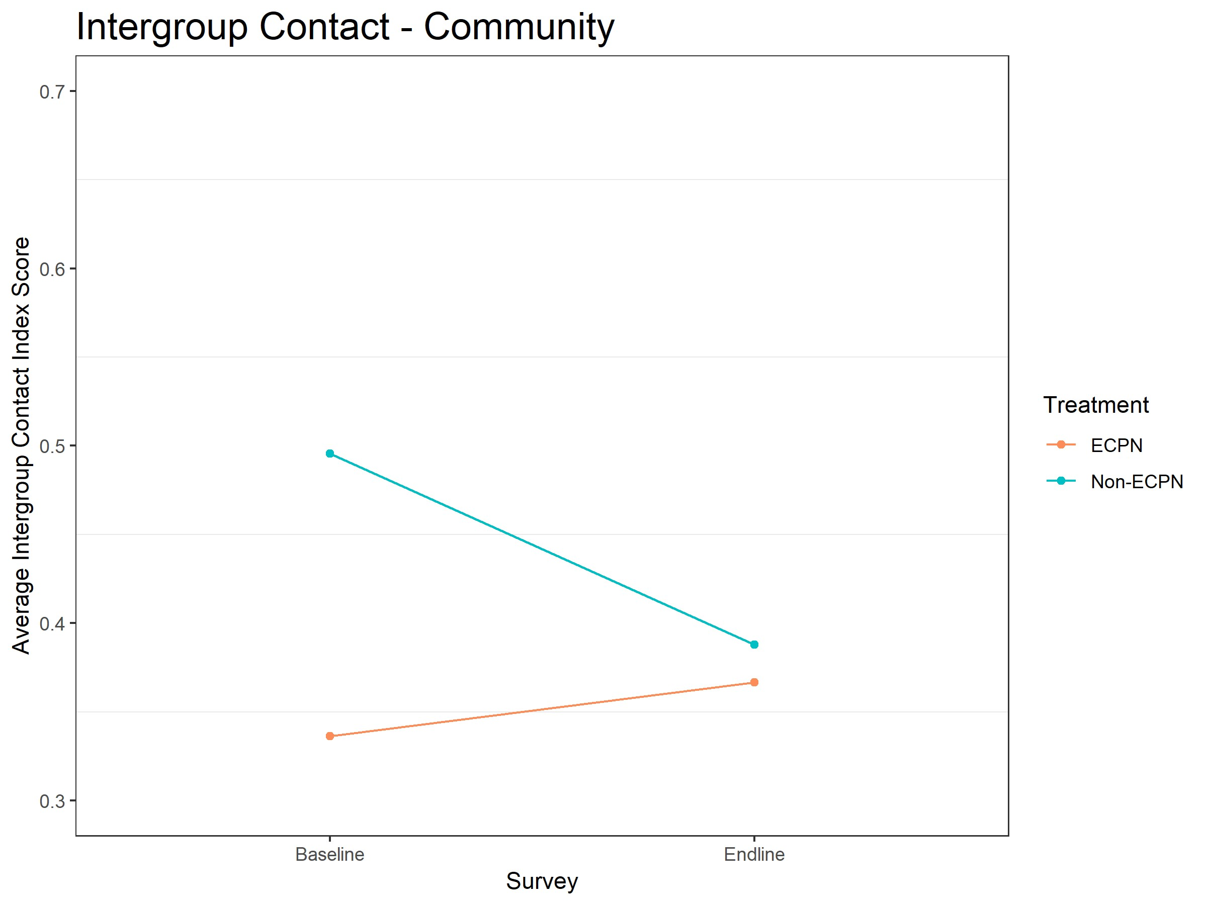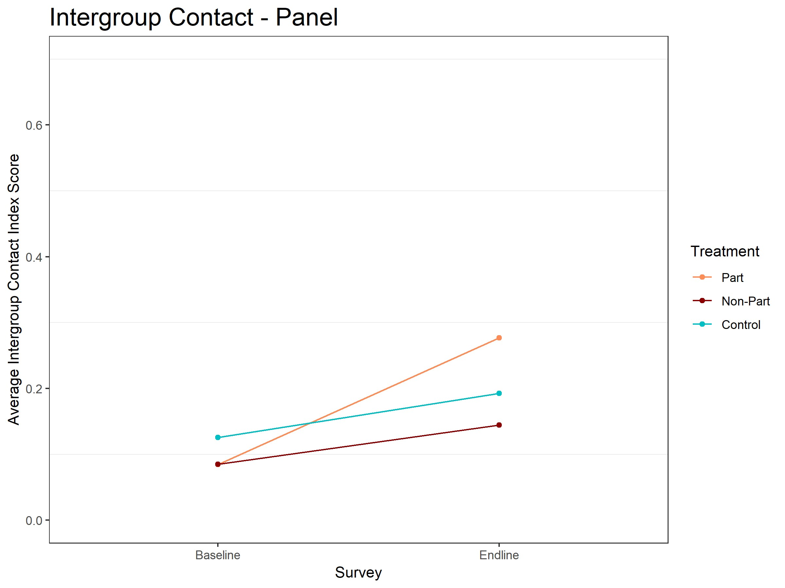

**(a) Descriptive change in community-level voluntary contact from baseline to endline.** Red line is treatment site average, **(b) Descriptive change in individual-level voluntary contact** blue line is control site average. Moving up the Y-axis indicates **from baseline to endline.** Red line is participant average, dark improved affect between groups. red line is nonparticipant average, blue line is control average.

**Figure 4:** Voluntary Contact

Figures 4a and 4b show the descriptive change in contact for treatment and control communities. The community-level self-reports show that intergroup contact declined sharply in control communities but rose slightly in treatment communities. It is impressive that ECPN increased contact while the social environment led to a sharp decline in control sites. The secular decline is due to the displacement in Benue, where intergroup contact went down for every group, though it declined far less in treatment sites. In Nassarawa, intergroup contact increased in both treatment and control sites, but far more in treatment sites.

At the individual-level, intergroup contact increased for committee participants but stayed largely the same for nonparticipants and controls. The large community-level effect, however, suggests that the effects of ECPN *did* extend to nonparticipants in treatment communities. But the effect did not extend to the type of nonparticipant who we could track down and resurvey.

## 5.3 Insecurity

ECPN’s substantially decreased feelings of insecurity in the treatment group. The effect is large in both the community-level and the individual-level data. Security in ECPN communities improved far more from baseline to endline than in control communities. At the individual-level, participants and nonparticipants improved equally, suggesting that these increases reflect a change in the conflict environment that impacts the entire community, not just respondents involved in ECPN committees. These improvements in treatment communities are especially powerful because other survey questions show that ECPN increased awareness of the conflict – respondents in ECPN communities are more likely than the control to know that violence between groups has occurred recently, yet they feel more secure.

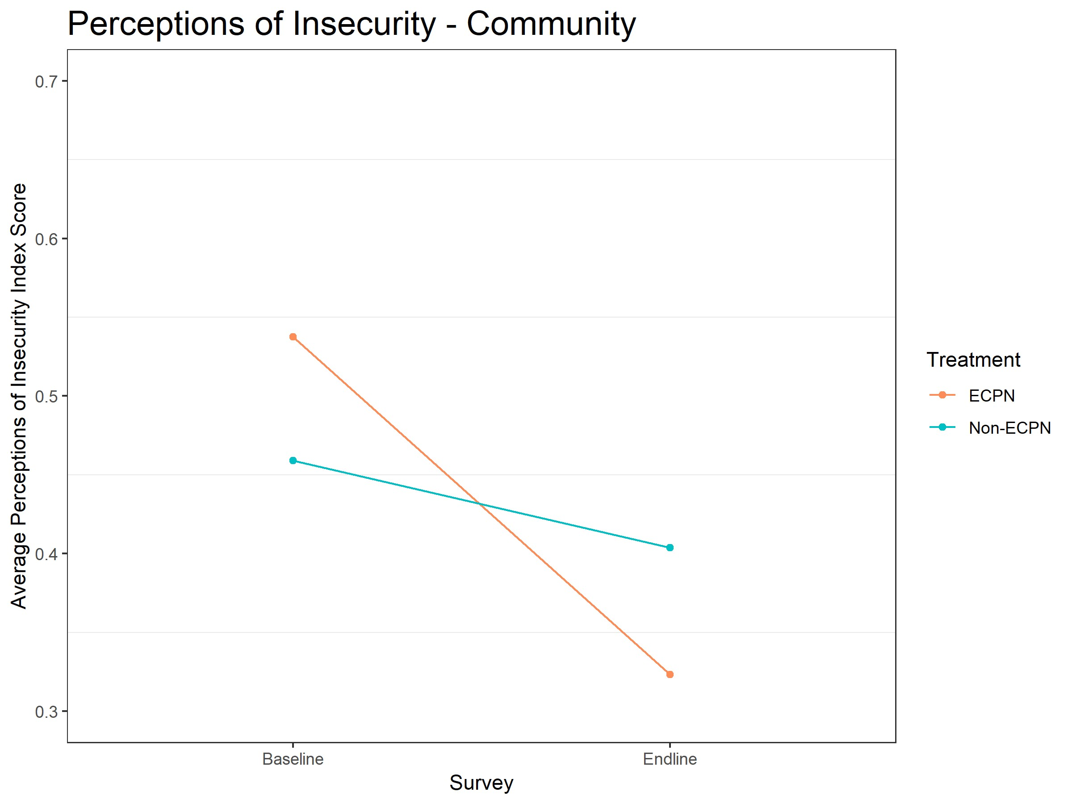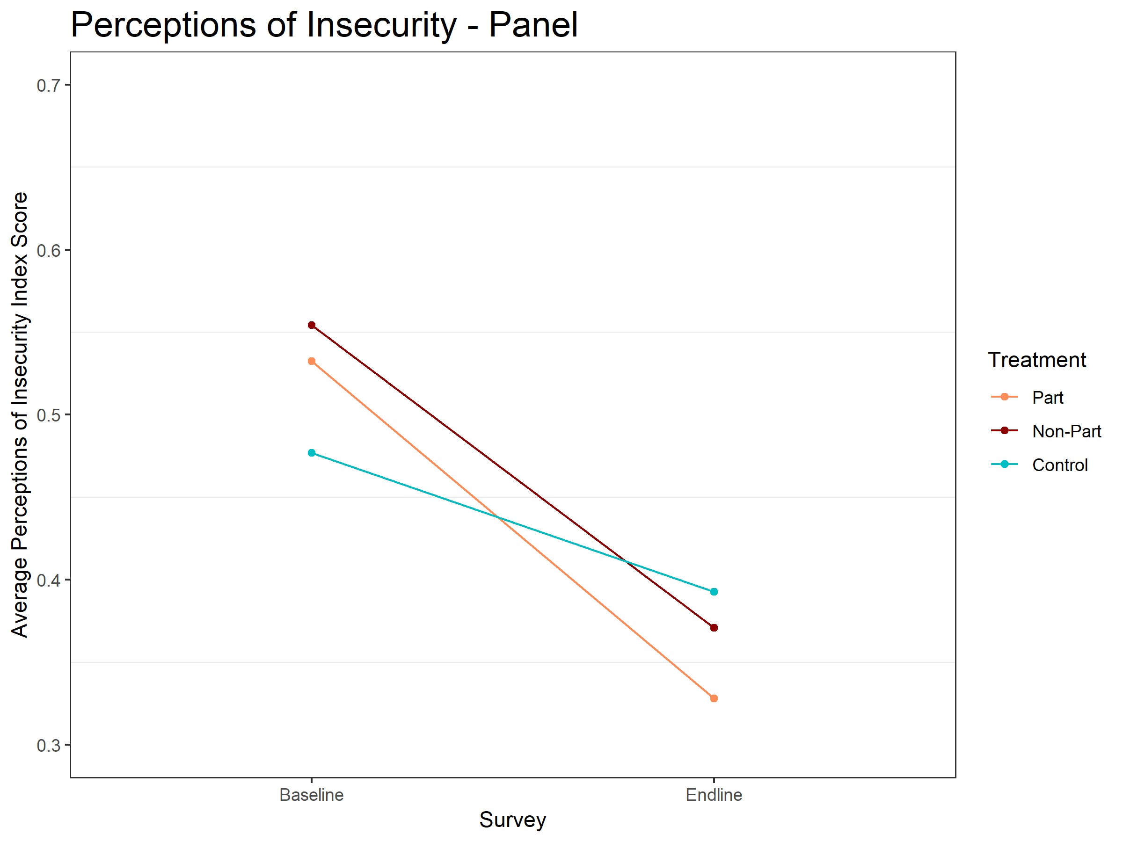

**(a) Descriptive change in community-level insecurity from baseline to endline.** Red line is treatment site average, blue line **(b) Descriptive change in individual-level insecurity from** is control site average. Moving up the Y-axis indicates improved **baseline to endline.** Red line is participant average, dark red affect between groups. line is nonparticipant average, blue line is control average.

**Figure 5:** Voluntary Contact

Figures 5a and 5b show the descriptive change in insecurity for treatment and control communities. The insecurity of control communities declines slightly from baseline to endline but insecurity in treatment communities declines substantially more. ECPN communities initially felt more insecure than control communities but were more secure at the end of the program. ECPN substantially improved the security of people in intervention communities. **5.4 Placebo: attitudes about violence**

To provide evidence that these survey results are due to intergroup contact and not due to social desirability bias, we analyze the effect of ECPN on attitudes about violence. If ECPN affects attitudes about violence, then we worry that other self-reports were affected by social desirability bias. If ECPN has no effect on attitudes about violence, then it is unlikely that other self-reports were affected by social desirability bias.

ECPN has no effect on attitudes about violence in the community-level data or the individual-level data. The lack of an effect on this placebo outcome, plus our use of survey experiments and behavioral observation to corroborate survey self-reports, suggests that our self-report results for primary outcomes are not due to social desirability bias. More details about the placebo analysis are available in Appendix C.

## 5.5 Mechanisms: Empathy, Threat, and Ingroup Expansion

Our results suggest that ECPN improved intergroup relations between farmers and pastoralists. We also undertook an exploratory analysis to learn the mechanisms through which ECPN affected attitudes. Based on the literature about contact theory, we looked for evidence that ECPN worked through empathy and perspective-taking, reduced feelings of threat, and expansion of the respondent’s ingroup to include the former outgroup.

Our exploratory analysis suggests that ECPN may have worked through increasing empathy. ECPN led to increased empathy in the community and individual-level analyses. In turn, increased empathy correlated with improved intergroup affect in the community-level data and with increases in intergroup affect and intergroup contact at the individual level. Increased perspective-taking also correlated with intergroup affect and intergroup contact in both analyses. ECPN may have led to increased perspective-taking, though not quite to a statistically significant level. This analysis suggests that increased empathy is a plausible mechanism through which ECPN improved intergroup relations. Because empathy was not randomly assigned, though, it’s equally plausible that ECPN improved intergroup affect and fostered intergroup contact, and that those outcomes led to increased empathy.

There is no evidence that ECPN reduced perceptions of threat or expanded perceptions of the ingroup. ECPN did not effect either survey index, and the public goods game shows that the treatment group was not better at coordinating than the control group. Treatment communities donated *less* to the shared community fund than control communities. At the individual-level, ECPN participants donated less than nonparticipants who donated less than respondents in the control group. This is the opposite pattern of what

we would expect if intergroup contact caused the communities to think of each other as part of one ingroup. Reduced threat and ingroup expansion are still plausible psychological mechanisms – each correlated strongly with at least one outcome – though neither was increased by ECPN.

More details about the mechanisms analyses can be found in Appendix C.

# 6 Discussion

This paper provides evidence that intergroup contact can improve intergroup relations, even in dire circumstances. We tested the effects of a programmatic contact intervention in an active and escalating conflict between farmers and pastoralists in Nigeria. The extreme violence of this context and personal involvement of the research subjects poses a tough test for contact to improve intergroup relations. The violence provides grievances that feed outgroup animosity and reinforce group differences, strengthen social and psychological barriers to improving attitudes, and reinforces the perception that groups’ material incentives are opposed. Despite the difficult context, the program improved intergroup affect, fostered more intergroup contact, and decreased feelings of insecurity in these communities. Methodologically, this study demonstrates the benefits of measuring outcomes at baseline and endline in a treatment group and in a control group as a means of capturing the secular trend.

We believe the program improved group relations and the prospects for peace because groups shared a latent interest that could be activated by contact. The shared interest was “latent” because it was not being identified by the groups in conflict. Cooperative contact helped reveal the latent shared interest to both groups by demonstrating how the groups can work together to achieve a common goal and removing psychological and social barriers to identifying the shared interest. Contact also provides the groups with opportunities to send costly signals of their intent to cooperate, which are important for intergroup cooperation (Kydd 2000). More studies need to be conducted to determine the limits of contact and the conditions under which contact can effectively improve intergroup relations.

This study also points to an opportunity for collaboration between scholars of intergroup contact and scholars of conflict. These literatures are often concerned with the same end goal – reducing conflict – but rarely speak to one another. Conflict scholars often see conflict as a bargaining problem, and violence as a bargaining failure. The conflict literature points to a lack of trust as the primary cause of conflict and usually posits a strong third party actor as necessary to guarantee peace. Intergroup contact research hints that intergroup contact can create cooperative norms and institutions that serve the same function as a strong third party. Improving relations – especially improving trust – through psychological interventions like intergroup contact can help groups overcome commitment problems and reduce the likelihood of violence.

Contactcouldhelpestablishcooperativenormsandinstitutionsinanumberofways. Inourfieldwork, we see evidence that contact strengthened existing conflict resolution structures, like leader arbitration. The leadership of each group convene with the “plaintiff” and “defendant” to arbitrate cross-group disagreements, such as cows caught grazing on farmland. Our research partners on the ground noted that these structures became more effective in ECPN communities because pastoralists became more aware of the financial value of the crops destroyed by cows and farmers became more aware of the difficulty of controlling and corralling thousands of cows.[17] Contact could also encourage ingroup policing: ingroup members punishing other ingroup members who violate the rights of outgroup members (Ditlmann and Samii 2016; Fearon and Laitin 1996). If groups “punish [their own] miscreants” (Fearon and Laitin 1996, 722), in a way that is visible to the other side, then the other side does not need to retaliate against the transgression.[ˆingroupPolice] Visible ingroup policing shows each side that the other can be trusted, alleviating commitment problems.

This paper also teaches us about settling disputes between sedentary peoples and semi-nomadic peoples. Violent conflict between settled peoples and semi-nomadic peoples is on the rise throughout Africa (Kuusaana and Bukari 2015; Mwamfupe 2015; Nnoko-Mewanu 2018). This study focuses on the Fulani, the largest semi-nomadic people on Earth (Encyclopedia 2017). Their way of life makes them targets for violence throughout Africa. Along with this conflict in Nigeria, Fulani in Mali have been the targets of violence so severe that researchers at Armed Conflict Location & Event Data Project called it “ethnic cleansing” (Economist 2019). Understanding how to prevent violent conflict between Fulani and settled peoples can help prevent violence that targets other nomadic, semi-nomadic, and itinerant peoples, such as the Tuaregs in West Africa, Kochi in Afghanistan, Khoisan of Southern Africa, and Romani of Europe. Preventing such violence could help preserve a dying way of life.

There remain several opportunities to learn about the effects of contact in conflict environments. First, this study employed a design to test the hypothesis that contact would improve group relations in an active conflict. It also provided exploratory evidence of the mechanisms through which contact affects group relations, showing that contact may have worked through increased empathy. Future studies can bring more causal evidence to the question of *how* contact improves group relations. Second, our program was designed, implemented, and randomized at the community-level because conflict between farmers and pastoralists occurs at the community level. Future studies should randomize individual community members’ participation in a contact-based intervention. Such studies could learn much about the affect of contact on individuals, including the dosage of contact necessary to improve attitudes, as well as how social norms and interpersonal discussion diffuse the positive effects of contact to individuals without outgroup contact.

Third, contact interventions, explicitly or implicitly, involve the groups cooperating to *achieve* a joint goal. ECPN was designed to benefit all communities by having the conflicting communities cooperate successfully. But what if contact is not successful and the goal is not achieved? Does contact itself still improve attitudes, or does contact work because groups begin to associate cross-group cooperation with good outcomes? In a similar vein, are Allport’s conditions necessary for contact to achieve its aims, or are they only needed insofar as they ensure the intergroup cooperation generates positive outcomes for both groups?

Future studies should determine the necessity of Allport’s conditions and attempt to differentiate the fact of contact from the outcomes that group cooperation produces.

# 7 Appendices

## 7.1 Appendix A: Randomization Inference and Bootstrapping

Randomization inference and bootstrapping are nonparametric methods to generate *p*-values (randomization inference) and confidence intervals (bootstrapping). With *randomization inference*, we first shuffle the treatment variable to break the relationship between treatment and outcomes. Next we regress outcomes on treatment using our regression equation and store the resulting coefficient. Lastly, we repeat that process

10,000 times to create the distribution of coefficients we would observe if treatment had no effect on outcomes – the null hypothesis. Our *p*-value is the proportion of the null distribution that is greater than or equal to our observed coefficient.

*Bootstrapping* for standard errors is similar, but instead of shuffling the treatment indicator we resample units with replacement. By resampling with replacement, we create the empirical distribution of our data and the range of possible treatment effects we might observe if we repeated the experiment 10,000 times. The treatment effect at the 2.5th percentile and at the 97.5th percentile are equivalent to a 95% confidence interval (Efron and Tibshirani 1994).

In each of these procedures, we mimic our randomization process by randomizing/resampling the intervention to communities in site-level clusters and within state blocks. This means that both communities in an implementation site (farmers and pastoralists) will always be treated/sampled together and that assignment to the intervention and resampling are conducted separately in Nassarawa and Benue, just as the intervention

was assigned in this study. This procedure ensures that our null distribution (for *p*-values) is created by randomizing the intervention between exchangeable units and that our empirical distribution (for confidence intervals) is created by resampling units as they were sampled. **7.2 Appendix B: Results with Additive Indices**

These tables show results for self-report survey outcomes made with additive indices. The tables include the coefficients and *p*-values with additive indices for community- and individual-level analyses.

|  |  |  |  |  |
| --- | --- | --- | --- | --- |
|  | ag_coef | ag_p | ind_coef | ind_p |
| Affect | 0.093 | 0.037 | 0.062 | 0.056 |
| Insecurity | 0.015 | 0.174 | 0.030 | 0.011 |
| Contact | 0.054 | 0.193 | 0.070 | 0.143 |

**Table 1: Effect of ECPN on main outcomes with additive indices.** The first and second columns are coefficients and *p*-values for aggregate community-level analyses. The third and fourth columns are coefficients and *p*-values for individual-level analyses.

## 7.3 Appendix C: Mechanisms and Placebo Analysis

These tables show results for mechanism and placebo outcomes using inverse-covariance weighted indices. The tables include the coefficients and *p*-values for community- and individual-level analyses.

|  |  |  |  |  |
| --- | --- | --- | --- | --- |
|  | ag_coef | ag_p | ind_coef | ind_p |
| Threat | -0.065 | 0.796 | 0.007 | 0.350 |
| Empathy | 0.129 | 0.089 | 0.127 | 0.010 |
| Perspective-Taking | -0.040 | 0.640 | 0.029 | 0.195 |
| Ingroup Expansion | 0.036 | 0.252 | 0.016 | 0.166 |
| Placebo (Violence) | -0.067 | 0.691 | -0.007 | 0.556 |

**Table 2: Effect of ECPN on mechanism and placebo outcomes.** The first and second columns are coefficients and *p*-values for aggregate community-level analyses. The third and fourth columns are coefficients and *p*-values for individual-level analyses.

## 7.4 Appendix D: Survey Questions Outgroup Affect

* With regards to someone from [X GROUP], would you feel comfortable:
  + if they worked in your field?
  + paying them to watch your animals?
  + trading goods with them?
  + sharing a meal with them?
  + with a close relative marrying a person from [X GROUP]?
* From 1-5, how much do you trust people from [X GROUP] in your area?
* Now I’m going to ask you questions about your community here in Benue/Nassarawa, including [X GROUP]. Please tell me how strongly you agree/disagree with each of the following statements: People in this area can be trusted.

### Contact

* Now I’m going to ask you questions about your contact with [X GROUP] in your area.
  + Think of the market you go to most frequently. During the past month, have members of X GROUP gone to that market too? In the past month, how many times did you interact with X group in the market?
* In the past month, have you:
  + Joined a member of X group for a social event outside the home? How often?
  + Hosted a member of X group for a ceremony in your home? How often?
  + Gone to the home of a member of X group for a ceremony? How often?
  + Have you interacted with members of X group in any other way in the past month?

### Insecurity

* In the last year were there any areas that you avoided going to or through because of insecurity during the night?
* In the last year were there any areas that you avoided going to or through because of insecurity, during the day?
* In the last year, did insecurity ever prevent you from:
  + Working when you wanted to work? About how many days were you unable to work?
  + Going to the market?
  + Getting water for the household?
  + Going to your field/farm?
  + Moving your animals to grazing areas?
  + Moving your animals to water?
  + Earning money or going to work?
  + Going to school?

### Endorsement Experiment

• Imagine that there is a proposal by [**the Farmer’s Cooperative Society**/**MACBAN**] for action to enhance access to clean water in rural areas. Though expensive, the proposal aims to bring fresh, clean water to hundreds of areas without access to it, including this one. If this were proposed, how would you feel about it?

### Percent Experiemnt

* Think about groups that you might join in your leisure time. Would you join a group that had

**5/25/50/75**% X Group members?

* Think about the community you live in. Would you live in a community that had **5/25/50/75**% X Group members?

### Violence Placebo

• Now I am going to ask you some questions about the use of violence. Is it always, sometimes, rarely, or never justified to use violence to do each of the following:

* Retaliate against violence
* Defend one’s group
* Maintain culture and traditions
* Defend one’s religion
* Bring criminals to justice
* Force the government to change their policies

### Threat

• Please tell me how strongly you agree/disagree with each of the following statements:

* You see X group as a threat to your community
* You think X group have too much influence on your community
* You think that people from X group have different morals than people from your group

### Empathy and Perspective Taking

* Suppose something unfortunate happened to someone from X group in this community, such as a serious illness or the death of a parent. How likely is it that some people in the community from your group would get together to help them?
* Suppose something unfortunate happened to someone from your group in this community, such as a serious illness or the death of a parent. How likely is it that some people in the community from X group would get together to help them?
* Some people say [X GROUP] is responsible for most of the violence in this community, while others say that both groups are responsible for the violence here. Which is closer to your view?

### Ingroup Expansion

• Now I’m going to ask you questions about your community here in Benue/Nassarawa, including X group. Please answer honestly and remember that your responses will remain confidential. Please tell me how strongly you agree/disagree with each of the following statements:

* People in this area are willing to help their neighbors across ethnic and religious lines
* People in this area can be trusted
* People in this area generally do not get along together
* People in this area do not share the same morals
* People in this area see the benefits of working together to achieve common goals
* What proportion of your group in this area contribute time or money toward common development goals, such as building a levy or repairing a road?
* What proportion of X group in this area contribute time or money toward common development goals, such as building a levy or repairing a road?
* If there was a water supply problem in this community, how likely is it that people from your group and people from X group would cooperate to try to solve the problem?

### Public Goods Game

"Thank you very much for participating in our survey. Before I go, there is one last thing. As you may have heard, we have development funds to use in this community. We have randomly selected you as one of the 50 people to receive these funds. These funds are not for a Mercy Corps project, but rather for you to keep personally or to donate to a community fund.

We have 1,000 Naira to give to you. It is yours, and you can use it either way–for yourself or for a community good.

Your community and [joint farmer/pastoralist community] have created a project committee to whom you can donate this money so that it may be used to help both communities. The project committee has 4 people from each community. We have found a donor that will match the funds that you all contribute to the project committee, so that if you donate 100 Naira the project committee receives 300 Naira, and if you donate all 1,000 Naira the project committee receives 3,000 Naira. You are welcome to donate none, some, or all of the money to the project committee.

These are your individual donation envelopes. All the donations will be private – only you will know how much money you donated. It essential that you keep how much you give private – please do not tell anyone. I have with me a donation envelope to collect donations. Please go into your home, put however much of the 1,000 Naira you wish to donate to the project committee in the envelope, take whatever amount you want to keep for yourself, and come back to place your envelope in the donation envelope. Remember, you are welcome to donate none, some, or all of the money to the project committee. After that we are finished and you may continue your day. We will come back and publicly announce how much money your community’s project committee will receive."

# References

Akinwotu, Emmanuel. 2018. “Nigeria’s Farmers and Herders Fight a Deadly Battle for

Scarce Resources.” *New York Times*. [https://www.nytimes.com/2018/06/25/world/africa/ nigeria-herders-farmers.html.](https://www.nytimes.com/2018/06/25/world/africa/nigeria-herders-farmers.html)

Allport, Gordon. 1954. “The Nature of Prejudice.” *Garden City, NJ Anchor*.

Al Ramiah, Ananthi, and Miles Hewstone. 2013. “Intergroup Contact as a Tool for Reducing, Resolving, and Preventing Intergroup Conflict: Evidence, Limitations, and Potential.” *American Psychologist* 68(7): 527.

Barlow, Fiona Kate et al. 2012. “The Contact Caveat: Negative Contact Predicts Increased Prejudice More Than Positive Contact Predicts Reduced Prejudice.” *Personality and Social Psychology Bulletin* 38(12): 1629–43.

Bar-Tal, Daniel. 2000. “From Intractable Conflict Through Conflict Resolution to Reconciliation: Psychological Analysis.” *Political Psychology* 21(2): 351–65.

———. 2007. “Sociopsychological Foundations of Intractable Conflicts.” *American Behavioral Scientist* 50(11): 1430–53.

Bar-Tal, Daniel, and Talia Avrahamzon. 2017. “Development of Delegitimization and Animosity

in the Context of Intractable Conflict.”

Bassett, Thomas J. 2009. “Mobile Pastoralism on the Brink of Land Privatization in Northern côte

d’Ivoire.” *Geoforum* 40(5): 756–66.

Batson, C Daniel et al. 1997. “Empathy and Attitudes: Can Feeling for a Member of a Stigmatized Group Improve Feelings Toward the Group?” *Journal of personality and social psychology* 72(1): 105.

Boisjoly, Johanne et al. 2006. “Empathy or Antipathy? The Impact of Diversity.” *American Economic Review* 96(5): 1890–1905.

Bornstein, Gary. 2003. “Intergroup Conflict: Individual, Group, and Collective Interests.” *Person-*

*ality and social psychology review* 7(2): 129–45.

Broockman, David, and Joshua Kalla. 2016. “Durably Reducing Transphobia: A Field Experiment on Door-to-Door Canvassing.” *Science* 352(6282): 220–24.

Burns, Justine, Lucia Corno, and Eliana La Ferrara. 2015. *Interaction, Prejudice and Performance. Evidence from South Africa*. Working paper.

Carrell, Scott E, Mark Hoekstra, and James E West. 2015. *The Impact of Intergroup Contact on Racial Attitudes and Revealed Preferences*. National Bureau of Economic Research.

Christ, Oliver et al. 2014. “Contextual Effect of Positive Intergroup Contact on Outgroup Prejudice.” *Proceedings of the National Academy of Sciences* 111(11): 3996–4000.

Cook, Stuart W. 1985. “Experimenting on Social Issues: The Case of School Desegregation.” *American Psychologist* 40(4): 452.

Cook, Stuart Wellford, Lawrence Samuel Wrightsman, and Shirley Wrightsman. 1971. *The Effect*

*of Unintended Interracial Contact Upon Racial Interaction and Attitude Change*. Educational resources in information center, US Department of health, education & welfare.

Cotula, Lorenzo, Camilla Toulmin, Ced Hesse, and others. 2004. *Land Tenure and Administration*

*in Africa: Lessons of Experience and Emerging Issues*. International Institute for Environment; Development London.

Daniel, Soni. 2018. “Anti-Open Grazing Law: Nass, Benue, Kwara, Taraba Tackle Defence Minis-

ter.” *Vanguard*. [https://www.vanguardngr.com/2018/06/anti-open-grazing-law-nass-benue-kwara-taraba-t](https://www.vanguardngr.com/2018/06/anti-open-grazing-law-nass-benue-kwara-taraba-tackle-defence-minister/) Deutsch, Morton. 1973. *The Resolution of Conflict: Constructive and Destructive Processes*. Yale University Press.

Deutsch, Morton, and Mary Evans Collins. 1951. *Interracial Housing: A Psychological Evaluation of a Social Experiment*. U of Minnesota Press.

Ditlmann, Ruth K, and Cyrus Samii. 2016. “Can Intergroup Contact Affect Ingroup Dynamics? Insights from a Field Study with Jewish and Arab-Palestinian Youth in Israel.” *Peace and Conflict: Journal of Peace Psychology* 22(4): 380.

Ditlmann, Ruth K, Cyrus Samii, and Thomas Zeitzoff. 2017. “Addressing Violent Intergroup Conflict from the Bottom up?” *Social Issues and Policy Review* 11(1): 38–77.

Doosje, Bertjan, Russell Spears, and Willem Koomen. 1995. “When Bad Isn’t All Bad: Strategic Use of Sample Information in Generalization and Stereotyping.” *Journal of Personality and Social psychology* 69(4): 642.

Dovidio, John F, Angelika Love, Fabian MH Schellhaas, and Miles Hewstone. 2017. “Reducing

Intergroup Bias Through Intergroup Contact: Twenty Years of Progress and Future Directions.” *Group*

*Processes & Intergroup Relations* 20(5): 606–20.

Duru, Peter. 2018. “Court Stops Inspector General from Proscribing Benue Livestock Guard.” *Van-*

*guard*. [https://www.vanguardngr.com/2018/11/court-stops-ig-from-proscribing-benue-livestock-guards](https://www.vanguardngr.com/2018/11/court-stops-ig-from-proscribing-benue-livestock-guards/) Economist, The. 2019. “Malicious Malitias: States in the Sahel Have Unleashed Ethnic Gangs

with Guns.” *The Economist*. [https://www.economist.com/middle-east-and-africa/2019/05/04/ states-in-the-sahel-have-unleashed-ethnic-gangs-with-guns.](https://www.economist.com/middle-east-and-africa/2019/05/04/states-in-the-sahel-have-unleashed-ethnic-gangs-with-guns)

Efron, Bradley, and Robert J Tibshirani. 1994. *An Introduction to the Bootstrap*. CRC press.

Encyclopedia, NewWorld. 2017. “Fulani—NewWorldEncyclopedia,” [//www.newworldencyclop](//www.newworldencyclopedia.org/p/index.php?title=Fulani&oldid=1004777)edia.

[org/p/index.php?title=Fulani&oldid=1004777.](//www.newworldencyclopedia.org/p/index.php?title=Fulani&oldid=1004777)

Fearon, James D. 1994. “Ethnic War as a Commitment Problem.” In *Annual Meetings of the American Political Science Association*, 2–5.

———. 1995. “Rationalist Explanations for War.” *International organization* 49(3): 379–414.

Fearon, James D, and David D Laitin. 1996. “Explaining Interethnic Cooperation.” *American*

*political science review* 90(4): 715–35.

———. 2000. “Violence and the Social Construction of Ethnic Identity.” *International organization* 54(4): 845–77.

Festinger, Leon. 1962. 2 *A Theory of Cognitive Dissonance*. Stanford university press.

Gaertner, Samuel L, and John F Dovidio. 2014. *Reducing Intergroup Bias: The Common Ingroup Identity Model*. Psychology Press.

[m](https://frontera.net/news/africa/nigeria-violence-in-the-middle-belt-becomes-major-concern-for-president-buhari/)

Gaertner, Samuel L et al. 1993. “The Common Ingroup Identity Model: Recategorization and the Reduction of Intergroup Bias.” *European review of social psychology* 4(1): 1–26.

Gubler, Joshua R. 2013. “When Humanizing the Enemy Fails: The Role of Dissonance and Justification in Intergroup Conflict.” In *Annual Meeting of the American Political Science Association*,

Hailemariam, Adium. 2018. “Nigeria: Violence in the Middle Belt Becomes Major Concern for

PresidentBuhari.” *Frontera*. [https://frontera.net/news/africa/nigeria-violence-in-the-middle-belt-beco](https://frontera.net/news/africa/nigeria-violence-in-the-middle-belt-becomes-major-concern-for-president-buhari/) Harrison, Glenn W, and John A List. 2004. “Field Experiments.” *Journal of Economic literature* 42(4): 1009–55.

Harwood, Asch. 2019. “Update: The Numbers Behind Sectarian Violence in Nigeria.” *Council on*

*ForeignRelations*. [https://www.cfr.org/blog/update-numbers-behind-sectarian-violence-nigeria.](https://www.cfr.org/blog/update-numbers-behind-sectarian-violence-nigeria)

Ilo, Udo Jude, Jonathan-Ichavar Ier, and Yemi Adamolekun. 2019. “The Deadliest Conflict You’ve Never Heard of: Nigeria’s Cattle Herders and Farmers Wage a Resource War.” *Foreign Affairs*. [https://www. foreignaffairs.com/articles/nigeria/2019-01-23/deadliest-conflict-youve-never-heard.](https://www.foreignaffairs.com/articles/nigeria/2019-01-23/deadliest-conflict-youve-never-heard) Kertzer, Joshua D, Ryan Brutger, and Kai Quek. 2018. “Strategic Empathy and the Security

Dilemma: Cross-National Experimental Evidence from China and the United States.”

Klein, William M, and Ziva Kunda. 1992. “Motivated Person Perception: Constructing Justifica-

tions for Desired Beliefs.” *Journal of experimental social psychology* 28(2): 145–68.

Kunda, Ziva. 1990. “The Case for Motivated Reasoning.” *Psychological bulletin* 108(3): 480.

Kuusaana, Elias Danyi, and Kaderi Noagah Bukari. 2015. “Land Conflicts Between Smallholders and Fulani Pastoralists in Ghana: Evidence from the Asante Akim North District (Aand).” *Journal of rural studies* 42: 52–62.

Kydd, Andrew. 2000. “Trust, Reassurance, and Cooperation.” *International Organization* 54(2): 325–57.

Lemmer, Gunnar, and Ulrich Wagner. 2015. “Can We Really Reduce Ethnic Prejudice Outside the Lab? A Meta-Analysis of Direct and Indirect Contact Interventions.” *European Journal of Social Psychology* 45(2): 152–68.

Marmaros, David, and Bruce Sacerdote. 2006. “How Do Friendships Form?” *The Quarterly Journal of Economics* 121(1): 79–119.

McDonnel, Tim. 2017. “Why It’s Now a Crime to Let Cattle Graze Freely in 2 Nigerian

States.” *National Public Radio (NPR)*. [https://www.npr.org/sections/goatsandsoda/2017/12/12/ 569913821/why-its-now-a-crime-to-let-cattle-graze-freely-in-2-nigerian-states.](https://www.npr.org/sections/goatsandsoda/2017/12/12/569913821/why-its-now-a-crime-to-let-cattle-graze-freely-in-2-nigerian-states)

McDougal, Topher L et al. 2015. “The Effect of Farmer-Pastoralist Violence on Income: New

Survey Evidence from Nigeria’s Middle Belt States.” *Economics of Peace and Security Journal* 10(1): 54–65. Mousa, Salma. 2018. “Overcoming the Trust Deficit: Intergroup Contact and Associational Life in

Post-Isis Iraq.”

Mwamfupe, Davis. 2015. “Persistence of Farmer-Herder Conflicts in Tanzania.” *International Journal of Scientific and Research Publications* 5(2): 1–8.

Network, Nigeria Research. 2014. “Indigeneity, Belonging, and Religious Freedom in Nigeria:

Citizens’ Views from the Street.” *5. NRN Policy Brief*. [https://www.researchgate.net/publication/ 333320680_Indigeneity_Belonging_Religious_Freedom_in_Nigeria.](https://www.researchgate.net/publication/333320680_Indigeneity_Belonging_Religious_Freedom_in_Nigeria)

Nickerson, Raymond S. 1998. “Confirmation Bias: A Ubiquitous Phenomenon in Many Guises.” *Review of general psychology* 2(2): 175–220.

Nnoko-Mewanu, Juliana. 2018. “Farmer-Herder Conflicts on the Rise in Africa.” *Human Rights Watch*.

Okpara, Uche T, Lindsay C Stringer, Andrew J Dougill, and Mohammed D Bila. 2015. “Conflicts About Water in Lake Chad: Are Environmental, Vulnerability and Security Issues Linked?” *Progress in*

*Development Studies* 15(4): 308–25.

Page-Gould, Elizabeth, Rodolfo Mendoza-Denton, and Linda R Tropp. 2008. “With a Little Help from My Cross-Group Friend: Reducing Anxiety in Intergroup Contexts Through Cross-Group Friendship.”

*Journal of personality and social psychology* 95(5): 1080.

Paluck, Elizabeth Levy. 2009. “Reducing Intergroup Prejudice and Conflict Using the Media: A Field Experiment in Rwanda.” *Journal of personality and social psychology* 96(3): 574.

Paluck, Elizabeth Levy, Seth A Green, and Donald P Green. 2019. “The Contact Hypothesis Re-Evaluated.” *Behavioural Public Policy* 3(2): 129–58.

Paolini, Stefania, JakeHarwood, andMarkRubin. 2010. “NegativeIntergroupContactMakesGroup Memberships Salient: Explaining Why Intergroup Conflict Endures.” *Personality and Social Psychology*

*Bulletin* 36(12): 1723–38.

Pettigrew, Thomas F, and Linda R Tropp. 2006. “A Meta-Analytic Test of Intergroup Contact Theory.” *Journal of personality and social psychology* 90(5): 751.

———. 2008. “How Does Intergroup Contact Reduce Prejudice? Meta-Analytic Tests of Three Mediators.” *European Journal of Social Psychology* 38(6): 922–34.

Rao, Gautam. 2019. “Familiarity Does Not Breed Contempt: Generosity, Discrimination, and Diversity in Delhi Schools.” *American Economic Review* 109(3): 774–809.

Rimé, Bernard, Patrick Kanyangara, Vincent Yzerbyt, and Dario Paez. 2011. “The Impact of

Gacaca Tribunals in Rwanda: Psychosocial Effects of Participation in a Truth and Reconciliation Process

After a Genocide.” *European Journal of Social Psychology* 41(6): 695–706.

Rohner, Dominic, Mathias Thoenig, and Fabrizio Zilibotti. 2013. “War Signals: A Theory of Trade, Trust, and Conflict.” *Review of Economic Studies* 80(3): 1114–47.

Scacco, Alexandra, and Shana S Warren. 2018. “Can Social Contact Reduce Prejudice and Discrimination? Evidence from a Field Experiment in Nigeria.” *American Political Science Review* 112(3): 654–77.

Slavin, Robert E, and Robert Cooper. 1999. “Improving Intergroup Relations: Lessons Learned from Cooperative Learning Programs.” *Journal of Social issues* 55(4): 647–63.

Stark, Tobias H, Andreas Flache, and René Veenstra. 2013. “Generalization of Positive and Negative Attitudes Toward Individuals to Outgroup Attitudes.” *Personality and Social Psychology Bulletin* 39(5): 608–22.

Stephan, Walter G, and Cookie White Stephan. 1985. “Intergroup Anxiety.” *Journal of social issues* 41(3): 157–75.

Sundberg, Ralph, and Erik Melander. 2013. “Introducing the Ucdp Georeferenced Event Dataset.” *Journal of Peace Research* 50(4): 523–32.

Tajfel, Henri, and John C Turner. 1979. “An Integrative Theory of Intergroup Conflict.” *The social psychology of intergroup relations* 33(47): 74.

Tavris, Carol, and Elliot Aronson. 2008. *Mistakes Were Made (but Not by Me): Why We Justify Foolish Beliefs, Bad Decisions, and Hurtful Acts*. Houghton Mifflin Harcourt.

Thomas, Natalie, and Sumant Nigam. 2018. “Twentieth-Century Climate Change over Africa: Seasonal Hydroclimate Trends and Sahara Desert Expansion.” *Journal of Climate* 31(9): 3349–70.

Unah, Linus. 2018. “In Nigeria’s Diverse Middle Belt, a Drying Landscape Deepens Violent Divides.” *Christian Science Minitor*.

UNHCR. 2019. *UNHCR Statistical Yearbook*. https://www.unhcr.org/en-us/figures-at-aglance.html: United Nations High Commission for Refugees.

Van Dessel, Pieter, Sean Hughes, and Jan De Houwer. 2019. “How Do Actions Influence Attitudes?

An Inferential Account of the Impact of Action Performance on Stimulus Evaluation.” *Personality and Social*

*Psychology Review* 23(3): 267–84.

Van Laar, Colette, Shana Levin, Stacey Sinclair, and Jim Sidanius. 2005. “The Effect of University Roommate Contact on Ethnic Attitudes and Behavior.” *Journal of Experimental Social Psychology* 41(4): 329–45.

Van Zomeren, Martijn, Agneta H Fischer, and Russell Spears. 2007. “Testing the Limits of

Tolerance: How Intergroup Anxiety Amplifies Negative and Offensive Responses to Out-Group-Initiated

Contact.” *Personality and Social Psychology Bulletin* 33(12): 1686–99.

Verwimp, Philip, and others. 2012. “Food Security, Violent Conflict and Human Development: Causes and Consequences.” *United Nations Development Programme Working Paper*: 1–13.

Ward, Andrew et al. 1997. “Naive Realism in Everyday Life: Implications for Social Conflict and Misunderstanding.” *Values and knowledge*: 103–35.

Weiss, Chagai M. 2019. “Curing Prejudice Through Representative Bureaucracies: Evidence from a Natural Experiment in Israeli Medical Clinics.”

Winking, Jeffrey, and Nicholas Mizer. 2013. “Natural-Field Dictator Game Shows No Altruistic Giving.” *Evolution and Human Behavior* 34(4): 288–93.

Wright, Stephen C, Arthur Aron, Tracy McLaughlin-Volpe, and Stacy A Ropp. 1997. “The

Extended Contact Effect: Knowledge of Cross-Group Friendships and Prejudice.” *Journal of Personality and Social psychology* 73(1): 73.

1. We will use the term *cooperative contact* to refer to contact that meets Allport’s conditions. Those conditions are (1) intergroup cooperation (2) with equal status (3) to achieve shared goals (4) with support of local authorities. Note that *equal status* does not mean that the groups must have the same status in society, but that the groups share equal status in the cooperative situation. Cooperative contact stands in contrast to other forms of incidental or unstructured contact that may not have positive effects on intergroup relations.
2. The communities built boreholes, market stalls, and primary health care facilities, for example.
3. In a public goods game (PGG), research subjects are given money and told they can keep the money or donate it to a public fund. Money donated to the public fund is multiplied by some amount and then shared with all subjects. Our PGG is *natural* because it was conducted in a natural setting, rather than a lab. The funding for the PGG came from the National Science Foundation under Grant No. 1656871.
4. <https://qz.com/africa/1315749/nigeria-herdsmen-farmer-attacks-are-damaging-agriculture-economy/>
5. In past decades, compensation for crop damage would have been standardized, but these traditional agreements have fallen apart in recent years (Cotula et al. 2004; Kuusaana and Bukari 2015). With no agreed upon compensation and no authority to punish illegal grazing or illegal cattle rustling, groups take justice into their own hands.
6. To identify eligible sites, we undertook a scoping exercise to determine if the two communities in an implementation site had a demonstrated need for a peacebuilding program and were willing to participate in one. We defined “demonstrated need” as the communities engaging in violent clashes within one year of the scoping exercise. Willingness to participate in the program was obtained through conversations with community leaders, none of whom refused the program.
7. This experimental design was pre-registered with Evidence in Governance and Politics (EGAP) under ID 20150716AA. The preregistration can be found at [http://egap.org/registration/1242.](http://egap.org/registration/1242)
8. We initially randomly assigned baseline survey respondents to be part of ECPN committees, but random assignment proved difficult. Many people who were not selected wanted to be on the committees, and some people who were selected were not able to participate or could not be located when the committees were launched. As a result, people self-selected into committees.
9. We use two different equations because the effectiveness of each equation depends on the correlation between treatment assignment and baseline outcomes. The “controlling-for” method of equation 1 is more precise but is biased when treatment assignment correlates with baseline outcomes. The “differencing” method of equation 2 is unbiased but less precise. For a comparison between these methods, see [https://declaredesign.org/blog/2019-01-15-change-scores.html.](https://declaredesign.org/blog/2019-01-15-change-scores.html)
10. Much of the self-reports and the observations are overdispersed count data. We recode all count data as rank.
11. Taking food or beverages at a social event is a sign of closeness and intimacy in these contexts. Casual attendees would not take food or beverages
12. Observations were made in two periods: July 2016 – February 2017, immediately after the project commenced but before joint project committees convened, and September 2017 – December 2017, after project committees convened but before the endline survey began. Events that occurred February 2017 or earlier are baseline measurements; events occurring September 2017 or later are endline measurements.
13. This experiment was based on a question from the GSS asking respondents if they would favor or oppose living in a neighborhood that was half white/black.
14. Asking respondents to recount the number of violent events does not accurately measure the scale of the conflict because those answers are determined by the awareness and memory of the community members. Awareness of individual violent events is low because many of the violent events occur in fields and grazing routes far from the town center and residential areas. In addition, ECPN sought to increase awareness of violent events through its conflict forums. The type of event that all community members are aware of – large massacres, burning of homes, etc... – generally lead to the disintegration of both communities as community members flee the area fearing further violence or reprisals. These large-scale events are rare and none occurred in intervention or control communities during the study.
15. These threat questions are based on questions from Van Zomeren, Fischer, and Spears (2007)
16. This game is similar to the one implemented by Fearon, Humphreys, and Weinstein (2009) as part of a similar study on community-driven development in Liberia.
17. We are especially grateful to Israel Okpe for his observations about farmer-pastoralist conflict dynamics.