**BIG DATA RACER – IoT Edition**

The game is a car racer game, where a user drives around a track for a selected numbers of track, trying to get a good time, and trying to avoid the engine to overheat.

Game weather characteristics are affected by real weather. The temperature impacts on how fast the engine overheats, the clock time impacts on whether there is day or night in the game, and rain/snow information impacts on whether rain or snow is present in the game. Also, cloud information determines how much (if any) clouds are present in the game.

The game is based on the existing “Big Data Racer” game, which fetched the weather information from open weather databases, based on the location of the user.

In the IoT version of the game, the weather information is fetched from local sensors (instead of weather databases). In the IoT project, the following types of sensors are used:

* Temperature sensor
* Humidity sensor
* Brightness sensor

The sensors are connected to a server, from where the game fetches the information (using an HTTP GET request). The server provides the information in the same format used by the previously used weather database, so the only change in the game code was to modify the URL from where the game gets the information.

Since the sensors don’t give as much data as the weather database, some assumptions and compromises where done:

If the temperature is above 0 degrees, and the humidity is over 70%, we assume it is raining.

If the temperature is below 0 degrees, and the humidity is over 70%, we assume it is snowing

If it’s either raining or snowing, the cloud percentage value is set to 50%

The brightness is used to determine whether it’s day or night. The sensor provides the brightness value in ohms, and if the value above 700 we assume it is day.

In the IoT project, the URL to start the game is: <http://10.94.63.245:8084/bigdata_game_iot/index.html>

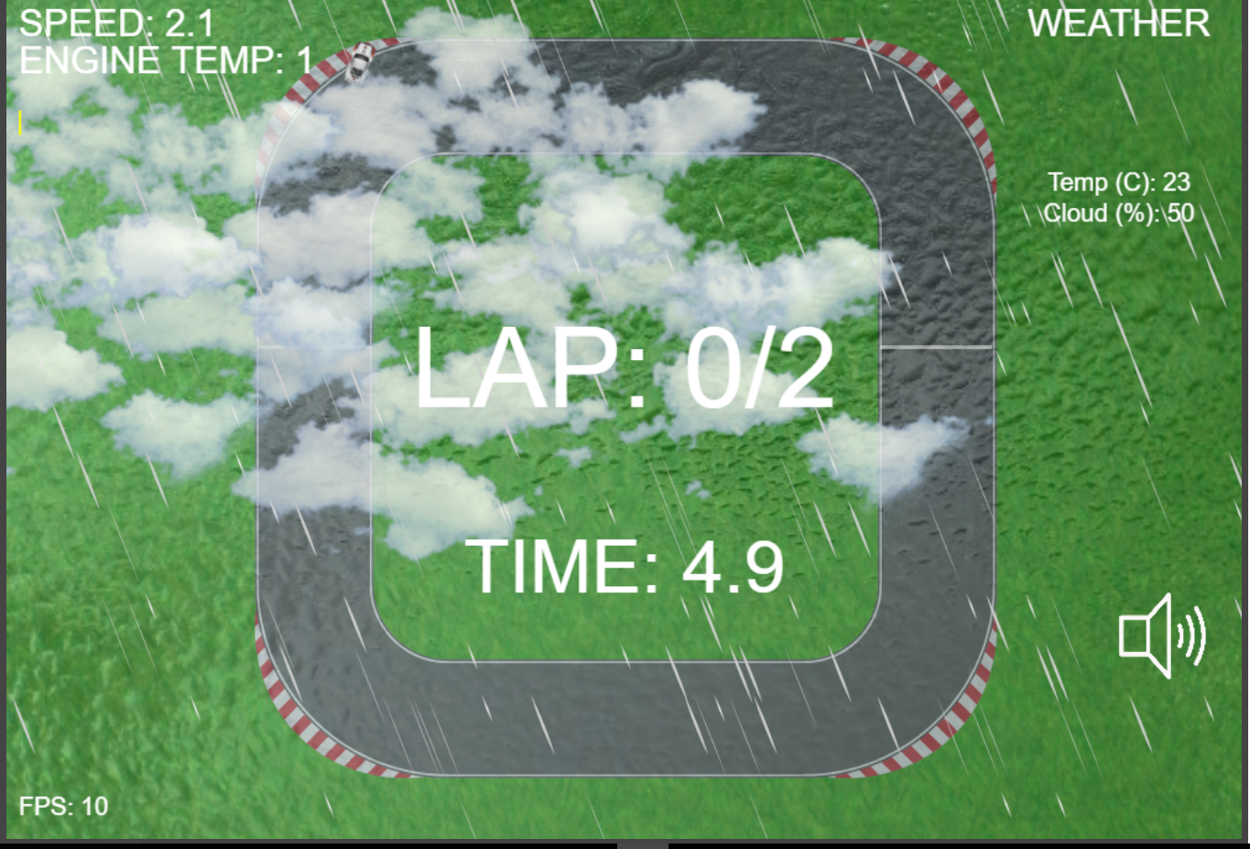

Game screenshot: rain and clouds during day

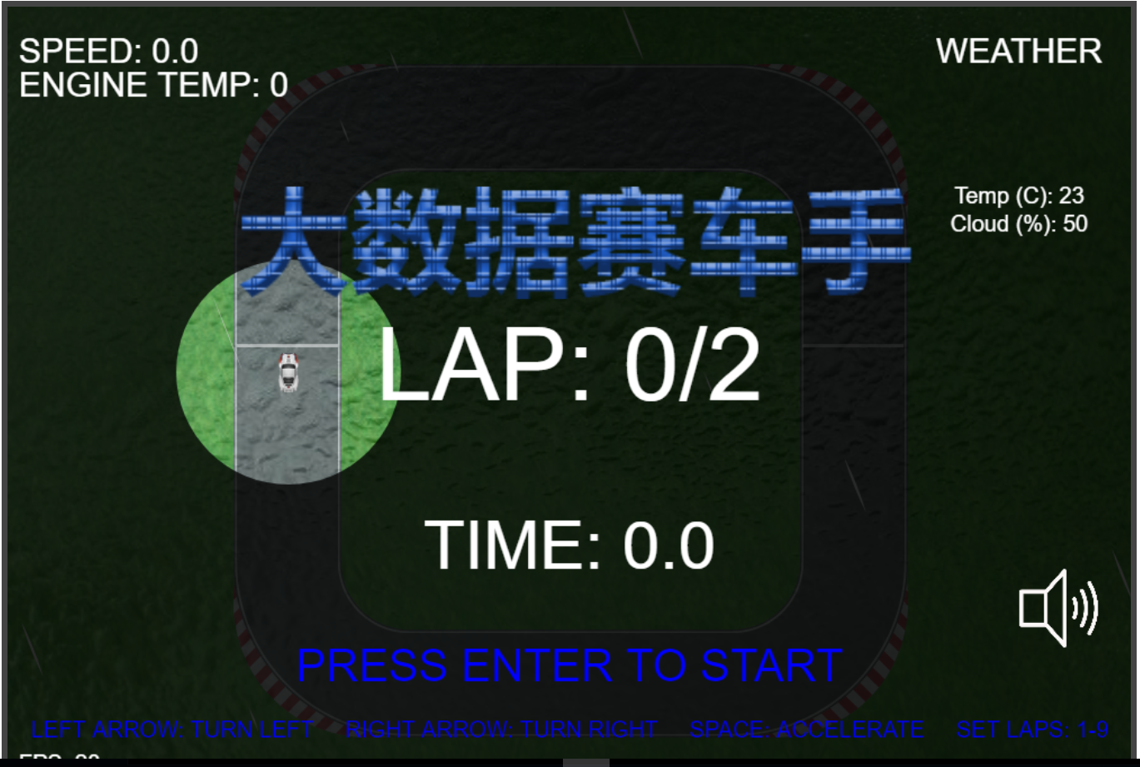

Game screenshot: rain and cloud during night

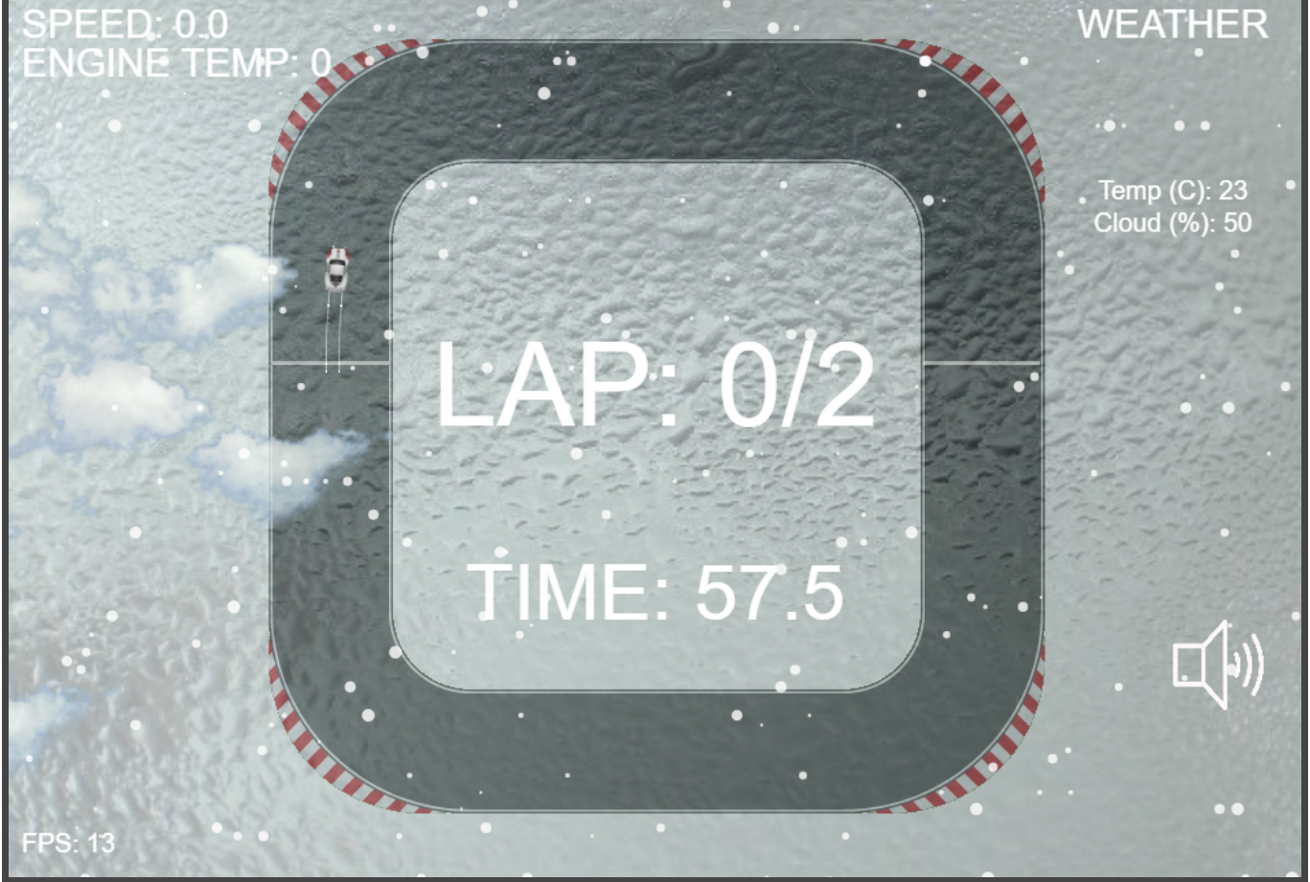

Game screenshot: snow and cloud during day