test1.R

User

2020-06-13

library(ellipse)

## Warning: package 'ellipse' was built under R version 3.6.3

##   
## Attaching package: 'ellipse'

## The following object is masked from 'package:graphics':  
##   
## pairs

library(Rfast)

## Warning: package 'Rfast' was built under R version 3.6.3

## Loading required package: Rcpp

## Loading required package: RcppZiggurat

## Warning: package 'RcppZiggurat' was built under R version 3.6.3

setwd("C:\\Users\\User\\Desktop\\School\\Math_537\\Test1")  
  
data=read.csv("genderwage.csv")  
  
############################################  
#1 a)  
  
x=data$female  
y=data$male  
n=length(x)  
  
variance=matrix(var(data),ncol=2)/n  
  
muX=mean(x)  
muY=mean(y)  
mu=matrix(c(muX,muY),2,1)  
muT=mean(cbind(x,y))  
  
findMu=function(x,mu,variance)  
{  
 xy=c(x,x)  
   
 result=t(mu-xy)%*%solve(variance)%*%(mu-xy)  
 return(result)  
}  
  
result=optim(par=20,fn=findMu,mu=mu,variance=variance)

## Warning in optim(par = 20, fn = findMu, mu = mu, variance = variance): one-dimensional optimization by Nelder-Mead is unreliable:  
## use "Brent" or optimize() directly

mu0=matrix(c(result$par,result$par),2,1)  
  
t2=t(mu-mu0)%*%solve(variance)%*%(mu-mu0)  
  
pval=2*(1-pf((n-2)/((n-1)*2)*t2,2,n-2))  
  
pval

## [,1]  
## [1,] 7.215637e-10

############################################  
#1 b)  
  
eig=eigen(variance)  
  
lam1=eig$values[1]  
lam2=eig$values[2]  
  
v1=eig$vectors[,1]  
v2=eig$vectors[,2]  
  
dist =(2*(n-1)/(n-2))*qf(.95,2,n-2)  
  
a1=v1*sqrt(lam1)*sqrt(dist)  
a2=v2*sqrt(lam2)*sqrt(dist)  
  
plot(x,y,xlim=(c(15,26)),ylim=(c(17,29)))  
points(muX,muY,pch=19,cex=1,col=3)  
lines(ellipse(variance,centre=c(muX,muY)),col=3)  
  
lines(c(muX,muX+a1[1]),c(muY,muY+a1[2]),lwd=.5,col=2)  
lines(c(muX,muX+a2[1]),c(muY,muY+a2[2]),lwd=.5,col=2)  
  
lines(c(0,28),c(0,28),lwd=.5,col=2)  
points(mu0[1],mu0[2],pch=19,cex=1,col=2)

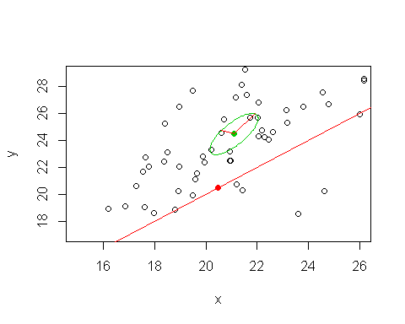

############################################  
#1 c)  
  
lowerX=muX-qt(.975,n-1)*sd(x)/sqrt(n)  
upperX=muX+qt(.975,n-1)*sd(x)/sqrt(n)  
  
print(lowerX)

## [1] 20.335

print(muX)

## [1] 21.1021

print(upperX)

## [1] 21.8692

lowerY=muY-qt(.975,n-1)*sd(y)/sqrt(n)  
upperY=muY+qt(.975,n-1)*sd(y)/sqrt(n)  
  
print(lowerY)

## [1] 23.22128

print(muY)

## [1] 24.46516

print(upperY)

## [1] 25.70905

############################################  
#1 d)  
  
xa = mean(x) - qt(.9875,length(x)-1)*sd(x)/sqrt(length(x))  
xb = mean(x) + qt(.9875,length(x)-1)*sd(x)/sqrt(length(x))  
  
ya = mean(y) - qt(.9875,length(y)-1)*sd(y)/sqrt(length(y))  
yb = mean(y) + qt(.9875,length(y)-1)*sd(y)/sqrt(length(y))  
  
plot(x,y,xlim=(c(15,26)),ylim=(c(17,29)))  
points(muX,muY,pch=19,cex=1,col=3)  
lines(ellipse(variance,centre=c(muX,muY)),col=3)  
  
lines(c(muX,muX+a1[1]),c(muY,muY+a1[2]),lwd=.5,col=2)  
lines(c(muX,muX+a2[1]),c(muY,muY+a2[2]),lwd=.5,col=2)  
  
lines(c(0,28),c(0,28),lwd=.5,col=2)  
points(mu0[1],mu0[2],pch=19,cex=1,col=2)  
  
lines(c(xa,xb),c(ya,ya),lty=2,col=4)  
lines(c(xa,xb),c(yb,yb),lty=2,col=4)  
lines(c(xa,xa),c(ya,yb),lty=2,col=4)  
lines(c(xb,xb),c(ya,yb),lty=2,col=4)

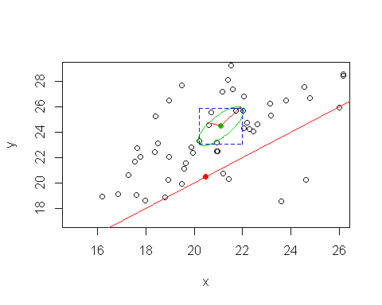

############################################  
#1 e)  
  
muM=matrix(c(22.5,24.5),2,1)  
muR=matrix(c(21.5,26),2,1)  
  
sigM=matrix(c(12,8,8,12),2,2)  
sigR=matrix(c(9,8,8,16),2,2)  
  
likeRatio=prod(dmvnorm(as.matrix(data),muM,sigM))/prod(dmvnorm(as.matrix(data),muR,sigR))  
  
#Rachel is the winner, sorry M  
  
############################################  
#1 f)  
  
eig=eigen(cov(as.matrix(data)))  
vec=eig$vectors  
l=eig$values  
  
eMu0=vec[,1]%*%mu0  
eX=as.matrix(data)%*%vec[,1]  
  
t=(mean(eX)-eMu0)/(sd(eX)/sqrt(n))  
2*(1-pt(t,n-1))

## [,1]  
## [1,] 8.056076e-07