test2.R

User

2020-06-22

library(mvtnorm)  
library(RVAideMemoire)

## *** Package RVAideMemoire v 0.9-77 ***

library(rstatix)

##   
## Attaching package: 'rstatix'

## The following object is masked from 'package:stats':  
##   
## filter

library(mnormt)  
library(nFactors)

## Loading required package: lattice

##   
## Attaching package: 'nFactors'

## The following object is masked from 'package:lattice':  
##   
## parallel

setwd('C:\\Users\\User\\Desktop\\School\\Math_537\\Test2')  
data=read.table('Apple.txt', header=T)  
  
head(data)

## Rootstock y1 y2 y3 y4  
## 1 1 1.11 2.569 3.58 0.760  
## 2 1 1.19 2.928 3.75 0.821  
## 3 1 1.09 2.865 3.93 0.928  
## 4 1 1.25 3.844 3.94 1.009  
## 5 1 1.11 3.027 3.60 0.766  
## 6 1 1.08 2.336 3.51 0.726

######################################################  
#1 a)  
  
y=cbind(data$y1,data$y2,data$y3,data$y4)  
model=manova(y~as.factor(Rootstock),data=data)  
lam=summary.manova(model,test="Wilks")$stats[3]  
lam

## [1] 0.1540077

######################################################  
#1 b)  
  
temp=summary.manova(model,test="Wilks")  
temp$SS$Residuals

## [,1] [,2] [,3] [,4]  
## [1,] 0.3199875 1.696564 0.5540875 0.217140  
## [2,] 1.6965637 12.142790 4.3636125 2.110214  
## [3,] 0.5540875 4.363612 4.2908125 2.481656  
## [4,] 0.2171400 2.110214 2.4816562 1.722525

model$residuals

## [,1] [,2] [,3] [,4]  
## 1 -0.02750 -0.408125 -0.15875 -0.111125  
## 2 0.05250 -0.049125 0.01125 -0.050125  
## 3 -0.04750 -0.112125 0.19125 0.056875  
## 4 0.11250 0.866875 0.20125 0.137875  
## 5 -0.02750 0.049875 -0.13875 -0.105125  
## 6 -0.05750 -0.641125 -0.22875 -0.145125  
## 7 -0.02750 0.233875 0.24125 0.337875  
## 8 0.02250 0.059875 -0.11875 -0.121125  
## 9 -0.10750 -1.035125 -0.42500 -0.244500  
## 10 0.01250 -0.224125 -0.45500 -0.186500  
## 11 -0.04750 0.268875 0.35500 0.354500  
## 12 0.09250 0.796875 0.46500 0.236500  
## 13 0.01250 -0.327125 -0.13500 -0.083500  
## 14 -0.00750 -0.091125 0.13500 -0.036500  
## 15 0.01250 0.273875 0.17500 0.214500  
## 16 0.03250 0.337875 -0.11500 -0.254500  
## 17 -0.03750 -0.310250 -0.69500 -0.479375  
## 18 -0.11750 -0.500250 -0.01500 0.006625  
## 19 -0.04750 -0.148250 -0.07500 -0.194375  
## 20 -0.08750 -0.425250 0.21500 0.221625  
## 21 0.04250 0.205750 0.02500 0.084625  
## 22 0.09250 0.269750 0.32500 0.179625  
## 23 0.09250 0.492750 0.11500 0.114625  
## 24 0.06250 0.415750 0.10500 0.066625  
## 25 0.12250 -0.041750 -0.01625 -0.095000  
## 26 -0.06750 -0.528750 0.14375 0.202000  
## 27 0.04250 0.121250 0.14375 -0.016000  
## 28 -0.08750 -0.440750 0.01375 0.028000  
## 29 -0.10750 -0.680750 -0.63625 -0.346000  
## 30 0.01250 0.438250 0.04375 0.046000  
## 31 0.10250 0.721250 0.36375 0.203000  
## 32 -0.01750 0.411250 -0.05625 -0.022000  
## 33 -0.17000 -1.025250 -0.27250 -0.097000  
## 34 0.07000 -0.005250 -0.15250 -0.030000  
## 35 0.06000 0.525750 0.47750 0.200000  
## 36 -0.03000 -0.227250 0.10750 0.061000  
## 37 -0.09000 -0.478250 -0.84250 -0.508000  
## 38 0.14000 0.808750 0.09750 -0.044000  
## 39 -0.03000 -0.141250 0.32750 0.274000  
## 40 0.05000 0.542750 0.25750 0.144000  
## 41 0.07375 0.598375 0.16375 0.065000  
## 42 -0.28625 -1.374625 -0.45625 -0.129000  
## 43 0.01375 -0.015625 0.15375 0.055000  
## 44 -0.01625 -0.082625 0.39375 0.118000  
## 45 0.01375 -0.265625 -0.25625 -0.125000  
## 46 0.03375 0.036375 -0.38625 -0.173000  
## 47 0.09375 0.849375 0.03375 -0.028000  
## 48 0.07375 0.254375 0.35375 0.217000

mqqnorm(model$residuals)

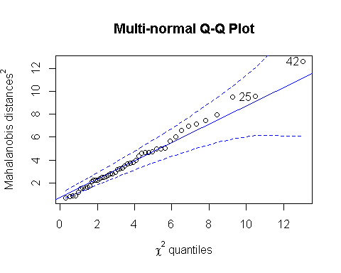

## [1] 42 25

#fairly normal  
  
  
box_m(y, data$Rootstock)

## # A tibble: 1 x 4  
## statistic p.value parameter method   
## <dbl> <dbl> <dbl> <chr>   
## 1 44.0 0.711 50 Box's M-test for Homogeneity of Covariance Matric~

# With a p-value of .711 this implies that each y_i came from similar variances.  
  
  
######################################################  
#1 c)  
  
n=10000  
lam2=matrix(0,1,n)  
  
data2=as.matrix(data)  
  
ind=sample(1:48,replace=T)  
final=cbind((data2[,1]),(data2[ind,2:5]))  
results= final[,2:5]  
y=cbind(final[,2],final[,3],final[,4],final[,5])  
model=manova(y~as.factor(final[,1]),data=as.data.frame(final))  
lam2[1]=summary.manova(model,test="Wilks")$stats[3]  
  
for(i in 2:n)  
{  
 ind=sample(1:48,replace=T)  
 final=cbind((data2[,1]),(data2[ind,2:5]))  
 results=results+final[,2:5]  
 y=cbind(final[,2],final[,3],final[,4],final[,5])  
 model=manova(y~as.factor(final[,1]),data=as.data.frame(final))  
 lam2[i]=summary.manova(model,test="Wilks")$stats[3]  
}  
  
sum(lam2<lam)/n

## [1] 0

results=results/n  
  
results=cbind((data2[,1]),results)  
y=cbind(results[,2],results[,3],results[,4],results[,5])  
model=manova(y~as.factor(results[,1]),data=as.data.frame(results))  
mqqnorm(model$residuals)

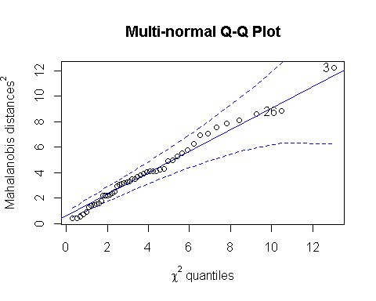

## [1] 3 26

######################################################  
#2 a)  
  
data2=read.table('drivPoints.txt', sep=",", header=T)  
  
data2F=scale(data2[,6:dim(data2)[2]],scale=F)  
  
pca = prcomp(data2F)  
pca

## Standard deviations (1, .., p=14):  
## [1] 96.989608 49.020727 9.624131 8.328001 4.206615 3.476437 2.617391  
## [8] 2.510391 1.937855 1.734361 1.621667 1.489140 1.224986 1.037106  
##   
## Rotation (n x k) = (14 x 14):  
## PC1 PC2 PC3 PC4 PC5 PC6  
## xF 0.022139210 -0.364691878 0.25895493 -0.548645238 0.039618288 -0.16728177  
## yF -0.405234308 -0.004778740 -0.26409687 -0.063828886 -0.024108922 -0.21234173  
## wF -0.005415327 0.048131327 0.14303311 0.767759768 0.181515296 -0.23689076  
## hF 0.009165877 -0.073678717 0.77630615 0.104973303 -0.042171033 0.42989565  
## xRE 0.004989021 -0.416446184 -0.10826090 0.018492764 0.251632361 0.22953706  
## yRE -0.393713598 0.006608796 -0.03590325 0.008890949 0.038302284 0.06596350  
## xLE 0.014991964 -0.399378853 0.08544017 0.019941142 0.314556678 -0.19500235  
## yLE -0.415892117 -0.031293068 -0.13671720 -0.005511949 0.223947416 0.24128765  
## xN 0.018698874 -0.487562171 -0.30072123 0.229893445 0.057778273 0.34210424  
## yN -0.405475548 -0.007788982 0.15285279 -0.019743770 0.362372110 0.04941103  
## xRM 0.011153666 -0.379847163 -0.12601406 0.164184853 -0.653772537 0.14944976  
## yRM -0.402354929 -0.021147988 0.18580243 0.053648042 -0.359204093 -0.16931529  
## xLM 0.048896923 -0.373292785 0.14299816 0.101111441 -0.001664671 -0.60097517  
## yLM -0.421652110 -0.058496574 0.12820531 0.017077591 -0.241118098 -0.03264033  
## PC7 PC8 PC9 PC10 PC11 PC12  
## xF 0.40491612 -0.33589079 0.33157585 -0.09590638 0.08240220 -0.22078009  
## yF -0.11704124 -0.05737643 0.32405676 -0.40915082 -0.53188154 0.36370552  
## wF 0.31735222 -0.36542852 0.17719603 -0.13047353 0.06369219 -0.08038808  
## hF -0.21461040 0.13603592 0.13139530 -0.25335383 -0.19443019 0.09321161  
## xRE 0.12138798 -0.10914983 -0.12095685 -0.17674548 0.36762451 0.62912712  
## yRE 0.08383014 0.19473543 0.05547406 -0.26257109 0.14851806 -0.41279575  
## xLE -0.40467679 -0.35098949 -0.37023166 0.15586806 -0.38526016 -0.20312112  
## yLE -0.20689352 -0.07460613 -0.18571629 -0.32753504 0.27539435 -0.32374509  
## xN -0.08718797 0.20064332 0.52304943 0.35787832 -0.08996423 -0.17686412  
## yN 0.51446644 0.32120677 -0.28163416 0.33918403 -0.28181877 0.10262474  
## xRM 0.30047412 -0.03691901 -0.41203819 -0.19909829 -0.20384079 -0.10348746  
## yRM -0.02933347 -0.03832200 0.14530317 0.29567071 0.06679623 0.05287241  
## xLM -0.15730543 0.57588955 -0.04397738 -0.15662530 0.23206093 0.01905817  
## yLM -0.24305524 -0.27447109 -0.03729036 0.34016760 0.31559282 0.18939995  
## PC13 PC14  
## xF -0.10970164 0.073477543  
## yF -0.10803058 -0.003552877  
## wF -0.06914370 0.026523228  
## hF -0.04143233 -0.001925596  
## xRE 0.29061840 -0.102728541  
## yRE 0.28845793 -0.667175639  
## xLE 0.19535238 -0.139401899  
## yLE -0.14222970 0.554921054  
## xN -0.08702378 0.042554583  
## yN -0.14530951 0.068836782  
## xRM -0.09530381 0.024390902  
## yRM 0.64366421 0.331878469  
## xLM -0.14985572 0.082970898  
## yLM -0.51885202 -0.294385271

plot(pca,type="l")

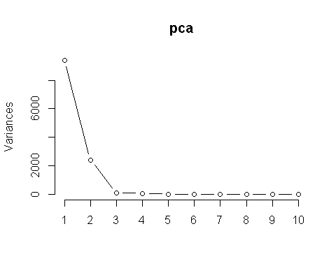

source("ggbiplot2.R")  
  
componet=pca$rotation[,1:2]  
  
#All principle components printed  
  
g = ggbiplot(pca, obs.scale = 1, var.scale = 1,   
 groups = as.factor(data2[,4]), ellipse = TRUE,  
 circle = TRUE)

##   
## Attaching package: 'plyr'

## The following objects are masked from 'package:rstatix':  
##   
## desc, mutate

g <- g + scale_color_discrete(name = '')  
g <- g + theme(legend.direction = 'horizontal',   
 legend.position = 'top')  
g

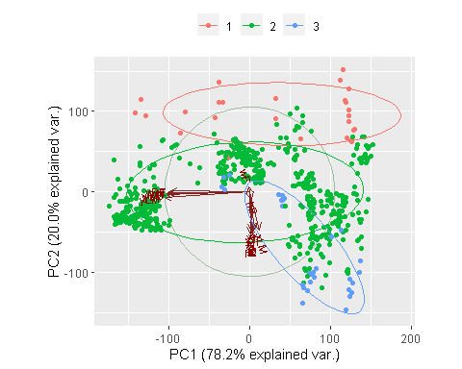

#Only the first two principle componenets printed (important ones)  
  
g = ggbiplot(pca, obs.scale = 1, var.scale = 1,   
 groups = as.factor(data2[,4]), ellipse = TRUE,  
 circle = TRUE,numComp=2)  
g <- g + scale_color_discrete(name = '')  
g <- g + theme(legend.direction = 'horizontal',   
 legend.position = 'top')  
g

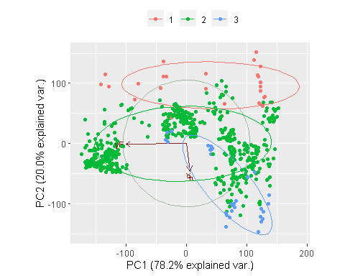

head(data2)

## fileName subject imgNum label ang xF yF wF hF xRE yRE xLE  
## 1 20130529_01_Driv_001_f 1 1 2 0 292 209 100 112 323 232 367  
## 2 20130529_01_Driv_002_f 1 2 2 0 286 200 109 128 324 235 366  
## 3 20130529_01_Driv_003_f 1 3 2 0 290 204 105 121 325 240 367  
## 4 20130529_01_Driv_004_f 1 4 2 0 287 202 112 118 325 230 369  
## 5 20130529_01_Driv_005_f 1 5 2 0 290 193 104 119 325 224 366  
## 6 20130529_01_Driv_006_f 1 6 2 0 290 204 105 118 324 231 368  
## yLE xN yN xRM yRM xLM yLM  
## 1 231 353 254 332 278 361 278  
## 2 235 353 258 333 281 361 281  
## 3 239 351 260 334 282 362 282  
## 4 230 353 253 335 274 362 275  
## 5 225 353 244 333 268 363 268  
## 6 232 351 253 335 277 362 276

######################################################  
#2 b)  
  
X=data2F  
  
f1=factanal(data2F,factors=9,rotation="varimax")  
  
f2=factanal(data2F,factors=4,rotation="varimax")  
  
ev <- eigen(cor(X)) # get eigenvalues  
ap <- parallel(subject=nrow(X),var=ncol(X),  
 rep=100,cent=.05)  
nS <- nScree(x=ev$values, aparallel=ap$eigen$qevpea)  
plotnScree(nS)

