Sales Predictor

Christopher Himmel

January 16, 2016

# Introduction

A valuable exercise in retail is being able to predict sales of your inventory. Predictive models can be used to do this, building a relationship betwen given information that you have currently and future sales. Current information includes previous sales and Item attributes, of which there are many.

The many item attributes are recorded when the new SKU's are entered by hand one by one, or loaded as a group by uploading them and processing them into the system. They are stored in the Inventory Master file (INVMST). Sales history is loaded as stores sell inventory, quantities and prices are uploaded from the Point-Of-Sale and accumulated into a few buckets in the Inventory Balance files (INVBAL and INVCBL).

The data used for this exercise is directly pulled out of JDA's Merchandise Management System, which runs on IBM's System-i. The information is downloaded from INVMST, INVCBL and INVBAL (limited to only ISTORE between 1001 and 1003).

The following is the R code and results from this exercise.

# Set up R environment

#Needed<-c("dplyr", "tm", "wordcloud", "SnowballC", "corrplot", "rpart", "rattle", "randomForest", "tidyr", "ggplot2")  
#install.packages(Needed, dependencies=TRUE)  
library(tm)  
library(dplyr)  
library(wordcloud)  
library(SnowballC)  
library(corrplot)  
library(rpart)  
library(rattle)

## Warning: package 'rattle' was built under R version 3.2.5

library(randomForest)  
library(tidyr)  
library(ggplot2)  
setwd("C:/Users/Christopher Himmel/Dropbox/Deep Learning/SlideRule Foundations/Capstone")

# Upload data pulled out of MMS

Load and view Item Master (INVMST):

Item_Master = read.csv("INVMST - Item Master.csv")  
#View(Item_Master)  
#summary(Item_Master)

Load and view Chain Level Inventory Balance file (INVCBL):

Inv_Bal_Chain = read.csv("INVCBL - Chain Level Inventory Balance Data.csv")  
#View(Inv_Bal_Chain)  
#summary(Inv_Bal_Chain)

Load and view Store Level Inventory Balance file, filtered for Niquea'D stores (INVBAL):

Inv_Bal_Store = read.csv("INVBAL - Store Level Inventory Balance Data - Niquea'D.csv")  
#View(Inv_Bal_Store)  
#summary(Inv_Bal_Store)

# Format data set

Create chain level field with combined regular sales and advertised sales:

Inv_Bal_Chain_mut <-  
 Inv_Bal_Chain %>%  
 mutate(chn_sales=CBRSUY+CBASUY)

Create total Niquea'D summarized sales with combined regular sales and advertised sales:

Inv_Bal_Store_sum <-   
 Inv_Bal_Store %>%  
 group_by(INUMBR) %>%  
 summarise(nd_sales=sum(IBRSUY+IBASUY),  
 IBHAND_sum=sum(IBHAND),  
 IBWKCR_sum=sum(IBWKCR),  
 IBWK01_sum=sum(IBWK01),  
 IBWK02_sum=sum(IBWK02),  
 IBWK03_sum=sum(IBWK03),  
 IBWK04_sum=sum(IBWK04),  
 IBWK05_sum=sum(IBWK05),  
 IBWK06_sum=sum(IBWK06),  
 IBWK07_sum=sum(IBWK07),  
 IBWK08_sum=sum(IBWK08))  
Inv_Bal_Store_sum <- subset(Inv_Bal_Store_sum, IBHAND_sum!=0 | nd_sales!=0)

Combine two new sales numbers into one file by SKU:

Inv_values <-  
 Inv_Bal_Store_sum %>%  
 left_join(Inv_Bal_Chain_mut, by="INUMBR") %>%  
 select(INUMBR,nd_sales,chn_sales,IBHAND_sum,IBWKCR_sum,IBWK01_sum,IBWK02_sum,IBWK03_sum,IBWK04_sum,  
 IBWK05_sum,IBWK06_sum,IBWK07_sum,IBWK08_sum)

Combine SKU, sales data into one file for analysis:

Inv_final <-  
 Inv_values %>%  
 left_join(Item_Master, by="INUMBR")

# Break descriptions down for learning

Extract word list from description:

word_list <- paste(Inv_final$IDESCR, collapse=" ")  
word_list_vector <- VectorSource(word_list)  
rm(word_list)  
word_list_corpus <- Corpus(word_list_vector)  
rm(word_list_vector)  
  
word_list_corpus <- tm_map(word_list_corpus, content_transformer(tolower))  
word_list_corpus <- tm_map(word_list_corpus, removePunctuation)  
word_list_corpus <- tm_map(word_list_corpus, stripWhitespace)  
word_list_corpus <- tm_map(word_list_corpus, removeNumbers)  
word_list_corpus <- tm_map(word_list_corpus, removeWords, stopwords("english"))  
word_list_corpus <- tm_map(word_list_corpus, stemDocument)  
  
tdm<-TermDocumentMatrix(word_list_corpus)  
rm(word_list_corpus)  
tdm2<-as.matrix(tdm)  
rm(tdm)  
tdm3<-as.data.frame(tdm2)  
rm(tdm2)  
colnames(tdm3)<-c("count")  
tdm4<-subset(tdm3,tdm3$count>132)  
rm(tdm3)  
top_words_list<-rownames(tdm4)  
rm(tdm4)

Generate training vecto:

description_list <- Inv_final$IDESCR  
description_list_vector <- VectorSource(description_list)  
rm(description_list)  
description_list_corpus <- Corpus(description_list_vector)  
rm(description_list_vector)  
  
description_list_corpus <- tm_map(description_list_corpus, content_transformer(tolower))  
description_list_corpus <- tm_map(description_list_corpus, removePunctuation)  
description_list_corpus <- tm_map(description_list_corpus, stripWhitespace)  
description_list_corpus <- tm_map(description_list_corpus, removeNumbers)  
description_list_corpus <- tm_map(description_list_corpus, removeWords, stopwords("english"))  
description_list_corpus <- tm_map(description_list_corpus, stemDocument)  
  
dtm_dataset<-DocumentTermMatrix(description_list_corpus)  
rm(description_list_corpus)  
dtm_dataset2<-as.matrix(dtm_dataset)  
rm(dtm_dataset)  
dtm_match<-match(top_words_list,colnames(dtm_dataset2))  
dtm_dataset_top<-dtm_dataset2[,dtm_match]  
rm(dtm_dataset2)  
dtm_dataset_topdf<-as.data.frame(dtm_dataset_top)  
rm(dtm_dataset_top)  
colnames(dtm_dataset_topdf)<-paste("w", colnames(dtm_dataset_topdf), sep="_")

Add word values to training set:

Inv_final$rownumber<-c(1:nrow(Inv_final))  
dtm_dataset_topdf$rownumber<-rownames(dtm_dataset_topdf)  
Inv_final<-merge(Inv_final,dtm_dataset_topdf,by="rownumber")

# Test each attribute for significant amount of data

Visualize each column of data:

# IDESCR - factors of descriptions  
# ICHECK - all Zeros  
barplot(table(Inv_final$ICHECK),main="ICHECK")

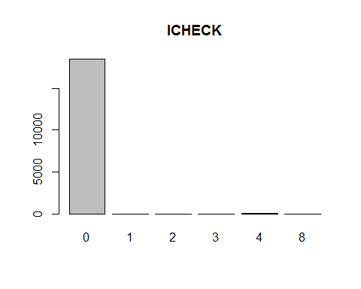

# IDSCCD - minimal values  
barplot(table(Inv_final$IDSCCD),main="IDSCCD")

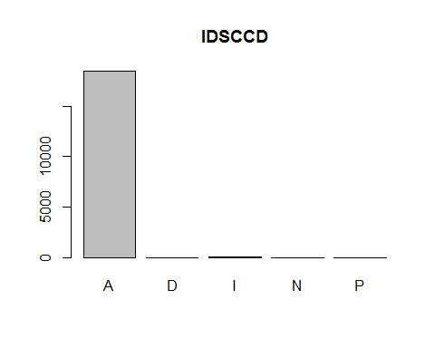

# ISORT - factors of descriptions  
# ISTYLN - all NA's  
# ASNUM - distributed values  
barplot(table(Inv_final$ASNUM),main="ASNUM")

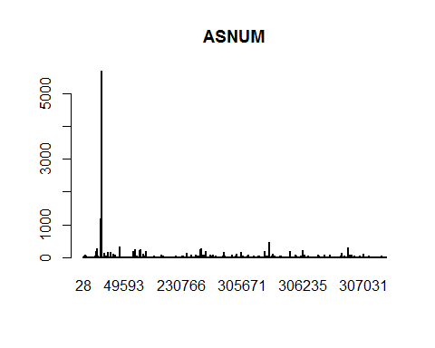

# IVNDPN - empty  
barplot(table(Inv_final$IVNDPN),main="IVNDPN")

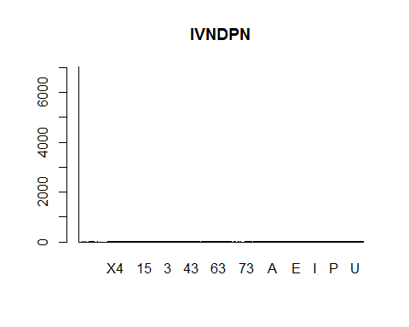

# IMFGR - empty  
barplot(table(Inv_final$IMFGR),main="IMFGR")

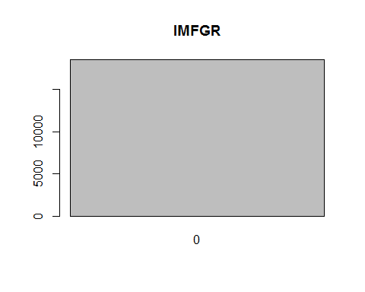

# IMFGNO - some values  
barplot(table(Inv_final$IMFGNO),main="IMFGNO")

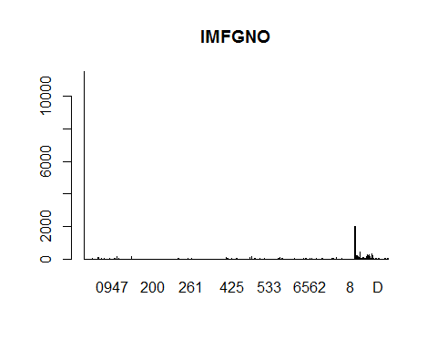

# IDEPT - use  
barplot(table(Inv_final$IDEPT),main="IDEPT")

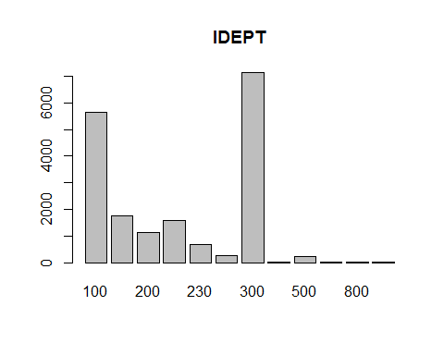

# ISDEPT - use  
barplot(table(Inv_final$ISDEPT),main="ISDEPT")

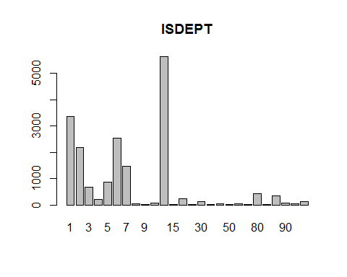

# ICLAS - use  
barplot(table(Inv_final$ICLAS),main="ICLAS")

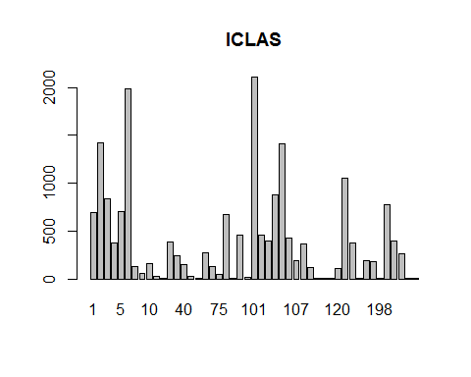

# ISCLAS - use  
barplot(table(Inv_final$ISCLAS),main="ISCLAS")

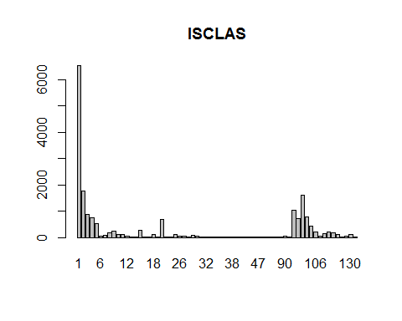

# BYRNUM - convert NA's to 0  
Inv_final$BYRNUM[is.na(Inv_final$BYRNUM)]<-0  
barplot(table(Inv_final$BYRNUM),main="BYRNUM")

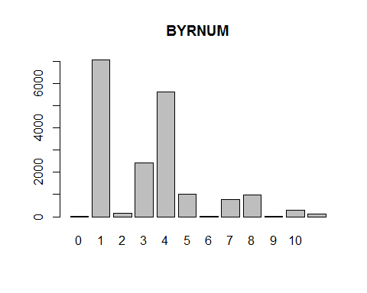

# IASPAC - empty  
barplot(table(Inv_final$IASPAC),main="IASPAC")

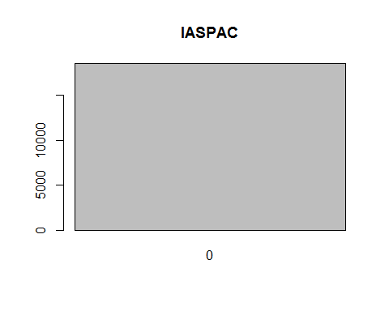

# IADVYN - empty  
barplot(table(Inv_final$IADVYN),main="IADVYN")

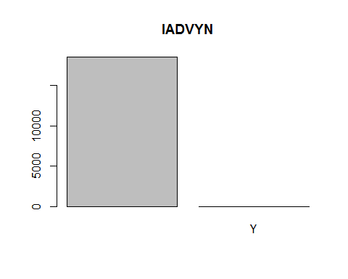

# IBUYCD - mostly empty  
barplot(table(Inv_final$IBUYCD),main="IBUYCD")

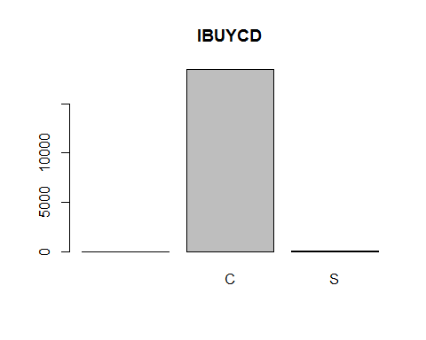

# ISET - empty  
barplot(table(Inv_final$ISET),main="ISET")

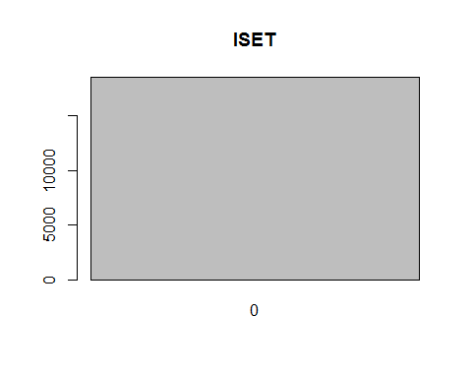

# IWARNT - mostly empty  
barplot(table(Inv_final$IWARNT),main="IWARNT")

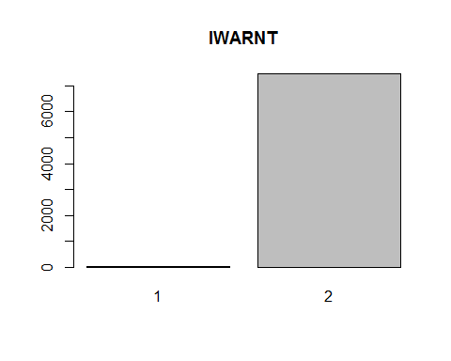

# IPRMPT - mostly empty  
barplot(table(Inv_final$IPRMPT),main="IPRMPT")

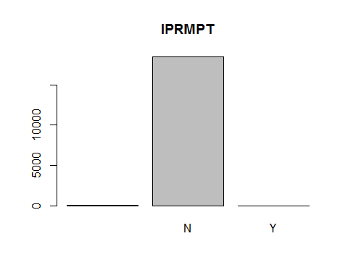

# IPRVNT - mostly empty  
barplot(table(Inv_final$IPRVNT),main="IPRVNT")

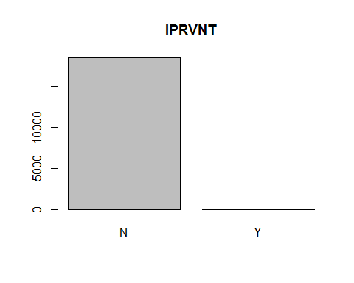

# ITKTTR - convert NA's to 0  
Inv_final$ITKTTR[is.na(Inv_final$ITKTTR)]<-0  
barplot(table(Inv_final$ITKTTR),main="ITKTTR")

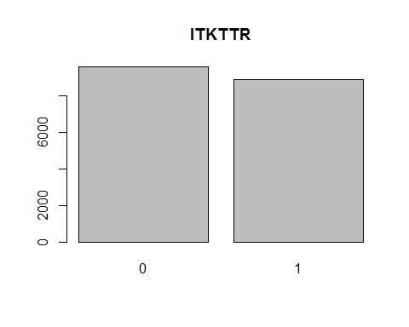

# ITKTTA - mostly empty  
barplot(table(Inv_final$ITKTTA),main="ITKTTA")

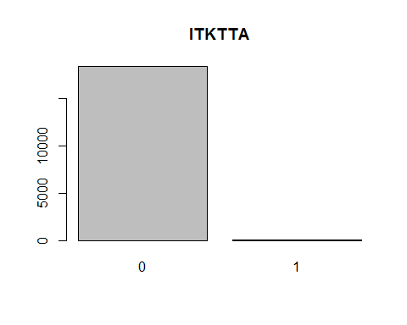

# ITKTN  
barplot(table(Inv_final$ITKTN),main="ITKTN")

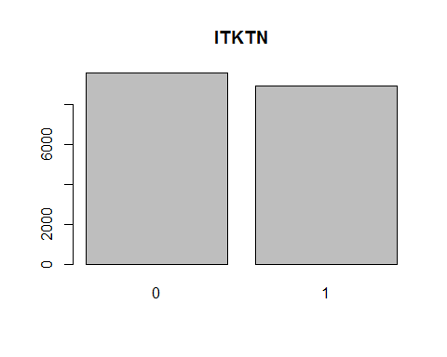

# ILBLTR - convert NA's to 0  
Inv_final$ILBLTR[is.na(Inv_final$ILBLTR)]<-0  
barplot(table(Inv_final$ILBLTR),main="ILBLTR")

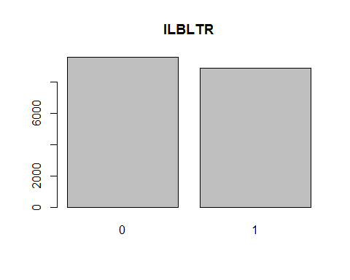

# ILBLTA - empty  
barplot(table(Inv_final$ILBLTA),main="ILBLTA")

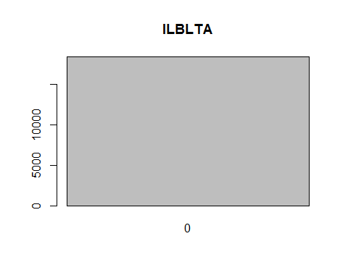

# IFINLN  
barplot(table(Inv_final$IFINLN),main="IFINLN")

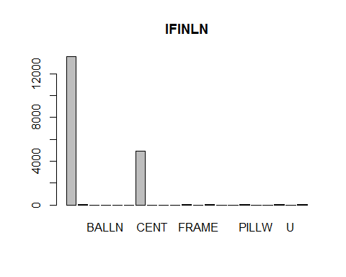

# IPROFL - mostly empty  
barplot(table(Inv_final$IPROFL),main="IPROFL")

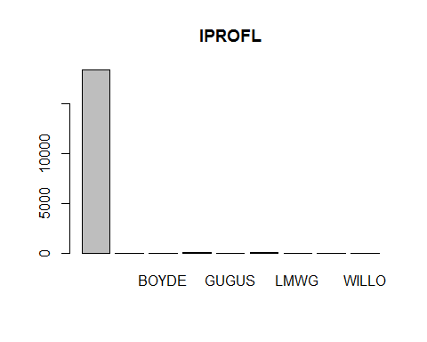

# IMODUL - mostly empty  
barplot(table(Inv_final$IMODUL),main="IMODUL")

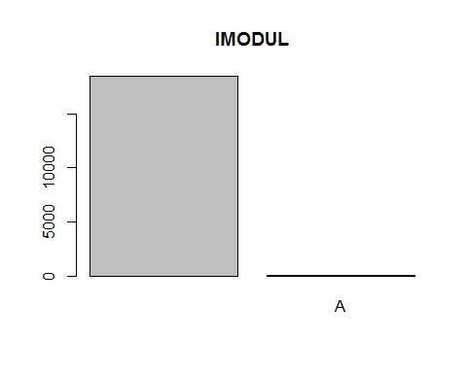

# ISTYPE  
barplot(table(Inv_final$ISTYPE),main="ISTYPE")

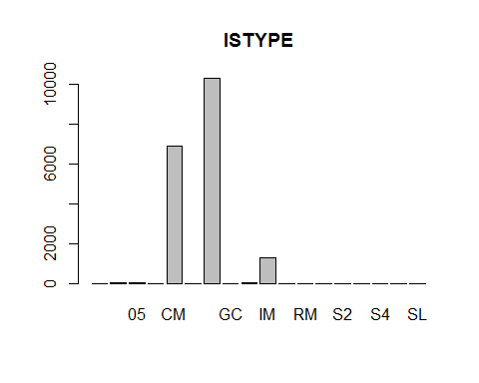

# ISCOLR - mostly empty  
barplot(table(Inv_final$ISCOLR),main="ISCOLR")

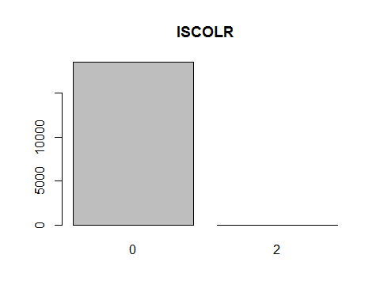

# ISSIZE - mostly empty  
barplot(table(Inv_final$ISSIZE),main="ISSIZE")

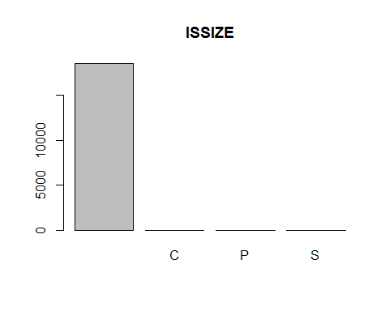

# IHAZCD - all NA's  
# MCHNUM - all NA's  
# ISUBST - empty  
barplot(table(Inv_final$ISUBST),main="ISUBST")

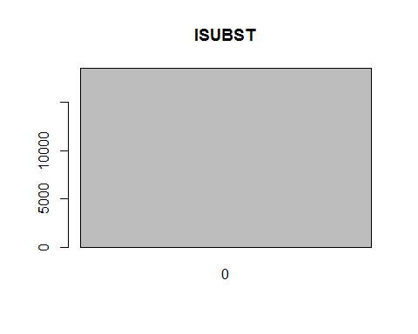

# ICORE - empty  
barplot(table(Inv_final$ICORE),main="ICORE")

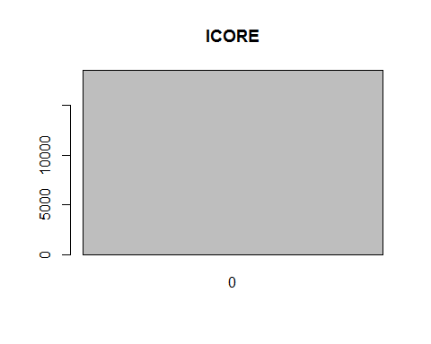

# IREPL - empty  
barplot(table(Inv_final$IREPL),main="IREPL")

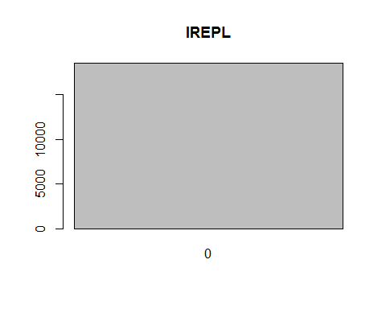

# ISLUM - mostly empty  
barplot(table(Inv_final$ISLUM),main="ISLUM")

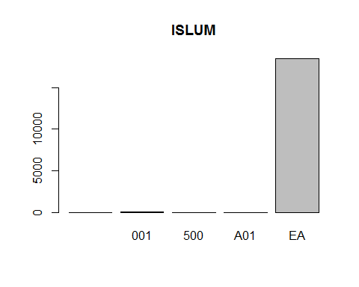

# IUMCV2 - all 1's  
barplot(table(Inv_final$IUMCV2),main="IUMCV2")

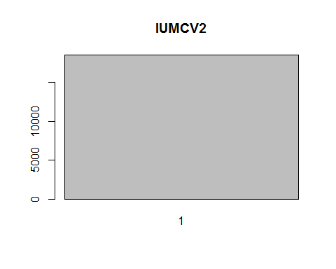

# IBYUM - all EA's  
barplot(table(Inv_final$IBYUM),main="IBYUM")

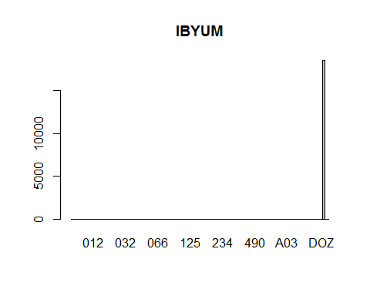

# IMINPK  
barplot(table(Inv_final$IMINPK),main="IMINPK")

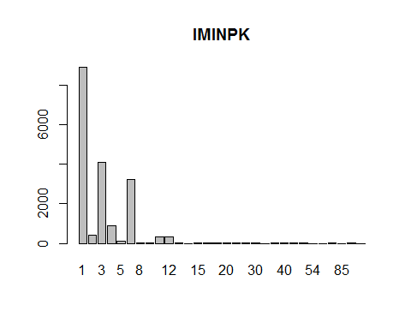

# ISTDPK  
barplot(table(Inv_final$ISTDPK),main="ISTDPK")

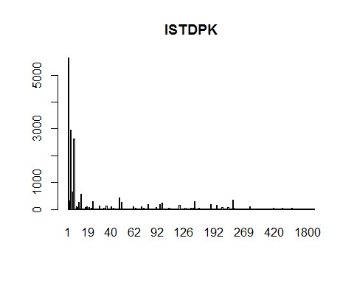

# IHLDOR - mostly empty  
barplot(table(Inv_final$IHLDOR),main="IHLDOR")

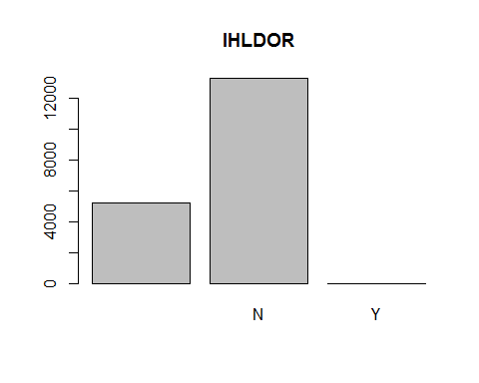

# IMOQTY - mostly empty  
barplot(table(Inv_final$IMOQTY),main="IMOQTY")

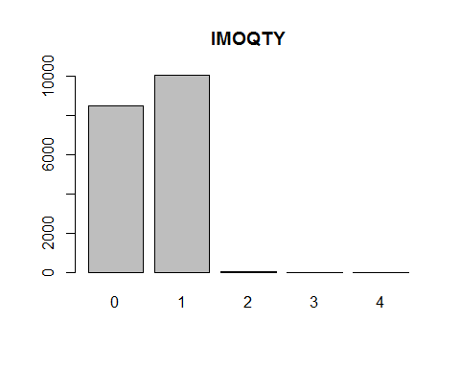

# IMNSTK - empty  
barplot(table(Inv_final$IMNSTK),main="IMNSTK")

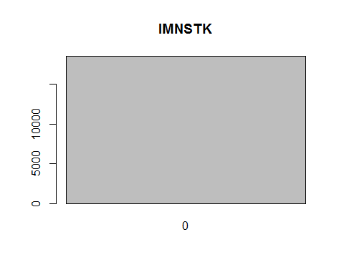

# IMXSTK  
barplot(table(Inv_final$IMXSTK),main="IMXSTK")

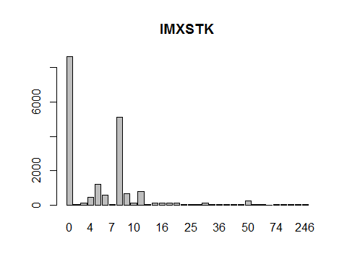

# IMDSTK - empty  
barplot(table(Inv_final$IMDSTK),main="IMDSTK")

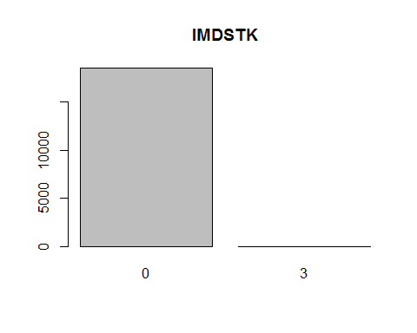

# IDSPLY  
barplot(table(Inv_final$IDSPLY),main="IDSPLY")

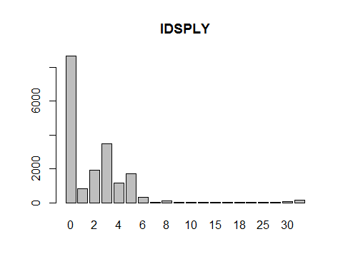

# IOMULT - mostly empty  
barplot(table(Inv_final$IOMULT),main="IOMULT")

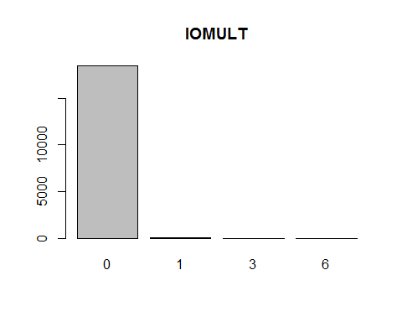

# IRPLCD - convert NA's to 0  
Inv_final$IRPLCD[is.na(Inv_final$IRPLCD)]<-0  
barplot(table(Inv_final$IRPLCD),main="IRPLCD")

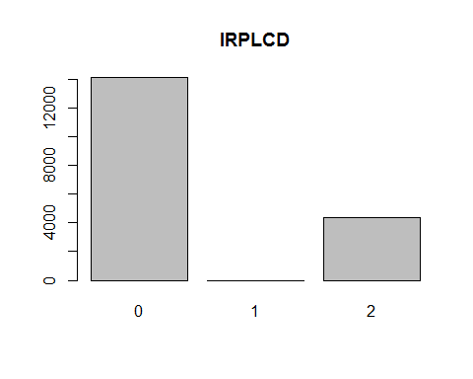

# IMFPRC - empty  
barplot(table(Inv_final$IMFPRC),main="IMFPRC")

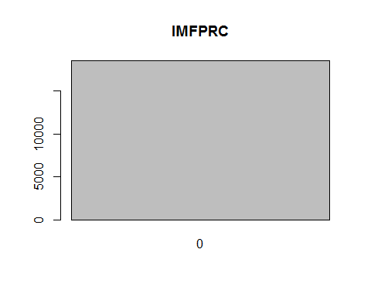

# IWGHT - there is one outlier that throws the significance off  
barplot(table(Inv_final$IWGHT),main="IWGHT")

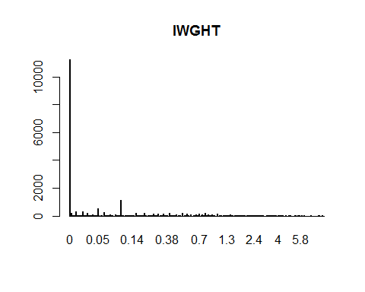

Inv_final$IWGHT[Inv_final$IWGHT==3001.4]=0  
# ICUBE - investigate taking the log(ICUBE)  
barplot(table(Inv_final$ICUBE),main="ICUBE")

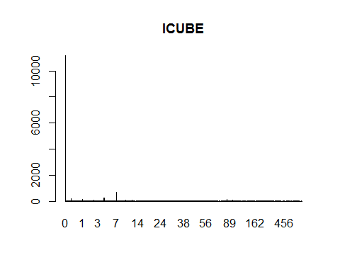

# IDLGTH - investigate taking the log(ICUBE)  
barplot(table(Inv_final$IDLGTH),main="IDLGTH")

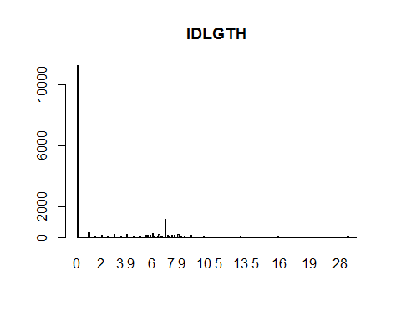

# IDWDTH - investigate taking the log(ICUBE)  
barplot(table(Inv_final$IDWDTH),main="IDWDTH")

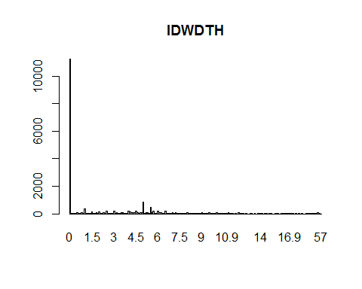

# IDHGHT - investigate taking the log(ICUBE)  
barplot(table(Inv_final$IDHGHT),main="IDHGHT")

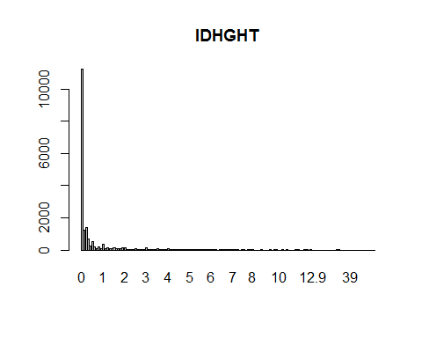

# IMDATE  
barplot(table(Inv_final$IMDATE),main="IMDATE")

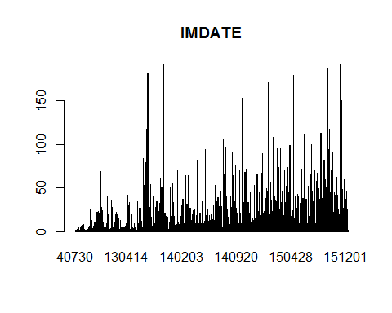

# IMCENT - empty  
barplot(table(Inv_final$IMCENT),main="IMCENT")

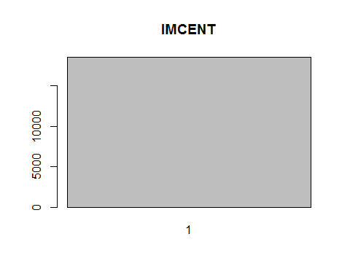

# IVPLTI - not significant  
barplot(table(Inv_final$IVPLTI),main="IVPLTI")

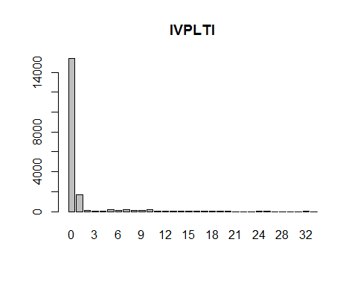

# IVPLHI  
barplot(table(Inv_final$IVPLHI),main="IVPLHI")

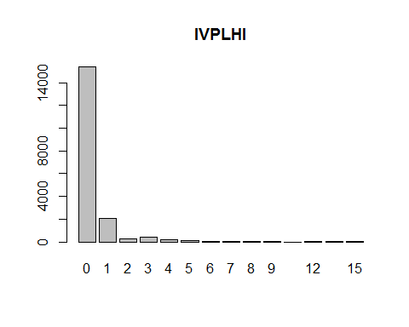

# SHPNUM - empty  
barplot(table(Inv_final$SHPNUM),main="SHPNUM")

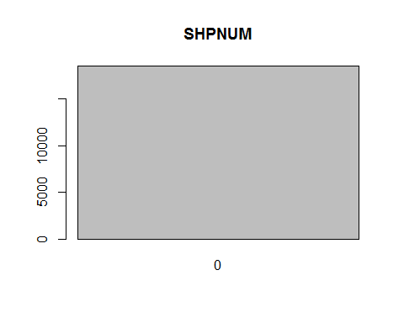

# Lots of NA's in IDISTM, replace with 0  
Inv_final$IDISTM[is.na(Inv_final$IDISTM)]<-0  
barplot(table(Inv_final$IDISTM),main="IDISTM")

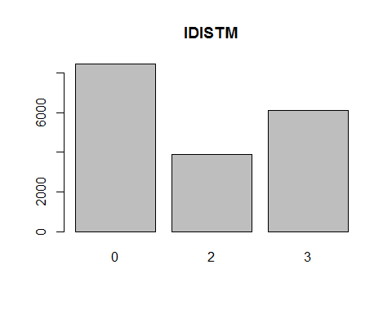

# IHLDWO - empty  
barplot(table(Inv_final$IHLDWO),main="IHLDWO")

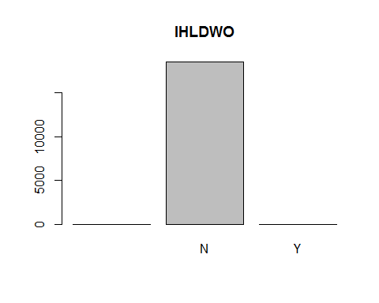

# IIGNUM - empty  
barplot(table(Inv_final$IIGNUM),main="IIGNUM")

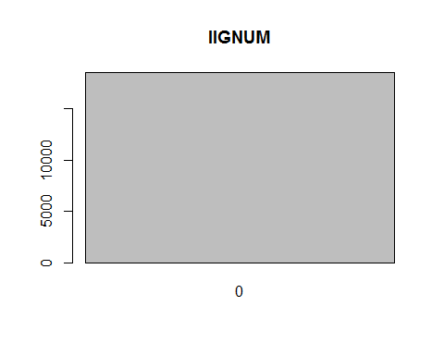

# ISDIM - empty  
barplot(table(Inv_final$ISDIM),main="ISDIM")

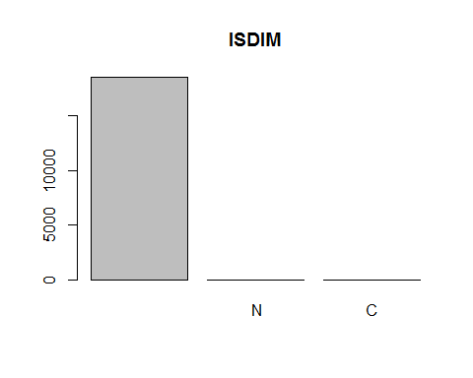

# IVATCD - all NA's  
# IPLAN - empty  
barplot(table(Inv_final$IPLAN),main="IPLAN")

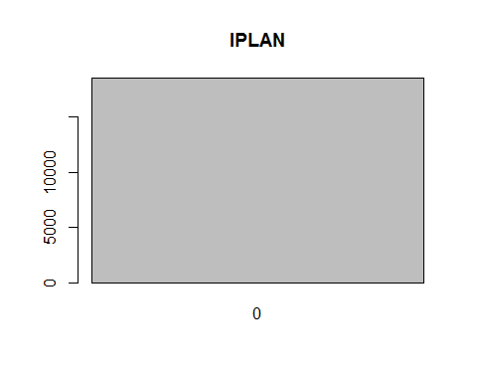

# IVLRK1 - empty  
barplot(table(Inv_final$IVLRK1),main="IVLRK1")

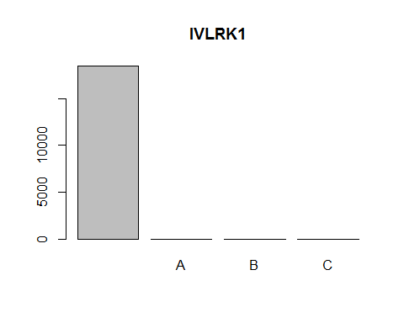

# IVLRK2 - empty  
barplot(table(Inv_final$IVLRK2),main="IVLRK2")

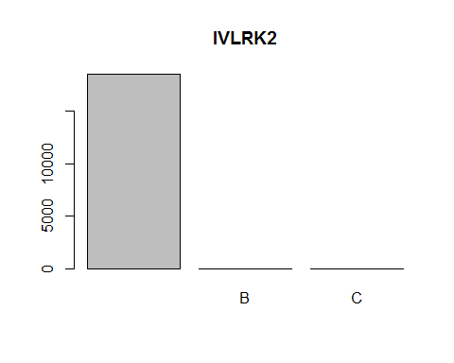

# IVLRK3 - all NA's  
# IVLRK4 - all NA's  
# IRPLCN - empty  
barplot(table(Inv_final$IRPLCN),main="IRPLCN")

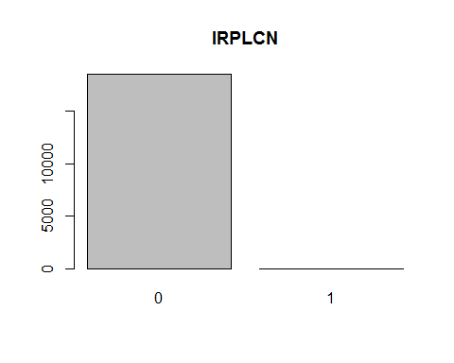

# IRPLDT - empty  
barplot(table(Inv_final$IRPLDT),main="IRPLDT")

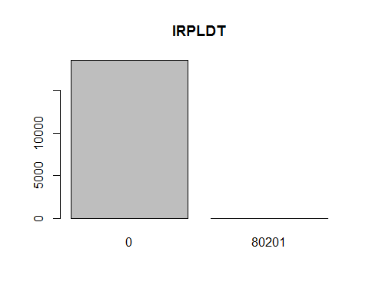

# ISEASN  
barplot(table(Inv_final$ISEASN),main="ISEASN")

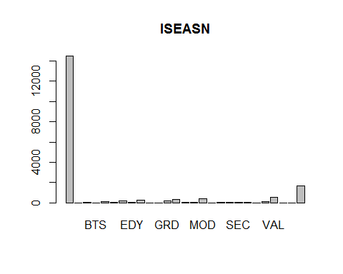

# IDEADC  
barplot(table(Inv_final$IDEADC),main="IDEADC")

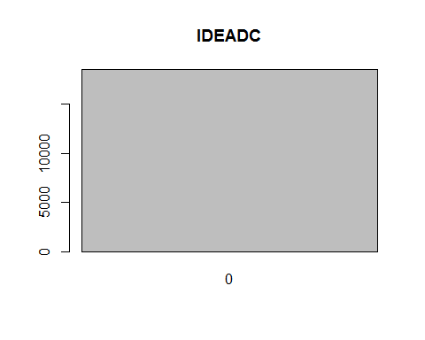

# IDEADD - empty  
barplot(table(Inv_final$IDEADD),main="IDEADD")

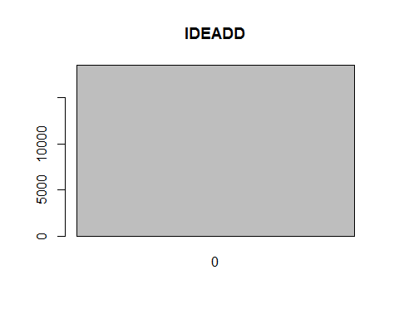

# INLRTL  
barplot(table(Inv_final$INLRTL),main="INLRTL")

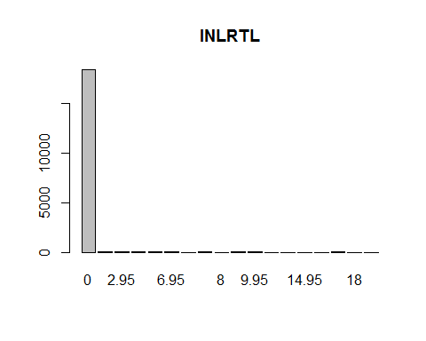

# IHANDL is all NA's  
# IATRB1 - empty  
barplot(table(Inv_final$IATRB1),main="IATRB1")

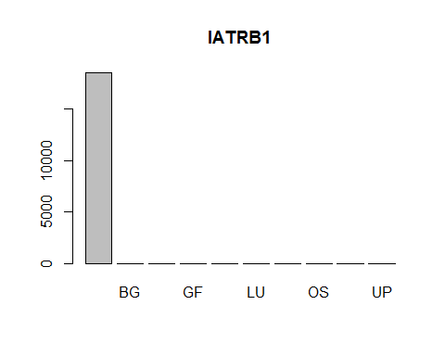

# IATRB2 - empty  
barplot(table(Inv_final$IATRB2),main="IATRB2")

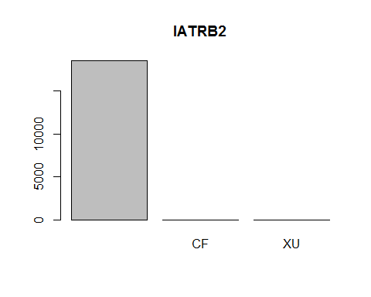

# IATRB3  
barplot(table(Inv_final$IATRB3),main="IATRB3")

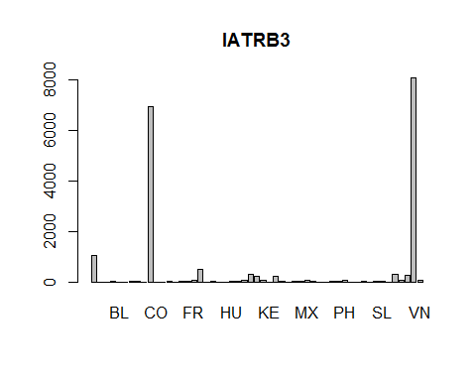

# IATRB4 - empty  
barplot(table(Inv_final$IATRB4),main="IATRB4")

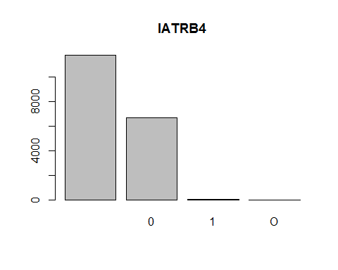

# IATRB5 - all N's  
barplot(table(Inv_final$IATRB5),main="IATRB5")

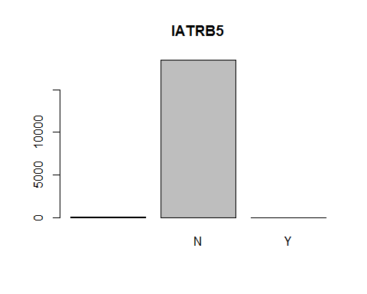

# IPRCCH  
barplot(table(Inv_final$IPRCCH),main="IPRCCH")

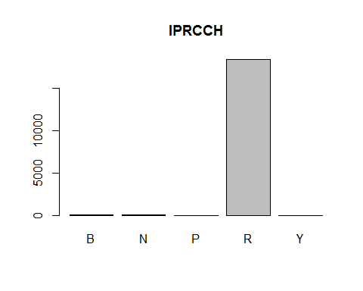

# IPRCZN - all N's  
barplot(table(Inv_final$IPRCZN),main="IPRCZN")

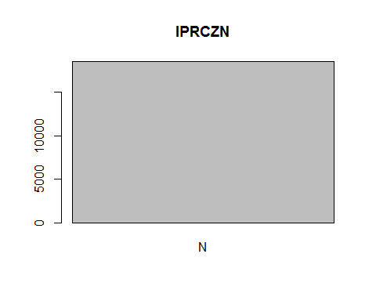

# IPRCST  
barplot(table(Inv_final$IPRCST),main="IPRCST")

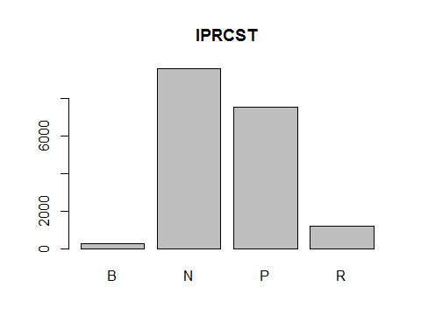

# IASNUM - empty  
barplot(table(Inv_final$IASNUM),main="IASNUM")

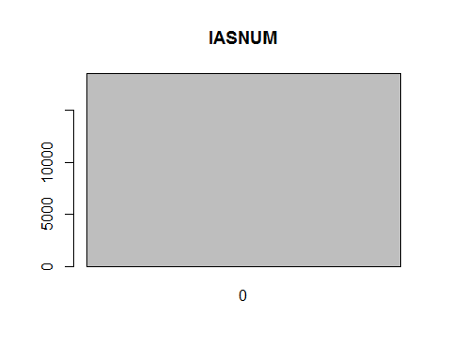

# ICORGP  
barplot(table(Inv_final$ICORGP),main="ICORGP")

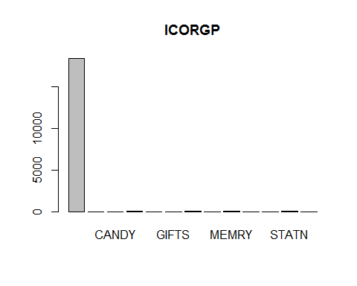

# ILEAD  
barplot(table(Inv_final$ILEAD),main="ILEAD")

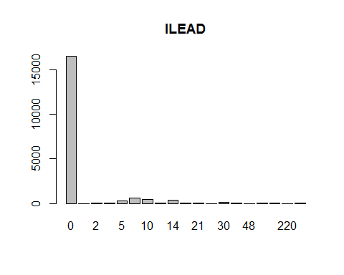

# IHZCOD - all NA's  
# IFRACT - all NA's  
# IMCRDT - distributed  
barplot(table(Inv_final$IMCRDT),main="IMCRDT")

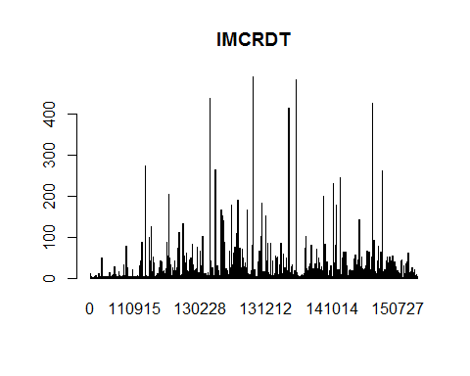

# IMCRCN - all 1's  
barplot(table(Inv_final$IMCRCN),main="IMCRCN")

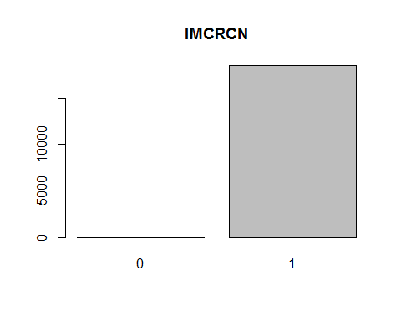

# Check cross correlation of attributes to eliminate reduncancy

Create corrplot of Inventory Master (we see that ITKTTR, ITKTN and ILBLTR are highly correlated. ITKTTR, it turns out is not a significant predictor of sales, so it will be removed. ILBLTR will also be removed due to colinearity.)

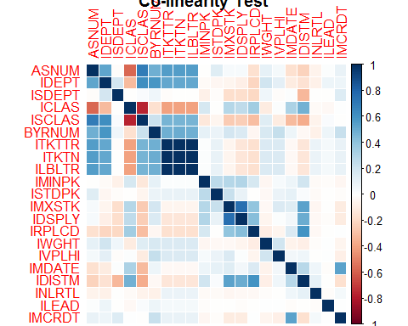

# Build basis Linear Regression model

Linear Regression model (on Sales and Inventory only). R-squared: 0.3234

##   
## Call:  
## lm(formula = IBWK01_sum ~ IBHAND_sum + IBWK02_sum + IBWK03_sum +   
## IBWK04_sum + IBWK05_sum + IBWK06_sum + IBWK07_sum + IBWK08_sum,   
## data = Inv_final)  
##   
## Residuals:  
## Min 1Q Median 3Q Max   
## -20.932 -0.073 -0.060 0.003 85.439   
##   
## Coefficients:  
## Estimate Std. Error t value Pr(>|t|)   
## (Intercept) 0.0726392 0.0086790 8.370 < 2e-16 ***  
## IBHAND_sum -0.0126419 0.0004206 -30.058 < 2e-16 ***  
## IBWK02_sum 0.3861978 0.0131358 29.401 < 2e-16 ***  
## IBWK03_sum 0.4871922 0.0170954 28.498 < 2e-16 ***  
## IBWK04_sum 0.3668130 0.0122928 29.840 < 2e-16 ***  
## IBWK05_sum 0.0614428 0.0166662 3.687 0.000228 ***  
## IBWK06_sum 0.3215253 0.0173860 18.493 < 2e-16 ***  
## IBWK07_sum 0.3214523 0.0207956 15.458 < 2e-16 ***  
## IBWK08_sum 0.0354741 0.0157216 2.256 0.024057 *   
## ---  
## Signif. codes: 0 '***' 0.001 '**' 0.01 '*' 0.05 '.' 0.1 ' ' 1  
##   
## Residual standard error: 1.089 on 18484 degrees of freedom  
## Multiple R-squared: 0.3234, Adjusted R-squared: 0.3231   
## F-statistic: 1104 on 8 and 18484 DF, p-value: < 2.2e-16

Complete working Linear Regression model (all non-empty attributes). R-squared: 0.4574

##   
## Call:  
## lm(formula = IBWK01_sum ~ IBHAND_sum + IBWK02_sum + IBWK03_sum +   
## IBWK04_sum + IBWK05_sum + IBWK06_sum + IBWK07_sum + IBWK08_sum +   
## ASNUM + IDEPT + ISDEPT + ICLAS + ISCLAS + IMFGNO + BYRNUM +   
## ITKTTR + ITKTN + ILBLTR + IFINLN + ISTYPE + IMINPK + ISTDPK +   
## IMXSTK + IDSPLY + IRPLCD + IWGHT + IVPLHI + IMDATE + IDISTM +   
## ISEASN + INLRTL + IATRB3 + IPRCCH + IPRCST + ICORGP + ILEAD +   
## IMCRDT, data = Inv_final)  
##   
## Residuals:  
## Min 1Q Median 3Q Max   
## -30.243 -0.129 -0.012 0.080 60.455   
##   
## Coefficients: (5 not defined because of singularities)  
## Estimate Std. Error t value Pr(>|t|)   
## (Intercept) -7.817e-02 3.133e-01 -0.250 0.802946   
## IBHAND_sum -1.037e-02 4.251e-04 -24.400 < 2e-16 ***  
## IBWK02_sum 3.172e-01 1.238e-02 25.614 < 2e-16 ***  
## IBWK03_sum 4.436e-01 1.564e-02 28.361 < 2e-16 ***  
## IBWK04_sum 2.882e-01 1.134e-02 25.410 < 2e-16 ***  
## IBWK05_sum 1.071e-01 1.521e-02 7.039 2.01e-12 ***  
## IBWK06_sum 2.718e-01 1.587e-02 17.124 < 2e-16 ***  
## IBWK07_sum 2.530e-01 1.911e-02 13.236 < 2e-16 ***  
## IBWK08_sum 3.744e-02 1.441e-02 2.598 0.009383 **   
## ASNUM -2.418e-07 1.081e-07 -2.237 0.025298 *   
## IDEPT 4.405e-04 1.833e-04 2.403 0.016265 *   
## ISDEPT -2.459e-03 1.191e-03 -2.064 0.038992 *   
## ICLAS -1.076e-03 3.790e-04 -2.839 0.004525 **   
## ISCLAS -1.184e-03 5.268e-04 -2.247 0.024643 *   
## IMFGNO0147 7.305e-02 3.111e-01 0.235 0.814360   
## IMFGNO0307 8.077e-03 1.973e-01 0.041 0.967344   
## IMFGNO0397 9.522e-02 2.730e-01 0.349 0.727280   
## IMFGNO0467 2.445e-01 1.003e+00 0.244 0.807442   
## IMFGNO0473 2.749e-02 5.871e-01 0.047 0.962646   
## IMFGNO0753 -1.215e-01 7.103e-01 -0.171 0.864153   
## IMFGNO1003730 -1.278e-02 1.786e-01 -0.072 0.942969   
## IMFGNO1042 -1.097e-01 3.227e-01 -0.340 0.733811   
## IMFGNO1043 -5.646e-02 1.689e-01 -0.334 0.738137   
## IMFGNO1047 -4.153e-02 1.790e-01 -0.232 0.816517   
## IMFGNO1127 4.346e-01 9.939e-01 0.437 0.661917   
## IMFGNO1413 -4.258e-02 1.845e-01 -0.231 0.817536   
## IMFGNO1417 2.444e-01 1.062e+00 0.230 0.818070   
## IMFGNO1762 -3.292e-02 9.940e-01 -0.033 0.973576   
## IMFGNO1875 6.593e-02 9.952e-01 0.066 0.947181   
## IMFGNO2113 -4.469e-02 9.939e-01 -0.045 0.964133   
## IMFGNO2125 1.954e-01 9.957e-01 0.196 0.844385   
## IMFGNO2407 -5.704e-01 9.953e-01 -0.573 0.566539   
## IMFGNO2417 -5.057e-01 4.143e-01 -1.221 0.222194   
## IMFGNO2467 -2.370e-01 9.948e-01 -0.238 0.811712   
## IMFGNO2497 -2.952e-01 1.272e+00 -0.232 0.816485   
## IMFGNO2607 -5.499e-02 7.131e-01 -0.077 0.938535   
## IMFGNO2657 -1.328e-02 9.953e-01 -0.013 0.989354   
## IMFGNO2803 -1.563e-01 9.949e-01 -0.157 0.875154   
## IMFGNO4132 -7.716e-02 2.665e-01 -0.290 0.772147   
## IMFGNO4137 -5.486e-02 3.390e-01 -0.162 0.871446   
## IMFGNO4157 -3.825e-03 1.008e+00 -0.004 0.996974   
## IMFGNO4227 -3.944e-01 1.394e+00 -0.283 0.777335   
## IMFGNO4237 2.332e-02 5.025e-01 0.046 0.962982   
## IMFGNO4247 3.167e-02 1.011e+00 0.031 0.975010   
## IMFGNO4363 -3.138e-01 1.204e+00 -0.261 0.794461   
## IMFGNO4373 -3.581e-01 1.078e+00 -0.332 0.739848   
## IMFGNO4772 -7.302e-01 2.324e-01 -3.143 0.001677 **   
## IMFGNO4773 -7.004e-01 2.122e-01 -3.300 0.000967 ***  
## IMFGNO4777 -4.389e-01 1.901e-01 -2.309 0.020970 *   
## IMFGNO4843 -6.587e-01 4.352e-01 -1.514 0.130128   
## IMFGNO4867 -5.624e-01 9.959e-01 -0.565 0.572302   
## IMFGNO4977 -3.628e-01 2.440e-01 -1.487 0.137134   
## IMFGNO5107 -7.076e-01 4.689e-01 -1.509 0.131312   
## IMFGNO5457 -3.123e-01 1.006e+00 -0.310 0.756275   
## IMFGNO5691 -2.164e-01 5.083e-01 -0.426 0.670321   
## IMFGNO5692 -1.457e-01 4.777e-01 -0.305 0.760298   
## IMFGNO5693 -1.584e-01 2.327e-01 -0.681 0.495978   
## IMFGNO5697 -1.809e-01 2.120e-01 -0.853 0.393721   
## IMFGNO5712 -1.296e-01 9.991e-01 -0.130 0.896751   
## IMFGNO5743 -1.074e-01 3.775e-01 -0.284 0.776080   
## IMFGNO6147 1.079e-01 4.052e-01 0.266 0.790058   
## IMFGNO6337 -4.481e-02 3.352e-01 -0.134 0.893637   
## IMFGNO6413 -1.116e-01 3.584e-01 -0.311 0.755576   
## IMFGNO6417 -1.180e-01 5.308e-01 -0.222 0.824113   
## IMFGNO6557 4.019e-02 7.331e-01 0.055 0.956282   
## IMFGNO6577 1.142e-01 6.521e-01 0.175 0.860994   
## IMFGNO6647 -5.662e-02 4.826e-01 -0.117 0.906600   
## IMFGNO6893 -6.654e-02 9.976e-01 -0.067 0.946823   
## IMFGNO6897 -1.631e-01 2.375e-01 -0.687 0.492189   
## IMFGNO6903 -1.903e-01 9.978e-01 -0.191 0.848729   
## IMFGNO7172 -8.813e-02 4.238e-01 -0.208 0.835280   
## IMFGNO7173 -6.156e-02 3.256e-01 -0.189 0.850060   
## IMFGNO7177 -1.013e-01 2.787e-01 -0.363 0.716238   
## IMFGNO7247 -4.940e-02 1.991e-01 -0.248 0.804029   
## IMFGNO7493 -1.291e-01 7.222e-01 -0.179 0.858087   
## IMFGNO7657 -2.089e-01 1.003e+00 -0.208 0.835090   
## IMFGNO8811 -1.565e-01 9.951e-01 -0.157 0.875067   
## IMFGNO9011 -8.774e-02 1.800e-01 -0.487 0.626012   
## IMFGNO9029 -1.385e-01 1.546e-01 -0.895 0.370560   
## IMFGNO9041 -8.504e-02 3.228e-01 -0.263 0.792197   
## IMFGNO9059 -5.111e-02 9.935e-01 -0.051 0.958971   
## IMFGNO9069 -1.989e-01 2.100e-01 -0.947 0.343600   
## IMFGNO9079 5.698e-03 1.729e-01 0.033 0.973716   
## IMFGNO9089 -7.323e-02 1.731e-01 -0.423 0.672175   
## IMFGNO9099 1.764e-01 2.090e-01 0.844 0.398573   
## IMFGNO9109 -2.400e-01 1.810e-01 -1.326 0.184871   
## IMFGNO9119 -2.458e-01 2.063e-01 -1.191 0.233583   
## IMFGNO9139 -2.029e-01 1.877e-01 -1.081 0.279610   
## IMFGNO9269 -5.524e-02 1.655e-01 -0.334 0.738519   
## IMFGNO9291 -1.614e-01 7.489e-01 -0.215 0.829392   
## IMFGNO9311 -1.936e-01 5.171e-01 -0.374 0.708109   
## IMFGNO9331 -7.655e-02 2.897e-01 -0.264 0.791606   
## IMFGNO9341 -6.989e-01 1.009e+00 -0.693 0.488350   
## IMFGNO9361 -4.059e-01 2.204e-01 -1.842 0.065522 .   
## IMFGNO9381 -1.207e-01 2.248e-01 -0.537 0.591294   
## IMFGNO9391 -1.054e-01 2.820e-01 -0.374 0.708499   
## IMFGNO9411 -7.614e-02 2.867e-01 -0.266 0.790564   
## IMFGNO9421 -7.857e-02 2.930e-01 -0.268 0.788568   
## IMFGNO9431 -9.871e-02 3.836e-01 -0.257 0.796949   
## IMFGNO9451 -3.121e-01 2.555e-01 -1.221 0.221915   
## IMFGNO9471 -1.702e-01 5.900e-01 -0.289 0.772944   
## IMFGNO9499 -1.505e-01 2.446e-01 -0.615 0.538376   
## IMFGNO9509 -7.972e-01 9.903e-01 -0.805 0.420829   
## IMFGNO9529 7.888e-02 1.797e-01 0.439 0.660749   
## IMFGNO9539 6.486e-03 8.016e-01 0.008 0.993544   
## IMFGNO9549 -9.054e-02 2.031e-01 -0.446 0.655814   
## IMFGNO9559 -1.052e-01 2.188e-01 -0.481 0.630690   
## IMFGNO9569 -1.738e-01 3.265e-01 -0.532 0.594489   
## IMFGNO9579 -6.145e-02 1.880e-01 -0.327 0.743796   
## IMFGNO9589 -8.624e-02 2.181e-01 -0.395 0.692486   
## IMFGNO9599 -7.869e-02 2.173e-01 -0.362 0.717299   
## IMFGNO9629 -1.018e-01 4.308e-01 -0.236 0.813186   
## IMFGNO9649 3.404e-02 2.992e-01 0.114 0.909419   
## IMFGNO9659 5.615e-02 6.721e-01 0.084 0.933418   
## IMFGNO9669 3.583e-02 2.806e-01 0.128 0.898412   
## IMFGNO9679 2.782e-01 1.802e-01 1.544 0.122528   
## IMFGNO9689 4.004e-02 3.023e-01 0.132 0.894633   
## IMFGNO9699 -1.243e-01 3.433e-01 -0.362 0.717423   
## IMFGNO9739 3.653e-01 1.845e-01 1.980 0.047724 *   
## IMFGNO9749 -1.202e-01 3.642e-01 -0.330 0.741457   
## IMFGNO9769 1.605e-01 5.471e-01 0.293 0.769257   
## IMFGNO9789 3.891e-02 5.349e-01 0.073 0.942015   
## IMFGNOANNIVERSARY 1.155e-01 6.945e-01 0.166 0.867964   
## IMFGNOBATH -4.949e-01 2.867e-01 -1.726 0.084299 .   
## IMFGNOE2049 CRYS/M -7.054e-02 4.394e-01 -0.161 0.872456   
## IMFGNOMEMO FOLIO 9.773e-03 9.818e-01 0.010 0.992058   
## IMFGNOMSL20 -2.427e-01 9.824e-01 -0.247 0.804845   
## IMFGNOPORRINGER 1.217e-01 9.828e-01 0.124 0.901426   
## IMFGNOPZ-RABBIT -5.189e-03 4.399e-01 -0.012 0.990589   
## IMFGNOWALLET 1.016e-01 9.816e-01 0.104 0.917544   
## IMFGNOWHITE CITY 5.649e-03 4.917e-01 0.011 0.990834   
## IMFGNOY -4.474e-02 1.727e-01 -0.259 0.795551   
## BYRNUM -1.659e-02 6.295e-03 -2.636 0.008401 **   
## ITKTTR 9.132e-02 3.559e-01 0.257 0.797469   
## ITKTN 1.222e+00 4.044e-01 3.021 0.002522 **   
## ILBLTR -1.369e+00 5.386e-01 -2.542 0.011015 *   
## IFINLNACCES 3.238e-01 1.077e+00 0.301 0.763593   
## IFINLNCARDS -8.106e-02 1.051e-01 -0.771 0.440422   
## IFINLNCOLLE 8.333e-01 1.751e+00 0.476 0.634252   
## IFINLNDISC 6.765e-01 1.066e+00 0.635 0.525727   
## IFINLNGIFT -2.152e-01 1.135e+00 -0.190 0.849642   
## IFINLNOTHER -1.424e+00 3.873e-01 -3.676 0.000237 ***  
## IFINLNSTATN -2.932e-03 4.619e-01 -0.006 0.994935   
## IFINLNWRAP 1.081e-02 6.969e-01 0.016 0.987625   
## ISTYPE05 -1.321e+00 5.126e-01 -2.578 0.009952 **   
## ISTYPECM -4.313e-02 2.704e-01 -0.160 0.873269   
## ISTYPEDM -7.438e-02 2.225e-01 -0.334 0.738201   
## ISTYPEGW 3.265e+01 7.338e-01 44.496 < 2e-16 ***  
## ISTYPEIM -2.279e-02 2.245e-01 -0.102 0.919151   
## IMINPK 7.474e-03 1.589e-03 4.704 2.57e-06 ***  
## ISTDPK -1.891e-04 7.062e-05 -2.677 0.007430 **   
## IMXSTK 1.843e-03 1.452e-03 1.269 0.204401   
## IDSPLY 6.272e-03 2.920e-03 2.148 0.031703 *   
## IRPLCD -7.418e-03 1.199e-02 -0.619 0.536121   
## IWGHT -1.263e-02 1.097e-02 -1.152 0.249540   
## IVPLHI -2.370e-02 8.376e-03 -2.830 0.004660 **   
## IMDATE 4.973e-06 1.263e-06 3.938 8.23e-05 ***  
## IDISTM -5.936e-02 1.187e-02 -5.000 5.78e-07 ***  
## ISEASNBOS NA NA NA NA   
## ISEASNCAL 1.809e-01 1.528e-01 1.184 0.236289   
## ISEASNCOM NA NA NA NA   
## ISEASNEAS -7.800e-02 1.363e-01 -0.572 0.567242   
## ISEASNEDY -8.119e-02 1.050e+00 -0.077 0.938387   
## ISEASNFAD -8.631e-02 1.475e-01 -0.585 0.558428   
## ISEASNGRD -6.899e-04 1.496e-01 -0.005 0.996320   
## ISEASNHAL -1.054e-01 1.906e-01 -0.553 0.580052   
## ISEASNHNK 5.490e-01 1.730e-01 3.174 0.001507 **   
## ISEASNJNY -1.751e-02 2.366e-01 -0.074 0.940992   
## ISEASNMOD -7.868e-02 1.116e-01 -0.705 0.480757   
## ISEASNNYD 8.547e-02 6.947e-01 0.123 0.902076   
## ISEASNPAS -1.958e-01 5.689e-01 -0.344 0.730737   
## ISEASNSEC NA NA NA NA   
## ISEASNSTP NA NA NA NA   
## ISEASNTHG 2.369e-01 9.951e-01 0.238 0.811798   
## ISEASNVAL -1.566e-02 1.172e-01 -0.134 0.893682   
## ISEASNXMS 6.331e-01 7.860e-02 8.055 8.43e-16 ***  
## INLRTL 2.331e-02 1.309e-02 1.780 0.075063 .   
## IATRB3AU 4.610e-01 3.290e-01 1.401 0.161217   
## IATRB3CA 1.585e-02 2.002e-01 0.079 0.936906   
## IATRB3CH -1.918e-01 1.627e-01 -1.178 0.238685   
## IATRB3CN 3.297e-02 3.731e-02 0.884 0.376844   
## IATRB3DE 4.188e-01 3.305e-01 1.267 0.205110   
## IATRB3EN 3.085e-02 6.954e-01 0.044 0.964619   
## IATRB3ES 2.024e-02 1.702e-01 0.119 0.905336   
## IATRB3FR 4.639e-02 1.209e-01 0.384 0.701189   
## IATRB3GB -9.368e-02 6.435e-02 -1.456 0.145503   
## IATRB3HK -9.601e-02 3.162e-01 -0.304 0.761398   
## IATRB3HU 5.850e-02 2.288e-01 0.256 0.798209   
## IATRB3ID 5.333e-01 2.360e-01 2.260 0.023816 *   
## IATRB3IL -1.318e-01 1.409e-01 -0.936 0.349464   
## IATRB3IN 6.497e-02 6.651e-02 0.977 0.328637   
## IATRB3IT 9.831e-02 7.481e-02 1.314 0.188815   
## IATRB3JP -3.173e-01 1.665e-01 -1.905 0.056771 .   
## IATRB3KR 1.178e-01 7.614e-02 1.548 0.121711   
## IATRB3LB -3.297e-02 1.954e-01 -0.169 0.866043   
## IATRB3MA 1.089e-02 5.677e-01 0.019 0.984693   
## IATRB3MG 8.347e-02 2.345e-01 0.356 0.721916   
## IATRB3MX -1.844e-03 1.395e-01 -0.013 0.989452   
## IATRB3MY 1.805e-01 3.038e-01 0.594 0.552411   
## IATRB3NP -2.332e-02 2.855e-01 -0.082 0.934919   
## IATRB3PE -1.319e-01 2.745e-01 -0.480 0.630883   
## IATRB3PH 1.627e-01 1.361e-01 1.196 0.231703   
## IATRB3PT -4.002e-01 5.693e-01 -0.703 0.482085   
## IATRB3SG 1.678e-01 5.688e-01 0.295 0.767994   
## IATRB3SL 2.935e+00 6.947e-01 4.224 2.41e-05 ***  
## IATRB3TH -1.094e-01 6.793e-02 -1.610 0.107385   
## IATRB3TR -5.526e-02 1.456e-01 -0.380 0.704249   
## IATRB3TW 5.151e-01 8.147e-02 6.322 2.64e-10 ***  
## IATRB3US 2.675e-02 3.700e-02 0.723 0.469780   
## IATRB3VN -1.159e-01 1.642e-01 -0.706 0.480110   
## IPRCCHN -1.737e+00 2.118e-01 -8.199 2.59e-16 ***  
## IPRCCHR -9.299e-02 1.333e-01 -0.698 0.485412   
## IPRCSTN 1.572e-01 6.947e-02 2.263 0.023632 *   
## IPRCSTP 8.668e-02 6.890e-02 1.258 0.208360   
## IPRCSTR 1.323e-01 7.434e-02 1.780 0.075054 .   
## ICORGPCARDS 4.222e-02 3.787e-01 0.111 0.911227   
## ICORGPCOLLE -7.822e-01 1.449e+00 -0.540 0.589259   
## ICORGPGIFTS 3.971e-02 1.260e+00 0.032 0.974863   
## ICORGPHOMDE -2.666e-01 1.138e+00 -0.234 0.814794   
## ICORGPMEMRY 1.111e-01 9.819e-01 0.113 0.909918   
## ICORGPSEASN 1.978e+01 1.525e+00 12.965 < 2e-16 ***  
## ICORGPSTATN 1.606e-01 4.158e-01 0.386 0.699371   
## ICORGPWRAP NA NA NA NA   
## ILEAD -3.921e-04 6.231e-04 -0.629 0.529130   
## IMCRDT -2.300e-06 1.030e-06 -2.234 0.025523 *   
## ---  
## Signif. codes: 0 '***' 0.001 '**' 0.01 '*' 0.05 '.' 0.1 ' ' 1  
##   
## Residual standard error: 0.981 on 18273 degrees of freedom  
## Multiple R-squared: 0.4574, Adjusted R-squared: 0.4509   
## F-statistic: 70.33 on 219 and 18273 DF, p-value: < 2.2e-16

Add top 50 words to Linear Regression model. R-squared: 0.4586

##   
## Call:  
## lm(formula = IBWK01_sum ~ IBHAND_sum + IBWK02_sum + IBWK03_sum +   
## IBWK04_sum + IBWK05_sum + IBWK06_sum + IBWK07_sum + IBWK08_sum +   
## ASNUM + IDEPT + ISDEPT + ICLAS + ISCLAS + IMFGNO + BYRNUM +   
## ITKTTR + ITKTN + ILBLTR + IFINLN + ISTYPE + IMINPK + ISTDPK +   
## IMXSTK + IDSPLY + IRPLCD + IWGHT + IVPLHI + IMDATE + IDISTM +   
## ISEASN + INLRTL + IATRB3 + IPRCCH + IPRCST + ICORGP + ILEAD +   
## IMCRDT + w_babi + w_bag + w_bdi + w_bird + w_birthday + w_black +   
## w_blue + w_box + w_bracelet + w_butterfli + w_cake + w_candl +   
## w_card + w_cardx + w_conv + w_crystal + w_dog + w_dress +   
## w_earring + w_floral + w_flower + w_gem + w_general + w_girl +   
## w_glass + w_glitter + w_gold + w_handmad + w_happi + w_heart +   
## w_love + w_med + w_mini + w_mom + w_neck + w_necklac + w_note +   
## w_pink + w_print + w_red + w_ribbon + w_set + w_silver +   
## w_soap + w_thank + w_tree + w_vintag + w_wed + w_white +   
## w_xbc, data = Inv_final)  
##   
## Residuals:  
## Min 1Q Median 3Q Max   
## -30.260 -0.146 -0.011 0.086 60.455   
##   
## Coefficients: (5 not defined because of singularities)  
## Estimate Std. Error t value Pr(>|t|)   
## (Intercept) -1.456e-01 3.163e-01 -0.460 0.645236   
## IBHAND_sum -1.041e-02 4.263e-04 -24.418 < 2e-16 ***  
## IBWK02_sum 3.171e-01 1.240e-02 25.567 < 2e-16 ***  
## IBWK03_sum 4.425e-01 1.566e-02 28.248 < 2e-16 ***  
## IBWK04_sum 2.886e-01 1.136e-02 25.406 < 2e-16 ***  
## IBWK05_sum 1.059e-01 1.524e-02 6.951 3.74e-12 ***  
## IBWK06_sum 2.718e-01 1.590e-02 17.098 < 2e-16 ***  
## IBWK07_sum 2.524e-01 1.916e-02 13.172 < 2e-16 ***  
## IBWK08_sum 3.794e-02 1.444e-02 2.628 0.008601 **   
## ASNUM -2.544e-07 1.094e-07 -2.326 0.020035 *   
## IDEPT 4.103e-04 1.888e-04 2.173 0.029799 *   
## ISDEPT -2.234e-03 1.323e-03 -1.689 0.091241 .   
## ICLAS -1.039e-03 3.826e-04 -2.715 0.006637 **   
## ISCLAS -1.199e-03 5.361e-04 -2.236 0.025369 *   
## IMFGNO0147 7.466e-02 3.133e-01 0.238 0.811634   
## IMFGNO0307 5.927e-02 2.147e-01 0.276 0.782521   
## IMFGNO0397 1.322e-01 2.789e-01 0.474 0.635465   
## IMFGNO0467 2.787e-01 1.007e+00 0.277 0.781879   
## IMFGNO0473 4.173e-02 5.880e-01 0.071 0.943414   
## IMFGNO0753 -9.992e-02 7.117e-01 -0.140 0.888352   
## IMFGNO1003730 3.271e-02 1.896e-01 0.173 0.863029   
## IMFGNO1042 -6.975e-02 3.295e-01 -0.212 0.832333   
## IMFGNO1043 -2.624e-02 1.758e-01 -0.149 0.881378   
## IMFGNO1047 -2.742e-02 1.811e-01 -0.151 0.879622   
## IMFGNO1127 4.845e-01 9.978e-01 0.486 0.627265   
## IMFGNO1413 -1.227e-02 1.961e-01 -0.063 0.950105   
## IMFGNO1417 2.357e-01 1.064e+00 0.222 0.824647   
## IMFGNO1762 1.280e-02 9.977e-01 0.013 0.989765   
## IMFGNO1875 5.124e-02 9.958e-01 0.051 0.958961   
## IMFGNO2113 -5.747e-02 9.944e-01 -0.058 0.953918   
## IMFGNO2125 2.707e-01 1.005e+00 0.269 0.787644   
## IMFGNO2407 -6.157e-01 9.976e-01 -0.617 0.537099   
## IMFGNO2417 -5.986e-01 4.199e-01 -1.426 0.154008   
## IMFGNO2467 -2.456e-01 9.954e-01 -0.247 0.805107   
## IMFGNO2497 -2.903e-01 1.274e+00 -0.228 0.819706   
## IMFGNO2607 -5.014e-02 7.143e-01 -0.070 0.944042   
## IMFGNO2657 -5.420e-02 9.977e-01 -0.054 0.956677   
## IMFGNO2803 -9.835e-02 9.978e-01 -0.099 0.921483   
## IMFGNO4132 -1.155e-01 2.682e-01 -0.431 0.666727   
## IMFGNO4137 -7.351e-02 3.398e-01 -0.216 0.828740   
## IMFGNO4157 -1.882e-02 1.009e+00 -0.019 0.985117   
## IMFGNO4227 -4.107e-01 1.395e+00 -0.294 0.768488   
## IMFGNO4237 3.840e-03 5.042e-01 0.008 0.993924   
## IMFGNO4247 -5.630e-02 1.013e+00 -0.056 0.955690   
## IMFGNO4363 -3.261e-01 1.205e+00 -0.271 0.786679   
## IMFGNO4373 -3.763e-01 1.079e+00 -0.349 0.727247   
## IMFGNO4772 -7.543e-01 2.346e-01 -3.215 0.001305 **   
## IMFGNO4773 -7.046e-01 2.135e-01 -3.301 0.000965 ***  
## IMFGNO4777 -4.612e-01 1.915e-01 -2.408 0.016055 *   
## IMFGNO4843 -6.827e-01 4.374e-01 -1.561 0.118533   
## IMFGNO4867 -6.210e-01 9.985e-01 -0.622 0.534042   
## IMFGNO4977 -4.007e-01 2.489e-01 -1.610 0.107455   
## IMFGNO5107 -7.239e-01 4.724e-01 -1.532 0.125480   
## IMFGNO5457 -2.887e-01 1.007e+00 -0.287 0.774396   
## IMFGNO5691 -2.072e-01 5.085e-01 -0.408 0.683634   
## IMFGNO5692 -1.433e-01 4.791e-01 -0.299 0.764875   
## IMFGNO5693 -1.573e-01 2.350e-01 -0.669 0.503380   
## IMFGNO5697 -1.917e-01 2.144e-01 -0.894 0.371109   
## IMFGNO5712 -1.160e-01 9.998e-01 -0.116 0.907655   
## IMFGNO5743 -1.067e-01 3.790e-01 -0.282 0.778263   
## IMFGNO6147 8.970e-02 4.090e-01 0.219 0.826399   
## IMFGNO6337 -6.184e-02 3.361e-01 -0.184 0.854017   
## IMFGNO6413 -1.435e-01 3.598e-01 -0.399 0.689958   
## IMFGNO6417 -2.184e-01 5.369e-01 -0.407 0.684168   
## IMFGNO6557 -6.945e-02 7.395e-01 -0.094 0.925177   
## IMFGNO6577 1.050e-02 6.591e-01 0.016 0.987286   
## IMFGNO6647 -6.349e-02 4.850e-01 -0.131 0.895850   
## IMFGNO6893 -5.936e-02 9.984e-01 -0.059 0.952594   
## IMFGNO6897 -1.765e-01 2.390e-01 -0.738 0.460284   
## IMFGNO6903 -2.290e-01 1.000e+00 -0.229 0.818945   
## IMFGNO7172 -1.281e-01 4.253e-01 -0.301 0.763296   
## IMFGNO7173 -6.942e-02 3.264e-01 -0.213 0.831584   
## IMFGNO7177 -1.092e-01 2.797e-01 -0.390 0.696307   
## IMFGNO7247 -7.856e-02 2.007e-01 -0.391 0.695522   
## IMFGNO7493 -1.383e-01 7.227e-01 -0.191 0.848210   
## IMFGNO7657 -2.263e-01 1.004e+00 -0.225 0.821668   
## IMFGNO8811 -9.055e-02 1.006e+00 -0.090 0.928252   
## IMFGNO9011 -9.739e-02 1.811e-01 -0.538 0.590768   
## IMFGNO9029 -1.534e-01 1.561e-01 -0.983 0.325789   
## IMFGNO9041 -9.467e-02 3.238e-01 -0.292 0.769995   
## IMFGNO9059 -3.243e-02 9.973e-01 -0.033 0.974058   
## IMFGNO9069 -2.034e-01 2.116e-01 -0.961 0.336478   
## IMFGNO9079 -2.390e-02 1.743e-01 -0.137 0.890927   
## IMFGNO9089 -8.633e-02 1.765e-01 -0.489 0.624813   
## IMFGNO9099 1.600e-01 2.099e-01 0.762 0.445916   
## IMFGNO9109 -2.826e-01 1.828e-01 -1.546 0.122186   
## IMFGNO9119 -2.422e-01 2.073e-01 -1.168 0.242817   
## IMFGNO9139 -2.210e-01 1.890e-01 -1.169 0.242222   
## IMFGNO9269 -7.843e-02 1.668e-01 -0.470 0.638167   
## IMFGNO9291 -1.654e-01 7.496e-01 -0.221 0.825377   
## IMFGNO9311 -2.129e-01 5.178e-01 -0.411 0.681003   
## IMFGNO9331 -9.610e-02 2.908e-01 -0.331 0.741019   
## IMFGNO9341 -7.133e-01 1.009e+00 -0.707 0.479741   
## IMFGNO9361 -4.221e-01 2.217e-01 -1.904 0.056900 .   
## IMFGNO9381 -1.250e-01 2.262e-01 -0.553 0.580524   
## IMFGNO9391 -1.312e-01 2.832e-01 -0.463 0.643024   
## IMFGNO9411 -1.194e-01 2.885e-01 -0.414 0.679093   
## IMFGNO9421 -8.439e-02 2.940e-01 -0.287 0.774096   
## IMFGNO9431 -1.085e-01 3.843e-01 -0.282 0.777683   
## IMFGNO9451 -3.300e-01 2.567e-01 -1.285 0.198672   
## IMFGNO9471 -1.809e-01 5.906e-01 -0.306 0.759317   
## IMFGNO9499 -1.780e-01 2.457e-01 -0.724 0.468937   
## IMFGNO9509 -8.509e-01 9.912e-01 -0.858 0.390675   
## IMFGNO9529 4.302e-02 1.813e-01 0.237 0.812472   
## IMFGNO9539 -2.652e-02 8.023e-01 -0.033 0.973627   
## IMFGNO9549 -9.799e-02 2.048e-01 -0.478 0.632334   
## IMFGNO9559 -1.410e-01 2.204e-01 -0.639 0.522543   
## IMFGNO9569 -2.060e-01 3.278e-01 -0.628 0.529817   
## IMFGNO9579 -7.216e-02 1.896e-01 -0.381 0.703486   
## IMFGNO9589 -9.450e-02 2.192e-01 -0.431 0.666393   
## IMFGNO9599 -8.626e-02 2.183e-01 -0.395 0.692688   
## IMFGNO9629 -1.628e-01 4.335e-01 -0.375 0.707307   
## IMFGNO9649 -4.319e-02 3.046e-01 -0.142 0.887263   
## IMFGNO9659 1.468e-02 6.733e-01 0.022 0.982606   
## IMFGNO9669 -1.335e-02 2.847e-01 -0.047 0.962601   
## IMFGNO9679 2.316e-01 1.873e-01 1.237 0.216161   
## IMFGNO9689 -3.519e-02 3.082e-01 -0.114 0.909084   
## IMFGNO9699 -1.535e-01 3.467e-01 -0.443 0.658062   
## IMFGNO9739 3.679e-01 1.877e-01 1.960 0.049980 *   
## IMFGNO9749 -1.359e-01 3.650e-01 -0.372 0.709733   
## IMFGNO9769 1.578e-01 5.479e-01 0.288 0.773364   
## IMFGNO9789 2.990e-02 5.377e-01 0.056 0.955651   
## IMFGNOANNIVERSARY 1.017e-01 6.979e-01 0.146 0.884106   
## IMFGNOBATH -4.799e-01 2.869e-01 -1.673 0.094399 .   
## IMFGNOE2049 CRYS/M -1.155e-01 4.410e-01 -0.262 0.793464   
## IMFGNOMEMO FOLIO 1.313e-02 9.822e-01 0.013 0.989335   
## IMFGNOMSL20 -2.385e-01 9.827e-01 -0.243 0.808269   
## IMFGNOPORRINGER 1.252e-01 9.831e-01 0.127 0.898695   
## IMFGNOPZ-RABBIT 5.048e-03 4.403e-01 0.011 0.990854   
## IMFGNOWALLET 1.313e-01 9.837e-01 0.133 0.893816   
## IMFGNOWHITE CITY 4.428e-03 4.927e-01 0.009 0.992829   
## IMFGNOY -4.171e-02 1.734e-01 -0.240 0.809952   
## BYRNUM -1.785e-02 6.347e-03 -2.812 0.004926 **   
## ITKTTR 1.273e-01 3.587e-01 0.355 0.722599   
## ITKTN 1.242e+00 4.049e-01 3.068 0.002156 **   
## ILBLTR -1.428e+00 5.408e-01 -2.640 0.008305 **   
## IFINLNACCES 3.306e-01 1.077e+00 0.307 0.758863   
## IFINLNCARDS -7.755e-02 1.061e-01 -0.731 0.464772   
## IFINLNCOLLE 8.487e-01 1.758e+00 0.483 0.629175   
## IFINLNDISC 6.199e-01 1.070e+00 0.580 0.562236   
## IFINLNGIFT -2.130e-01 1.136e+00 -0.188 0.851240   
## IFINLNOTHER -1.469e+00 3.907e-01 -3.760 0.000171 ***  
## IFINLNSTATN -5.552e-02 4.641e-01 -0.120 0.904775   
## IFINLNWRAP -1.871e-02 6.989e-01 -0.027 0.978642   
## ISTYPE05 -1.229e+00 5.213e-01 -2.358 0.018391 *   
## ISTYPECM -1.057e-02 2.724e-01 -0.039 0.969039   
## ISTYPEDM -4.371e-02 2.241e-01 -0.195 0.845358   
## ISTYPEGW 3.274e+01 7.361e-01 44.476 < 2e-16 ***  
## ISTYPEIM -9.131e-03 2.258e-01 -0.040 0.967752   
## IMINPK 7.493e-03 1.601e-03 4.679 2.90e-06 ***  
## ISTDPK -2.184e-04 7.235e-05 -3.018 0.002545 **   
## IMXSTK 1.879e-03 1.461e-03 1.286 0.198486   
## IDSPLY 8.026e-03 3.839e-03 2.090 0.036592 *   
## IRPLCD -7.753e-03 1.211e-02 -0.640 0.522047   
## IWGHT -1.221e-02 1.102e-02 -1.107 0.268102   
## IVPLHI -2.573e-02 8.549e-03 -3.010 0.002614 **   
## IMDATE 5.049e-06 1.275e-06 3.961 7.48e-05 ***  
## IDISTM -6.264e-02 1.262e-02 -4.965 6.92e-07 ***  
## ISEASNBOS NA NA NA NA   
## ISEASNCAL 1.641e-01 1.636e-01 1.004 0.315626   
## ISEASNCOM NA NA NA NA   
## ISEASNEAS -6.556e-02 1.371e-01 -0.478 0.632588   
## ISEASNEDY -1.141e-01 1.052e+00 -0.108 0.913608   
## ISEASNFAD -8.929e-02 1.480e-01 -0.603 0.546204   
## ISEASNGRD -2.846e-03 1.502e-01 -0.019 0.984886   
## ISEASNHAL -1.028e-01 1.911e-01 -0.538 0.590540   
## ISEASNHNK 5.538e-01 1.737e-01 3.188 0.001436 **   
## ISEASNJNY -3.201e-02 2.376e-01 -0.135 0.892813   
## ISEASNMOD -9.383e-02 1.142e-01 -0.821 0.411378   
## ISEASNNYD 8.577e-02 6.949e-01 0.123 0.901772   
## ISEASNPAS -1.987e-01 5.697e-01 -0.349 0.727297   
## ISEASNSEC NA NA NA NA   
## ISEASNSTP NA NA NA NA   
## ISEASNTHG 2.415e-01 9.956e-01 0.243 0.808312   
## ISEASNVAL -3.849e-02 1.190e-01 -0.323 0.746370   
## ISEASNXMS 6.255e-01 7.902e-02 7.915 2.60e-15 ***  
## INLRTL 2.292e-02 1.317e-02 1.740 0.081886 .   
## IATRB3AU 4.650e-01 3.294e-01 1.412 0.158106   
## IATRB3CA 5.582e-03 2.010e-01 0.028 0.977838   
## IATRB3CH -1.855e-01 1.634e-01 -1.135 0.256363   
## IATRB3CN 3.269e-02 3.813e-02 0.857 0.391212   
## IATRB3DE 4.172e-01 3.308e-01 1.261 0.207359   
## IATRB3EN -5.828e-03 7.004e-01 -0.008 0.993361   
## IATRB3ES 1.184e-02 1.718e-01 0.069 0.945043   
## IATRB3FR 3.328e-02 1.222e-01 0.272 0.785374   
## IATRB3GB -8.212e-02 6.564e-02 -1.251 0.210934   
## IATRB3HK -7.937e-02 3.168e-01 -0.251 0.802200   
## IATRB3HU 3.541e-02 2.306e-01 0.154 0.877948   
## IATRB3ID 5.398e-01 2.364e-01 2.283 0.022431 *   
## IATRB3IL -1.392e-01 1.416e-01 -0.983 0.325780   
## IATRB3IN 5.488e-02 6.713e-02 0.818 0.413594   
## IATRB3IT 9.203e-02 7.542e-02 1.220 0.222394   
## IATRB3JP -3.212e-01 1.683e-01 -1.908 0.056383 .   
## IATRB3KR 1.266e-01 7.738e-02 1.637 0.101744   
## IATRB3LB -3.293e-02 1.961e-01 -0.168 0.866662   
## IATRB3MA 5.788e-02 5.725e-01 0.101 0.919471   
## IATRB3MG 8.600e-02 2.349e-01 0.366 0.714242   
## IATRB3MX 1.904e-04 1.400e-01 0.001 0.998915   
## IATRB3MY 1.816e-01 3.041e-01 0.597 0.550545   
## IATRB3NP -3.023e-02 2.859e-01 -0.106 0.915791   
## IATRB3PE -9.357e-02 2.781e-01 -0.336 0.736498   
## IATRB3PH 1.618e-01 1.367e-01 1.184 0.236404   
## IATRB3PT -4.311e-01 5.743e-01 -0.751 0.452880   
## IATRB3SG 1.559e-01 5.697e-01 0.274 0.784306   
## IATRB3SL 2.932e+00 6.984e-01 4.199 2.70e-05 ***  
## IATRB3TH -1.052e-01 6.878e-02 -1.529 0.126172   
## IATRB3TR -5.800e-02 1.464e-01 -0.396 0.692027   
## IATRB3TW 4.531e-01 8.542e-02 5.304 1.14e-07 ***  
## IATRB3US 2.400e-02 3.783e-02 0.634 0.525794   
## IATRB3VN -1.046e-01 1.661e-01 -0.630 0.528623   
## IPRCCHN -1.712e+00 2.125e-01 -8.057 8.29e-16 ***  
## IPRCCHR -8.131e-02 1.338e-01 -0.608 0.543351   
## IPRCSTN 1.513e-01 6.972e-02 2.171 0.029976 *   
## IPRCSTP 8.197e-02 6.911e-02 1.186 0.235598   
## IPRCSTR 1.276e-01 7.486e-02 1.704 0.088316 .   
## ICORGPCARDS 7.772e-02 3.809e-01 0.204 0.838312   
## ICORGPCOLLE -7.233e-01 1.453e+00 -0.498 0.618662   
## ICORGPGIFTS 9.341e-02 1.261e+00 0.074 0.940972   
## ICORGPHOMDE -2.411e-01 1.139e+00 -0.212 0.832316   
## ICORGPMEMRY 1.314e-01 9.823e-01 0.134 0.893592   
## ICORGPSEASN 1.981e+01 1.526e+00 12.979 < 2e-16 ***  
## ICORGPSTATN 1.964e-01 4.173e-01 0.471 0.637816   
## ICORGPWRAP NA NA NA NA   
## ILEAD -4.087e-04 6.257e-04 -0.653 0.513651   
## IMCRDT -2.062e-06 1.040e-06 -1.982 0.047504 *   
## w_babi -6.471e-02 6.995e-02 -0.925 0.354894   
## w_bag 6.709e-02 5.957e-02 1.126 0.260083   
## w_bdi -6.140e-02 9.167e-02 -0.670 0.503003   
## w_bird -2.516e-02 6.774e-02 -0.371 0.710340   
## w_birthday -3.217e-02 5.486e-02 -0.586 0.557576   
## w_black 1.042e-01 6.019e-02 1.730 0.083567 .   
## w_blue 3.101e-02 6.566e-02 0.472 0.636720   
## w_box 1.001e-01 6.956e-02 1.440 0.149974   
## w_bracelet 7.659e-03 8.733e-02 0.088 0.930115   
## w_butterfli 7.875e-03 7.566e-02 0.104 0.917107   
## w_cake 4.926e-03 7.765e-02 0.063 0.949424   
## w_candl 2.488e-02 6.959e-02 0.357 0.720750   
## w_card -2.313e-02 5.645e-02 -0.410 0.682034   
## w_cardx -8.375e-02 1.364e-01 -0.614 0.539171   
## w_conv -2.014e-02 1.155e-01 -0.174 0.861621   
## w_crystal 3.733e-02 6.818e-02 0.548 0.583975   
## w_dog -2.931e-02 7.964e-02 -0.368 0.712859   
## w_dress -5.527e-02 7.617e-02 -0.726 0.468102   
## w_earring 2.240e-02 8.482e-02 0.264 0.791737   
## w_floral 4.204e-02 5.858e-02 0.718 0.472988   
## w_flower 1.310e-02 4.506e-02 0.291 0.771240   
## w_gem -2.164e-03 7.207e-02 -0.030 0.976052   
## w_general 1.015e-01 8.946e-02 1.135 0.256444   
## w_girl 6.299e-02 6.294e-02 1.001 0.316995   
## w_glass 3.033e-03 7.231e-02 0.042 0.966541   
## w_glitter -1.137e-01 8.111e-02 -1.401 0.161102   
## w_gold -2.375e-02 5.783e-02 -0.411 0.681270   
## w_handmad 1.411e-02 8.271e-02 0.171 0.864509   
## w_happi 8.896e-03 6.581e-02 0.135 0.892476   
## w_heart 4.245e-02 6.333e-02 0.670 0.502715   
## w_love 2.756e-02 5.791e-02 0.476 0.634192   
## w_med -9.889e-02 8.497e-02 -1.164 0.244547   
## w_mini -3.900e-02 8.759e-02 -0.445 0.656118   
## w_mom 4.074e-02 8.353e-02 0.488 0.625716   
## w_neck -2.094e-02 8.210e-02 -0.255 0.798685   
## w_necklac -2.575e-02 8.588e-02 -0.300 0.764273   
## w_note 4.264e-02 6.388e-02 0.667 0.504498   
## w_pink -9.867e-03 6.913e-02 -0.143 0.886505   
## w_print -6.893e-02 9.067e-02 -0.760 0.447112   
## w_red 1.124e-01 6.708e-02 1.676 0.093841 .   
## w_ribbon 1.827e-01 9.550e-02 1.913 0.055766 .   
## w_set 4.321e-02 6.610e-02 0.654 0.513294   
## w_silver 1.852e-01 7.444e-02 2.488 0.012850 *   
## w_soap 3.945e-02 7.471e-02 0.528 0.597451   
## w_thank -4.305e-02 8.394e-02 -0.513 0.608027   
## w_tree 1.490e-01 6.718e-02 2.217 0.026629 *   
## w_vintag -1.043e-01 8.175e-02 -1.276 0.202101   
## w_wed -5.905e-02 8.070e-02 -0.732 0.464351   
## w_white 8.121e-02 7.446e-02 1.091 0.275458   
## w_xbc -6.027e-02 9.314e-02 -0.647 0.517611   
## ---  
## Signif. codes: 0 '***' 0.001 '**' 0.01 '*' 0.05 '.' 0.1 ' ' 1  
##   
## Residual standard error: 0.9813 on 18223 degrees of freedom  
## Multiple R-squared: 0.4586, Adjusted R-squared: 0.4506   
## F-statistic: 57.38 on 269 and 18223 DF, p-value: < 2.2e-16

Minimal Linear Regression model (all non-empty attributes, removing non-correlated and colinear attributes) Attributes removed: ISDEPT, ITKTTR, ILBLTR, ISTDPK, IWGHT, IMDATE, ILEAD. R-squared: 0.4574

##   
## Call:  
## lm(formula = IBWK01_sum ~ IBHAND_sum + IBWK02_sum + IBWK03_sum +   
## IBWK04_sum + IBWK05_sum + IBWK06_sum + IBWK07_sum + IBWK08_sum +   
## ASNUM + IDEPT + ICLAS + ISCLAS + IMFGNO + BYRNUM + ITKTN +   
## IFINLN + ISTYPE + IMINPK + IMXSTK + IDSPLY + IRPLCD + IVPLHI +   
## IDISTM + ISEASN + INLRTL + IATRB3 + IPRCCH + IPRCST + ICORGP +   
## IMCRDT + w_babi + w_bag + w_bdi + w_bird + w_birthday + w_black +   
## w_blue + w_box + w_bracelet + w_butterfli + w_cake + w_candl +   
## w_card + w_cardx + w_conv + w_crystal + w_dog + w_dress +   
## w_earring + w_floral + w_flower + w_gem + w_general + w_girl +   
## w_glass + w_glitter + w_gold + w_handmad + w_happi + w_heart +   
## w_love + w_med + w_mini + w_mom + w_neck + w_necklac + w_note +   
## w_pink + w_print + w_red + w_ribbon + w_set + w_silver +   
## w_soap + w_thank + w_tree + w_vintag + w_wed + w_white +   
## w_xbc, data = Inv_final)  
##   
## Residuals:  
## Min 1Q Median 3Q Max   
## -30.290 -0.141 -0.012 0.081 60.512   
##   
## Coefficients: (5 not defined because of singularities)  
## Estimate Std. Error t value Pr(>|t|)   
## (Intercept) 3.303e-01 2.987e-01 1.106 0.268814   
## IBHAND_sum -1.028e-02 4.255e-04 -24.163 < 2e-16 ***  
## IBWK02_sum 3.188e-01 1.239e-02 25.716 < 2e-16 ***  
## IBWK03_sum 4.429e-01 1.567e-02 28.257 < 2e-16 ***  
## IBWK04_sum 2.908e-01 1.136e-02 25.596 < 2e-16 ***  
## IBWK05_sum 1.060e-01 1.525e-02 6.952 3.71e-12 ***  
## IBWK06_sum 2.735e-01 1.590e-02 17.203 < 2e-16 ***  
## IBWK07_sum 2.543e-01 1.917e-02 13.263 < 2e-16 ***  
## IBWK08_sum 3.779e-02 1.445e-02 2.616 0.008895 **   
## ASNUM -2.793e-07 1.086e-07 -2.570 0.010166 *   
## IDEPT 3.651e-04 1.788e-04 2.042 0.041142 *   
## ICLAS -1.108e-03 3.821e-04 -2.900 0.003741 **   
## ISCLAS -1.590e-03 5.292e-04 -3.005 0.002658 **   
## IMFGNO0147 7.515e-02 3.135e-01 0.240 0.810520   
## IMFGNO0307 2.963e-02 2.145e-01 0.138 0.890147   
## IMFGNO0397 9.058e-02 2.788e-01 0.325 0.745244   
## IMFGNO0467 2.357e-01 1.007e+00 0.234 0.815046   
## IMFGNO0473 -2.239e-02 5.882e-01 -0.038 0.969641   
## IMFGNO0753 -1.095e-01 7.123e-01 -0.154 0.877803   
## IMFGNO1003730 6.952e-02 1.895e-01 0.367 0.713738   
## IMFGNO1042 -1.357e-01 3.292e-01 -0.412 0.680112   
## IMFGNO1043 -5.541e-02 1.756e-01 -0.316 0.752383   
## IMFGNO1047 -1.608e-02 1.812e-01 -0.089 0.929273   
## IMFGNO1127 4.252e-01 9.985e-01 0.426 0.670227   
## IMFGNO1413 -1.217e-02 1.962e-01 -0.062 0.950546   
## IMFGNO1417 -7.504e-04 1.063e+00 -0.001 0.999437   
## IMFGNO1762 -4.118e-02 9.985e-01 -0.041 0.967098   
## IMFGNO1875 2.020e-02 9.965e-01 0.020 0.983831   
## IMFGNO2113 -1.418e-01 9.950e-01 -0.143 0.886661   
## IMFGNO2125 1.611e-01 1.005e+00 0.160 0.872692   
## IMFGNO2407 -6.335e-01 9.984e-01 -0.634 0.525785   
## IMFGNO2417 -8.398e-01 4.152e-01 -2.023 0.043134 *   
## IMFGNO2467 -3.230e-01 9.960e-01 -0.324 0.745683   
## IMFGNO2497 -3.399e-01 1.274e+00 -0.267 0.789734   
## IMFGNO2607 -1.211e-01 7.147e-01 -0.169 0.865418   
## IMFGNO2657 -4.415e-02 9.985e-01 -0.044 0.964733   
## IMFGNO2803 -1.933e-01 9.984e-01 -0.194 0.846498   
## IMFGNO4132 -1.320e-01 2.671e-01 -0.494 0.621196   
## IMFGNO4137 -6.621e-02 3.392e-01 -0.195 0.845247   
## IMFGNO4157 -5.112e-02 1.009e+00 -0.051 0.959604   
## IMFGNO4227 -3.669e-01 1.396e+00 -0.263 0.792752   
## IMFGNO4237 -1.449e-01 5.018e-01 -0.289 0.772800   
## IMFGNO4247 -1.855e-01 1.013e+00 -0.183 0.854724   
## IMFGNO4363 -3.086e-01 1.206e+00 -0.256 0.798036   
## IMFGNO4373 -3.022e-01 1.080e+00 -0.280 0.779582   
## IMFGNO4772 -7.147e-01 2.283e-01 -3.130 0.001749 **   
## IMFGNO4773 -6.583e-01 2.066e-01 -3.186 0.001444 **   
## IMFGNO4777 -3.979e-01 1.839e-01 -2.164 0.030461 *   
## IMFGNO4843 -6.933e-01 4.338e-01 -1.598 0.110047   
## IMFGNO4867 -6.757e-01 9.974e-01 -0.677 0.498164   
## IMFGNO4977 -4.716e-01 2.455e-01 -1.921 0.054773 .   
## IMFGNO5107 -8.320e-01 4.702e-01 -1.769 0.076851 .   
## IMFGNO5457 -6.286e-01 1.005e+00 -0.625 0.531811   
## IMFGNO5691 -2.418e-01 5.089e-01 -0.475 0.634680   
## IMFGNO5692 -1.632e-01 4.788e-01 -0.341 0.733167   
## IMFGNO5693 -1.462e-01 2.342e-01 -0.624 0.532381   
## IMFGNO5697 -1.577e-01 2.136e-01 -0.738 0.460453   
## IMFGNO5712 -1.654e-01 1.000e+00 -0.165 0.868633   
## IMFGNO5743 -1.365e-01 3.783e-01 -0.361 0.718205   
## IMFGNO6147 -9.432e-02 3.976e-01 -0.237 0.812475   
## IMFGNO6337 -1.373e-01 3.357e-01 -0.409 0.682410   
## IMFGNO6413 -2.145e-01 3.595e-01 -0.597 0.550770   
## IMFGNO6417 -2.691e-01 5.371e-01 -0.501 0.616400   
## IMFGNO6557 -1.200e-01 7.400e-01 -0.162 0.871173   
## IMFGNO6577 -9.644e-02 6.591e-01 -0.146 0.883682   
## IMFGNO6647 -1.422e-01 4.850e-01 -0.293 0.769342   
## IMFGNO6893 -1.489e-01 9.989e-01 -0.149 0.881475   
## IMFGNO6897 -1.639e-01 2.391e-01 -0.685 0.493094   
## IMFGNO6903 -2.760e-01 1.001e+00 -0.276 0.782766   
## IMFGNO7172 -1.471e-01 4.253e-01 -0.346 0.729471   
## IMFGNO7173 -1.180e-01 3.259e-01 -0.362 0.717358   
## IMFGNO7177 -9.872e-02 2.797e-01 -0.353 0.724172   
## IMFGNO7247 -7.185e-02 2.008e-01 -0.358 0.720483   
## IMFGNO7493 -1.686e-01 7.229e-01 -0.233 0.815542   
## IMFGNO7657 -3.326e-01 1.004e+00 -0.331 0.740525   
## IMFGNO8811 -1.357e-01 1.006e+00 -0.135 0.892737   
## IMFGNO9011 -1.278e-01 1.809e-01 -0.706 0.479949   
## IMFGNO9029 -1.833e-01 1.557e-01 -1.177 0.239252   
## IMFGNO9041 -1.192e-01 3.239e-01 -0.368 0.712908   
## IMFGNO9059 -7.301e-02 9.981e-01 -0.073 0.941689   
## IMFGNO9069 -2.389e-01 2.114e-01 -1.130 0.258540   
## IMFGNO9079 -2.038e-02 1.742e-01 -0.117 0.906902   
## IMFGNO9089 -7.136e-02 1.765e-01 -0.404 0.685897   
## IMFGNO9099 1.371e-01 2.097e-01 0.654 0.513181   
## IMFGNO9109 -2.638e-01 1.826e-01 -1.445 0.148421   
## IMFGNO9119 -2.487e-01 2.073e-01 -1.200 0.230299   
## IMFGNO9139 -2.498e-01 1.888e-01 -1.323 0.185857   
## IMFGNO9269 -7.359e-02 1.668e-01 -0.441 0.659050   
## IMFGNO9291 -1.705e-01 7.494e-01 -0.227 0.820049   
## IMFGNO9311 -2.180e-01 5.182e-01 -0.421 0.674008   
## IMFGNO9331 -8.680e-02 2.903e-01 -0.299 0.764941   
## IMFGNO9341 -6.255e-01 1.010e+00 -0.619 0.535766   
## IMFGNO9361 -3.556e-01 2.163e-01 -1.644 0.100098   
## IMFGNO9381 -1.310e-01 2.255e-01 -0.581 0.561367   
## IMFGNO9391 -2.057e-01 2.827e-01 -0.728 0.466769   
## IMFGNO9411 -1.807e-01 2.882e-01 -0.627 0.530625   
## IMFGNO9421 -1.150e-01 2.938e-01 -0.392 0.695431   
## IMFGNO9431 -1.458e-01 3.840e-01 -0.380 0.704162   
## IMFGNO9451 -3.487e-01 2.568e-01 -1.358 0.174570   
## IMFGNO9471 -2.483e-01 5.908e-01 -0.420 0.674337   
## IMFGNO9499 -1.695e-01 2.453e-01 -0.691 0.489592   
## IMFGNO9509 -7.714e-01 9.919e-01 -0.778 0.436793   
## IMFGNO9529 1.235e-01 1.753e-01 0.705 0.480933   
## IMFGNO9539 -6.650e-02 8.030e-01 -0.083 0.933999   
## IMFGNO9549 -1.382e-01 2.040e-01 -0.678 0.497997   
## IMFGNO9559 -1.859e-01 2.204e-01 -0.844 0.398838   
## IMFGNO9569 -2.442e-01 3.279e-01 -0.745 0.456423   
## IMFGNO9579 -1.125e-01 1.894e-01 -0.594 0.552519   
## IMFGNO9589 -1.052e-01 2.193e-01 -0.480 0.631328   
## IMFGNO9599 -1.128e-01 2.177e-01 -0.518 0.604274   
## IMFGNO9629 -2.110e-01 4.324e-01 -0.488 0.625620   
## IMFGNO9649 -1.285e-01 3.036e-01 -0.423 0.672153   
## IMFGNO9659 -3.083e-02 6.738e-01 -0.046 0.963503   
## IMFGNO9669 -1.611e-01 2.798e-01 -0.576 0.564897   
## IMFGNO9679 1.220e-01 1.809e-01 0.674 0.500151   
## IMFGNO9689 -2.146e-01 2.939e-01 -0.730 0.465224   
## IMFGNO9699 -1.775e-01 3.469e-01 -0.512 0.608922   
## IMFGNO9739 3.269e-01 1.874e-01 1.744 0.081169 .   
## IMFGNO9749 -1.853e-01 3.651e-01 -0.507 0.611870   
## IMFGNO9769 5.517e-03 5.464e-01 0.010 0.991943   
## IMFGNO9789 -1.769e-01 5.292e-01 -0.334 0.738141   
## IMFGNOANNIVERSARY 1.334e-01 6.985e-01 0.191 0.848574   
## IMFGNOBATH -4.235e-01 2.865e-01 -1.478 0.139333   
## IMFGNOE2049 CRYS/M -1.213e-01 4.414e-01 -0.275 0.783507   
## IMFGNOMEMO FOLIO -2.395e-02 9.829e-01 -0.024 0.980564   
## IMFGNOMSL20 -2.735e-01 9.836e-01 -0.278 0.780993   
## IMFGNOPORRINGER 1.104e-01 9.840e-01 0.112 0.910701   
## IMFGNOPZ-RABBIT 6.809e-03 4.407e-01 0.015 0.987673   
## IMFGNOWALLET 8.256e-02 9.845e-01 0.084 0.933166   
## IMFGNOWHITE CITY -3.947e-02 4.929e-01 -0.080 0.936163   
## IMFGNOY 3.505e-02 1.724e-01 0.203 0.838879   
## BYRNUM -1.726e-02 6.329e-03 -2.727 0.006390 **   
## ITKTN -5.370e-02 2.328e-02 -2.307 0.021069 *   
## IFINLNACCES 4.482e-01 1.077e+00 0.416 0.677419   
## IFINLNCARDS -8.287e-02 1.061e-01 -0.781 0.434984   
## IFINLNCOLLE 8.956e-01 1.757e+00 0.510 0.610254   
## IFINLNDISC 7.970e-01 1.068e+00 0.746 0.455522   
## IFINLNGIFT -1.349e-01 1.136e+00 -0.119 0.905466   
## IFINLNOTHER -1.521e+00 3.897e-01 -3.904 9.51e-05 ***  
## IFINLNSTATN -2.685e-02 4.550e-01 -0.059 0.952951   
## IFINLNWRAP 1.141e-01 6.987e-01 0.163 0.870257   
## ISTYPE05 1.558e-02 3.291e-01 0.047 0.962255   
## ISTYPECM -1.004e-02 2.725e-01 -0.037 0.970612   
## ISTYPEDM -7.908e-02 2.242e-01 -0.353 0.724268   
## ISTYPEGW 3.277e+01 7.366e-01 44.492 < 2e-16 ***  
## ISTYPEIM -4.659e-02 2.259e-01 -0.206 0.836591   
## IMINPK 6.542e-03 1.554e-03 4.211 2.56e-05 ***  
## IMXSTK 1.647e-03 1.434e-03 1.149 0.250658   
## IDSPLY 6.717e-03 3.817e-03 1.760 0.078489 .   
## IRPLCD -1.539e-02 1.191e-02 -1.292 0.196311   
## IVPLHI -2.331e-02 8.439e-03 -2.762 0.005745 **   
## IDISTM -4.819e-02 1.212e-02 -3.977 6.99e-05 ***  
## ISEASNBOS NA NA NA NA   
## ISEASNCAL -4.521e-02 9.962e-02 -0.454 0.649964   
## ISEASNCOM NA NA NA NA   
## ISEASNEAS -5.242e-02 1.371e-01 -0.382 0.702253   
## ISEASNEDY -1.051e-01 1.052e+00 -0.100 0.920461   
## ISEASNFAD -9.983e-02 1.476e-01 -0.676 0.498955   
## ISEASNGRD -3.057e-02 1.491e-01 -0.205 0.837583   
## ISEASNHAL -1.307e-01 1.897e-01 -0.689 0.490990   
## ISEASNHNK 5.703e-01 1.716e-01 3.324 0.000889 ***  
## ISEASNJNY -3.281e-02 2.347e-01 -0.140 0.888815   
## ISEASNMOD -9.233e-02 1.140e-01 -0.810 0.417945   
## ISEASNNYD 8.024e-02 6.955e-01 0.115 0.908159   
## ISEASNPAS -1.921e-01 5.702e-01 -0.337 0.736191   
## ISEASNSEC NA NA NA NA   
## ISEASNSTP NA NA NA NA   
## ISEASNTHG 1.219e-01 9.961e-01 0.122 0.902632   
## ISEASNVAL -9.002e-02 1.173e-01 -0.767 0.442990   
## ISEASNXMS 5.340e-01 5.823e-02 9.170 < 2e-16 ***  
## INLRTL 2.167e-02 1.315e-02 1.648 0.099447 .   
## IATRB3AU 4.691e-01 3.297e-01 1.423 0.154813   
## IATRB3CA -4.519e-03 2.007e-01 -0.023 0.982032   
## IATRB3CH -2.155e-01 1.629e-01 -1.323 0.185883   
## IATRB3CN 2.180e-02 3.792e-02 0.575 0.565322   
## IATRB3DE 4.101e-01 3.311e-01 1.239 0.215409   
## IATRB3EN 1.319e-02 7.010e-01 0.019 0.984985   
## IATRB3ES -1.179e-02 1.718e-01 -0.069 0.945295   
## IATRB3FR 1.406e-02 1.223e-01 0.115 0.908449   
## IATRB3GB -1.218e-01 6.450e-02 -1.888 0.059010 .   
## IATRB3HK -1.112e-01 3.159e-01 -0.352 0.724962   
## IATRB3HU -2.677e-02 2.304e-01 -0.116 0.907525   
## IATRB3ID 5.217e-01 2.366e-01 2.205 0.027475 *   
## IATRB3IL -1.664e-01 1.415e-01 -1.176 0.239667   
## IATRB3IN 1.268e-02 6.609e-02 0.192 0.847818   
## IATRB3IT 7.446e-02 7.512e-02 0.991 0.321546   
## IATRB3JP -3.793e-01 1.668e-01 -2.274 0.022991 *   
## IATRB3KR 1.124e-01 7.728e-02 1.455 0.145786   
## IATRB3LB -7.608e-02 1.961e-01 -0.388 0.698015   
## IATRB3MA -9.851e-03 5.728e-01 -0.017 0.986278   
## IATRB3MG 9.250e-02 2.350e-01 0.394 0.693898   
## IATRB3MX -3.471e-02 1.396e-01 -0.249 0.803680   
## IATRB3MY 1.865e-01 3.044e-01 0.613 0.540165   
## IATRB3NP -4.778e-02 2.861e-01 -0.167 0.867363   
## IATRB3PE -8.474e-02 2.782e-01 -0.305 0.760693   
## IATRB3PH 1.670e-01 1.366e-01 1.222 0.221752   
## IATRB3PT -4.261e-01 5.748e-01 -0.741 0.458506   
## IATRB3SG 1.229e-01 5.700e-01 0.216 0.829352   
## IATRB3SL 2.968e+00 6.990e-01 4.246 2.19e-05 ***  
## IATRB3TH -1.372e-01 6.771e-02 -2.026 0.042820 *   
## IATRB3TR -6.240e-02 1.463e-01 -0.427 0.669730   
## IATRB3TW 4.241e-01 8.494e-02 4.993 6.00e-07 ***  
## IATRB3US 1.413e-02 3.771e-02 0.375 0.707840   
## IATRB3VN -1.095e-01 1.659e-01 -0.660 0.509070   
## IPRCCHN -1.734e+00 2.123e-01 -8.170 3.29e-16 ***  
## IPRCCHR -9.592e-02 1.334e-01 -0.719 0.472125   
## IPRCSTN 1.761e-01 6.956e-02 2.531 0.011366 *   
## IPRCSTP 8.989e-02 6.903e-02 1.302 0.192859   
## IPRCSTR 1.443e-01 7.480e-02 1.929 0.053730 .   
## ICORGPCARDS 1.331e-01 3.808e-01 0.350 0.726702   
## ICORGPCOLLE -8.700e-01 1.452e+00 -0.599 0.549025   
## ICORGPGIFTS 1.791e-01 1.262e+00 0.142 0.887177   
## ICORGPHOMDE -3.156e-01 1.140e+00 -0.277 0.781836   
## ICORGPMEMRY 1.480e-01 9.831e-01 0.151 0.880319   
## ICORGPSEASN 1.972e+01 1.527e+00 12.914 < 2e-16 ***  
## ICORGPSTATN 2.708e-01 4.025e-01 0.673 0.501186   
## ICORGPWRAP NA NA NA NA   
## IMCRDT -1.314e-08 8.548e-07 -0.015 0.987731   
## w_babi -6.428e-02 7.000e-02 -0.918 0.358503   
## w_bag 5.777e-02 5.940e-02 0.973 0.330798   
## w_bdi -6.012e-02 9.175e-02 -0.655 0.512331   
## w_bird -3.296e-02 6.777e-02 -0.486 0.626752   
## w_birthday -3.071e-02 5.489e-02 -0.559 0.575904   
## w_black 9.895e-02 6.021e-02 1.643 0.100329   
## w_blue 2.770e-02 6.571e-02 0.422 0.673352   
## w_box 1.039e-01 6.947e-02 1.496 0.134698   
## w_bracelet -8.302e-03 8.723e-02 -0.095 0.924176   
## w_butterfli 1.112e-02 7.572e-02 0.147 0.883256   
## w_cake 8.193e-03 7.772e-02 0.105 0.916046   
## w_candl 3.580e-02 6.958e-02 0.515 0.606896   
## w_card -1.173e-02 5.634e-02 -0.208 0.835121   
## w_cardx -3.037e-02 1.360e-01 -0.223 0.823340   
## w_conv -1.470e-02 1.156e-01 -0.127 0.898874   
## w_crystal 2.395e-02 6.806e-02 0.352 0.724964   
## w_dog -2.920e-02 7.971e-02 -0.366 0.714185   
## w_dress -5.781e-02 7.623e-02 -0.758 0.448253   
## w_earring -2.995e-03 8.465e-02 -0.035 0.971775   
## w_floral 4.233e-02 5.862e-02 0.722 0.470200   
## w_flower 1.240e-02 4.509e-02 0.275 0.783367   
## w_gem -4.199e-03 7.214e-02 -0.058 0.953584   
## w_general 9.140e-02 8.948e-02 1.021 0.307074   
## w_girl 5.997e-02 6.288e-02 0.954 0.340261   
## w_glass 4.190e-03 7.236e-02 0.058 0.953825   
## w_glitter -1.103e-01 8.118e-02 -1.359 0.174320   
## w_gold -2.553e-02 5.786e-02 -0.441 0.659121   
## w_handmad 1.209e-02 8.277e-02 0.146 0.883841   
## w_happi 9.357e-03 6.586e-02 0.142 0.887018   
## w_heart 4.426e-02 6.338e-02 0.698 0.484968   
## w_love 3.188e-02 5.795e-02 0.550 0.582264   
## w_med -1.031e-01 8.504e-02 -1.212 0.225429   
## w_mini -3.140e-02 8.761e-02 -0.358 0.720085   
## w_mom 4.110e-02 8.360e-02 0.492 0.622965   
## w_neck -3.804e-02 8.203e-02 -0.464 0.642872   
## w_necklac -5.066e-02 8.575e-02 -0.591 0.554650   
## w_note 4.939e-02 6.392e-02 0.773 0.439689   
## w_pink -9.320e-03 6.917e-02 -0.135 0.892808   
## w_print -6.093e-02 9.071e-02 -0.672 0.501785   
## w_red 1.075e-01 6.711e-02 1.601 0.109335   
## w_ribbon 1.565e-01 9.496e-02 1.648 0.099356 .   
## w_set 4.222e-02 6.610e-02 0.639 0.523020   
## w_silver 1.840e-01 7.445e-02 2.471 0.013476 *   
## w_soap 5.225e-02 7.465e-02 0.700 0.483972   
## w_thank -3.456e-02 8.397e-02 -0.412 0.680685   
## w_tree 1.482e-01 6.723e-02 2.205 0.027492 *   
## w_vintag -9.227e-02 8.175e-02 -1.129 0.259024   
## w_wed -6.616e-02 8.075e-02 -0.819 0.412640   
## w_white 7.783e-02 7.452e-02 1.044 0.296313   
## w_xbc -1.000e-01 8.404e-02 -1.190 0.234065   
## ---  
## Signif. codes: 0 '***' 0.001 '**' 0.01 '*' 0.05 '.' 0.1 ' ' 1  
##   
## Residual standard error: 0.9822 on 18230 degrees of freedom  
## Multiple R-squared: 0.4574, Adjusted R-squared: 0.4496   
## F-statistic: 58.65 on 262 and 18230 DF, p-value: < 2.2e-16

# Prepare data for model evaluation

Break data set up into Training and Test sets (70-30).

set.seed(123)  
index<-sample(1:nrow(Inv_final),size=0.7*nrow(Inv_final))  
  
Inv_final_train<-Inv_final[index,]  
Inv_final_test<-Inv_final[-index,]

Remove factor levels from test set not in training set.

# Create models and evaluate

Calculate Baseline Model

best.guess<-mean(Inv_final_train$IBWK01_sum)  
RMSE.baseline<-sqrt(mean((best.guess-Inv_final_test$IBWK01_sum)^2))  
message('RMSE: ', RMSE.baseline)

## RMSE: 1.9548638714503

MAE.baseline<-mean(abs(best.guess-Inv_final_test$IBWK01_sum))  
message('MAE: ', MAE.baseline)

## MAE: 0.433979110779536

Create minimal Linear Regression model on Training Data

##   
## Call:  
## lm(formula = IBWK01_sum ~ IBHAND_sum + IBWK02_sum + IBWK03_sum +   
## IBWK04_sum + IBWK05_sum + IBWK06_sum + IBWK07_sum + IBWK08_sum +   
## ASNUM + IDEPT + ICLAS + ISCLAS + IMFGNO + BYRNUM + ITKTN +   
## IFINLN + ISTYPE + IMINPK + IMXSTK + IDSPLY + IRPLCD + IVPLHI +   
## IDISTM + ISEASN + INLRTL + IATRB3 + IPRCCH + IPRCST + ICORGP +   
## IMCRDT + w_babi + w_bag + w_bdi + w_bird + w_birthday + w_black +   
## w_blue + w_box + w_bracelet + w_butterfli + w_cake + w_candl +   
## w_card + w_cardx + w_conv + w_crystal + w_dog + w_dress +   
## w_earring + w_floral + w_flower + w_gem + w_general + w_girl +   
## w_glass + w_glitter + w_gold + w_handmad + w_happi + w_heart +   
## w_love + w_med + w_mini + w_mom + w_neck + w_necklac + w_note +   
## w_pink + w_print + w_red + w_ribbon + w_set + w_silver +   
## w_soap + w_thank + w_tree + w_vintag + w_wed + w_white +   
## w_xbc, data = Inv_final)  
##   
## Residuals:  
## Min 1Q Median 3Q Max   
## -30.290 -0.141 -0.012 0.081 60.512   
##   
## Coefficients: (5 not defined because of singularities)  
## Estimate Std. Error t value Pr(>|t|)   
## (Intercept) 3.303e-01 2.987e-01 1.106 0.268814   
## IBHAND_sum -1.028e-02 4.255e-04 -24.163 < 2e-16 ***  
## IBWK02_sum 3.188e-01 1.239e-02 25.716 < 2e-16 ***  
## IBWK03_sum 4.429e-01 1.567e-02 28.257 < 2e-16 ***  
## IBWK04_sum 2.908e-01 1.136e-02 25.596 < 2e-16 ***  
## IBWK05_sum 1.060e-01 1.525e-02 6.952 3.71e-12 ***  
## IBWK06_sum 2.735e-01 1.590e-02 17.203 < 2e-16 ***  
## IBWK07_sum 2.543e-01 1.917e-02 13.263 < 2e-16 ***  
## IBWK08_sum 3.779e-02 1.445e-02 2.616 0.008895 **   
## ASNUM -2.793e-07 1.086e-07 -2.570 0.010166 *   
## IDEPT 3.651e-04 1.788e-04 2.042 0.041142 *   
## ICLAS -1.108e-03 3.821e-04 -2.900 0.003741 **   
## ISCLAS -1.590e-03 5.292e-04 -3.005 0.002658 **   
## IMFGNO0147 7.515e-02 3.135e-01 0.240 0.810520   
## IMFGNO0307 2.963e-02 2.145e-01 0.138 0.890147   
## IMFGNO0397 9.058e-02 2.788e-01 0.325 0.745244   
## IMFGNO0467 2.357e-01 1.007e+00 0.234 0.815046   
## IMFGNO0473 -2.239e-02 5.882e-01 -0.038 0.969641   
## IMFGNO0753 -1.095e-01 7.123e-01 -0.154 0.877803   
## IMFGNO1003730 6.952e-02 1.895e-01 0.367 0.713738   
## IMFGNO1042 -1.357e-01 3.292e-01 -0.412 0.680112   
## IMFGNO1043 -5.541e-02 1.756e-01 -0.316 0.752383   
## IMFGNO1047 -1.608e-02 1.812e-01 -0.089 0.929273   
## IMFGNO1127 4.252e-01 9.985e-01 0.426 0.670227   
## IMFGNO1413 -1.217e-02 1.962e-01 -0.062 0.950546   
## IMFGNO1417 -7.504e-04 1.063e+00 -0.001 0.999437   
## IMFGNO1762 -4.118e-02 9.985e-01 -0.041 0.967098   
## IMFGNO1875 2.020e-02 9.965e-01 0.020 0.983831   
## IMFGNO2113 -1.418e-01 9.950e-01 -0.143 0.886661   
## IMFGNO2125 1.611e-01 1.005e+00 0.160 0.872692   
## IMFGNO2407 -6.335e-01 9.984e-01 -0.634 0.525785   
## IMFGNO2417 -8.398e-01 4.152e-01 -2.023 0.043134 *   
## IMFGNO2467 -3.230e-01 9.960e-01 -0.324 0.745683   
## IMFGNO2497 -3.399e-01 1.274e+00 -0.267 0.789734   
## IMFGNO2607 -1.211e-01 7.147e-01 -0.169 0.865418   
## IMFGNO2657 -4.415e-02 9.985e-01 -0.044 0.964733   
## IMFGNO2803 -1.933e-01 9.984e-01 -0.194 0.846498   
## IMFGNO4132 -1.320e-01 2.671e-01 -0.494 0.621196   
## IMFGNO4137 -6.621e-02 3.392e-01 -0.195 0.845247   
## IMFGNO4157 -5.112e-02 1.009e+00 -0.051 0.959604   
## IMFGNO4227 -3.669e-01 1.396e+00 -0.263 0.792752   
## IMFGNO4237 -1.449e-01 5.018e-01 -0.289 0.772800   
## IMFGNO4247 -1.855e-01 1.013e+00 -0.183 0.854724   
## IMFGNO4363 -3.086e-01 1.206e+00 -0.256 0.798036   
## IMFGNO4373 -3.022e-01 1.080e+00 -0.280 0.779582   
## IMFGNO4772 -7.147e-01 2.283e-01 -3.130 0.001749 **   
## IMFGNO4773 -6.583e-01 2.066e-01 -3.186 0.001444 **   
## IMFGNO4777 -3.979e-01 1.839e-01 -2.164 0.030461 *   
## IMFGNO4843 -6.933e-01 4.338e-01 -1.598 0.110047   
## IMFGNO4867 -6.757e-01 9.974e-01 -0.677 0.498164   
## IMFGNO4977 -4.716e-01 2.455e-01 -1.921 0.054773 .   
## IMFGNO5107 -8.320e-01 4.702e-01 -1.769 0.076851 .   
## IMFGNO5457 -6.286e-01 1.005e+00 -0.625 0.531811   
## IMFGNO5691 -2.418e-01 5.089e-01 -0.475 0.634680   
## IMFGNO5692 -1.632e-01 4.788e-01 -0.341 0.733167   
## IMFGNO5693 -1.462e-01 2.342e-01 -0.624 0.532381   
## IMFGNO5697 -1.577e-01 2.136e-01 -0.738 0.460453   
## IMFGNO5712 -1.654e-01 1.000e+00 -0.165 0.868633   
## IMFGNO5743 -1.365e-01 3.783e-01 -0.361 0.718205   
## IMFGNO6147 -9.432e-02 3.976e-01 -0.237 0.812475   
## IMFGNO6337 -1.373e-01 3.357e-01 -0.409 0.682410   
## IMFGNO6413 -2.145e-01 3.595e-01 -0.597 0.550770   
## IMFGNO6417 -2.691e-01 5.371e-01 -0.501 0.616400   
## IMFGNO6557 -1.200e-01 7.400e-01 -0.162 0.871173   
## IMFGNO6577 -9.644e-02 6.591e-01 -0.146 0.883682   
## IMFGNO6647 -1.422e-01 4.850e-01 -0.293 0.769342   
## IMFGNO6893 -1.489e-01 9.989e-01 -0.149 0.881475   
## IMFGNO6897 -1.639e-01 2.391e-01 -0.685 0.493094   
## IMFGNO6903 -2.760e-01 1.001e+00 -0.276 0.782766   
## IMFGNO7172 -1.471e-01 4.253e-01 -0.346 0.729471   
## IMFGNO7173 -1.180e-01 3.259e-01 -0.362 0.717358   
## IMFGNO7177 -9.872e-02 2.797e-01 -0.353 0.724172   
## IMFGNO7247 -7.185e-02 2.008e-01 -0.358 0.720483   
## IMFGNO7493 -1.686e-01 7.229e-01 -0.233 0.815542   
## IMFGNO7657 -3.326e-01 1.004e+00 -0.331 0.740525   
## IMFGNO8811 -1.357e-01 1.006e+00 -0.135 0.892737   
## IMFGNO9011 -1.278e-01 1.809e-01 -0.706 0.479949   
## IMFGNO9029 -1.833e-01 1.557e-01 -1.177 0.239252   
## IMFGNO9041 -1.192e-01 3.239e-01 -0.368 0.712908   
## IMFGNO9059 -7.301e-02 9.981e-01 -0.073 0.941689   
## IMFGNO9069 -2.389e-01 2.114e-01 -1.130 0.258540   
## IMFGNO9079 -2.038e-02 1.742e-01 -0.117 0.906902   
## IMFGNO9089 -7.136e-02 1.765e-01 -0.404 0.685897   
## IMFGNO9099 1.371e-01 2.097e-01 0.654 0.513181   
## IMFGNO9109 -2.638e-01 1.826e-01 -1.445 0.148421   
## IMFGNO9119 -2.487e-01 2.073e-01 -1.200 0.230299   
## IMFGNO9139 -2.498e-01 1.888e-01 -1.323 0.185857   
## IMFGNO9269 -7.359e-02 1.668e-01 -0.441 0.659050   
## IMFGNO9291 -1.705e-01 7.494e-01 -0.227 0.820049   
## IMFGNO9311 -2.180e-01 5.182e-01 -0.421 0.674008   
## IMFGNO9331 -8.680e-02 2.903e-01 -0.299 0.764941   
## IMFGNO9341 -6.255e-01 1.010e+00 -0.619 0.535766   
## IMFGNO9361 -3.556e-01 2.163e-01 -1.644 0.100098   
## IMFGNO9381 -1.310e-01 2.255e-01 -0.581 0.561367   
## IMFGNO9391 -2.057e-01 2.827e-01 -0.728 0.466769   
## IMFGNO9411 -1.807e-01 2.882e-01 -0.627 0.530625   
## IMFGNO9421 -1.150e-01 2.938e-01 -0.392 0.695431   
## IMFGNO9431 -1.458e-01 3.840e-01 -0.380 0.704162   
## IMFGNO9451 -3.487e-01 2.568e-01 -1.358 0.174570   
## IMFGNO9471 -2.483e-01 5.908e-01 -0.420 0.674337   
## IMFGNO9499 -1.695e-01 2.453e-01 -0.691 0.489592   
## IMFGNO9509 -7.714e-01 9.919e-01 -0.778 0.436793   
## IMFGNO9529 1.235e-01 1.753e-01 0.705 0.480933   
## IMFGNO9539 -6.650e-02 8.030e-01 -0.083 0.933999   
## IMFGNO9549 -1.382e-01 2.040e-01 -0.678 0.497997   
## IMFGNO9559 -1.859e-01 2.204e-01 -0.844 0.398838   
## IMFGNO9569 -2.442e-01 3.279e-01 -0.745 0.456423   
## IMFGNO9579 -1.125e-01 1.894e-01 -0.594 0.552519   
## IMFGNO9589 -1.052e-01 2.193e-01 -0.480 0.631328   
## IMFGNO9599 -1.128e-01 2.177e-01 -0.518 0.604274   
## IMFGNO9629 -2.110e-01 4.324e-01 -0.488 0.625620   
## IMFGNO9649 -1.285e-01 3.036e-01 -0.423 0.672153   
## IMFGNO9659 -3.083e-02 6.738e-01 -0.046 0.963503   
## IMFGNO9669 -1.611e-01 2.798e-01 -0.576 0.564897   
## IMFGNO9679 1.220e-01 1.809e-01 0.674 0.500151   
## IMFGNO9689 -2.146e-01 2.939e-01 -0.730 0.465224   
## IMFGNO9699 -1.775e-01 3.469e-01 -0.512 0.608922   
## IMFGNO9739 3.269e-01 1.874e-01 1.744 0.081169 .   
## IMFGNO9749 -1.853e-01 3.651e-01 -0.507 0.611870   
## IMFGNO9769 5.517e-03 5.464e-01 0.010 0.991943   
## IMFGNO9789 -1.769e-01 5.292e-01 -0.334 0.738141   
## IMFGNOANNIVERSARY 1.334e-01 6.985e-01 0.191 0.848574   
## IMFGNOBATH -4.235e-01 2.865e-01 -1.478 0.139333   
## IMFGNOE2049 CRYS/M -1.213e-01 4.414e-01 -0.275 0.783507   
## IMFGNOMEMO FOLIO -2.395e-02 9.829e-01 -0.024 0.980564   
## IMFGNOMSL20 -2.735e-01 9.836e-01 -0.278 0.780993   
## IMFGNOPORRINGER 1.104e-01 9.840e-01 0.112 0.910701   
## IMFGNOPZ-RABBIT 6.809e-03 4.407e-01 0.015 0.987673   
## IMFGNOWALLET 8.256e-02 9.845e-01 0.084 0.933166   
## IMFGNOWHITE CITY -3.947e-02 4.929e-01 -0.080 0.936163   
## IMFGNOY 3.505e-02 1.724e-01 0.203 0.838879   
## BYRNUM -1.726e-02 6.329e-03 -2.727 0.006390 **   
## ITKTN -5.370e-02 2.328e-02 -2.307 0.021069 *   
## IFINLNACCES 4.482e-01 1.077e+00 0.416 0.677419   
## IFINLNCARDS -8.287e-02 1.061e-01 -0.781 0.434984   
## IFINLNCOLLE 8.956e-01 1.757e+00 0.510 0.610254   
## IFINLNDISC 7.970e-01 1.068e+00 0.746 0.455522   
## IFINLNGIFT -1.349e-01 1.136e+00 -0.119 0.905466   
## IFINLNOTHER -1.521e+00 3.897e-01 -3.904 9.51e-05 ***  
## IFINLNSTATN -2.685e-02 4.550e-01 -0.059 0.952951   
## IFINLNWRAP 1.141e-01 6.987e-01 0.163 0.870257   
## ISTYPE05 1.558e-02 3.291e-01 0.047 0.962255   
## ISTYPECM -1.004e-02 2.725e-01 -0.037 0.970612   
## ISTYPEDM -7.908e-02 2.242e-01 -0.353 0.724268   
## ISTYPEGW 3.277e+01 7.366e-01 44.492 < 2e-16 ***  
## ISTYPEIM -4.659e-02 2.259e-01 -0.206 0.836591   
## IMINPK 6.542e-03 1.554e-03 4.211 2.56e-05 ***  
## IMXSTK 1.647e-03 1.434e-03 1.149 0.250658   
## IDSPLY 6.717e-03 3.817e-03 1.760 0.078489 .   
## IRPLCD -1.539e-02 1.191e-02 -1.292 0.196311   
## IVPLHI -2.331e-02 8.439e-03 -2.762 0.005745 **   
## IDISTM -4.819e-02 1.212e-02 -3.977 6.99e-05 ***  
## ISEASNBOS NA NA NA NA   
## ISEASNCAL -4.521e-02 9.962e-02 -0.454 0.649964   
## ISEASNCOM NA NA NA NA   
## ISEASNEAS -5.242e-02 1.371e-01 -0.382 0.702253   
## ISEASNEDY -1.051e-01 1.052e+00 -0.100 0.920461   
## ISEASNFAD -9.983e-02 1.476e-01 -0.676 0.498955   
## ISEASNGRD -3.057e-02 1.491e-01 -0.205 0.837583   
## ISEASNHAL -1.307e-01 1.897e-01 -0.689 0.490990   
## ISEASNHNK 5.703e-01 1.716e-01 3.324 0.000889 ***  
## ISEASNJNY -3.281e-02 2.347e-01 -0.140 0.888815   
## ISEASNMOD -9.233e-02 1.140e-01 -0.810 0.417945   
## ISEASNNYD 8.024e-02 6.955e-01 0.115 0.908159   
## ISEASNPAS -1.921e-01 5.702e-01 -0.337 0.736191   
## ISEASNSEC NA NA NA NA   
## ISEASNSTP NA NA NA NA   
## ISEASNTHG 1.219e-01 9.961e-01 0.122 0.902632   
## ISEASNVAL -9.002e-02 1.173e-01 -0.767 0.442990   
## ISEASNXMS 5.340e-01 5.823e-02 9.170 < 2e-16 ***  
## INLRTL 2.167e-02 1.315e-02 1.648 0.099447 .   
## IATRB3AU 4.691e-01 3.297e-01 1.423 0.154813   
## IATRB3CA -4.519e-03 2.007e-01 -0.023 0.982032   
## IATRB3CH -2.155e-01 1.629e-01 -1.323 0.185883   
## IATRB3CN 2.180e-02 3.792e-02 0.575 0.565322   
## IATRB3DE 4.101e-01 3.311e-01 1.239 0.215409   
## IATRB3EN 1.319e-02 7.010e-01 0.019 0.984985   
## IATRB3ES -1.179e-02 1.718e-01 -0.069 0.945295   
## IATRB3FR 1.406e-02 1.223e-01 0.115 0.908449   
## IATRB3GB -1.218e-01 6.450e-02 -1.888 0.059010 .   
## IATRB3HK -1.112e-01 3.159e-01 -0.352 0.724962   
## IATRB3HU -2.677e-02 2.304e-01 -0.116 0.907525   
## IATRB3ID 5.217e-01 2.366e-01 2.205 0.027475 *   
## IATRB3IL -1.664e-01 1.415e-01 -1.176 0.239667   
## IATRB3IN 1.268e-02 6.609e-02 0.192 0.847818   
## IATRB3IT 7.446e-02 7.512e-02 0.991 0.321546   
## IATRB3JP -3.793e-01 1.668e-01 -2.274 0.022991 *   
## IATRB3KR 1.124e-01 7.728e-02 1.455 0.145786   
## IATRB3LB -7.608e-02 1.961e-01 -0.388 0.698015   
## IATRB3MA -9.851e-03 5.728e-01 -0.017 0.986278   
## IATRB3MG 9.250e-02 2.350e-01 0.394 0.693898   
## IATRB3MX -3.471e-02 1.396e-01 -0.249 0.803680   
## IATRB3MY 1.865e-01 3.044e-01 0.613 0.540165   
## IATRB3NP -4.778e-02 2.861e-01 -0.167 0.867363   
## IATRB3PE -8.474e-02 2.782e-01 -0.305 0.760693   
## IATRB3PH 1.670e-01 1.366e-01 1.222 0.221752   
## IATRB3PT -4.261e-01 5.748e-01 -0.741 0.458506   
## IATRB3SG 1.229e-01 5.700e-01 0.216 0.829352   
## IATRB3SL 2.968e+00 6.990e-01 4.246 2.19e-05 ***  
## IATRB3TH -1.372e-01 6.771e-02 -2.026 0.042820 *   
## IATRB3TR -6.240e-02 1.463e-01 -0.427 0.669730   
## IATRB3TW 4.241e-01 8.494e-02 4.993 6.00e-07 ***  
## IATRB3US 1.413e-02 3.771e-02 0.375 0.707840   
## IATRB3VN -1.095e-01 1.659e-01 -0.660 0.509070   
## IPRCCHN -1.734e+00 2.123e-01 -8.170 3.29e-16 ***  
## IPRCCHR -9.592e-02 1.334e-01 -0.719 0.472125   
## IPRCSTN 1.761e-01 6.956e-02 2.531 0.011366 *   
## IPRCSTP 8.989e-02 6.903e-02 1.302 0.192859   
## IPRCSTR 1.443e-01 7.480e-02 1.929 0.053730 .   
## ICORGPCARDS 1.331e-01 3.808e-01 0.350 0.726702   
## ICORGPCOLLE -8.700e-01 1.452e+00 -0.599 0.549025   
## ICORGPGIFTS 1.791e-01 1.262e+00 0.142 0.887177   
## ICORGPHOMDE -3.156e-01 1.140e+00 -0.277 0.781836   
## ICORGPMEMRY 1.480e-01 9.831e-01 0.151 0.880319   
## ICORGPSEASN 1.972e+01 1.527e+00 12.914 < 2e-16 ***  
## ICORGPSTATN 2.708e-01 4.025e-01 0.673 0.501186   
## ICORGPWRAP NA NA NA NA   
## IMCRDT -1.314e-08 8.548e-07 -0.015 0.987731   
## w_babi -6.428e-02 7.000e-02 -0.918 0.358503   
## w_bag 5.777e-02 5.940e-02 0.973 0.330798   
## w_bdi -6.012e-02 9.175e-02 -0.655 0.512331   
## w_bird -3.296e-02 6.777e-02 -0.486 0.626752   
## w_birthday -3.071e-02 5.489e-02 -0.559 0.575904   
## w_black 9.895e-02 6.021e-02 1.643 0.100329   
## w_blue 2.770e-02 6.571e-02 0.422 0.673352   
## w_box 1.039e-01 6.947e-02 1.496 0.134698   
## w_bracelet -8.302e-03 8.723e-02 -0.095 0.924176   
## w_butterfli 1.112e-02 7.572e-02 0.147 0.883256   
## w_cake 8.193e-03 7.772e-02 0.105 0.916046   
## w_candl 3.580e-02 6.958e-02 0.515 0.606896   
## w_card -1.173e-02 5.634e-02 -0.208 0.835121   
## w_cardx -3.037e-02 1.360e-01 -0.223 0.823340   
## w_conv -1.470e-02 1.156e-01 -0.127 0.898874   
## w_crystal 2.395e-02 6.806e-02 0.352 0.724964   
## w_dog -2.920e-02 7.971e-02 -0.366 0.714185   
## w_dress -5.781e-02 7.623e-02 -0.758 0.448253   
## w_earring -2.995e-03 8.465e-02 -0.035 0.971775   
## w_floral 4.233e-02 5.862e-02 0.722 0.470200   
## w_flower 1.240e-02 4.509e-02 0.275 0.783367   
## w_gem -4.199e-03 7.214e-02 -0.058 0.953584   
## w_general 9.140e-02 8.948e-02 1.021 0.307074   
## w_girl 5.997e-02 6.288e-02 0.954 0.340261   
## w_glass 4.190e-03 7.236e-02 0.058 0.953825   
## w_glitter -1.103e-01 8.118e-02 -1.359 0.174320   
## w_gold -2.553e-02 5.786e-02 -0.441 0.659121   
## w_handmad 1.209e-02 8.277e-02 0.146 0.883841   
## w_happi 9.357e-03 6.586e-02 0.142 0.887018   
## w_heart 4.426e-02 6.338e-02 0.698 0.484968   
## w_love 3.188e-02 5.795e-02 0.550 0.582264   
## w_med -1.031e-01 8.504e-02 -1.212 0.225429   
## w_mini -3.140e-02 8.761e-02 -0.358 0.720085   
## w_mom 4.110e-02 8.360e-02 0.492 0.622965   
## w_neck -3.804e-02 8.203e-02 -0.464 0.642872   
## w_necklac -5.066e-02 8.575e-02 -0.591 0.554650   
## w_note 4.939e-02 6.392e-02 0.773 0.439689   
## w_pink -9.320e-03 6.917e-02 -0.135 0.892808   
## w_print -6.093e-02 9.071e-02 -0.672 0.501785   
## w_red 1.075e-01 6.711e-02 1.601 0.109335   
## w_ribbon 1.565e-01 9.496e-02 1.648 0.099356 .   
## w_set 4.222e-02 6.610e-02 0.639 0.523020   
## w_silver 1.840e-01 7.445e-02 2.471 0.013476 *   
## w_soap 5.225e-02 7.465e-02 0.700 0.483972   
## w_thank -3.456e-02 8.397e-02 -0.412 0.680685   
## w_tree 1.482e-01 6.723e-02 2.205 0.027492 *   
## w_vintag -9.227e-02 8.175e-02 -1.129 0.259024   
## w_wed -6.616e-02 8.075e-02 -0.819 0.412640   
## w_white 7.783e-02 7.452e-02 1.044 0.296313   
## w_xbc -1.000e-01 8.404e-02 -1.190 0.234065   
## ---  
## Signif. codes: 0 '***' 0.001 '**' 0.01 '*' 0.05 '.' 0.1 ' ' 1  
##   
## Residual standard error: 0.9822 on 18230 degrees of freedom  
## Multiple R-squared: 0.4574, Adjusted R-squared: 0.4496   
## F-statistic: 58.65 on 262 and 18230 DF, p-value: < 2.2e-16

Calculate errors on LR model

## Warning in predict.lm(model_lr, Inv_final_test): prediction from a rank-  
## deficient fit may be misleading

## RMSE: 1.80277977926967

## MAE: 0.43804161422031

Create Decision Tree model

## Call:  
## rpart(formula = IBWK01_sum ~ IBHAND_sum + IBWK02_sum + IBWK03_sum +   
## IBWK04_sum + IBWK05_sum + IBWK06_sum + IBWK07_sum + IBWK08_sum +   
## ASNUM + IDEPT + ICLAS + ISCLAS + IMFGNO + BYRNUM + ITKTN +   
## IFINLN + ISTYPE + IMINPK + IMXSTK + IDSPLY + IRPLCD + IVPLHI +   
## IDISTM + ISEASN + INLRTL + IATRB3 + IPRCCH + IPRCST + ICORGP +   
## IMCRDT + w_babi + w_bag + w_bdi + w_bird + w_birthday + w_black +   
## w_blue + w_box + w_bracelet + w_butterfli + w_cake + w_candl +   
## w_card + w_cardx + w_conv + w_crystal + w_dog + w_dress +   
## w_earring + w_floral + w_flower + w_gem + w_general + w_girl +   
## w_glass + w_glitter + w_gold + w_handmad + w_happi + w_heart +   
## w_love + w_med + w_mini + w_mom + w_neck + w_necklac + w_note +   
## w_pink + w_print + w_red + w_ribbon + w_set + w_silver +   
## w_soap + w_thank + w_tree + w_vintag + w_wed + w_white +   
## w_xbc, data = Inv_final_train)  
## n= 12945   
##   
## CP nsplit rel error xerror xstd  
## 1 0.10488562 0 1.0000000 1.0000851 0.08820635  
## 2 0.05076975 1 0.8951144 0.8971839 0.07896143  
## 3 0.04618865 2 0.8443446 0.9166624 0.07920750  
## 4 0.01691557 3 0.7981560 0.8404029 0.07252158  
## 5 0.01301362 4 0.7812404 0.8334597 0.07220699  
## 6 0.01000000 6 0.7552132 0.8345771 0.07277312  
##   
## Variable importance  
## IBWK02_sum IMFGNO IBWK03_sum IBHAND_sum IBWK04_sum IBWK07_sum   
## 54 21 15 4 2 2   
## IBWK06_sum IATRB3 IBWK05_sum   
## 1 1 1   
##   
## Node number 1: 12945 observations, complexity param=0.1048856  
## mean=0.2387022, MSE=0.8660031   
## left son=2 (12503 obs) right son=3 (442 obs)  
## Primary splits:  
## IBWK02_sum < 1.5 to the left, improve=0.10488560, (0 missing)  
## IBWK03_sum < 7.5 to the left, improve=0.08332687, (0 missing)  
## ISEASN splits as LLLLLLLLLRLLRLLLLLR, improve=0.07283461, (0 missing)  
## IMFGNO splits as LLLLLLLLLLLLLLLLLLLLLLLLLLLLLLLLLLLLLLLLLLLLLLLLLLLLLLLLLLLLLLRLLLLLLLLLLLLLLLLLLRRLLLLLLLRLLRLLRLRLLLLLLLLL, improve=0.07066254, (0 missing)  
## IBHAND_sum < -36.5 to the right, improve=0.04495054, (0 missing)  
## Surrogate splits:  
## IBWK03_sum < 4.5 to the left, agree=0.967, adj=0.020, (0 split)  
## IBWK06_sum < 3.5 to the left, agree=0.966, adj=0.011, (0 split)  
## IBHAND_sum < -56.5 to the right, agree=0.966, adj=0.009, (0 split)  
## IMCRDT < 30209 to the right, agree=0.966, adj=0.009, (0 split)  
## IBWK05_sum < 9.5 to the left, agree=0.966, adj=0.005, (0 split)  
##   
## Node number 2: 12503 observations, complexity param=0.04618865  
## mean=0.1820363, MSE=0.5438443   
## left son=4 (11984 obs) right son=5 (519 obs)  
## Primary splits:  
## IMFGNO splits as LLLLLLLLLLLLLLLLLLLLLLLLLLLLLLLLLLLLLLLLLLLLLLLLLLLLLLLLLLLLLLRLLLLLLLLLLLLLLLLLLRRLLLLLLLRLLRLLRLRLLLLLLLLL, improve=0.07614966, (0 missing)  
## ISEASN splits as LLLLLLLLLRLLLLLLLLR, improve=0.06814574, (0 missing)  
## IBWK03_sum < 0.5 to the left, improve=0.04558609, (0 missing)  
## IBWK02_sum < 0.5 to the left, improve=0.04021285, (0 missing)  
## IBWK04_sum < 0.5 to the left, improve=0.03483760, (0 missing)  
## Surrogate splits:  
## w_xbc < 0.5 to the left, agree=0.959, adj=0.006, (0 split)  
##   
## Node number 3: 442 observations, complexity param=0.05076975  
## mean=1.841629, MSE=7.31881   
## left son=6 (432 obs) right son=7 (10 obs)  
## Primary splits:  
## IBWK02_sum < 8.5 to the left, improve=0.17593970, (0 missing)  
## IBHAND_sum < -37 to the right, improve=0.13627340, (0 missing)  
## IBWK03_sum < 4.5 to the left, improve=0.13468950, (0 missing)  
## IPRCCH splits as LRL, improve=0.09423275, (0 missing)  
## IBWK05_sum < 4.5 to the left, improve=0.08565021, (0 missing)  
## Surrogate splits:  
## IBHAND_sum < -205.5 to the right, agree=0.982, adj=0.2, (0 split)  
## IBWK03_sum < 16 to the left, agree=0.982, adj=0.2, (0 split)  
## IBWK04_sum < 6.5 to the left, agree=0.980, adj=0.1, (0 split)  
## IBWK07_sum < 5.5 to the left, agree=0.980, adj=0.1, (0 split)  
##   
## Node number 4: 11984 observations, complexity param=0.01691557  
## mean=0.1396862, MSE=0.3870298   
## left son=8 (11332 obs) right son=9 (652 obs)  
## Primary splits:  
## IBWK03_sum < 0.5 to the left, improve=0.04088481, (0 missing)  
## IBWK02_sum < 0.5 to the left, improve=0.03954880, (0 missing)  
## IBWK04_sum < 0.5 to the left, improve=0.03727983, (0 missing)  
## IMCRDT < 150503.5 to the left, improve=0.03202731, (0 missing)  
## IBWK05_sum < 0.5 to the left, improve=0.02731359, (0 missing)  
##   
## Node number 5: 519 observations  
## mean=1.159923, MSE=3.167103   
##   
## Node number 6: 432 observations, complexity param=0.01301362  
## mean=1.668981, MSE=5.068667   
## left son=12 (413 obs) right son=13 (19 obs)  
## Primary splits:  
## IMFGNO splits as L--------L-----------------LL---------------------------L--LLLLLL-L----L---------LL-------L-LR--L----L------, improve=0.06613890, (0 missing)  
## ISEASN splits as L-L------L--L-----R, improve=0.05946678, (0 missing)  
## IBWK03_sum < 3.5 to the left, improve=0.05921541, (0 missing)  
## IDISTM < 2.5 to the right, improve=0.05470957, (0 missing)  
## IMXSTK < 4.5 to the right, improve=0.05012445, (0 missing)  
##   
## Node number 7: 10 observations  
## mean=9.3, MSE=47.61   
##   
## Node number 8: 11332 observations  
## mean=0.1095129, MSE=0.2729522   
##   
## Node number 9: 652 observations  
## mean=0.6641104, MSE=2.078896   
##   
## Node number 12: 413 observations, complexity param=0.01301362  
## mean=1.544794, MSE=4.524023   
## left son=24 (387 obs) right son=25 (26 obs)  
## Primary splits:  
## IBWK03_sum < 3.5 to the left, improve=0.07865143, (0 missing)  
## IBWK06_sum < 2.5 to the left, improve=0.05370829, (0 missing)  
## IBWK05_sum < 4.5 to the left, improve=0.05333399, (0 missing)  
## IMCRDT < 151021.5 to the left, improve=0.05333399, (0 missing)  
## IDISTM < 2.5 to the right, improve=0.04808077, (0 missing)  
## Surrogate splits:  
## IATRB3 splits as L--LLL-LLL--LLLLLL---L---R---L-LLL, agree=0.944, adj=0.115, (0 split)  
## IBWK04_sum < 6.5 to the left, agree=0.942, adj=0.077, (0 split)  
## IBWK05_sum < 9 to the left, agree=0.942, adj=0.077, (0 split)  
## IBWK06_sum < 7 to the left, agree=0.939, adj=0.038, (0 split)  
## IMFGNO splits as L--------L-----------------LL---------------------------L--LLLLLL-L----L---------LL-------L-L---L----R------, agree=0.939, adj=0.038, (0 split)  
##   
## Node number 13: 19 observations  
## mean=4.368421, MSE=9.285319   
##   
## Node number 24: 387 observations  
## mean=1.390181, MSE=3.736648   
##   
## Node number 25: 26 observations  
## mean=3.846154, MSE=10.59172

Calculate errors on DT model

## RMSE: 1.80259416503853

## MAE: 0.353243168001567

Prune resulting model (had no effect)

##   
## Regression tree:  
## rpart(formula = IBWK01_sum ~ IBHAND_sum + IBWK02_sum + IBWK03_sum +   
## IBWK04_sum + IBWK05_sum + IBWK06_sum + IBWK07_sum + IBWK08_sum +   
## ASNUM + IDEPT + ICLAS + ISCLAS + IMFGNO + BYRNUM + ITKTN +   
## IFINLN + ISTYPE + IMINPK + IMXSTK + IDSPLY + IRPLCD + IVPLHI +   
## IDISTM + ISEASN + INLRTL + IATRB3 + IPRCCH + IPRCST + ICORGP +   
## IMCRDT + w_babi + w_bag + w_bdi + w_bird + w_birthday + w_black +   
## w_blue + w_box + w_bracelet + w_butterfli + w_cake + w_candl +   
## w_card + w_cardx + w_conv + w_crystal + w_dog + w_dress +   
## w_earring + w_floral + w_flower + w_gem + w_general + w_girl +   
## w_glass + w_glitter + w_gold + w_handmad + w_happi + w_heart +   
## w_love + w_med + w_mini + w_mom + w_neck + w_necklac + w_note +   
## w_pink + w_print + w_red + w_ribbon + w_set + w_silver +   
## w_soap + w_thank + w_tree + w_vintag + w_wed + w_white +   
## w_xbc, data = Inv_final_train)  
##   
## Variables actually used in tree construction:  
## [1] IBWK02_sum IBWK03_sum IMFGNO   
##   
## Root node error: 11210/12945 = 0.866  
##   
## n= 12945   
##   
## CP nsplit rel error xerror xstd  
## 1 0.104886 0 1.00000 1.00009 0.088206  
## 2 0.050770 1 0.89511 0.89718 0.078961  
## 3 0.046189 2 0.84434 0.91666 0.079208  
## 4 0.016916 3 0.79816 0.84040 0.072522  
## 5 0.013014 4 0.78124 0.83346 0.072207  
## 6 0.010000 6 0.75521 0.83458 0.072773

Calculate errors on pruned DT model

## RMSE: 1.80096003260273

## MAE: 0.354597340475177

Create Random Forest model

## Minimum MSE tree count:491

## Importance of independent variables:

## % Inc MSE  
## IBHAND_sum 51.62652106  
## ISEASN 48.17256585  
## IMCRDT 35.05698195  
## ASNUM 26.23837461  
## IBWK02_sum 26.14725303  
## ICLAS 26.00000691  
## IBWK03_sum 22.89854333  
## IRPLCD 22.56228296  
## IDEPT 22.22851283  
## IMINPK 20.78416522  
## ISCLAS 19.92215683  
## IBWK04_sum 17.67647127  
## IATRB3 17.65947548  
## w_xbc 15.52237042  
## INLRTL 15.42231291  
## IBWK07_sum 15.03452619  
## IPRCST 14.25385853  
## ISTYPE 14.03957717  
## w_earring 13.54359765  
## IMXSTK 13.50775160  
## IDISTM 13.04991793  
## w_dress 11.67863120  
## BYRNUM 11.57735759  
## ITKTN 11.40097151  
## w_cardx 11.37236354  
## IFINLN 10.80295851  
## IDSPLY 8.87874056  
## IBWK06_sum 7.63584355  
## IVPLHI 7.13465322  
## w_mom 7.12270635  
## IBWK05_sum 6.84308366  
## w_bag 6.36399177  
## w_vintag 4.80732240  
## w_card 4.60499378  
## w_print 4.23248710  
## w_necklac 3.56748116  
## w_gold 3.34692642  
## w_candl 3.16404247  
## w_black 2.77267428  
## w_wed 2.61166544  
## w_glitter 2.37185974  
## w_ribbon 2.09498851  
## w_soap 1.81446864  
## w_flower 1.81321403  
## w_note 1.51953538  
## w_heart 1.49323033  
## IBWK08_sum 1.46776563  
## w_babi 1.41559116  
## w_love 1.21617457  
## w_conv 1.18149935  
## IPRCCH 0.50369216  
## w_med 0.36725738  
## w_bdi 0.36077711  
## w_white 0.31128181  
## w_mini 0.14009926  
## w_girl 0.03755366  
## w_pink -0.15430648  
## w_box -0.23411966  
## w_bird -0.49915377  
## w_butterfli -0.73026050  
## w_floral -0.92913205  
## w_blue -0.99911348  
## w_set -1.00381591  
## w_glass -1.29726749  
## w_general -1.40209024  
## w_handmad -1.95567929  
## w_dog -3.09327209  
## ICORGP -3.21687984  
## w_silver -3.24517441  
## w_cake -3.51410572  
## w_happi -4.68336510  
## w_thank -5.04766767  
## w_bracelet -5.11434930  
## w_crystal -5.87597968  
## w_gem -6.64338444  
## w_birthday -7.80190825  
## w_red -8.88863893  
## w_neck -10.08320853  
## w_tree -11.83945288

Calculate errors on RF model

## RMSE: 1.8036312335846

## MAE: 0.469687620182553

# Putting it all together!

## Method RMSE MAE  
## 1 Baseline 1.95 0.43  
## 2 Linear Regression 1.80 0.44  
## 3 Full tree 1.80 0.35  
## 4 Pruned tree 1.80 0.35  
## 5 Random forest 1.80 0.47

## First few predictions:

## Actual Baseline LinReg DecTree DecTreePruned RandForest  
## 2 2 0.24 0.00 0.11 0.11 0.29  
## 3 0 0.24 0.01 0.11 0.11 0.05  
## 5 0 0.24 -0.28 0.11 0.11 0.04  
## 7 0 0.24 0.50 0.11 0.11 1.29  
## 13 1 0.24 0.22 0.11 0.11 1.25  
## 15 2 0.24 -0.13 0.11 0.11 0.31

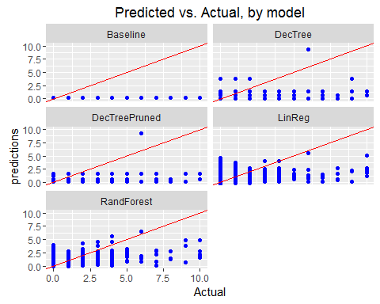

# Summary

From RMSE and MAE measurements, it appears that the Decision Tree model is the best. Looking at the graphs of Predicted vs. Actual, Random Forest looks to push closer to ideal. More input is needed to get a better prediction of R-squared of 0.46.