Christopher Hinton
DSCI 508
08/27/2023
Determining Trade Union Status

In this project, the primary objective was to develop a machine-learning solution to predict whether members of the United Data Scientists Union would maintain their membership or leave. The project began with comprehensive data preprocessing to ensure data quality and suitability for modeling. The dataset originally contained a 'LeftUnion' variable as the target, which was transformed into binary targets ('LeftUnion_No' and 'LeftUnion_Yes') during the data cleaning and encoding process.
Python was selected as the primary programming language due to its flexibility and my personal experience. Several essential libraries were employed throughout the project, including Pandas for data manipulation, Numpy for mathematical operations, Scikit-learn for modeling and preprocessing, and Matplotlib for data visualization.
The data preprocessing process involved a series of critical steps. Outlier detection was conducted on three numerical variables with values greater than 1 using box plots and z-scores. Shown below is a screenshot of the associated box plots used to identify outliers.
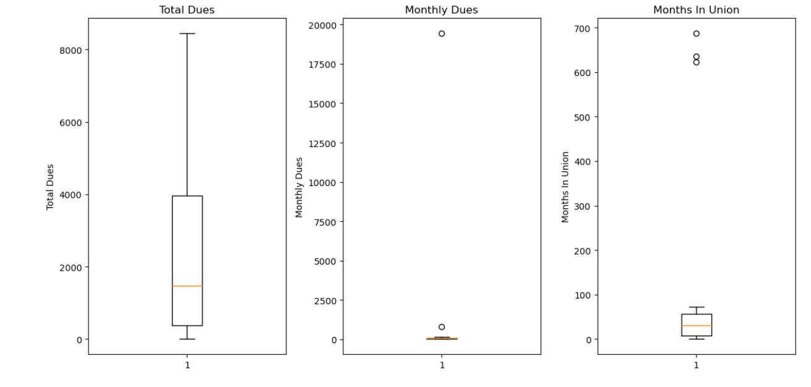
As seen above the ‘TotalDues’ plot shows a large forth quartile, but no significant outliers. The ‘MonthlyDues’ plot shows one definite outlier and a few other possible outliers. My intuition based on this graph told me there was an error in the data, but with no contact point to gather correct data it would likely be removed. The ‘MonthsInUnion’ plot shows three definite and distinct outliers. My hope was that the outliers from these different plots would align, and I would be able to keep most of the data. Luckily, that was the case. I tried a few different built-in z-score calculators but was not getting good results, so I built my own. As seen in the screenshot below I was able to conclusively show that the outliers in the ‘MonthsInUnion’ variable were the same outliers from the other variables. As the ‘MonthsInUnion’ had the most outliers I chose to remove all those observations. 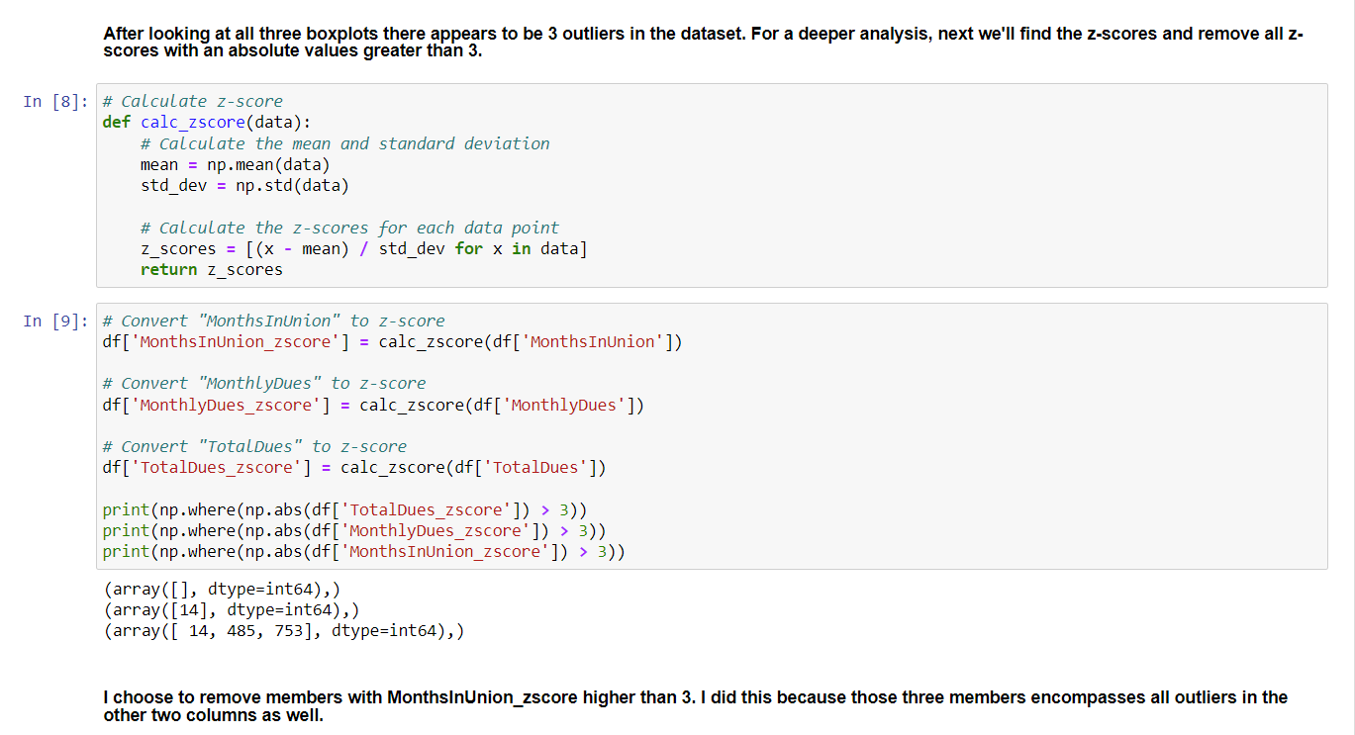
Additionally, generic variables that did not contribute significantly to the analysis were excluded, reducing the feature count from 21 to 13. To handle inconsistencies in the 'TotalDues' column, string values were converted to integers, and '#VALUE!' entries were standardized to 0. Categorical variables underwent encoding using dummy variables, expanding the feature set to 28 variables. To optimize the dataset's dimensionality, Principal Component Analysis (PCA) with Scree Plot was successfully applied, reducing the feature count to 13 while retaining 100% of the explained variance.
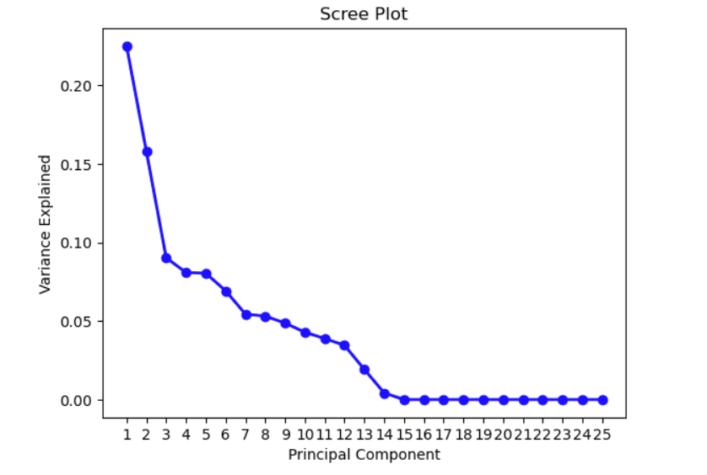
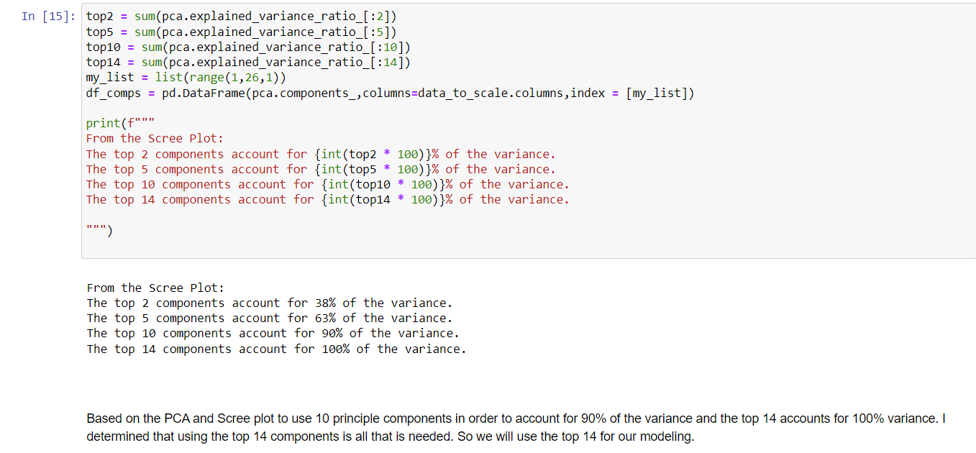
Data visualization played a crucial role in gaining insights. Hexbin and Scatter plots were employed to visualize the relationship between 'MonthsInUnion' and 'TotalDues,' revealing that a majority of union members were relatively new. There was a notable forming of a distinctive triangular data pattern as the data point moved from left to right.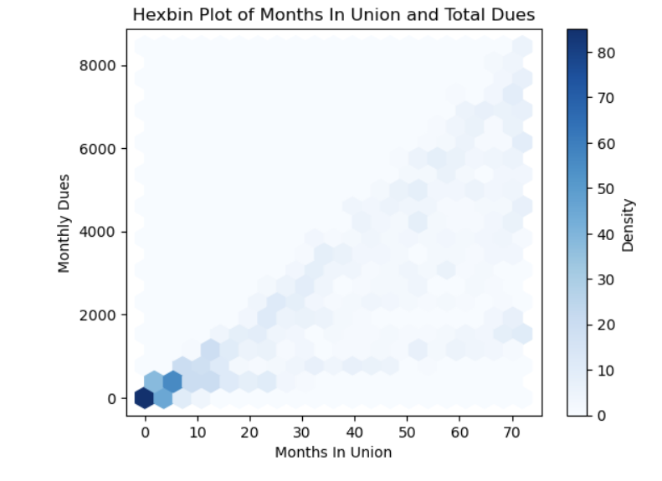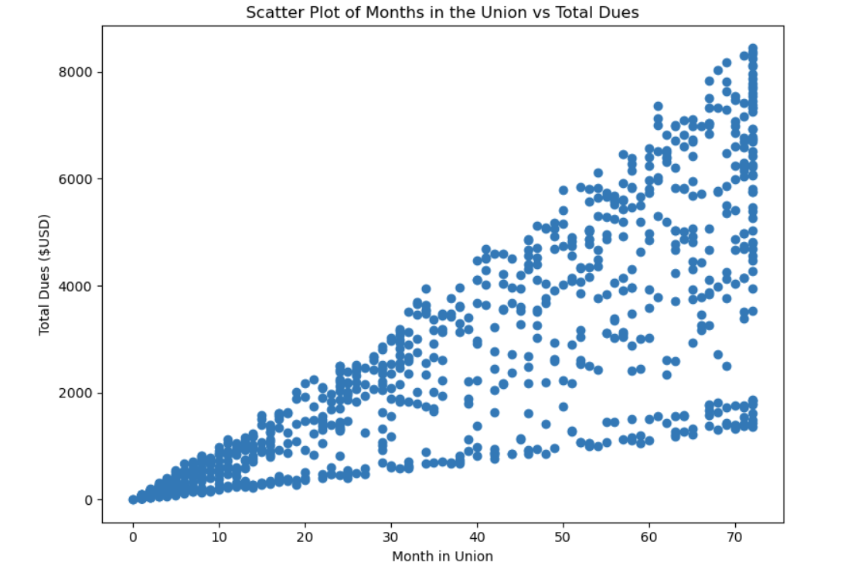
Code generation was an integral part of this project. Python code utilizing Scikit-learn was employed to create and evaluate the Linear Regression, Random Forest, and Support Vector Machine (SVM) models. The analysis included three machine learning models: Linear Regression, Random Forest, and Support Vector Machine (SVM). Linear Regression, while not well-suited for binary outcomes, served as a baseline model and achieved an accuracy score of 36.96%. In contrast, Random Forests demonstrated their effectiveness, achieving a significantly higher accuracy score of 80.67% due to their ability to handle complex relationships. The SVM model excelled with an accuracy score of 82.00%, outperforming the other models, likely due to its capacity to handle high-dimensional data and well-defined class boundaries.
When comparing these results to that of a blind guess, it is evident that two of the three models significantly outperformed random chance. A blind guess would yield an accuracy close to 50% for a binary classification problem. The Linear Regression model's accuracy of 36.96% suggests that it struggled to capture the underlying patterns in the data. In contrast, the Random Forest and SVM models demonstrated their ability to uncover meaningful patterns and perform notably better than Linear Regression or random guessing, resulting in accuracy scores of 80.67% and 82.00%, respectively.
Given more time, several aspects of the project could be enhanced. Firstly, feature engineering and selection methods could be explored to improve model performance further. Given more expertise and experience I would have loved to implement a neural network, but after days of trying gave up on that model. Additionally, hyperparameter tuning for the Random Forest and SVM models could be conducted to fine-tune their performance. Further data exploration and domain-specific insights could also lead to improved feature selection. Obviously, it would be outside the scope of this project, but I would have liked to collect more data or conduct additional surveys to enrich the dataset which might have enhanced the models' predictive power. Once again, the outlier in the ‘MonthlyDues’ feature really bothered me. Lastly, an ensemble of models or advanced machine learning techniques could be considered to combine the strengths of different algorithms for even better performance, but time was a huge factor for this project.

