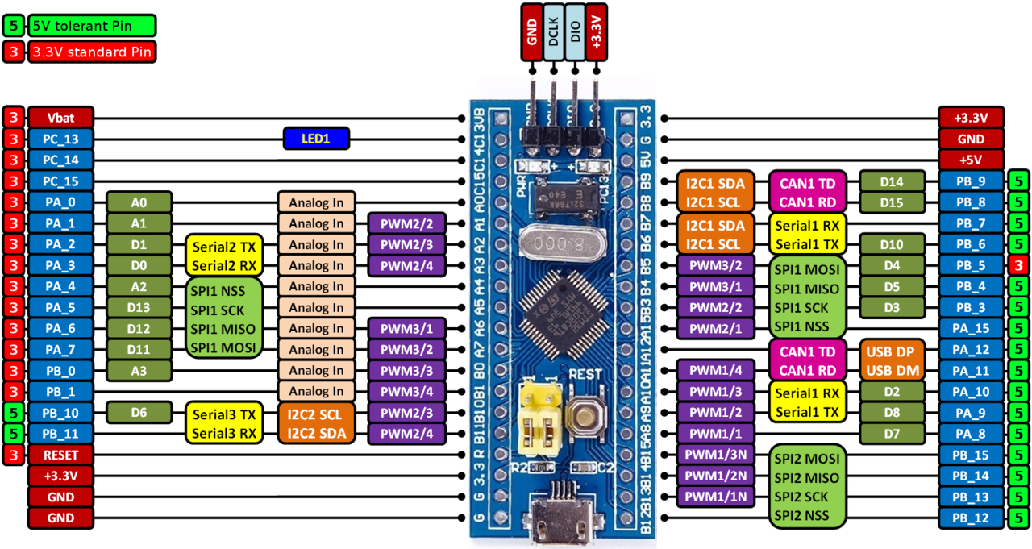

stm32f103ct6

=https://github.com/rogerclarkmelbourne/Arduino_STM32/wiki/Programming-an-STM32F103XXX-with-a-generic-%22ST-Link-V2%22-programmer-from-Linuxhttps://github.com/rogerclarkmelbourne/Arduino_STM32/wiki/Programming-an-STM32F103XXX-with-a-generic-%22ST-Link-V2%22-programmer-from-Linux

http://fun-tech.se/stm32/OpenOCD/gdb.php

sudo apt-get install arm-none-eabi-gdb arm-none-eabi-gcc arm-none-eabi-binutils openocd

openocd -f /usr/share/openocd/scripts/interface/stlink-v2.cfg -f /usr//share/openocd/scripts/target/stm32f1x.cfg

m$ telnet localhost 4444
Trying 127.0.0.1...
Connected to localhost.
Escape character is '^]'.
Open On-Chip Debugger
> reset halt
stm32f1x.cpu: target state: halted
target halted due to debug-request, current mode: Thread
xPSR: 0x01000000 pc: 0x00000668 msp: 0x20001000
> flash write_image erase bin/Debug/blinky_debug.bin 0x08000000
auto erase enabled
device id = 0x20036410
flash size = 64kbytes
stm32f1x.cpu: target state: halted
target halted due to breakpoint, current mode: Thread
xPSR: 0x61000000 pc: 0x2000003a msp: 0x20001000
wrote 2048 bytes from file bin/Debug/blinky_debug.bin in 0.179247s (11.158 KiB/s)
>

arm-none-eabi-gdb ddfdf

