The Biology of Pompe Disease

Abstract
Pompe disease (PD), an autosomal recessive inherited disease featuring Acid alpha-glucosidase (GAA) deficiency, compromises patients’ health outcomes via causing cardiomyopathy, respiratory insufficiency and motor impairment. Two clinical phenotypes of PD include infantile onset pompe disease and late onset pompe disease, corresponding to different residual GAA activity. Mutations including c.1799G>A and c.-32-13T>G could reduce GAA expression and its catalytic capacity, thereby inducing mitochondrial dysfunction in myofibres and halting autophagic flux mainly in skeletal muscle, eventually causes hypertrophic cardiomyopathy in IOPD and skeletal muscle weakness. The central nervous system is also involved in PD. The M6PR-mediated GAA uptake provides pathway for enzyme replacement therapy (ERT), while the inherent limitations of it necessitate improved therapies. It could be expected that continuous exploration in PD pathogenesis will lay the solid theoretical foundation for emerging strategies including gene therapies or next-generation ERT, providing potential strategies improving delivery efficiency and blood brain barrier penetration.

1. Introduction
Pompe disease (PD) is a rare autosomal recessive disorder characterised by deficiency of acid alpha-glucosidase (GAA), whose progression can lead to infantile fatal cardiac or respiratory failure. Classically, two forms are recognized: the infantile onset PD (IOPD) and late onset PD (LOPD). The IOPD is characterized by hypertrophic cardiomyopathy and progressive muscle weakness. The LOPD, however, features motor impairment, respiratory dysfunction and minor cardiac damage. (Sharshakova et al., 2026)

Divergence in residual GAA catalytic capacity, which is caused by divergence in mutation, helps distinguish IOPD and LOPD. Splicing mutations promise higher level of residual GAA activity and are associated with LOPD, while missense mutations could cause significant disruption and be linked to IOPD. (Sharshakova et al., 2026)

The incidence of PD depends on geographic and ethnic factors, varying from 1 in 14000 to 1 in 600000. Specifically, IOPD-related mutations are more common for Eastern Asia population compared to other major population groups. (Sharshakova et al., 2026)

In this essay, the pathogenesis of PD is demonstrated from the molecular to the organ level, and both autophagic flux blockage and the mitochondrial dysfunction will be the focus. Based on the understanding of the biological basis, the principles of enzyme replacement therapy (ERT) and emerging therapies targeting its limitations will also be discussed.

2. The Pathogenesis of PD
2.1 The GAA Gene and Protein Biology
Located on the chromosome 17, the GAA gene has 20 exons, among which the exon 2 is significant. The exon 2 is important because it contains the start codon, implying its key role in GAA expression.
To date, 739 mutations have been recognized as “harmful”, and the missense/nonsense mutation, exemplifying c.1799G>A, shows a dominance with a proportion of 55.8%. Another major mutation type is splicing mutation like c.-32-13T>G, which shares the percentage of 11.6%. (Peruzzo et al., 2025)
Shifting the lysosomal glycogen into glucose, GAA is a alpha-glucosidase within the lysosome and is deputed to conduct glycogen degradation. In Golgi, it is modified with mannose-6-phosphate (M6P), specifically delivered to autophagosome-fused lysosomes by vesicles containing M6P receptors (M6PRs), and then released to degrade glycogen. Notably, even though a few GAAs will be secreted extracellularly, the recyclable membranous M6PRs from adjacent cells will re-capture these enzymes and send them to the lysosome. (van der Beek et al., 2025)
2.2 Two Specific Mutations and Their Molecular Consequences
Two typical mutations, the c.1799G>A and the c.-32-13T>G, will be discussed. They represent distinct mechanisms by which mutations affect the GAA protein: the former one mainly influences the catalytic capability of GAA, while the latter one impairs the expression of GAA.

The c.1799G>A (p. Arg600His) is a missense mutation altering the amino acid residue 600, which plays a vital role in maintaining enzymic thermostability and substrate identification. Eroding residual GAA activity by 98%, it shows obvious association with IOPD. Mechanistically, alteration from G to A at nucleotide site 1799 leads to the shift from arginine to histidine, which dramatically disrupt the catalytic ability of GAA via influencing turnover number of the enzyme by up to 700-fold. Furthermore, the decreasing thermostability caused by the mutation will further compromise GAA activity. (Iacono et al., 2025)

The c.-32-13T>G is a splicing mutation skipping exon 2 via compromising the function of correct exon 2’s acceptor and donor. As discussed, containing exon 2 is significant for a full-function mRNA, and that is why skipping exon 2 makes majority of mature mRNAs dysfunctional, which means that no normal GAA will be transcribed utilizing these aberrant splicing isoforms of transcripts. However, the leaky nature of c.-32-13T>G enables the existence of normal GAA for 20% approximately, which explains why it is associated with LOPD. (Peruzzo et al., 2025)

2.3 Downstream Consequences: Autophagy Flux Blockage and Mitochondrial Dysfunction
The decline of GAA activity caused by mutations erodes its glycogen-degradation capacity, thereby causing glycogen accumulation and a series of serious consequences, via mechanisms including the impaired autophagy and mitochondrial dysfunction. Autophagy mainly affects skeletal muscle cells and, to some extent, affects cardiac muscle cell function by influencing mitophagy, while mitochondrial dysfunction is one of the main causes of cardiac muscle cell damage. Table 1 compares this cascade in normal state and in the two major Pompe disease phenotypes.
Table 1: Pathophysiology Comparison Table for Pompe Disease
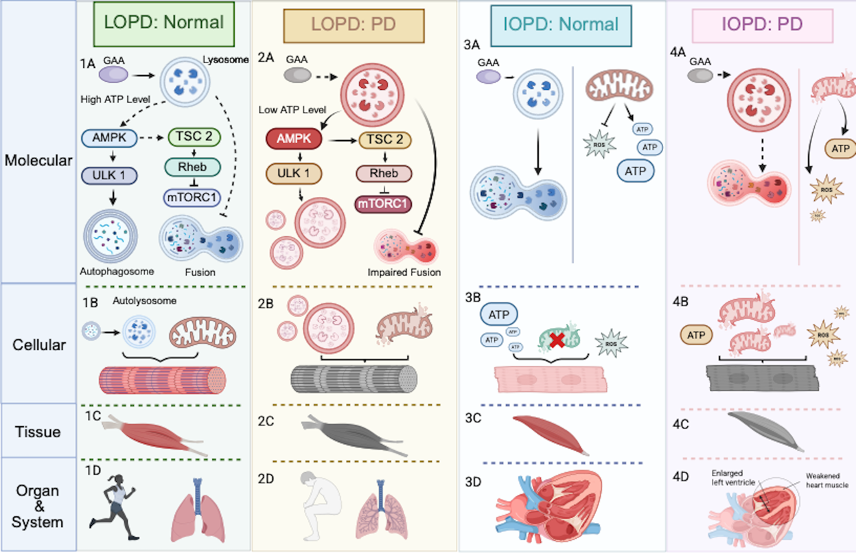
Figure 1: Comparison of Pathogenesis between LOPD and IOPD. Panels are organised by phenotype and biological level: 1 = LOPD: Normal, 2`= LOPD: PD, 3`= IOPD: Normal, and 4 = IOPD: PD; A = Molecular, B= Cellular, C= Tissue, and D= Organ and Body System.
1A: GAA is fully functional: ADP/ATP ratio is well maintained; normal autophagosome-lysosome fusion supports mitochondrial autophagy; lysosome size remains normal; AMPK activity is relatively low -> lower autophagosome production. 1B: Functioning autophagic flux supports efficient autophagosome-lysosome fusion; damaged mitochondria cleared; myofibres maintain normal contractile function. 1C: Skeletal myofibres preserve normal function and metabolic homeostasis. 1D Motor function and respiratory muscles are well functioning. 2A: Residual GAA activity present but insufficient -> rising ADP/ATP ratio -> AMPK activation; activated AMPK phosphorylates ULK1, directly upregulating autophagosome production. Furthermore, AMPK activates TSC2, which downregulates mTORC1 via suppressing Rheb. Glycogen accumulation impairs autophagosome-lysosome fusion, undermining autophagy. 2B: Functioning autophagic flux supports efficient autophagosome-lysosome fusion; damaged mitochondria cleared; myofibres maintain normal contractile function. 2C: Vacuolated myofibres develop; myofibrillar atrophy in skeletal muscles including diaphragms. 2D: Progressive proximal and axial weakness -> motor intolerance and respiratory impairment. 3A: GAA is fully functional: ADP/ATP ratio is well maintained; normal autophagosome-lysosome fusion and lysosome size; lysosome size remains normal; cardiomyocyte mitochondria function well -> abundant ATP, normal ROS. 3B: Cardiomyocytes function well with abundant ATP generation, normal ROS, and effective damaged mitochondria clearance. 3C: Myocardial fibres maintain normal wall thickness. 3D: The heart maintains effective filling and output. 4A: GAA is fully functional: ADP/ATP ratio is well maintained; normal autophagosome-lysosome fusion and lysosome size; lysosome size remains normal; cardiomyocyte mitochondria function well -> abundant ATP, normal ROS. 4B: Cardiomyocyte dysfunction or apoptosis, via two mechanisms: impaired mitochondrial autophagy fails to clear damaged mitochondria -> increased ROS -> ATP decline -> indirect apoptosis; lysosomal expansion directly impairs mitochondria -> direct apoptosis. 4C: The myocardium becomes hypertrophic. 4D: The heart maintains effective filling and output.

Note. Autophagic flux blockage adapted from Do et al. (2024) and Sharshakova et al. (2026); mitochondrial dysfunction and its downstream consequences based on Huang et al. (2023), Lim et al. (2015) and Sánchez-Porras et al. (2023).

Even though a systematic understanding of pathogenesis in IOPD and LOPD has not been established, the interaction and differentiation between crucial pathways in both phenotypes can be witnessed. On the one hand, despite the significance of AMPK-regulated autophagy flux blockage in LOPD, it seems to have a limited influence in terms of cardiac muscles: the direct impact from lysosomal expansion predominantly impairs the myofibres in cardiac muscles. On the other hand, the mitophagy blockage caused by blocked autophagy flux plays a vital role in PD progression in cardiomyocytes.

Notably, PD also cause impairment in central nervous system (CNS). Not only does GAA deficiency compromise the skeletal and cardiac muscle, pathologic accumulation of glycogen in spinal motor neurons and neurogliocytes can also be witnessed.
3. Current and Future Therapies: Targeting the Underlying Biology

3.1 Current Therapy: Enzyme Replacement Therapy
As discussed, the M6PR-mediated GAA uptake establishes the biological basis of ERT. As the figure 2 shows, after the non-specific intravenous injection of recombinant-human GAA (rhGAA) on whose surface are M6P residues, it is expected that the membranous M6PR will recognize the rhGAA and engulf them, thereby alleviating the glycogen accumulation, which is fundamental in PD (van der Beek et al., 2025).
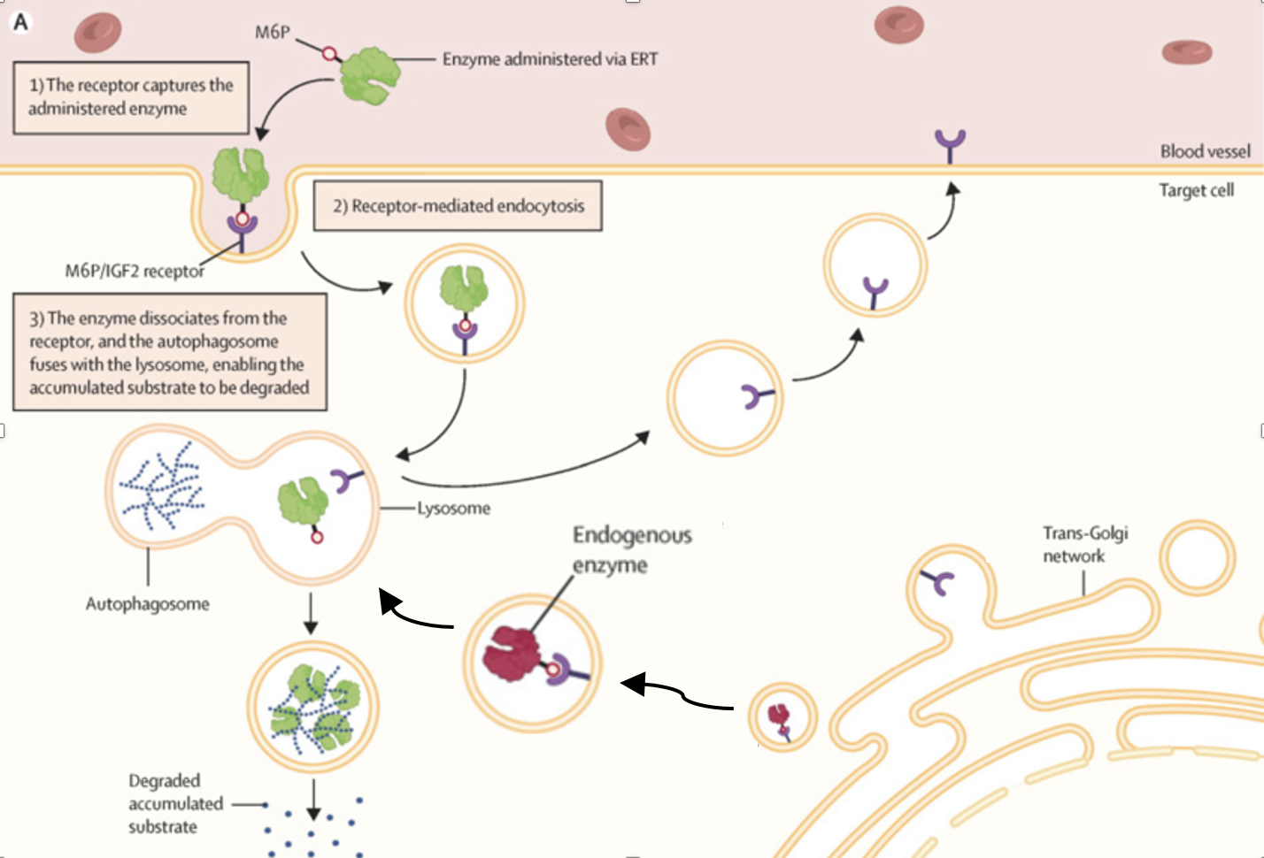
Figure 2: Mechanism of enzyme replacement therapy in lysosomal storage disorders. (adapted from van der Beek et al., 2025).
However, the biological basis that ERT relied on also brings inherent limitations. First, the impaired autophagic flux also disrupts mitophagy, which influence the expression level of M6PR and thereby halting the rhGAA capturing (Tarallo et al., 2021). Second, with ERT-mediated prolongation of patient survival, classic infantile-onset cases have shown significant CNS involvement, while traditional ERT cannot support crossing BBB (van der Beek et al., 2025).
3.2 Emerging Therapies Targeting the Limitations of ERT
Focusing on the first problem, adeno-associated virus (AAV)-derived gene therapy is introduced. Targeting muscular tissues via exploiting muscle-specific promoters and AAV vectors, it can continuously express endogenous GAA without M6PR mediation, providing an innovative scheme in improving GAA delivery efficiency (Sharshakova et al., 2026). What is worth mentioning is that a new therapy enhancing correct splicing of exon 2 via modification of related small nuclear ribonucleoproteins (snRNPs) is under development. This method is specifically promising for exon 2 skipping mutations like c.-32-13T>G (Peruzzo et al., 2025).
In terms of the second issue, one possible solution is integrating target transferrin receptors with rhGAA. Such combination enables the rhGAA to cross the BBB and replenish the GAA level. In research using mice as model organism, this fused protein has successfully downregulated the glycogen level in brain and spinal cord and showing suppression on the neuroinflammation. (Sharshakova et al., 2026).

Conclusion
Owing to the researchers’ long-term commitment, a relatively clear understanding of PD pathogenesis has been established. Gene mutations lead to GAA deficiency affecting either GAA activity or its expression levels, thereby producing a multi-level pathology from lysosomal glycogen accumulation to downstream consequences like autophagic flux blockage and mitochondrial dysfunction to the progression of hypertrophic cardiomyopathy, movement impairment, and respiratory disorder. Despite insufficient understanding of difference between IOPD and LOPD pathogenesis, it can be partially explained via distinct pathogenic mechanisms and different residual GAA activity.
The ERT therapy has achieved therapeutic effects. However, biological limitation including insufficient delivery to skeletal muscle and CNS have restricted its spectrum of application. In response, a more comprehensive understanding of PD biology becomes essential, serving as the foundation for next-generation strategies including AAV-derived therapies and improved ERT to directly address these biological limitations.

Reflection
The two most useful sources include "Pompe disease: Pathogenesis, molecular mechanisms, neurological aspects, diagnostics and modern therapeutic approaches" and "Failure of autophagy in Pompe disease"
The first source illustrates the current understanding of PD with an impressive content coverage. From GAA gene biology and M6PR-mediated enzyme uptake to the current challenges and emerging therapies, the broad framework becomes beneficial when structural narratives are required. Furthermore, its explanation of mechanistic basis underlying the treatment rationale is valuable when discussing biology of ERT.
The second source provides mechanistic depth when autophagic failure in PD is discussed. Comparing AMPK-mTOR regulatory mechanism in both normal and interrupted state in detail, it provides insights of the molecular basis when exploring how GAA deficiency leads to downstream consequences.
Combining these complementary resources, I managed to organize the essay from general disease biology to specific molecular mechanisms.

References
Do, H., Meena, N. K., & Raben, N. (2024). Failure of autophagy in Pompe disease. Biomolecules, 14(5), 573. https://doi.org/10.3390/biom14050573
Huang, W., Zhou, R., Jiang, C., Wang, J., Zhou, Y., Xu, X., Wang, T., Li, A., & Zhang, Y. (2024). Mitochondrial dysfunction is associated with hypertrophic cardiomyopathy in Pompe disease-specific induced pluripotent stem cell-derived cardiomyocytes. Cell proliferation, 57(4), e13573. https://doi.org/10.1111/cpr.13573
Iacono, R., Paragliola, F. M. P., Strazzulli, A., & Moracci, M. (2025). A stable GH31 α-glucosidase as a model system for the study of mutations leading to human glycogen storage disease type II. Journal of enzyme inhibition and medicinal chemistry, 40(1), 2468859. https://doi.org/10.1080/14756366.2025.2468859
Lim, J. A., Li, L., Kakhlon, O., Myerowitz, R., & Raben, N. (2015). Defects in calcium homeostasis and mitochondria can be reversed in Pompe disease. Autophagy, 11(2), 385–402. https://doi.org/10.1080/15548627.2015.1009779
Peruzzo, P., Bergamin, N., Bon, M., Cappelli, S., Longo, A., Goina, E., Stuani, C., Buratti, E., & Dardis, A. (2025). Rescue of common and rare exon 2 skipping variants of the GAA gene using modified U1 snRNA. Molecular medicine (Cambridge, Mass.), 31(1), 45. https://doi.org/10.1186/s10020-025-01090-z
Sánchez-Porras, V., Guevara-Morales, J. M., & Echeverri-Peña, O. Y. (2023). From Acid Alpha-Glucosidase Deficiency to Autophagy: Understanding the Bases of POMPE Disease. International journal of molecular sciences, 24(15), 12481. https://doi.org/10.3390/ijms241512481
Sharshakova, A., Fattakhova, A., Solovyeva, V., Sufianov, A., Sufianova, G., Kutovoi, G., & Rizvanov, A. (2026). Pompe Disease: Pathogenesis, Molecular Mechanisms, Neurological Aspects, Diagnostics and Modern Therapeutic Approaches. International journal of molecular sciences, 27(8), 3703. https://doi.org/10.3390/ijms27083703
Tarallo, A., Damiano, C., Strollo, S., Minopoli, N., Indrieri, A., Polishchuk, E., Zappa, F., Nusco, E., Fecarotta, S., Porto, C., Coletta, M., Iacono, R., Moracci, M., Polishchuk, R., Medina, D. L., Imbimbo, P., Monti, D. M., De Matteis, M. A., & Parenti, G. (2021). Correction of oxidative stress enhances enzyme replacement therapy in Pompe disease. EMBO molecular medicine, 13(11), e14434. https://doi.org/10.15252/emmm.202114434
van der Beek, N. A. M. E., Theunissen, M. T. M., van den Hout, J. M. P., Pijnappel, W. W. M., Schoser, B., Laforêt, P., Parenti, G., van Doorn, P. A., & van der Ploeg, A. T. (2025). Clinical insights in enzyme replacement therapy for metabolic storage disorders: lessons from Pompe disease. The Lancet. Neurology, 24(3), 230–245. https://doi.org/10.1016/S1474-4422(24)00518-0

Marker’s opinion on the essay:
The essay would be stronger if you developed the comparison between normal and affected individuals more clearly at the whole-body level, for example normal cardiac and respiratory function versus hypertrophic cardiomyopathy, respiratory insufficiency, and skeletal muscle weakness in Pompe disease.
The abstract contains relevant scientific content, but it needs to work better as a standalone summary. If you introduce terms such as infantile-onset Pompe disease and late-onset Pompe disease, define the abbreviations at first use, for example infantile-onset Pompe disease (IOPD) and late-onset Pompe disease (LOPD). The flow of the abstract also needs improvement, as the sentences currently do not always connect logically. Try to make the abstract move clearly from disease cause to selected mutations, to cellular consequences, to clinical phenotype, and finally to therapy.
The figures show a good effort, especially Figure 1, which attempts to summarise a complex comparison between IOPD and LOPD. However, the figure legends are not consistently effective. Some legends are very detailed, but the wording is not always precise enough, and the figure itself is difficult to interpret because there is a lot of information presented at once. Figure 2 has much less explanation and would benefit from a proper legend that explains what the figure shows and how it supports the discussion of ERT. Your text and figures should work together: the figure should support a specific point made in the paragraph, and the paragraph should guide the reader on how to interpret the figure.
Referencing needs more careful handling. Please place the author’s surname and year of publication immediately after the borrowed idea, for example (Smith, 2022), rather than placing one citation at the end of a whole paragraph. This makes it clearer which source supports which claim. This is especially important in sections discussing newer literature, emerging therapies, CNS involvement, and detailed molecular pathways, where claims need secure evidence.
The scientific detail is generally accurate and substantial, but the essay needs smoother connections between paragraphs. At times, strong individual points are presented without enough bridging explanation. Try to add linking sentences that explain why the next idea follows from the previous one. For example, after discussing GAA deficiency, make the transition to autophagic dysfunction explicit; after discussing cellular dysfunction, explain how this produces the clinical phenotype.
The reflection shows a good critique of the two selected sources, and you clearly understand why they are useful. To improve it further, expand on exactly how these sources helped you build the essay. For example, did one source help you structure the pathway from gene mutation to autophagy? Did another help you decide how to discuss therapy limitations? This would make the reflection more personal and analytical rather than mainly descriptive.
Overall, this is a knowledgeable and ambitious essay with strong mechanistic content. To move it higher, focus on making the abstract more logical, improving citation placement, tightening figure legends, strengthening paragraph-to-paragraph flow, and extending the normal-versus-disease comparison to the whole-body level.

