Steps for rviz setup:

1. Run roscore, then run rviz
2. Play rosbag and rosrun trackerapi trackerapi3.py
3. In rviz under displays change fixed frame from map to velodyne
   1. Also change background color to white

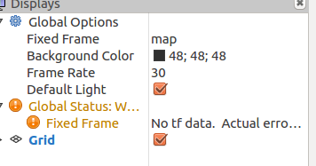

1. Add visualizations by topic

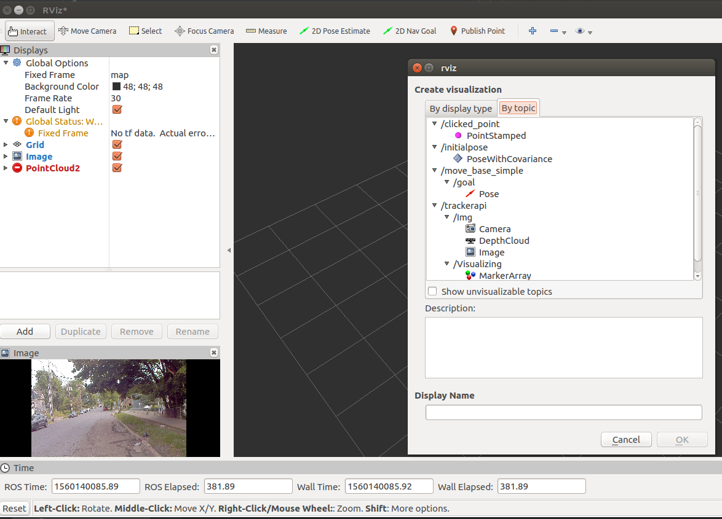

* 1. Velodyne pointcloud: velo/pointcloud/Pointcloud2
     1. Set to color transformer to Flat Color
     2. Increase size to 0.05
     3. Set color to blue

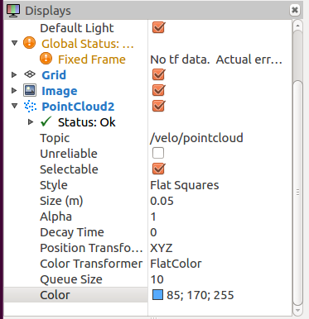

* 1. LDLS pointcloud: ldls/foreground/PointCloud2
     1. Color set to red
     2. Set size to 0.2

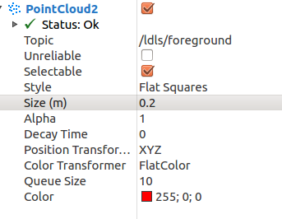

* 1. PIXOR detections: pixor/all_cars/pointCloud2
     1. Color set to pink
     2. Set size to 0.5

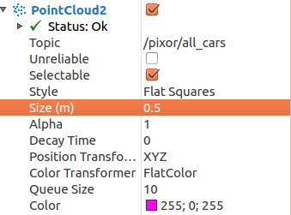

* 1. Tracker output: trackerapi/visualizing/markerarray
  2. Mask RCNN Segmented Images:/maskrcnn/visualization/image

After adding all topics rviz should look like this:

