Submitted by: Marwah Mahsal Khan
Course name= BDA400 - Data Science Tools and Techniques
Date: September 28, 2026

Assignment 2
Technical Analysis using R, Preliminary Stage

Github repository:

https://github.com/cdimmk1985-crypto/TechnicalAnalysis
Contents
AI Assistance Declaration 1
1. Setting up GitHub 1
1.1 Installing Git 1
1.2 Creating the repository 1
1.3 Uploading the files 1
2. Installing R and RStudio 1
3. Installing R Packages 1
4. Project Setup - portfolio.txt 1
5. Function to Import Stock Data 1
6. Functions to Compute Statistics 1
6.1 Mode 1
6.2 Moving averages 1
6.3 Other statistics 1
6.4 Results 1
7. Displaying the Data 1
7.1 Historical data table 1
7.2 Quote summary 1
7.3 Charts 1
8. Running the Analysis 1
Files in the A02 folder 1
Notes 1
GitHub Repository 1

AI Assistance Declaration
I used Claude (Anthropic) as a study partner for this assignment. It helped me write the R functions in stock_functions.R, the technical_analysis.Rmd file and the README, and it helped with wording in parts of this report. I did the GitHub setup, the R, RStudio and package installs, ran and knitted the code on my own laptop, took all the screenshots, and checked that the output was correct. I went through every function so I understand what each line does. I am responsible for the accuracy and originality of this work.

1. Setting up GitHub
I already had a GitHub account from Assignment 1 (username cdimmk1985-crypto), so I used that one. For this project I made a new repository called TechnicalAnalysis, since this is the repo that will hold all three stages of the project. Inside it there is one folder per assignment, starting with A02 for this one.

1.1 Installing Git
I followed the GitHub install guide and downloaded Git for Windows (version 2.55.0) from git-scm.com. I went through the installer with the default options. To check it installed properly I opened Command Prompt and ran:
git --version
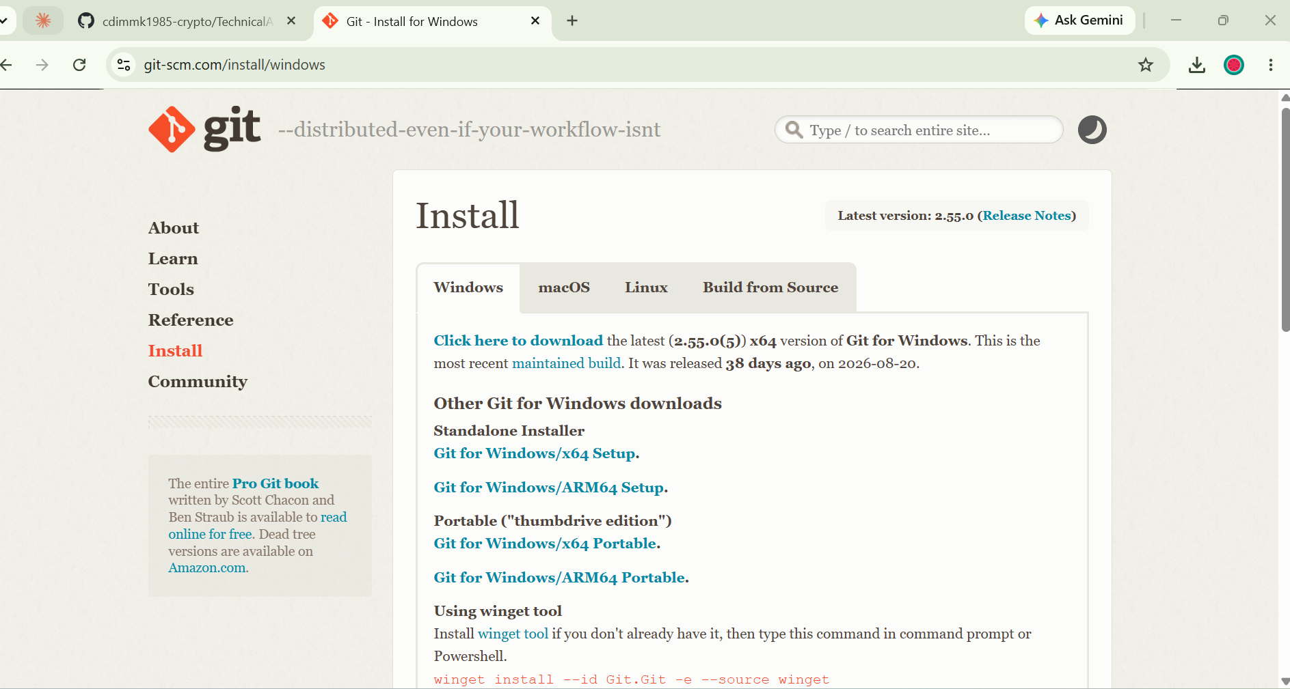
Figure 1.1a: Git for Windows download page
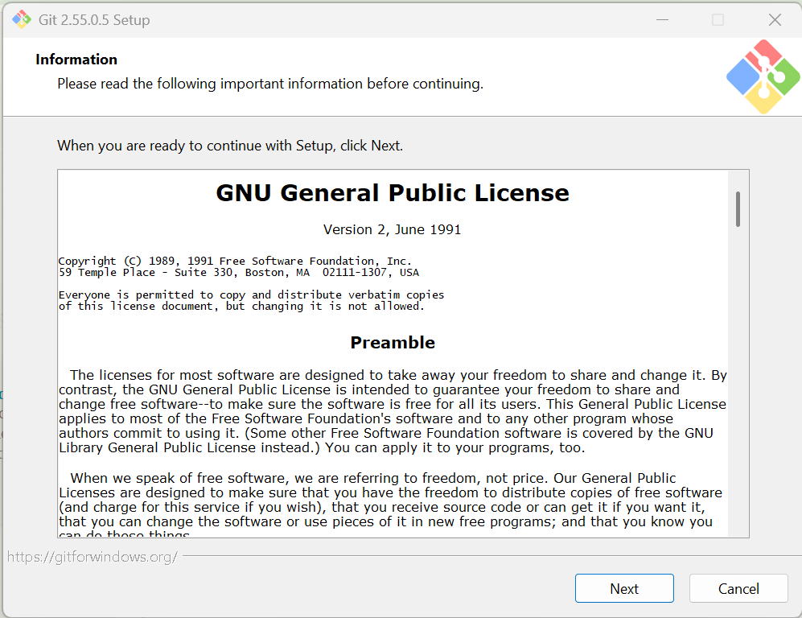
Figure 1.1b: Git installer, first screen
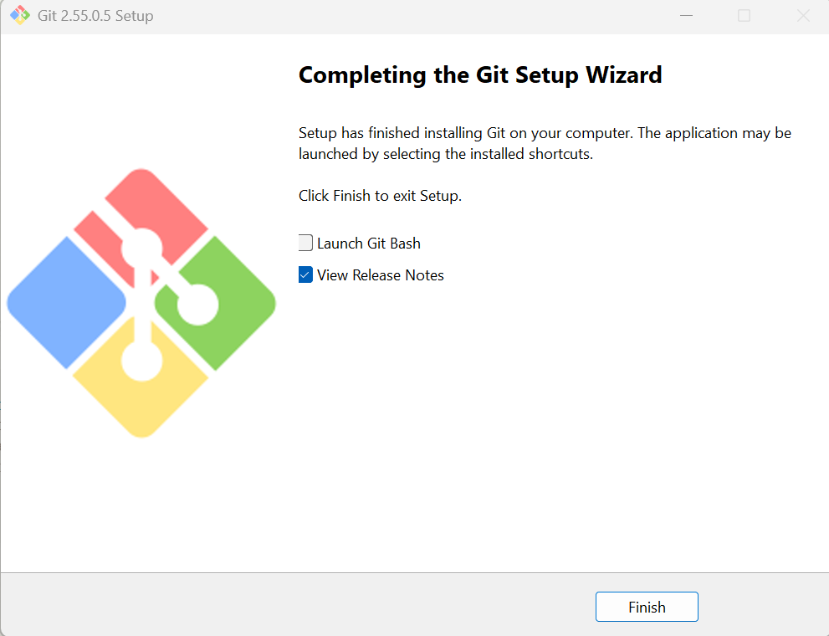
Figure 1.1c: Git installation finished
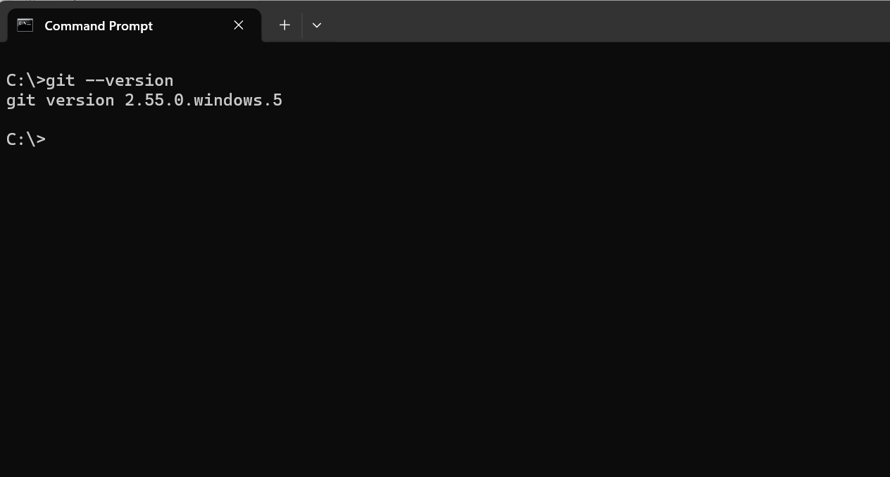
Figure 1.2: git --version in Command Prompt

1.2 Creating the repository
After logging in I clicked New repository, named it TechnicalAnalysis, added a short description, set it to Public so my instructor can see it, and turned on "Add README". I left .gitignore and license as none.
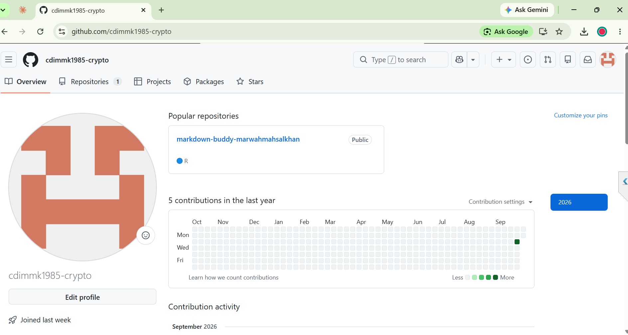
Figure 1.3: Logged in to my GitHub profile
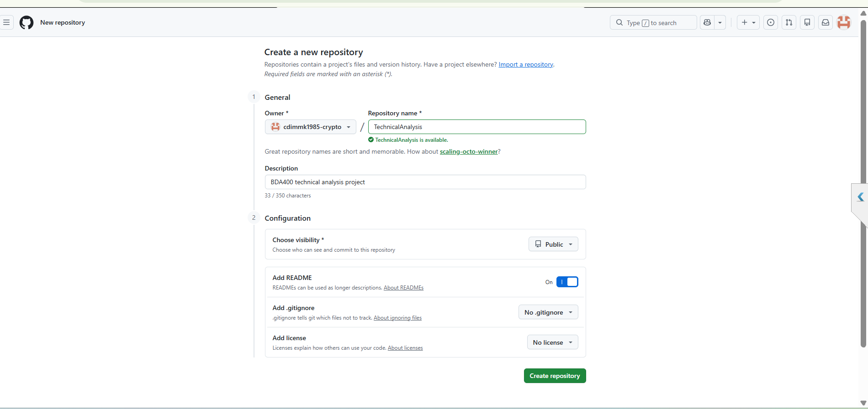
Figure 1.4: Creating the TechnicalAnalysis repository
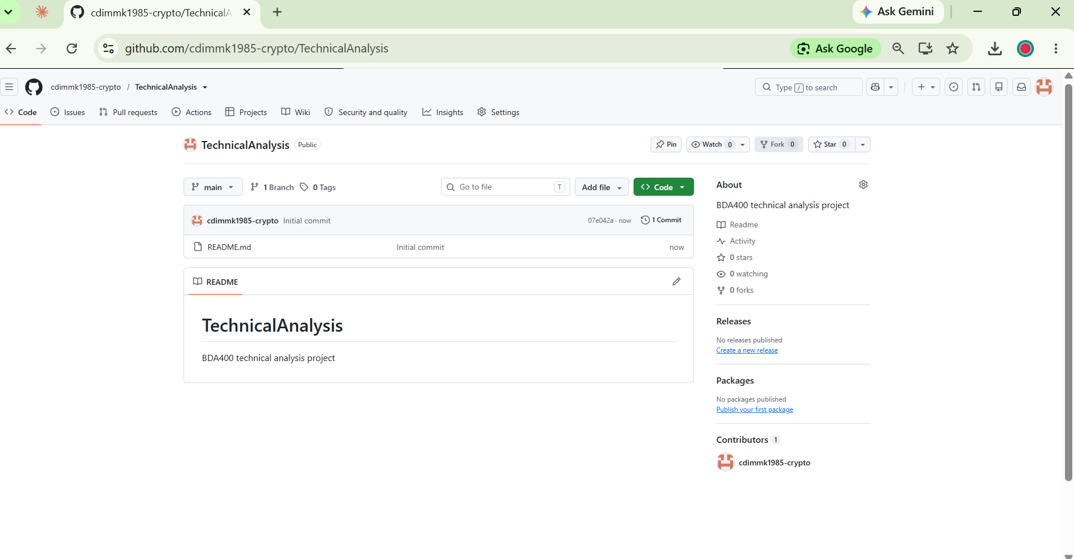
Figure 1.5: The new TechnicalAnalysis repository

1.3 Uploading the files
Once the code was working, I uploaded my files using Add file > Upload files and dragged in the whole A02 folder, which keeps the folder structure. Then I committed the changes.
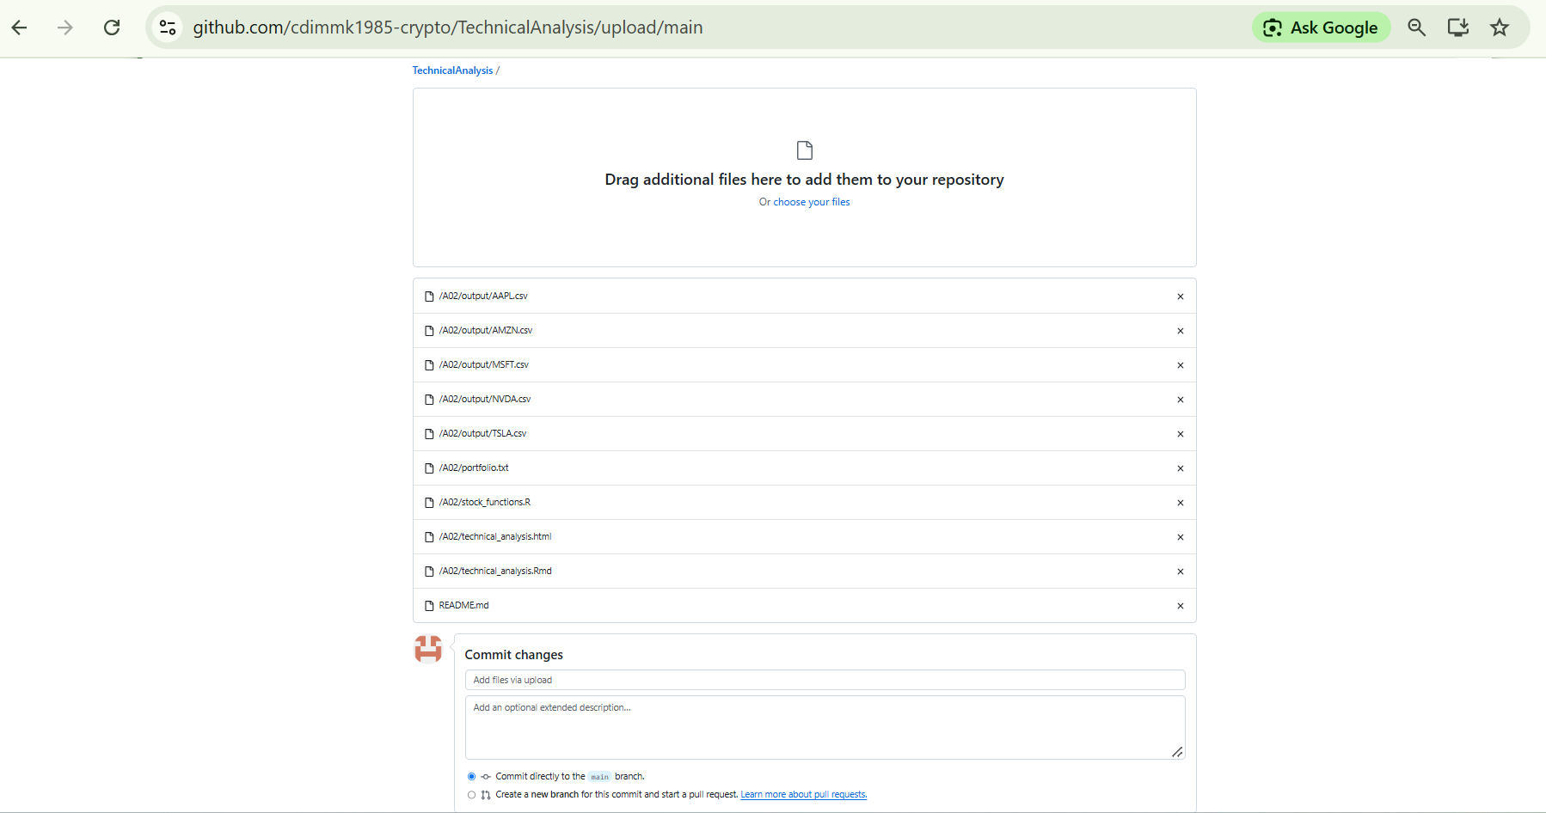
Figure 1.6: Uploading the A02 folder
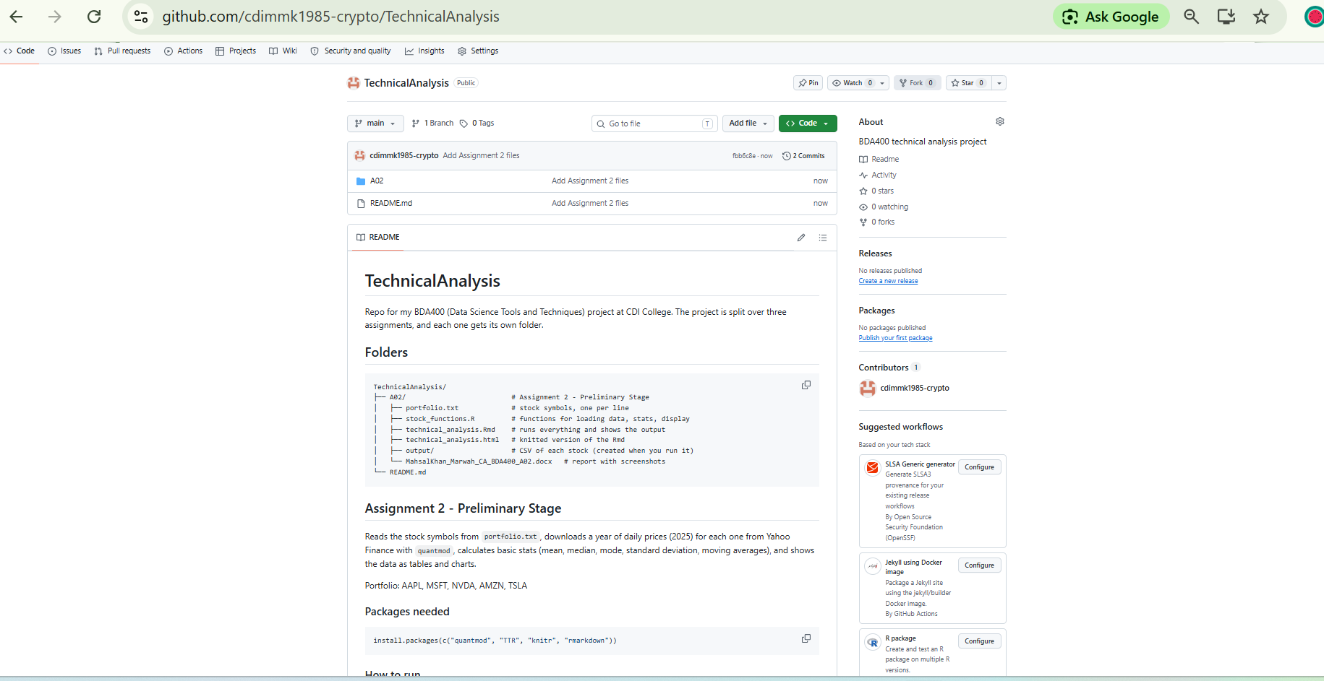
Figure 1.7: Repository with the A02 folder

2. Installing R and RStudio
R is the actual programming language and RStudio is the editor (IDE) that runs on top of it, so R has to be installed first. I downloaded R 4.6.1 for Windows from CRAN (cran.rstudio.com) and went through the installer using the default options. Then I downloaded RStudio Desktop 2026.09.0 from Posit and installed it the same way.
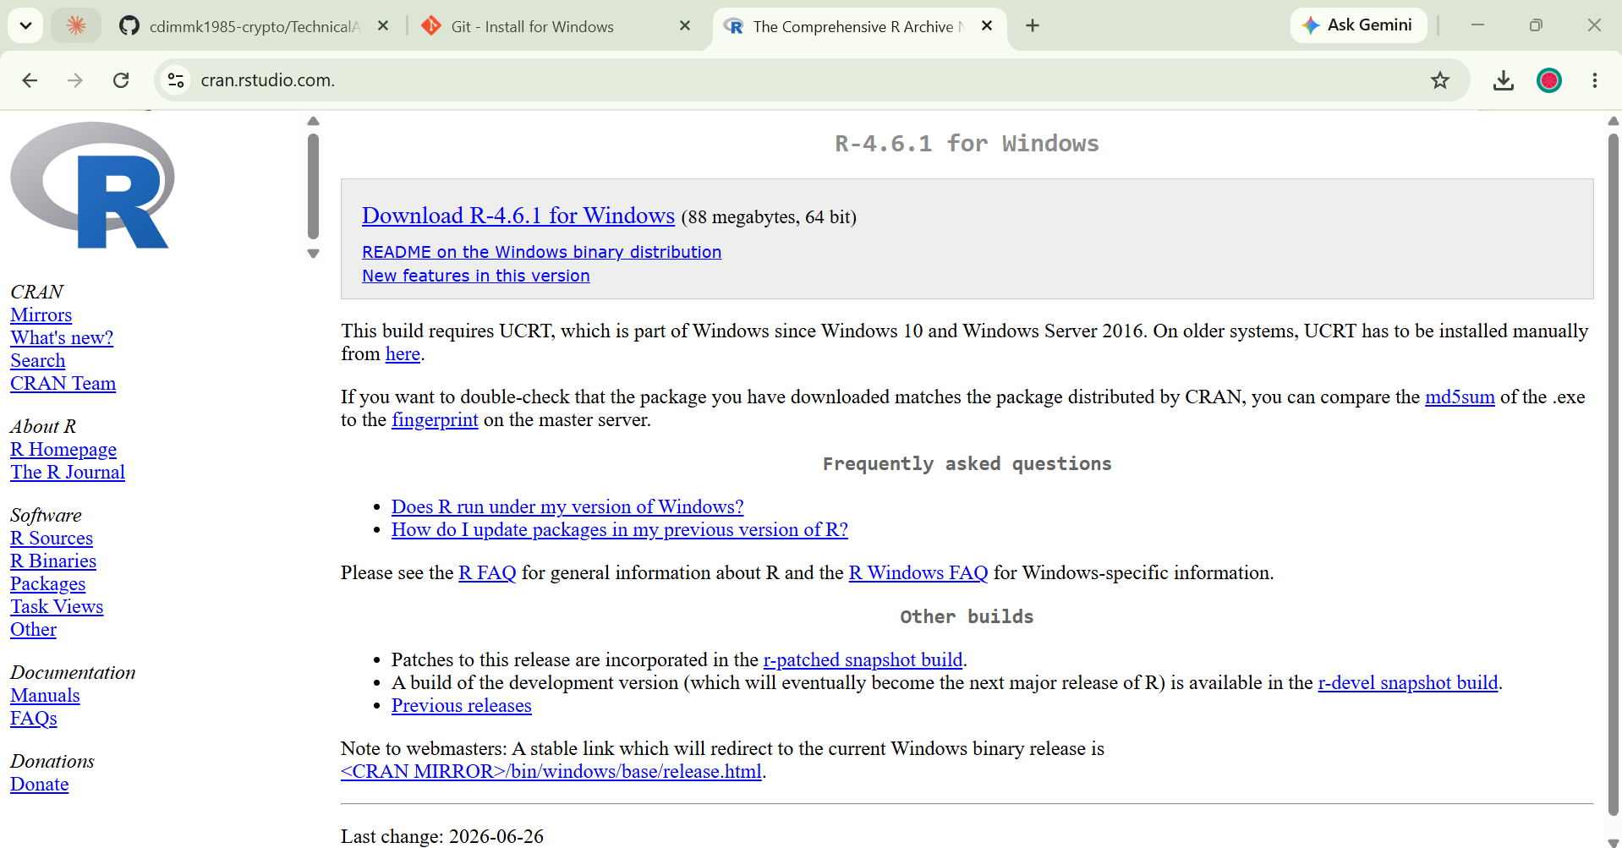
Figure 2.1: Downloading R 4.6.1 from CRAN
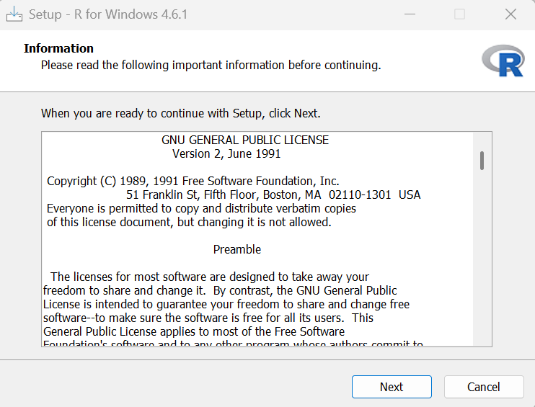
Figure 2.2: R setup wizard
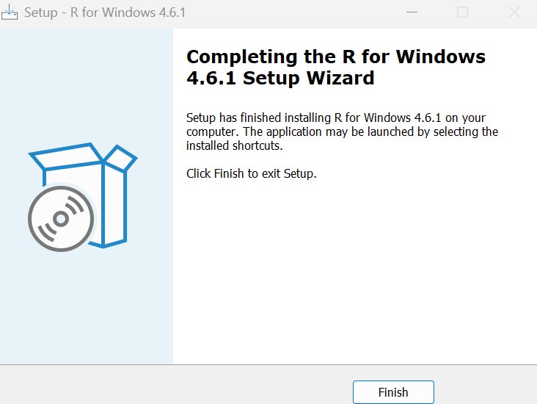
Figure 2.3: R installation finished
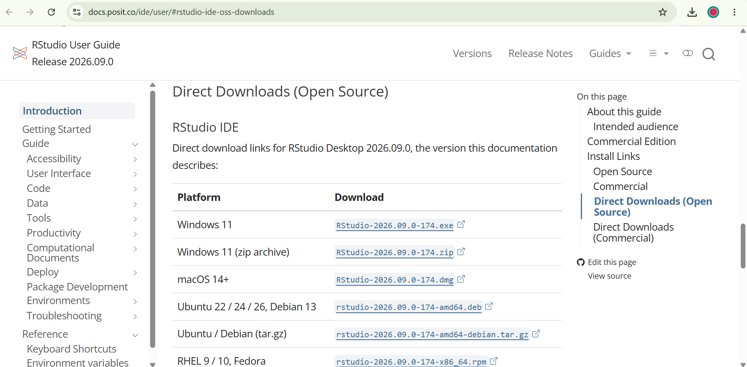
Figure 2.4: RStudio Desktop download links
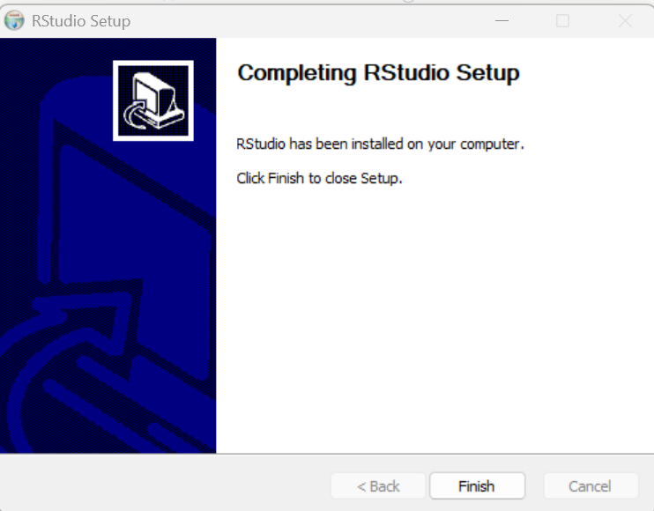
Figure 2.5: RStudio installation finished
To confirm everything worked I opened RStudio and checked which version of R it was using:
R.version.string
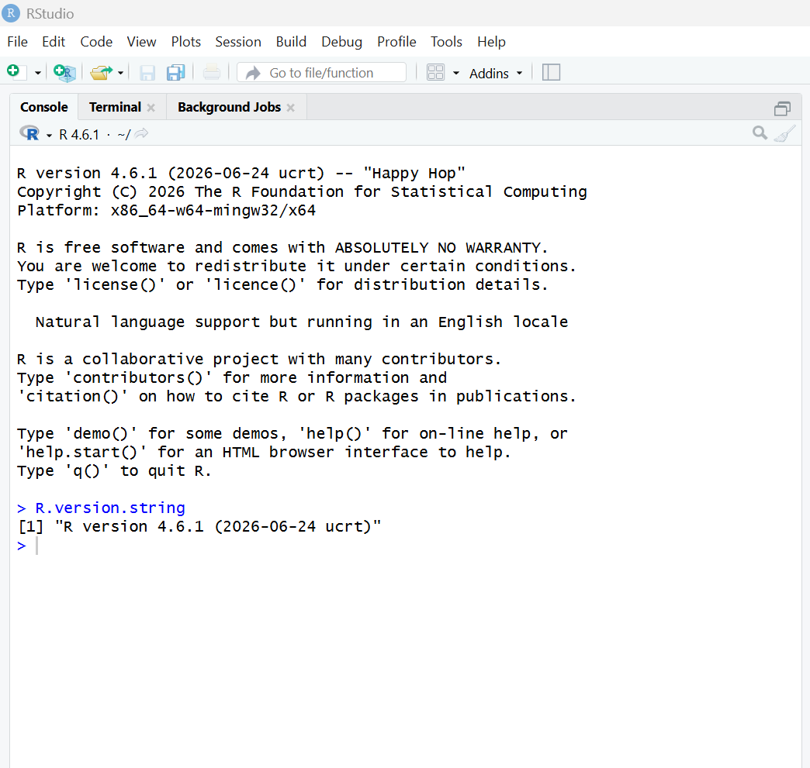
Figure 2.6: Checking the R version in RStudio

3. Installing R Packages
For this stage I needed four packages. I installed them all at once in the RStudio console:
install.packages(c("quantmod", "TTR", "knitr", "rmarkdown"))
- quantmod - downloads stock data (getSymbols) and draws financial charts (chartSeries).
- TTR - Technical Trading Rules, used here for the simple moving average function SMA().
- knitr and rmarkdown - needed to knit the .Rmd file into an HTML report.
quantmod also installed xts and zoo automatically since it depends on them. These two handle time series data, which is what quantmod returns stock prices as.
Then I loaded them and checked the versions to make sure there were no errors. The installed versions were quantmod 0.4.29 and TTR 0.24.4. The messages about zoo masking as.Date() are normal, they just mean zoo has its own version of that function. library(TTR) printed nothing because quantmod had already loaded it.
library(quantmod)
library(TTR)
packageVersion("quantmod")
packageVersion("TTR")
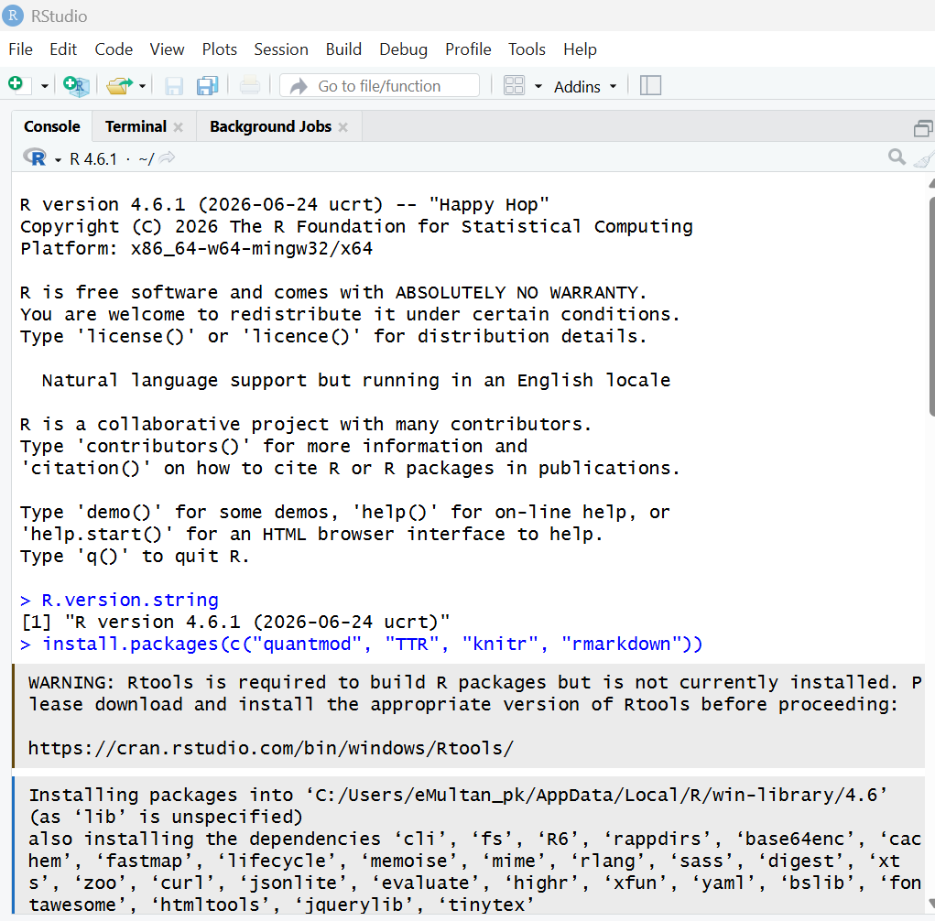
Figure 3.1: Running install.packages()
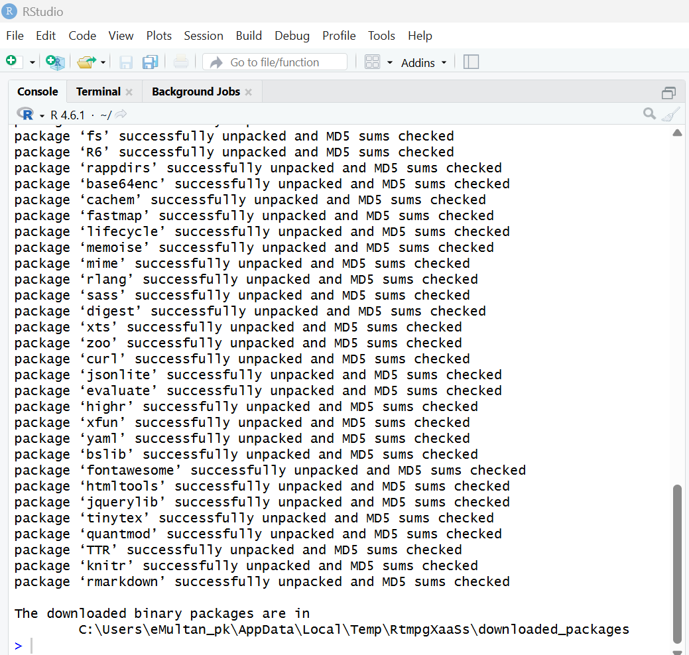
Figure 3.2: All packages installed successfully
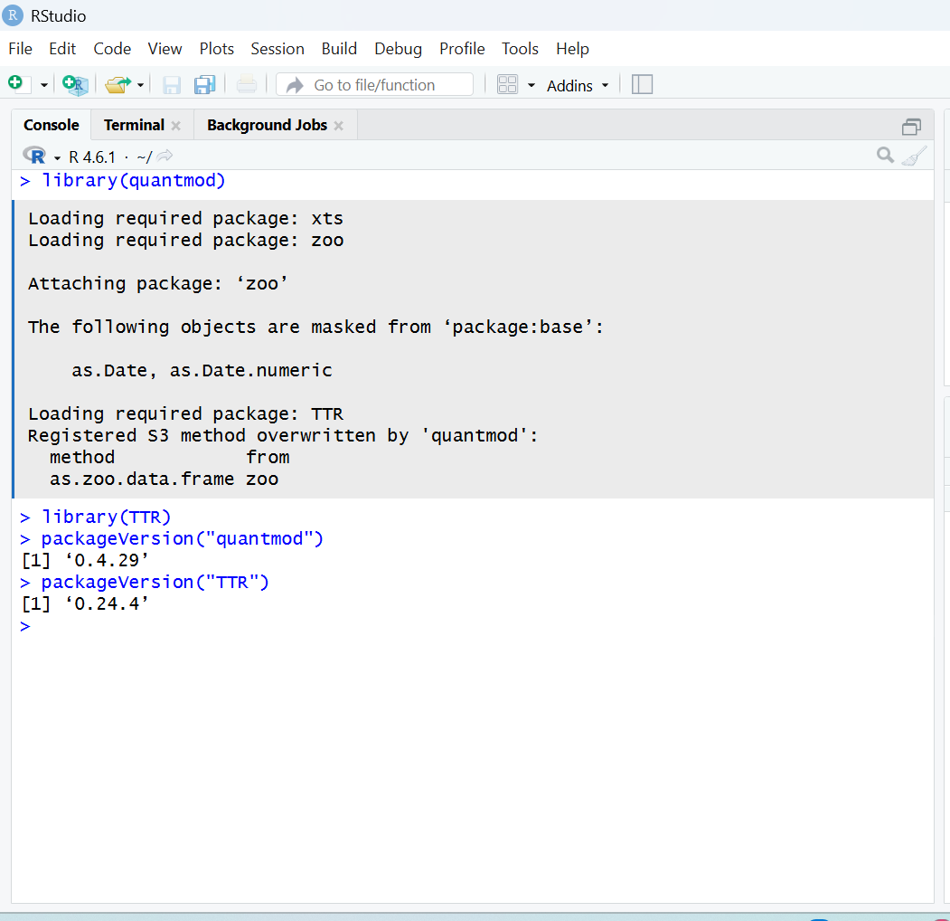
Figure 3.3: Loading the packages and checking versions
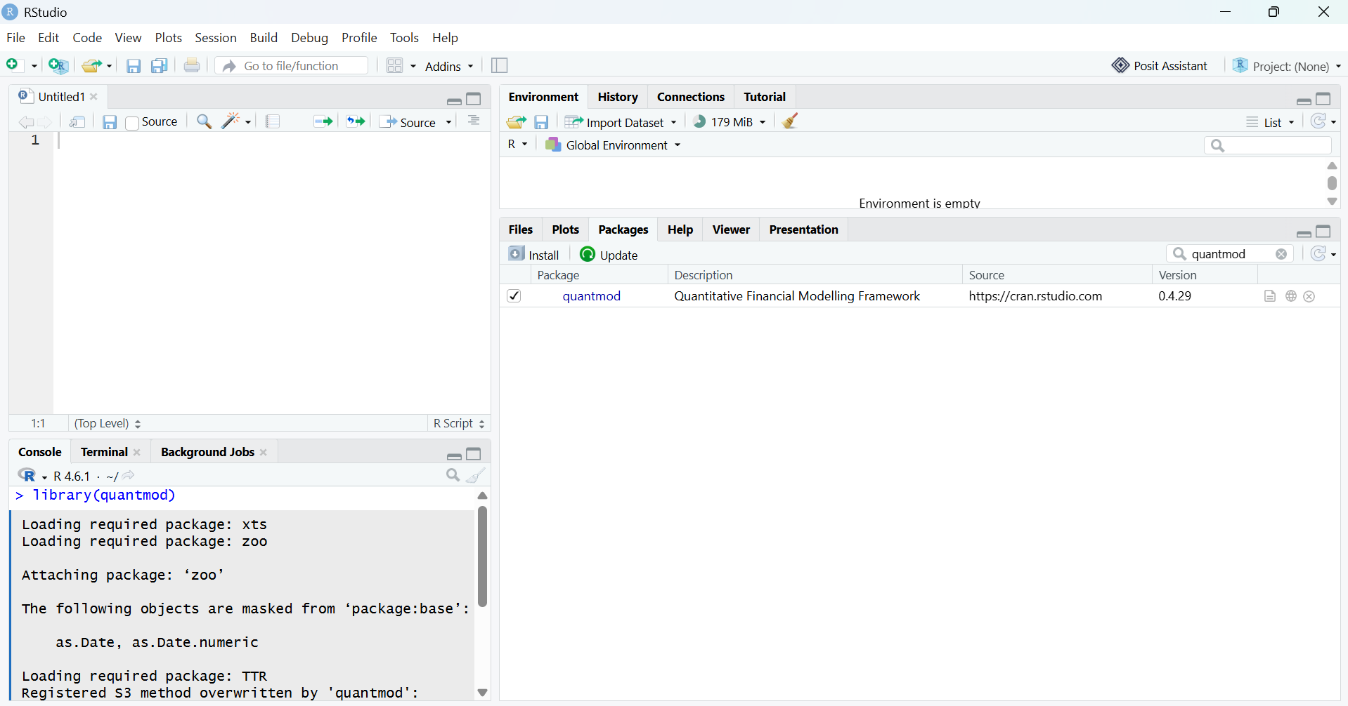
Figure 3.4a: quantmod in the Packages tab
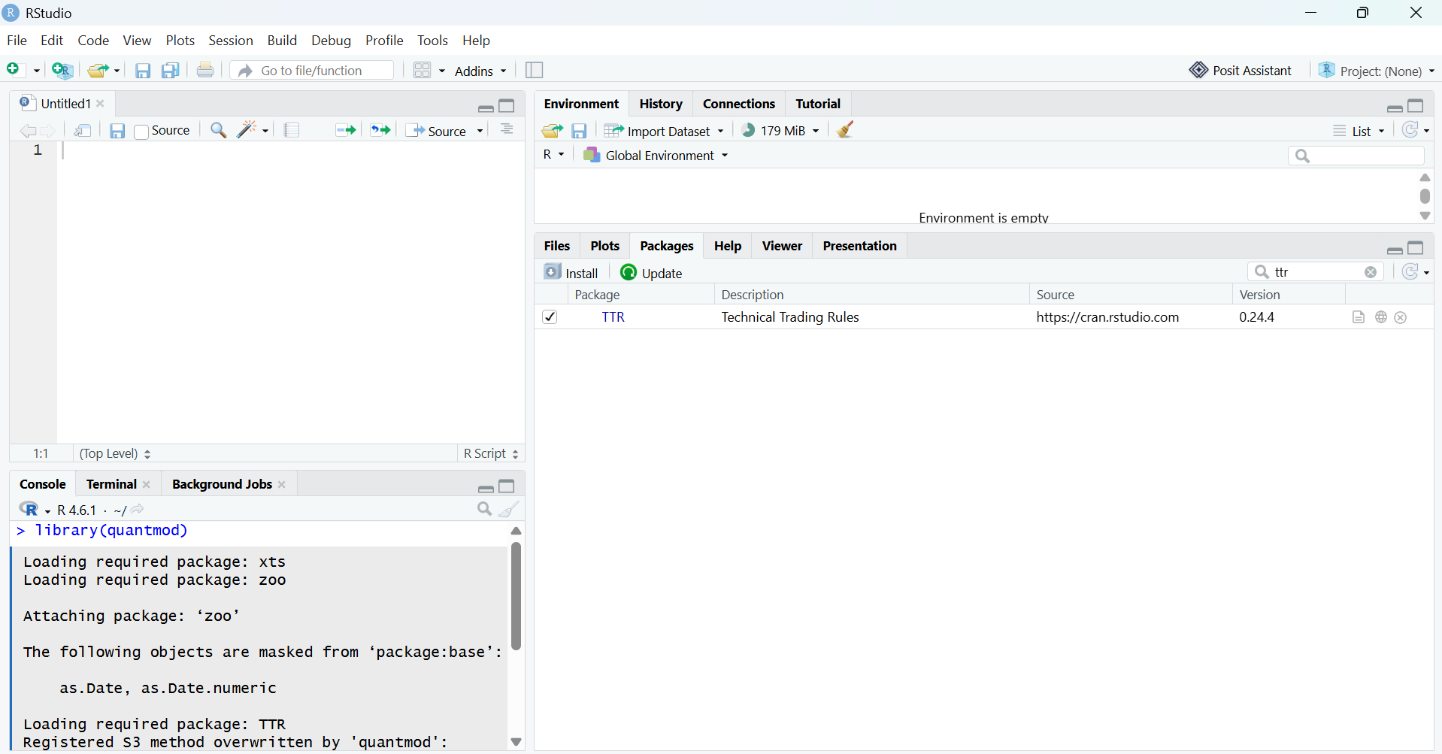
Figure 3.4b: TTR in the Packages tab

4. Project Setup - portfolio.txt
I made a plain text file called portfolio.txt in the A02 folder with one stock symbol per line. I picked five well-known US stocks: four big tech companies plus Tesla, which moves around a lot more, so it should be interesting to compare later when the project gets into technical indicators.
AAPL
MSFT
NVDA
AMZN
TSLA
Apple (AAPL), Microsoft (MSFT), NVIDIA (NVDA), Amazon (AMZN) and Tesla (TSLA). I kept the file to just the symbols with nothing else, so the code can read it line by line without having to skip headers or comments. The read function still removes blank lines and extra spaces just in case.
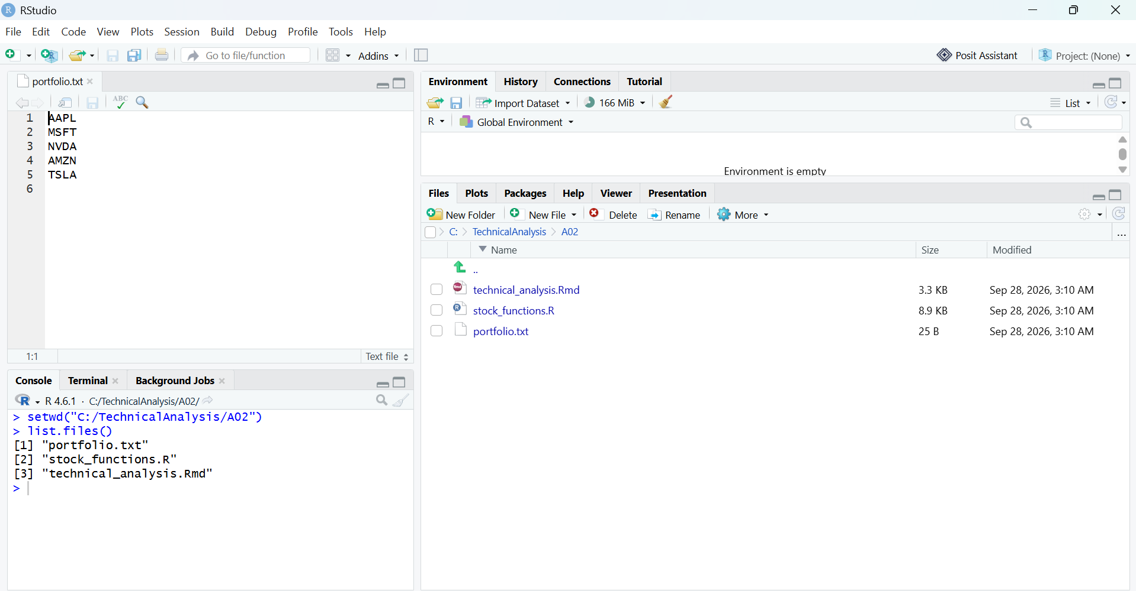
Figure 4.1: portfolio.txt open in RStudio

5. Function to Import Stock Data
All my functions are in stock_functions.R, and the Rmd file loads them with source(). First, a small helper reads portfolio.txt:
# Reads portfolio.txt and returns a clean vector of stock symbols.
# Blank lines and extra spaces are removed, and everything is made uppercase
# so "aapl " and "AAPL" count as the same symbol.
read_portfolio <- function(file = "portfolio.txt") {
if (!file.exists(file)) {
stop("Can't find ", file, " - check your working directory.")
}
symbols <- readLines(file, warn = FALSE)
symbols <- toupper(trimws(symbols))
symbols <- symbols[symbols != ""]
unique(symbols)
}
Then load_stock_data() goes through each symbol and downloads its daily prices from Yahoo Finance with getSymbols(). I used a fixed date range (all of 2025) so the results stay the same every time I run it.
# Reads portfolio.txt, downloads daily prices for every symbol from Yahoo
# Finance using quantmod, and returns a named list with one data frame per
# stock (e.g. stocks$AAPL, stocks$MSFT).
#
# quantmod gives back an xts object (a time series), so each one is converted
# into a normal data frame with the date as its own column.
#
# Note: "to" is set to 2026-01-01 so the whole of 2025 is included. Jan 1 is
# a market holiday anyway so no extra day gets pulled in.
load_stock_data <- function(file = "portfolio.txt",
from = "2025-01-01",
to = "2026-01-01") {
symbols <- read_portfolio(file)
stocks <- list()

for (sym in symbols) {
message("Downloading ", sym, " ...")

stock_df <- tryCatch({
xts_data <- getSymbols(sym, src = "yahoo", from = from, to = to,
auto.assign = FALSE)
df <- data.frame(Date = index(xts_data), coredata(xts_data))
# quantmod names columns like "AAPL.Open" - simplify them
colnames(df) <- c("Date", "Open", "High", "Low", "Close",
"Volume", "Adjusted")
df
}, error = function(e) {
message(" Could not download ", sym, ": ", conditionMessage(e))
NULL
})

if (!is.null(stock_df)) {
stocks[[sym]] <- stock_df
}
}

message("Loaded ", length(stocks), " of ", length(symbols), " symbols.")
stocks
}
A few things I had to think about here:
- getSymbols() returns an xts object, not a data frame. Since the assignment asks for data frames, I convert each one with data.frame() and move the dates out of the index into their own Date column.
- auto.assign = FALSE makes getSymbols() return the data instead of creating a variable in the background. That way I can store everything in one named list, so stocks$AAPL, stocks$MSFT and so on are each a separate data frame.
- tryCatch() means that if one symbol fails (like a typo in portfolio.txt), it prints a message and moves on instead of the whole thing crashing.
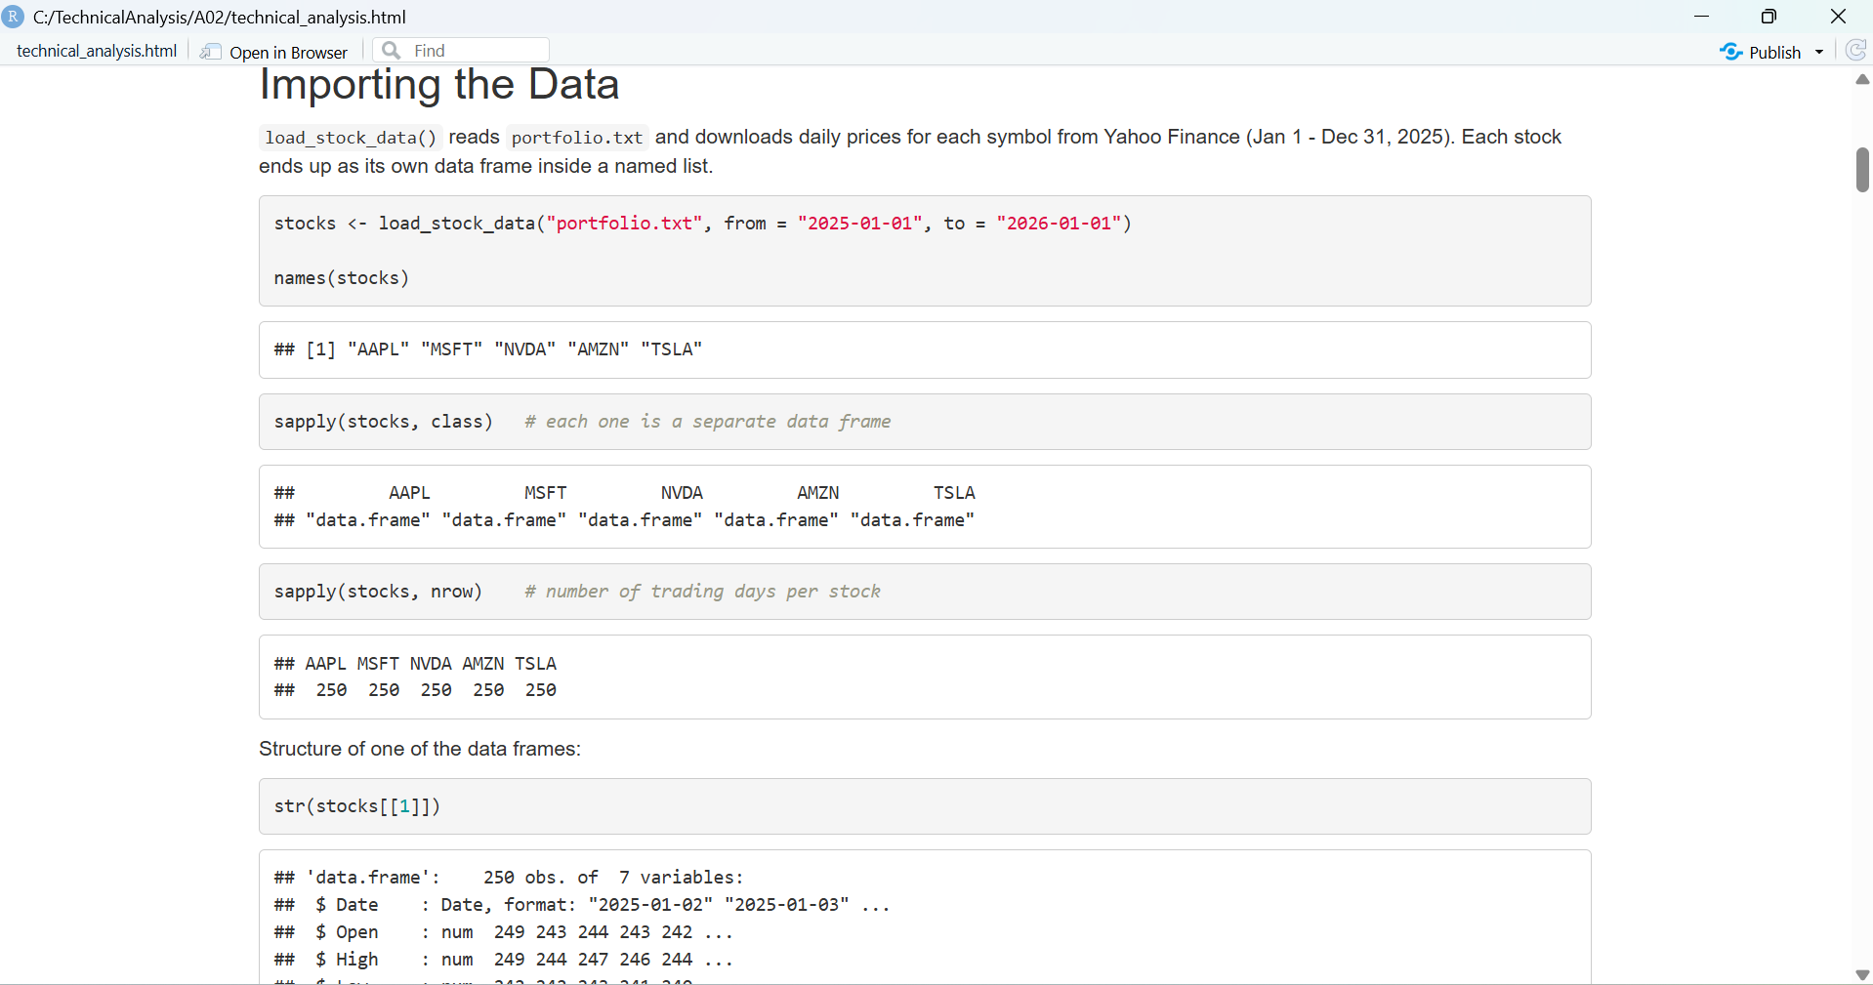
Figure 5.1: Loading the stock data
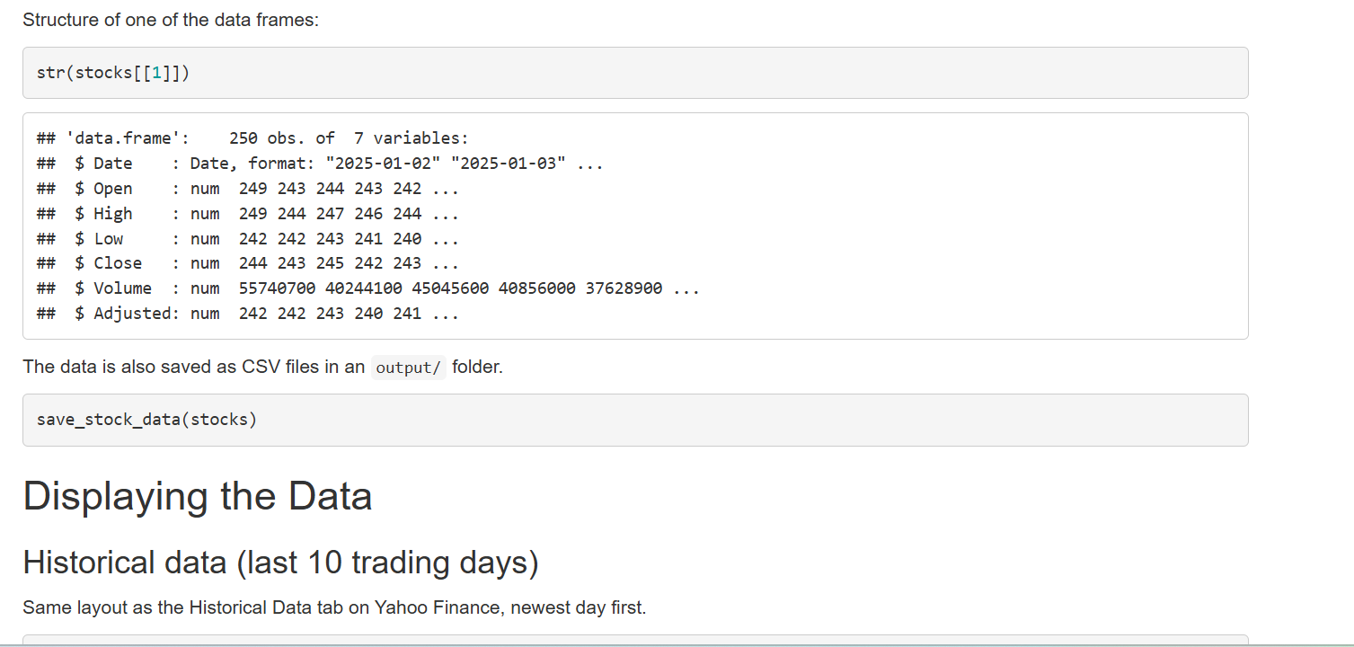
Figure 5.2: Structure of one stock data frame

6. Functions to Compute Statistics
The statistics are all based on the daily closing price. calculate_statistics() takes one stock data frame and returns a one-row data frame, and calculate_all_statistics() runs it on every stock and stacks the rows into one table.
# Takes one stock's data frame and returns a one-row data frame of stats
# based on the daily closing price. The moving averages reported are the most
# recent values (last trading day in the data).
calculate_statistics <- function(stock_df, symbol = "") {
close <- stock_df$Close
sma20 <- SMA(close, n = 20)
sma50 <- SMA(close, n = 50)

data.frame(
Symbol = symbol,
From = min(stock_df$Date),
To = max(stock_df$Date),
Days = length(close),
Mean = round(mean(close, na.rm = TRUE), 2),
Median = round(median(close, na.rm = TRUE), 2),
Mode = calc_mode(close),
SD = round(sd(close, na.rm = TRUE), 2),
Min = round(min(close, na.rm = TRUE), 2),
Max = round(max(close, na.rm = TRUE), 2),
SMA_20_Last = round(tail(sma20, 1), 2),
SMA_50_Last = round(tail(sma50, 1), 2)
)
}
# Runs calculate_statistics() on every stock in the list and stacks the
# results into one table (one row per stock).
calculate_all_statistics <- function(stocks) {
rows <- lapply(names(stocks), function(sym) {
calculate_statistics(stocks[[sym]], sym)
})
do.call(rbind, rows)
}

6.1 Mode
The mode was the tricky one. R's built-in mode() doesn't calculate the statistical mode at all, it just tells you the data type of an object. And even with my own function, closing prices almost never land on the exact same cent twice, so the "mode" of raw prices would basically be random. So I round to the nearest dollar first and then find the most common value:
# Base R doesn't have a function for the statistical mode (R's mode() tells
# you the storage type of an object, not the most common value).
# Closing prices almost never repeat to the exact cent, so the prices are
# rounded first (to the nearest dollar by default) and then the most common
# rounded value is returned. If there's a tie, the lowest value wins because
# table() sorts values in increasing order and which.max() takes the first.
calc_mode <- function(x, digits = 0) {
x <- round(x[!is.na(x)], digits)
counts <- table(x)
as.numeric(names(counts)[which.max(counts)])
}

6.2 Moving averages
A simple moving average (SMA) is the average closing price over the last n days, recalculated each day. It smooths out the day-to-day noise so the trend is easier to see. I used SMA() from TTR with 20 days (about one month of trading) and 50 days (about 2.5 months). The first 19 values of the 20-day SMA are NA because there aren't 20 days of data yet. The table shows the value from the last trading day of the year.
# Adds 20-day and 50-day simple moving average columns to a stock's data
# frame using SMA() from TTR. The first 19 (or 49) rows are NA because there
# aren't enough earlier days yet to average.
add_moving_averages <- function(stock_df, short_n = 20, long_n = 50) {
stock_df$SMA_20 <- SMA(stock_df$Close, n = short_n)
stock_df$SMA_50 <- SMA(stock_df$Close, n = long_n)
stock_df
}

6.3 Other statistics
- Mean and median use mean() and median(). If the mean is a lot higher than the median, it means a few very high prices are pulling the average up.
- Standard deviation uses sd(), which is the sample standard deviation (divides by n - 1). It shows how spread out the prices were over the year.
- Min and max show the range, and I also included the number of trading days so it's obvious the data loaded completely.

6.4 Results
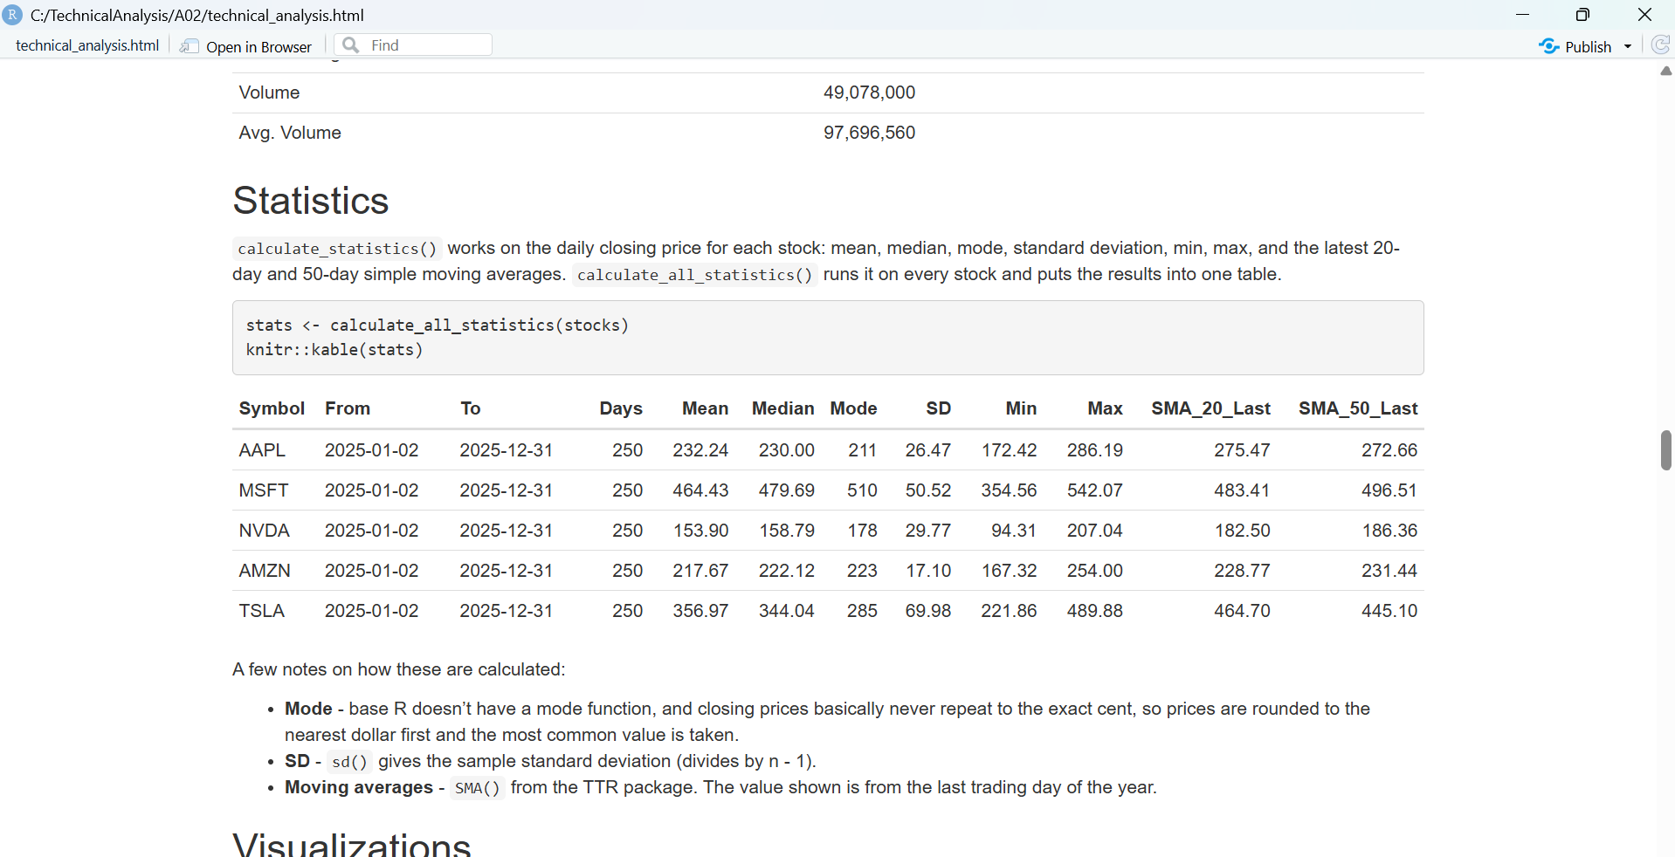
Figure 6.1: Statistics table
All five stocks have 250 trading days, which is the full 2025 trading year, so every download was complete. A few things stood out to me:
- TSLA has the biggest standard deviation ($69.98), but it is also one of the more expensive stocks, so comparing SD in dollars isn't really fair. When I divided the SD by the mean, TSLA (about 19.6%) and NVDA (about 19.3%) were the most volatile, and AMZN was the most stable at about 7.9%. AAPL and MSFT were in between at around 11%.
- For MSFT the mean ($464.43) is quite a bit lower than the median ($479.69), which means some lower prices earlier in the year pulled the average down. TSLA is the opposite, its mean ($356.97) is above the median ($344.04) because of the high prices near the end of the year.
- At the end of the year the 20-day SMA was above the 50-day SMA for AAPL and TSLA, so their recent prices were higher than their longer-term trend. For MSFT, NVDA and AMZN the 20-day was below the 50-day, meaning they had cooled off a bit in the last month. This is the kind of comparison the later stages of the project will build on.

7. Displaying the Data
Before writing these I looked at how Yahoo Finance shows stock data, and I tried to copy a few of the common ways it gets presented.

7.1 Historical data table
display_historical() shows the last 10 trading days, newest first, with the same columns as the Historical Data tab on Yahoo (Date, Open, High, Low, Close, Adj Close, Volume).
# Shows the most recent n rows of a stock, newest first, laid out the same
# way Yahoo Finance's "Historical Data" tab does it.
display_historical <- function(stock_df, symbol = "", n = 10) {
recent <- tail(stock_df, n)
recent <- recent[order(recent$Date, decreasing = TRUE), ]
out <- data.frame(
Date = format(recent$Date, "%b %d, %Y"),
Open = sprintf("%.2f", recent$Open),
High = sprintf("%.2f", recent$High),
Low = sprintf("%.2f", recent$Low),
Close = sprintf("%.2f", recent$Close),
`Adj Close` = sprintf("%.2f", recent$Adjusted),
Volume = formatC(recent$Volume, format = "d", big.mark = ","),
check.names = FALSE
)
rownames(out) <- NULL
cat("\n", symbol, "- last", n, "trading days\n")
out
}
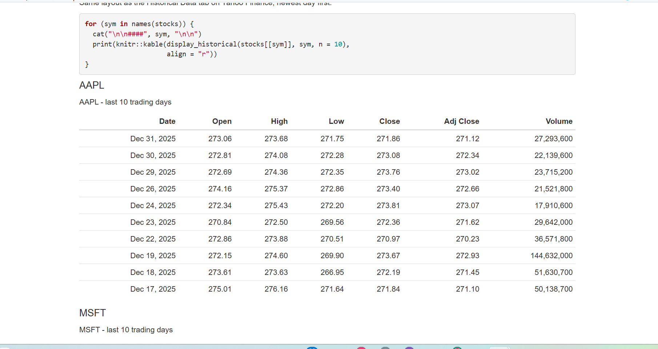
Figure 7.1: Historical data table

7.2 Quote summary
display_quote_summary() is like the summary box at the top of a stock page: last close, previous close, the day's range, the range over the whole period, and volume vs average volume.
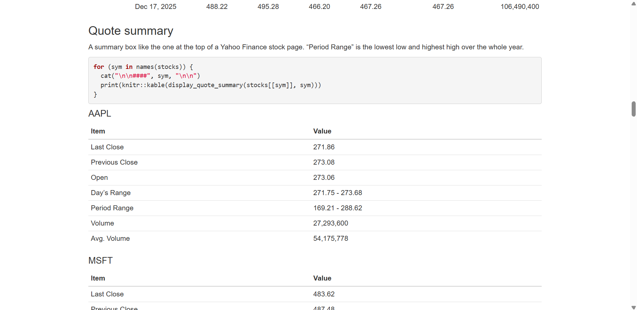
Figure 7.2: Quote summary

7.3 Charts
I made three kinds of charts:
- Closing price with moving averages - base R line chart with the 20-day SMA in blue and the 50-day SMA in red.
- Candlestick chart with volume - uses quantmod's chartSeries(). Each candle shows the open, high, low and close for one day, with volume bars underneath.
- Relative performance - all five stocks on one chart, rebased so each one starts at 100. The actual prices are very different, so without this the cheaper stocks would just look like flat lines at the bottom.
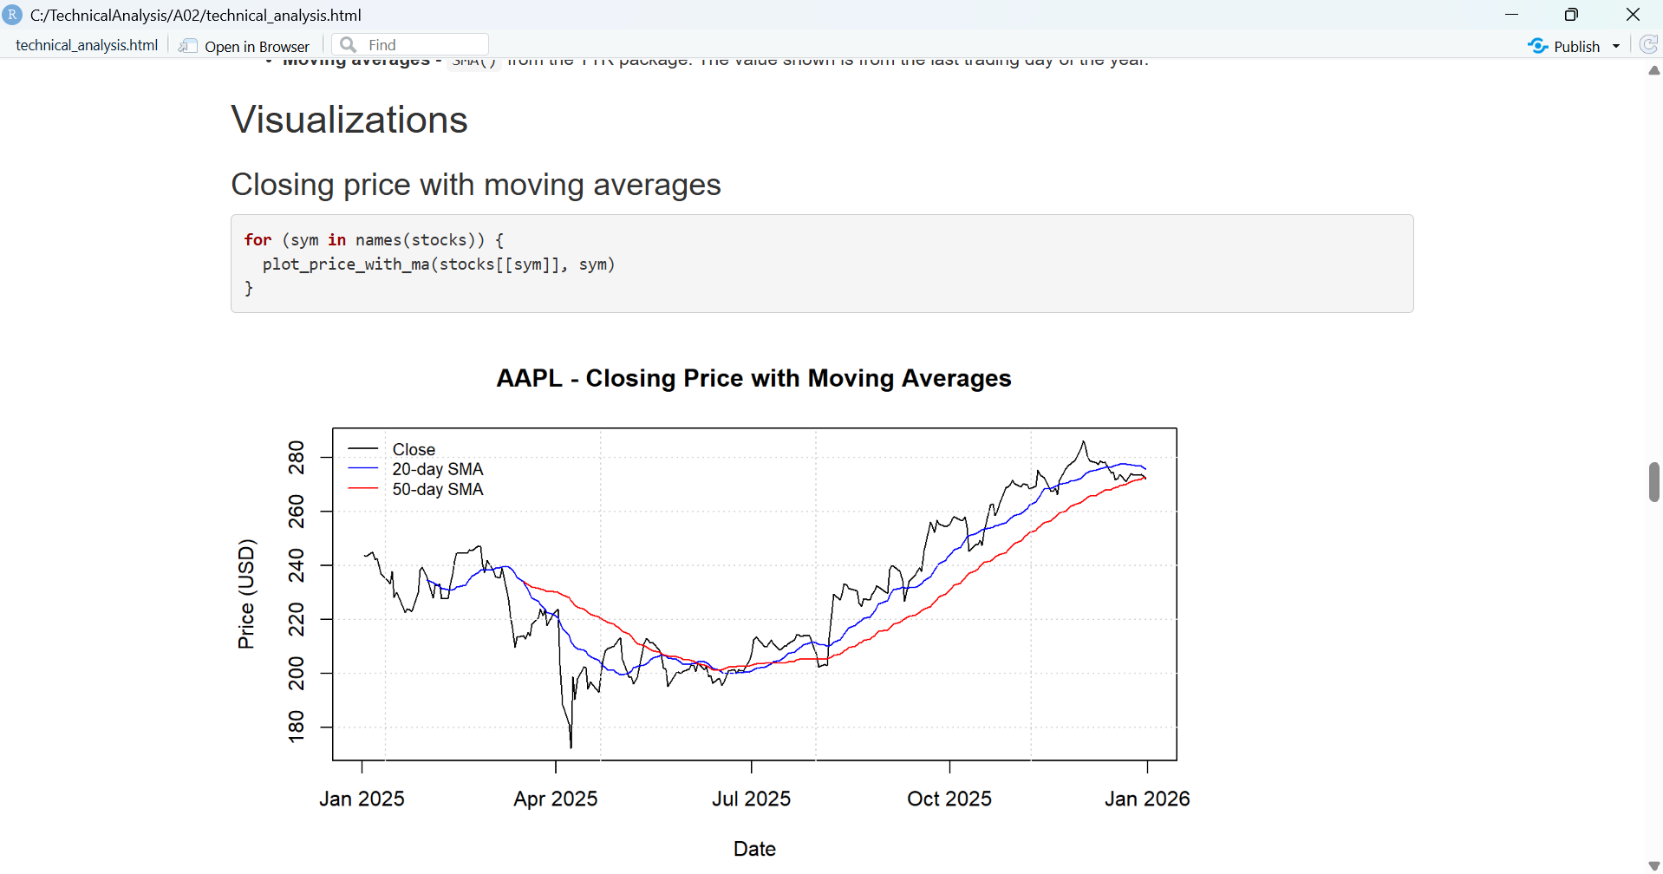
Figure 7.3: Closing price with moving averages
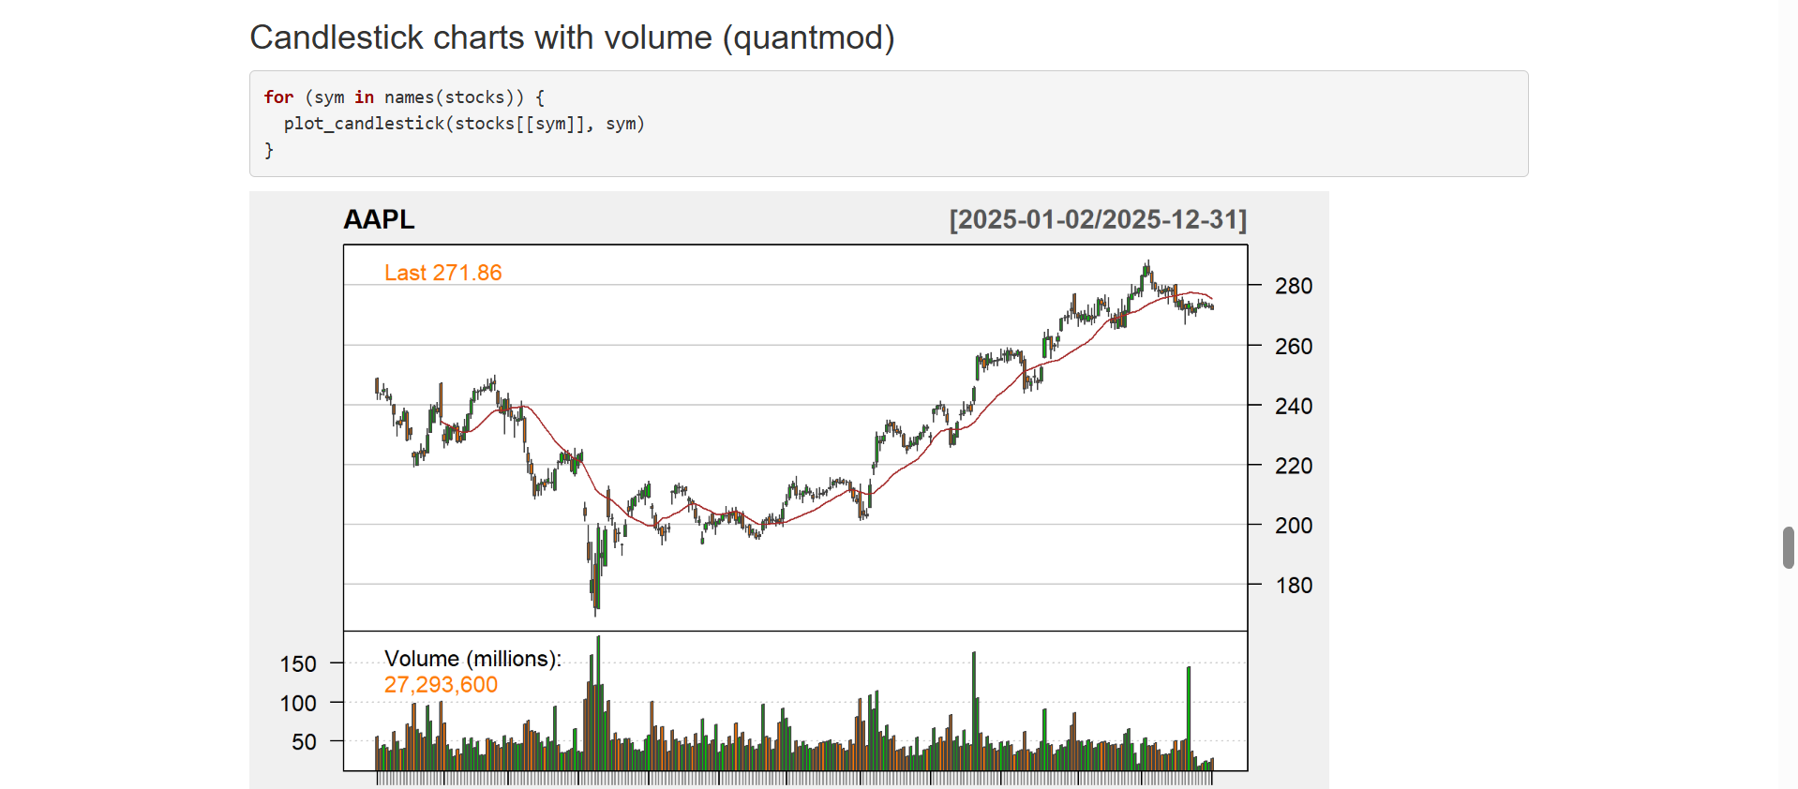
Figure 7.4: Candlestick chart with volume
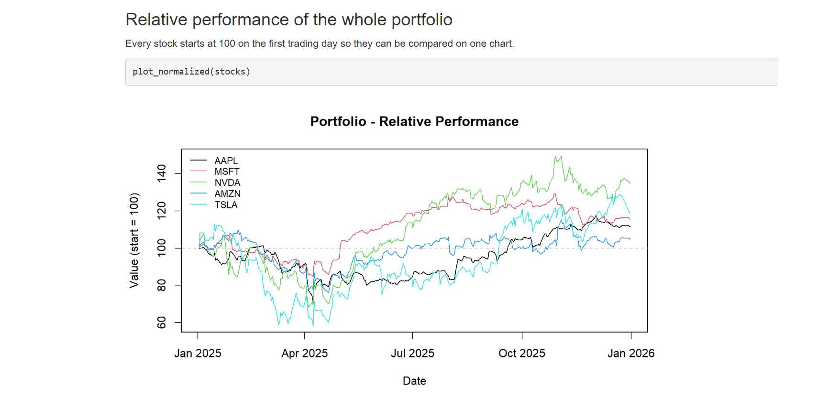
Figure 7.5: Relative performance of the portfolio

8. Running the Analysis
technical_analysis.Rmd puts everything together: it loads the functions, reads the portfolio, downloads the data, saves a CSV for each stock into an output folder, then shows the tables, statistics and charts. I opened it in RStudio and clicked Knit, which produced technical_analysis.html.
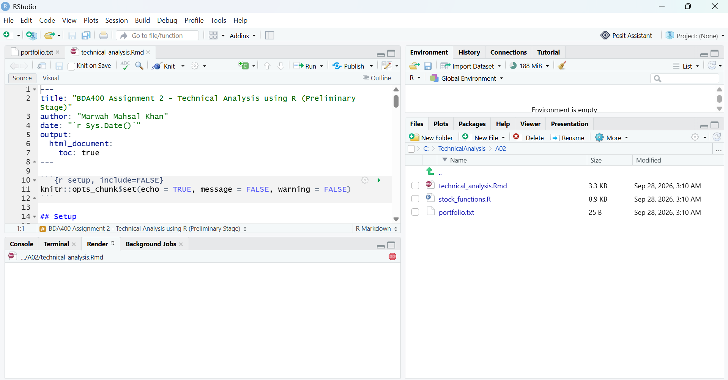
Figure 8.1: technical_analysis.Rmd in RStudio
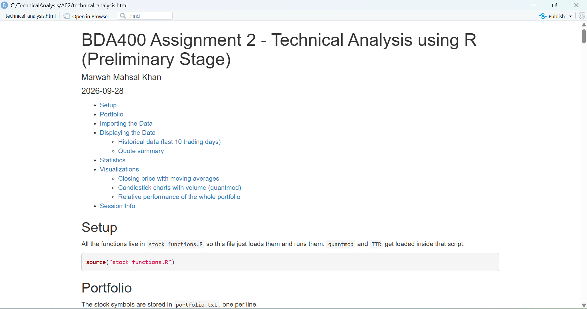
Figure 8.2: Knitted HTML report

Files in the A02 folder
File | What it is
portfolio.txt | List of stock symbols
stock_functions.R | All the functions (load, statistics, display, charts)
technical_analysis.Rmd | Runs the analysis and displays the results
technical_analysis.html | Knitted output of the Rmd
output/ | CSV file for each stock
MahsalKhan_Marwah_CA_BDA400_A02.docx | This report

Notes
When I ran install.packages() I got a warning saying Rtools is required to build R packages. I looked into it and Rtools is only needed when a package has to be compiled from source code. On Windows, R downloaded ready-made binary versions of all the packages instead, which is why every package still says "successfully unpacked and MD5 sums checked". So I didn't need to install Rtools for this assignment.
I also kept the project in C:\TechnicalAnalysis\A02 instead of my Documents folder, so the file paths are short and the same folder structure can go straight into the GitHub repository.
The first time I knitted the report, the candlestick charts showed the last price as 271.859985351562 instead of 271.86. This happens because computers store decimal numbers in binary, so a number like 271.86 can't be stored exactly. The tables were fine because they round the numbers for display, but chartSeries() prints the raw value. I fixed it by rounding the prices to 2 decimals inside plot_candlestick() before making the chart, then knitted again.

GitHub Repository
All files for this assignment are in the A02 folder of my repository:
https://github.com/cdimmk1985-crypto/TechnicalAnalysis

