AC/DC Framework
Analysis Concepts / Derivation Concepts
Framework Overview
Draft v0.1

1. Introduction
The AC/DC Framework (Analysis Concepts / Derivation Concepts) provides a comprehensive approach to specifying clinical trial data transformations and statistical analyses in a machine-executable, standard-independent way.
The framework enables a fundamental shift from hardcoded programming to configurable metadata specifications, where analysis intent is captured once and can be automatically translated to multiple implementation targets.

1.1 Vision
- Define once, execute anywhere: Specifications translate to R, SAS, Python, and other languages
- Standard-independent: Works with ADaM, SDTM, OMOP, FHIR, and future standards
- Machine-executable: Metadata drives automated code generation
- Semantically rich: Captures clinical intent, not just computational steps

1.2 Framework Architecture
The framework follows a three-layer architecture for both data derivation and statistical analysis:
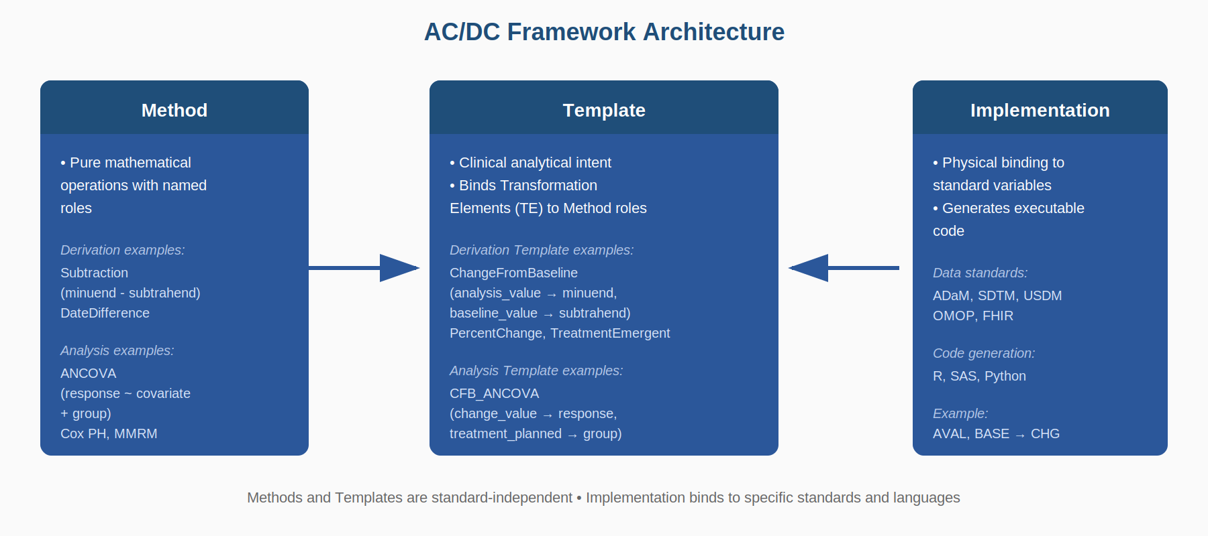
Methods define pure operations using named roles. Templates bind Transformation Elements to those roles for specific clinical purposes. Implementation provides the physical binding to data standards and generates executable code.

2. Framework Documents
The AC/DC Framework is defined across two complementary specification documents:

Document | Purpose
Clinical Transformation Model (CTM) | Defines WHAT concepts exist: Transformation Elements (TEs) at both observation and inference levels, their relationships, and implementation bindings to physical standards.
Methods, Templates & DEL | Defines HOW transformations work: Methods (operations with roles), Templates (clinical patterns binding TEs to Methods), SDMX Data Cube integration, and the Derivation Expression Language.

2.1 Clinical Transformation Model (CTM)
The CTM is the semantic foundation of the framework. It defines Transformation Elements (TEs) organized into two levels based on granularity:
Observation-level TEs
Data concepts at the subject/visit/timepoint granularity - inputs and outputs of derivation methods:
Category | Examples
Value | observation_value, analysis_value, baseline_value, change_value, percent_change
Identity | study, site, region, subject, sequence
Timing | timepoint, visit, period, phase, relative_time
Treatment | treatment_planned, treatment_actual, dose
Flag | population_flag, baseline_flag, treatment_emergent_flag
Time-to-Event | tte_origin, event_date, time_to_event, censor_indicator

Inference-level TEs
Statistical outputs at the analysis/comparison granularity - outputs of analysis methods:
Category | Examples
Estimate | estimate, ls_mean, ls_mean_difference, odds_ratio, hazard_ratio
Interval | confidence_interval, confidence_interval_lower, confidence_interval_upper
Test | p_value, t_statistic, f_statistic, degrees_of_freedom
Descriptive | count, mean, median, standard_deviation, minimum, maximum

The CTM also defines Implementation Bindings that map TEs to physical variables in specific standards (ADaM, SDTM, OMOP, FHIR).

2.2 Methods, Templates & DEL
This document defines the operational components that specify how derivations and analyses are performed.
Methods
Methods are reusable operation specifications with named roles:
Type | Derivation Methods | Analysis Methods
Purpose | Computational operations | Statistical procedures
Examples | Subtraction, Division, DateDifference, Aggregation | ANCOVA, MMRM, Cox PH, Chi-Square
Expression | DEL arithmetic (difference := minuend - subtrahend) | Wilkinson-Rogers notation (response ~ covariate + group)

Templates
Templates bind Transformation Elements to Method roles for clinical purposes:
Template | Method | Clinical Intent
ChangeFromBaseline | Subtraction | Calculate absolute change from baseline
CFB_ANCOVA | ancova | Compare treatment effect on change from baseline
TTE_CoxPH | cox_proportional_hazards | Compare time-to-event between treatment groups

Derivation Expression Language (DEL)
DEL provides two expression types: arithmetic expressions for derivations and Wilkinson-Rogers notation for statistical models. Both translate to multiple target languages.

3. How the Documents Connect
The two framework documents form a layered specification where each references the other:

Connection | From | To
Templates → CTM TEs | Template role bindings | Reference Transformation Elements by name
Templates → Methods | Template uses_method property | References Method by name
Templates → Cube Roles | Role binding cube_role property | Assigns measure/dimension/filter role
CTM Bindings → TEs | Implementation binding table | Maps physical variables to TEs (AVAL → analysis_value)

3.1 Example: Change from Baseline Analysis
This example shows how the documents work together for a typical efficacy analysis:
1. CTM defines the concepts:
- analysis_value (Observation-level TE) - the post-baseline measurement
- baseline_value (Observation-level TE) - the baseline measurement
- change_value (Observation-level TE) - the derived change
- treatment_planned (Observation-level TE) - the randomized treatment
- p_value, ls_mean (Inference-level TEs) - statistical outputs
2. Methods/Templates/DEL defines the operations:
- Subtraction Method: difference := minuend - subtrahend
- ChangeFromBaseline Template: binds analysis_value → minuend, baseline_value → subtrahend
- ANCOVA Method: response ~ covariate + group
- CFB_ANCOVA Template: binds change_value → response (measure), baseline_value → covariate, treatment_planned → group (dimension)
3. CTM provides implementation bindings:
- ADaM binding: AVAL → analysis_value, BASE → baseline_value, CHG → change_value
- Code generation: PROC GLM; CLASS TRT; MODEL CHG = BASE TRT;

4. Recommended Reading Order
Order | Document | Focus
1 | This Overview | Understand the framework architecture and document relationships
2 | CTM Specification | Learn the vocabulary: Observation-level and Inference-level TEs, and implementation bindings
3 | Methods, Templates & DEL | Understand operations, SDMX Data Cube integration, and expression languages

5. Key Principles
- Separation of concerns: WHAT concepts exist (CTM) vs HOW transformations work (Methods/Templates)
- Standard-independence: Core specifications work across ADaM, SDTM, OMOP, FHIR
- Machine-executable: Metadata drives code generation, not human programming
- Semantic richness: Clinical intent is captured, not just computational steps
- Unified pattern: Both derivation and analysis follow Method → Template → Implementation
- CDISC-maintained: Methods and Templates are part of the AC/DC standard library
- Extensible: Organizations can add custom templates while maintaining compatibility

