Urban heat island evidence
Southwark heat hazard and UHeatRank map

Urban heat island in Southwark
The urban heat island is the extra heat a city holds compared with the countryside around it. Roads, pavements and buildings absorb heat by day and trap it (London Climate Ready Partnership, n.d.). Southwark sits at the centre of London’s heat island, with summer temperatures estimated around 4.5°C above rural areas (Southwark Council, 2025).

Evidence
- central London was up to 10°C warmer than rural areas in the 2003 heatwave, and the heat island can add 5 to 6°C to night-time temperatures (London Climate Ready Partnership, n.d.)
- in the July 2022 heatwave the heat island averaged 2.3°C and peaked at 7.2°C, strongest at night and in central London (Simpson, Brousse and Heaviside, 2024)
- it caused an estimated 141 deaths in Greater London over that heatwave, 38% of all heat-related deaths (Simpson, Brousse and Heaviside, 2024)
- 8% of Greater London (14 km²) is a persistent heat island, with mean summer surface temperature of 40.56°C or more over 2013 to 2023; clusters sit in east London, the western edge and south of the Thames (Krenz and Amann, 2025)
- Asian (39.10°C) and Black (39.00°C) residents face higher mean surface temperatures than White residents (38.57°C); children aged 4 and under face the highest of any age group (Krenz and Amann, 2025)
- the least well-off are exposed to surface temperatures 4.38°C higher than the most affluent (90th against 10th percentile) (Krenz and Amann, 2025)
- heat reduces walking accessibility in affected areas by 6 to 9%, hitting Asian and Black communities hardest (Krenz and Amann, 2025)
- higher heat risk in London correlates directly with greater socio-economic vulnerability (Greater London Authority and Arup, 2024)
- green cover sets the local pattern: Kilburn and South Hampstead (38% vegetation) ran over 7°C hotter than nearby Regent’s Park (89%) (Arup, 2023)

UHeatRank map
Arup’s UHeatRank, produced for the GLA, ranks every LSOA in London from 1 (coolest) to 5 (hottest) using the UHeat tool (Greater London Authority and Arup, 2024). It models neighbourhood temperatures, which is closer to what people feel than surface temperature alone.
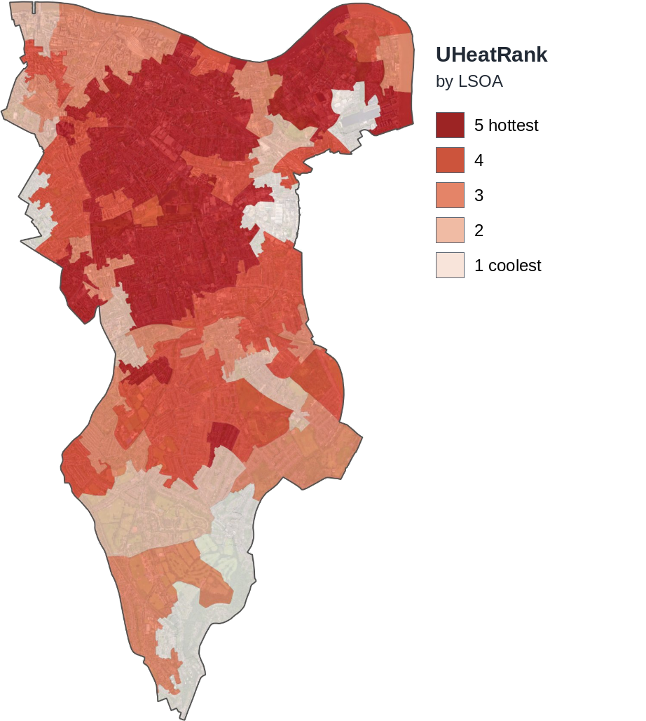
Figure 1. UHeatRank by LSOA, Southwark. Source: Greater London Authority and Arup (2024).
The hottest areas run through the north and centre of the borough. Walworth, Camberwell, Peckham and South Bermondsey combine the highest heat rank with the least green space and the highest deprivation (Southwark Council, 2025). The south of the borough and the larger parks rank lowest.

London heat island map
Krenz and Amann (2025) map persistent heat islands across London from Landsat summer imagery, 2013 to 2023, at 30 m resolution. Areas shown have mean surface temperature of 40.56°C or more.
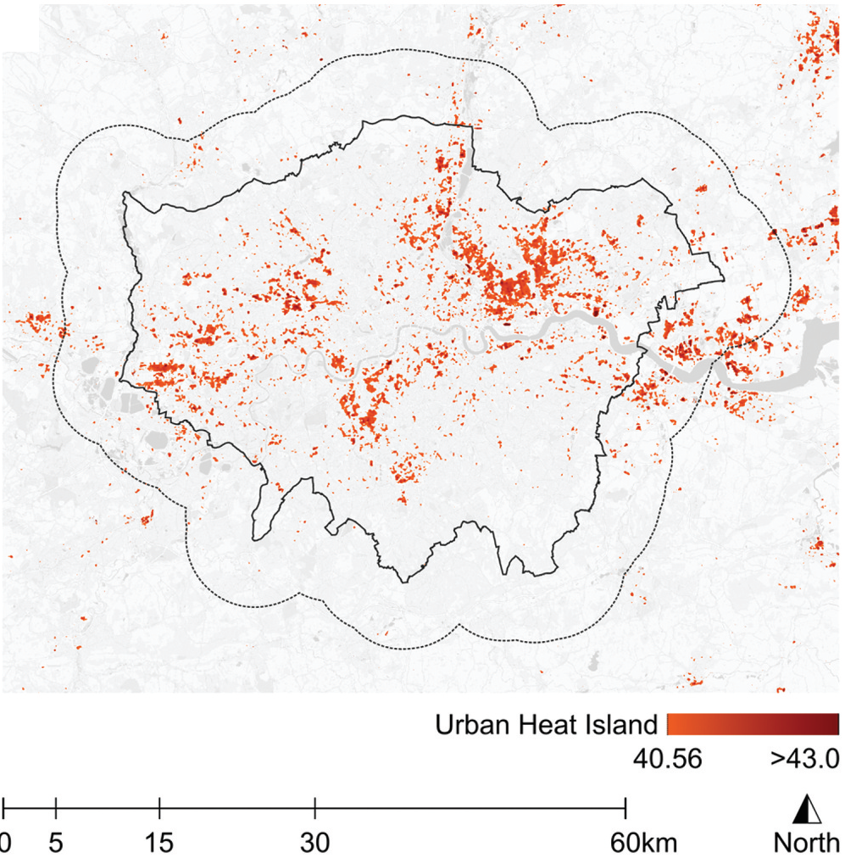
Figure 2. Urban heat island areas, Greater London, 2013 to 2023. Source: Krenz and Amann (2025), Figure 2b, CC BY 4.0.

Land surface temperature
The WRI Cool Cities Lab shows the same pattern at street scale. Hot-season surface temperatures across south London range from about 33°C to 43°C, with the Thames and large green spaces coolest (WRI, 2026). Surface temperature exceeds air temperature, so this shows pattern, not rank.
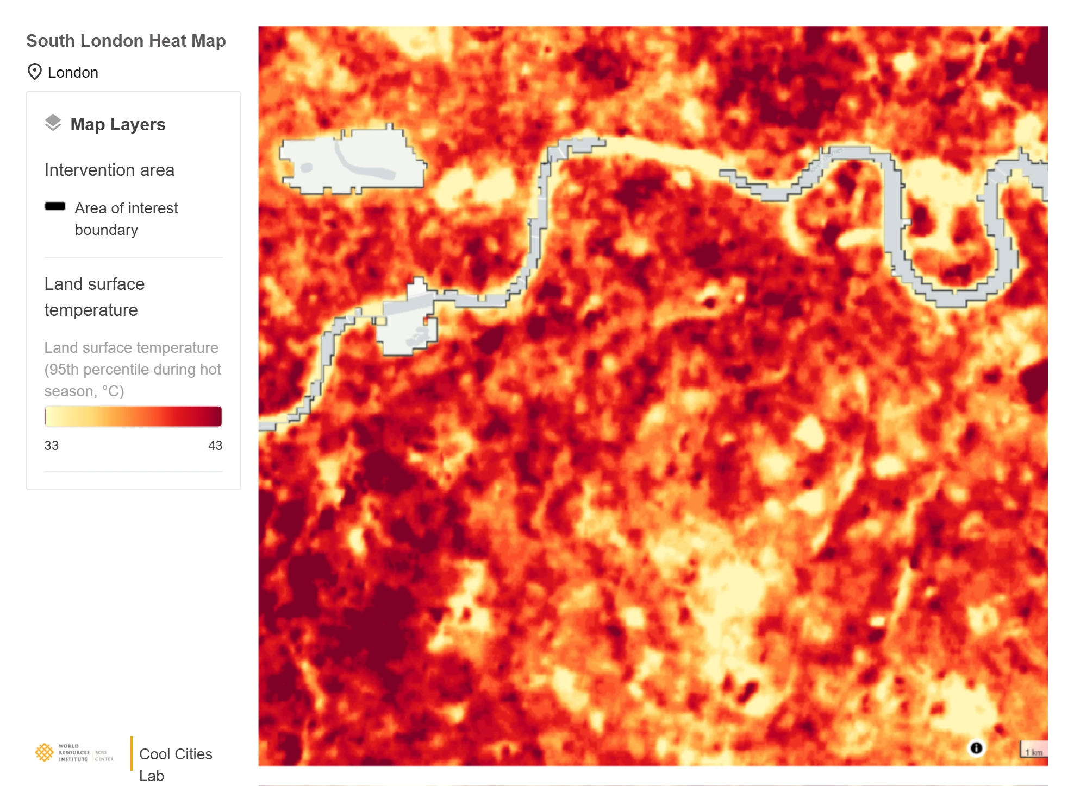
Figure 3. Land surface temperature, 95th percentile hot season (°C). Source: WRI (2026).

Works cited
Arup (2023) Urban Heat Snapshot. London: Arup. Available at: arup.com/insights/urban-heat-snapshot (Accessed: 29 September 2026).
Greater London Authority and Arup (2024) Properties Vulnerable to Heat Impacts in London: Prioritisation for Adaptation Interventions. London: Greater London Authority. Available at: london.gov.uk (Accessed: 29 September 2026).
Krenz, K. and Amann, L. (2025) ’Urban heat island effect: examining spatial patterns of socio-demographic inequalities in Greater London’, Cities & Health, 9(5), pp. 901 to 924. Available at: doi.org/10.1080/23748834.2025.2489854.
London Climate Ready Partnership (n.d.) Heatwaves. Available at: climatelondon.org (Accessed: 29 September 2026).
Simpson, C.H., Brousse, O. and Heaviside, C. (2024) ’Estimated mortality attributable to the urban heat island during the record-breaking 2022 heatwave in London’, Environmental Research Letters, 19(9), 094047. Available at: doi.org/10.1088/1748-9326/ad6c65.
Southwark Council (2025) Hot Weather and Health: Southwark’s Joint Strategic Needs Assessment. London: London Borough of Southwark, Public Health Division.
World Resources Institute (WRI) (2026) Cool Cities Lab. Washington, DC: WRI Ross Center for Sustainable Cities. Available at: coolcities.wri.org (Accessed: 29 September 2026).

