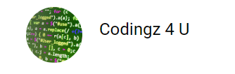

Python all at once: A developer guide

1. Installation of Python on Windows
   1. Python Version history
   2. Python installation on Windows
   3. Pycharm Installation on Windows

**Python Version History**

Python Software Foundation (PSF) supports 2 major versions of python, 2.x and 3.x. Python 2.x is not easy to directly port Python 3.x. So, they supported Python 2 until January 2020, and they stopped supporting it henceforth.

Python 3.x was released on December 3rd 2008. It designed to rectify certain flaws in earlier version. Python 3 backported all major features of python2.x

**Python installation on Windows**

Installing python windows is very simple like other software, which involves 3 steps:

1. Download the binaries
2. Run the Executable installer
3. Add Python to PATH environmental variables
4. Verify python installation

You can choose the version of Python you wish to install. It is recommended to install the latest version of Python, which is 3.10.2 [ at the time of writing this article, will change latter]

**Download the binaries**

## Step 1: Download the Python Installer binaries

1. Open the [official Python website](https://www.python.org/downloads/windows/) in your web browser. Navigate to the Downloads tab for Windows.
2. Choose the latest Python 3 release. In our example, we can choose Python 3.10.2 as this is the latest it is available.
3. Click on the link to download **Windows x86 executable installer** if you are using a 32-bit installer. In case your Windows installation is a 64-bit system, then download **Windows x86-64 executable installer**.

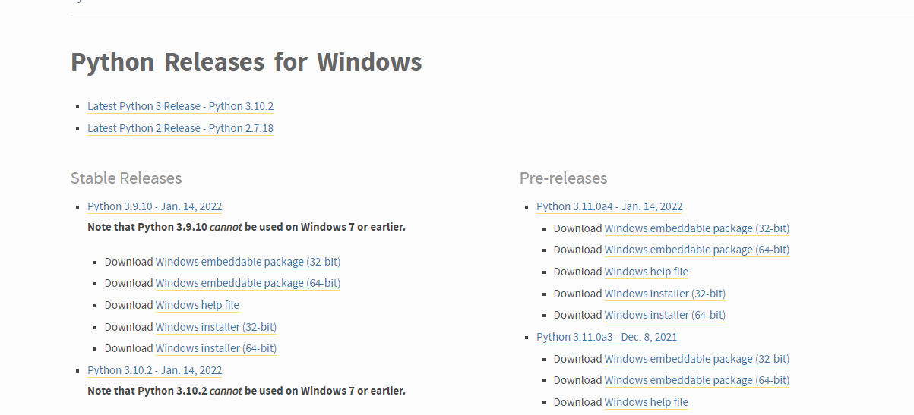

## Step 2: Run the Executable Installer

1. Once the installer is downloaded, run the Python installer.
2. Check the Install launcher for all users check box. Further, you may check the Add Python 3.10 to path check box to include the interpreter in the execution path.

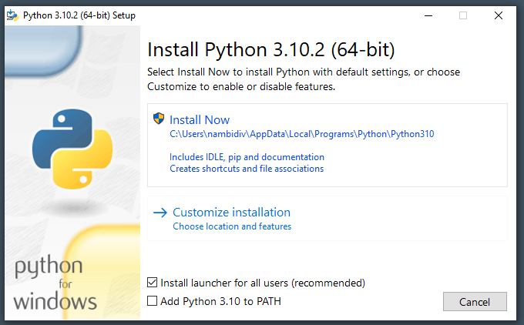

1. Better to select **Customize installation,** so that you can tick the below optional features and advanced options:

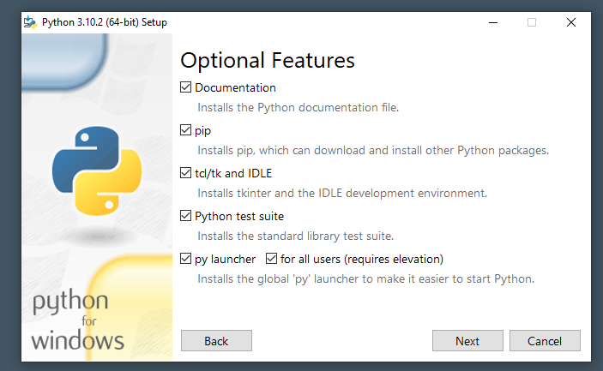

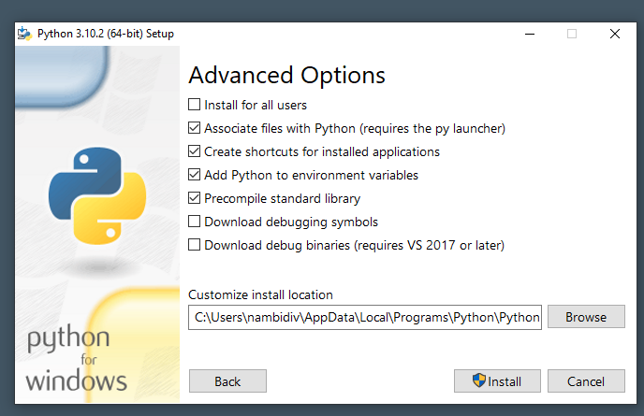

## Step 3: Add Python to environmental variables

The last (optional) step in the installation process is to add Python Path to the System Environment variables. This step is done to access Python through the command line. In case you have added Python to environment variables while setting the Advanced options during the installation procedure, you can avoid this step. Else, this step is done manually as follows.

In the Start menu, search for “advanced system settings”. Select “View advanced system settings”. In the “System Properties” window, click on the “Advanced” tab and then click on the “Environment Variables” button

You can see the installation path In the above window, I changed the same to c:\opt\Python. Since I opted Add python to environment variable it Is already done 😊

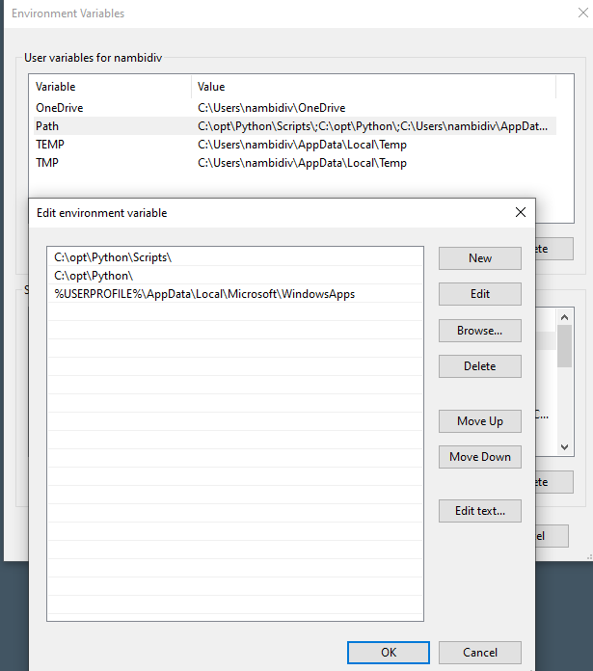

## Step 4: Verify python installation

## For verifying python installation, we can open windows command line/ power shell and type python. You will get something like below screen:

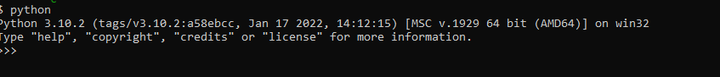

Or we can start the same from start menu by typing python as below

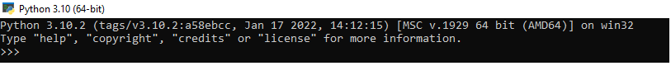

**PyCharm installation on Windows**

There are a lot of IDES available for python. I generally use PyCharm as the community version is free and it is easy to install and use.

We need to do below steps to download and install PyCharm IDE on Windows:

**Step 1)** Download PyCharm : Visit  <https://www.jetbrains.com/pycharm/download/> and click the “DOWNLOAD” link under the Community Section. Professional section is licenced and if want to buy that, then you can go with Professional.

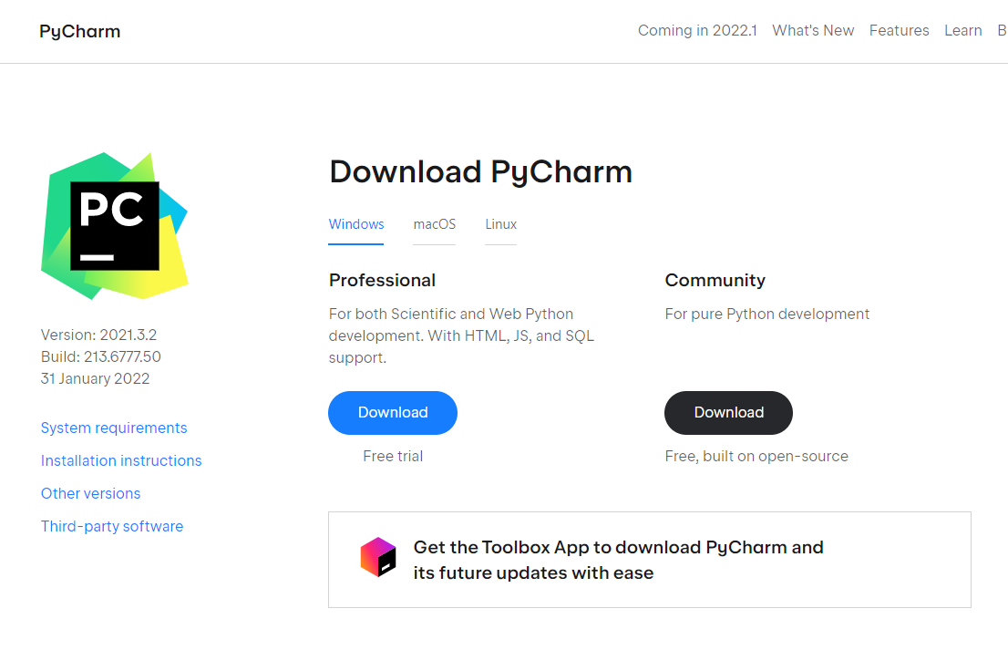

**Step 2)** Install PyCharm. Double click pycharm-community-2021.3.1.exe and from the setup wizard should have started. Click “Next”, as below:

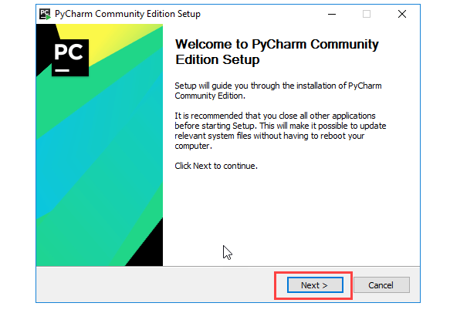

You can change the installation directory if required here

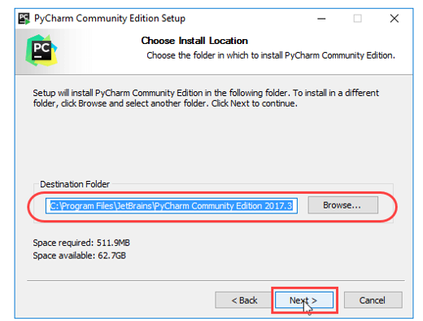

Create destop shortcut if required.

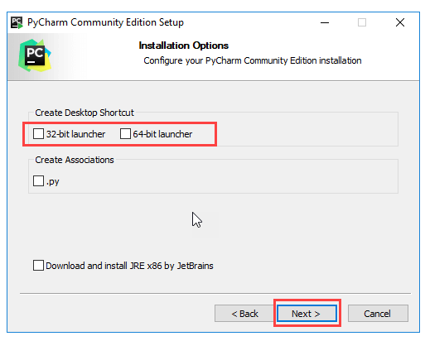

Choose the start menu folder. Keep selected JetBrains and click on “Install”, click next and wait till installation get completed.

