Demo :

Step 1: Download wordpress plug(server side) from our support url.
http://imzc.net/wp-content/uploads/2012/02/wp_plug_oath_otp.zip

Step 2: Login to your wordpress admin page.

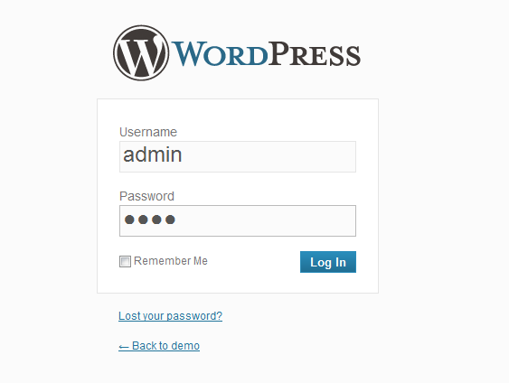
Step 3: Goto the pulg install page,then upload the zip file (step 1)
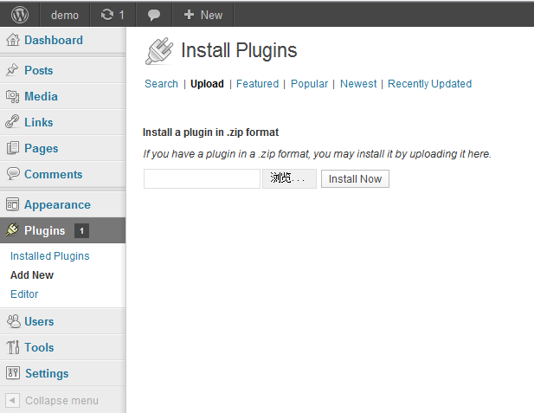

Step 4:Activate the Plugin
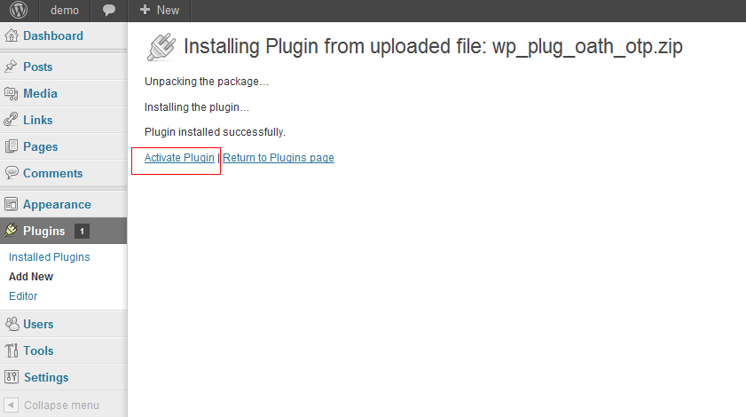

Step 5: Go to the OATH_OTP setting page to set the shake hand key.
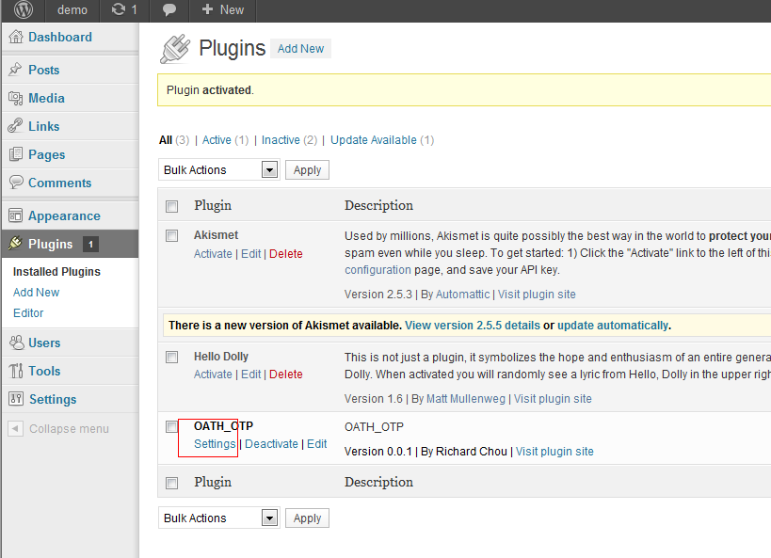

Step 6: Set up your oather shakehand key "demotest"

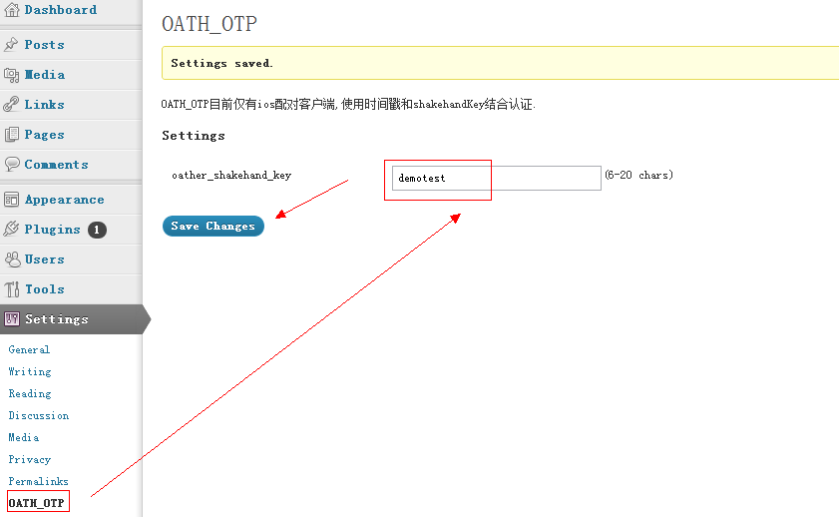

Step 7: Download wp_otp app from appstore and install it. Then open app,click "+",input your blog's nick name(must be letters or numbers),at the demo ,I type "demo",click button "OK":

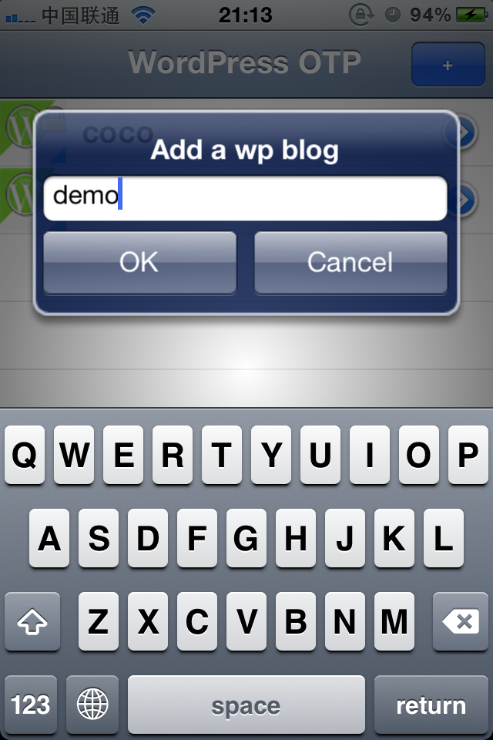

Step 8: Return to the main page,and click "demo" cell,then go to the "demo" blog page,input your shake hand key(step6),then click "Save" button.
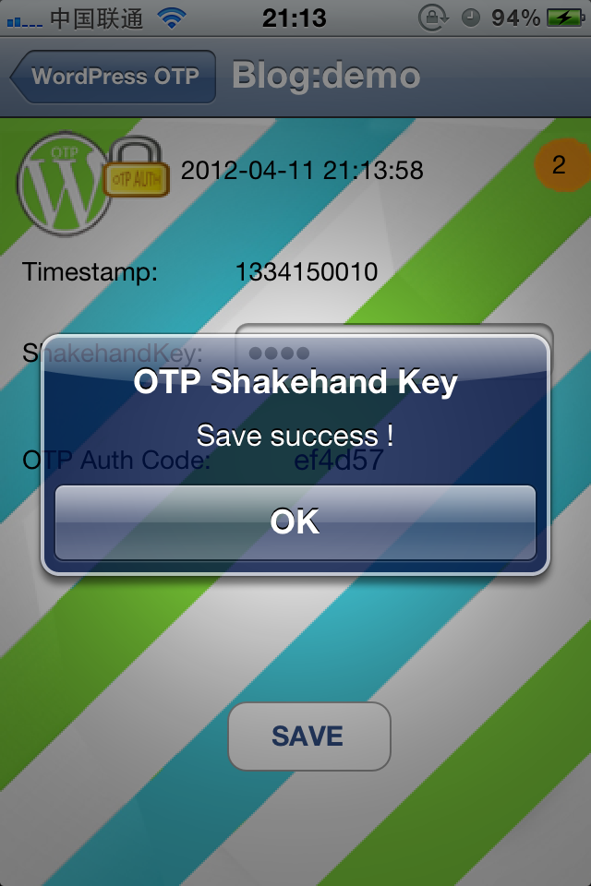

Step 9: Open your blog again,now,you can see, an OATH_OTP input field appears on the login page, fill it with the OTP Auth Code displayed on your iphone .Then you can login to the admin page. If you use a wrong otp auth code,you will not allowed to login to the admin page.

