Main Menu

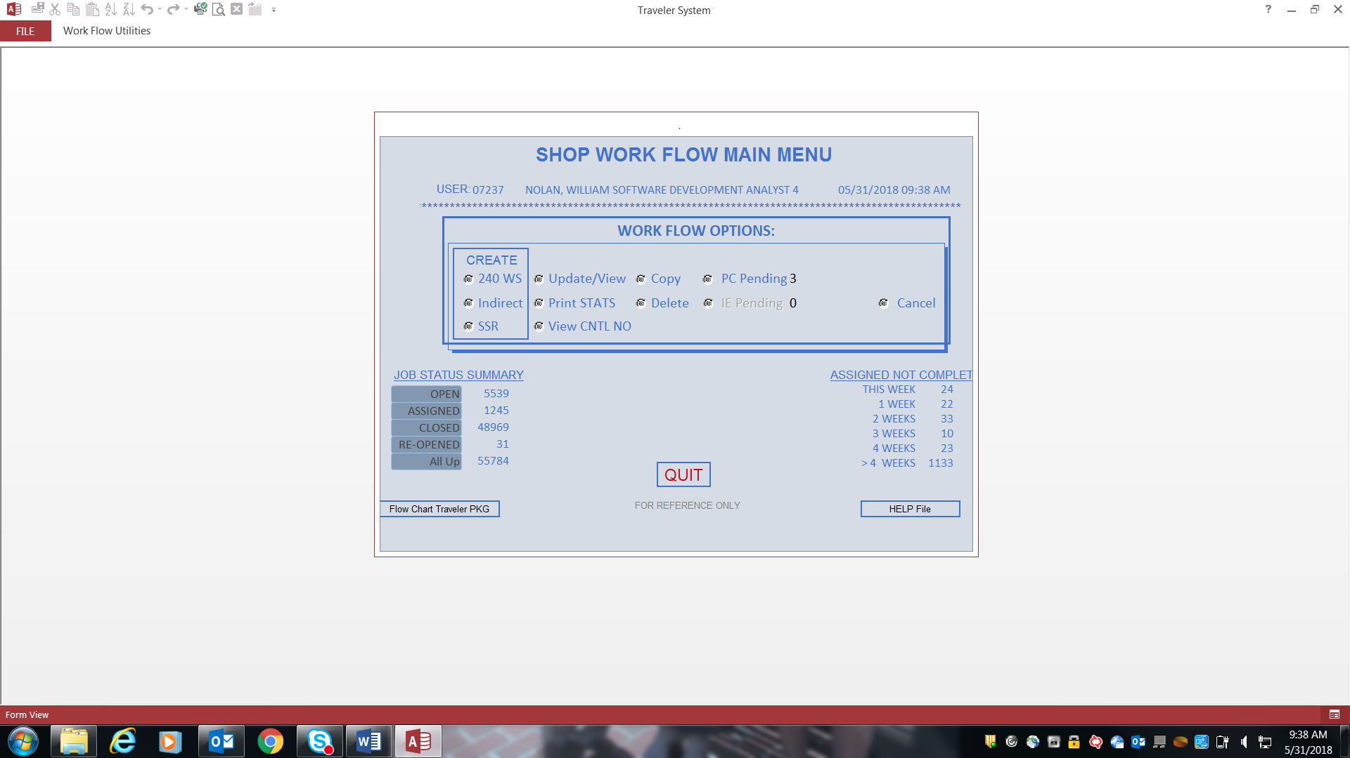

Click on Update/View button, gives you list of Hulls to select from. This list comes from table tHull_LOC, field HULL.

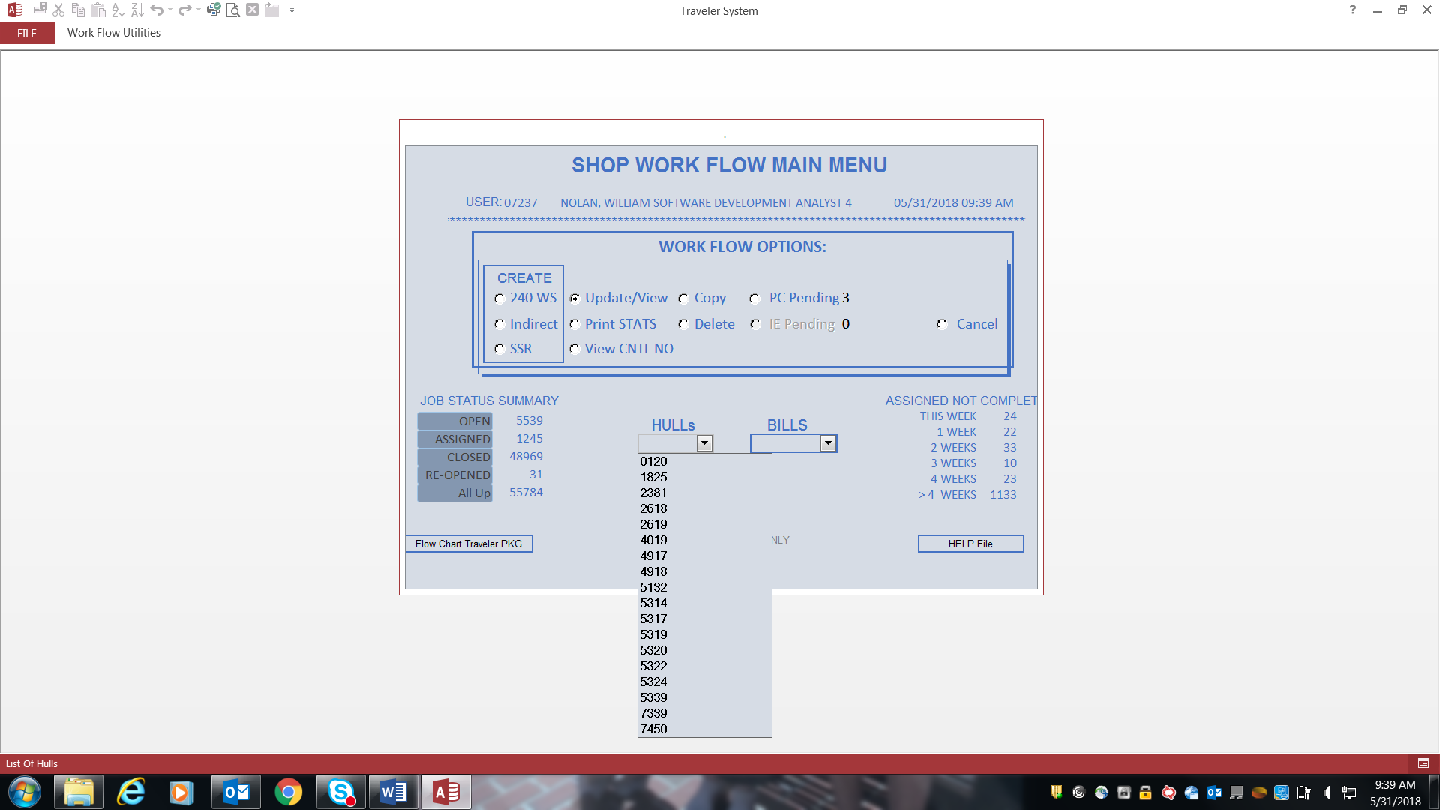

I select Hull 5322 and it gives me a list of existing Bills (Work Orders) to select from which come from table tTRV_Bills, field WO based upon HULL selected.

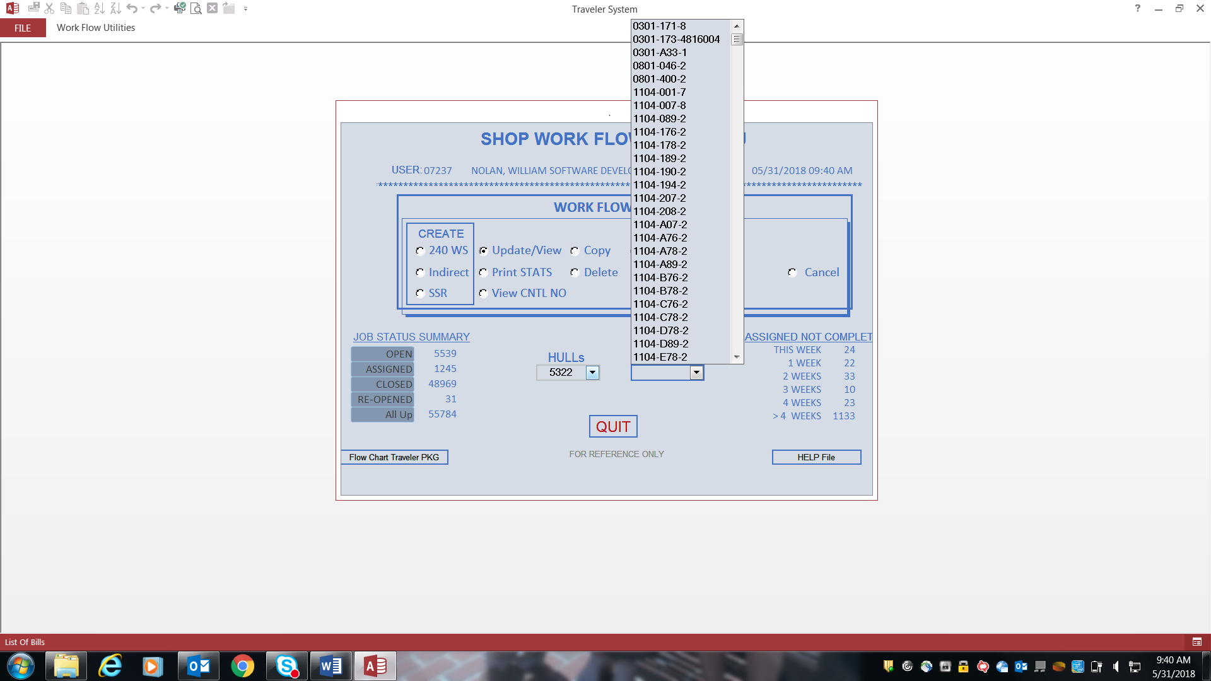

I select Bill 1104-176-2 and this screen appears which is Traveler 300 for Hull 5322. If you look at bottom left corner you will see that this is 1 of 23 Travelers for this Hull/Bill. You can click the arrows to scroll through all 23 of them.

Top half of screen Data Mapping:

Based upon HULL and Bill selected you would query the TRV table. I would order data by CTL_NO, they do not appear to be doing this.

All of the following fields from TRV table.

HULL is field HULL. BILL is field WO. CNTL-NO is field CTL_NO. COMPLETE is field CTL_NO_COMPLETE.

DWG is field DWG. PC NO is field PC_NO. MATL SOURCE is field MAT_SOURCE. QTY is field QTY.

HL QTY is field HLQTY. FEED BILL is field FEED_BILL.

REFERENCE FIELDS box: 1st box is Reference Drawing which is field REFDWG. 2nd box is Reference PC NO which is field REFPC_NO. 3rd box is Reference Source which is field REFMAT_SOURCE. 4th box is Machine Shop QTY which is field MSQTY.

5th box is Additional Description which is field REFDescription.

OP is a dropdown of Operation codes on the Work Order/Jobs. It comes from field OP.

CC is the Cost Center on the Work Order. It comes from field CC.

DESCRIPTION is field DESCRIPTION. SUPPORT DESCRIPTION and PL ITEM TEXT is field SUPPORT_DESCR.

NEXT ASSY is field NEXT_ASSY.

CAT MATL is field CAT_MATL. CAT SIZE is field CAT_SIZE. CAT MATL DESCRIPTION is field CAT_MATL_DESCRIPTION. CAT SPEC is field CAT_SPEC.

Bottom half of screen Data Mapping:

Based upon HULL, Bill, CNTL-NO displayed you would query the TRV_Sub table. I would order by ID field.

All of the following fields from TRV_Sub table.

SEQ is field ID. W/C is field WRK_CTR. WORK_CENTER_DESCRIPTION is field WorkCenter_Desc.

2 NEW FIELDS AUTO_ID from TVL_sub table. Not sure what these are.

JOB INSTRUCTION is field TITLE. STD is field STD. ACT is field ACT. ASSIGN TO is field BADGE. Job Stat is field JOB_STAT.

Very bottom of screen Data Mapping:

Based upon HULL and Bill selected you would query the TRV table.

All of the following fields from TRV table.

PC Create/Copy Complete field is PC1 & PC1_DATE.

IE Complete field is IE & IE_DATE.

PC Traveler Complete field is PC2 & PC2_DATE.

CNTL-NO Complete is field CTL_NO_COMPLETE.

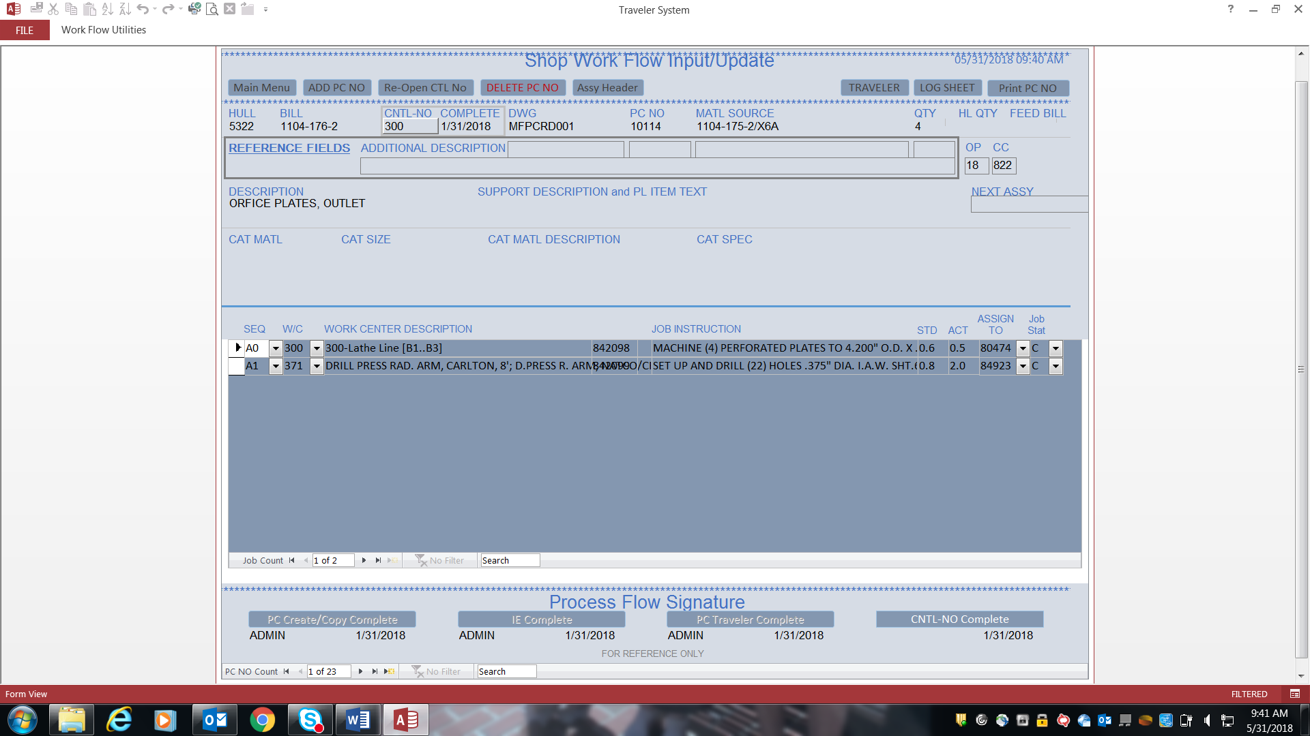

You can click LOG SHEET at upper right corner and you can get list of all Travelers for this Hull/Bill.

Data Mapping:

Based upon HULL and Bill selected you would query the TRV table and order data by CTL_NO.

All of the following fields from TRV table.

HULL is field HULL. BILL is field WO. SHOP is field SHOP_CD.

CNTL-NO is field CTL_NO.

DWG is field DWG. PC NO is field PC_NO. MATL SOURCE is field MAT_SOURCE. QTY is field QTY.

ASSY is field ASSY_PC – If 0 then display NO, if 1 then display YES.

COMPLETE is field CTL_NO_COMPLETE.

Calculated fields:

STD is sum of field STD on TRV_Sub table based upon the HULL and CTL_NO.

JOB STATUS (O, A, C, R) are sum of rows on TRV_Sub table at HULL, CNTL_NO level based upon the following.

O is Open – JOB_STAT field = ‘O’.

A is Assigned – JOB_STAT field = ‘A’.

C is Complete – JOB_STAT field = ‘C’.

R is Reopened – JOB_STAT field = ‘R’.

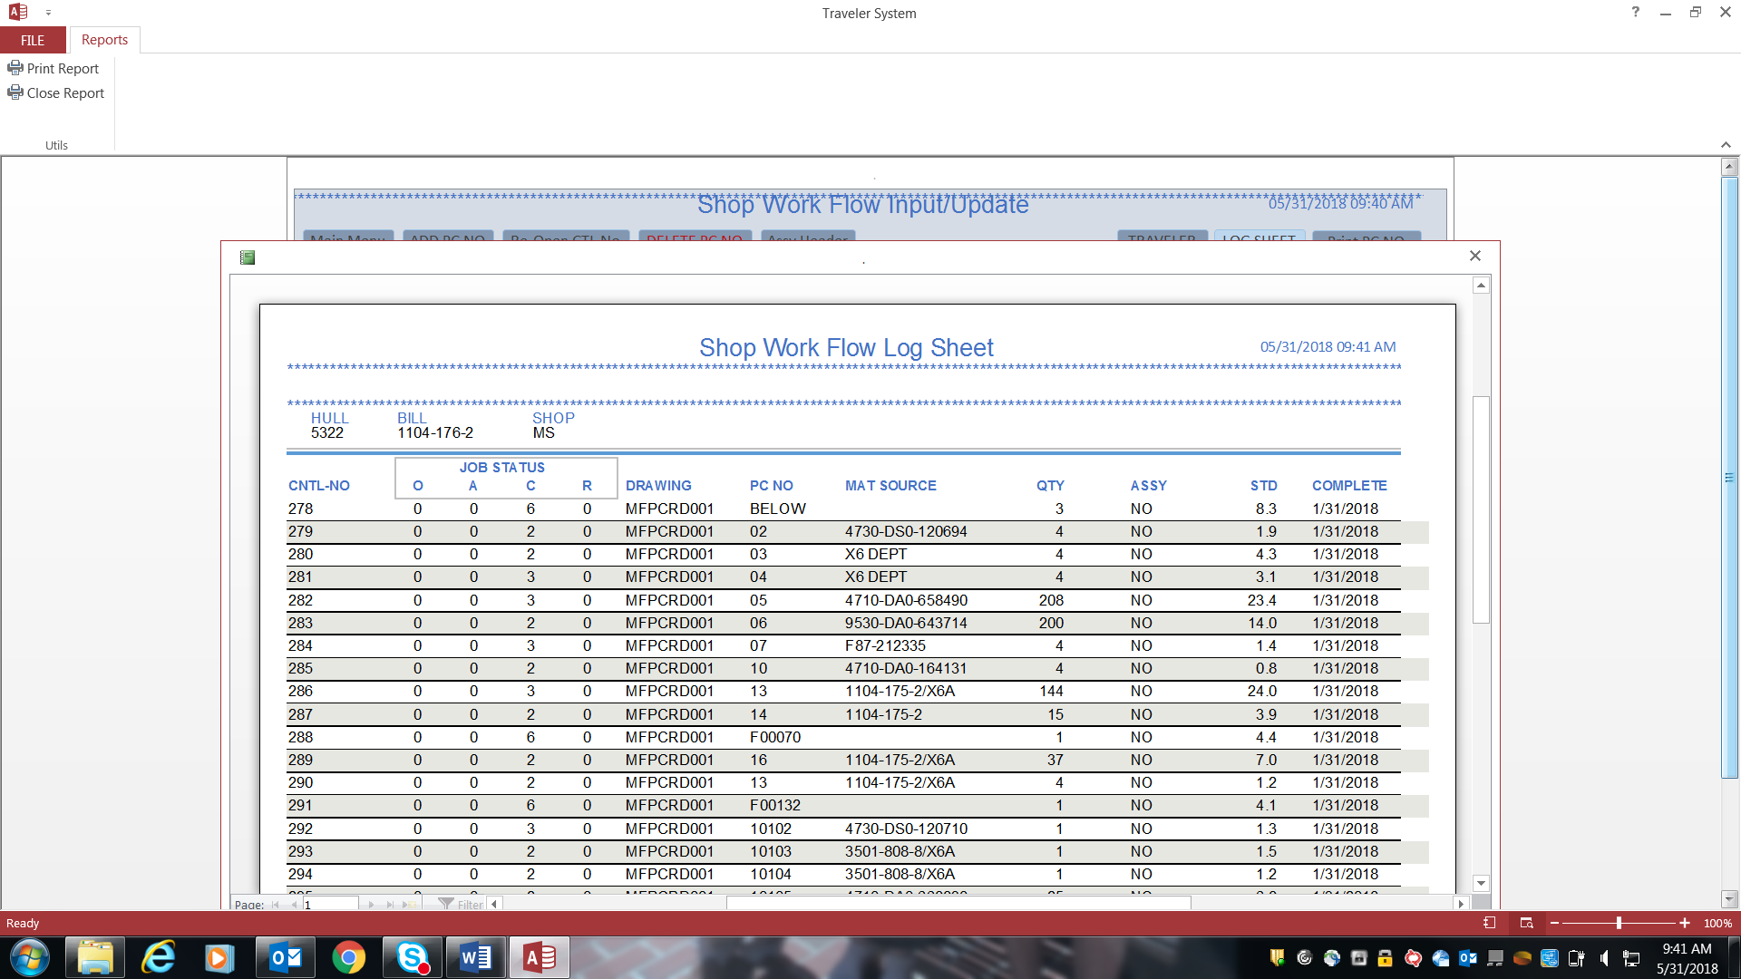

Bottom of screen, wouldn’t quite fit on 1 screen.

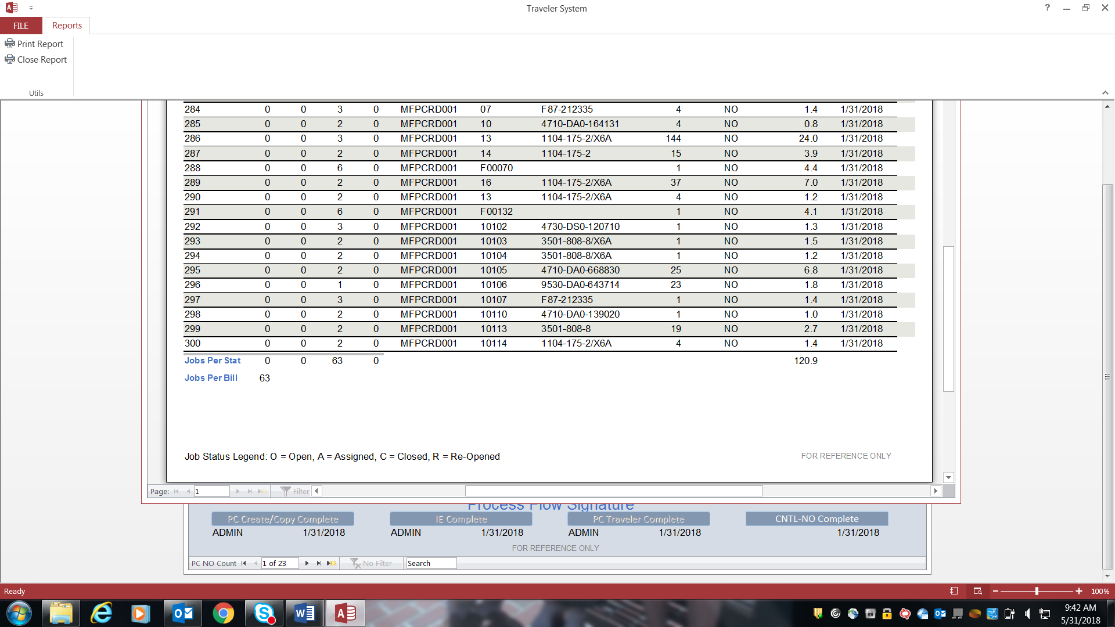

Back to MAIN MENU.

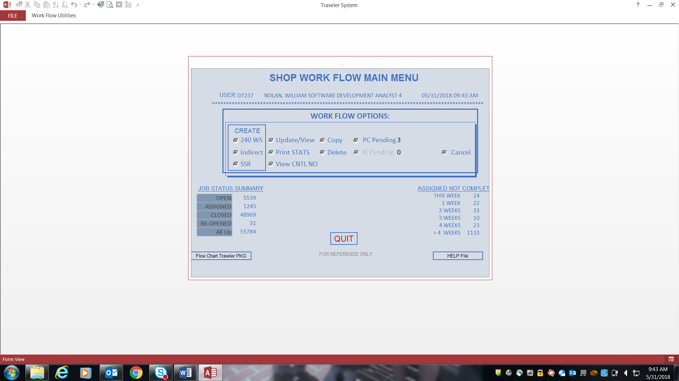

Click on OPEN under JOB STATUS SUMMARY at bottom left of screen. Generates Excel report.

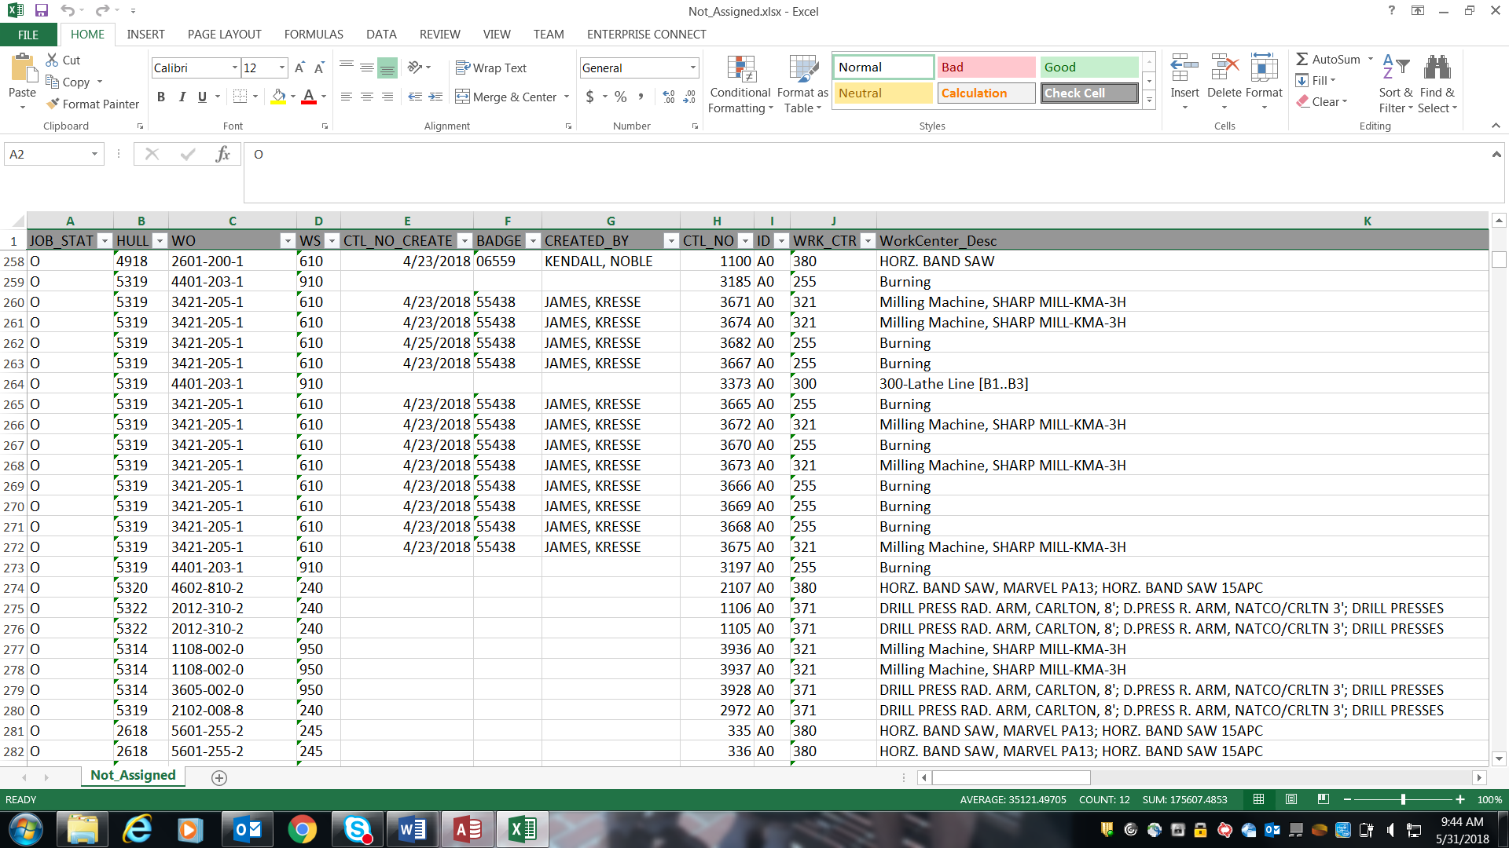

You can join the TRV table and TRV_Sub table on Hull & CTL_NO where JOB_STAT on TRV_Sub table = ‘O’.

Fields on spreadsheet:

JOB_STAT is field JOB_STAT from TRV_Sub table

HULL is field HULL from TRV_SUB table

WO is field WO from TRV table

WS is field WS from TRV table

CTL_NO_CREATE is field CTL_NO_CREATE on TRV table

BADGE is field BADGE on TRV table

CREATED_BY is field 5N2 on TRV table

CTL_NO is field CTL_NO on TRV table

ID is field ID from TRV_Sub table

WRK_CTR is field WRK_CTR from TRV_Sub table

WorkCenter_Desc is field WorkCenter_Desc from TRV_Sub table

TITLE is field TITLE from TRV_Sub table

STD is field STD from TRV_Sub table

SS is field SS from TRV table

SC is field SC from TRV table

AS is field AS from TRV table,

AC is field AC from TRV table

Click on ASSIGNED under JOB STATUS SUMMARY at bottom left of screen. Generates Excel report.

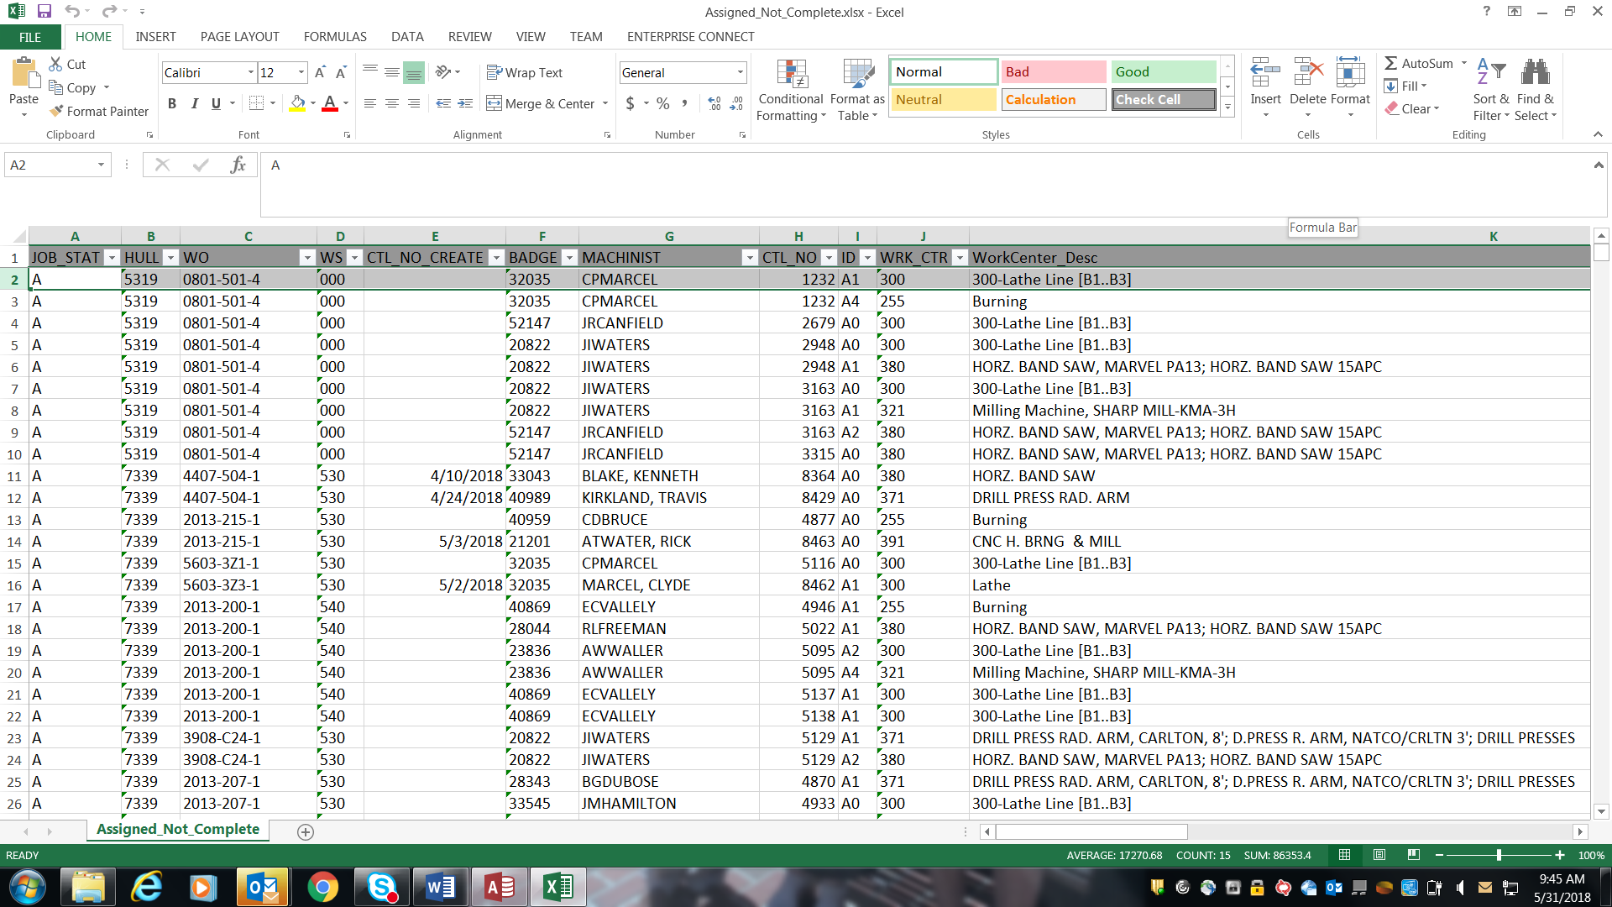

You can join the TRV table and TRV_Sub table on Hull & CTL_NO where JOB_STAT on TRV_Sub table = ‘A’.

Fields on spreadsheet:

JOB_STAT is field JOB_STAT from TRV_Sub table

HULL is field HULL from TRV_SUB table

WO is field WO from TRV table

WS is field WS from TRV table

CTL_NO_CREATE is field CTL_NO_CREATE on TRV table

BADGE is field BADGE on TRV_Sub table

MACHINIST is field NAME on TRV_Sub table

CTL_NO is field CTL_NO on TRV table

ID is field ID from TRV_Sub table

WRK_CTR is field WRK_CTR from TRV_Sub table

WorkCenter_Desc is field WorkCenter_Desc from TRV_Sub table

TITLE is field TITLE from TRV_Sub table

STD is field STD from TRV_Sub table

ACT_HRS is field ACT on TRV_Sub table

SS is field SS from TRV table

SC is field SC from TRV table

AS is field AS from TRV table,

AC is field AC from TRV table

Click on CLOSED under JOB STATUS SUMMARY at bottom left of screen and nothing happens. You can see all the CLOSED in the All Up Excel report.

Click on All Up under JOB STATUS SUMMARY at bottom left of screen. Generates Excel report.

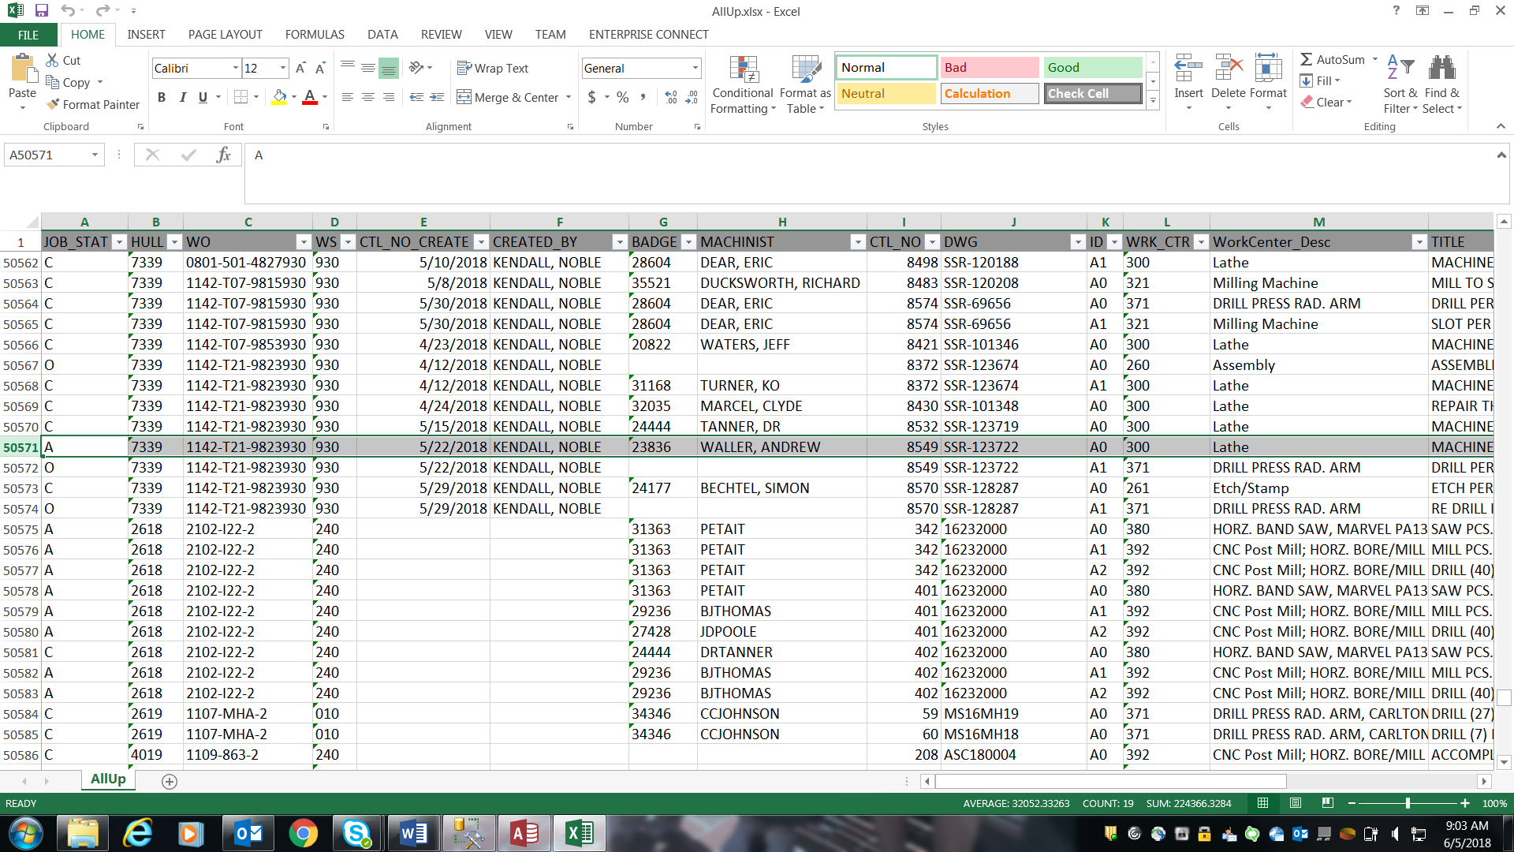

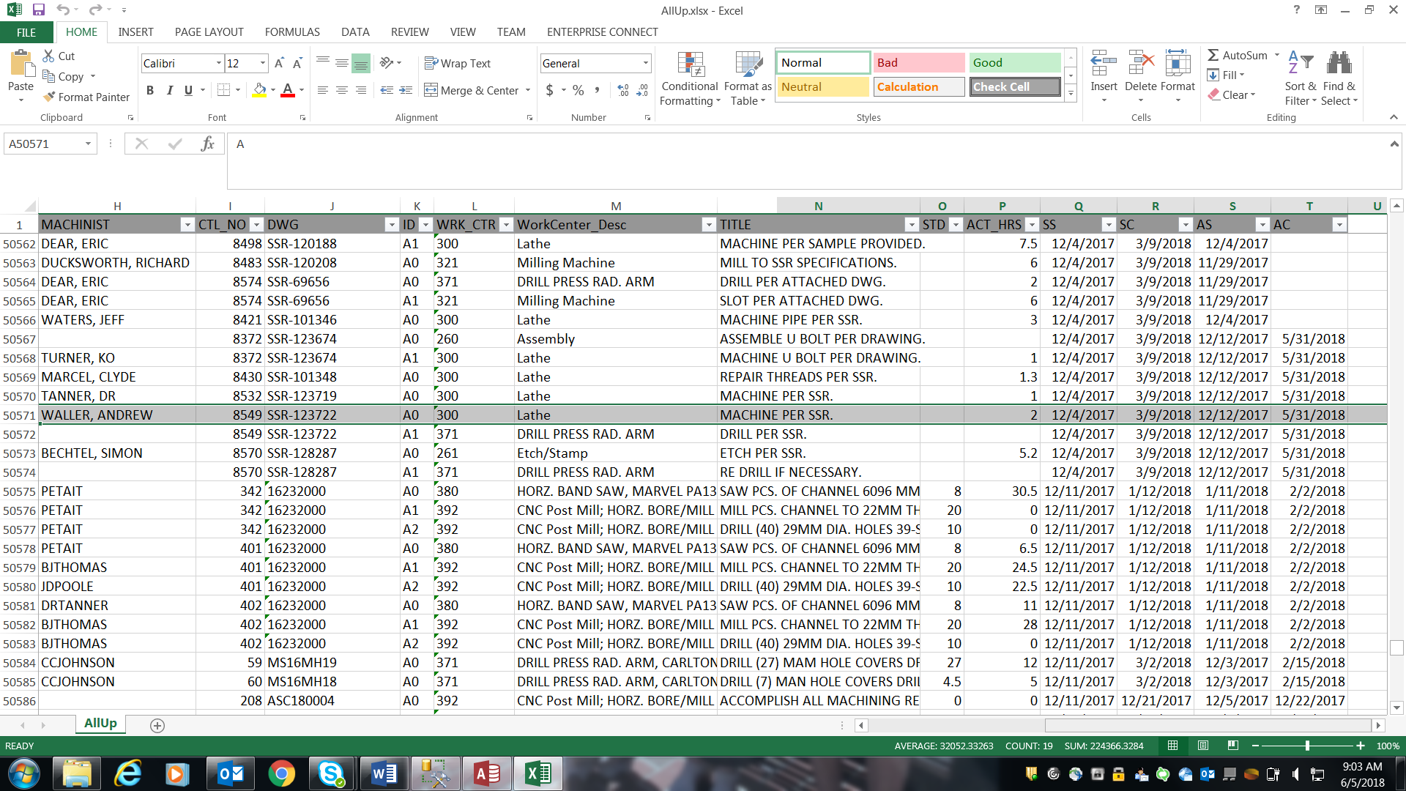

You can join the TRV table and TRV_Sub table on Hull & CTL_NO.

Fields on spreadsheet:

JOB_STAT is field JOB_STAT from TRV_Sub table

HULL is field HULL from TRV_SUB table

WO is field WO from TRV table

WS is field WS from TRV table

CTL_NO_CREATE is field CTL_NO_CREATE on TRV table

CREATED_BY is field 5N2 from TRV table

BADGE is field BADGE on TRV_Sub table

MACHINIST is field NAME on TRV_Sub table

CTL_NO is field CTL_NO on TRV table

DWG is field DWG from TRV table

ID is field ID from TRV_Sub table

WRK_CTR is field WRK_CTR from TRV_Sub table

WorkCenter_Desc is field WorkCenter_Desc from TRV_Sub table

TITLE is field TITLE from TRV_Sub table

STD is field STD from TRV_Sub table

ACT_HRS is field ACT on TRV_Sub table

SS is field SS from TRV table

SC is field SC from TRV table

AS is field AS from TRV table,

AC is field AC from TRV table

Click on REOPENED under JOB STATUS SUMMARY at bottom left of screen. Pops up screen below which is the view/update screen.

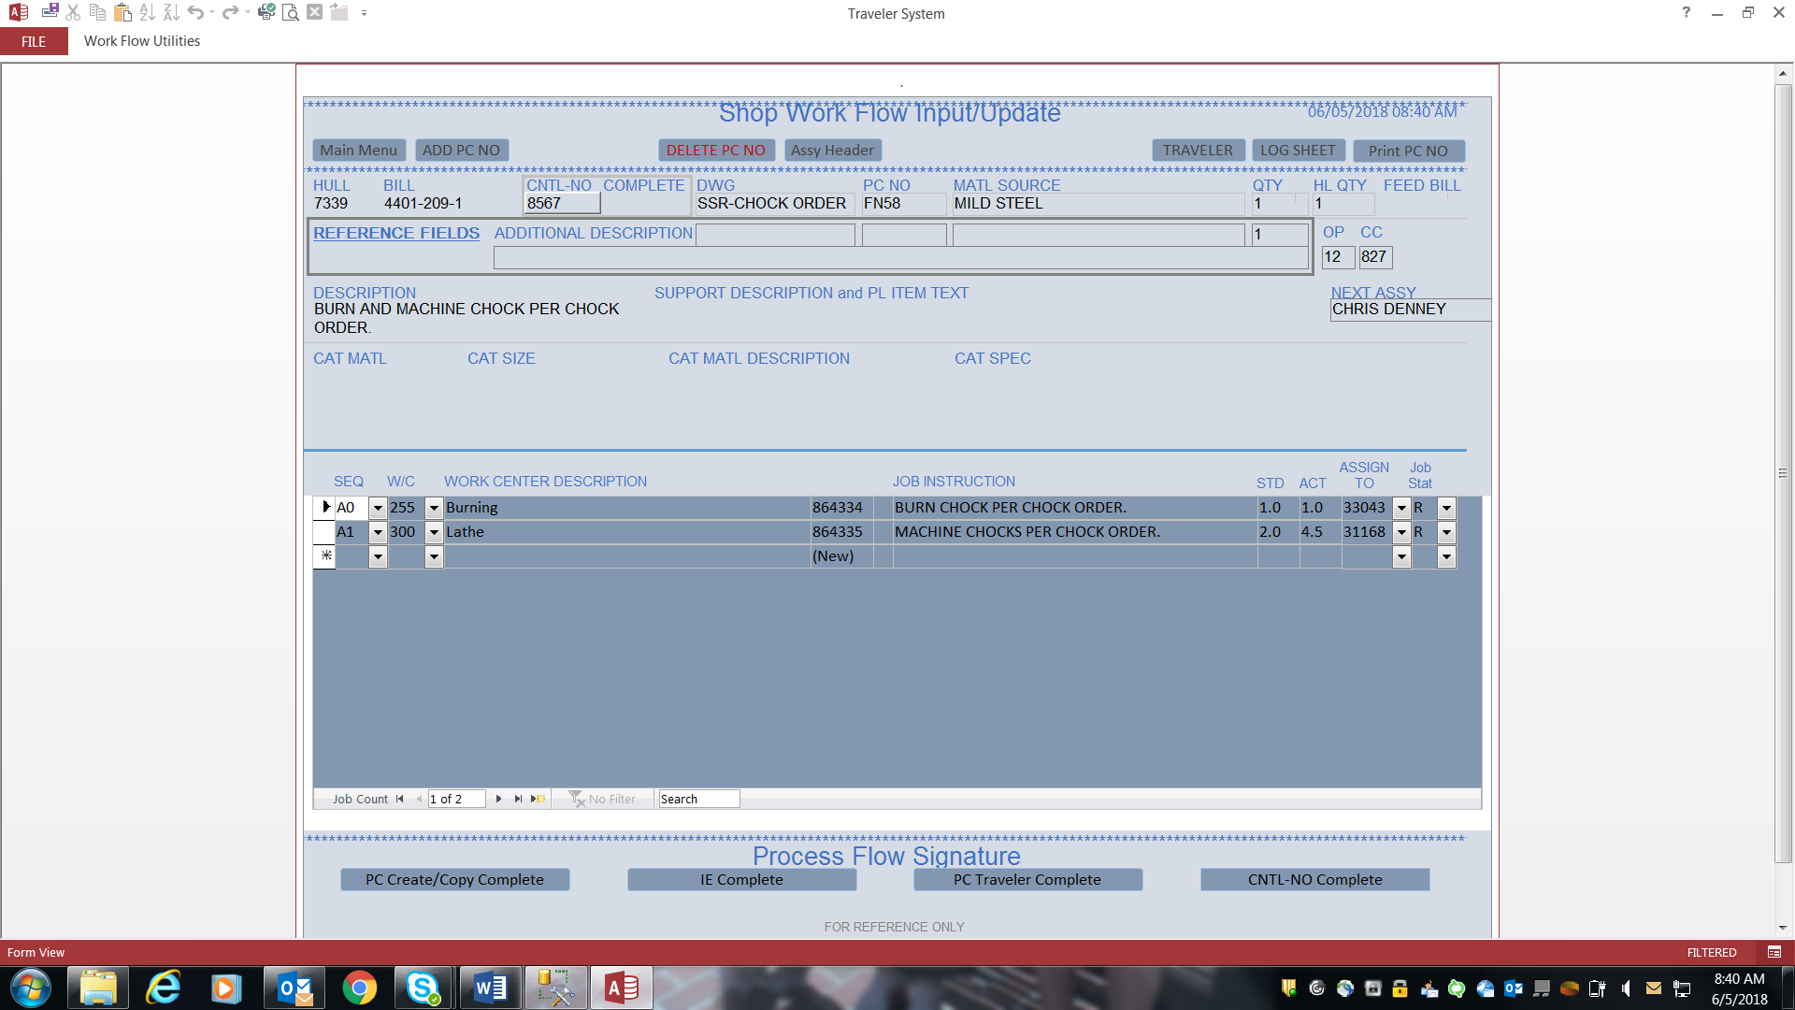

MAIN MENU – ASSIGNED NOT COMPLETE totals at bottom right of screen.

These totals come from query that uses the IN_WORK date field on TRV_Sub table. Still trying to get details of query.

