Chelsea McElhiney
Module 2 Assignment – Data Models
The following images illustrate the Entity Relationship Diagram (ERD) and the equivalent NoSQL data structure for the given business rules.

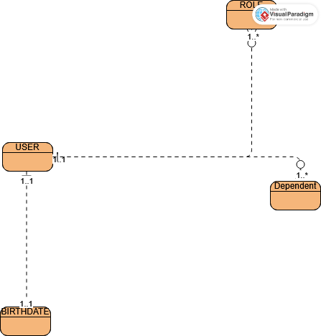

Entity Relationship Diagram.



NoSQL Data Structure.

