Chelsea McElhiney
Module 4 Assignment
July 11th, 2026
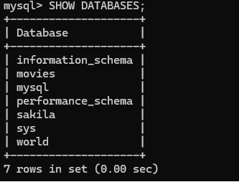
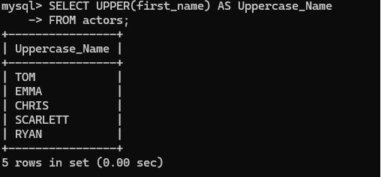
The UPPER() function converts text to uppercase. It can be useful when displaying names in a consistent format or when performing case-insensitive comparisons.
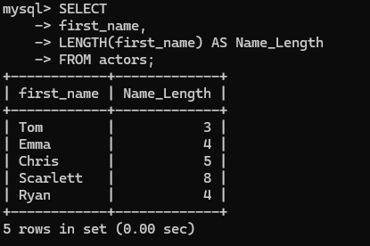
LENGTH() returns the number of characters in a string. This is useful for validating data or checking character limits.
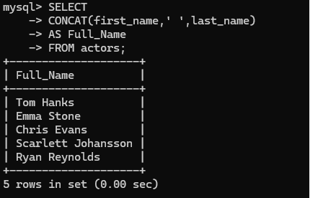
CONCAT() joins multiple strings together. It is commonly used to display first and last names as a single value.

