Chelsea McElhiney
Module 5 Assignment
July 11th, 2026
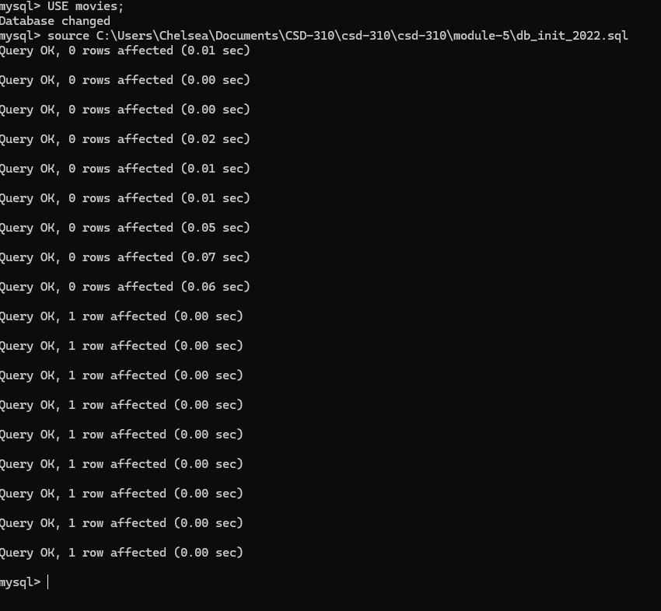
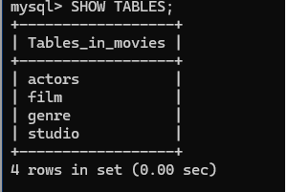
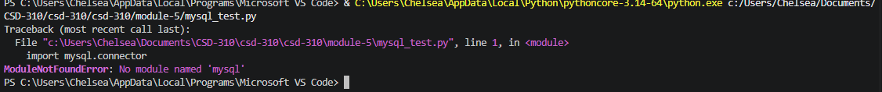
https://github.com/cdmcelh-svg/csd-310

