Chelsea McElhiney
CSD-310
Module 6 Assignment
7/18/2026
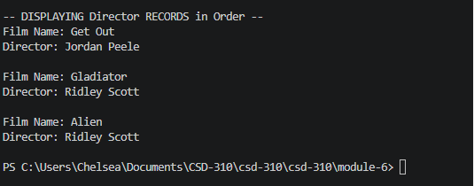
https://github.com/cdmcelh-svg/csd-310

