Mini-Sentinel – OMOP Common Data Models Harmonization (crosswalk) Pilot

Background
Sentinel
A national electronic system that will transform FDA’s ability to track the safety of drugs, biologics, medical devices--and ultimately all FDA-regulated products once they reach the market--is now on the horizon. Launched in May 2008 by FDA, the Sentinel Initiative aims to develop and implement a proactive system that will complement existing systems that the Agency has in place to track reports of adverse events linked to the use of its regulated products.
Mini-Sentinel
In September 2009, Harvard Pilgrim Healthcare (HPHC) was awarded with the contract to develop and test the scientific operations needed for the Sentinel Initiative; create and pilot test a coordinating center with continuous access to electronic healthcare data systems (claims, EHR, registries, …); establish a distributed network utilizing a federated architecture. The Mini-Sentinel Coordinating Center (MSCC) and participating data partners design and use a common data model (CDM) as the basis for their analytic approach. Each data partner will transform their local data into the Mini-Sentinel CDM.
Observational Medical Outcomes Partnership (OMOP)
OMOP is a public-private partnership to serve the public health by testing whether multi-source observational data can improve our ability to assess drug safety and benefits. OMOP’s team has also developed a Common data Model (CDM), library of methods and other findings from their central and distributed partners which could inform Mini-Sentinel. The OMOP common data model includes a single data schema that can be applied to disparate data types (claims, EHR). It utilizes standardized controlled terminologies.
Objectives and Benefits
In order to learn from both Mini-Sentinel and OMOP initiatives, the Food and Drug Administration is interested in conducting a pilot to harmonize the Mini-Sentinel and OMOP’s CDMs. This would allow Mini-Sentinel data partners to apply programs that were created by OMOP to characterize data (OSCAR, NATHAN); identify outliers and conduct quality checking (GROUCH). This collaboration will result in Operational efficiency savings by leveraging both mini-Sentinel and OMOP’s resources (developed programs, knowledge and expertise).
The eleven methods developed by OMOP’s methods partners can be tested both against Mini-Sentinel’s raw data as well as on good tuned, customized drug and condition eras in development by the Mini-Sentinel Operations team members.
Process
The flow diagram below illustrates the processes for 2 use cases:

The first use case illustrated the reuse of OMOP methods on mini-Sentinel distributed databases.

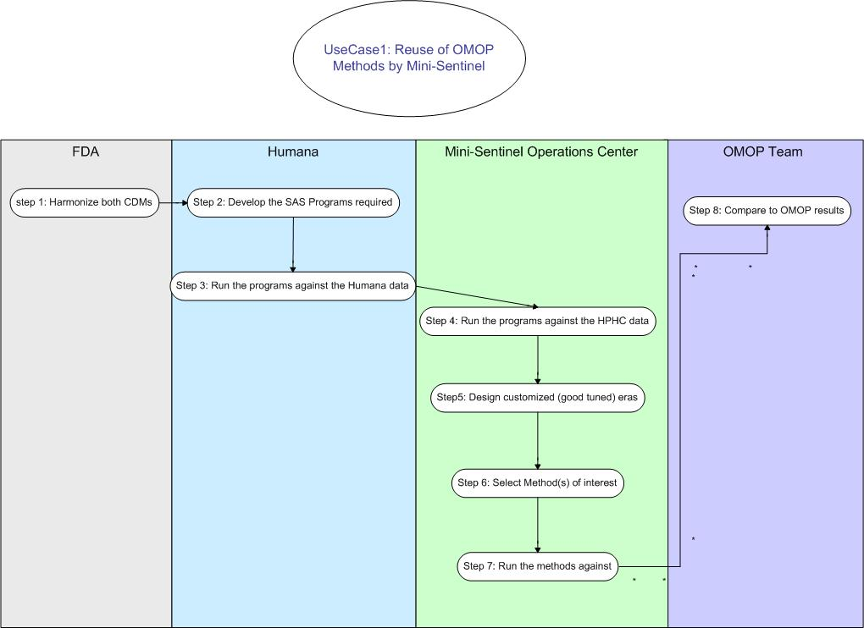

The second use case illustrates use of various SAS programs developed by OMOP team on the mini-Sentinel distributed databases.

