

Chameleon Cloud Tutorial
Chameleon API



Program Solicitation # NSF 13-602

CISE Research Infrastructure: Mid-Scale Infrastructure - NSFCloud (CRI: NSFCloud)
Application Program Interface

Objectives

In this tutorial, you will learn about the Application program Interface ,how it works with open stack.

Tutorial Action | Time Required
Step 1: Introduction of API on Open Stack  You will learn what is API and how it works with Open Stack. | 5 minutes
Step 2: Nova CLI installation and Configure RC file  To begin, we will learn the process of installing NOVA CLI and how to configure RC file | 10 minutes
Step 3: Key Stone Introduction and installation  We will discuss about Key stone its features and how API works with Key Stone. | 15 minutes
Step 4: Nova Usage  Lastly, we will implement the Nova on API | 10 minutes

Prerequisites
- Knowledge of API
- A SSH Client(how to use SSH)
- Basic Knowledge of LINUX
- Basic knowledge on Open Stack applications.

What is Application Program Interface ?
An application program interface (API) is code that allows two software programs to communicate with each other. Typically, APIs are released for third-party development as part of a software development kit (SDK) or as an open API published on the Internet.
What is Open API
Open API (often referred to as OpenAPI new technology) is a term used in the Application Programming Interface (API) process that uses sets of technologies that enable websites to interact with each other by using REST, SOAP, JAVA SCRIPT other web technologies.
How API Works ?
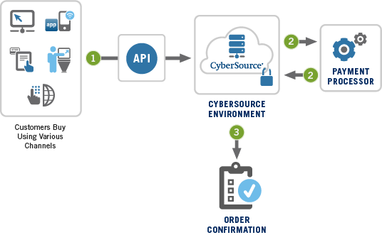

API for OPEN STACK
A set of language bindings that provide a language-level API for accessing OpenStack in a manner consistent with language standards.
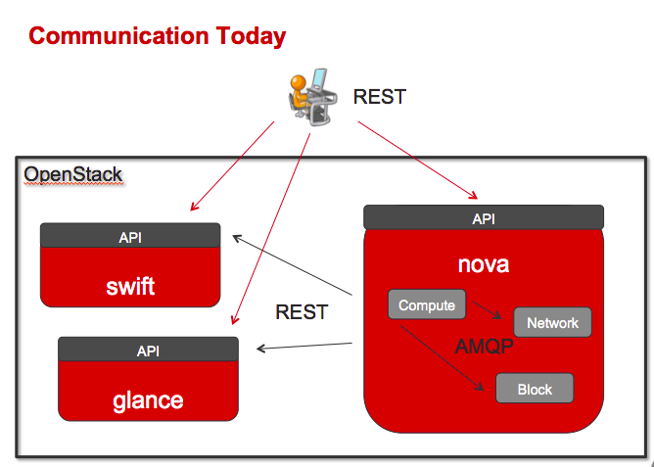
Each OpenStack project provides a command-line client, which enables you to access the project API through easy-to-use commands
Some of the Open Stack Services and Clients
Service | Client
Block Storage | Cinder
Compute | Nova
Object Storage | Swift

Nova CLI Installation:
Nova which is a client for Compute service which creates and manages images , instances and flavors.

Installing nova using pip
# pip install python-novaclient

Uninistall Nova
# pip uninstall python-novaclient
Configuration of RC file
Login to the Chameloen Account → Project → Access & Security → API Access
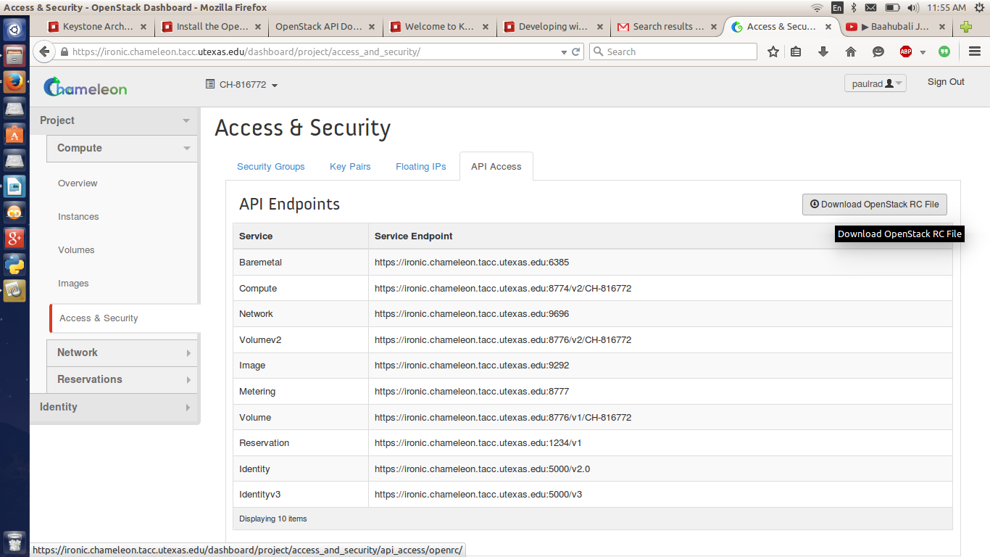
Click on the Download Open Stack RC file and save it.
Advanced Resource Leasing Reservation.
Login to the Chameloen account → Project → Reservation → Leases → Create Lease/Delete Lease.
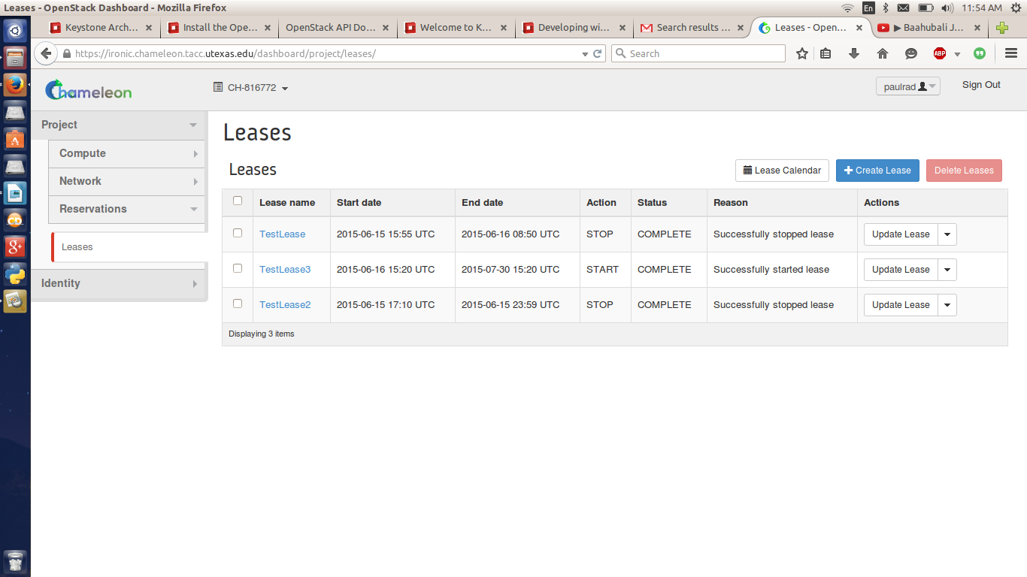
Let us check how NOVA works
- Using Chameleon account Create an instance
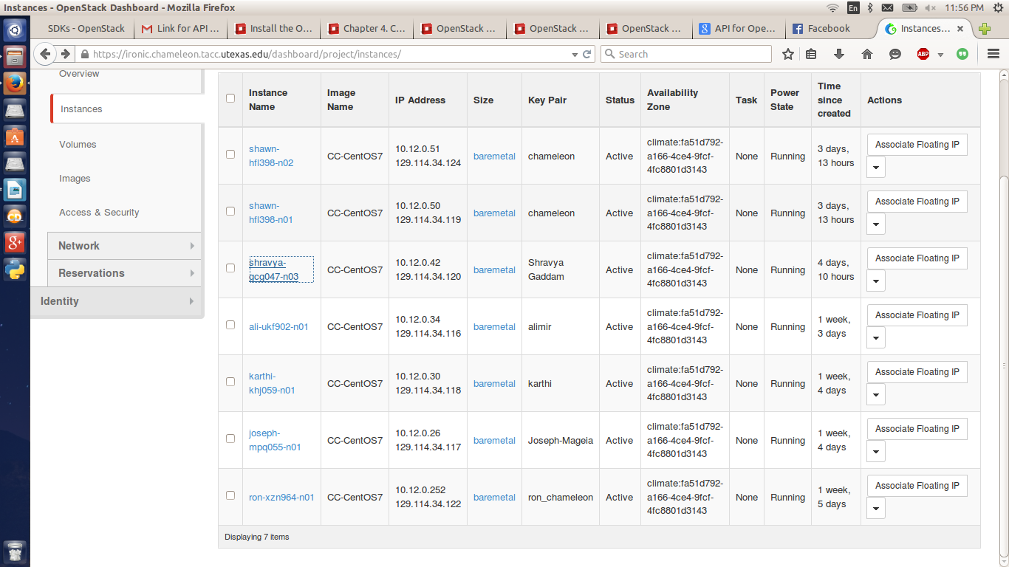
- Login to port that is associated with the IP address.
- Use the following Commands.
Open the RC configuration file that we have saved already.
[cc@shravya-gcg047-n03 ~]$ Cat CH-816772-openrc.sh
The file looks in the below format and verify the highlighted fields.
#!/bin/bash

# To use an Openstack cloud you need to authenticate against keystone, which

# returns a **Token** and **Service Catalog**. The catalog contains the

# endpoint for all services the user/tenant has access to - including nova,

# glance, keystone, swift.

#
# *NOTE*: Using the 2.0 *auth api* does not mean that compute api is 2.0. We

# will use the 1.1 *compute api*

export OS_AUTH_URL=https://ironic.chameleon.tacc.utexas.edu:5000/v2.0

# With the addition of Keystone we have standardized on the term **tenant**

# as the entity that owns the resources.

export OS_TENANT_ID=CH-816772

export OS_TENANT_NAME="CH-816772"

# In addition to the owning entity (tenant), openstack stores the entity

# performing the action as the **user**.

export OS_USERNAME="paulrad"

# With Keystone you pass the keystone password.

echo "Please enter your OpenStack Password: "

read -sr OS_PASSWORD_INPUT

export OS_PASSWORD=$OS_PASSWORD_INPUT

# If your configuration has multiple regions, we set that information here.

# OS_REGION_NAME is optional and only valid in certain environments.

export OS_REGION_NAME="regionOne"

# Don't leave a blank variable, unset it if it was empty

if [ -z "$OS_REGION_NAME" ]; then unset OS_REGION_NAME; fi
[cc@shravya-gcg047-n03 ~]$ source CH-816772-openrc.sh
KeyStone : Keystone is an OpenStack project that provides Identity, Token, Catalog and Policy services for use specifically by projects in the OpenStack family. It implements Open Stack's Identity API
Prerequisites for Keystone development
- Git
- Phython latest version
- Virtual env
- pip
- msgfmt(part of gittext package)
- setuptools.
Setup steps for keystone
$ git clone https://git.openstack.org/openstack/keystone.git

installing dependencies—for ubuntu
$ sudo apt-get install python-dev python3-dev libxml2-dev libxslt1-dev \ libsasl2-dev libsqlite3-dev libssl-dev libldap2-dev libffi-dev

Installing virtual environment and activating it
$ python tools/install_venv.py
$ source .venv/bin/activate

Install the dependencies for running keystone
$ pip install -r requirements.txt

Install the dependencies for developing, testing, and running keystone
$ pip install -r test-requirements.txt

Use 'python setup.py' to link Keystone into Python's site-packages
$ python setup.py develop
Verifying keystone is set up perfectly
$ source .venv/bin/activate
you should be able to import keystone with out any issue
$ python -c "import keystone"

Developing with Keystone
Configuring Keystone
        - $ cp etc/keystone.conf.sample etc/keystone.conf

Running Keystone
$ tools/with_venv.sh bin/keystone-all

Testing Keystone
$ pip install tox

To execute the tests just run
$ tox

Nova Usage
Now Check for the NOVA USAGE
[cc@shravya-gcg047-n03 ~]$ nova usage
Usage from 2015-05-27 to 2015-06-25:
+---------+--------------+-----------+---------------+
| Servers | RAM MB-Hours | CPU Hours | Disk GB-Hours |
+---------+--------------+-----------+---------------+
| 22 | 12716184.32 | 9031.38 | 144502.09 |
+---------+--------------+-----------+---------------+

Now checking for the Key Pair.
[cc@shravya-gcg047-n03 ~]$ nova keypair-list

+---------------+-------------------------------------------------+

| Name | Fingerprint |

+---------------+-------------------------------------------------+

| Paul Rad | 5f:3e:27:7b:df:17:fe:18:15:7c:eb:65:84:14:75:7f |

| Ron_Laptop | 50:09:57:56:7f:80:53:e6:97:87:df:f0:b0:38:c9:e6 |

| Sam Silvestro | fa:c8:ba:fe:0e:7e:3e:a6:b3:b2:1f:61:25:31:37:0b |
+---------------+-------------------------------------------------+
The above command will trigger the API of Nova and display the key pairs that are associated with it.
Using API and deleting the Keypairs.
Using a Command Nova-keypair add
[cc@shravya-gcg047-n03 ~]$ nova keypair-add Testkeypair > Test.pem

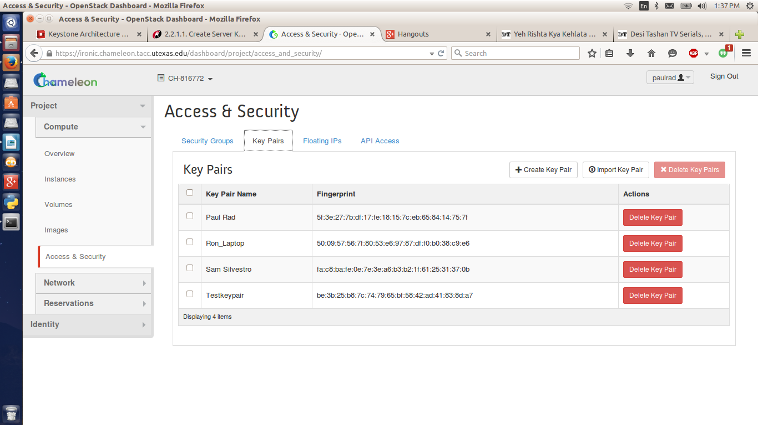
Checking for Key list to ensure the key pair is added
[cc@shravya-gcg047-n03 ~]$ nova keypair-list

+---------------+-------------------------------------------------+

| Name | Fingerprint |

+---------------+-------------------------------------------------+

| Paul Rad | 5f:3e:27:7b:df:17:fe:18:15:7c:eb:65:84:14:75:7f |

| Ron_Laptop | 50:09:57:56:7f:80:53:e6:97:87:df:f0:b0:38:c9:e6 |

| Sam Silvestro | fa:c8:ba:fe:0e:7e:3e:a6:b3:b2:1f:61:25:31:37:0b |

| Testkeypair | be:3b:25:b8:7c:74:79:65:bf:58:42:ad:41:83:8d:a7 |

+---------------+-------------------------------------------------+

Usng a command Nova-keypair-delete
[cc@shravya-gcg047-n03 ~]$ nova keypair-delete "TestKeypair"
This will trigger to the NOVA API and deletes a key pair associated with it
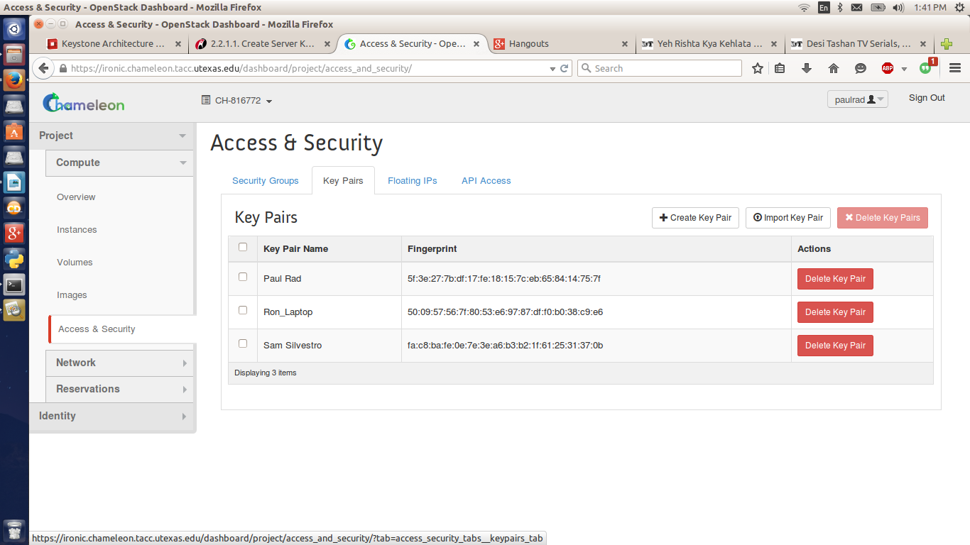
Checking the keypair list to verify whether it is deleted correctty
[cc@shravya-gcg047-n03 ~]$ nova keypair-list

+---------------+-------------------------------------------------+

| Name | Fingerprint |

+---------------+-------------------------------------------------+

| Paul Rad | 5f:3e:27:7b:df:17:fe:18:15:7c:eb:65:84:14:75:7f |

| Ron_Laptop | 50:09:57:56:7f:80:53:e6:97:87:df:f0:b0:38:c9:e6 |

| Sam Silvestro | fa:c8:ba:fe:0e:7e:3e:a6:b3:b2:1f:61:25:31:37:0b |

+---------------+-------------------------------------------------+

This can be achieved using other Cloud Source API Like
Swift ,glance,neutron,trove,openstack,Cinder etc

References
http://docs.openstack.org/user-guide/cli_cheat_sheet.html#block-storage-cinder
http://docs.openstack.org/cli-reference/content/install_clients.html

